[Table_Main]
Research Report
22 Feb 2026
Vertiv(VRT US)
A Near Pure Play On Powering Up and Cooling Down AI Data Center with strategical partnership with NVIDIA into next-gen AIDC structures: Initiation
 |  | Vertiv Holdings co. is a global leader in the critical digital infrastructure. The company designs, manufactures, sells, installs, maintains, and services critical digital infrastructure technologies and rapidly deployable customized solutions to meet the specific business requirements and needs of data centers, communication networks, and commercial and industrial environments. The principal offerings of Vertiv include Products, especially of critical power and thermal managemet, and Services & spares. Vertiv’s full-year 2025 results show a company successfully scaling its operations to meet the unprecedented demand of the AI era. While top-line growth was substantial, the most significant narrative was the company's ability to maintain and expand its profitability despite regional volatility and supply chain complexities.  The data center market is still considered to be in the early stages of a long-term construction cycle driven by AI. While the data center construction boom is dramatically increasing demand for IT equipment, it is also driving proportional growth in supporting non-IT infrastructure. Vertiv serves as a near pure play on powering up and cooling down AI Data Center.  The fast-growing power density of AIDCs and redundancy has brought increasing demand for power supply systems, requiring higher capacity switchgear, power distribution, UPS systems, and standby power to serve as a robust backbone for the entire power train. Vertiv occupies a preeminent position within this high-growth sector by offering a uniquely holistic power architecture.  Meanwhile, the densification of AI server clusters is forcing an evolution from air-cooled to liquid-cooled to address increasing power requirements. Vertiv distinguishes itself in this evolving landscape through its unmatched ability to provide comprehensive, end-to-end thermal management ecosystems that bridge the gap between air and liquid cooling. We believe, Vertiv will continue to lead through its full expertise in data center power and cooling infrastructure and strategic partnership with key clients like NVIDIA in the future.  Valuation& recommendation  We estimate that revenue of Vertiv from year 2026 to 2028 will be $13,540 / 18,375/ 21,813 million, with the net profit of $ 2,380/ 3,570/ 4,208 million. Based on the DCF valuation model, our target price of Vertiv is $ 279.97, we initiate coverage on the stock with “Outperform”.  Risks  Slowing growth and misexecution; Slowing demand activity in data center; Continued trade tensions and shifting U.S. tariff policies; Technological Obsolescence.
  [Table_Info]
  Initiate with OUTPERFORM
  Rating | OUTPERFORM
  Current Price | 243.75
  Target Price | 279.97
  Market cap | 93.26bn
  Shares in issue | 382.60mn
  1 yr high - low | 243.75-59.41
  Note: Current Price 243.75 is the close price on 20 Feb 2026
  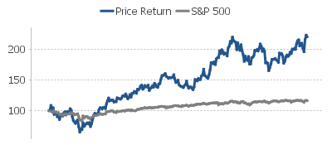
  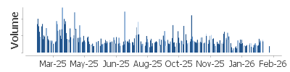
  Source: HFI
  [Table_Profit]
  US$ mn | Dec-25A |  | Dec-26E |  | Dec-27E |  | Dec-28E
  Revenue | 10,230 |  | 13,540 |  | 18,375 |  | 21,813
  （+/-） | 27.69% |  | 32.36% |  | 35.71% |  | 18.71%
  Net profit | 1,640 |  | 2,378 |  | 3,517 |  | 4,208
  （+/-） | 49% |  | 851% |  | 848% |  | 767%
  Diluted EPS (US$) | 4.20 |  | 6.06 |  | 9.04 |  | 10.95
  GPM | 36.3% |  | 36.3% |  | 39.0% |  | 39.0%
  ROE | 41.6% |  | 39.8% |  | 38.5% |  | 32.4%
  P/E | 58 |  | 40 |  | 27 |  | 22
  Source: Company data, HFI
[Table_Author]
Bin Yang, SFC:BSQ313 | Yida Deng, SFC:BVF321
harryyang@hfisec.com.hk | dengyida@hfisec.com.hk

Contents

1. Vertiv: deliver end-to-end power and cooling technologies 3
1.1 Vertiv is a global leader in critical digital infrastructure with the most complete portfolio 3
1.2 Financial performance highlights 8
2. Data Centers will not be completed without power and thermal solutions 10
2.1 AI Data Center (AIDC) construction keeps growing 10
2.2 Powering AI: The power supply equipment system is crucial to AIDC 12
2.3 Cooling AI: liquid cooling penetration is up 16
3. Vertiv differentiates through its full expertise in powering and cooling and strategic partnership with NVIDIA 20
3.1 Vertiv’s dominance in data center power and cooling infrastructure with end-to-end systems and services expertise 20
3.2 Partnership with key industry leaders to build the future of AI infrastructure 22
4. Valuation& recommendation 24
5. Risks 26

- Vertiv: deliver end-to-end power and cooling technologies

1.1 Vertiv is a global leader in critical digital infrastructure with the most complete portfolio
Vertiv Holdings co. is a global leader in the critical digital infrastructure. The company designs, manufactures, sells, installs, maintains, and services critical digital infrastructure technologies and rapidly deployable customized solutions to meet the specific business requirements and needs of data centers, communication networks, and commercial and industrial environments.

Figure: Business overview
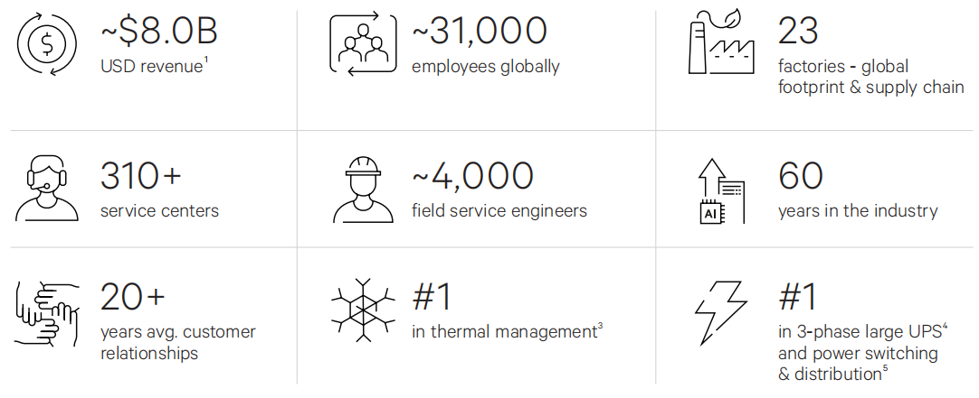
Source: Company, HFI
Note: :1 Based on FY 2024 revenue, net sales reached $10.2 billion in 2025; 2 Market segment rounded to 5%; 3 Dell’ Oro Data Center Physical Infrastructure reporting 2024. 4 Omdia UPS Hardware Market Tracker 2024, >250kva. 5 Omdia Data Center Power Distribution Tracker 2024.

Vertiv Holdings Co boasts a foundational pedigree that dates back to 1946, though its modern industrial identity was truly forged in 1965 with the establishment of Liebert Corporation. As the pioneer of the first precision cooling systems for computer rooms, Liebert created a high-barrier-to-entry niche that eventually drew a strategic acquisition by Emerson Electric in 1987. Under the Emerson umbrella, the entity was reorganized in 2000 as Emerson Network Power, a period defined by aggressive M&A activity designed to build a full-stack critical infrastructure provider. By integrating market leaders such as ASCO, Avocent, and Knürr AG, the division successfully diversified its portfolio across power transfer, remote management, and modular enclosure solutions.

The most significant inflection point for investors occurred in 2016, when Emerson executed a strategic divestiture of the unit, rebranding it as Vertiv to operate as an independent, pure-play infrastructure specialist. This transition culminated in Vertiv’s public market debut on February 7, 2020, via a high-profile business combination with GS Acquisition Holdings Corp, a SPAC sponsored by an affiliate of Goldman Sachs. Since its listing, the company has transitioned from a legacy industrial subsidiary into a leading-edge beneficiary of the global build-out in data center capacity and AI-driven thermal demand, marking a successful structural evolution from a family-founded enterprise to a scaled, global platform.
Since 2016, the company has conducted a series of acquisitions, targeting high-growth sectors, specifically Power Distribution and Liquid Cooling. Here is a list of Vertiv’s significant acquisitions:

Table: Product and services categories
Year | Company | Key Focus Area | Details
2018 | Energy Labs | Custom Air Handling | Enhanced indirect evaporative cooling for hyperscalers.
2018 | Geist | Rack PDUs | Secured leadership in rack-level power distribution.
2021 | E&I Engineering | Switchgear & Busway | Expansion: The $2B deal completed the full power chain.
2023 | CoolTera | Liquid Cooling (CDU) | AI Readiness: Acquired to lead in high-density chip cooling.
2025 | Waylay NV | GenAI & IoT Software | Added AI-driven automation for infrastructure monitoring.
2025 | Great Lakes | Custom Racks& Enclosures | Boosted "White Space" integration and speed-to-market.
2025 | PurgeRite | Liquid Cooling Services | Strengthened lifecycle support for AI liquid cooling systems.

Source: Company, HFI

Vertiv now has three reporting segments that break down sales by region: Americas, Asia Pacific and EMEA. While net sales reached $10.2 billion in 2025, the underlying drivers varied significantly across the three reporting segments:

- Americas (62% of sales): Performance was characterized by strong, broad-based organic growth across all product lines and customer segments. Despite the negative impact of tariffs, the region achieved a higher adjusted operating margin through effective price-cost management, productivity gains, and operational leverage.
- Asia Pacific (20% of sales): Organic sales faced challenges due to macroeconomic conditions in China, although other Asian markets remained resilient. Margins in this segment were squeezed by unfavorable "mix" and volume de-leverage.
- EMEA (18% of sales): Organic sales remained soft, primarily due to data center industry constraints. However, the outlook is optimistic; a strong surge in fourth-quarter orders and a robust pipeline are expected to support revenue growth in the second half of 2026. While margins were lower than the previous year due to operating leverage headwinds, the segment saw a strong sequential improvement as anticipated.

Vertiv has the most complete critical digital infrastructure portfolio. The principal offerings of Vertiv include Products (~80% of sales) and Services & spares (~20% of sales) under brands include Vertiv, Liebert, NetSure, Geist, Energy Labs, ERS, Albér, and Avocent:

Products: The company identifies delivery of products as performance obligations. Such products include AC and DC power management, thermal management, low/medium voltage switchgear, busbar, integrated modular solutions, racks, single phase UPS, rack power distribution, rack thermal systems, configurable integrated solutions, energy storage solutions, hardware, and software for managing I.T. equipment.

Services & spares: Global services include both pre-sale and after-sales services, for example, preventative maintenance, project management, acceptance testing, engineering and consulting, performance assessments, remote monitoring, training,
spare parts, and critical digital infrastructure software. The company provides consistent service delivery for critical facilities in all regions of the world with service provided by knowledgeable, local specialists.

Table: Product and services categories
Categories | Offerings (number of offerings)
Critical Power | Uninterruptible Power Supplies (UPS) (217)  Power Distribution (123)  DC Power Systems (81)  Static Transfer Switches (6)  Industrial AC and DC Systems (4)
Thermal Management | Room Cooling (50)  Rack Cooling (26)  In-Row Cooling (25)  Thermal Control and Monitoring (9)  Free Cooling Chillers (5)
Facilities, Enclosures and Racks | Integrated Solutions (59)  Outdoor Enclosures (11)  Racks and Containment (2)
Monitoring, Control and Management | IT Management (219)  Monitoring (77)  Software (57)
Services | Project Services (15)  Performance Optimization Services (6)  Training (2)

Source: Company, HFI

Figure: Vertiv has the most complete critical digital infrastructure portfolio
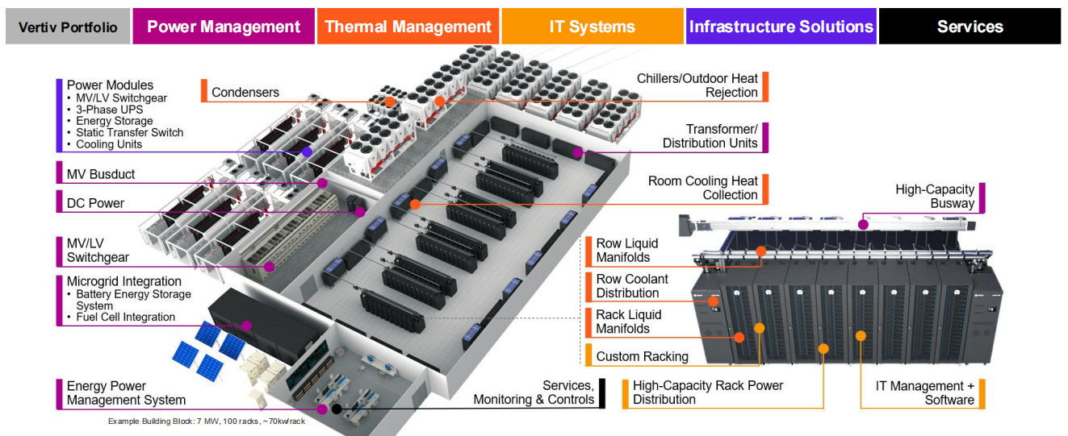
Source: Company, HFI
Competition faced by the company is driven by reliability, quality, price, service, and customer relationships. Vertiv faces two main types of rivals: large global providers (e.g., Schneider Electric, Eaton, Legrand, Huawei) and niche players (e.g., Delta Electronics, Stulz, Johnson Controls, Socomec). While most competitors focus on a specific product or region, Vertiv differentiates itself through application expertise, deep customer collaboration, the industry’s most complete portfolio, continuous innovation, proven reliability and quality, a truly global footprint, and an industry-leading global service network.

Headquartered in Westerville, Ohio, USA, Vertiv does business in more than 130 countries. Vertiv’s customers operate in some of the world's most critical industries. The company primarily serve customers across three main end markets:

- Data centers (~80% of sales), including hyperscale/cloud, colocation, and enterprise;
- Communication networks (~10% of sales),and
- Commercial and industrial applications (~10% of sales).

The company engages these customers through a global network of direct sales teams, independent representatives, channel partners, and OEMs. Vertiv often collaborates closely with clients from initial planning through delivery and ongoing service, fostering deep, long-term relationships that frequently span decades.

Figure: 2024FY Revenue breakdown
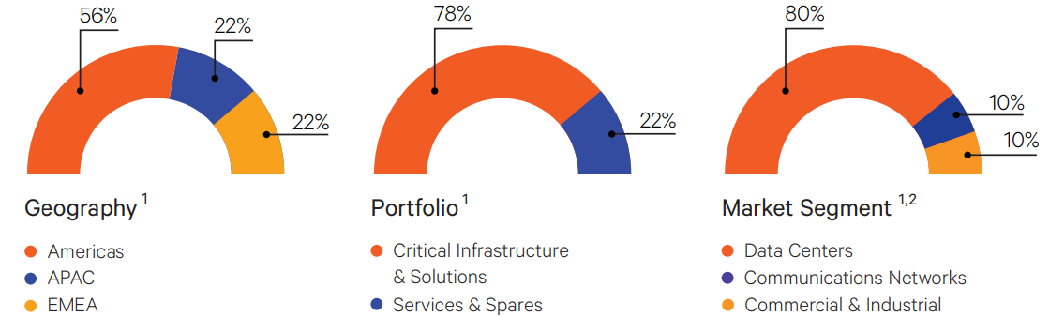
Source: Company, HFI
Note: :1 Based on FY 2024 revenue, for the year ended December 31, 2025, Vertiv’s net sales were $10.2 billion, of which 62% was transacted in the Americas; 20% was transacted in Asia Pacific; and 18% was transacted in Europe, Middle East & Africa.; 80% for product, 20% for Services in 2025. 2 Market segment rounded to 5%; Prior to 2024, the Company previously reported critical infrastructure & solutions and integrated rack solutions revenue separately. In 2024, the previously reported revenue for those product and service offerings are combined and reported as products as they are now collectively managed together.

Vertiv is led by an experienced executive team with deep expertise in global industrial operations, power systems, and digital infrastructure. CEO Giordano Albertazzi, who joined in 2023, previously held leadership roles at Nidec, GE, and ABB, bringing a strong focus on innovation and operational rigor. CFO Rob Johnson, formerly of Generac, drives financial discipline and strategic capital allocation. COO Gary Niederpruem, a long-time Vertiv veteran, oversees global manufacturing, supply chain, and service delivery—ensuring reliable execution at scale.

The company’s operational foundation is the Vertiv Operating System (VOS), a structured framework rooted in lean principles and continuous improvement. VOS provides a standardized, enterprise-wide approach to running the business, with clear ownership of seven core end-to-end processes. While championed by leadership, VOS is embedded across all levels of the organization to drive efficiency, quality, and customer responsiveness and allow the company the ability to drive further productivity savings to help offset inflation.

Figure: Leadership team
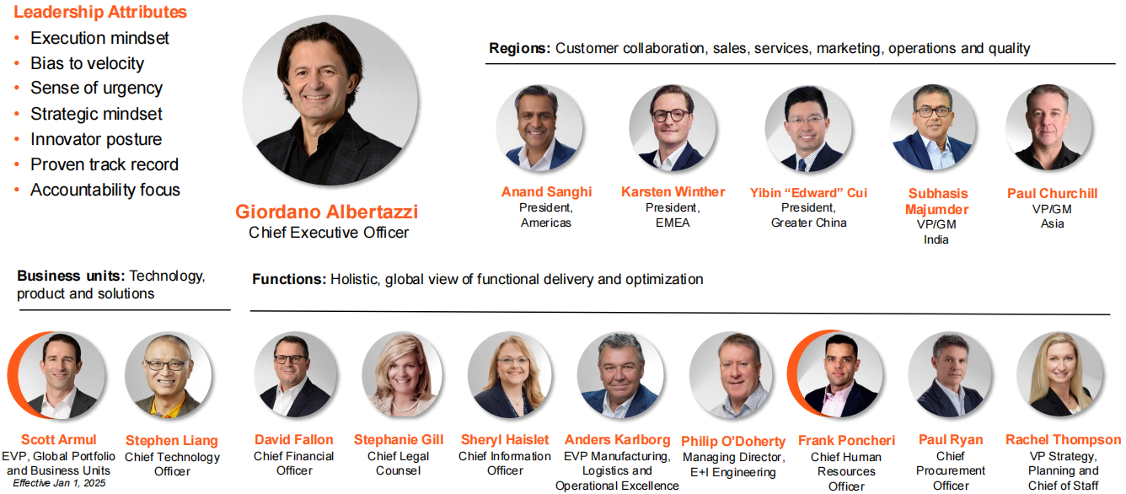
Source: Company, HFI
The company now is actively expanding its global capacity footprint. As of the end of 2024, Vertiv operates 24 manufacturing and assembly facilities, including 9 in the Americas, 10 in EMEA, and 5 in Asia Pacific. The company also maintains a robust service network with over 310 service centers and approximately 4,000 field engineers. The company is investing in global manufacturing and service capacity across all regions, notably AMER to support sustained growth with disciplined fixed cost management.

Figure: Global presence
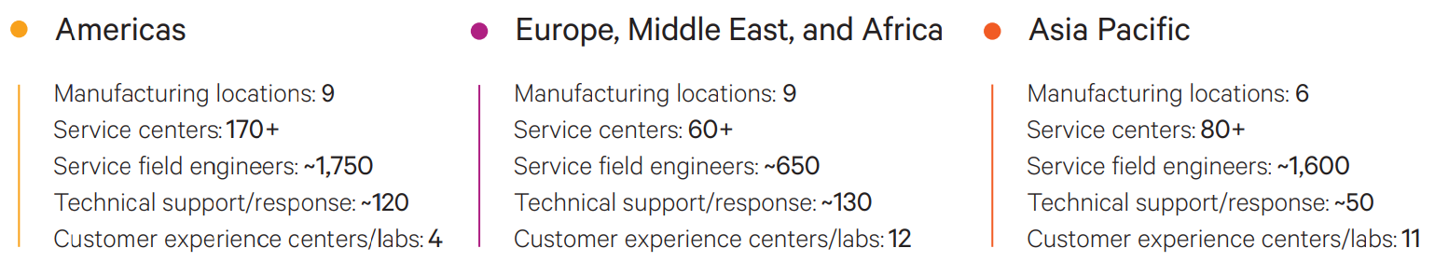
Source: Company, HFI

1.2 Financial performance highlights
Vertiv’s full-year 2025 results, reported on February 11, 2026, show a company successfully scaling its operations to meet the unprecedented demand of the AI era. While top-line growth was substantial, the most significant narrative was the company's ability to maintain and expand its profitability despite regional volatility and supply chain complexities.

Vertiv reported total net sales of $10.23 billion for 2025, a 28% increase over 2024. This growth was remarkably efficient, as the company leveraged its fixed costs to drive profit growth that significantly outpaced revenue gains. The company maintained a strong gross margin of 36.3% throughout 2025. This was driven by a favorable "price-cost" dynamic, where the premium nature of AI-ready liquid cooling and high-density power products allowed Vertiv to more than offset inflationary pressures and rising raw material costs. Especially, the Americas region served as the primary engine for Vertiv's growth in 2025. This segment saw a staggering 41% increase in organic sales for the full year, with the fourth quarter alone surging 46%. This performance was driven by the rapid build-out of hyperscale and colocation data centers in North America. By the end of 2025, the Americas accounted for roughly 63% of Vertiv’s total revenue.

For the full year, adjusted operating profit reached $2.1 billion, a 35% increase from 2024. This resulted in an adjusted operating margin of 20.4%, a 100-basis-point expansion compared to the 19.4% recorded in the prior year. The margin expansion was particularly impressive given the company’s increased investment in research and development (ER&D) and capacity expansion during the year.

Vertiv saw a dramatic rise in bottom-line earnings. The company's adjusted (non-GAAP) net income was significantly bolstered by operational leverage and lower interest expenses as debt was paid down. Adjusted diluted EPS grew 47% to $4.20 for the full year 2025. Based on the weighted average share count, this implies a non-GAAP net income of approximately $1.6 billion, up from approximately $1.1 billion in 2024. This puts the non-GAAP net income margin at approximately 15.6%, a notable improvement over the 2024 margin (roughly 13.8%), highlighting the company's increased efficiency in converting top-line growth into bottom-line value.
Figure: Vertiv’s financial data in total and by segments
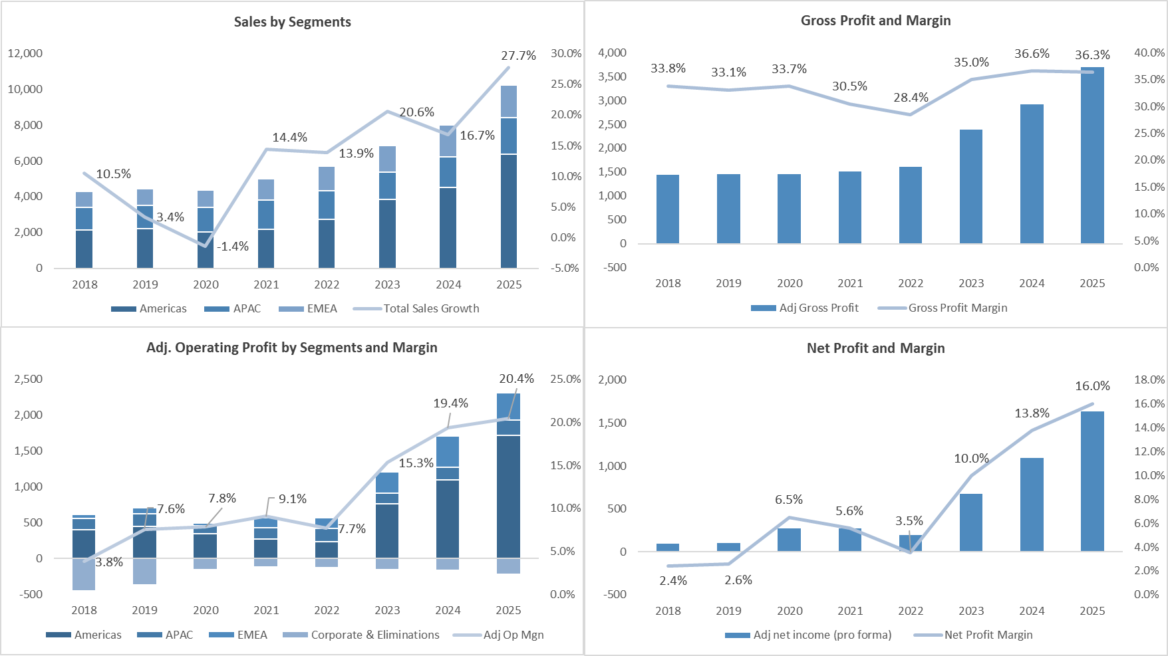
Source: Company, HFI

Vertiv’s full-year 2026 financial guidance projects a year of continued significant expansion fueled by a massive $15 billion backlog and accelerating global demand for AI infrastructure. The company expects net sales to range between $13.25 billion and $13.75 billion, representing an organic growth rate of 27% to 29% compared to 2025. Profitability is also forecast to rise sharply, with adjusted operating profit projected between $2.98 billion and $3.10 billion and adjusted operating margins expanding to between 22.0% and 23.0%. This robust operational performance is expected to translate into adjusted diluted EPS of $5.97 to $6.07, a roughly 43% increase at the midpoint.

Table: 2026 Guidance
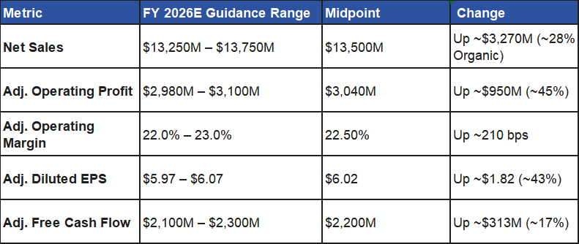
Source: Company, HFI

2. Data Centers will not be completed without power and thermal solutions

2.1 AI Data Center (AIDC) construction keeps growing
Since early 2020, global data center construction and hyperscale capital expenditure have surged by 200–250%, fueled by cloud adoption, enterprise IT upgrades, and the rapid rollout of generative AI. According to a report from Synergy Research Group in December 2025, the total number of operational hyperscale data centers worldwide has reached 1,297, nearly doubling from approximately 700–800 in early 2020, with the United States accounting for about 50–54% of the global share. The researchers estimate that there are currently over 750 hyperscale facilities under construction or in planning worldwide, with global total capacity expected to at least double by 2028, and over 75% of new capacity dedicated to AI training and inference tasks.

Figure: Hyperscale operator CapEx and data center capacity added
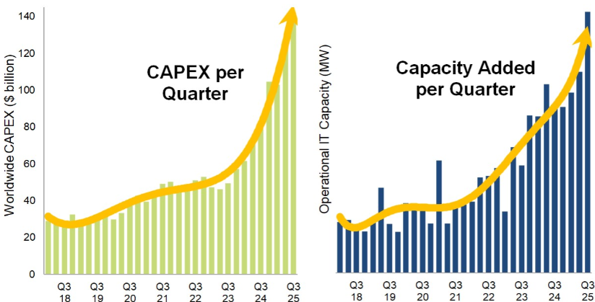
Source:Synergy Research Group, HFI

Although the current investment scale is already unprecedented, the data center market is still considered to be in the early stages of a long-term construction cycle driven by AI. McKinsey indicates that currently built AI-related infrastructure meets only a small fraction of projected future demand over the next decade. It estimates that by 2030, cumulative global investment in data centers could reach around $6.7 trillion to keep pace with compute demand with a significant portion driven by AI, and the US is expected to continue leading in investment share. Over the past three years since the launch of ChatGPT, we have seen improved growth metrics across nearly all key hyperscalers in their total company revenues, especially their cloud-specific revenues and they have consistently revised upward their capital expenditure plans. Thus, we expect continued strong growth in AIDC construction.

Figure: Top 5 hyperscale operators’ revenue keeps rising
Source: Bloomberg, HFI

Figure: US CSPs’ rising 2025 full-year capex guidance, 1Q25-4Q25 and 2026 Guidance (USD bn)
Source: Bloomberg, HFI

While the AI-driven data center construction boom is dramatically increasing demand for IT equipment, it is also driving proportional growth in supporting non-IT infrastructure. Data center investments can be broadly divided into two CapEx categories: IT CapEx (servers, storage, networking, etc.) and non-IT CapEx (power, cooling, building shell, etc.). The sharp rise in total CapEx is primarily fuelled by IT equipment, which typically accounts for ~70% of overall spending in modern facilities, while non-IT CapEx makes up the remaining ~30%. For high-density AI data centers in particular, the IT share can be even higher due to the compute-intensive nature of AI workloads.

Non-IT CapEx remains essential to enable these high-density environments, however, supporting reliable power delivery, advanced cooling for extreme heat loads, and robust facility structures. For example, co-location operator Digital Realty has indicated that for a new data center facility excluding IT equipment the total capital investment breaks down roughly as follows:

- ~30% for building shell and core
- ~35% for electrical systems
- ~25% for HVAC and mechanical systems
- ~15% for racks and containment
This construction surge in AIDCs therefore creates broad opportunities not only for IT hardware suppliers but also for companies providing capital goods and services in the non-IT domain—such as electrical infrastructure, cooling technologies, structural engineering, and specialized construction firms.

Figure: Co-location data centre Capex split (excluding IT equipment)
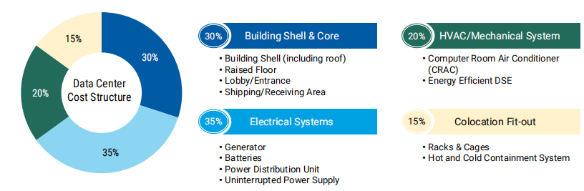
Source: Digital Realty, HFI

2.2 Powering AI: The power supply equipment system is crucial to AIDC

Power is the lifeblood of AI, energizing the data centers that drive both intensive model training and real-time inference. The sheer scale of AI computation is staggering, requiring massive amounts of electricity to process the vast datasets essential for development and ongoing operations. This energy is channeled into high-density server clusters—dense groupings of high-performance chips—that demand a stable, dependable power source to ensure peak efficiency. Ultimately, a robust power supply system is the backbone of an AIDC, guaranteeing the uptime and consistency required for non-stop AI workloads.

In the conventional UPS-based power supply architecture of a data center, power follows the following path:

From the outside-in, the system functions to step down the voltage from grid.

- The utility delivers either High Voltage (>100kV) or Medium Voltage power. In the former case, an on-site substation with power transformers is required to step it down to Medium Voltage (MV).
- MV power will then be safely distributed using MV switchgear into another Transformer, physically near the data hall, stepping down voltage to Low Voltage (415V) (LV).
- Paired with a transformer is a LV Generator that also outputs at 415V AC. If there is an outage from the electrical utility, an Auto Transfer Switch (ATS) will automatically switch power to the generator.

There are then two power paths: one towards the IT Equipment, and the other cooling equipment.

- The IT Equipment path first flows through a UPS system connected to a bank of batteries: it is common to have 5-10 min of battery storage, enough time for the generators to turn on (within a minute) and avoid a temporary outage.

Figure: A simplified illustration of electric flow in a typical data center
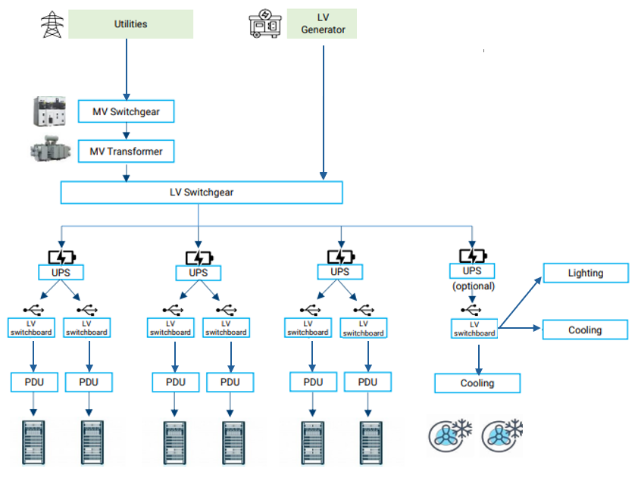
Source: HFI

- The “UPS Power” is then supplied directly to IT Equipment, generally via Power Distribution Units (PDUs).

- The last step is delivering electricity to the chip, via Power Supply Units (PSU) and Voltage Regulator Modules (VRM)

Figure: Uninterrupted power supply and power distribution in the power supply architecture
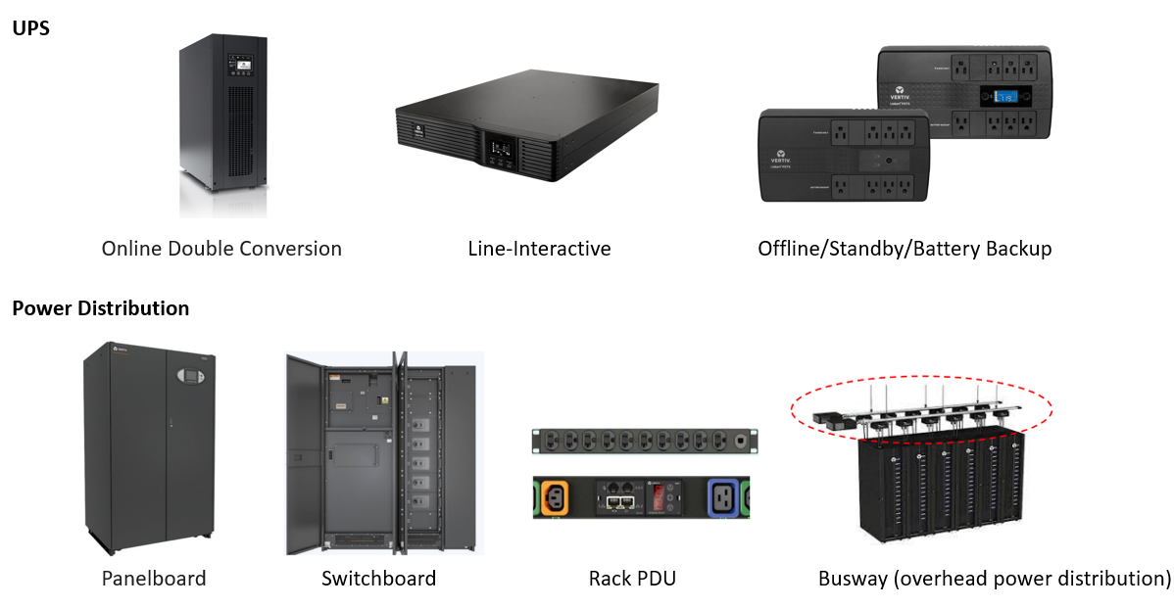
Source: Vertiv, HFI

Compared with traditional data centers, the fast-growing power density of AIDCs has brought increasing demand for power supply systems, requiring higher capacity switchgear, power distribution, UPS systems, and standby power to serve as a robust backbone for the entire power train. Unlike traditional cloud data centers, which typically consume 10–50 MW, modern AI clusters demand far more intensive energy footprints. A single AI training cluster can now exceed 100 MW, with next-generation facilities approaching or surpassing 200 MW (and some planned at gigawatt scale).

This surge is first driven by chip-level power demand. Taking NVIDIA as an example, since the 2014 launch of the Titan X, the first dedicated AI computing card under the Maxwell architecture, to the R100 and R200 GPUs within the latest Vera Rubin architecture, the power consumption of a single GPU chip has escalated from 250W to over 1,000W for Blackwell B200 units, reaching up to 1,800W–2,300W for the next-generation Rubin series. This has been further pushed to 3,600W and beyond through advanced multi-die and dual-chip superchip designs. At the rack level, the escalation is even more dramatic. NVIDIA’s GB200 NVL72 platform represents a paradigm shift in rack-scale computing, specifically engineered for Blackwell GPUs. By integrating 72 GPUs and 36 Grace CPUs into a single NVLink domain, the system enables 13.5TB of unified HBM3e memory. This density drives rack-level power requirements to 132kW nominal, with electrical peak demands (EDPp) reaching 192kW. Looking forward, the Vera Rubin NVL144 and future Kyber architectures are projected to push these densities to a staggering 600kW per rack, requiring a total transformation of the power train infrastructure.

Figure: Anticipated increases in extreme and overall industry rack densities
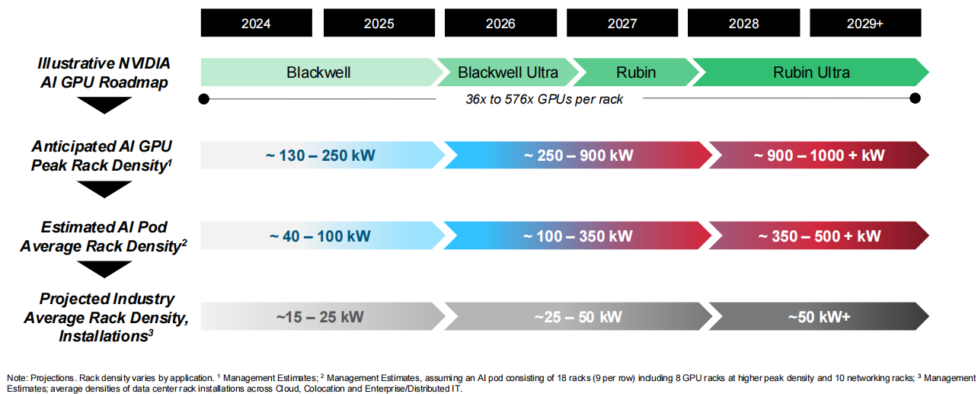
Source: Company, HFI

In addition to more power-intensive workloads, AI workloads are increasingly more mission-critical, which require higher redundancy to mitigate downtime risk. The ANSI/TIA-942 standard provides a vital framework for this evaluation, categorizing data centers into progressive “Rated” levels. Under this system, a higher rating (such as Rated 3) must satisfy all the technical requirements of the lower levels while adding specific layers of fault tolerance and maintainability.

Redundancy is defined by configurations such as N, N+1, or 2N. For instance, if a facility requires ten transformers to operate (N=10), an N+1 configuration involves eleven units (one spare), whereas a 2N configuration requires twenty units.

While Rated 3 remains the global standard for large-scale facilities, there is a clear transition toward enhanced reliability in the power train. Data centers now typically mandate N+1 redundancy for primary upstream components like transformers and generators but are increasingly adopting 2N redundancy for critical downstream distribution, specifically for Uninterruptible Power Supplies (UPS) and Power Distribution Units (PDU) to ensure fault tolerance at the rack level. Plus, traditional data centers typically provide UPS backup only for IT equipment. In contrast, to prevent thermal runaway, AIDCs must also connect part of the cooling circulation pumps to redundant power systems, further driving up the demand for power supply and distribution capacity.

Table: The ANSI/TIA-942 standard
Rating Level | Common Name | Key Characteristic | Redundancy
Rated 1 | Basic | No redundant capacity, single path to power with99.671% availability. | N
Rated 2 | Redundant | Rated 1 + Redundant capacity + 99.741%availability. | N+1
Rated 3 | Concurrently Maintainable | Rated 1 + Rated 2 + dual power systems +99.982% availability. | N+1
Rated 4 | Fault Tolerant | Rated 1 + Rated 2 + Rated 3 + dual powersystems + HVACSystems + 99.995% availability. | 2(N+1) or 2N

Source: Bloomberg, HFI

In light of these evolving requirements, the landscape of AIDC power infrastructure is shifting from a commodity-based market to one defined by high-stakes engineering and integrated reliability. As power densities climb and the margin for error shrinks, the industry is no longer just looking for individual components, but for sophisticated, end-to-end power trains that can handle the volatile load swings characteristic of GPU-accelerated computing. This transition favors providers who possess the technical depth to bridge the gap between utility-scale power entry and chip-level delivery, ensuring that the increased redundancy does not result in prohibitive complexity or inefficiency.

Vertiv occupies a preeminent position within this high-growth sector by offering a uniquely holistic power architecture that transforms these challenges into operational advantages. While many competitors focus on isolated segments of the power chain, Vertiv’s strength lies in its ability to deliver integrated, large-scale power blocks that are specifically optimized for the rapid deployment cycles of AI hyperscalers. By leveraging a deep heritage in mission-critical infrastructure, Vertiv provides the high-capacity switchgear and UPS systems necessary to support N+1 and 2N architectures with a level of modularity that allows operators to scale their power capacity in lockstep with their compute density. This seamless integration not only simplifies the increasingly dense power train but also maximizes the total cost of ownership through superior energy efficiency and a proven track record of maintaining uptime in the world's most demanding AI environments.

2.3 Cooling AI: liquid cooling penetration is up
Cooling is indispensable in data centers, representing ~30% of total power consumption. The critical IT equipment in a data center operates continuously around the clock 24/7, generating a lot of heat in the white space. This makes cooling critical to ensure that the IT space operates safely and efficiently, as excessively high temperatures can cause an electrical short-circuit and excessive humidity can cause condensation and hence machine outage.

The densification of AI server clusters is forcing an evolution from air-cooled to liquid-cooled to address increasing power requirements. As GPU thermal densities skyrocket and racks become more crowded to meet HPC demands, air processing is now showing its limits. Traditional air cooling cannot cool high-density racks efficiently and sustainably. With a 10°C temperature spike capable of cutting a server's reliability and lifespan in half, data center operators are turning from room-based cooling and row-based cooling to rack-level cooling and even liquid cooling options to ensure the reliability and sustainability of AI-driven infrastructure. Grand view research estimates that the global data center liquid cooling market size was $5.38 billion in 2024 with North America being the largest market and projects it to reach $ 17.77 billion by 2030, growing at a CAGR of 21.6% from 2025 to 2030.
Figure: Liquid cooling versus air cooling
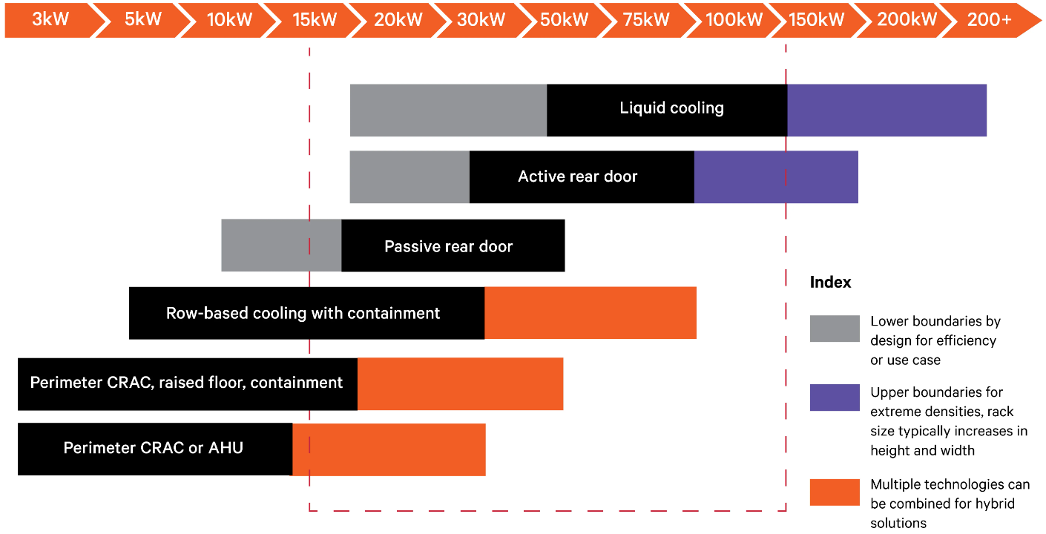
Source：Company, HFI

Beyond its impressive efficiency, liquid cooling represents a fundamental shift in data center thermodynamics by leveraging fluids that are up to 3,000 times more effective at heat transfer than air. This superior thermal performance enables a dramatic reduction in energy consumption, allowing facilities to drive Power Usage Effectiveness (PUE) down to 1.1 or lower by eliminating the need for power-hungry fans and massive HVAC systems. Furthermore, the use of closed-loop systems promotes significant water conservation and optimizes the physical footprint of the data center, allowing for much higher compute density without the spatial constraints of traditional airflow. Ultimately, by maintaining a stable thermal environment and minimizing the hotspots that plague air-cooled aisles, liquid cooling enhances long-term hardware reliability by shielding delicate silicon from constant thermal stress.

Data center operators are pursuing some of three paths with liquid cooling. The first path is the rear-door heat exchangers: Passive or active heat exchangers replace the rear door of the IT equipment rack with a liquid heat exchanger. These systems can be used in conjunction with air-cooling systems to cool environments with mixed rack densities. The second path is Direct-to-chip liquid cooling: Direct-to-chip cold plates sit atop the board’s heat-generating components to draw off heat through single-phase cold plates or two-phase evaporation units. These cooling technologies can remove about 70-75% of the heat generated by the equipment in the rack, leaving 25-30% that must be removed by air-cooling systems. The third and ultimate path is Immersion cooling: Single-phase and two-phase immersion cooling systems submerge servers and other components in the rack in a thermally conductive dielectric liquid or fluid, eliminating the need for air cooling. This approach maximizes the thermal transfer properties of liquid and is the most energy-efficient form of liquid cooling on the market.

Table: Comparative analysis of liquid cooling paths
Metric | Rear-Door Heat Exchanger (RDHX) | Direct-to-Chip (DTC) / Cold Plate | Immersion Cooling (Single/Two-Phase)
Capital Investment | Low to Moderate. Uses standard racks; primary cost is the door and CDU. | Moderate to High. Requires custom server manifolds and internal cold plates. | High. Requires specialized tanks, dielectric fluid, and floor reinforcement.
Space Taken | Minimal. Fits on existing rack footprints; adds only a few inches to depth. | Moderate. Requires room for Coolant Distribution Units (CDUs) and piping. | High. Horizontal tanks take up more floor area than vertical racks.
Ease of Retrofit | Excellent. Can be bolted onto almost any existing IT rack. | Moderate. Requires modifying server internals and adding rack plumbing. | Difficult. Requires a complete overhaul of the data center floor and hardware.
Heat Removal Efficiency | Moderate. Cools air before it exits the rack; still relies on air inside the server. | High. Removes 70%–80% of heat directly from the hottest components. | Maximum. Virtually 100% of heat is captured by the fluid.
PUE (Relative) | 1.2 – 1.4. Better than traditional air but still utilizes server fans. | 1.1 – 1.2. Significant energy savings by reducing or removing server fans. | 1.02 – 1.05. The gold standard for efficiency; eliminates fans and room AC entirely.

Source: Bloomberg, HFI

In a typical AIDC using liquid cooling as its thermal management, the system operation starts at the Liquid Cooled Racks where specialized manifolds deliver coolant directly to high-density hardware. The heart of this operation is the Coolant Distribution Unit (CDU), which regulates pressure and separates the internal server chemistry from the facility's Indoor Chilled Water supply. For the most demanding compute loads, Immersion Tanks bypass traditional heat sinks entirely by submerging components in dielectric fluid to maximize compaction. Finally, all that captured energy is routed to the Heat Rejection units, namely the outdoor chillers and fluid coolers, where the thermal load is exhausted into the atmosphere, allowing the cooled liquid to cycle back and begin the process again.

Figure: Core components of a liquid cooling system
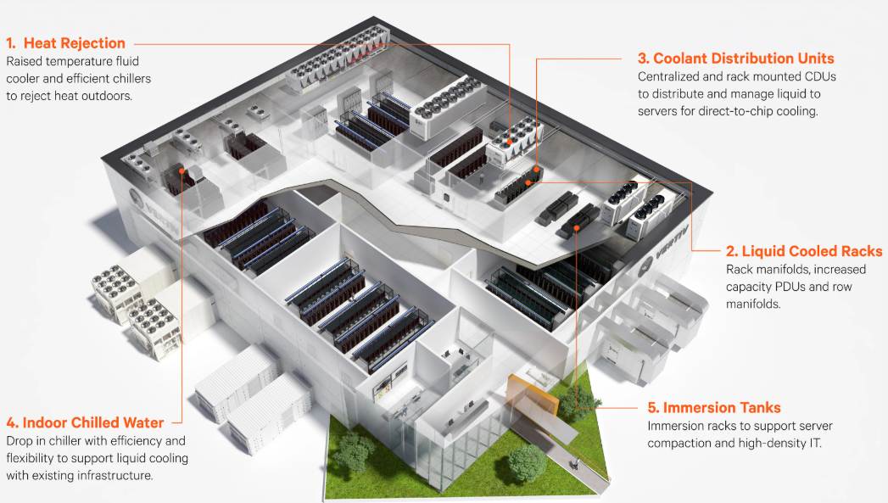
Source: Company, HFI

As operators navigate the transition from rear-door cooling to direct-to-chip and immersion solutions, the complexity of the "gray space" and "white space" integration increases exponentially. This shift necessitates a partner who can manage the entire thermal chain—from the heat generated at the processor to the ultimate rejection of that heat outside the building—rather than a provider of siloed components.

Vertiv distinguishes itself in this evolving landscape through its unmatched ability to provide comprehensive, end-to-end thermal management ecosystems that bridge the gap between air and liquid cooling. Unlike niche players, Vertiv offers a "coolant-agnostic" portfolio that allows data center operators to implement hybrid environments, seamlessly integrating Coolant Distribution Units (CDUs) and secondary fluid loops with existing infrastructure. Vertiv’s unique advantage lies in its global manufacturing scale and specialized engineering services, which enable the rapid deployment of high-capacity liquid cooling solutions that are rigorously tested for leak-free reliability and precision control. By mastering the intricate balance of flow rates, pressure management, and thermal stability, Vertiv ensures that the world’s most advanced AI clusters can reach their full performance potential without being throttled by thermal constraints.

3. Vertiv differentiates through its full expertise in powering and cooling and strategic partnership with NVIDIA

3.1 Vertiv’s dominance in data center power and cooling infrastructure with end-to-end systems and services expertise

Vertiv possesses unique end-to-end systems and services expertise to tackle the increasingly difficult power and cooling challenges in the AI industry by offering a comprehensive and integrated portfolio, while many competitors specialize in either power or cooling. Building on such leading competitive edge, Vertiv Infrastructure Solutions, consisting of Vertiv OneCore nad Vertiv SmartRun delivers speed to token with end-to-end, pre-engineered, and pre-fabricated systems to enable growth.

Figure: End-to-end systems and services expertise architecture for DCs
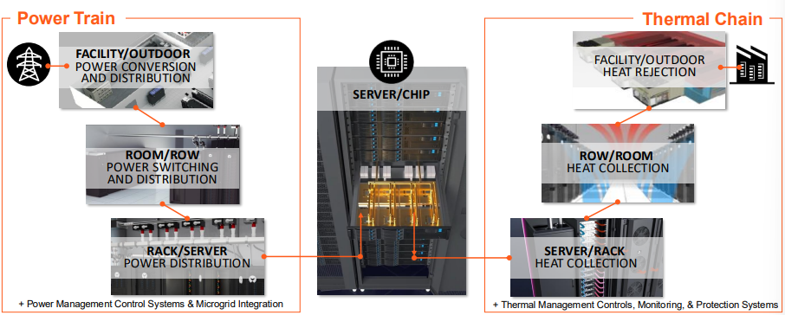

Source: Company, HFI

Vertiv OneCore is an end-to-end, "slab-up" prefabricated data center solution designed to rapidly deploy high-density capacity for AI, High-Performance Computing (HPC), and colocation environments. It provides a complete turnkey infrastructure by integrating Vertiv’s power, cooling, and management technologies into factory-assembled building blocks—such as power skids and thermal modules—all housed within a Vertiv-supplied steel building shell. Designed for facilities ranging from 5MW to over 50MW, OneCore eliminates the complexity of managing multiple vendors and significantly compresses construction timelines through parallel manufacturing and simplified on-site assembly, reducing on-site deployment time from 18–24 months to less than 6 months..

Vertiv SmartRun is a modular, prefabricated overhead infrastructure system specifically engineered to speed up the fit-out of the data center "white space". It consolidates critical components—including high-density power distribution busways, liquid cooling piping, network cabling, and hot-aisle containment—into a single, integrated platform. By utilizing a "one-lift" installation model, SmartRun can be deployed up to 85% faster than traditional stick-build methods, enabling a single crew to install over 1MW of capacity per day. Its compact, modular design allows it to fit through standard doors, making it ideal for both new builds and retrofitting existing facilities to handle high-density AI workloads.

Figure: Vertiv OneCore and Vertiv Smartrun
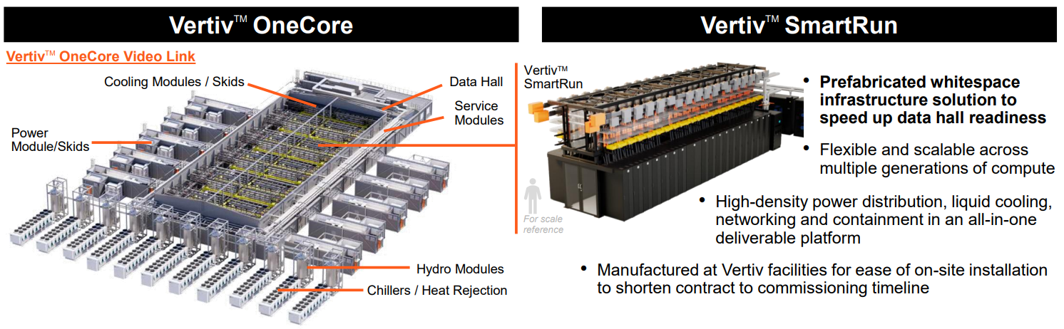
Source: Company, HFI

By integrating the macro-scale efficiency of the OneCore architecture with the micro-scale modularity of the SmartRun ecosystem, Vertiv provides a uniquely unified and holistic portfolio that addresses the bifurcated demands of the modern data center. Compared to the electrical peers (ABB, Siemens and Legrand), Vertiv (and Schneider & Eaton) has a comprehensive portfolio in data centre cooling solutions, allowing operators to bridge the gap between massive, centralized power requirements and the granular, high-density cooling needs of the rack level, enabling customers to deploy large-scale AI capacity with significantly reduced lead times and lower operational complexity. In addition, Vertiv leads in the equipment that supports current liquid cooling technologies, such as Cooling Distribution Unit (CDU) which is used to distribute and control coolant used for liquid cooling.

Table: Product Portfolio of Vertiv and competitors
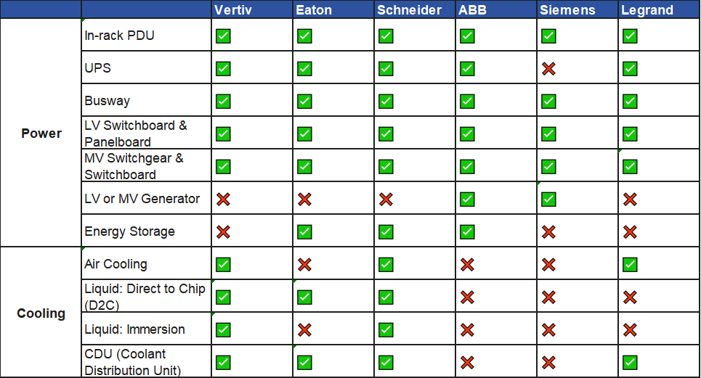
Source: HFI

Furthermore, we believe Vertiv represents a premier "pure-play" investment vehicle within the critical infrastructure space. Unlike diversified conglomerates, like Schneider and Eaton, Vertiv’s singular focus on the data center environment with 80% revenue from DC customers allows for rapid R&D iteration and deep technical alignment with the cooling and power demands of next-generation silicon. As a result, the company is exceptionally well-positioned to capture outsized value during the current AI supercycle, acting as a fundamental enabler for the global build-out of accelerated computing clusters where reliability and thermal management are the primary bottlenecks to growth.

Lastly, global service network is also another moat of Vertiv against competition from new entrants. As data centers transition to high-stakes liquid cooling and high-density power architectures, the operational risk of a leak or a power failure scales exponentially; in this environment, a service contract is not just maintenance, but an insurance policy against catastrophic downtime. Vertiv maintains the world’s largest dedicated service force for data center infrastructure with 4000+ field engineers. This capital-intensive service infrastructure, built over decades of boots-on-the-ground experience, creates a significant barrier to entry.

3.2 Partnership with key industry leaders to build the future of AI infrastructure

Building on the current technology and product, we believe Vertiv’s strategic collaborations are key to shaping the future of digital infrastructure. By working alongside the most influential technology providers, the company accelerates innovation, simplifies complexity, and guides customers through the infrastructure transformation demanded by AI.

In March 2024, Vertiv formally joined the NVIDIA Partner Network (NPN) as a Solution Advisor. Vertiv is among a select few physical infrastructure providers within this network capable of offering comprehensive power and cooling design recommendations for NVIDIA GPU clusters. Vertiv’s liquid cooling manifolds and power shelves are often designed 12–18 months in advance of new GPU launches (like the Blackwell and upcoming Rubin architectures), ensuring that the infrastructure, especially cooling and power is perfectly matched with chip performance.

The most significant achievement of this partnership is the joint development of a 7MW reference architecture for the NVIDIA Blackwell GB200 NVL72 platform. Within this architecture, Vertiv and NVIDIA co-designed a liquid cooling-based solution. The framework covers a complete end-to-end configuration, ranging from CDUs and Manifolds to precision cooling and UPS power systems.

Additionally, Vertiv and NVIDIA are collaborating on the design and engineering readiness of an 800V DC power architecture. This initiative aims to meet the demands for higher power density and efficiency of future NVIDIA platforms, such as the Rubin Ultra platform scheduled for release in 2027. HVDC architecture is a competing AIDC power supply solution of UPS-based architecture. Compared with UPS-based solution, HVDC removes the AC/DC/AC conversion at UPS and the AC/DC conversion at PSU. It directly supplies power to servers after converting AC to DC with a rectification module and charges the battery modules at the same time. As such, it can achieve higher energy efficiency (>95%, vs. ~92% for UPS-based) thanks to less power conversion. It also improves power supply reliability, saves space (up to 30%), and construction costs (up to 20%), and has higher compatibility to renewable power.

Figure: Datacenter architecture over time
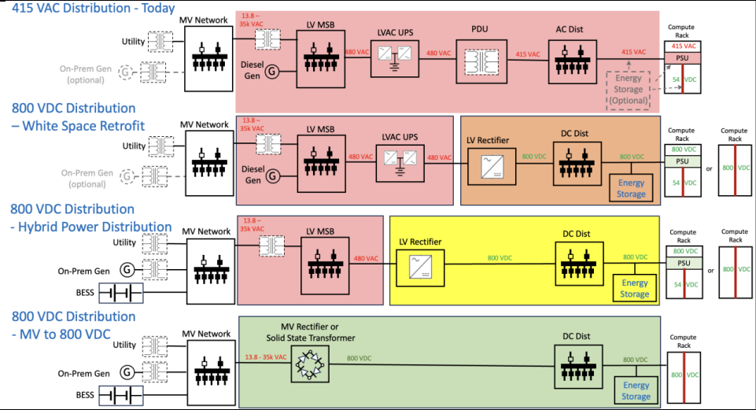
Source: Nvdia, HFI

Vertiv is uniquely positioned with systems-level expertise in AC- and DC-based power architectures, thermal chain and service expertise. We believe that as AI infrastructure construction surges, this ecosystem lock-in with key partners will allow Vertiv to capture a leading share of the hyperscale data center market.

4. Valuation& recommendation
We estimate that revenue of Vertiv from year 2026 to 2028 will be $13,540 / 18,375/ 21,813 million, with the net profit of $ 2,380/ 3,570/ 4,208 million. Based on the DCF valuation model, our target price of Vertiv is $ 279.97, we initiate coverage on the stock with “Outperform”.

Table: DCF Model
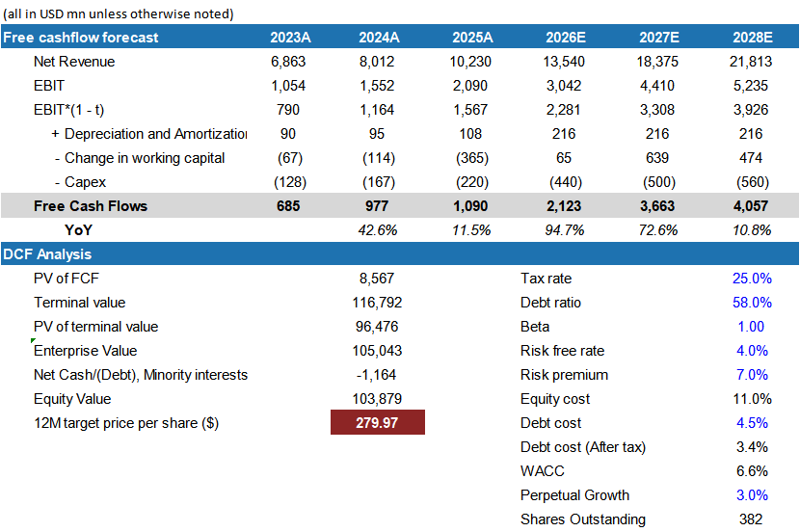
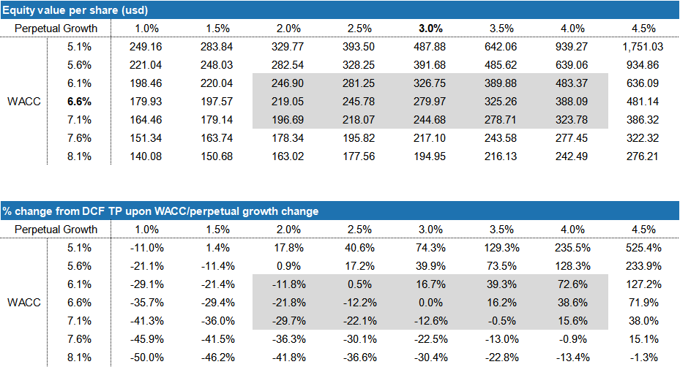
Source: Company, HTI

Table: Financial Summary
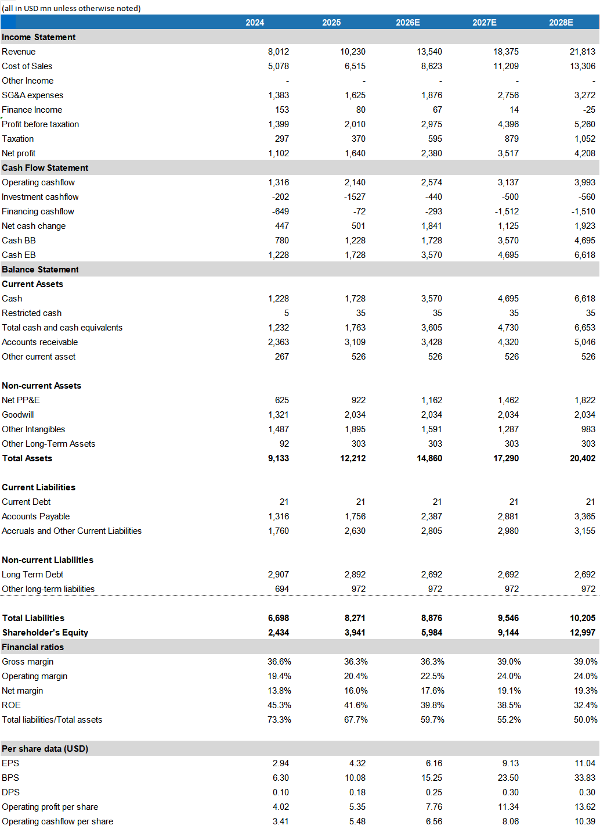
Source: Company, HTI

5. Risks
Slowing growth and misexecution; Slowing demand activity in data center; Continued trade tensions and shifting U.S. tariff policies; Technological Obsolescence.

[Table_APPENDIX]
[Table_disclaimer]
APPENDIX
IMPORTANT DISCLOSURES
This research report is distributed by HuaFu International (HK) Financial Holdings Limited (referred as HuaFu International below), which is authorized to engage in securities activities in its respective jurisdiction.
Analyst Certification:
I, Bin Yang, certify that (i) the views expressed in this research report accurately reflect my personal views about any or all of the subject companies or issuers referred to in this research and (ii) no part of my compensation was, is or will be directly or indirectly related to the specific recommendations or views expressed in this research report; and that I (including members of my household) have no financial interest in the security or securities of the subject companies discussed.
I, Yida Deng, certify that (i) the views expressed in this research report accurately reflect my personal views about any or all of the subject companies or issuers referred to in this research and (ii) no part of my compensation was, is or will be directly or indirectly related to the specific recommendations or views expressed in this research report; and that I (including members of my household) have no financial interest in the security or securities of the subject companies discussed.
Conflict of Interest Disclosures
HuaFu International and some of its affiliates may engage in investment banking and / or serve as a market maker or hold proprietary trading positions of certain stocks or companies in this research report. As far as this research report is concerned, please send an email to lcd@hfisec.com.hk if the information about any company mentioned in this report is needed).
Ratings Definitions (from 1 Jul 2020):
HuaFu International uses a relative rating system using Outperform, Neutral, or Underperform for recommending the stocks we cover to investors. Investors should carefully read the definitions of all ratings used in HuaFu International Research. In addition, since HuaFu International Research contains more complete information concerning the analyst's views, investors should carefully read HuaFu International Research, in its entirety, and not infer the contents from the rating alone. In any case, ratings (or research) should not be used or relied upon as investment advice. An investor's decision to buy or sell a stock should depend on individual circumstances (such as the investor's existing holdings) and other considerations.
Analyst Stock Ratings
Outperform: The stock’s total return over the next 12-18 months is expected to exceed the return of its relevant broad market benchmark by over 10%, as indicated below.
Neutral: The stock’s total return over the next 12-18 months is expected to be in line with the return of its relevant broad market benchmark, as indicated below. Underperform: The stock’s total return over the next 12-18 months is expected to be below the return of its relevant broad market benchmark by over 10%, as indicated below.
Benchmarks for each stock’s listed region are as follows: Japan – TOPIX, Korea – KOSPI, Taiwan – TAIEX, India – Nifty100, US – SP500; for all other China-concept stocks – MSCI China.

HuaFu International Non-Rated Research: HuaFu International publishes quantitative, screening or short reports which may rank stocks according to valuation and other metrics or may suggest prices based on possible valuation multiples. Such rankings or suggested prices do not purport to be stock ratings or target prices or fundamental values and are for information only.
HuaFu International Coverage of A-Shares: HuaFu International may cover and rate A-Shares . HuaFu Securities, the ultimate parent company of HuaFu International based in FuZhou, covers and publishes research on these same A-Shares for distribution in mainland China. However, the rating system employed by HuaFu International differs from that used by HuaFu Securites and even the teams covering the same A-share stocks might be totally independently different, as a result there may be a difference in their coverage ratings, target prices and research logics for the same A-share stocks.
IMPORTANT DISCLAIMER
The research report is issued by HuaFu International, a licensed corporation to carry on Type 4 regulated activity (advising on securities) for the purpose of the Securities and Futures Ordinance (Cap. 571) of Hong Kong.
The information and opinions contained in this research report have been compiled or arrived at from sources believed to be reliable and in good faith but no representation or warranty, express or implied, is made by HuaFu International or any other related members from which this research report may be received, as to their accuracy, completeness or correctness. All opinions expressed herein are as of the date of this research report and are subject to change without notice. This research report is for information purpose only. Descriptions of any companies or their securities mentioned herein are not intended to be complete and this research report is not, and should not be construed expressly or impliedly as, an offer to buy or sell securities. The securities referred to in this research report may not be eligible for purchase or sale in some jurisdictions. If an investment product is denominated in a currency other than an investor's home currency, a change in exchange rates may adversely affect the investment. Past performance is not necessarily indicative of future results. Certain transactions, including those involving derivatives, give rise to substantial risk and are not suitable for all investors. You should also bear in mind that recommendations in this research report are not tailor-made for you. The analyst has not taken into account your unique financial circumstances, such as your financial situation and risk appetite. You must, therefore, analyze and should, where applicable, consult your own legal, tax, accounting, financial and other professional advisers to evaluate whether the recommendations suits you before investment. Neither HuaFu International nor any of its directors, employees or agents accepts any liability whatsoever for any direct or consequential loss arising from any use of the materials contained in this research report.
HuaFu International and its affiliates, officers, directors, and employees, excluding the analysts responsible for the content of this document, will from time to time have long or short positions in, act as principal in, and buy or sell, the securities or derivatives, if any, referred to in this research report. Sales, traders, and other professionals of HuaFu International may provide oral or written market commentary or trading strategies to the relevant clients and the companies within HuaFu International that reflect opinions that are contrary to the opinions expressed in this research report. HuaFu Internatioal may make investment decisions that are inconsistent with the recommendations or views expressed in this research report. HuaFu International is under no obligation to ensure that such other trading decisions, ideas or recommendations are brought to the attention of any recipient of this research report.
Please refer to HuaFu International’s website www.hfisec.com.hk for further information on HuaFu International’s organizational and administrative arrangements set up for the prevention and avoidance of conflicts of interest with respect to Research.

DISTRIBUTION AND REGIONAL NOTICES
Except as otherwise indicated below, any Recipient wishing to discuss this research report or effect any transaction in any security discussed in HuaFu International’s research should contact the HuaFu International salesperson in their own country or region.
Notice to Hong Kong investors: The research report is distributed by HuaFu International, which is a licensed corporation to carry on Type 1 regulated activity (dealing in securities) in Hong Kong. This research report does not constitute a solicitation or an offer of securities or an invitation to the public within the meaning of the SFO. This research report is only to be circulated to "Professional Investors" as defined in the SFO. This research report has not been reviewed by the Securities and Futures Commission. You should not make investment decisions solely on the basis of the information contained in this research report. Recipients of this research report are to contact HuaFu International salespersons in respect of any matters arising from, or in connection with, the research report.

People’s Republic of China (PRC): In the PRC, the research report is directed for the sole use of those who receive the research report in accordance with the applicable PRC laws and regulations. Further, the information on the research report does not constitute "production and business activities in the PRC" under relevant PRC laws. This research report does not constitute a public offer of the security, whether by sale or subscription, in the PRC. Further, no legal or natural persons of the PRC may directly or indirectly purchase any of the security or any beneficial interest therein without obtaining all prior PRC government approvals or licenses that are required, whether statutorily or otherwise. Persons who come into possession of this research are required to observe these restrictions.
This research report is intended for the recipients only and may not be reproduced or redistributed without the written consent of an authorized signatory of HuaFu International.
Copyright: HuaFu International 2025. All rights reserved

[Table_RecommendationChart]
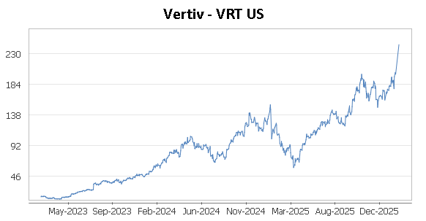
Source: Company data Bloomberg, HFI estimates

