[Table_Main]
Research Report
29 Jan 2026
GE Vernova(GEV US)
Explosive Growth in FY2025 as Profitability Shifts from Order-Driven to Capacity-Driven
 |  | Revenue and profitability for Q4 and FY2025 is beyond market expectations. In Q4, company revenue was $11.0B, up 4% year-over-year, beating the market consensus of $10.3B. Net income reached $3.7B, with a net margin of 33.5%. Note that this high profit includes a $2.9B tax benefit. Excluding the tax benefit, the net margin would be ~7.3% vs 5% in Q3. Adjusted EBITDA was $1.2B, with 10.6% margin. Free Cash Flow (FCF) remained strong at $1.8B for the quarter. Q4 orders reached $22.2B, representing 65% organic growth. Backlog increased by $15.0B quarter-over-quarter, primarily driven by equipment and service orders in the Power and Electrification segments. For 2025, full-year revenue was $38.1B, up 9, exceeding market expectations of $37.4B. Net income stood at $4.9B with a 12.8% margin. Net Income grew by ~27% YoY with net margin ~5.2% vs 4% in 24, excluding the tax benefit. Adjusted EBITDA was $3.2B with an 8.4% margin. Annual FCF reached $3.7B, a year-over-year increase of 117.6%. Annual orders totaled $59.3B, an organic increase of 34%. Growth was centered on equipment within Power and Electrification, alongside service growth across all segments. Total backlog surged by $31.2B to reach $150B.  Looking forward, GEV raised its guidance for both 2026 and 2028. Revenue is projected at $44.0B–$45.0B (upward revision from $41.0B–$42.0B) in 26 and $56.0B (up from $52.0B) in 28. Adjusted EBITDA Margin is targeted at 11%–13% in 26 and 20% in 28. FCF is expected to reach $5.0B–$5.5B (upward revision from $4.5B–$5.0B) in 26 and $24.0B (up from $22.0B) in 28.  GEV’s profitability has transitioned from being order-driven to capacity-driven. For the Power segment, the backlog has been pushed to $94.4B, covering 4.77 years of revenue, up from 4.3 years in Q3, forming a dominant seller’s market for GEV. Current Service Reservation Agreements (SRAs) command margins 10-20% higher than the existing backlog, effectively locking in premium earnings through 2030. For Electrification segment, revenue grew 28% in 2025 with a 590bps margin jump. We believe the Prolec GE acquisition will further secure the critical transformer supply chain for data center demand. Current 2026 margin guidance (11-13%) is likely to remain conservative. Now The primary challenge for GEV is no longer securing orders but executing the $150B backlog via the Q3 2026 capacity ramp-up.  Valuation & recommendation: Based on raised outlook, we estimate the company's revenue from 2026 to 2028 will be $45/48.5/56.7B, with updated net income of $4359/6734/9513 million. Our target price is USD 880.01 per share derived from the DCF model and maintain OUTPERFORM rating.  Risks: Capacity ramp-up falling short of expectations; Data center power demand below expectations; Intensifying competition.
  [Table_Info]
  Maintain OUTPERFORM
  Rating | OUTPERFORM
  Current Price | 711.59
  Target Price | 880.01
  Market cap | 193.07bn
  Shares in issue | 271.32mn
  1 yr high - low | 723.00-270.13
  Note: Current Price 711.59 is the close price on 28 Jan 2026
  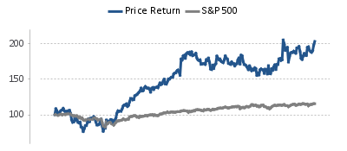
  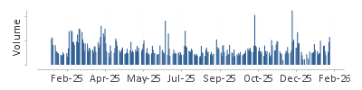
  Source: HFI
  [Table_Profit]
  US$ mn | Dec-25A |  | Dec-26E |  | Dec-27E |  | Dec-28E
  Revenue | 38,068 |  | 45,000 |  | 48,460 |  | 56,709
  （+/-） | 9.00% |  | 18.21% |  | 7.69% |  | 17.02%
  Net profit | 4,884 |  | 4,359 |  | 6,734 |  | 9,513
  （+/-） | 213% |  | -11% |  | 54% |  | 41%
  Diluted EPS (US$) | 17.69 |  | 15.90 |  | 24.72 |  | 35.15
  GPM | 19.8% |  | 24.6% |  | 29.6% |  | 32.0%
  ROE | 39.7% |  | 30.5% |  | 36.1% |  | 36.9%
  P/E | 40 |  | 45 |  | 29 |  | 20
  Source: Company data, HFI
[Table_Author]
Bin Yang, SFC:BSQ313
harryyang@hfisec.com.hk

Table 1: DCF model
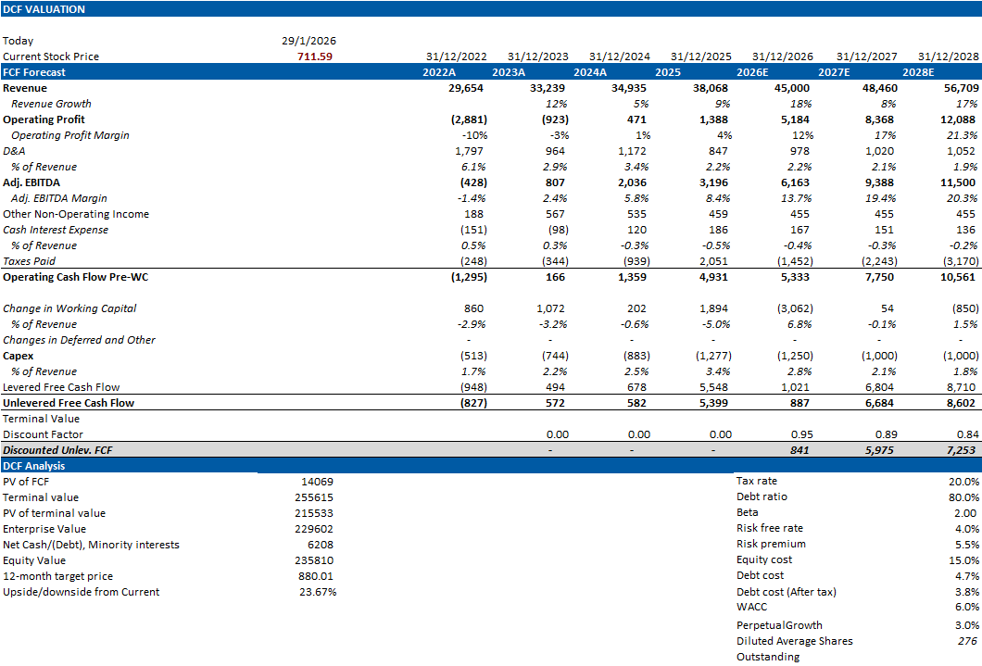
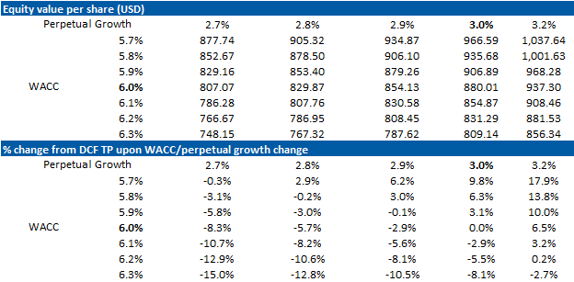
Source: HFI

Table 2: financial summary
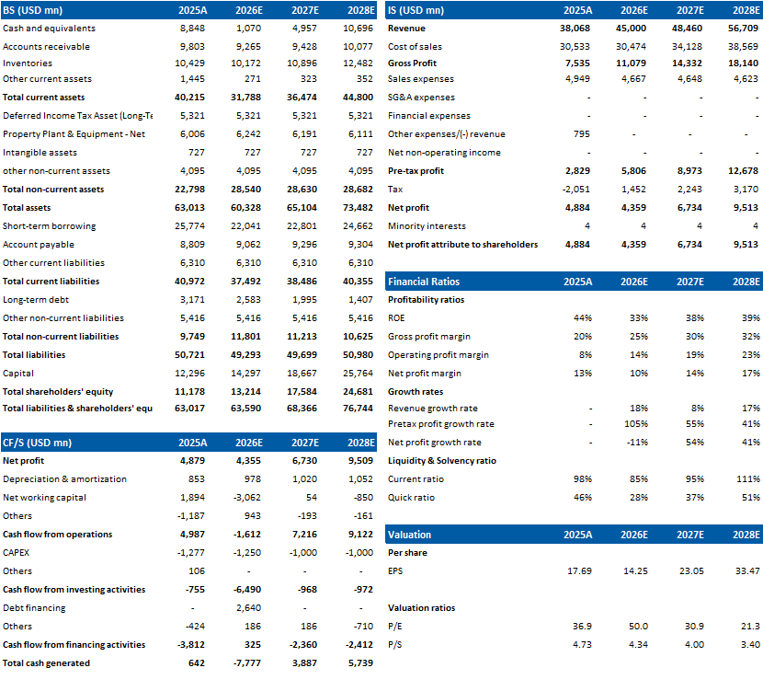
Source: HFI

[Table_APPENDIX]
[Table_disclaimer]
APPENDIX
IMPORTANT DISCLOSURES
This research report is distributed by HuaFu International (HK) Financial Holdings Limited (referred as HuaFu International below), which is authorized to engage in securities activities in its respective jurisdiction.
Analyst Certification:
I, Bin Yang, certify that (i) the views expressed in this research report accurately reflect my personal views about any or all of the subject companies or issuers referred to in this research and (ii) no part of my compensation was, is or will be directly or indirectly related to the specific recommendations or views expressed in this research report; and that I (including members of my household) have no financial interest in the security or securities of the subject companies discussed.
Conflict of Interest Disclosures
HuaFu International and some of its affiliates may engage in investment banking and / or serve as a market maker or hold proprietary trading positions of certain stocks or companies in this research report. As far as this research report is concerned, please send an email to lcd@hfisec.com.hk if the information about any company mentioned in this report is needed).
Ratings Definitions (from 1 Jul 2020):
HuaFu International uses a relative rating system using Outperform, Neutral, or Underperform for recommending the stocks we cover to investors. Investors should carefully read the definitions of all ratings used in HuaFu International Research. In addition, since HuaFu International Research contains more complete information concerning the analyst's views, investors should carefully read HuaFu International Research, in its entirety, and not infer the contents from the rating alone. In any case, ratings (or research) should not be used or relied upon as investment advice. An investor's decision to buy or sell a stock should depend on individual circumstances (such as the investor's existing holdings) and other considerations.
Analyst Stock Ratings
Outperform: The stock’s total return over the next 12-18 months is expected to exceed the return of its relevant broad market benchmark by over 10%, as indicated below.
Neutral: The stock’s total return over the next 12-18 months is expected to be in line with the return of its relevant broad market benchmark, as indicated below. Underperform: The stock’s total return over the next 12-18 months is expected to be below the return of its relevant broad market benchmark by over 10%, as indicated below.
Benchmarks for each stock’s listed region are as follows: Japan – TOPIX, Korea – KOSPI, Taiwan – TAIEX, India – Nifty100, US – SP500; for all other China-concept stocks – MSCI China.

HuaFu International Non-Rated Research: HuaFu International publishes quantitative, screening or short reports which may rank stocks according to valuation and other metrics or may suggest prices based on possible valuation multiples. Such rankings or suggested prices do not purport to be stock ratings or target prices or fundamental values and are for information only.
HuaFu International Coverage of A-Shares: HuaFu International may cover and rate A-Shares . HuaFu Securities, the ultimate parent company of HuaFu International based in FuZhou, covers and publishes research on these same A-Shares for distribution in mainland China. However, the rating system employed by HuaFu International differs from that used by HuaFu Securites and even the teams covering the same A-share stocks might be totally independently different, as a result there may be a difference in their coverage ratings, target prices and research logics for the same A-share stocks.
IMPORTANT DISCLAIMER
The research report is issued by HuaFu International, a licensed corporation to carry on Type 4 regulated activity (advising on securities) for the purpose of the Securities and Futures Ordinance (Cap. 571) of Hong Kong.
The information and opinions contained in this research report have been compiled or arrived at from sources believed to be reliable and in good faith but no representation or warranty, express or implied, is made by HuaFu International or any other related members from which this research report may be received, as to their accuracy, completeness or correctness. All opinions expressed herein are as of the date of this research report and are subject to change without notice. This research report is for information purpose only. Descriptions of any companies or their securities mentioned herein are not intended to be complete and this research report is not, and should not be construed expressly or impliedly as, an offer to buy or sell securities. The securities referred to in this research report may not be eligible for purchase or sale in some jurisdictions. If an investment product is denominated in a currency other than an investor's home currency, a change in exchange rates may adversely affect the investment. Past performance is not necessarily indicative of future results. Certain transactions, including those involving derivatives, give rise to substantial risk and are not suitable for all investors. You should also bear in mind that recommendations in this research report are not tailor-made for you. The analyst has not taken into account your unique financial circumstances, such as your financial situation and risk appetite. You must, therefore, analyze and should, where applicable, consult your own legal, tax, accounting, financial and other professional advisers to evaluate whether the recommendations suits you before investment. Neither HuaFu International nor any of its directors, employees or agents accepts any liability whatsoever for any direct or consequential loss arising from any use of the materials contained in this research report.
HuaFu International and its affiliates, officers, directors, and employees, excluding the analysts responsible for the content of this document, will from time to time have long or short positions in, act as principal in, and buy or sell, the securities or derivatives, if any, referred to in this research report. Sales, traders, and other professionals of HuaFu International may provide oral or written market commentary or trading strategies to the relevant clients and the companies within HuaFu International that reflect opinions that are contrary to the opinions expressed in this research report. HuaFu Internatioal may make investment decisions that are inconsistent with the recommendations or views expressed in this research report. HuaFu International is under no obligation to ensure that such other trading decisions, ideas or recommendations are brought to the attention of any recipient of this research report.
Please refer to HuaFu International’s website www.hfisec.com.hk for further information on HuaFu International’s organizational and administrative arrangements set up for the prevention and avoidance of conflicts of interest with respect to Research.

DISTRIBUTION AND REGIONAL NOTICES
Except as otherwise indicated below, any Recipient wishing to discuss this research report or effect any transaction in any security discussed in HuaFu International’s research should contact the HuaFu International salesperson in their own country or region.
Notice to Hong Kong investors: The research report is distributed by HuaFu International, which is a licensed corporation to carry on Type 1 regulated activity (dealing in securities) in Hong Kong. This research report does not constitute a solicitation or an offer of securities or an invitation to the public within the meaning of the SFO. This research report is only to be circulated to "Professional Investors" as defined in the SFO. This research report has not been reviewed by the Securities and Futures Commission. You should not make investment decisions solely on the basis of the information contained in this research report. Recipients of this research report are to contact HuaFu International salespersons in respect of any matters arising from, or in connection with, the research report.

People’s Republic of China (PRC): In the PRC, the research report is directed for the sole use of those who receive the research report in accordance with the applicable PRC laws and regulations. Further, the information on the research report does not constitute "production and business activities in the PRC" under relevant PRC laws. This research report does not constitute a public offer of the security, whether by sale or subscription, in the PRC. Further, no legal or natural persons of the PRC may directly or indirectly purchase any of the security or any beneficial interest therein without obtaining all prior PRC government approvals or licenses that are required, whether statutorily or otherwise. Persons who come into possession of this research are required to observe these restrictions.
This research report is intended for the recipients only and may not be reproduced or redistributed without the written consent of an authorized signatory of HuaFu International.
Copyright: HuaFu International 2025. All rights reserved

Recommendation Chart
[Table_RecommendationChart]
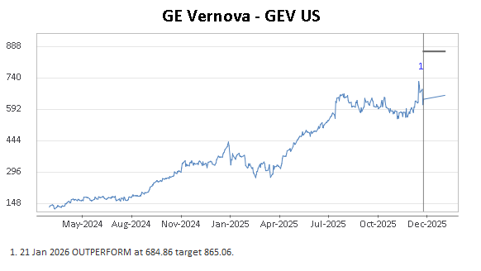
Source: Company data Bloomberg, HFI estimates

