[Table_Main]
Research Report
9 Mar 2026
Eaton(ETN US)
The world's premier power management company highly aligned with secular megatrends driving generational growth: Initiation
 |  | Eaton is now a leader in intelligent power management. The company has successfully reinvented itself from a legacy industrial manufacturer into a premier global powerhouse positioned at the nexus of the world's most significant secular trends. As of early 2026, Eaton stands as a critical enabler of the energy transition, electrification, and the massive infrastructure build-out required by the artificial intelligence revolution. With 2025 revenue reaching a record $27.4 billion, the firm has evolved from a mere component supplier into the essential "arms dealer" for the modern grid and digital economy.  AI demand is driving unprecedented growth in Eaton's Electrical Americas segment. This segment serves as the primary growth engine, contributing nearly 50% of total revenue as it captures the explosion in hyperscale data center capacity. With North American data center vacancy rates hitting a record low of 1.4% in late 2025, Eaton’s integrated "Grid-to-Chip" solutions have become the gold standard for reliability. The company's unique ability to manage the entire power chain—from high-voltage substations to AI-specific rack architectures—provides a competitive moat that rivals find difficult to replicate.  Massive grid modernization and aerospace backlogs provide long-term revenue visibility. Chronic underinvestment has left 70% of the U.S. grid over 25 years old, necessitating over $1.1 trillion in growth expenditures through 2029. Simultaneously, the Aerospace "crown jewel" is benefiting from a 13-year commercial aircraft backlog and increased defense spending for aging military fleets. These converging tailwinds have pushed Eaton’s total historical backlog to a record $19.6 billion as of 2025, ensuring high visibility for future earnings conversion.  Valuation & recommendation  We estimate that revenue of Eaton from year 2026 to 2032 will be $29,505 /31,735/ 34,159/ 36,779/ 39,628/ 42,714/ 46,072 million, with the net profit of 4,724/ 5,116/ 5,544/ 6,008/ 6,157/ 6,645/ 7,177 million. Based on the DCF valuation model, our target price of Eaton is $ 391.17, and we initiate coverage on the stock with “Outperform”.  Risks  Slowing growth and misexecution; Slowing demand activity in data center; Continued trade tensions and shifting U.S. tariff policies; Technological Obsolescence.
  [Table_Info]
  Initiate with OUTPERFORM
  Rating | OUTPERFORM
  Current Price | 347.75
  Target Price | 391.17
  Market cap | 135.38bn
  Shares in issue | 388.40mn
  1 yr high - low | 396.09-244.95
  Note: Current Price 347.75 is the close price on 6 Mar 2026
  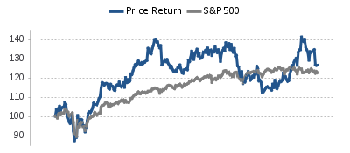
  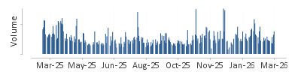
  Source: HFI
  [Table_Profit]
  US$ mn | Dec-25A |  | Dec-26E |  | Dec-27E |  | Dec-28E
  Revenue | 27,450 |  | 29,505 |  | 31,735 |  | 34,159
  （+/-） | 10.34% |  | 7.48% |  | 7.56% |  | 7.64%
  Net profit | 4,089 |  | 4,724 |  | 5,116 |  | 5,544
  （+/-） | 7.8% |  | 15.5% |  | 8.3% |  | 8.4%
  Diluted EPS (US$) | 10.33 |  | 11.93 |  | 12.92 |  | 14.00
  GPM | 37.6% |  | 37.7% |  | 37.8% |  | 37.9%
  ROE | 21.0% |  | 22.5% |  | 23.0% |  | 23.6%
  P/E | 34 |  | 29 |  | 27 |  | 25
  Source: Company data, HFI
[Table_Author]
Bin Yang, SFC:BSQ313 | Yida Deng, SFC:BVF321
harryyang@hfisec.com.hk | dengyida@hfisec.com.hk

Contents

1. Eaton: a global intelligent power management company 3
1.1 Eaton’s transformation into a leader in intelligent power management positions itself as a key beneficiary of global energy transition and AI tailwinds. 3
1.2 Financial performance highlights 11
2. Riding on the megatrends of digitalization and electrification 13
2.1 Powering up AI Data Centers: Insatiable demand for AI and cloud data center capacity accelerating growth in power management 13
2.2 AIDCPower grid upgrade and modernization: robust demand for electrical equipment when aging grid meets re-industrialization and more electricity generation. 16
2.3 Aerospace product upcycle: More defense spending with aging fleets and more commercial demand with record air travel. 19
3. Eaton is Positioned to Drive Continued Profitable Growth and Value Creation Across Core Electrical and Aerospace Businesses 20
4. Valuation& recommendation 22
5. Risks 24

- Eaton: a global intelligent power management company

1.1 Eaton’s transformation into a leader in intelligent power management positions itself as a key beneficiary of global energy transition and AI tailwinds.

Eaton is a company dedicated to developing intelligent power management products and solutions that transform the way the world manages power. Today, Eaton Corporation plc has successfully reinvented itself into a premier global intelligent power management company, uniquely positioned at the nexus of the world's most significant secular trends. As of early 2026, the company stands as a critical enabler of the energy transition, electrification, and the massive infrastructure build-out required by the artificial intelligence revolution. Eaton is no longer merely a component supplier; it has become the "arms dealer" for the modern grid and the digital economy. With a 2025 revenue of $27.4 billion and operations spanning 170 countries, the firm leverages its deep technical moat and the Eaton Business System (EBS) to drive superior operational excellence. By focusing on high-growth, high-margin sectors such as data centers and aerospace, Eaton has decoupled itself from traditional industrial cyclicality, commanding a valuation premium that reflects its role as a vital infrastructure backbone for the twenty-first century.

Figure: Eaton’s global capabilities
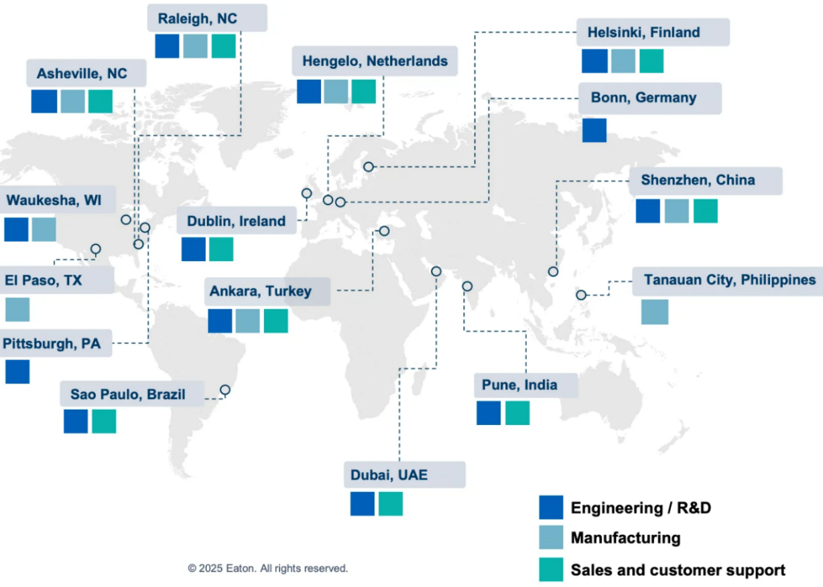
Source: Company, HFI

Eaton's century-long evolution showcases masterful strategic pivots toward high-growth electrical and digital power management markets. Starting as a 1911 pioneer in U.S. automotive axles and heavy-duty vehicle components, Eaton shifted decisively in 1994 by acquiring Westinghouse’s distribution and control business, building its electrical systems foundation. The 2012 acquisition of Cooper Industries doubled the electrical segment and centered the company on power management. Eaton then streamlined aggressively, divesting lighting and hydraulics to prioritize high-barrier, high-margin areas. This culminated in the January 26, 2026 announcement of spinning off its Mobility Group (Vehicle and eMobility segments) into an independent public company by early 2027 (expected end of Q1 2027), completing its transformation into a focused Electrical + Aerospace leader aligned with 2030 growth in secular megatrends.
Figure: Eaton’s stock performance
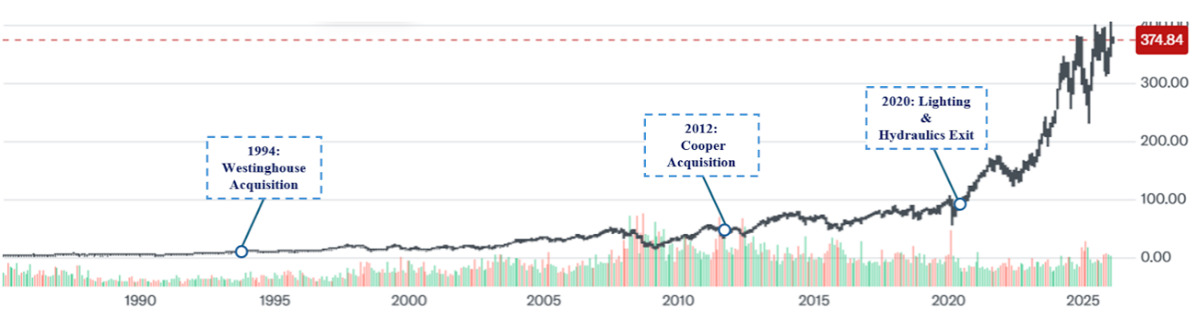
Source: Company, HFI

This strategic shedding of legacy assets has provided the financial and operational headroom for a new era of high-tech acquisitions. Complementing this structural pruning, Eaton’s recent inorganic growth strategy has been meticulously calibrated to fortify its technological leadership in the high-stakes sectors of AI-driven electrical infrastructure and aerospace. Since 2021, the multi-billion dollar acquisitions of Cobham Mission Systems and Ultra PCS have been instrumental in augmenting Eaton’s defense exposure and mission-critical electronics, providing a stable, high-margin revenue base. However, the most transformative shift in the current cycle is Eaton’s decisive move into thermal management and solid-state domains. The strategic purchase of Boyd Corporation announced in November 2025，stands out as a watershed moment, equipping Eaton with industry-leading liquid cooling capabilities essential for the high-power density of AI data centers. This acquisition, coupled with the integration of Exertherm’s continuous thermal monitoring, allows Eaton to offer a comprehensive, digitally-enabled power chain. Furthermore, the company’s focus on solid-state transformer (SST) technology represents a fundamental shift away from legacy mechanical hardware toward silicon-based power electronics, ensuring Eaton remains the preferred architecture provider for the global energy transition.

Figure: Eaton’s Electric portfolio actions
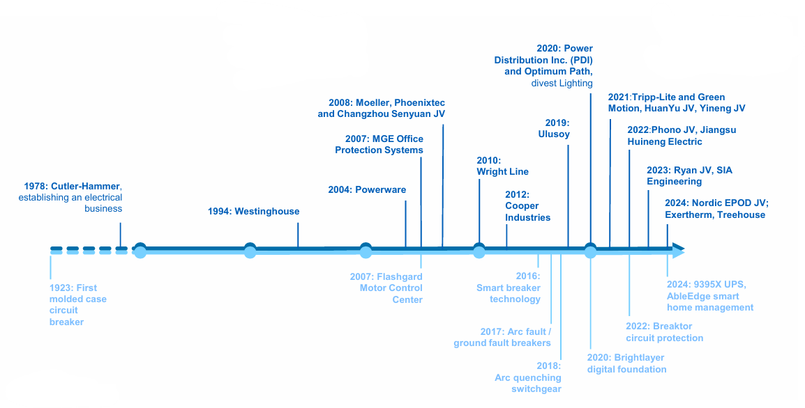
Source: Company, HFI
Figure: Eaton’s Aerospace portfolio actions
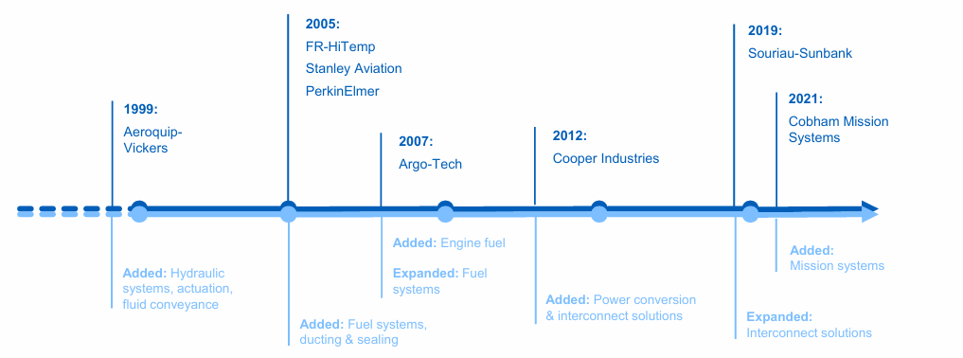
Source: Company, HFI

Massive capital investments in North American manufacturing capacity aim to alleviate supply constraints and monetize the record-high order backlog. To institutionalize its leadership in the electrification super-cycle, Eaton has accelerated its capital expenditure program, committing over $1.5 billion to expand its North American manufacturing footprint. This multi-year expansion, centered on key facilities in Nacogdoches, Texas, and Waukesha, Wisconsin, specifically targets the critical shortage of utility-scale transformers and voltage regulators that has constrained the utility sector. Furthermore, new production capacity in South Carolina and Mexico is being optimized for modular power distribution assemblies to meet the specialized, high-density power requirements of hyperscale AI data centers. By strategically scaling its physical infrastructure, Eaton is transitioning from a period of demand-led growth to a phase of capacity-driven realization, effectively de-risking its long-term revenue targets and ensuring the timely conversion of its record-breaking $15.3 billion order backlog into high-margin earnings.

ETN operates in five business segments: Electrical Americas (48.5% of FY 25 sales), Electrical Global (24.8% of FY 25 sales), Aerospace (15.5% of FY 25 sales), Vehicle (9.1 % of FY 25 sales) and eMobility (2.2% of FY 25 sales):
Figure: Segment sales and End-markets
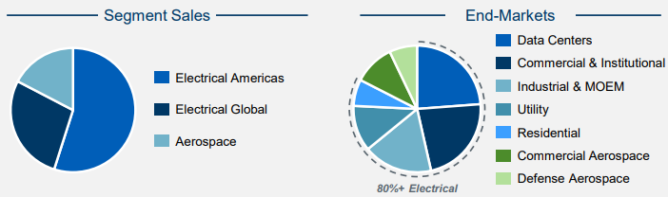
Source: Company, HFI

Electrical Americas serves as the primary growth engine, leveraging unprecedented demand from AI-driven data centers and utility grid modernization. The Electrical Americas segment remains the cornerstone of Eaton’s valuation, contributing nearly 50% of total revenue and exhibiting the most aggressive growth profile within the portfolio. This segment provides the critical architecture for power distribution, including medium-voltage switchgear, circuit breakers, and Uninterruptible Power Supplies (UPS). The explosion of generative AI has catalyzed a massive expansion in hyperscale data center capacity, where Eaton’s integrated solutions are the gold standard for reliability and thermal management. Furthermore, the push for grid modernization in North America, fueled by federal infrastructure spending and the integration of renewable energy sources, has created a multi-year backlog of utility-scale projects. Eaton’s ability to offer a comprehensive hardware-and-software stack ensures that it captures the full value chain of electrification. By integrating its industry-leading physical infrastructure with the Brightlayer digital platform, Eaton enables utilities to not only build the grid but also optimize it through real-time data and automated management, from the point of generation to the final consumer.

Figure: Portfolio of data center solutions
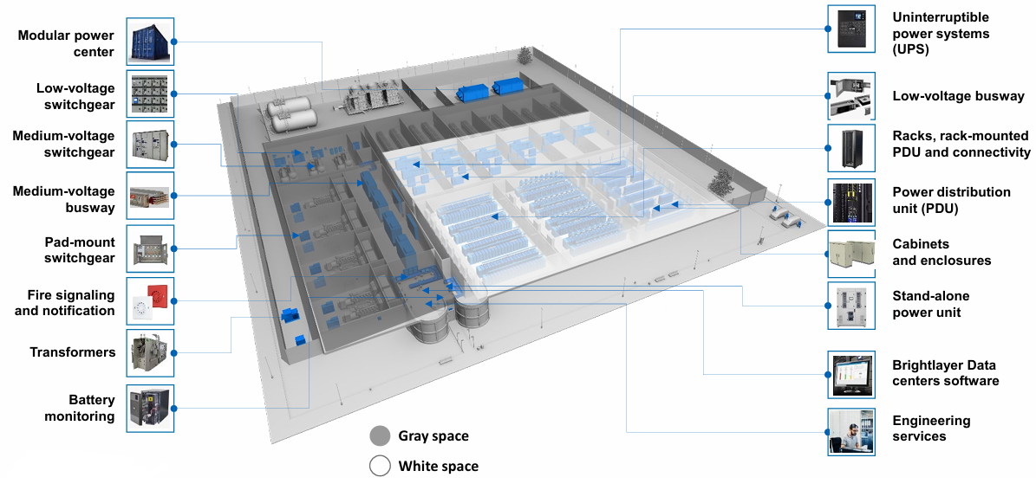
Source: Company, HFI

The Electrical Global segment reinforces Eaton’s market depth by capitalizing on international decarbonization and industrial automation initiatives. Operating as the international counterpart to the Americas division, Electrical Global captures the accelerating demand for energy transition solutions across Europe, the Middle East, and Asia-Pacific. This segment is particularly well-positioned to benefit from European "Green Deal" initiatives, where Eaton’s microgrid controllers and medium-voltage switchgear are essential for integrating intermittent wind and solar power into aging grid infrastructures. Beyond utilities, the segment serves a diverse array of industrial and commercial clients seeking to enhance energy efficiency through automation and smart power monitoring. Despite the fragmented nature of international markets, Eaton’s global footprint and localized supply chains allow it to maintain high operational margins while mitigating geopolitical risks. The segment’s growth is increasingly driven by "software-as-a-service" offerings that provide real-time energy analytics, further shifting the revenue mix toward recurring, high-margin digital services.

Figure: Portfolio of grid solutions
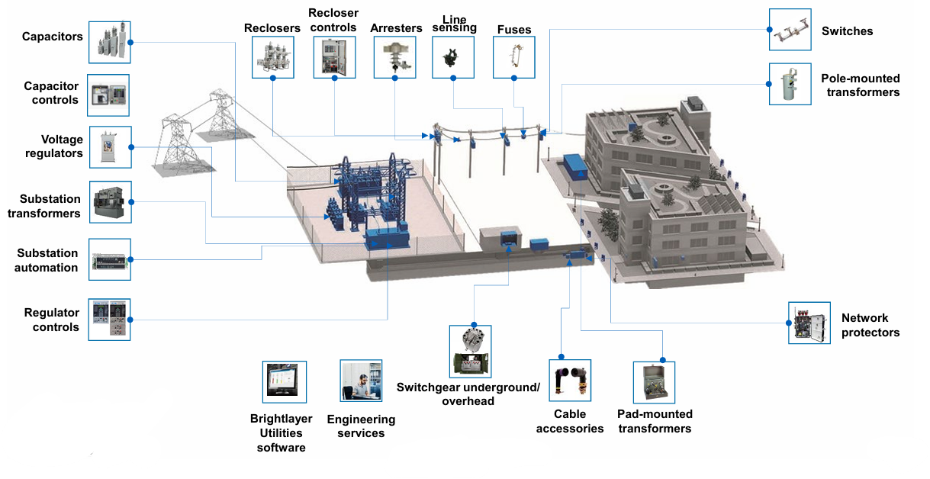
Source: Company, HFI

Eaton’s high-margin Aerospace business provides long-term cash flow visibility through robust defense spending and commercial aviation aftermarket demand. The Aerospace segment is frequently described as the "crown jewel" of the Eaton portfolio, characterized by extremely high barriers to entry and long-cycle revenue streams. As a Tier-1 supplier to OEMs like Boeing and Airbus, Eaton provides mission-critical fuel, hydraulic, and motion control systems that are integral to the world’s most advanced aircraft. The value proposition of this segment lies in its massive installed base, which generates high-margin aftermarket revenue for decades after an aircraft enters service. Following the total recovery of global air travel and a significant uptick in global defense budgets in 2025, Eaton has seen its aerospace backlog swell to record levels. The recent acquisitions of Cobham and Ultra PCS have further fortified its position in high-growth niches such as mission systems and defense electronics, ensuring that the segment remains a stable and highly profitable pillar of the overall corporate structure.
Figure: Portfolio of aerospace
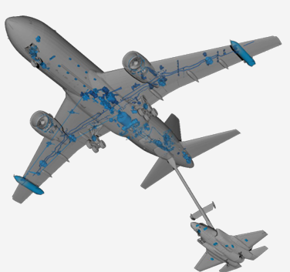
Source: Company, HFI

Eaton’s traditional Vehicle operations serve as a strategic "cash cow"， generating the robust liquidity necessary to fund the company’s high-growth technological pivots. Despite the planned early 2027 spinoff, this segment remains a dominant force in the global commercial vehicle market, maintaining market leadership in heavy-duty truck transmissions and fuel-efficient valvetrains. By leveraging the Eaton Business System to maximize margins and optimize capital expenditure, the business continues to provide a stable financial foundation while Eaton aggressively invests in next-generation power electronics.

Parallel to this, the eMobility segment acts as a high-growth incubator, developing the critical high-voltage power electronics essential for electrified transportation. This division specializes in advanced power distribution units (PDUs) and patented Breaktor® circuit protection technology, finding significant traction in the demanding commercial vehicle and off-highway sectors. By integrating eMobility with traditional vehicle operations into the upcoming "Mobility Group" spinoff, Eaton is creating a standalone leader with a balanced portfolio of legacy cash flows and future-ready technologies, ultimately allowing the remaining "Core Eaton" to achieve a pure-play valuation focused on Electrical and Aerospace markets.

Figure: Portfolio of vehicle and eMobility
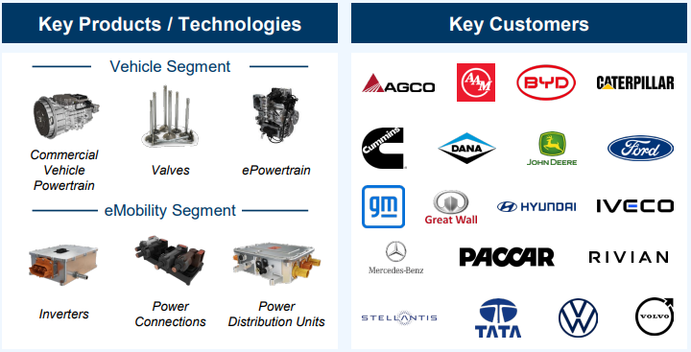
Source: Company, HFI

Figure: Segment sales and End-Markets
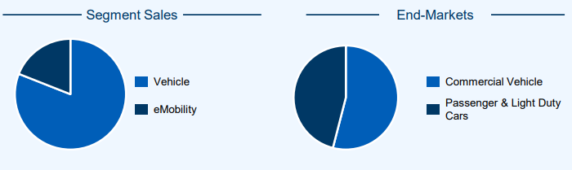
Source: Company, HFI

Under CEO Paulo Ruiz, Eaton is executing a rigorous 2030 strategy focused on digital integration and high-visibility backlog realization. The leadership transition to CEO Paulo Ruiz in mid-2025 has signaled a phase of intensified execution for Eaton’s "2030 Growth Strategy." Ruiz, a veteran with deep roots in both electrical engineering and industrial management, has prioritized the "digitalization of power" as the firm's next frontier. Under his guidance, the company has doubled down on its Brightlayer software suite, aiming to transform every piece of Eaton hardware into a data-generating asset. Complementing his vision is the appointment of David Foster as CFO in early 2026, whose decades of experience in global treasury and regional finance provide the operational rigor needed to manage the complex 2027 Mobility spinoff. Together, the executive team is focused on converting Eaton’s record-high order backlog into realized earnings, while simultaneously expanding margins through AI-driven manufacturing efficiencies and premium pricing strategies in supply-constrained markets.

Figure: Leadership team
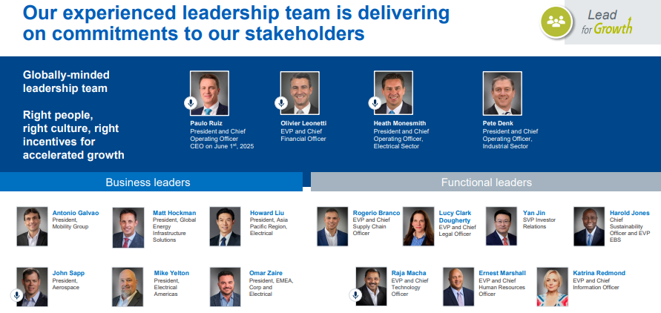
Source: Company, HFI

1.2 Financial performance highlights
Eaton’s revenue evolution between 2020 and 2025 reflects a successful pivot toward high-growth electrical markets and a structural decoupling from industrial cyclicality. Following the significant portfolio pruning that included the 2021 divestiture of the Hydraulics business, the company has delivered robust top-line performance, culminating in a record $27.4 billion in total revenue for FY2025, representing 10% year-over-year growth. The Electrical Americas segment has emerged as the primary growth engine, contributing approximately $132.8 billion in 2025 revenue as hyperscale data centers and utility grid modernization drive double-digit volume increases. Meanwhile, the Electrical Global segment, contributing $68.2 billion in 2025, continues to benefit from international grid decentralization and industrial automation across Europe and Asia. The Aerospace division has demonstrated remarkable resilience, achieving $4.09 billion in 2025 revenue through a mix of strong defense spending and a recovering commercial aviation aftermarket. Even the Mobility segments, which generated approximately $3 billion in combined revenue for 2025, have maintained stable performance through disciplined pricing while preparing for their strategic separation in early 2027.
Figure: Segment Revenue
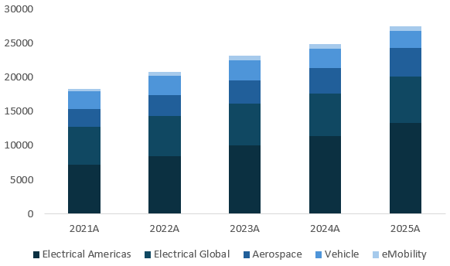
Source: Company, HFI

Sustained Gross Profit growth and disciplined cost management via the Eaton Business System have catalyzed significant margin expansion across the 2020-2025 period. The consistent upward trajectory in Gross Profit highlights Eaton’s successful transition toward higher-value, technology-driven solutions and its formidable pricing power within critical infrastructure markets. This operational leverage is clearly demonstrated by the record segment margin of 24.5% reached in 2025, which reflects the favorable mix-shift resulting from the integration of high-margin acquisitions like Cobham and Ultra PCS. The financial integrity of these margins is further validated by a record $3.6 billion in free cash flow, representing a conversion rate that anchors the company’s extensive $9 billion capital return program. Looking forward, Eaton’s 2030 strategic framework targets a consolidated segment operating margin of approximately 28%, with the flagship Electrical Americas segment projected to reach a peer-leading ~32%. By focusing on high-barrier technologies such as liquid cooling and solid-state power, Eaton is structurally re-rating its profitability profile as it approaches its 2027 pure-play transformation.

Figure: Gross Profit and Operating Profit
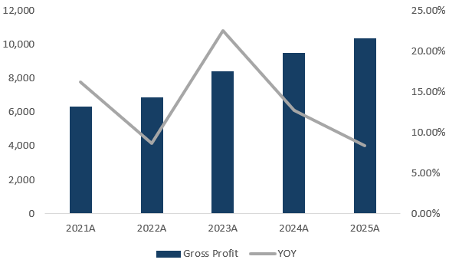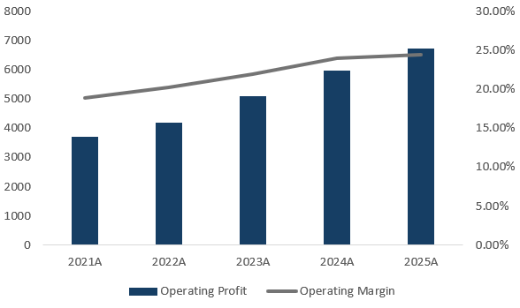
Source: Company, HFI

The 2026 guidance remains highly constructive, supported by a historic $15.3 billion order backlog and continued margin accretion. Management has issued a high-conviction outlook for 2026, targeting organic growth of 7% to 9% and adjusted EPS between $13.00 and $13.50. This near-term trajectory is significantly de-risked by the massive $15.3 billion backlog, which provides high visibility into revenue conversion through the upcoming fiscal year. The planned spinoff of the Mobility Group by early 2027 is expected to further catalyze earnings growth by allowing the remaining "Core Eaton" to operate as a high-margin, pure-play electrical and aerospace entity.

Figure: 2026 guidance
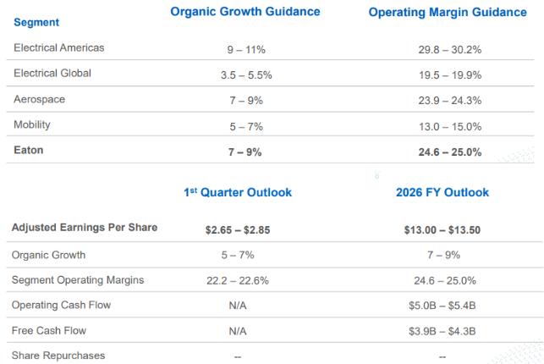
Source: Company, HFI

The 2030 strategic outlook envisions a period of aggressive compounding, with segment margins targeted to reach approximately 28%. Looking toward the end of the decade, Eaton's long-term framework targets an organic revenue CAGR of 6% to 9% and an adjusted EPS CAGR exceeding 12%. Profitability is expected to scale significantly, with segment operating margins projected at ~28%, led by a dominant ~32% target for Electrical Americas and ~27% for Aerospace. This vision is supported by a disciplined focus on high-quality earnings, with a targeted free cash flow to adjusted earnings conversion rate of 95% to 100%, ensuring ample liquidity for the company’s ongoing capital return and high-tech M&A programs.
Figure: 2030 strategy outlook
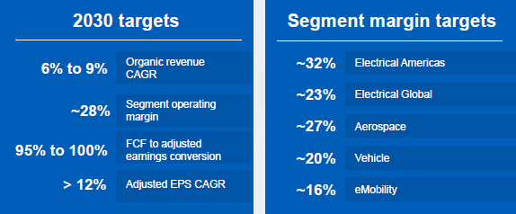
Source: Company, HFI

2. Riding on the megatrends of digitalization and electrification

2.1 Powering up AI Data Centers: Insatiable demand for AI and cloud data center capacity accelerating growth in power management
Data centers in the US are in short supply and construction of data centers in the U.S. is accelerating. According to the CBRE North America Data Center Trends H2 2025 report, the North American data center market is experiencing unprecedented tightening, with the overall vacancy rate in eight primary markets (defined by their massive inventory, high density of network providers, and the presence of major cloud service providers) plummeting to a record low of 1.4% by year-end 2025. This scarcity of available inventory is largely driven by a massive surge in demand from hyperscalers and AI-driven occupiers, who are racing to secure capacity well ahead of delivery. Consequently, rental rates have continued their upward trajectory for the fourth consecutive year, with average monthly asking prices for 250-to-500 kW requirements rising 6.5% year-over-year to $195.94 per kW/month, while large-scale requirements of 10 MW or more command even significant premiums.

Figure: H2 2025 Wholesale Primary Market Fundamentals
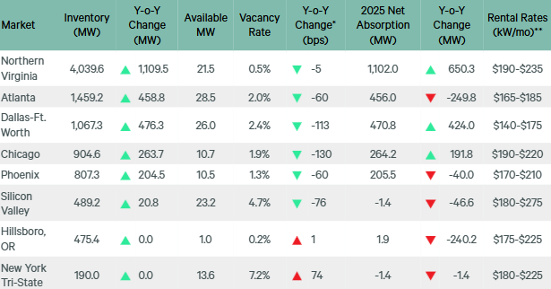
Note:*Vacancy year-over-year change is between H2 2025 and H2 2024.**Rental rates are quoted asking rates for 250+ kW at N+1/Tier III requirements.
Source: CBRE Research, CBRE Data Center Solutions, H2 2025.HFI

Figure: Average Asking Rental Rate with Y-o-Y % Change for Primary Markets
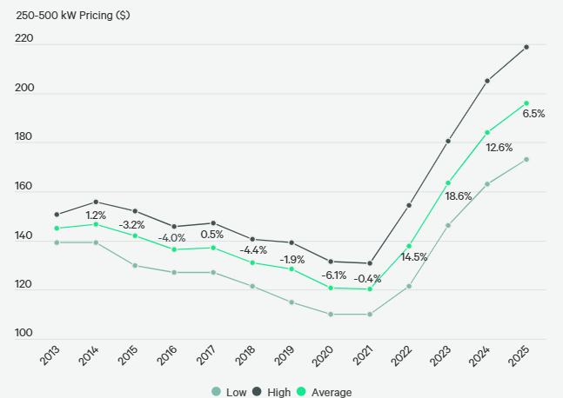
Source: CBRE Research, CBRE Data Center Solutions, H2 2025. HFI

Despite these supply constraints, the development pipeline remains robust as developers pivot toward power-first site selection to meet long-term needs. In 2025, primary market supply expanded by 36% year-over-year to reach a total of 9,432 MW, supported by a record net absorption of 2,497.6 MW. At the end of the year, there were approximately 5,994.4 MW of capacity under construction in primary markets, although new project starts have faced challenges due to power procurement hurdles and zoning delays. This supply is so tightly contested that 4,799.9 MW has already been secured by tenants, resulting in a staggering pre-lease ratio of approximately 80.1%. This high-demand environment has led to a highly pre-committed market, where most of the new capacity is leased long before construction is completed, reinforcing the sector's shift toward large-scale, AI-optimized infrastructure.

Figure: Primary Markets Net Absorption, Preleasing & Under Construction
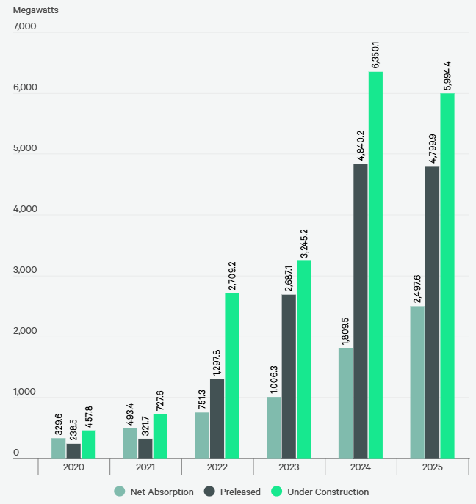
Source: CBRE Research, CBRE Data Center Solutions, H2 2025. HFI

While the AI-driven data center construction boom is dramatically increasing demand for IT equipment, the burgeoning market for AIDC is also driving a significant structural shift in investment toward non-IT Capital Expenditure (CapEx), including the power infrastructure. As AI clusters require exponentially more physical support than traditional cloud computing, the supporting non-IT construction spending—which includes the electrical, thermal management layers, building shell, etc.—now sees a commensurate increase with IT-related development costs. According to co-location operator Digital Realty, within a data center facility total capital investment excluding IT equipment breaks down roughly as follows:~30% for building shell and core; ~35% for electrical systems; ~20% for HVAC and mechanical systems; ~15% for racks and containment.

Figure: Co-location data centre Capex split (excluding IT equipment)
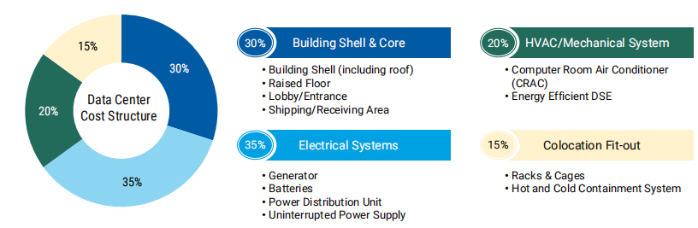
Source: Digital Realty, HFI

The surge in energy intensity of data center required more robust power management solution and create opportunities for solution providers, like Eaton, ABB, Vertiv, Schneider Electric. The intensification of AI training and inference has led to a dramatic spike in rack density, moving from traditional 5–10 kW racks to AI-specific configurations exceeding 50–100 kW per rack. To protect these high-value GPU clusters, operators are demanding higher redundancy and more sophisticated electrical architectures, contributing to forecasts that data center electricity consumption will grow from roughly 4% in 2024 to approximately 9% of total U.S. power demand by 2030, according to the Electric Power Research Institute (EPRI). The reliability of the entire power chain is now paramount. This urgency drives a 'flight to quality' for switchgear and UPS systems, as operators prioritize Tier-1 vendors who can provide the sophisticated, large-scale power management required to support ultra-dense AI workloads without interruption.

Figure: A simplified illustration of electric flow in a typical data center
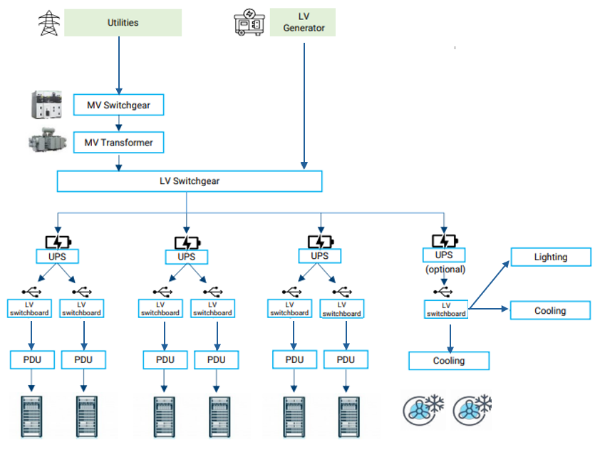
Source: HFI

2.2 AIDCPower grid upgrade and modernization: robust demand for electrical equipment when aging grid meets re-industrialization and more electricity generation.

The United States electrical grid is currently facing a critical inflection point characterized by decades of chronic underinvestment. Approximately 70% of the U.S. grid is now over 25 years old, a clear indicator of a systemic aging issue that has rendered the infrastructure increasingly fragile. As these legacy assets reach the end of their operational lifecycles, the frequency of grid failures and outages has escalated, mandating an accelerated replacement and hardening cycle to ensure national energy security. As per NERC, more than half of North America is at risk of energy shortfalls in the next five to 10 years. This necessary wave of equipment replacement is no longer discretionary but an urgent requirement to modernize a foundation that remained largely stagnant for the past 30 to 40 years.
Figure: Capacity and Energy Risk Assessment- Risk Area Summary (2025–29)
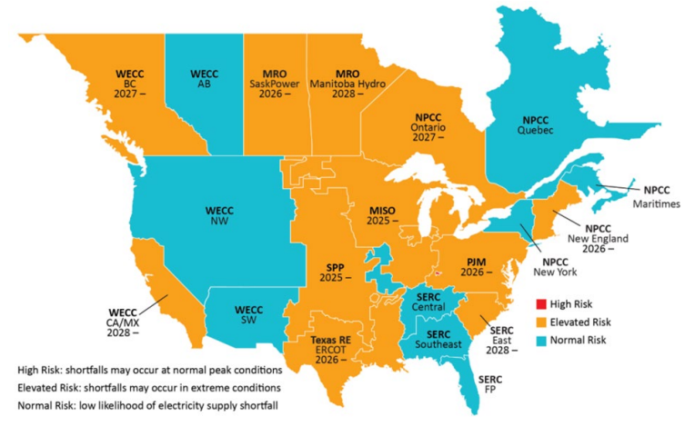
Source: Digital Realty, HFI

Compounding the pressure on this aging infrastructure is the massive demand surge driven by American re-industrialization and the rapid integration of renewable energy sources. According to the Department of Energy, U.S. electricity generation is expected to grow at 6x the Compound Annual Growth Rate (CAGR) over the year 2024 to 2030 compared to the pace seen over the last two decades. This unprecedented growth is propelled by the large-scale interconnection of solar and wind power, both of which introduce high levels of variability and load stress to the system.

To accommodate this transition, there is a burgeoning need for significant new capital investment focused on grid automation and digitalization. In response to increased demand, the utility sector in North America has started and is planning a surge in capital investment. According to Morningstar, investor-owned utilities in the U.S. have already invested more than $1.3 trillion in the past decade to enhance energy infrastructure. 4 Growth expenditures by these utilities are expected to exceed $1.1 trillion over the five-year period ending December 31, 2029. This macro-trend creates a robust, long-term demand cycle for advanced electrical equipment, as the grid must evolve from a passive distribution network into a dynamic, digitalized infrastructure capable of supporting the next era of industrial and technological expansion.

Figure: US grid situation
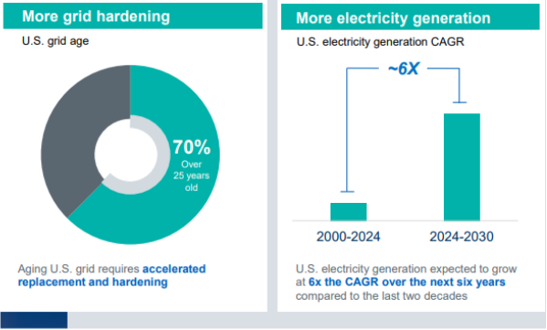
Source: U.S. Energy Information Administration and Department of Energy , HFI
The market for critical power infrastructure in 2025-2026 remains historically tight due to the unprecedented surge in demand from AI data centers and grid modernization with long lead time and rising prices for key components.

Table: Lead time for key electrical components
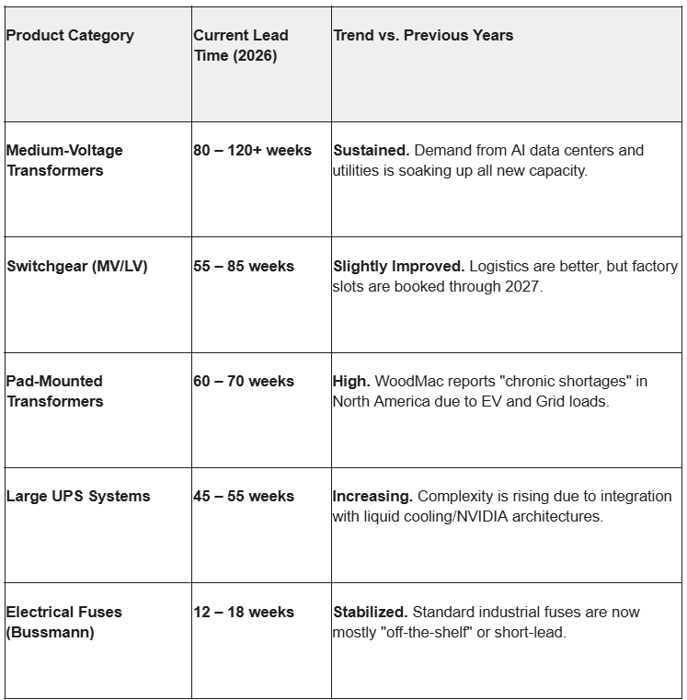
Source: Bloomberg, HFI
Figure: Transformer price index rising in the US
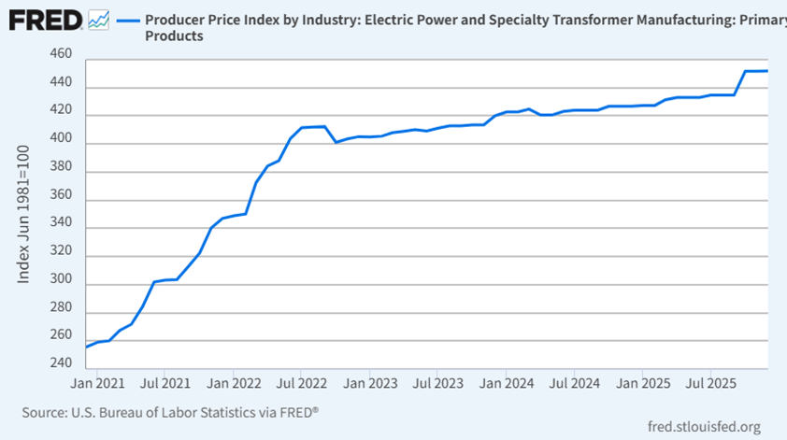
Source: Bloomberg, HFI

2.3 Aerospace product upcycle: More defense spending with aging fleets and more commercial demand with record air travel.
The defense aerospace sector is experiencing a period of high intensity driven by a dual necessity: maintaining a massive "legacy" fleet and accelerating the transition to next-generation platforms. According to the U.S. Government Accountability Office, the backbone of the U.S. Air Force—including B-52 bombers and KC-135 tankers—is over 60 years old on average. Keeping these "aging fleets" mission-ready requires constant, high-value retrofits, structural upgrades, and complex maintenance cycles. Simultaneously, global geopolitical tensions are pushing defense budgets toward "New Growth Platforms" like the FLRAA and T-7A. This creates a powerful financial tailwind where spending is mandated both for the survival of existing assets and the rapid procurement of future air superiority.

In the commercial realm, the aviation industry is witnessing a historic resurgence characterized by record air travel and a massive supply-demand imbalance. With Revenue Passenger Kilometers (RPK) projected to grow over 25% by 2030, airlines are desperate to expand their capacity. This has resulted in a staggering OE (Original Equipment) backlog of over 13 years for major aircraft manufacturers. Because demand for travel is outstripping the pace of new aircraft production, the industry is firing on all cylinders: factories are pushing for maximum output to clear the backlog, while existing commercial fleets are being flown harder and longer, necessitating more frequent servicing to keep up with the global passenger surge.
Figure: More defense spending and commercial demand
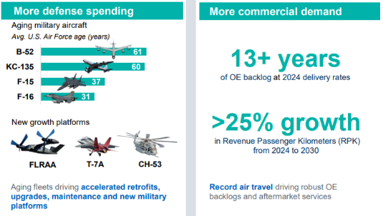
Source: Company , HFI

The convergence of these two trends creates strong demand for aerospace systems and components . In the defense sector, aftermarket solutions—such as specialized seals, engine-driven pumps, and fuel conveyance systems—are the lifeblood that keeps 60-year-old airframes safely in the sky. On the commercial side, every new plane sitting in the 13-year backlog represents a guaranteed future sale of high-pressure hydraulic systems, fuel inerting technologies, and advanced wing-flap actuators. Whether it is a retrofit for a vintage B-52 or a state-of-the-art system for a new Boeing or Airbus, these mission-critical components are indispensable, ensuring that as the world spends more on flight, the demand of aerospace systems and components remains at the heart of every takeoff and landing.

3. Eaton is Positioned to Drive Continued Profitable Growth and Value Creation Across Core Electrical and Aerospace Businesses
The planned spin-off of the Mobility segment marks a decisive shift in Eaton’s long-term strategy, streamlining the company’s portfolio to focus exclusively on its high-growth Electrical and Aerospace businesses. This transaction, expected to be completed by the end of Q1 2027, is structured to be tax-free to Eaton shareholders for U.S. federal income tax purposes, ensuring maximum value retention. By separating the more cyclical automotive-related assets, Eaton is positioning itself to fully capture the "generational growth" driven by powerful secular megatrends, including the global energy transition, the rapid expansion of AI-driven data centers, and the modernization of aging electrical grids. This narrowed focus allows for more targeted capital allocation and operational agility, ensuring that Eaton remains a pure-play leader in the electrification and aerospace power management sectors for decades to come.

In an increasingly competitive landscape where peers like Vertiv and Schneider Electric are also deep strategic partners with NVIDIA, Eaton distinguishes itself by its unique 'Grid-to-Chip' breadth. While rivals excel in specific areas like liquid cooling or modular white space, Eaton’s competitive moat lies in its ability to manage the entire power chain—integrating utility-scale high-voltage substations directly with AI-specific 800V HVDC rack architectures. This end-to-end control, combined with one of the industry's most robust North American manufacturing footprints, allows Eaton to deliver pre-validated, ultra-high-density power solutions that are purpose-built to handle the volatile 'power-burst' profiles of NVIDIA’s Blackwell and Rubin platforms at scale.

Figure: Eaton offers broadest portfolio of DC power management solutions
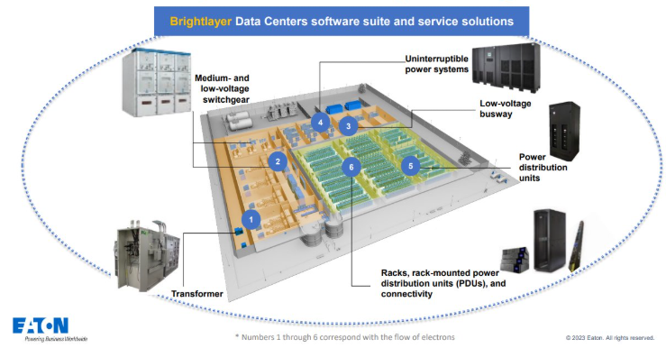
Source: Company, HFI

Beyond the white space of the data center, Eaton holds a competitive edge through its comprehensive utility-grade distribution infrastructure and advanced digital edge control solutions. Unlike many competitors who operate in silos, Eaton provides a seamless integration from the distribution substation directly to the end customer. Its Brightlayer digital platform and Grid Edge intelligence offer superior visibility and automated control, enabling faster fault isolation and service restoration compared to the more fragmented systems of its peers. By combining robust physical hardware—such as medium-voltage switchgear and transformers—with cutting-edge digital twins and edge analytics, Eaton empowers operators to optimize power quality and resilience across distributed IT environments, ensuring a level of operational continuity that remains a benchmark for the industry.

Finally, Eaton maintains a formidable competitive moat as a core supplier of integrated fuel, hydraulic, and electrical power solutions for both commercial and military aircraft. While competitors like Honeywell or Parker Hannifin compete in specific segments, Eaton’s strength lies in its ability to provide mission-critical systems that enhance fuel efficiency and operational reliability across the entire flight envelope. From high-pressure hydraulic pumps to advanced debris-monitoring systems and lightweight electrical distribution, Eaton’s technologies are embedded in the world’s most advanced platforms, including the latest generation of wide-body jets and frontline defense aircraft. By leveraging its deep domain expertise in power management, Eaton ensures that aerospace manufacturers can meet increasingly stringent safety and weight requirements, solidifying its role as an indispensable partner in the global aviation supply chain.
Eaton’s strategic position in core electrical and aerospace is evidenced by the fast-growing negotiations pipeline and record-breaking historical backlog, showing extended visibility and a high level of confidence in future growth. In the Electrical Americas segment, the backlog has surge to $13.2B in 2025, a stunning 31% increase year-on-year. The negotiations pipeline has also surged to $9.8B in 2025, representing more than 4x growth since 2019 and a CAGR of 26%. This momentum is further reflected in the company's total historical backlog, which reached a record $19.6B in 2025—comprising $15.3B from the Electrical Sector and $4.3B from the Aerospace Segment. Since 2021, the company has maintained significant annual backlog growth, including a 26% increase in the most recent year, providing a robust foundation for unprecedented demand. With more capacity expansion expected to be online soon, we believe the company is on track to deliver on 2026 and 2030 financial commitments with differentiated performance.
Figure: Negotiations and backlog remain robust and growing
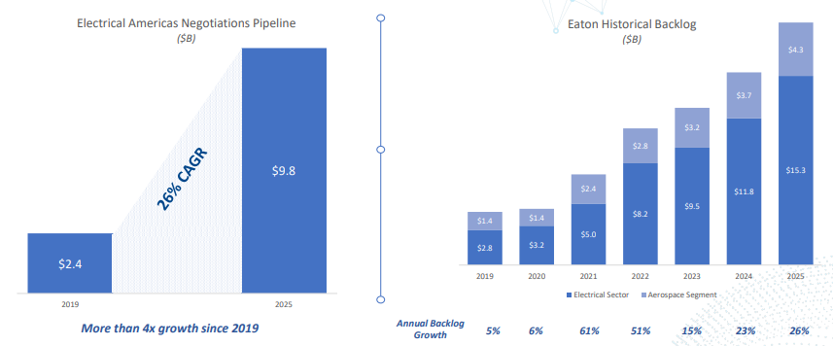
Source: Company, HFI

4. Valuation& recommendation
We estimate that revenue of Eaton from year 2026 to 2032 will be $29,505 /31,735/ 34,159/ 36,779/ 39,628/ 42,714/ 46,072 million, with the net profit of 4,724/ 5,116/ 5,544/ 6,008/ 6,157/ 6,645/ 7,177 million. Based on the DCF valuation model, our target price of Eaton is $ 391.17, and we initiate coverage on the stock with “Outperform”.

Table: DCF Model
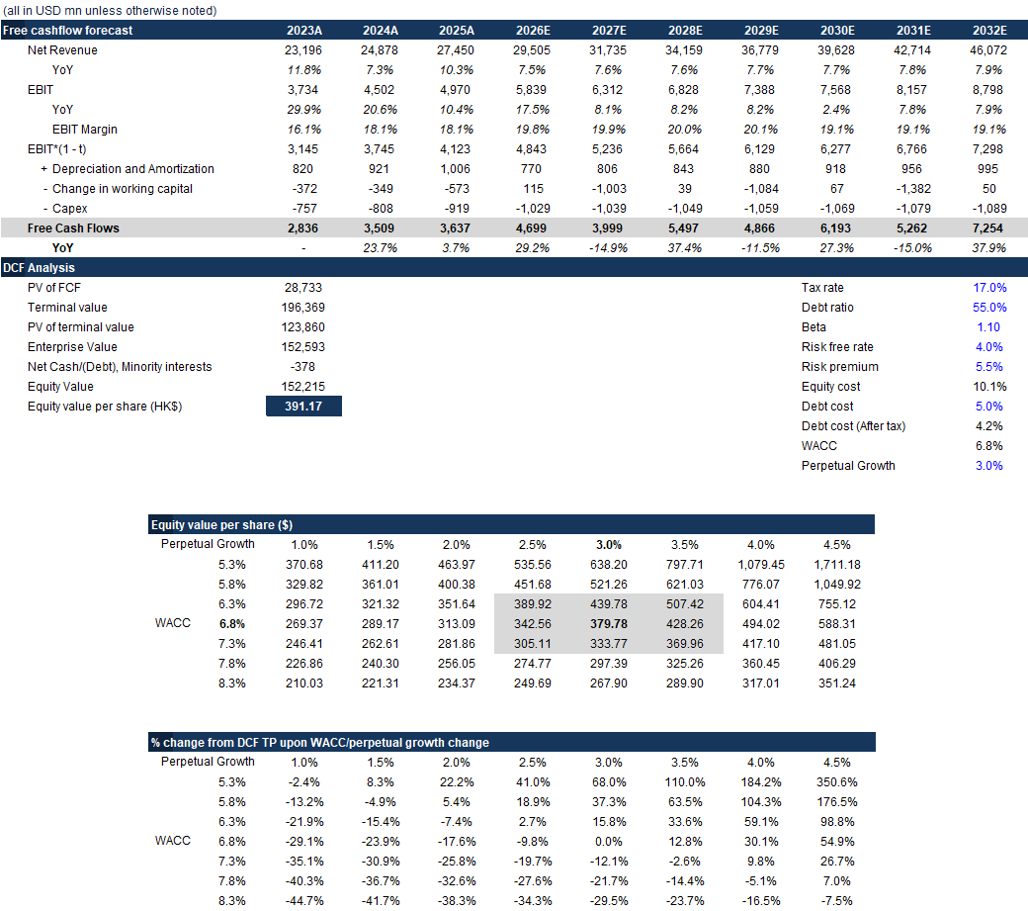
Source: Company, HFI

Table: Financial Summary
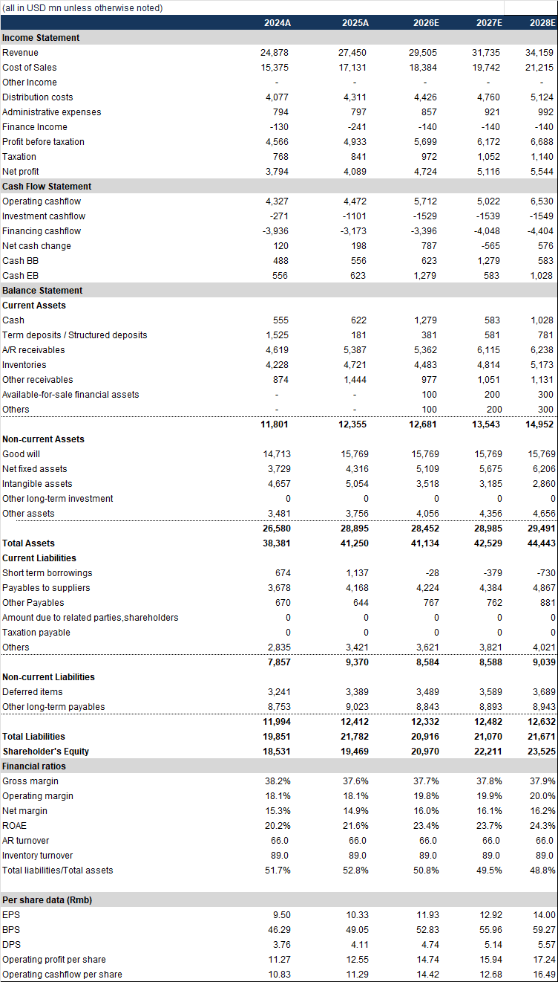
Source: Company, HFI

5. Risks
Slowing growth and misexecution; Slowing demand activity in data center; Continued trade tensions and shifting U.S. tariff policies; Technological Obsolescence.

[Table_APPENDIX]
[Table_disclaimer]
APPENDIX
IMPORTANT DISCLOSURES
This research report is distributed by HuaFu International (HK) Financial Holdings Limited (referred as HuaFu International below), which is authorized to engage in securities activities in its respective jurisdiction.
Analyst Certification:
I, Bin Yang, certify that (i) the views expressed in this research report accurately reflect my personal views about any or all of the subject companies or issuers referred to in this research and (ii) no part of my compensation was, is or will be directly or indirectly related to the specific recommendations or views expressed in this research report; and that I (including members of my household) have no financial interest in the security or securities of the subject companies discussed.
I, Yida Deng, certify that (i) the views expressed in this research report accurately reflect my personal views about any or all of the subject companies or issuers referred to in this research and (ii) no part of my compensation was, is or will be directly or indirectly related to the specific recommendations or views expressed in this research report; and that I (including members of my household) have no financial interest in the security or securities of the subject companies discussed.
Conflict of Interest Disclosures
HuaFu International and some of its affiliates may engage in investment banking and / or serve as a market maker or hold proprietary trading positions of certain stocks or companies in this research report. As far as this research report is concerned, please send an email to lcd@hfisec.com.hk if the information about any company mentioned in this report is needed).
Ratings Definitions (from 1 Jul 2020):
HuaFu International uses a relative rating system using Outperform, Neutral, or Underperform for recommending the stocks we cover to investors. Investors should carefully read the definitions of all ratings used in HuaFu International Research. In addition, since HuaFu International Research contains more complete information concerning the analyst's views, investors should carefully read HuaFu International Research, in its entirety, and not infer the contents from the rating alone. In any case, ratings (or research) should not be used or relied upon as investment advice. An investor's decision to buy or sell a stock should depend on individual circumstances (such as the investor's existing holdings) and other considerations.
Analyst Stock Ratings
Outperform: The stock’s total return over the next 12-18 months is expected to exceed the return of its relevant broad market benchmark by over 10%, as indicated below.
Neutral: The stock’s total return over the next 12-18 months is expected to be in line with the return of its relevant broad market benchmark, as indicated below. Underperform: The stock’s total return over the next 12-18 months is expected to be below the return of its relevant broad market benchmark by over 10%, as indicated below.
Benchmarks for each stock’s listed region are as follows: Japan – TOPIX, Korea – KOSPI, Taiwan – TAIEX, India – Nifty100, US – SP500; for all other China-concept stocks – MSCI China.

HuaFu International Non-Rated Research: HuaFu International publishes quantitative, screening or short reports which may rank stocks according to valuation and other metrics or may suggest prices based on possible valuation multiples. Such rankings or suggested prices do not purport to be stock ratings or target prices or fundamental values and are for information only.
HuaFu International Coverage of A-Shares: HuaFu International may cover and rate A-Shares . HuaFu Securities, the ultimate parent company of HuaFu International based in FuZhou, covers and publishes research on these same A-Shares for distribution in mainland China. However, the rating system employed by HuaFu International differs from that used by HuaFu Securites and even the teams covering the same A-share stocks might be totally independently different, as a result there may be a difference in their coverage ratings, target prices and research logics for the same A-share stocks.
IMPORTANT DISCLAIMER
The research report is issued by HuaFu International, a licensed corporation to carry on Type 4 regulated activity (advising on securities) for the purpose of the Securities and Futures Ordinance (Cap. 571) of Hong Kong.
The information and opinions contained in this research report have been compiled or arrived at from sources believed to be reliable and in good faith but no representation or warranty, express or implied, is made by HuaFu International or any other related members from which this research report may be received, as to their accuracy, completeness or correctness. All opinions expressed herein are as of the date of this research report and are subject to change without notice. This research report is for information purpose only. Descriptions of any companies or their securities mentioned herein are not intended to be complete and this research report is not, and should not be construed expressly or impliedly as, an offer to buy or sell securities. The securities referred to in this research report may not be eligible for purchase or sale in some jurisdictions. If an investment product is denominated in a currency other than an investor's home currency, a change in exchange rates may adversely affect the investment. Past performance is not necessarily indicative of future results. Certain transactions, including those involving derivatives, give rise to substantial risk and are not suitable for all investors. You should also bear in mind that recommendations in this research report are not tailor-made for you. The analyst has not taken into account your unique financial circumstances, such as your financial situation and risk appetite. You must, therefore, analyze and should, where applicable, consult your own legal, tax, accounting, financial and other professional advisers to evaluate whether the recommendations suits you before investment. Neither HuaFu International nor any of its directors, employees or agents accepts any liability whatsoever for any direct or consequential loss arising from any use of the materials contained in this research report.
HuaFu International and its affiliates, officers, directors, and employees, excluding the analysts responsible for the content of this document, will from time to time have long or short positions in, act as principal in, and buy or sell, the securities or derivatives, if any, referred to in this research report. Sales, traders, and other professionals of HuaFu International may provide oral or written market commentary or trading strategies to the relevant clients and the companies within HuaFu International that reflect opinions that are contrary to the opinions expressed in this research report. HuaFu Internatioal may make investment decisions that are inconsistent with the recommendations or views expressed in this research report. HuaFu International is under no obligation to ensure that such other trading decisions, ideas or recommendations are brought to the attention of any recipient of this research report.
Please refer to HuaFu International’s website www.hfisec.com.hk for further information on HuaFu International’s organizational and administrative arrangements set up for the prevention and avoidance of conflicts of interest with respect to Research.

DISTRIBUTION AND REGIONAL NOTICES
Except as otherwise indicated below, any Recipient wishing to discuss this research report or effect any transaction in any security discussed in HuaFu International’s research should contact the HuaFu International salesperson in their own country or region.
Notice to Hong Kong investors: The research report is distributed by HuaFu International, which is a licensed corporation to carry on Type 1 regulated activity (dealing in securities) in Hong Kong. This research report does not constitute a solicitation or an offer of securities or an invitation to the public within the meaning of the SFO. This research report is only to be circulated to "Professional Investors" as defined in the SFO. This research report has not been reviewed by the Securities and Futures Commission. You should not make investment decisions solely on the basis of the information contained in this research report. Recipients of this research report are to contact HuaFu International salespersons in respect of any matters arising from, or in connection with, the research report.

People’s Republic of China (PRC): In the PRC, the research report is directed for the sole use of those who receive the research report in accordance with the applicable PRC laws and regulations. Further, the information on the research report does not constitute "production and business activities in the PRC" under relevant PRC laws. This research report does not constitute a public offer of the security, whether by sale or subscription, in the PRC. Further, no legal or natural persons of the PRC may directly or indirectly purchase any of the security or any beneficial interest therein without obtaining all prior PRC government approvals or licenses that are required, whether statutorily or otherwise. Persons who come into possession of this research are required to observe these restrictions.
This research report is intended for the recipients only and may not be reproduced or redistributed without the written consent of an authorized signatory of HuaFu International.
Copyright: HuaFu International 2025. All rights reserved

Recommendation Chart
[Table_RecommendationChart]
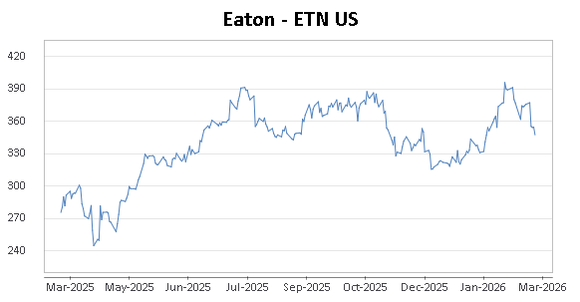
Source: Company data Bloomberg, HFI estimates

