Biologically informed TCR representations improve in-distribution prediction but fail to generalize to unseen epitopes
Erick Tejkowski¹ and Maria Elisa Paredes¹ (ORCID: 0009-0007-4967-8612)
¹ Independent researchers, Fairview Heights, Illinois, USA (Greater St. Louis)
ORCID iD: Maria Elisa Paredes: https://orcid.org/0009-0007-4967-8612
Correspondence: erick.tejkowski@gmail.com

Abstract
Background. Current T-cell receptor (TCR) specificity predictors perform reasonably on epitopes represented during training but fail to generalize to previously unseen epitopes. One proposed explanation is that existing receptor representations ignore biologically meaningful organization created during V(D)J recombination. We tested that prediction.
Methods. Using 203,308 VDJdb records (121,467 unique human TCRβ clonotypes after deduplication), we derived and reference-validated empirical V- and J-segment anchors, segmented each CDR3 into germline-derived termini and a junctional N-region, quantified order-dependent junctional organization, and compared biologically informed receptor features with raw CDR3 3-mers and a V/J-only control. Binding models were evaluated on both represented epitopes and epitopes withheld entirely from training, with independent confirmation on the official IMMREP23 benchmark.
Results. N-regions carry substantial order-dependent structure. A flat bigram model separates real from order-shuffled N-regions at AUC 0.6149; conditioning on the (V,J) pair raises this to 0.7162, a gain of +0.1013 (95% bootstrap CI [+0.0995, +0.1031]) that is not attributable to model capacity, since randomizing the conditioning labels removes it entirely (−0.0035). On seen epitopes, morphological tokenization outperforms raw 3-mers (0.7135 ± 0.0017 vs 0.6589 ± 0.0063). However, V and J gene identity alone reaches 0.7089 ± 0.0017, leaving approximately +0.005 attributable to junctional sequence. On unseen epitopes, all arms perform at chance and the morphological advantage disappears (+0.0046 ± 0.0104, pooled 95% CI [−0.0084, +0.0175]).
Benchmark confirmation. On the official IMMREP23 challenge data scored with the official Macro AUC0.1 metric, all conclusions replicate: morphological tokenization beats raw 3-mers (+0.0375 on seen peptides, CI [+0.0086, +0.0677]) but not V/J identity alone (+0.0091, CI [−0.0166, +0.0338]), and on the seven test peptides absent from training no method exceeds 0.52. A TCRdist-style baseline using all six CDR loops of both chains outperforms our morphological model (0.6281 vs 0.5893 overall), indicating that breadth of receptor coverage matters more than depth of morphological analysis.
Robustness. Retraining under four negative-generation schemes leaves two conclusions intact — no arm exceeds 0.5062 on unseen peptides, and morphological features never meaningfully exceed germline V/J identity alone — while revealing that the advantage of morphology over raw k-mers is contingent on training-set size (+0.034 at ~68,000 pairs, absent at ~29,000), with a size-matched control excluding decoy similarity as the cause.
Learning curve. Across six training-set sizes, the advantage over raw k-mers rose monotonically from +0.0080 to +0.0375 Macro AUC0.1 (+0.0118 per log training pair, r = 0.985), while raw k-mer performance remained approximately flat. The unseen-peptide advantage also increased monotonically but remained within experimental uncertainty throughout the observed range.
Conclusions. Biologically informed segmentation captures genuine, germline-conditioned organization within TCR CDR3 sequences, but those gains do not extend to previously unseen epitopes. Most of the within-distribution advantage is explained by V/J identity rather than junctional sequence. Improving receptor representation alone therefore appears insufficient for cross-epitope prediction.
Keywords: T-cell receptor, CDR3, biologically informed representation, V(D)J recombination, epitope specificity, generalization

1. Introduction
Predicting which antigen a T-cell receptor recognizes remains unsolved. The receptor repertoire is generated by V(D)J recombination, a stochastic process joining germline segments with nucleotide deletion and non-templated insertion at the junctions, concentrating diversity in CDR3 — the loop that contacts the peptide–MHC complex.
Recent community benchmarks consistently show that current predictors perform reasonably on epitopes represented during training but fail to generalize to previously unseen epitopes. Proposed explanations include shortcut learning, where models rely on V-gene identity, CDR3 length, or peptide frequency rather than learning receptor–antigen recognition.
A distinct line of argument holds that the problem is representational. Jerne’s 1984 Nobel lecture, The Generative Grammar of the Immune System, proposed a formal analogy between linguistics and immunology but did not implement it. Vu et al. (2024) revived the argument concretely, characterizing the tokens and grammar of the antibody language and diagnosing existing language models as domain-unspecific: they inherit NLP architectures while tokenizing at the amino acid or arbitrary k-mer level, encoding no immune-specific structure. Their paper is a framework and explicitly invites implementation.
This framework yields a simple prediction. If biologically meaningful CDR3 segments capture transferable information about receptor generation, then representations built from those segments should improve prediction for epitopes absent from training.
We tested this prediction directly. The results support the existence of biologically meaningful CDR3 organization but do not support the stronger prediction that this organization improves generalization to previously unseen epitopes.

2. Methods

2.1 Data and deduplication
We used VDJdb (accessed 2026-07-27), comprising 203,308 records. We retained human TCRβ entries with a CDR3β sequence, resolved V and J gene assignments, an annotated epitope, and only canonical amino acids, yielding 157,206 records. VDJdb reports the same clonotype from multiple studies; counting records inflates every downstream frequency. We collapsed to unique (CDR3, V, J, epitope) tuples, giving 121,467 clonotypes (1.29× row inflation overall, 2.07× for the influenza M1 epitope GILGFVFTL), retaining source study identifiers to permit cross-study replication analysis.

2.2 Empirical germline anchors
Rather than hand-typing germline CDR3 contributions, we derived them from data. For each V segment with at least 20 clonotypes, we computed the modal residue and its frequency at successive positions from the 5′ end, extending the anchor while modal frequency remained ≥0.80, capped at 8 residues; the procedure was mirrored from the 3′ end for J segments. Germline-encoded positions are near-invariant across clonotypes while junctional positions are not, producing a sharp frequency drop at the boundary.
This yielded anchors for 71 V and 15 J segments. VDJdb bundles a partial reference (res/segments.aaparts.txt) covering 16 V and 13 J human TRB segments; where the two overlap, 28 of 29 derived anchors are consistent with the reference (a derived anchor being a prefix/suffix of the reference contribution, or vice versa). The single discrepancy is TRBV7-2, where data support CASS and the reference lists CTSSL.

2.3 Decomposition
Each CDR3 was parsed as V-prefix + N-region + J-suffix. The V-prefix is the longest anchor prefix the sequence begins with. The J-suffix is the longest anchor suffix occurring at or within two residues of the 3′ end, requiring at least two matched residues; a strict terminal-match test fails on sequences carrying an extra trailing residue and causes the entire J region to be absorbed into the N-region, an error we encountered and corrected. Anchors shorter than three residues, arising from unresolved gene family names, were rejected. Records in which a germline J suffix occurs internally — framework FR4 sequence erroneously included, 32 records — were detected and excluded rather than parsed. Decomposition succeeded for 115,951 clonotypes (95.5%), and we assert post hoc that no retained N-region contains a full germline J suffix.

2.4 Order-dependent junctional structure and its controls
We asked whether N-regions carry information in residue order. For each held-out N-region we generated a decoy by permuting its residues, preserving length and composition exactly, so that only order is destroyed; a composition-randomized decoy was also generated as a sanity ceiling. Three add-0.5-smoothed bigram models were compared: a length-only control, a flat model pooled over all segments, and a model conditioned on the (V,J) pair interpolated with the pooled model (weight 0.7). Scores are log-likelihoods; discrimination is quantified by AUC.
Training and evaluation were split by study (320 training studies, 79 held out entirely), not by record, so no model can profit from memorizing a single laboratory’s batch. Because the conditioned model has many more parameters than the flat model, we added a permuted-label control: an identical conditioned model trained after randomly permuting (V,J) labels across clonotypes. If the conditioned model’s advantage were capacity, this control would reproduce it.

2.5 Unseen-epitope binding prediction
We intentionally used a simple linear classifier to isolate the contribution of receptor representation rather than maximize benchmark performance. Holding the learning algorithm fixed across feature sets makes differences easier to attribute to the representations themselves.
We formulated binding prediction as classification over (TCR, epitope) pairs. Positives are observed pairs; negatives re-pair a TCR with a different epitope from the same split, excluding known positives. Because a linear model on concatenated features cannot represent interaction and interaction is the task, we hashed the cross product of TCR and epitope features into 2¹⁸ buckets and trained logistic regression by SGD (3 epochs, learning rate 0.08, L2 1e-6). Epitope features (identity, length, position-specific residues, 3-mers) were held identical across arms.
The three models differed only in receptor representation: (i) raw CDR3 3-mers, (ii) a biologically informed representation comprising V gene, J gene, germline-derived termini, junctional-length bucket, and junctional 2- and 3-mers, and (iii) a V/J-only control.
We used the 20 most-represented epitopes, capped at 800 clonotypes each (16,000 total). For the unseen condition, epitopes were partitioned into 5 folds and withheld entirely; any test clonotype whose (CDR3, V, J) also occurred under a training epitope was dropped. The entire experiment was repeated across 5 seeds, since fold assignment and negative sampling both depend on the seed. A seen-epitope positive control (80/20 clonotype split within epitopes, 3 seeds) establishes that the harness can detect an effect.

2.6 Official IMMREP23 benchmark
To situate results against community data and a community metric, we repeated the comparison on the official IMMREP23 challenge dataset. We used the released sample training set (11,312 positive paired-chain records, 808 peptides) and the released test set with labels (3,484 records, 20 peptides, 17.2% positive). Negatives for training were generated by the challenge protocol: TCRs were swapped between peptides whose Levenshtein distance exceeds 3, at five negatives per positive, yielding 67,872 training pairs.
Scoring used the official metric, Macro AUC0.1: per-peptide partial ROC AUC to a false-positive rate of 0.1 with McClish standardization, averaged across peptides. We verified the implementation against the challenge documentation, which states that an all-zero submission scores 0.5; ours scores 0.5000 exactly.
Beyond the three arms above we added cdr123, using 3-mers of all six CDR loops of both chains, and two published-style reference baselines requiring no training: TCRbase-style nearest-neighbour similarity of CDR3β to the known binders of the query peptide, and TCRdist-style nearest-neighbour over all six CDR loops with CDR3 weighted threefold. Learned arms used L2-regularised logistic regression over hashed feature crosses (2¹⁸ buckets).
Critically, 13 of the 20 test peptides occur in the official training data and 7 do not, providing a seen/unseen partition within a single benchmark that we did not construct.

2.7 Negative-scheme robustness
Because negative-example construction is the factor community post-mortems most often blame for unstable TCR-specificity results, we retrained under four schemes and scored all of them on the identical official test set: challenge (decoy peptides at Levenshtein > 3, the official protocol), random (any other peptide), hard (decoy peptides at Levenshtein ≤ 3, adversarial), and matched. The hard scheme can serve negatives for only 3,729 of 11,312 positives, altering training size and class balance as well as decoy difficulty; matched therefore restricts to the same positives and draws decoys from the dissimilar pool, holding size and balance fixed so that decoy similarity is the only difference.

2.8 Learning curve
Because §2.7 established that the morpheme-over-k-mer advantage depends on training-set size, we characterized that dependence rather than merely noting it. The full pair set was built once under the challenge protocol and then subsampled by positive, carrying each positive’s five negatives with it so class balance is constant across sizes. Six sizes spanning 6,786 to 67,872 pairs were run at two seeds each, evaluated always on the complete official test set.

2.9 Statistics and reproducibility
Enrichment used Fisher’s exact test with Benjamini–Hochberg FDR control and a minimum count of 20, replacing an earlier pseudocount ratio. AUC was computed via the Mann–Whitney U statistic with tie handling. Confidence intervals are paired bootstrap (200 resamples for model comparison, 2,000 for per-epitope deltas).
All analyzes are implemented in Python standard library only, with no external dependencies, and are deterministic given a fixed seed (stable CRC32 hashing rather than Python’s randomized hash). Code: https://github.com/etejkowski/grammar-of-immunity, commit d4bf7fb. Runtime is approximately six minutes on a 2026 laptop (Python 3.9.6, macOS 14.8.4, arm64).

3. Results

3.1 Validation: public datasets can contain strong study-specific effects
Before analyzing sequence signal we characterized study composition (Table 1). The three most-studied epitopes differ sharply in how concentrated their evidence is: GILGFVFTL draws on 28 studies with the largest contributing 33.9%, whereas GLCTLVAML draws on 29 studies but a single tetramer-sort study (PMID 32184241) contributes 79.5% of clonotypes.
This is consequential. Bigram enrichment of GLCTLVAML N-regions against GILGFVFTL is dominated by cysteine-containing bigrams (NC 83.3×, q=3.9×10⁻²⁵; CV 26.1×; CF 18.0×). Cysteine occurs in 10.8% of N-regions in the EBV group against 0.4–0.6% in the influenza and CMV groups, and 667 of 679 cysteine-containing EBV N-regions originate from that one study. Requiring replication across independent studies separates the cases cleanly: influenza signals hold in 8 of 8 studies contributing ≥200 clonotypes (IR 11.7×, q=5.8×10⁻⁸⁸; MR 14.6×), while the EBV cysteine signals hold in only 1 of 2.
These observations illustrate how apparently epitope-specific sequence patterns can arise from study composition rather than immune biology.

3.2 Validation of biologically informed segmentation
Decomposition of the influenza M1 group recovers the expected junctional signature. At the level of distinct clonotypes, 12.9% of GILGFVFTL-specific N-regions contain RS and 41.0% of clonotypes use TRBV19, against 2.5% / 4.0% for CMV pp65 and 3.7% / 1.3% for EBV BMLF1 (Figure 6B).
Raw motif counts must not be used here, and the reason is instructive. The single sequence CASSIRSSYEQYF occurs in 1,077 VDJdb rows but constitutes one clonotype (Figure 6A). Counting rows produces motif frequencies inflated by three orders of magnitude for the most redundant sequences, and an earlier version of this analysis reported such counts as clonotype counts. After deduplication no individual N-region exceeds nine clonotypes, so the motif is properly characterized as a distributed family — RS at the core with variable flanks — rather than as a small set of frequent strings.
This reproduces a result published in 1998, which reported the influenza M1 response to be constrained to the BV17 family (TRBV19 in current nomenclature) with a conserved I/sRS(A)/S CDR3β motif, and explained structurally in 2003. The 41.0% TRBV19 usage and the RS core we measure correspond directly to those two observations. We present it as pipeline validation, not as a finding: recovering a 28-year-old result from first principles is evidence the decomposition tracks real biology.

3.3 Junctional regions contain reproducible order-dependent structure
We next asked whether junctional N-regions contain reproducible sequence organization beyond amino-acid composition alone. Using held-out studies and order-preserving decoys, we found that residue order carries substantial information and that conditioning on germline V/J context markedly strengthens discrimination.
The permuted-label control scores 0.6115, i.e. −0.0035 relative to flat: randomizing the conditioning labels while holding the model class and parameter count fixed removes the entire advantage. The gain is therefore attributable to morphological context, not capacity. Results against composition-randomized decoys are equivalent (0.6124 flat, 0.7229 conditioned).

3.4 Biologically informed segmentation does not improve generalization to unseen epitopes
On seen epitopes (Table 3), morphological features outperform raw 3-mers by +0.0546 AUC (0.7135 ± 0.0017 vs 0.6589 ± 0.0063), consistently across all three seeds. The harness therefore detects effects of this magnitude.
On unseen epitopes, all arms perform at chance: kmer3 0.5052 ± 0.0075, morpheme 0.5072 ± 0.0065, vjonly 0.4991 ± 0.0127. The morphological advantage is +0.0046 ± 0.0104 with pooled per-epitope bootstrap 95% CI [−0.0084, +0.0175] — null. Baseline collapse from 0.66 to 0.51 reproduces the field-wide pattern; the addition here is a positive control demonstrating the same pipeline attains 0.71 when the epitope is known, which licenses interpreting the unseen result as generalization failure rather than pipeline failure.
A single random seed initially produced an apparently significant improvement. Repeating the experiment across independent seeds eliminated the effect, indicating that single-seed evaluations are unreliable in this setting.

3.5 The within-distribution gain is explained primarily by germline V/J usage
The V/J-only arm reaches 0.7089 ± 0.0017 on seen epitopes against morpheme’s 0.7135 ± 0.0017. Germline segment identity thus accounts for essentially the whole morphological advantage, leaving roughly +0.005 attributable to junctional N-region sequence.
These results are consistent with previous reports that V- and J-gene identity accounts for much of the apparent predictive signal in TCR specificity models.

3.6 Independent benchmark confirms the pattern
Evaluation on the official IMMREP23 benchmark reproduced the principal findings. Biologically informed segmentation consistently outperformed raw CDR3 3-mers on peptides represented during training but provided no meaningful improvement for peptides absent from the training set.
Every internal conclusion replicates. Morphological tokenization beats raw CDR3β 3-mers overall (+0.0291, 95% CI [+0.0093, +0.0505], 15/20 peptides) and on seen peptides (+0.0375, CI [+0.0086, +0.0677]). It does not significantly beat V/J gene identity alone (+0.0091, CI [−0.0166, +0.0338]), reproducing §3.5 on independent data with an independent metric. On the seven unseen peptides the advantage is not significant (+0.0134, CI [−0.0016, +0.0267]) and all methods sit between 0.479 and 0.519 (Table 6).
A TCRdist-style comparison across all six CDR loops of both chains reached 0.6281 overall and 0.6971 on seen peptides, exceeding the biologically informed CDR3β model (0.5893 and 0.6378). Both nearest-neighbour baselines scored exactly 0.5000 on unseen peptides because no reference binders exist for peptides absent from training.

3.7 Training-set size determines the within-distribution advantage
Table 7 retrains under four negative-generation schemes. Two conclusions hold throughout. No arm exceeds 0.5062 on unseen peptides under any scheme, and morphological features never meaningfully exceed germline V/J identity alone (+0.0013, −0.0023, −0.0057, −0.0068).
The advantage of morphology over raw k-mers, however, does not hold. It is +0.0345 and +0.0333 under the two full-size schemes and −0.0022 and −0.0009 under the two reduced-size schemes. The size-matched control identifies the cause: hard (similar decoys, 28,085 pairs) and matched (dissimilar decoys, 29,957 pairs) give −0.0022 and −0.0009 respectively, differing by 0.0013. Decoy similarity is therefore not responsible; training-set size is. At roughly 68,000 training pairs morphological tokenization outperforms raw k-mers by about +0.034, and at roughly 29,000 pairs the advantage disappears irrespective of negative difficulty.
These findings indicate that the within-distribution benefit depends strongly on training-set size. They do not alter the principal conclusion that performance on unseen epitopes remains at chance.

3.8 Learning-curve analysis
Table 8 and Figure 7 resolve the question §3.7 raised. The advantage of morphological tokenization over raw k-mers rises monotonically with training size, from +0.0080 at 6,786 pairs to +0.0375 at 67,872, at +0.0118 Macro AUC0.1 per natural-log unit of training pairs (r = 0.985). It shows no sign of flattening: the slope over the upper half of the range (+0.0131) is slightly steeper than over the whole range.
The mechanism is visible in the arms separately. Raw k-mer performance is essentially flat across the sweep (0.6028 to 0.6003, slope +0.0009), while morphological performance climbs (0.6108 to 0.6378, slope +0.0127). Morphological tokenization is not a better fixed representation so much as a more data-responsive one: it converts additional training data into performance where flat k-mers do not.
One further comparison qualifies even this. The V/J-only arm is itself data-responsive, and in fact rises faster than the morpheme arm (+0.0167 per log-pair, r = 0.951, versus +0.0127). What additional data buys is therefore better estimation of germline segment preferences rather than of junctional grammar, which is the same conclusion §3.5 and §3.6 reached by other routes.
The unseen-peptide delta also increased monotonically, from +0.0019 to +0.0134 at +0.0048 per log-pair (r = 0.986). This trend is suggestive rather than conclusive because it is estimated from seven peptides and its confidence interval crosses zero throughout.
These results indicate that biologically informed features become more data-responsive at larger sample sizes, while gains for unseen epitopes remain too uncertain to support a claim of improved generalization.

4. Discussion
This study tested a specific prediction arising from biologically informed representations of antigen receptors.
This distinction is biologically plausible. V(D)J recombination determines how receptor diversity is generated, whereas antigen recognition determines which peptide–MHC complexes individual receptors bind. A representation may therefore accurately capture the statistical organization created during receptor generation without encoding the information required for receptor–antigen recognition. Our results suggest that the order-dependent structure measured within CDR3 reflects the former more strongly than the latter.

Independent evaluation on the official IMMREP23 benchmark reinforces this interpretation. The same qualitative conclusions emerge under an independent dataset, community evaluation protocol, and official scoring metric. Morphology-aware representations outperform raw CDR3 k-mer features for peptides represented during training, yet provide no significant advantage for peptides absent from training. A receptor representation incorporating all six CDR loops outperforms the present morphology-aware model, indicating that expanding receptor coverage currently contributes more predictive information than increasing representational sophistication within CDR3 alone.
Learning-curve analysis suggests that biologically informed representations benefit more from additional data than raw k-mer representations. However, the corresponding gains for previously unseen epitopes remain within experimental uncertainty, indicating that increased scale alone is unlikely to resolve the generalization problem with current representations.
Our results distinguish between modeling how immune receptors are generated and modeling what they recognize. Improving representations of receptor generation improves prediction within known antigen distributions but does not, by itself, improve prediction for previously unseen epitopes. Future progress is therefore likely to depend on models that jointly represent receptor and peptide–MHC biology rather than increasingly detailed receptor representations alone.

5. Limitations
- Model scope. The primary learned models use hashed feature crosses with logistic regression. This design isolates representation quality but cannot represent all higher-order interactions, and the null result should not be generalized to every possible model class. Published systems and protein-language-model embeddings were not run directly; our TCRbase-style and TCRdist-style implementations serve as calibration rather than authoritative reproductions.
- Dataset scope. Negative examples are generated by receptor–peptide re-pairing rather than experimentally verified non-binders. The internal analysis is limited to 20 epitopes capped at 800 clonotypes each, and the IMMREP23 unseen analysis contains seven peptides. These constraints may obscure small transferable effects.
- Biological scope. The primary analysis uses TCRβ, while α-chain and peptide–MHC context are incompletely represented. Empirical anchors are not IMGT annotations and may occasionally absorb convergent junctional residues, although agreement with the available reference is high (28 of 29 overlapping anchors).
- Scale. The learning curve spans 6,786 to 67,872 training pairs. Although the within-distribution advantage increases across this range, the available data do not establish whether the trend will persist or saturate at substantially larger scales.

6. Conclusion
We tested whether a receptor representation aligned with V(D)J-derived CDR3 boundaries would improve generalization to previously unseen epitopes. The representation captured genuine, germline-conditioned sequence organization and improved prediction within the training distribution, but those gains did not extend to unseen epitopes. Most of the observed advantage was explained by V/J identity rather than junctional sequence. These findings indicate that receptor-side biological realism alone is insufficient for cross-epitope prediction and that future progress will likely require models that learn receptor–peptide–MHC relationships directly.

Data and code availability
VDJdb: https://github.com/antigenomics/vdjdb-db. Analysis code, standard-library Python only, deterministic under fixed seeds: https://github.com/etejkowski/grammar-of-immunity, commit d4bf7fb. phase1_dataset.py builds the annotated dataset and enrichment tables; phase2_grammaticality.py reproduces Table 2; phase3_unseen_epitope.py reproduces Tables 3 and 4.

Author contributions
ET: conceptualization, linguistic formalization, software, analysis, writing — original draft. MEP: biological and immunological interpretation, verification of motif prior art, linguistic framing, critical revision. Both authors approved the submitted version and accept accountability for its content.

Competing interests
None declared.

Funding
None. This work used no institutional resources.

Acknowledgements
We thank the VDJdb curators for maintaining an openly available, study-attributed database, without which the batch-effect analysis in §3.1 would not have been possible.

Figures
All figures are generated by make_figures.py. Figures 1, 5 and 6 are computed directly from VDJdb; Figures 2–4 plot values produced by the phase and benchmark scripts.
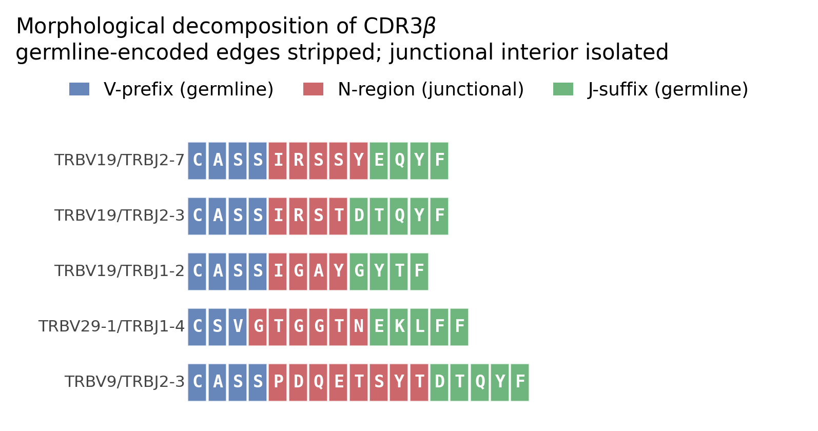
Figure 1 (fig1_decomposition.png). Morphological decomposition of CDR3β into germline V-prefix, junctional N-region, and germline J-suffix, for five real clonotypes spanning four V and four J segments.
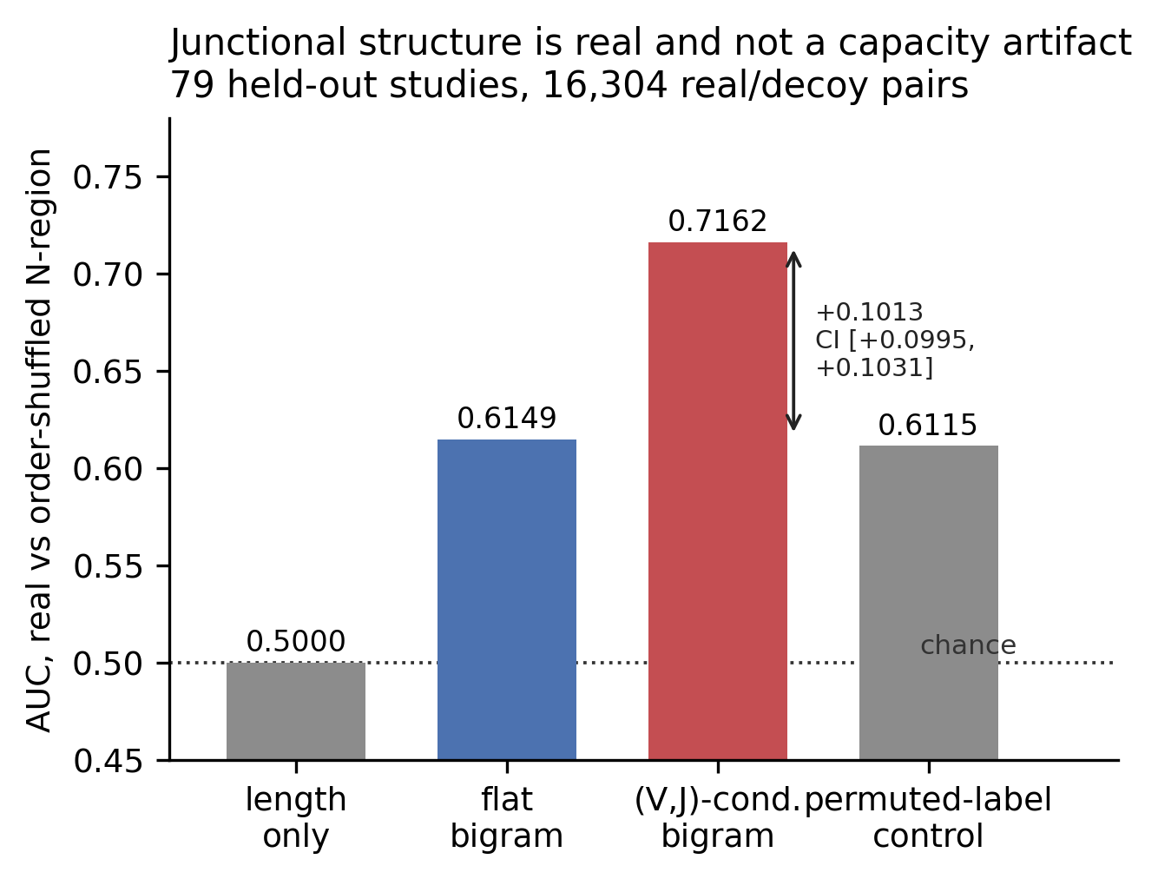
Figure 2 (fig2_grammaticality.png). Discrimination of real N-regions from order-shuffled decoys on 79 held-out studies. The length-only control is exactly 0.5000 as required; the permuted-label control establishes that the (V,J)-conditioned model’s +0.1013 gain is not model capacity.
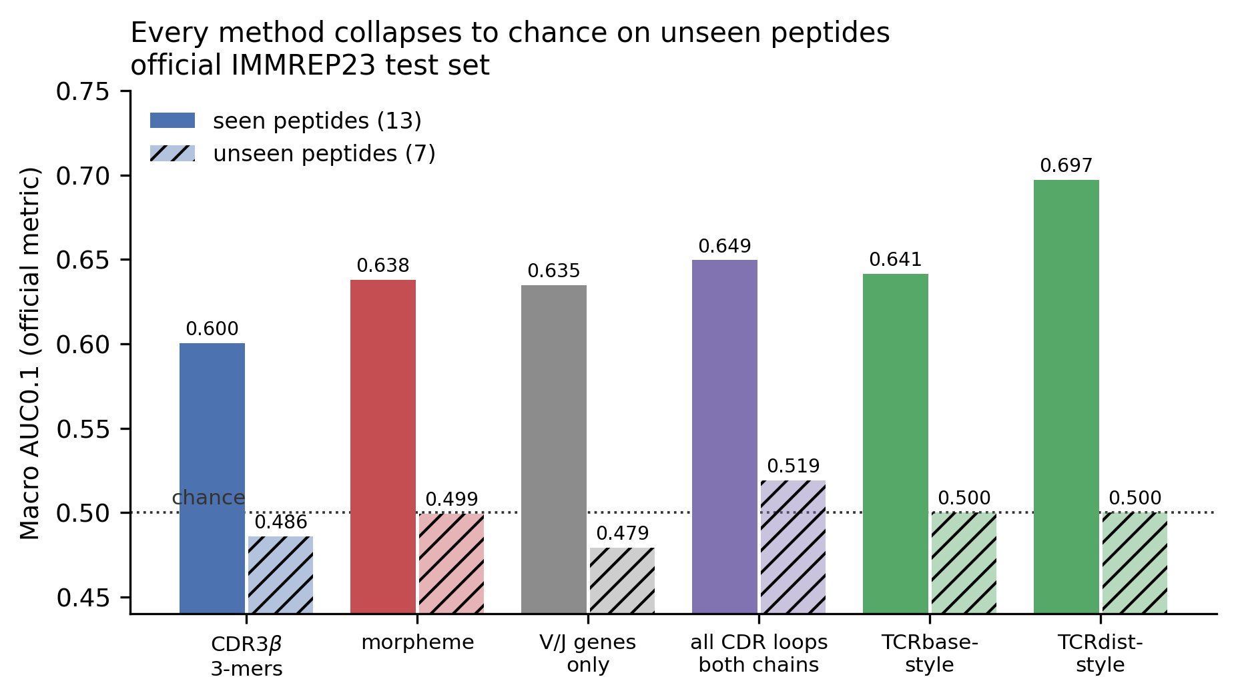
Figure 3 (fig3_seen_vs_unseen.png). Macro AUC0.1 on the official IMMREP23 test set, split by whether the test peptide appears in the official training data. Solid bars, seen peptides (13); hatched bars, unseen (7).
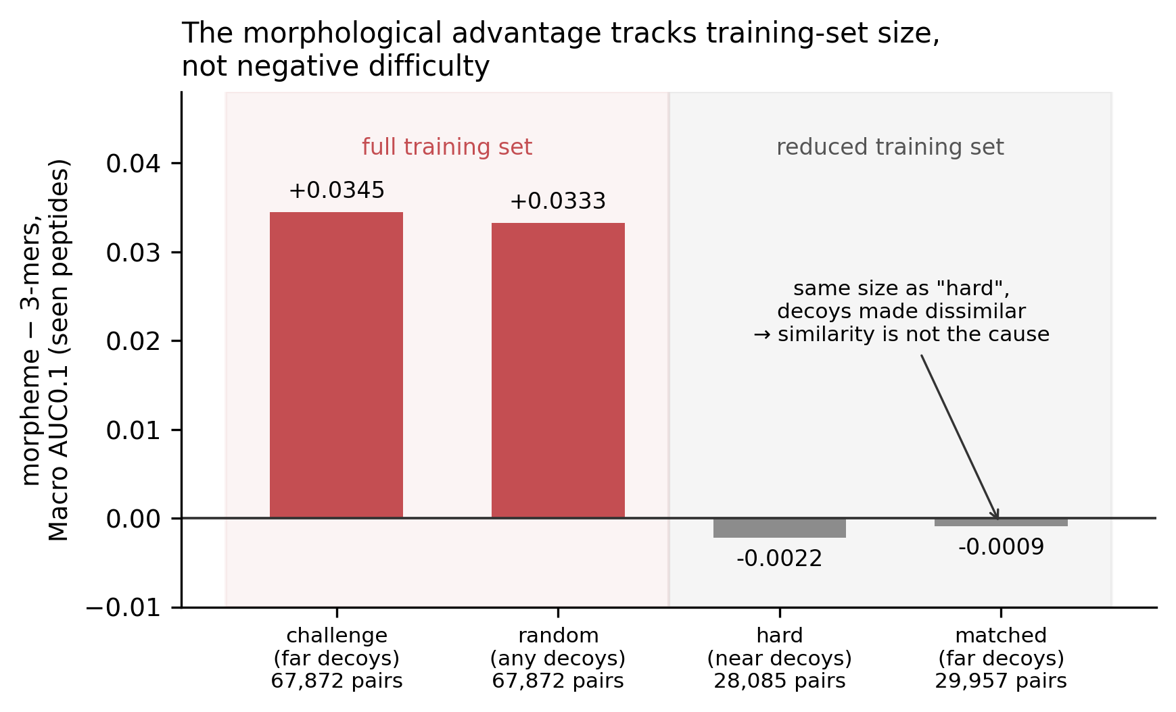
Figure 4 (fig4_data_scale.png). The morpheme-over-k-mer advantage under four negative-generation schemes. The matched scheme has the same training size as hard but dissimilar decoys, isolating training-set size as the cause.
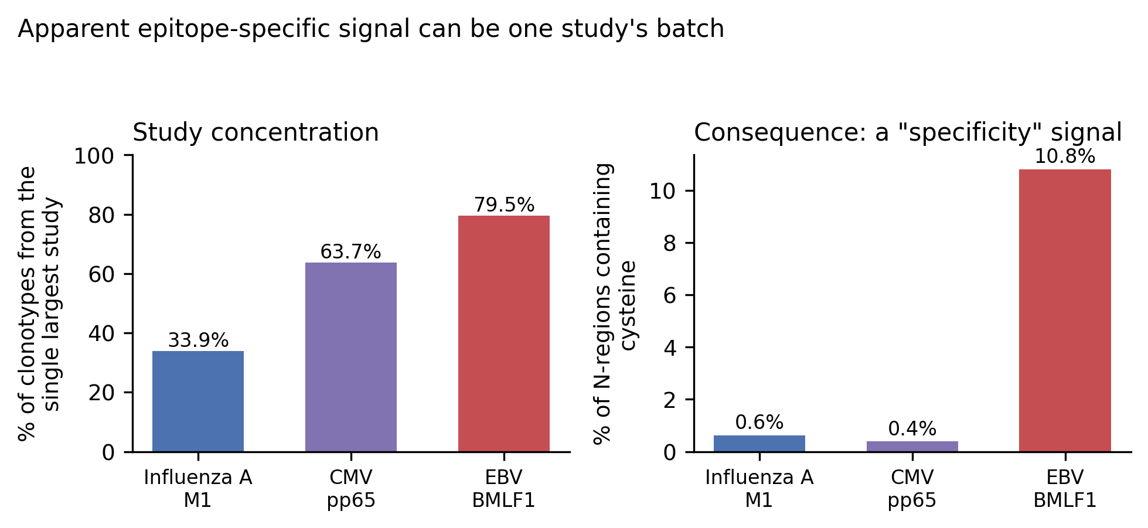
Figure 5 (fig5_batch_effect.png). Left, share of clonotypes contributed by the single largest study per epitope. Right, the resulting artifact: cysteine frequency in N-regions.
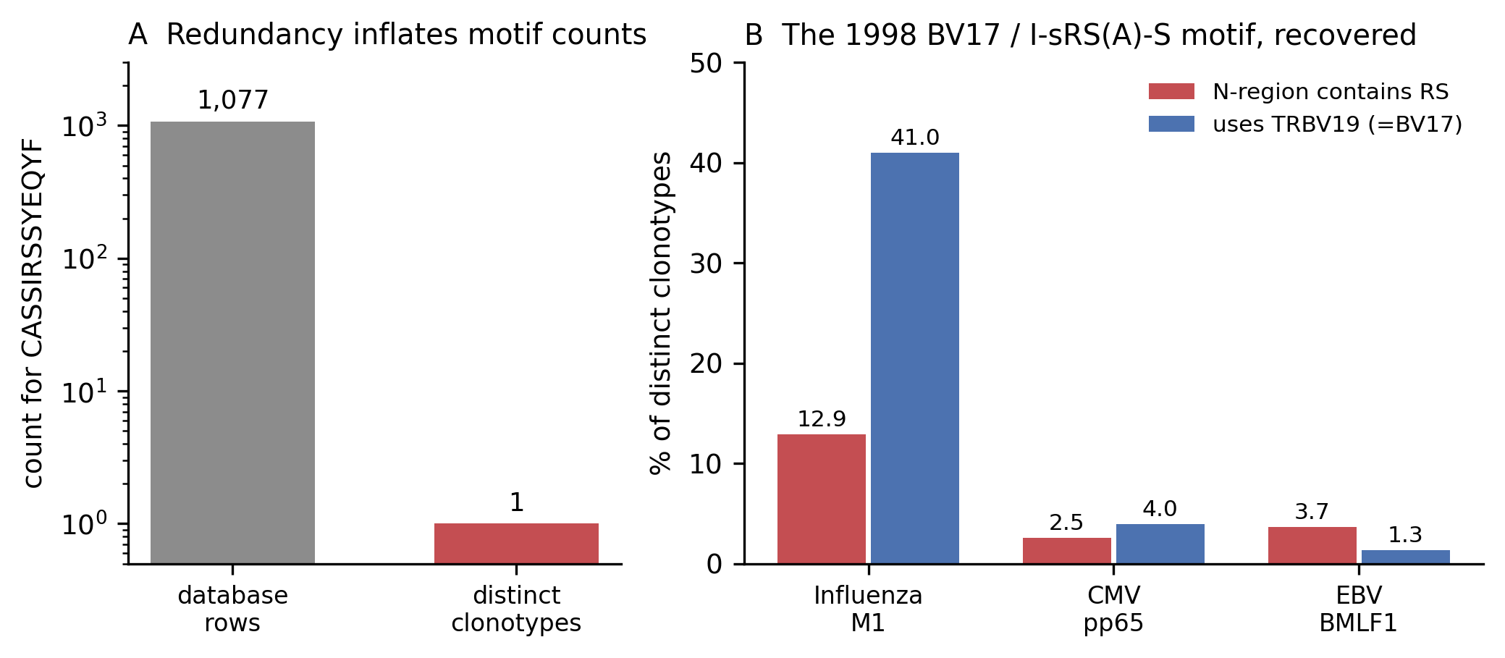
Figure 6 (fig6_motif_paradigm.png). A, database redundancy — CASSIRSSYEQYF occupies 1,077 rows but one clonotype (log scale). B, the 1998 motif at clonotype level.
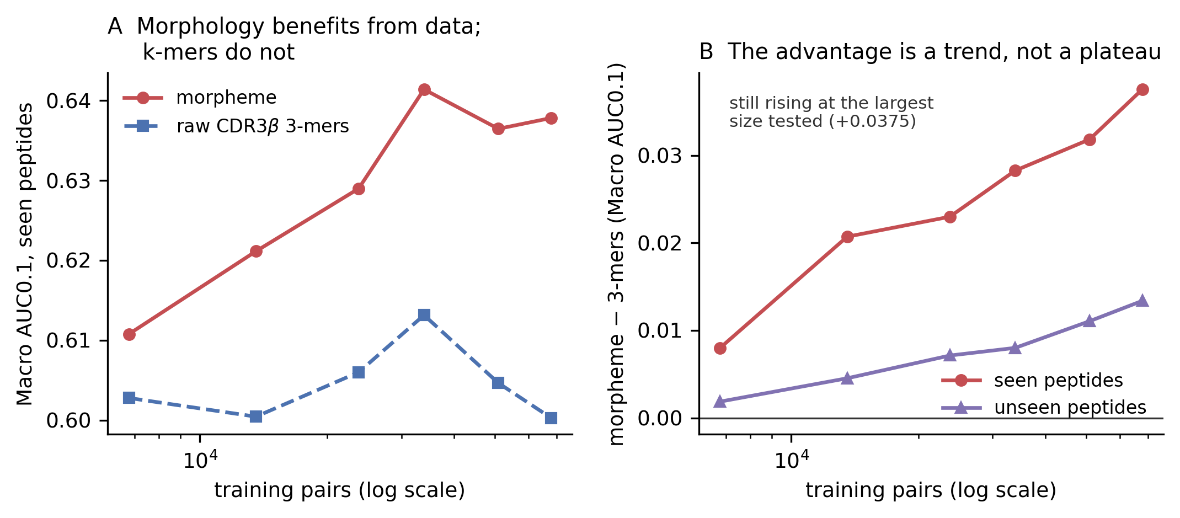
Figure 7 (fig7_learning_curve.png). A, Macro AUC0.1 on seen peptides against training-set size: morphological tokenization improves with data while raw k-mers stay flat. B, the morpheme-minus-k-mer advantage against training size for seen and unseen peptides; both rise monotonically and neither plateaus.

Tables
Table 1. Study composition of the three most-represented epitopes after clonotype deduplication and decomposition.
Epitope | Source | Clonotypes | Studies | Largest study share
GILGFVFTL | Influenza A M1 | 6,639 | 28 | 33.9%
NLVPMVATV | CMV pp65 | 13,042 | 47 | 63.7%
GLCTLVAML | EBV BMLF1 | 6,279 | 29 | 79.5% (PMID 32184241)
Table 2. Discrimination of real N-regions from order-preserving decoys, 79 held-out studies, 16,304 pairs.
Model | AUC (shuffled decoy) | AUC (resampled decoy) | Tests
Length only | 0.5000 | 0.5000 | control; must be 0.5
Flat bigram | 0.6149 | 0.6124 | residue order
(V,J)-conditioned bigram | 0.7162 | 0.7229 | order + morphology
Permuted-label control | 0.6115 | 0.6086 | capacity control
Conditioned − flat = +0.1013, 95% CI [+0.0995, +0.1031]. Permuted − flat = −0.0035.
Table 3. Binding prediction, seen epitopes (80/20 clonotype split, 3 seeds).
TCR features | AUC
Raw CDR3 3-mers | 0.6589 ± 0.0063
Morpheme | 0.7135 ± 0.0017
V/J genes only | 0.7089 ± 0.0017
Table 4. Binding prediction, epitopes withheld from training entirely (5 folds × 5 seeds).
TCR features | AUC
Raw CDR3 3-mers | 0.5052 ± 0.0075
Morpheme | 0.5072 ± 0.0065
V/J genes only | 0.4991 ± 0.0127
Morpheme − 3-mers = +0.0046 ± 0.0104, pooled per-epitope bootstrap 95% CI [−0.0084, +0.0175].
Table 5. Official IMMREP23 benchmark, Macro AUC0.1. Seen = test peptide occurs in the official training data (13); Unseen = absent (7).
Model | All | Seen | Unseen
CDR3β 3-mers | 0.5602 | 0.6003 | 0.4858
Morpheme | 0.5893 | 0.6378 | 0.4992
V/J genes only | 0.5802 | 0.6346 | 0.4791
All CDR loops, both chains | 0.6039 | 0.6495 | 0.5192
TCRbase-style nearest binder | 0.5919 | 0.6414 | 0.5000*
TCRdist-style weighted CDR | 0.6281 | 0.6971 | 0.5000*
* Constant score by construction; see §3.6.
Table 6. Paired per-peptide comparisons on IMMREP23, 5,000 bootstrap resamples.
Comparison | n | Wins | Δ Macro AUC0.1 | 95% CI | Significant
Morpheme − 3-mers, all | 20 | 15 | +0.0291 | [+0.0093, +0.0505] | yes
Morpheme − 3-mers, seen | 13 | 9 | +0.0375 | [+0.0086, +0.0677] | yes
Morpheme − 3-mers, unseen | 7 | 6 | +0.0134 | [−0.0016, +0.0267] | no
Morpheme − V/J only, all | 20 | 13 | +0.0091 | [−0.0166, +0.0338] | no
Morpheme − V/J only, seen | 13 | 7 | +0.0032 | [−0.0333, +0.0403] | no
Table 7. Negative-scheme robustness, all scored on the official IMMREP23 test set. matched is the size- and balance-matched control for hard, differing only in decoy peptide similarity.
Scheme | Decoy peptides | Training pairs | Positive rate | Morpheme − 3-mers (seen) | Morpheme − V/J only (all) | Max unseen
challenge | Levenshtein > 3 | 67,872 | 16.7% | +0.0345 | +0.0013 | 0.4995
random | any | 67,872 | 16.7% | +0.0333 | −0.0023 | 0.4978
hard | Levenshtein ≤ 3 | 28,085 | 40.3% | −0.0022 | −0.0057 | 0.5062
matched | Levenshtein > 3 | 29,957 | 37.8% | −0.0009 | −0.0068 | 0.4931
Table 8. Learning curve on the official IMMREP23 benchmark. Each row averages two seeds; class balance is constant across sizes.
Training pairs | Morpheme (seen) | 3-mers (seen) | Δ seen | Δ unseen
6,786 | 0.6108 | 0.6028 | +0.0080 | +0.0019
13,572 | 0.6211 | 0.6004 | +0.0207 | +0.0045
23,754 | 0.6290 | 0.6060 | +0.0230 | +0.0071
33,936 | 0.6414 | 0.6131 | +0.0283 | +0.0080
50,904 | 0.6365 | 0.6046 | +0.0318 | +0.0111
67,872 | 0.6378 | 0.6003 | +0.0375 | +0.0134
Slopes per natural-log training pair: Δ seen +0.0118 (r = 0.985), Δ unseen +0.0048 (r = 0.986); morpheme seen +0.0127, 3-mers seen +0.0009.

References
- Jerne NK. The generative grammar of the immune system. Nobel lecture, 8 December 1984. Biosci Rep. 1985;5(6):439–451. PMID 3899210.
- Vu MH, et al. Linguistics-based formalization of the antibody language as a basis for antibody language models. Nat Comput Sci. 2024. doi:10.1038/s43588-024-00642-3.
- Xu AM, et al. Entropic analysis of antigen-specific CDR3 domains identifies essential binding motifs shared by CDR3s with different antigen specificities. Cell Syst. 2023. PMID 37001518.
- IMMREP25: Unseen Peptides. 126 named submissions; 1,000 TCRs; 20 unseen peptides restricted by HLA-A*02:01 and HLA-B*40:01.
- Assessment of computational methods in predicting TCR–epitope binding recognition. Nat Methods. 2025. doi:10.1038/s41592-025-02910-0.
- Benchmarking of T cell receptor-epitope predictors with ePytope-TCR. Cell Genomics. 2025. PMID 40628266.
- New Benchmarking Shows Limited Generalization Power of TCR Antigenic Epitope Prediction Models. arXiv:2606.04994.
- Counterfactual Peptide Editing for Causal TCR–pMHC Binding Inference. arXiv:2604.13256. (Shortcut learning via V-gene identity and CDR3 length.)
- Contribution of T Cell Receptor Alpha and Beta CDR3, MHC Typing, V and J Genes to Peptide Binding Prediction. Front Immunol. 2021;12:664514.
- A class I MHC-restricted recall response to a viral peptide is highly polyclonal despite stringent CDR3 selection. J Immunol. 1998. PMID 9510187.
- A structural basis for immunodominant human T cell receptor recognition. Nat Immunol. 2003. PMID 12796775.
- Dyrka W, Pyzik M, et al. Probabilistic context-free grammars for protein sequence analysis: binding-site detection (BMC Syst Biol 2007); helix–helix contact classification (Algorithms Mol Biol 2013;8:31); pCFG estimation under contact-map constraints (PeerJ 2019;7:e6559).
- IMMREP23 challenge datasets. https://github.com/justin-barton/IMMREP23. Kaggle: TCR Specificity Prediction Challenge.
- Dash P, et al. Quantifiable predictive features define epitope-specific T cell receptor repertoires. Nature. 2017. (TCRdist.)
- Heather JM, et al. Stitchr: stitching coding TCR nucleotide sequences from V/J/CDR3 information. Nucleic Acids Res. 2022;gkac190.
- Dunbar J, Deane CM. ANARCI: antigen receptor numbering and receptor classification. Bioinformatics. 2016;32(2):298–300.
- Goncharov M, Bagaev D, Shcherbinin D, et al. VDJdb in the pandemic era: a compendium of T cell receptors specific for SARS-CoV-2. Nat Methods. 2022;19:1017–1019.
- Shugay M, et al. VDJdb: a curated database of T-cell receptor sequences with known antigen specificity. https://github.com/antigenomics/vdjdb-db.

