Home Automation

Introduction:
Home Automation is automating the switches of lights and fans like the control over the fans and lights and other household appliances will be under a web portal. It can be accessed from anywhere via INTERNET and other devices could be controlled. It’s done with a WIFI board connected to relay and then connected to lights and fans to access.

Components Required:
- Wemos D1 Mini – Wifi board
- Relay -12V
- light and fan (for testing)
- Patch chords.

Connection Diagram:

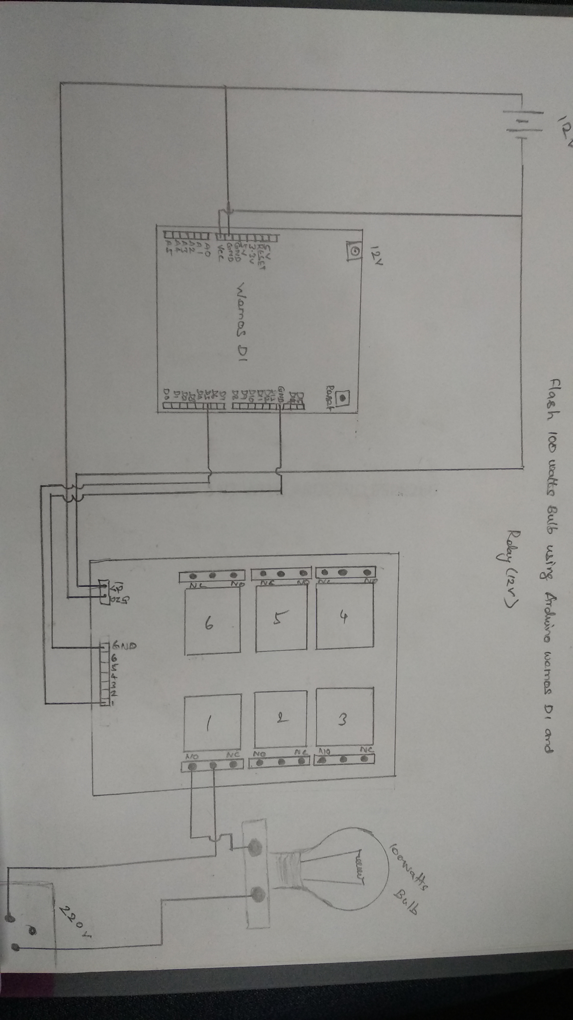
The Wemos D1 board should be given 12V supply with an adapter available. Then, the same could be connected in parallel to the relay which is also 12V. The light is connected to the one terminal of relay and to the plug point which is already available. Likewise, the fan is connected. Run the server (pusher integration.js) using node.js in Raspberry Pi and access the portal via the specified link in the Raspberry Pi. Now, toggle between the light and fan in the living room and it could be controlled with it.

Note:
Run the server only with Raspberry Pi and running the server in PC could lead to some faults.

