- Enlarge the following image and move it above the floor plans. ( I have attached image)

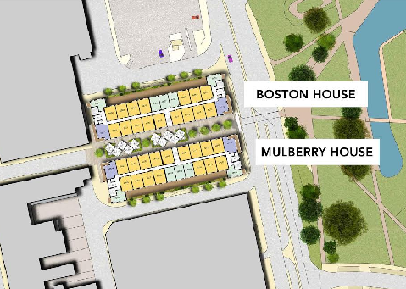

- Can you please add the compass rose (below) next to/below each floor plan image?

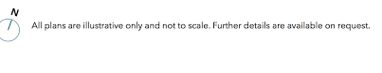

- I property highlight section , please make all sentence in one line not in 2 linke
For example :

Bath or shower with chrome plated
Controls

It will be : Bath or shower with chrome plated controls

Please make it for each block wherever applicable

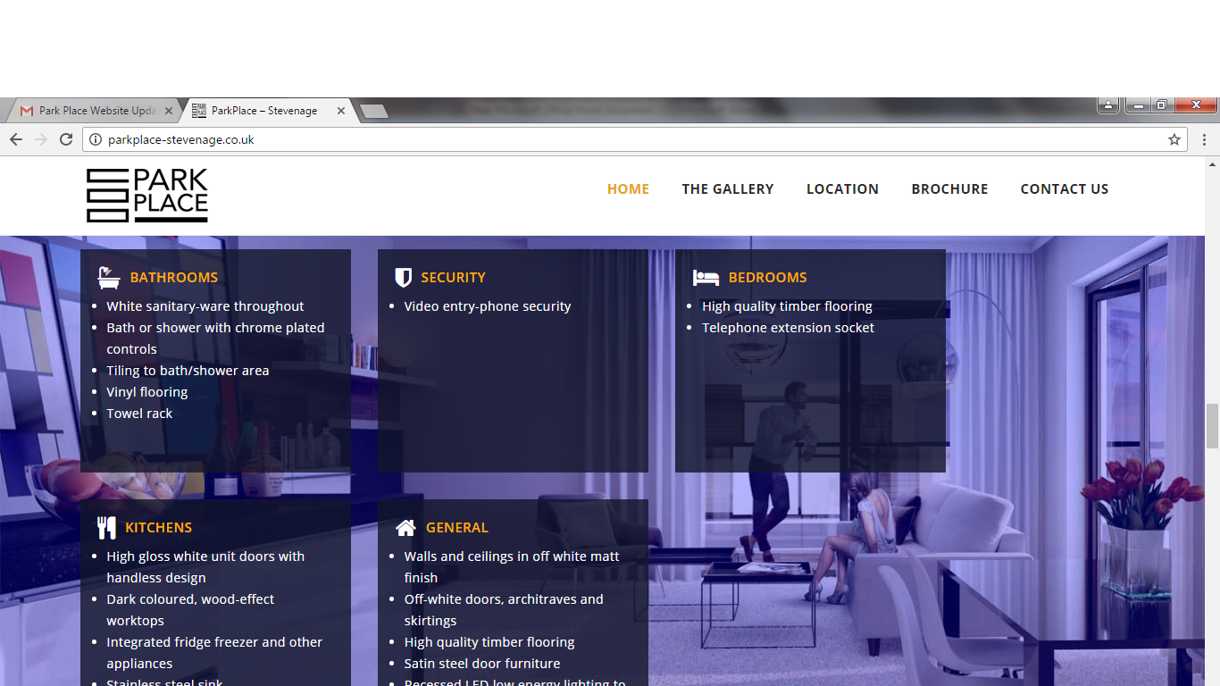

- Please make the height of suite box similar to other
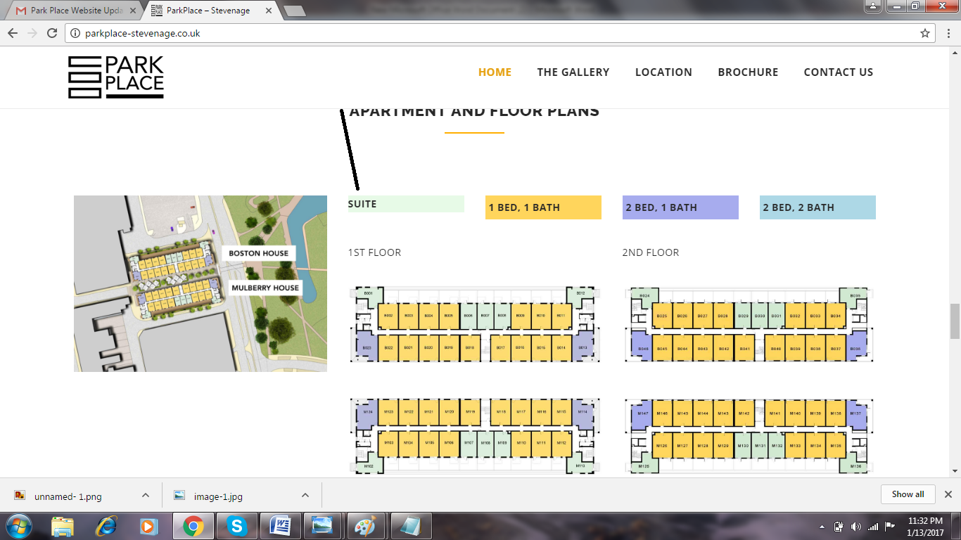

- We need to change the images that appear on box click in apartment section
Reason for change: we need to display the total size of blocks in sqft and ft.

Please download the images from here: https://wetransfer.com/downloads/48a5b25cb562d6be2b0245041012627920170113122444/58b8b4

Now we need to crop them like attached example ( I attached the image as well )
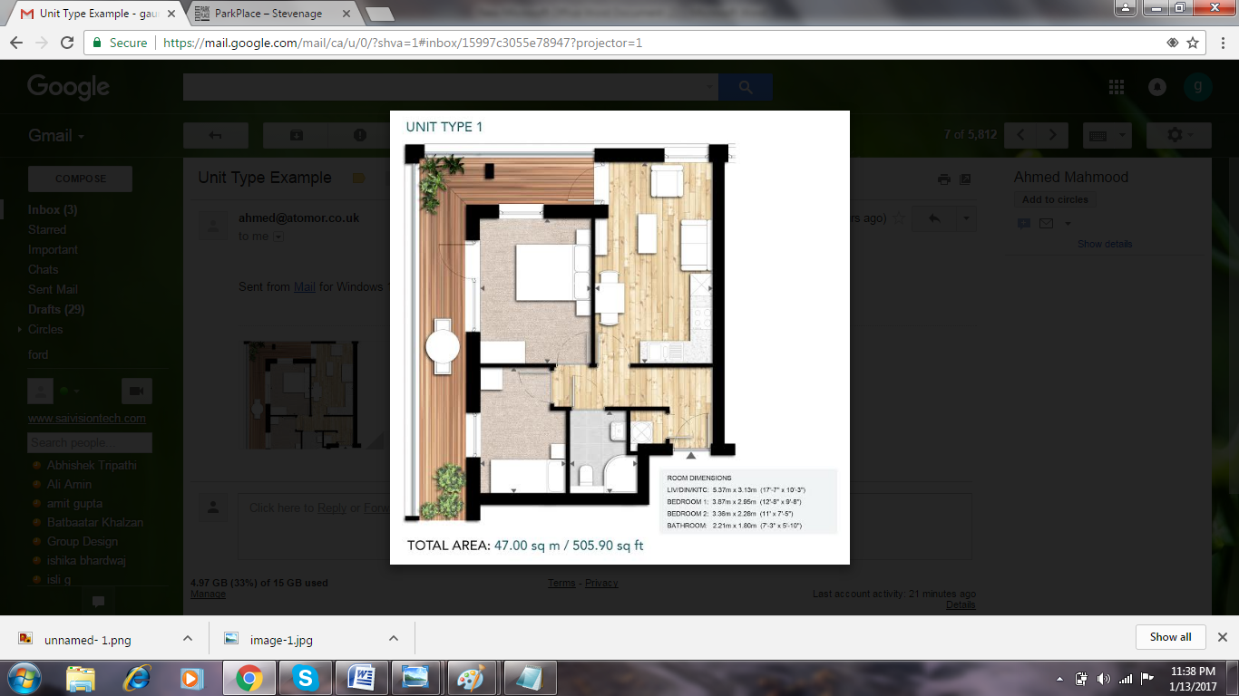

Please mention image name at to : Like UT-1 will be UNIT TYPE 1 ( ALL CAPS )
AT BOTTOM : TOTAL AREA : 47.00 sq m ( this is to be taken from image ) / 50 s ft ( this we need to calculate by Google say 47 squar meter to feet )

- ensure that the website is listed on Google ( its giving some issue I guess )

