General Comments

1) Why when I open every page, it shows the top menu like in grey for 2 seconds? As you can see below:


This happen due to css loader , if your server is fast you will not see , this is not an error

Find a Task
1) Tasks without image should display “No Image Available”. Pending Fixed Still not working. If I click in “Find a task”. It shows missing image. However, when I click in any of the tasks, it updates the image.
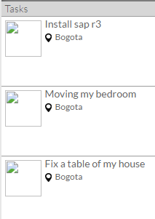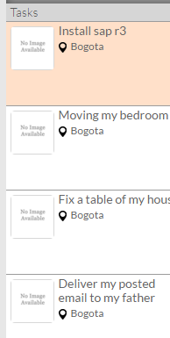
Fixed
Some time it may happen as images is not displaying due to that server Pending to test on server because happen again today

Profile (In my profile)
1) Edit Profile not working, I uploaded my picture (32kb) and it did not load the picture. Still empty. Pending

This is my hosting server issue , will work on your server , even you can check it on previous demo server link its working http://demoplace.co.in/newsite/ Still not working. To verify in server deployment.
2) I added images to my portfolio and they are not loading. To verify in server deployment.
Login
1) Pending to be delivered in hosting: Login with Facebook.

