General Comments

1) When it requires the user logged, it always send to the dashboard. It should continue the action. For example, if I am not logged and click in post a task. I login with my details but it redirect me to the dashboard. It should continue to the action that the user wants to do in this case, post a task. It happen in the following actions:
- Post a task
- Profile, when I click in “Hire the user”.
- Become a Taskers
- Make payments
Pending

Action continuation not feasible Why is not possible? What options do we have? Can we have the page in the session?

Home Page

1) On Ipad and Iphone: The image is cut and the button does not appear as follow: Pending Done Not working yet.


Categories
When the user is logged:
1) I use the “Get a Quote” button in “Christophersd Savant” and put a task. Where he can see the task that I put? I enter with his credentials and it’s not appearing that task to him.
User will receive invitation on his email, with a link to the task invited, from there he can navigate the url and place bid if he like
After two hours, I still have not received the invitation email. Check spam folder as well some time email may took time as its a busy ( demo ) server
Not working yet. (135pm)
2) When I click in “Get a quote”, it should only display the categories that belong to that user. Example: Vladimir R only have the following categories that we as administrators verify:

However, I can “Get a Quote” for a different category that they user belongs to.
3) There are categories repeated:
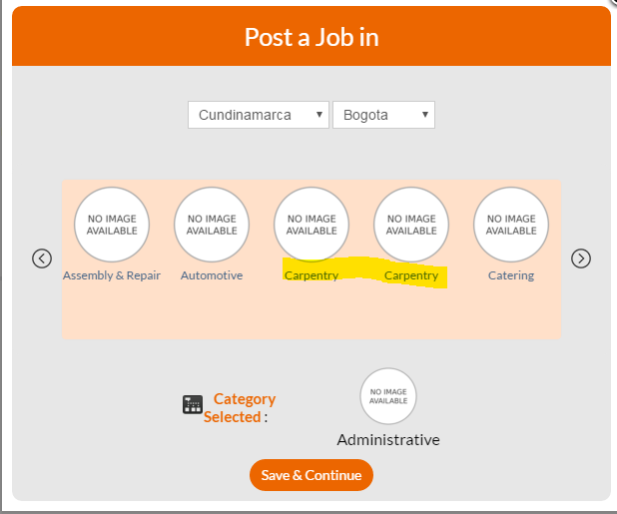

Profile (Visiting others profile)
When the user is not logged:
1) Trying to post for a task using vladoram@yahoo.com and I could not for insufficient credits. The user has 300 credits.
Ping me once you have time to go through on skype will explain how to clear cache from server
Pending to test
2) When I click in “Add as Favorite”, it should redirect me to the login page not to the sign up page. Pending Done Ok but the hand icon dissapear when I put over the button. It has fixed to include the link but when I put the mouse over the button, it’s not hand only mouse pointer. It should be similar to “Hire ..” button.
When the user is logged:
4) When I click in “Hire the User”, it should only display the categories that belong to that user similar to previous one.
5) If my user is already my favourite. I should not be able to add it again. It should appear the “Unfavorite” button. Pending fixed Ok but the hand icon dissapear when I put over the button. It has fixed to include the link but when I put the mouse over the button, it’s not hand only mouse pointer. It should be similar to “Hire ..” button.

Post a Task
When the user is not logged:
1) If I click in post a task, it redirects me to the login page which is OK. However, when I sign in with my details, the user should continue in post a task not in dashboard. Pending not feasible as mentioned above

When the user is logged:
2) How do users edit their own posted tasks?
in task details page there is a option to edit task. When I click in edit task, if I don’t have time, it appeared by default 2:40am. It should be empty if I don’t have time.
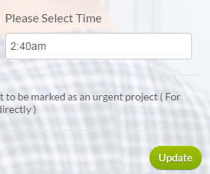
Find a Task
1) Tasks without image should display “No Image Available”. Pending Fixed Still not working. If I click in “Find a task”. It shows as follow. However, when I click in any of the tasks, it updates the image.
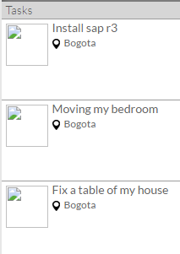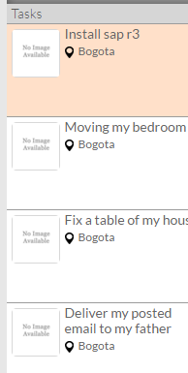
2) No “Date and Hour” deadline of the task displayed. Pending Fixed Please add “:” after time.
3) Wrong format date when I check offers. It’s not clear what that date means. Format date is dd/mm/yyyy hh:mm
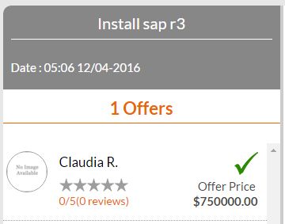
3) If I award the job and I don’t have funds to load the money, the status of the task remain open which is wrong. It should be “Accepted” because I already awarded it. For example, I award a task to “Claudia” user. It appears below.
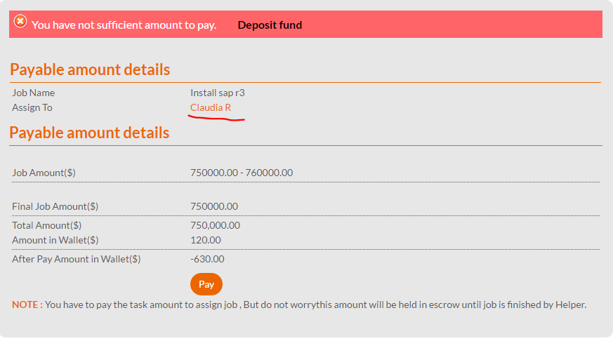
But If I open other window and view the task, it’s still Open. It should be awarded to Claudia even if I have not pay the task.
4) Following with the same sample, let’s say that I want to award the task but top up the money tomorrow. In the previous screen, I have awarded the job to Claudia. However, If I click in a different part of the website. I cannot go back to that screen. So the only option is to award again the job to Claudia again and that’s not practical. I should be able to go to my Assigned tasks. However, the task is not Assigned. I should have a button to Pay the task.
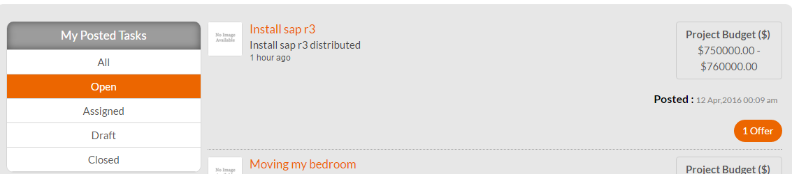
5) Missing all functionality (Load money, withdraw money) of the wallet menu. It should have an option here or in the profile.
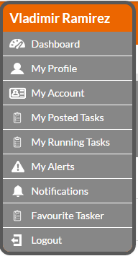
6) More options => “Post Similar Job”. Same issue that categories don’t fit. Pending Fixed Ok, but following the same logic that mentioned previously, in this case. If I’m going to put a similar job, it should show only the category of the job that it’s similar because that’s the idea to put a similar task.
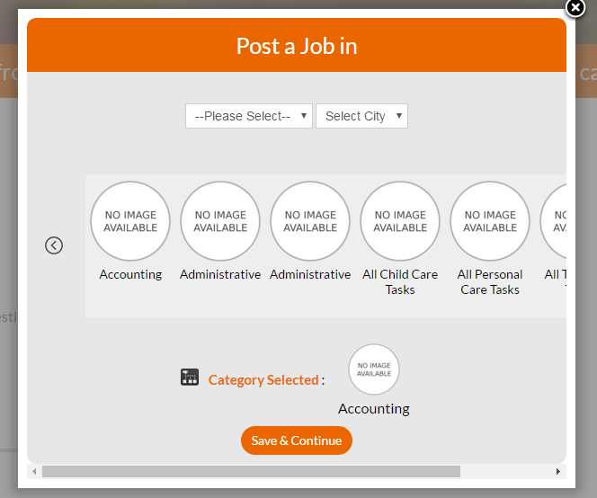
7) I could not test many offers in one task due that users don’t have credits. How can I add them from the admin manually? How can I see the credits per user?
purchase credits by bank , go to admin , credit by bank and select your entry and click confirm at top , for stripe as you mentioned not working let me check
I had 300 credits with stripe bought with vladoram@yahoo.com. Then, I add 150 credits by bank. I should have 450 credits. Now, I only have 150 credits in the dashboard.
Its working here properly , pls check again Pending to test
17) I also disabled credits for the admin but still cannot make the offer.
Its due to server cache, we need to delete server cache for the same, will let you know the path for the same also will show you Ok, pending to show me how it works let me know when you are available Pending to test
19) Missing requirement:
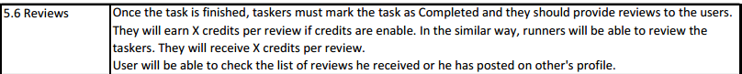
After awarding thask need to go to same screen from there you need to mark task as completed , that will take you to post review page. Yes, that is working but it’s not my question.
What I’m talking here is about the X credits per review. So If I give a review as poster, I will received 3 credits. I I giva a a review to the runner, I will receive 4 credits. So we estimulate that people always review. We should be able to define the 3 and 4 credits in the admin.
Sorry but I did not noticed / clear it earlier , I thought it’s a credit management from admin at This point its not doable by us for now , if you want you can duduct money for this ☹ Pending to decide about it.

