5. Task awarding without payment making:
If I am not having money in wallet it’s not allowing redirecting me to stripe not on pay page during awarding task or not through make payment from here link on task page

Also if the task is not paid is it possible to hide complete task button from here

4) When I click in “Hire the User”, it should only display the categories that belong to that user similar to previous one.

Check if possible Not done

6) More options => “Post Similar Job”. Same issue that categories don’t fit. Pending Fixed Ok, but following the same logic that mentioned previously, in this case. If I’m going to put a similar job, it should show only the category of the job that it’s similar because that’s the idea to put a similar task. Check if possible

Not done

3) In “Find jobs by Category”, If I click in Delivery => Resturant Delivery / office cleaning/accounting the same issue), it says that there is 1 task. However it’s empty as follow:

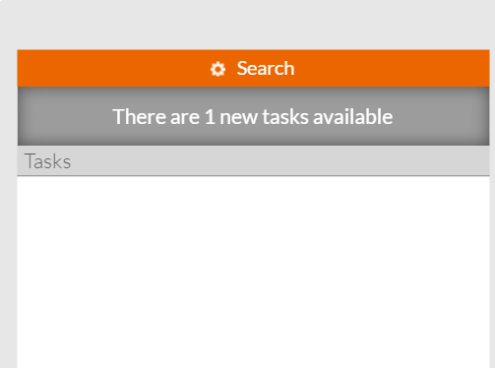
Done Not done

2) My running tasks not working well: Users: vladoram@yahoo.com or info@camellar.com
If I select “My Running Tasks” from the menu, it shows only 1 task. It should show 4 tasks.
In My Running Tasks section show those task list in which you place bid.Using info@camellar.com u place 4 task in that 1 are in spam and 3 is posted so in your posted task tab show 3 post.
You place 1 bid use you info@camellar.com email so in your My running task section show 1 post .

10) Why in the reporting tab? Only 20 tasks. What happen with the other 419 tasks? Pending check pagination Not working yet. There are 28 tasks and it’s only showing 20.

Not done

in stripe deposit for credit / wallet deposit

it shows usd as a currency , please make it cop
You can change this with the data-currency option in your Checkout configuration to display whatever currency you like:
https://stripe.com/docs/checkout#integration-simple-options Not done

Attachment
2) Testing the attachment, we uploaded our “20160417 Full Test.doc” document big in size and I received the following screen. The website should manage the error and not send us to a blank page with that message:
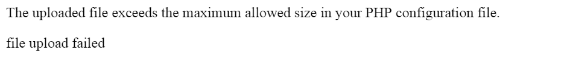
Please display this message in a pop up and on clicking to okay back to the task detail page ( where he is uploading the document )----

Can we do this in a page like that comes after making payment in stripe or bank , with a back button ?

