5. Task awarding without payment making:
If I am not having money in wallet it’s not allowing redirecting me to stripe not on pay page during awarding task or not through make payment from here link on task page

Also if the task is not paid is it possible to hide complete task button from here

4) When I click in “Hire the User”, it should only display the categories that belong to that user similar to previous one.

Check if possible

6) More options => “Post Similar Job”. Same issue that categories don’t fit. Pending Fixed Ok, but following the same logic that mentioned previously, in this case. If I’m going to put a similar job, it should show only the category of the job that it’s similar because that’s the idea to put a similar task. Check if possible

3) In “Find jobs by Category”, If I click in Delivery => Resturant Delivery or office cleaning / acconting the same issue), it says that there is 1 task. However it’s empty as follow:
Not done
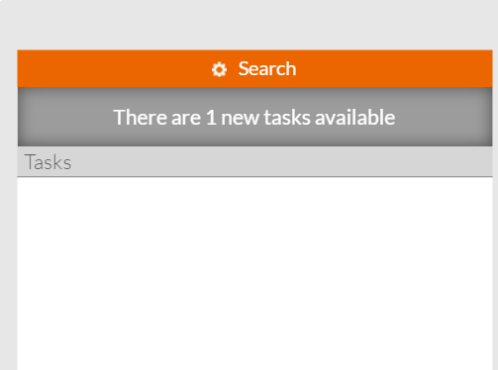
2) My running tasks not working well: Users: vladoram@yahoo.com or info@camellar.com
If I select “My Running Tasks” from the menu, it shows only 1 task. It should show 4 tasks.

4) url coming in place of category name
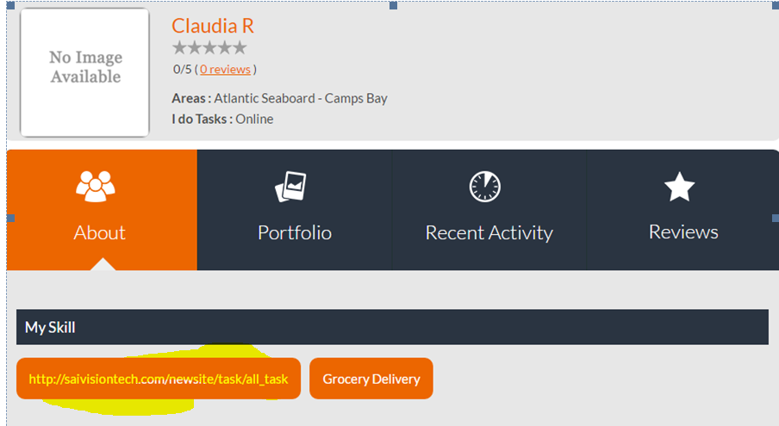

2) Search not working in Tasks
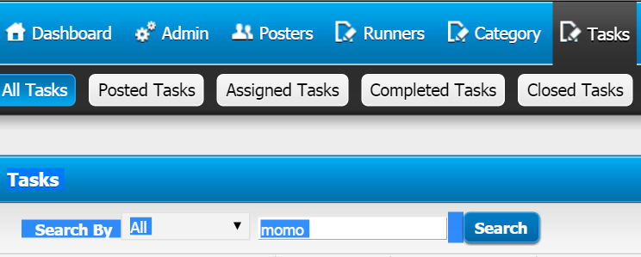

10) Why in the reporting tab? Only 20 tasks. What happen with the other 419 tasks? Pending check pagination Not working yet. There are 28 tasks and it’s only showing 20.

please hide dispute tab from settings from below link
http://saivisiontech.com/newsite/admin/site_setting/add_site_setting

also hide dispute from email templates

in stripe deposit for credit / wallet deposit

it shows usd as a currency , please make it cop
You can change this with the data-currency option in your Checkout configuration to display whatever currency you like:
https://stripe.com/docs/checkout#integration-simple-options

Attachment
2) Testing the attachment, we uploaded our “20160417 Full Test.doc” document big in size and I received the following screen. The website should manage the error and not send us to a blank page with that message:
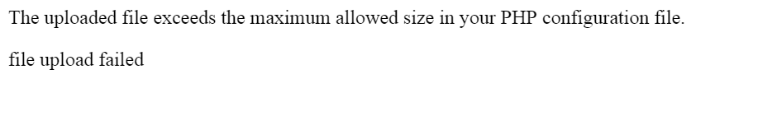
Please display this message in a pop up and on clicking to okay back to the task detail page ( where he is uploading the document )

