**Pages Comments**

1) General things:

Why when I open every page, it shows the top menu like in grey for 2 seconds? as you can see below:

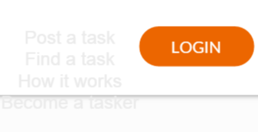

We want the border of all the boxes to be rounded as in the login page box. It looks sophisticated and elegant.



We do not like the colours in the following box. It’s too orange. The border is too big. Can we try with grey or maybe one line orange one line grey? Please borders rounded and very light border.

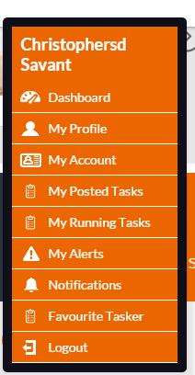

We like the following template that we used to have in all the pages:

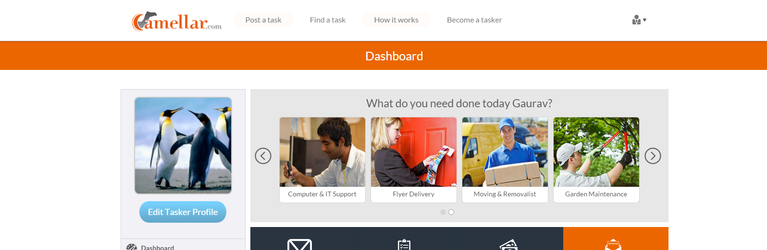

Please change the following template for all the pages that used them. It’s too orange in it.

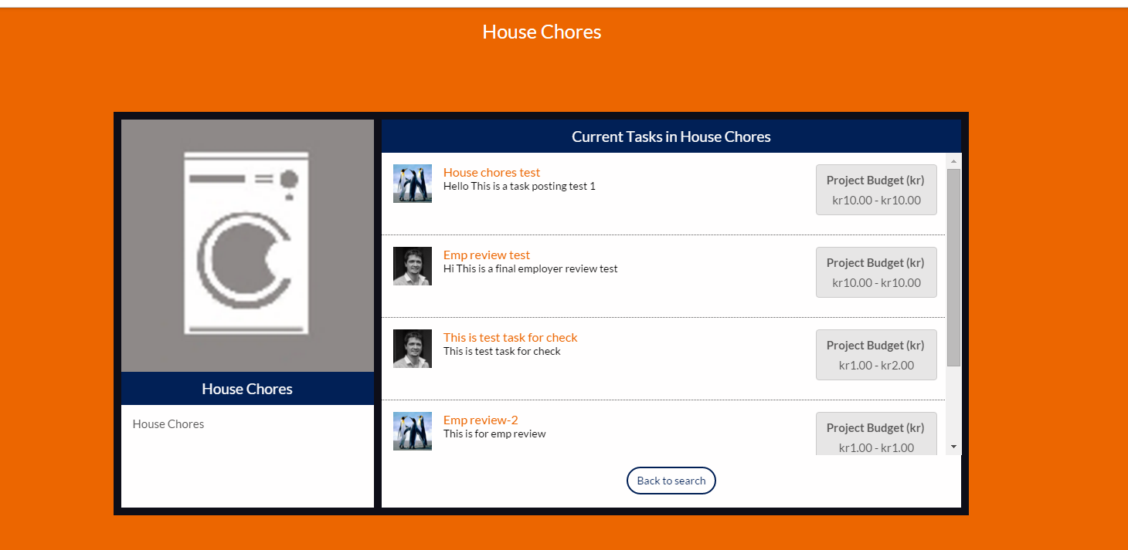

2) Home page: <http://demoplace.co.in/newsite/>

Desktop and Laptop: Ok

Iphone: White spaces to the right as you can see below

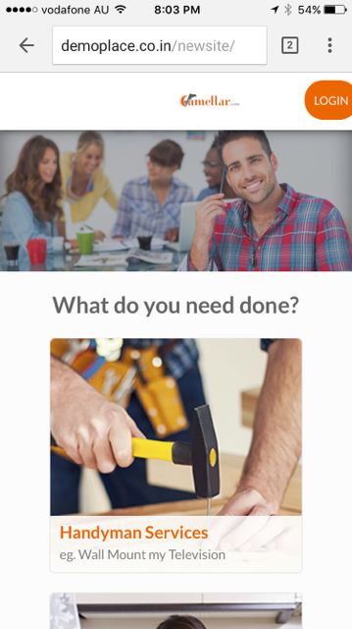  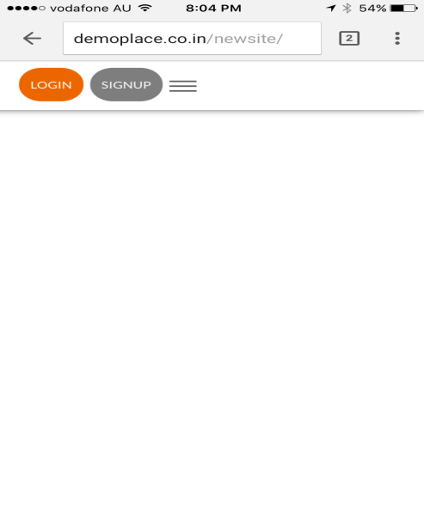

Ipad: White spaces to the right as you can see below

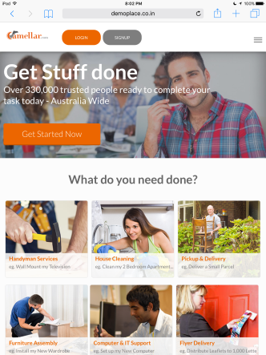 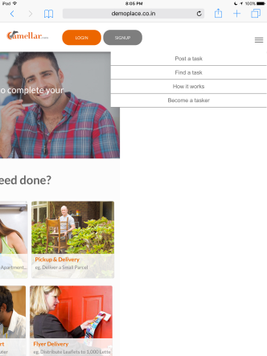

3) Log in: <http://demoplace.co.in/newsite/index.php/login>

Nice design. No white spaces.

Login with Facebook is pointing to LinkedIn (entowork profile) not to Facebook.  
  
4) Sign up: <http://demoplace.co.in/newsite/index.php/sign_up>

Nice design. No white spaces.

Login with Facebook is pointing to LinkedIn (entowork profile) not to Facebook.

We don’t need the zip code field. We don’t use zip code in the target country.

5) Thank you sign up: http://demoplace.co.in/newsite/home/thank_you/sign_up

Ok.

Why do I receive 2 mails? One for email confirmation and another one for support.  
  
6) How it works: <http://demoplace.co.in/newsite/index.php/how_it_works>

Ok.

7) Dashboard: <http://demoplace.co.in/newsite/dashboard>

- One error: I created a new account and when I open the dashboard found your name not mine.

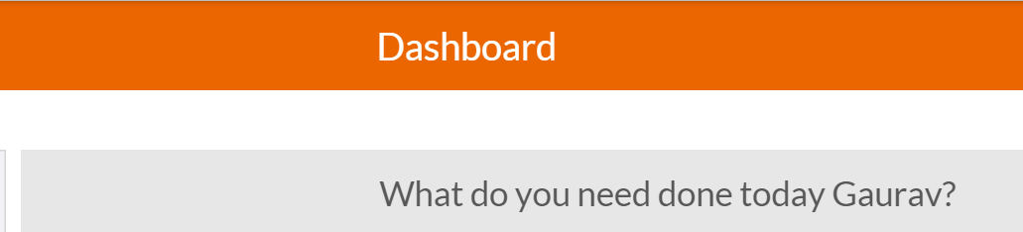

- Change colour of the button to this green so we don’t have many colours in the buttons.

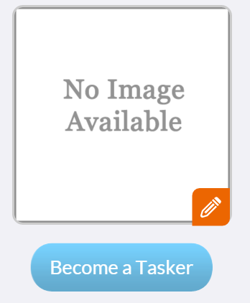 

- Task summary is empty by default with my new user. It should default to the second picture.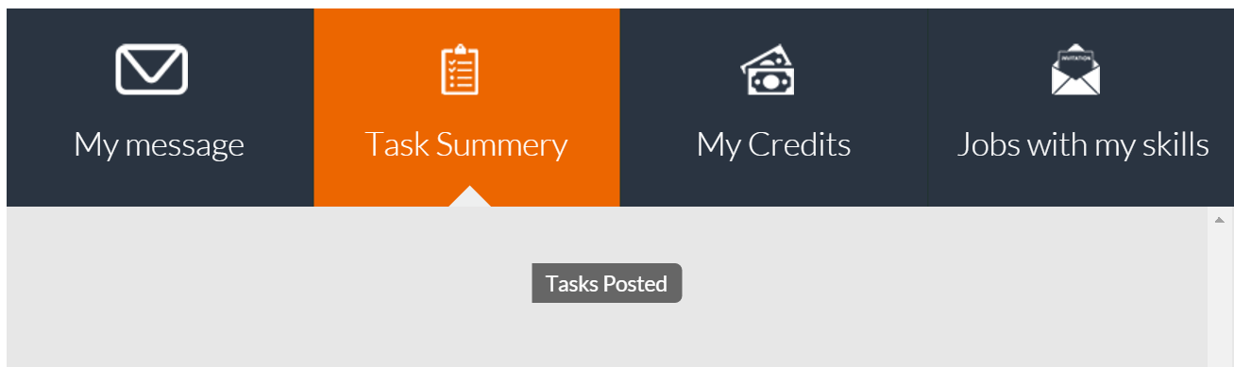

It should show the bars as when I press the button:

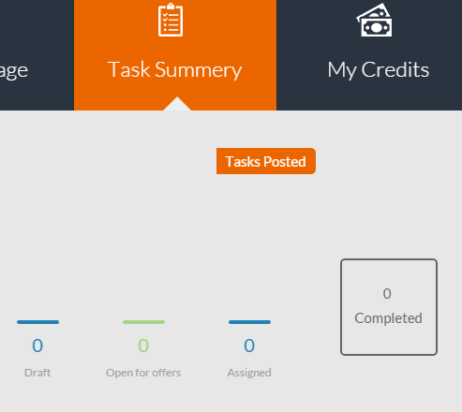

- We like the My Credits tab when we entered with a new user. Please do not forget that we should be able to hide that option from the administrator.

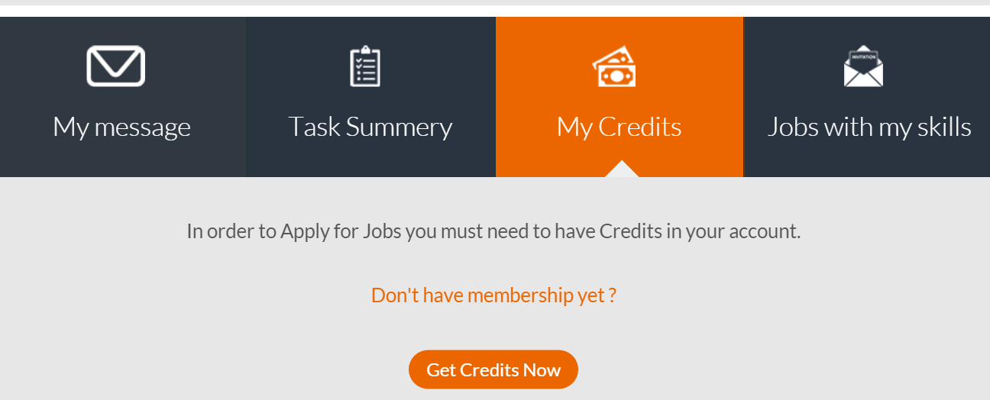

It’s not clear with your user if you have credits or no

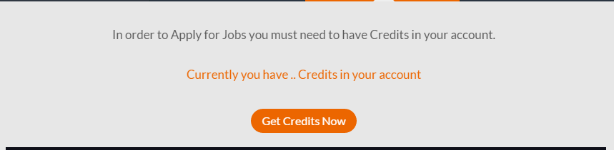

- Change two boxes to rounded borders.

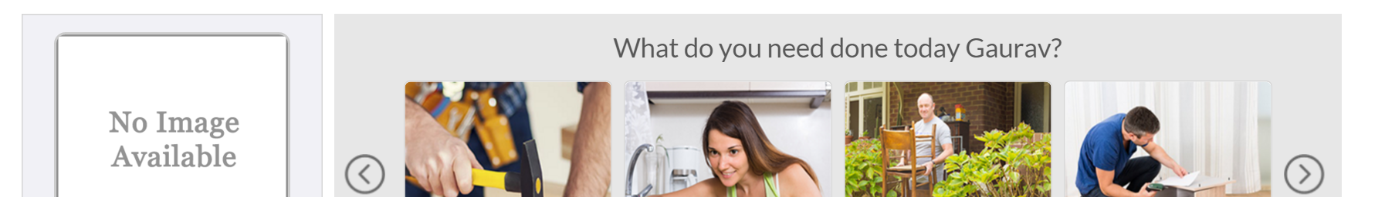

7.1) My account: <http://demoplace.co.in/newsite/account>

Too orange. Please follow recommendations of “General things” section regarding to the template.

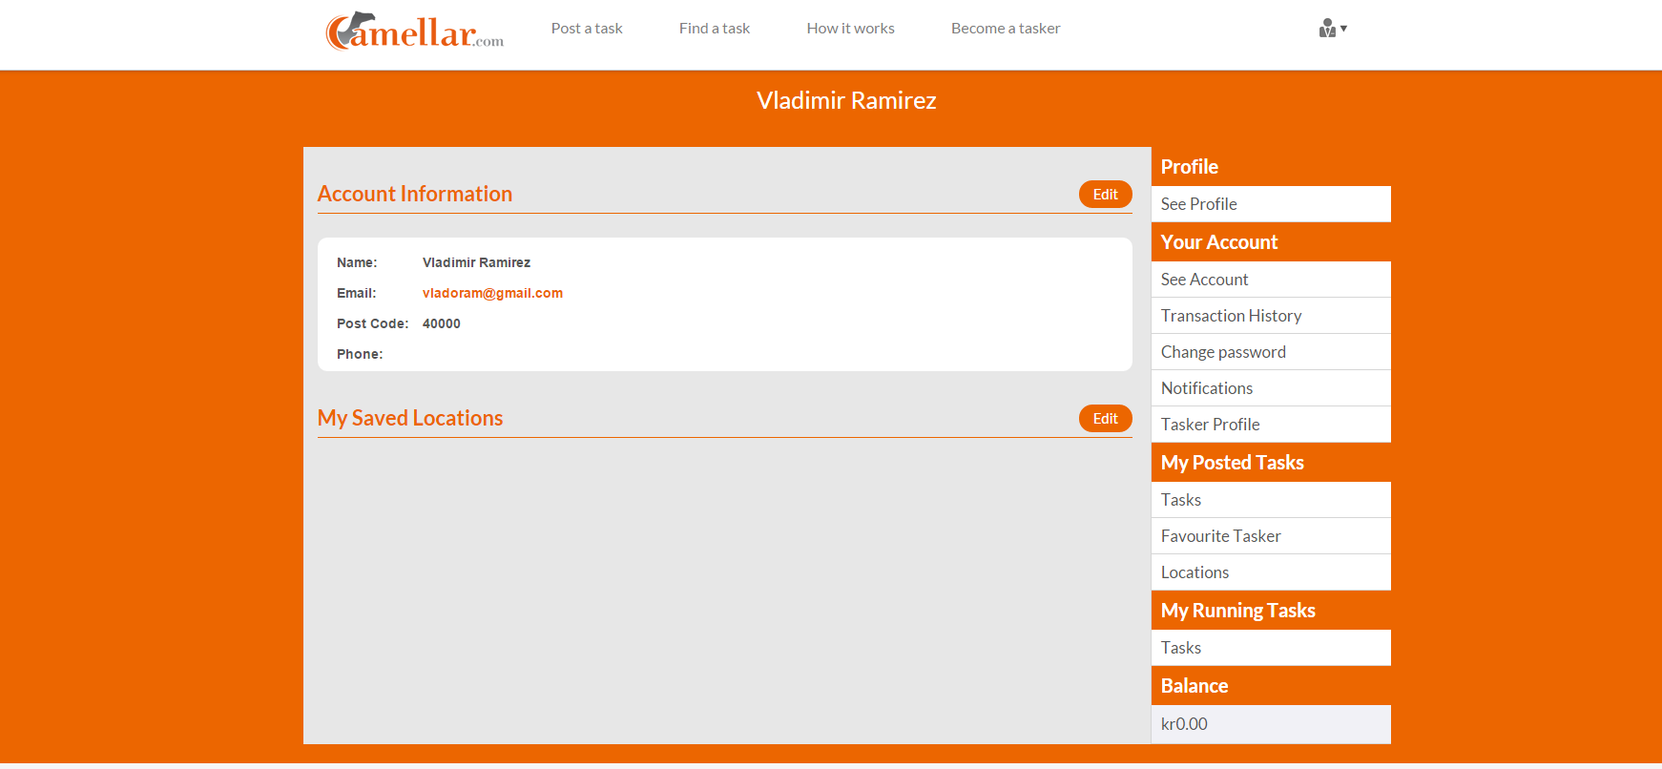

7.2) My Profile

Too orange. Please follow recommendations of “General things” section regarding to the template.

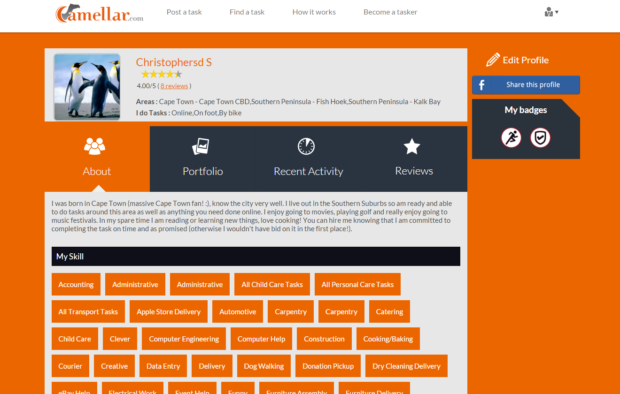

7.3) Messages

Too orange. Please follow recommendations of “General things” section regarding to the template.

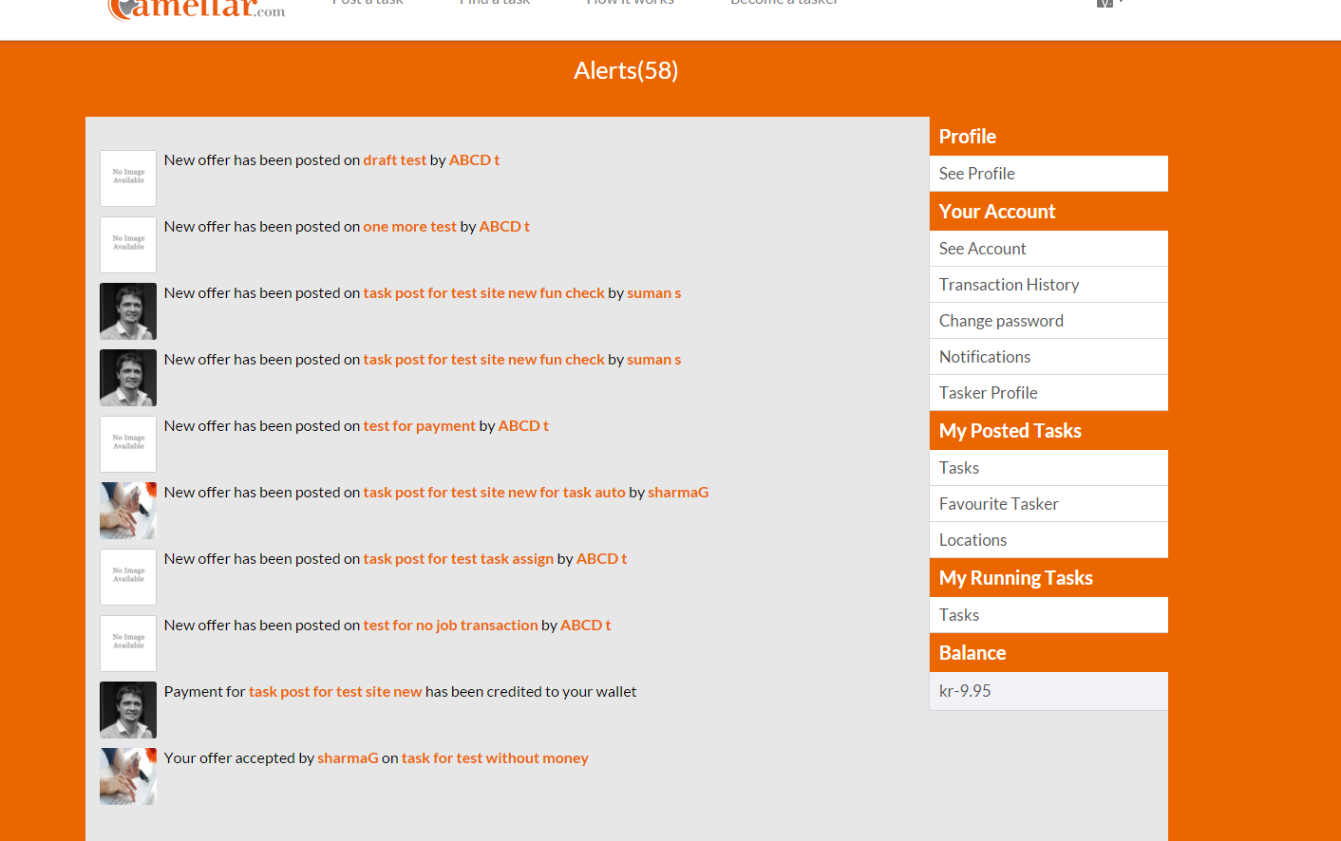

8) Draft task: <http://demoplace.co.in/newsite/tasks/draft-test>

Change main box to rounded borders. Please follow recommendations of “General things” section regarding to the template.

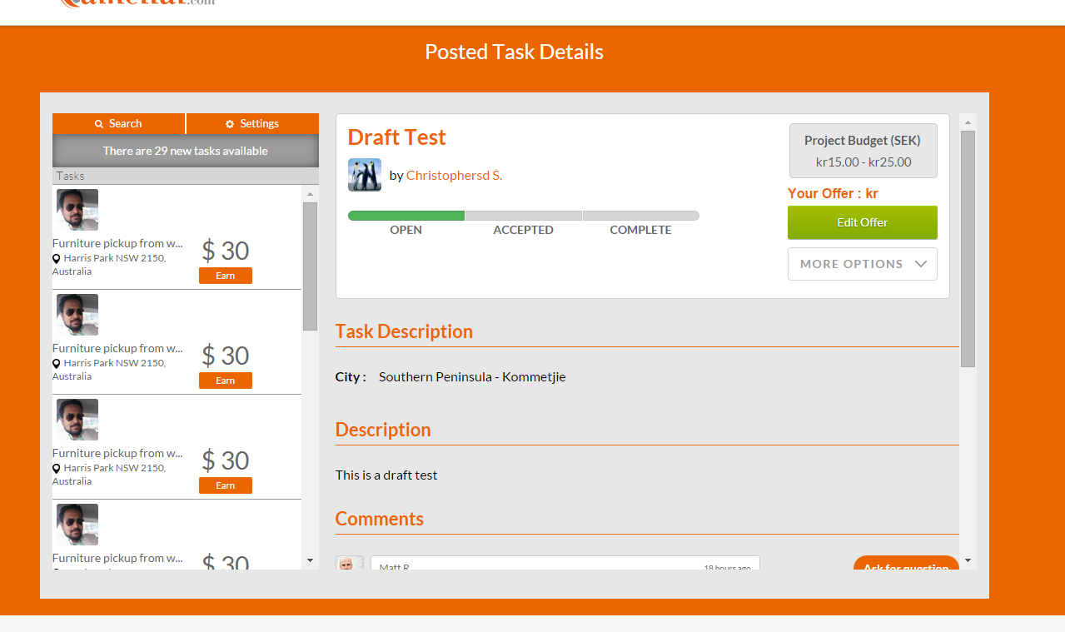

I was tempted to check the other pages:

9) Post a task: http://demoplace.co.in/newsite/index.php/task/newhome_task

We prefer the boxes to be rounded in the corners and it can be nice with a picture behind it like in the login page.

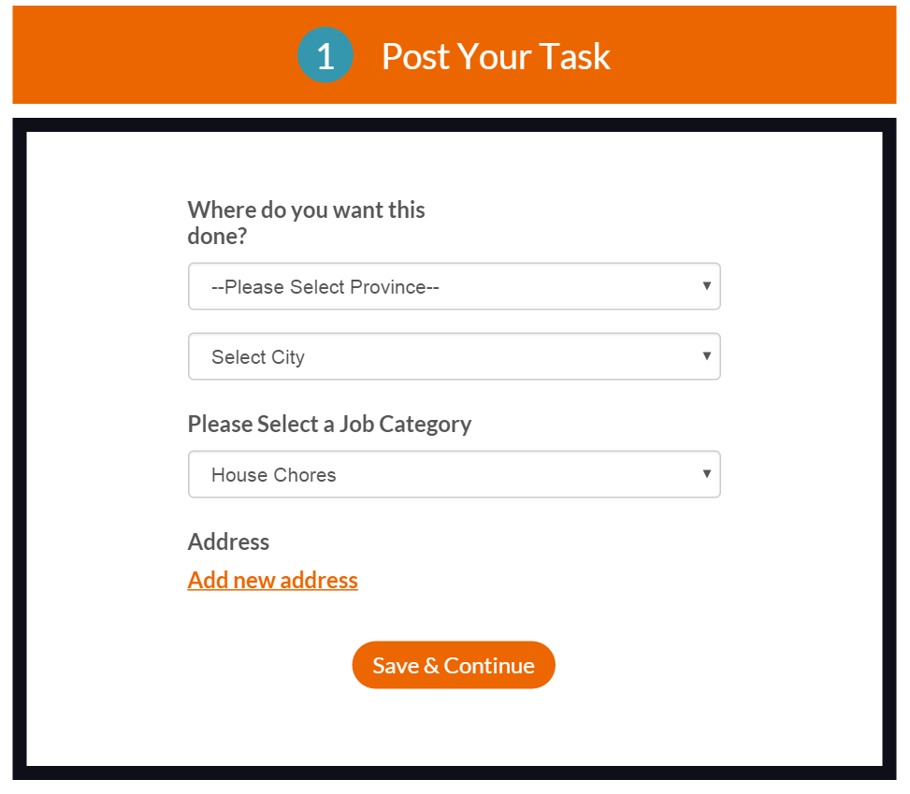 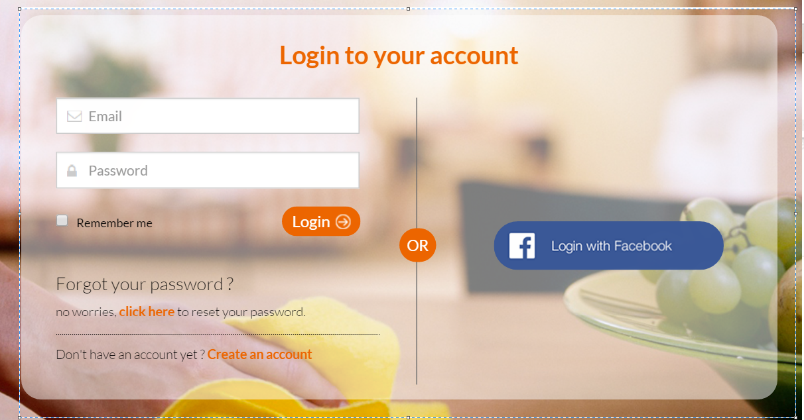

10) We need to redesign “Find a task” page:

