#Company_Logo#

**Business Rules Guide for App_Name**

*User guide for administrators to set rules in App_Name*

*The guide walks through the section of business rules to configure different types of rules for application.*

Company_Name

Date_Create

**COPYRIGHT**

Business Rules Guide for App_Name (Date_Create at Time_Create)

The information provided in this document, including URL and other Internet Web site references is "as-is" and for informational purposes only. The information contained herein is subject to change without notice and is not warranted to be error-free. Unless otherwise noted, the companies, organizations, products, domain names, e-mail addresses, logos, people, places, and events depicted in examples herein are fictitious and for only illustration purposes. No association with any real company, organization, product, domain name, e-mail address, logo, person, place, or event is intended or should be inferred.

This document does not provide you with any legal rights to any intellectual property in any section of application App_Name. You may copy and use this document for your internal, reference purposes.

© 2016 Company_Name. All rights reserved.

# Document Revision

Table 1: Revision History

|  |  |  |
| --- | --- | --- |
| Version | Date Published | Key Notes |
| 1.0 | Date_Create | First Release |
|  |  |  |
|  |  |  |
|  |  |  |

Table of Contents

Document Revision 3

Preface 6

Intended Audience 6

Document Accessibility 6

Related Documents 6

Conventions 6

About This Guide 8

Purpose and Scope 8

Point of Contact 8

Glossary 8

Introduction 10

Types of Business Rule Conditions 11

Condition Type 11

Operator Types 11

Getting Started 12

What you need 12

What are business rules? 12

Business rule uses 12

Accessing Business Rules 12

Set Business Rules 14

Rule Name 15

Select Entity 15

Apply for following roles 16

Select Criteria Type 16

Add Action 16

Example Business Rule 22

Test Business rule 24

# Preface

## Intended Audience

The document is intended for individuals/administrators who use App_Name application developed for Company_Name. The document is assessment of business rule capabilities of App_Name application. This guide also demonstrates implementing the business rule in the application.

## Document Accessibility

The company focuses on making products, services and supporting documents accessible with great usability to its users. To that end, this document includes features that make information available to users of technology. This document is published in WORD format and does not contain markup. Accessibility standards will continue to upgrade on timely basis and Company_Name is constantly engaging itself in activities to address technical obstacles to furnish the document to all its customers.

**Accessibility of Links to External Web Sites in Documentation**

The document may contain links to other websites (not owned by Company_Name) if required. Company does not evaluate nor makes any representations regarding the accessibility of these web sites.

## Related Documents

The document is first revision in its section and available only at respective application(s) portals. The company is not responsible for about authenticity of this document, if accessed from any third party website. The documents available are:

* App_Name User Guide
* Current Security Settings
* Current Business Rules
* Security Configuration Manual
* Business Rules Configuration Manual
* General Deployment Guide
* Database Design Document
* Troubleshooting Guide

## Conventions

Following are the conventions used in this document:

Words in single inverted commas (‘) are the nouns. These words in common English sometimes are used in different manners as required. Inverted commas differentiate these words used as simple English terms and specific terms (nouns). Ex: properties, associations, datatype etc.

™: The words with TM (Trademark) as superscript are registered words and cannot be used without prior permission of respective organization for commercial and profit activities.

Hyperlinks: Hyperlinks are the content that reflects the source at another place having a web address. The hyperlinks are URLs to these web addresses and are accessible by pressing (CTRL + click) in static documents and simple clicks on web pages.

Illustrative numbers: The numbering is done in figures (for example: figure 2) for users convenience to find the data easily. The contents are arranged numerically as per the figure.

Save: For any changes you, ‘Save’ button store these changes. The save button is present in all the forms and fields in App_Name and is not repeatedly acknowledged.

Cancel: For any changes you, ‘Cancel’ button discards these changes. The cancel button is present in all the forms and fields in App_Name and is not repeatedly acknowledged.

Checkbox: Checkbox presents the conditions that could be marked as true or false. The right sign in checkbox ✓ marks the condition as true. If left blank, the system considers it as false.

Fields: Fields are the space provided to fill the data. Some fields may have conditions depending on respective section or the rules.

Back to list: This option discards the changes and redirects you to the previous page.

Save and continue: This option saves your current changes and redirects you to next page.

Next: This option without saving current changes redirects you to next page.

Previous: This option without saving current changes redirects you to previous page.

# About This Guide

The guide describes how to configure a business rule in App_Name. It gives you an in-depth explanation on what a business rule signifies and how you can add a new one. A detailed list of what business rules App_Name uses are described in the requirement guide.

## Purpose and Scope

This manual is intended for application administrators. Any prior knowledge of a programming language will be helpful but not required or mandatory.

## Point of Contact

If you have any questions or concerns, please contact Company_Name at Company_Email.

## Glossary

This table explains all the variables are/may be used throughout this guide

Table 2: Variables used in this guide

|  |  |
| --- | --- |
| **Android APK** | The downloadable android application |
| **App** | Application |
| **ASP.NET** | Open Source server-side Web Application framework |
| **Association** | Relation between two entities |
| **Browser** | The interface used to access the internet |
| **Cancel** | Discard your unsaved changes and redirects you to previous page |
| **CRUD** | Create Read Update Delete |
| **Dependent Dropdown** | Dependency of one association on another |
| **Entity** | An independent existing thing |
| **Faceted Search** | Searching information from properties of an entity |
| **Group** | Collective display of properties (and associations) |
| **Launch** | Generate the application from present model |
| **Mobile View** | The application designed according to mobile interface |
| **Model Generator** | Defines entities, properties, associations and other features of application |
| **MVC** | Model View Controller (Microsoft’s technology) |
| **Next** | Redirects you to next page in form |
| **Password** | Password is the secret key, required to access the application |
| **Permissions** | Accessibility to add/edit/delete/view data of entity |
| **Previous** | Redirects you to previous page in form |
| **Property** | The things that belong to entity |
| **Record** | Complete details of data for an entity |
| **Roles** | Set of permissions to add/edit/view/delete for each entity |
| **Save** | Save your changes you made |
| **Save & Continue** | Save your changes and keeps you on same page |
| **Username** | It is the unique field that identifies an associated user |
| **Users** | People who have access to application |
| **Value** | Specific field of a record |
| **Workflow** | Defines status of application for any particular record in entity |

# Introduction

This document presents how to configure the business rules in *App_Name*.

To understand the document and business rules better, the table below gives a quick summary of the different business rules concepts supported by *App_Name*, and their impact on application behavior. The business rules in application are role specific i.e. the rule will be effective only on all users of role defined in rule.

|  |  |
| --- | --- |
| Name | Description |
| Email Notification | When users perform some specific action for example: a new registration or perform some operation in record, the email notification can automatically triggered to notify that user and other users of application about it. |
| Lock Record | If a user of a role puts invalid or undesired value in record, the complete record will be locked for all users of that role. On edit, the fields of record will show read only behavior and only privileged users can change the value to unlock it. |
| Conditional Mandatory Field | Some fields of a record can be made mandatory based on the value of other fields. For example: Tax field will be mandatory if the field of Total bill is greater than 20$. Conditional mandatory fields are imposed before data is saved and prevents users from missing any field in the form. |
| Read only Fields | An entity in application generally contains combination of all fields that users in different role is required. This makes many of the fields irrelevant to unconcerned users of another role. The record once saved value in property that fulfills the condition, the edit page of that record will make all fields unnecessary for users as read only. The users can assign value to property that matches with desired condition and on ‘save and continue’ or editing the record, the undesired fields will be read only. |
| Filter Dropdown | The values of dropdown by default shows the display names of all the records present in associated entity. The values can be filtered in dropdown based on condition set in associated entity. For example: a hospital has employees with employee type as doctor and nurse. In patient details, the doctor dropdown will only show list of doctors and nurse dropdown will show list of nurses. |
| Make fields hidden | On the same principles of read only fields, the irrelevant fields can be hidden for users of a role when condition is met in record. |

## Types of Business Rule Conditions

The conditions in business rule define how a rule will occur in entity of App_Name for a given role(s). The conditions are implemented in any of following categories:

### Condition Type

1. **On Add:** The condition is applicable whenever users will attempt to create a new record.
2. **On Update:** The condition is applicable whenever users will attempt to edit/update/modify the existing records of entity.
3. **On Add and Update:** The condition is applicable either on creating a new record or updating the existing records of entity.
4. **On Property Change:** The condition is applicable whenever users will attempt to change any property of existing records in entity.
5. **Single Condition:** Single condition means business rule has only one condition to be checked before executing the actions.
6. **Multiple Conditions:** When multiple conditions are present for a rule, the rule will check all the conditions before executing the action.

### Operator Types

1. **Equals to:** The action will execute when the value of property in entity will match the value defined in rule.
2. **Greater than:** The business rule will execute when the value of property in entity is greater than the value defined in rule.
3. **Less than:** The business rule will execute when the value of property in entity is less than the value defined in rule.
4. **Less than or equals to:** The business rule will execute when the value of property in entity is less than or equal to the value defined in rule.
5. **Greater than or equals to:** The business rule will execute when the value of property in entity is greater than or equal to the value defined in rule.
6. **Contains:** The business rule will execute when the value of property in entity contains the value defined in rule.
7. **Not equals to:** The business rule will execute when the value of property in entity is not equal to the value defined in rule.
8. **Pick from List:** The business rule will execute when the value of association matches with the value that is picked from the dropdown.

# Getting Started

## What you need

You need to have administrative access for App_Name in order to view or modify the business rules. If you see the Admin button on the top right corner of your homepage, you have admin privileges.

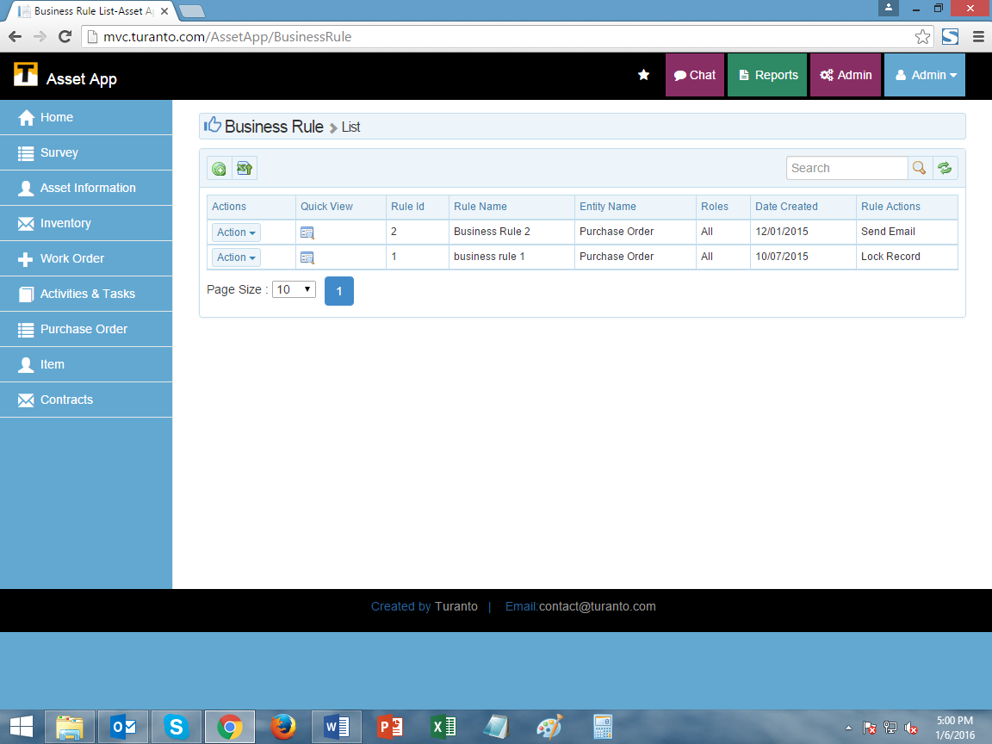

Figure 1: Admin options on the top right

Please contact your system administrator if you do not have the admin access.

## What are business rules?

Business rules are the custom ‘condition’ and ‘action’ arguments. They are the set of rules in an organization that define or constraint some aspect of business and always revolve to either true or false. The business rules are applicable at property level and if a condition is provided to a property than respective action will be taken at same and parallel properties.

## Business rule uses

The most important application of business rules is that you can set security polices based on them. Some real-life scenarios require a more complex access strategy or policy, which can involve specifying a series of rules to define the conditions under which an entity’s attributes can be accessed.

Example of business rule based security:

Consider a scenario in which the business rules require that all records with a customer turnover:

* Greater than or equal to $1M have the profit field restricted or hidden
* Less than $1M have the profit field displayed

The App_Name business rule settings can be configured to filter out and display records after applying the business rule.

You can use them to avoid reckless and insecure entries in forms. Assigning the business rules to create basic ‘case’ and ‘cause’ conditions.

In addition to the security and data integrity, business rules can also be set for conditions and trigger actions as configured like E-Mail Notifications, Alerts.

## Accessing Business Rules

Click on the purple admin button on the top right of App_Name homepage. This opens up the admin option pages.

For more information on Users, Roles, User based security, set company profile, and user defined pages, please visit the Security guide for App_Name.

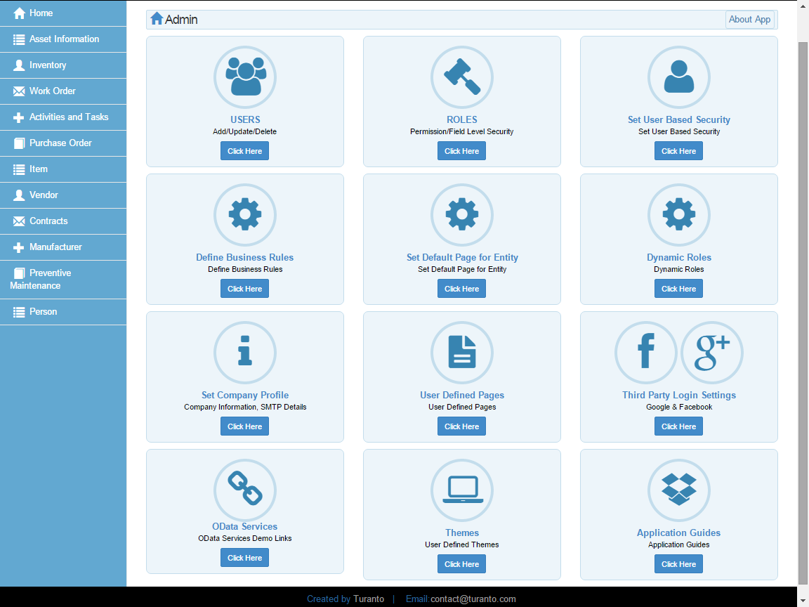

TODO: Replace this Image

Figure 2: Business rules in the admin section

## Set Business Rules

Business rules are intended to assert business structure or to control or influence the behavior of the business. In App_Name ‘Business Rules’ are the set of conditions and actions in an entity applicable to all user roles. These rules are applicable on all records of the entity once created. Generally an entity can have more than one rule but it is not recommended.

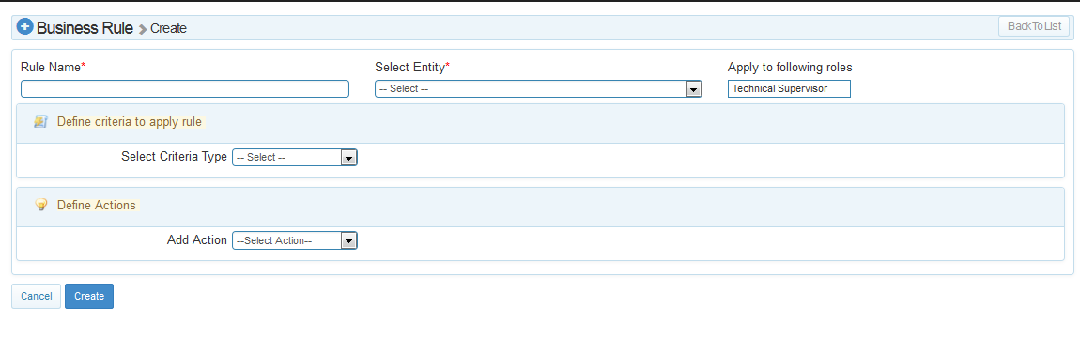

Figure 3: Create business rules screen

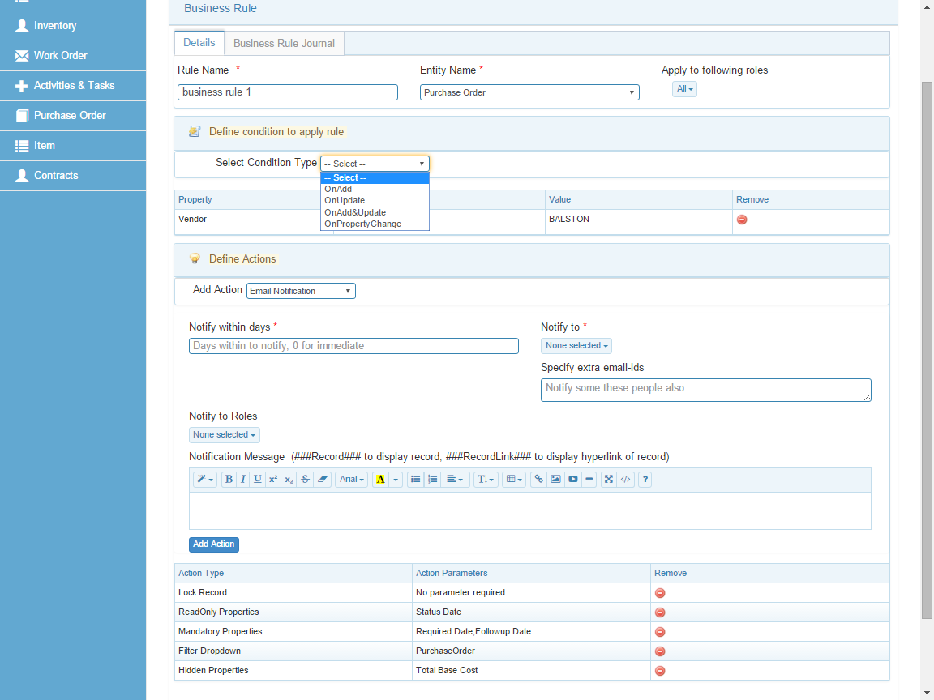

TODO: Replace this Image

Figure 4: Business Rule options

### Rule Name

The rule is recognized by this name. This field is mandatory as it is the identifier of the rule.

### Select Entity

The dropdown displays the list of all the entities. The rule will be applicable on the entity selected. This field is also mandatory.

### Apply for following roles

The rules are applicable on a user. Every user is classified by ‘application roles’. Multiple roles can be selected on which rule shall be applied.

### Select Criteria Type

The four conditions are the case of rule. If any record meets this case, the rule will cause relative ‘action’.

Table 3: Condition Types in Business Rule

|  |  |
| --- | --- |
| Condition Type | Description |
| On Add | Any addition of new record. |
| On Update | Editing the existing record. |
| On Add & Update | Adding or editing the exist record. |
| On Property Change | A change in specific property value according to following conditions |

Table 4: Condition Settings in Business Rule

|  |  |
| --- | --- |
| Condition Settings | Description |
| Select Property | Select any property of the mother entity. |
| Select Operator | Seven operating conditions are present to choose from:   * Equals to * Greater than * Less than * Less than or Equals to * Greater than or Equals to * Contains * Not Equals to * Pick from List |
| Property Value | Type the input figure of condition |

### Add Action

Following are types of ‘actions’ caused in case of any above criteria. One or more than one actions can be defined in a rule.

#### Make Records Read Only

The records of the entity will be locked edit permission from selected roles will be withdrawn.

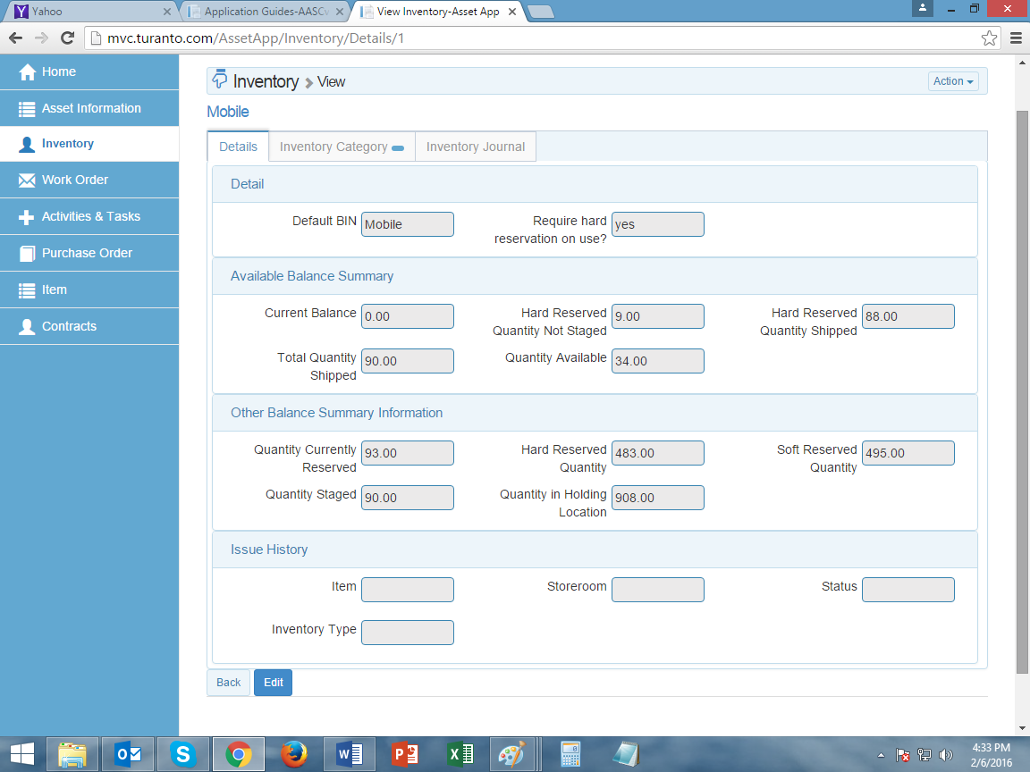

Figure 5: TODO (Write Caption)

#### Make Fields Read Only

Multiple properties selected in this section will not be editable for any record of entity.

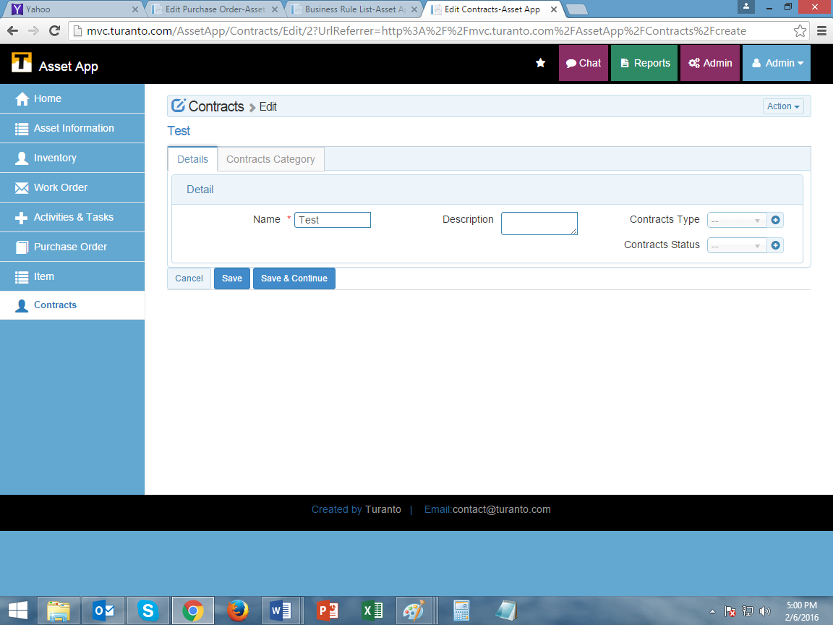

Figure 6: TODO (Write Caption) [Note: Contract type and contact status are read only fields]

#### Make Fields Mandatory

Multiple properties selected in this section will be marked as mandatory.

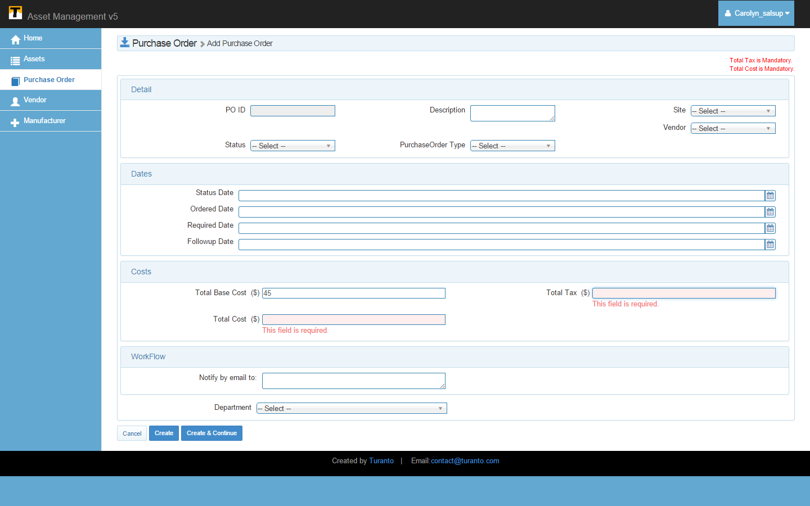

TODO: Replace this Image

Figure 7: TODO (Write Caption)

#### Email Notification

The notification has four fields:

**Notify Within Days**

Select the days you want to delay the notification (in case accidental rule is made). Select 0 if you want to send immediate notification.

**Notify To**

Select the users you want to send notification to. If the entity is not associated with users, only logged in user will be displayed.

**Notify To Roles**

The email notification can be sent to all the users of a role selected here. However please note that the email message will list the address of all the users to whom email is sent.

**Special Extra Email-Ids**

Type the email ids you want to acknowledge.

**Notification Message**

Type the notification message you want to send. Type the notification message you want to send. In notification message you can amend the complete record and link to record using keywords ###Record### and ###RecordLink### respectively along with message.

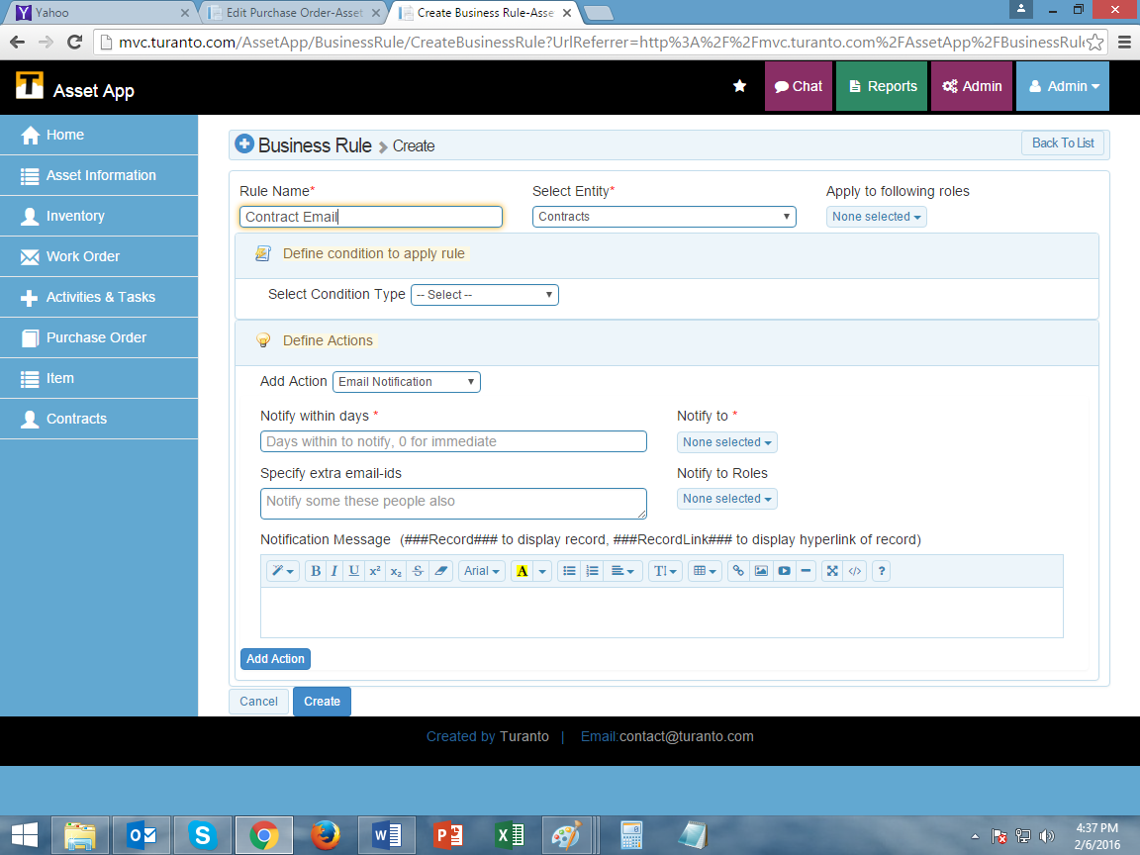

TODO: Replace this Image

Figure 8: TODO (Write Caption)

#### Filter Dropdown

The value of an entity can be filtered as what records are shown in dropdowns of associated entities. The business rule gives an option ‘filter dropdown’ as action; and condition of filtering of records based on value of its property.

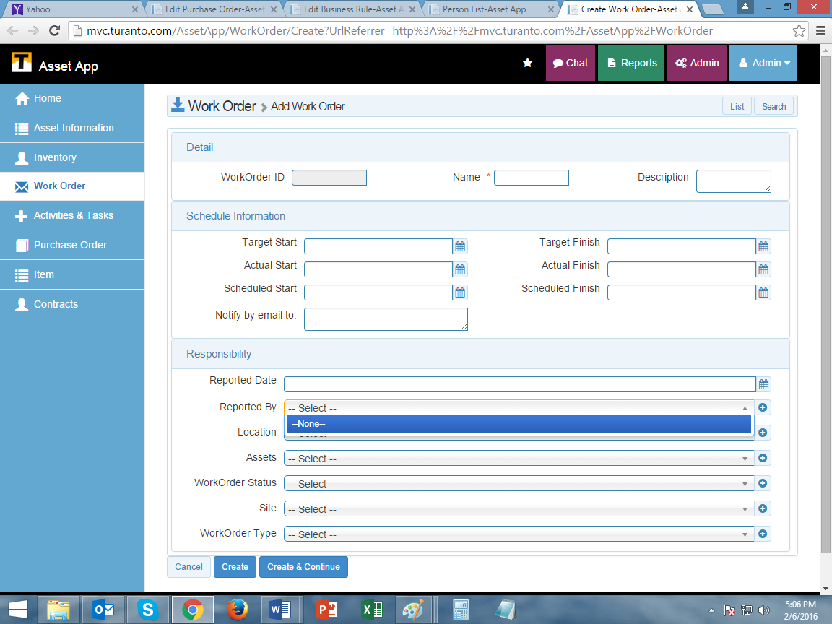

TODO: Replace this Image

Figure 9: TODO (Write Caption) [Note: The person with person status = Active will only be shown here]

#### Make Fields Hidden

The rule will hide all the desired fields on evaluating the condition. The action executes on the edit page to prevent accidental hiding a field that is mandatory on create page.

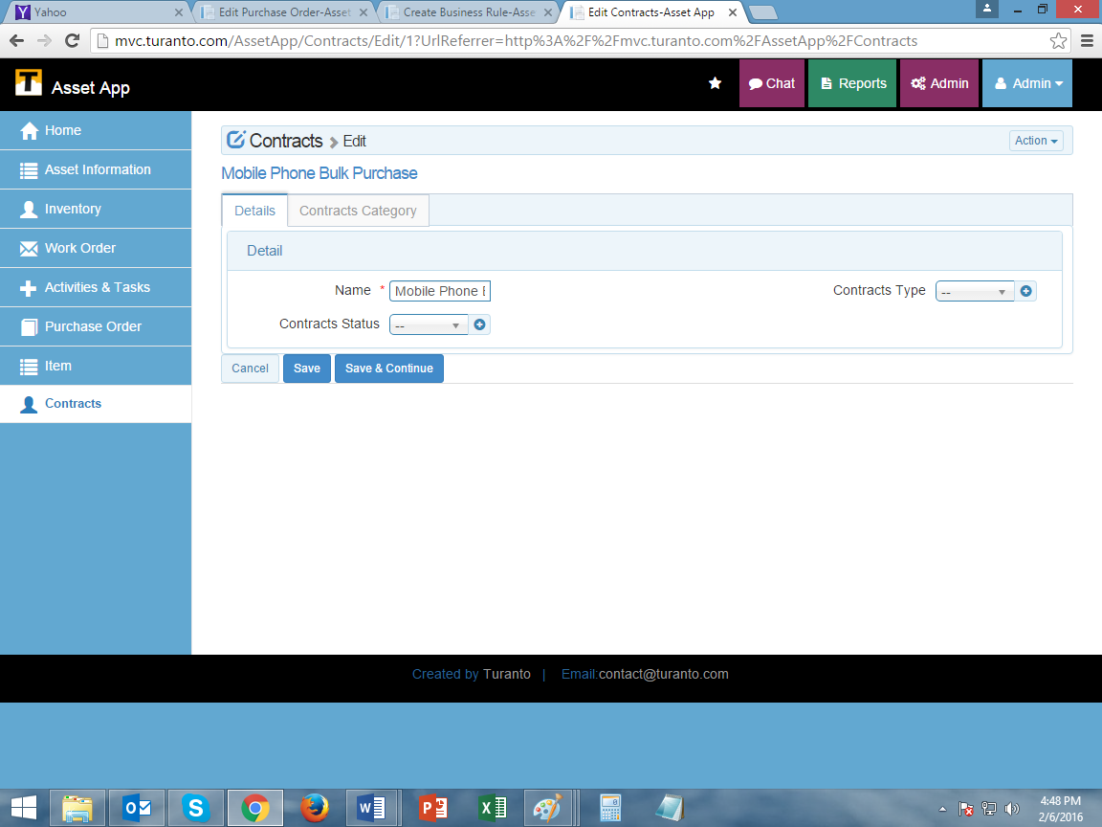

TODO: Replace this Image

Figure 10: TODO (Write Caption) [Note: Description field is hidden here]

# Example Business Rule

TODO: Replace the section with your own rule

The following section describes how to add a business role in an entity called Purchase Order in a mock application.

For example:

1. In Entity ‘**Purchase Order**’
2. For the role ‘**Sales Supervisor**’ and ‘**Sales Manager**’
3. On new add
4. If rate is greater than 0 (i.e. data is inserted in rate field)
5. The ‘**Total Cost**’ and ‘**Total Tax**’ fields will become mandatory.

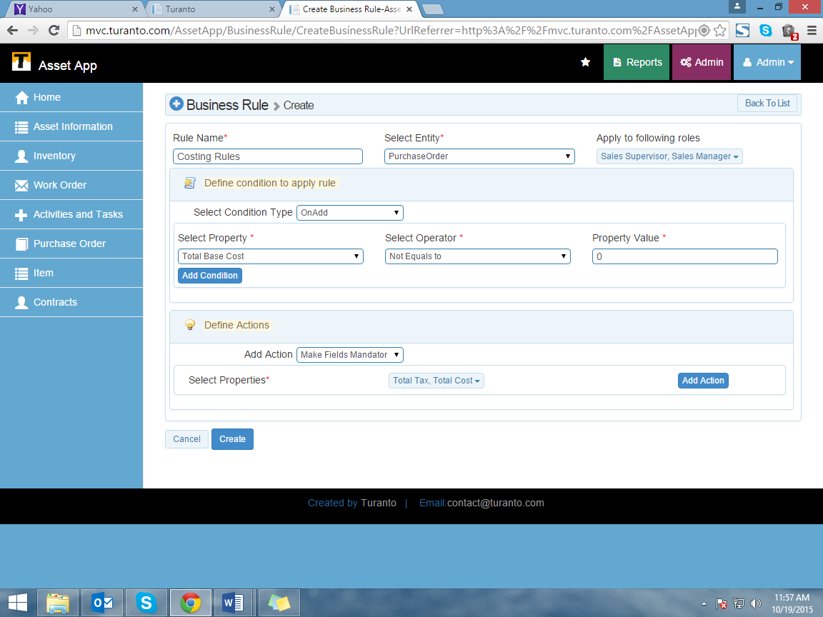

TODO: Replace this Image

Figure 11: Business Rule for ‘Purchase Order’

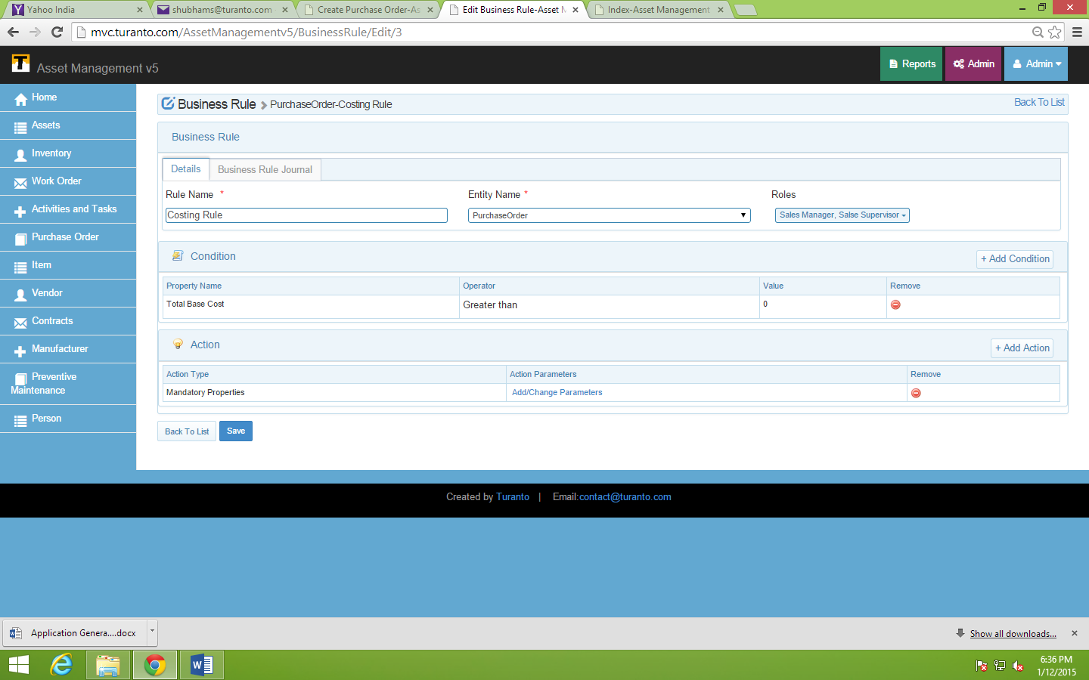

TODO: Replace this Image

Figure 12: Edit a Business Rule (Add more conditions and actions)

# **Test Business rule**



TODO: Replace this Image

Figure 13: Business Rule Example- ‘Total Base Cost > 0’ made ‘Total Tax’ and ‘Total Cost’ Properties Mandatory