#Company_Logo#

**Troubleshooting Guide for App_Name**

*Troubleshooting guide for all the roles in App_Name*

*The guide lists some of the common errors users make while working with the application. The production of document is not complete and everybody is allowed to add items in this document.*

Company_Name

Date_Create

**COPYRIGHT**

Troubleshooting Guide for App_Name (Date_Create)

The information provided in this document, including URL and other Internet Web site references is "as-is" and for informational purposes only. The information contained herein is subject to change without notice and is not warranted to be error-free. Unless otherwise noted, the companies, organizations, products, domain names, e-mail addresses, logos, people, places, and events depicted in examples herein are fictitious and for only illustration purposes. No association with any real company, organization, product, domain name, e-mail address, logo, person, place, or event is intended or should be inferred.

This document does not provide you with any legal rights to any intellectual property in any section of application App_Name. You may copy and use this document for your internal, reference purposes.

© 2016 Company_Name. All rights reserved.

# Document Revision

Table : Revision History

|  |  |  |
| --- | --- | --- |
| Version | Date Published | Key Notes |
| 1.0 | Date_Create | First Release |
|  |  |  |
|  |  |  |
|  |  |  |

Table of Contents

Document Revision 3

Preface 5

Intended Audience 5

Document Accessibility 5

Related Documents 5

Conventions 5

About This Guide 7

Purpose and Scope 7

Point of Contact 7

Glossary 7

Getting Started 9

Admin Area Errors 9

IIS Errors 9

Database Errors 9

Application Errors 10

Login Errors 10

Mandatory Fields 10

Import Errors 11

Issue Tracker 12

# Preface

## Intended Audience

This manual is intended for individuals/organizations who are using the application App_Name developed for Company_Name.

## Document Accessibility

The company focuses on making products, services and supporting documents accessible with great usability to its users. To that end, this document includes features that make information available to users of technology. This document is published in WORD format and does not contain markup. Accessibility standards will continue to upgrade on timely basis and Company_Name is constantly engaging itself in activities to address technical obstacles to furnish the document to all its customers.

**Accessibility of Links to External Web Sites in Documentation**

The document may contain links to other websites (not owned by Company_Name) if required. Company does not evaluate nor makes any representations regarding the accessibility of these web sites.

## Related Documents

The document is first revision in its section and available only at respective application(s) portals. The company is not responsible for about authenticity of this document, if accessed from any third party website. The documents available are:

* App_Name User Guide
* Current Security Settings
* Current Business Rules
* Security Configuration Manual
* Business Rules Configuration Manual
* General Deployment Guide
* Database Design Document
* Troubleshooting Guide

## Conventions

Following are the conventions used in this document:

Words in single inverted commas (‘) are the nouns. These words in common English sometimes are used in different manners as required. Inverted commas differentiate these words used as simple English terms and specific terms (nouns). Ex: properties, associations, datatype etc.

™: The words with TM (Trademark) as superscript are registered words and cannot be used without prior permission of respective organization for commercial and profit activities.

Hyperlinks: Hyperlinks are the content that reflects the source at another place having a web address. The hyperlinks are URLs to these web addresses and are accessible by pressing (CTRL + click) in static documents and simple clicks on web pages.

Illustrative numbers: The numbering is done in figures (for example: figure 2) for users convenience to find the data easily. The contents are arranged numerically as per the figure.

Save: For any changes you, ‘Save’ button store these changes. The save button is present in all the forms and fields in App_Name and is not repeatedly acknowledged.

Cancel: For any changes you, ‘Cancel’ button discards these changes. The cancel button is present in all the forms and fields in App_Name and is not repeatedly acknowledged.

Checkbox: Checkbox presents the conditions that could be marked as true or false. The right sign in checkbox ✓ marks the condition as true. If left blank, the system considers it as false.

Fields: Fields are the space provided to fill the data. Some fields may have conditions depending on respective section or the rules.

Back to list: This option discards the changes and redirects you to the previous page.

Save and continue: This option saves your current changes and redirects you to next page.

Next: This option without saving current changes redirects you to next page.

Previous: This option without saving current changes redirects you to previous page.

# About This Guide

The guide lists some of the errors commonly made by users. The content of guide is generated by analyzing the behavior of users as seen and reported to us. The production of this document is not complete and will be updated periodically. For the latest version of this document, please contact application administrator.

## Purpose and Scope

This manual is intended for application users. Any prior knowledge of a programming language will be helpful but not required or mandatory.

## Point of Contact

If you have any questions or concerns, please contact Company_Name at Company_Email.

## Glossary

This table explains all the variables are/may be used throughout this guide

Table : Variables used in this guide

|  |  |
| --- | --- |
| **Android APK** | The downloadable android application |
| **App** | Application |
| **ASP.NET** | Open Source server-side Web Application framework |
| **Association** | Relation between two entities |
| **Browser** | The interface used to access the internet |
| **Cancel** | Discard your unsaved changes and redirects you to previous page |
| **CRUD** | Create Read Update Delete |
| **Dependent Dropdown** | Dependency of one association on another |
| **Entity** | An independent existing thing |
| **Faceted Search** | Searching information from properties of an entity |
| **Group** | Collective display of properties (and associations) |
| **Launch** | Generate the application from present model |
| **Mobile View** | The application designed according to mobile interface |
| **Model Generator** | Defines entities, properties, associations and other features of application |
| **MVC** | Model View Controller (Microsoft’s technology) |
| **Next** | Redirects you to next page in form |
| **Password** | Password is the secret key, required to access the application |
| **Permissions** | Accessibility to add/edit/delete/view data of entity |
| **Previous** | Redirects you to previous page in form |
| **Property** | The things that belong to entity |
| **Record** | Complete details of data for an entity |
| **Roles** | Set of permissions to add/edit/view/delete for each entity |
| **Save** | Save your changes you made |
| **Save & Continue** | Save your changes and keeps you on same page |
| **Username** | It is the unique field that identifies an associated user |
| **Users** | People who have access to application |
| **Value** | Specific field of a record |
| **Workflow** | Defines status of application for any particular record in entity |

# Getting Started

The following sections will describe errors you may encounter in different areas of your application. You will require administrative access to App_Name, the database server and the application server to resolve most of these errors. These errors are updated frequently.

# Admin Area Errors

You can go to the Admin section (by clicking on the purple admin button on the homepage) and view all the errors by clicking on ‘Errors List’. It will give you a list of all errors that have occurred in App_Name.

# IIS Errors

In case of any errors, please follow these instructions:

• If you have two different servers for the database and the application, please check that they can communicate with each other using a connection.udl file.

• Check that the appropriate ports are open

• Check that the connection string in the web.config is correct

• Check that the application pool is set correctly

• Check that the bindings are correct

# Database Errors

In case of any errors, please follow these instructions:

* If you are having trouble logging into SSMS, please make sure that your server name, username and password is correct
* If you are having trouble attaching the database, make sure your user has the right privileges but checking the ‘Security’ option in SSMS or contact the database administrator
* Make sure you are not attaching a database with the same name as an already existing database
* Make sure that you have saved the database (that you are going to attach in SSMS) in the SQL Data folder

# Application Errors

This section describes the error you can get in App_Name during day to day activities.

## Login Errors

You get the ‘Invalid username or password’ if you type in an incorrect username or password. If you enter your username or password wrong five times in a row, your account will be locked. It will be automatically activated in a couple of hours or please contact your system administrator to unlock it immediately.

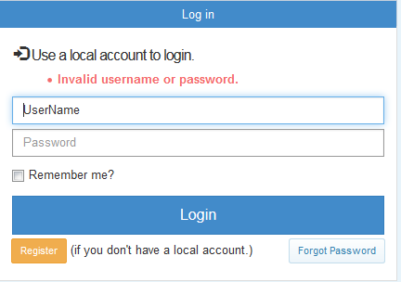

Figure : Invalid Username/password error

## Mandatory Fields

All the fields marked with a red asterisk are mandatory and you have to fill them before you save any changes. You get an error saying “The name field is required” which tells you exactly which field you need to enter before you are allowed to save.

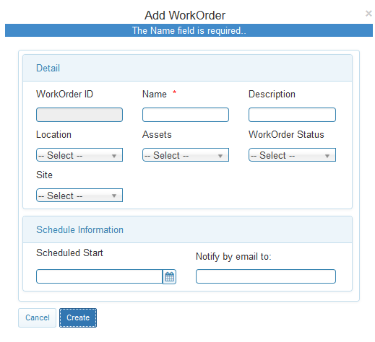

Figure : Mandatory Fields

## Import Errors

If you don’t enter the date in the upload screen, you get the following error. To resolve this error, please enter a date in the box or select it from the calendar.

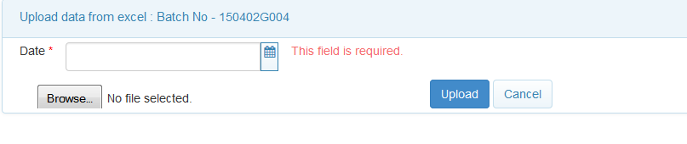

Figure : Date error

If your Excel file does not contain all the columns that AASR needs or the column names are different from the AASR mappings, you will receive the following error:

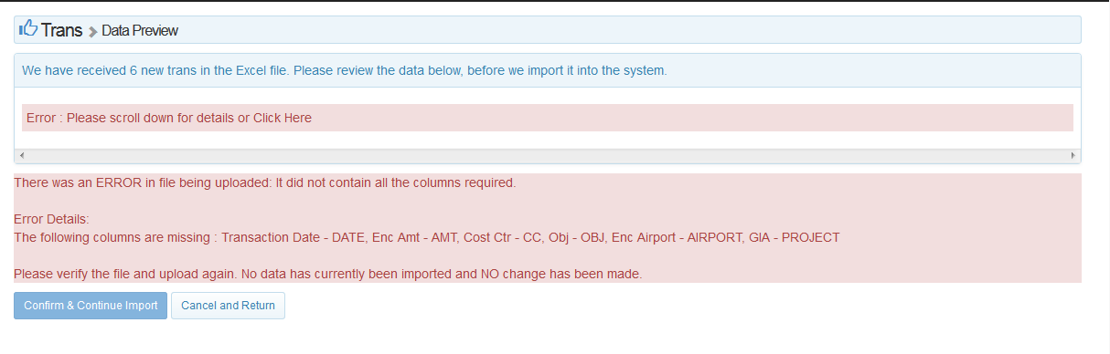

Figure : Excel file mapping error

The error tells you which columns are missing from the excel file and what their names should be in your excel file. For instance, the transaction date should be labelled as ‘DATE’ in your excel file. Please modify your Excel file and then re-upload.

In the case of details.all file, you will not be allowed to upload duplicate transaction ID. The system will give you the following error:

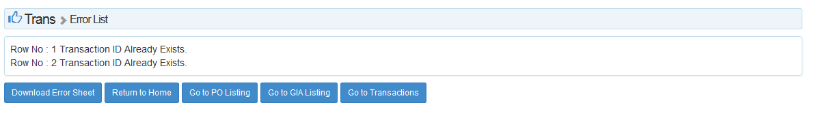

Figure : Error message for duplicate transaction

# Issue Tracker

An issue tracker can be deployed on your server to better keep track of all the errors and their statuses. The issue tracker already contains most of the things you would need to record the errors like the severity, status, summary of the error etc but it is also customizable. You can also attach any documents or images to the issue.

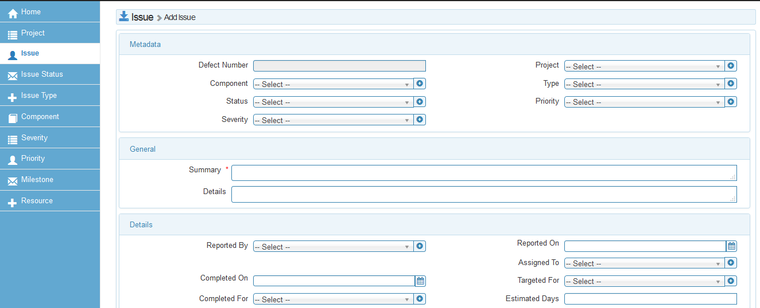

Figure : Example issue Tracker