

**e-Yantra Robotics Competition (eYRC 2019-20)**

**Task 3.1 – Supply Bot Questionnaire**

**<Team ID> (to be replaced with your team ID)**

|  |  |
| --- | --- |
| **Team leader name** |  |
| **College** |  |
| **Email** |  |
| **Date** |  |

(to be filled)

**Note: The pdf converted from this document should not exceed 5MB in size for upload.**

**Scope and Preparing the Arena**

**Q1. a. State the scope of the theme assigned to you. (5)**

< Teams should briefly explain in their own words the theme assigned. What in your opinion is the purpose of such an application?

Answer format: Text, Word - limit: 100 words>

**b. Upload the Final Arena Images. (20)**

< Prepare the arena according to the steps given in Section 3: Arena, of the Rulebook. Please follow the arena configuration shown in “Figure 1: Basic Elements of the Arena” of the rulebook.

Configuration for Capital and Relief Aid are similar to that mentioned in the Test_Setup_Read_Me.pdf document in the Task 3.2 folder and as given in the table below:

|  |  |
| --- | --- |
| **Node Type** | **Node Number** |
| Capital | 1 |
| Medical Aid | 3 |
| Food Supply | 6 |

Take a single photo of the completed arena such that the entire arena along with arena components such as Capital, Relief Aids, e-Yantra logo, primary cities, and all basic elements of the Arena etc., are clearly visible in the photo.

Answer Format:The image file should be pasted in the space provided for it in this document here below [the image should be (maximum) of 256x256 in jpg format]:

**Building Modules**

**Q2. Identify the major components required for designing the robotic system for the theme assigned to you. (5)**

< Teams should classify the components into various categories: mechanical systems, electronic systems etc. and mention how these units will be used in the theme. You may draw diagrams/figures to illustrate your answer.

Answer format: Bulleted form

1. Component 1

2. Component 2

3. Component ….etc. >

**Power Management**

**Q3. a. Explain the power management system required for a robot in general and for the theme assigned to you in particular. (5)**

< Teams should mention the power requirement of their system with current rating and voltage requirement. You can mention the number of batteries you think your system actually needs to use in your system with necessary justification. You can also draw some diagrams/figures to illustrate your answer.

Please provide the answer in your own words.

Answer format: Text, Word-limit: 100 words>

**b. Can there be a single power supply for your robot? - Yes/No/Don’t know. Please elaborate/justify your answer choice. (5)**

< Support your answer.

Answer format: Text, Word - limit: 200 words >

**Design Analysis**

**Q4.** **Teams have to design a robot which traverses an arena following a given path and simulate dispatching required Relief Aid.**

1. **How will your robot traverse the state represented by the Arena given in the rulebook?**

**(5)**

< Explain your path planning technique(s). Clearly specifying the hardware components, inputs and outputs for your technique. You can explain multiple techniques.

Word-limit: 300 words. >

**b. If you were to implement this theme in the real world scenario, what would be the actuators you will employ? Explain their purpose. (3)**

< Justify your answer by stating the advantage/s of the chosen actuator/s over others. Actuators that will be required for movement, planting mechanism, etc.

Answer format: Text, Word - limit: 200 words>

**c. What kind of mechanism will you design to ensure dispatch of Relief Aid? (10)**

<Explain your mechanism. You can put hand-made drawings/software based designs, as well (maximum 2 images/drawings of size 256x256)>

**Environment Sensing**

**Q5. a. Explain how you will use the given USB camera to decide the course of traversal.**

**(5)**

< Team should explain in detail how they will use the mounted USB camera to sense the environment associated with the theme. Explain the role of Camera in providing important feedback during the Run.

Answer format: Text, Word - limit: 300 words>

**b. What other sensors will the team use to aid their robot to complete its task successfully? (5)**

< Answer format: Bulleted form

1. Sensor 1

2. Sensor 2

3. Sensor 3 ….etc. >

**Testing your knowledge (Theme Analysis and Rulebook-related)**

**Q6. a. If a team has a condition such as that shown in figure 1 below compute the possible bonus, penalty if any and the maximum marks the team can score. Elaborate on bonuses or penalty if any - why it will be applicable? Also elaborate the conditions in which the team will score a maximum in this situation (5)**

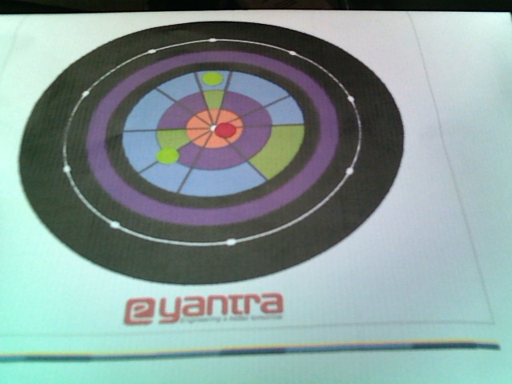

**Figure 1: Overlay Example**

< Analyse the formula provided in the rulebook and explain how it will affect the score.

Answer format: Text/Bulleted form >

**Note:** disregard the unequal shape of the coins, there are 2 green and 1 red coins in the Arena

**b. Name the different elements in the Arena. (3)**

<Answer format: Bulleted form

1:

2:

3:…etc. >

**c. If there are all 3 Food Supply (Green Color) Markers placed on the Arena, how many CBs can you have maximum for a run? (3)**

< Answer format: Text

Word-limit: 200 words >

**d. What are the different conditions that indicate the end of a run? (3)**

< Explain in your own words. Answer format: Bulleted form, word-limit: 300 words

Condition 1:

Condition 2:

Condition 3:…etc. >

**Algorithm Analysis**

**Q7. Draw a flowchart illustrating the algorithm you propose to use for theme implementation. (10)**

< The flowchart should elaborate on every possible function that you will be using for completing all the tasks in the assigned theme. Follow the standard pictorial representation used to draw the flowchart.

Answer format: Text, Word-limit: 1000 words >

**Challenges**

**Q8. What are the major challenges that you can anticipate in addressing this theme and how do you propose to tackle them? (8)**

< Answer format: Bulleted form

1. Challenge 1

2. Challenge 2

3. Challenge 3, etc. >