INB382 – Real Time Rendering Techniques
Enlightenment
Assignment Two: Global Illumination

Douglas Cook n6358993 & Nicholas Kinsey n5922917
9/15/2009

Contents
Deliverable Controls 3
Shader Techniques 3
Shadow Mapping 3
BillBoarding 5
HeightMapping 5
Shader Parameters 6
g_sunlight 6
g_time 6
g_normalTexture 6
g_worldMatrix, g_worldViewProjectionMatrix, 6
g_worldInverseTransposeMatrix 6
g_materials[] 6
g_lights[] 6
g_camera 6
g_lightworldviewprojectionmatrix 6
g_IsBillBoard 6
g_billboardTexture, g_shadowTexture, shadowsampler, billboardsampler 6
Statement of Completeness 7
Class Inheritance Structure 7
Highlights 9
References 10
Scene and Shader References 10
Model References 10

Assignment Two: Global Illumination

Deliverable Controls
Movement is undertaken through clicking both mouse buttons together.
Note that when the camera is behind the player it is designed to emulate the feeling of looking where the player is looking and hence pitch rotation is limited.
Fullscreen is toggled using F2.
DISCLAIMER: Some of the lighting techniques used in this assignment appear to be unstable under some varients of ATi cards.

Shader Techniques

Shadow Mapping
Shadow mapping entails the following operations: Rendering the depth map from the light to a texture. Using this texture to compare to the depth map of the scene and determining if the objects are occluded due to a variance in the depth buffer. The pixels are then lit depending on this.
For this assignment, the light count was brought down to three lights for scalability and to ensure framerate in the tutorial room. First the view was transformed to the perspective of the first light and was rendered to the red component of the texture. This was repeated with blue and green with the next two lights. This enabled us to use a single texture to get 3 light shadow mapping.
Also, the SGLib Renderer had to be extended in order to clear the zbuffer of the texture.
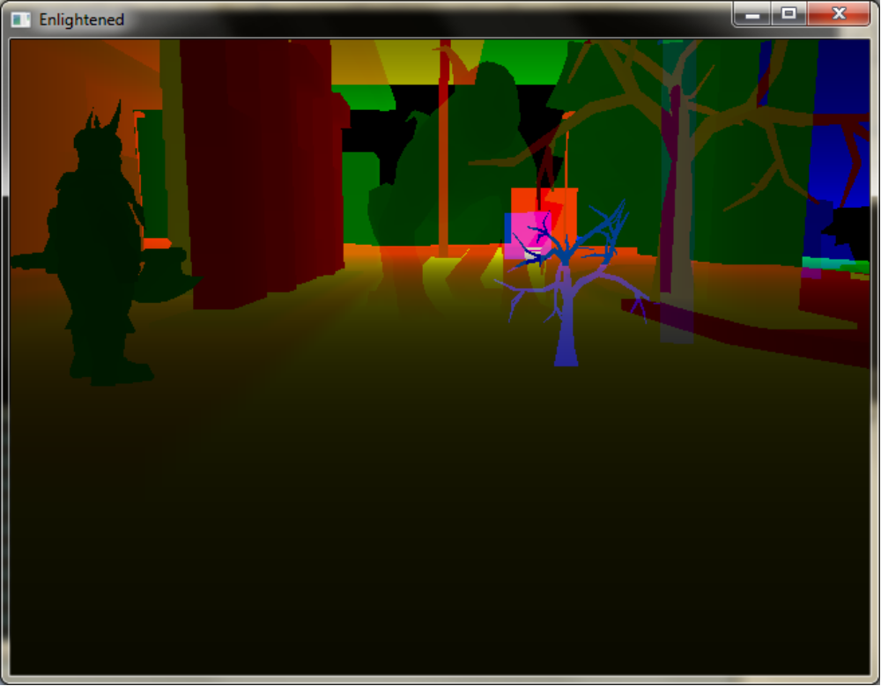
The lighting shader was converted into a three pass additive blend. This is so that scene renders of each light with shadows can be added together to form a multiple light shadowed render.
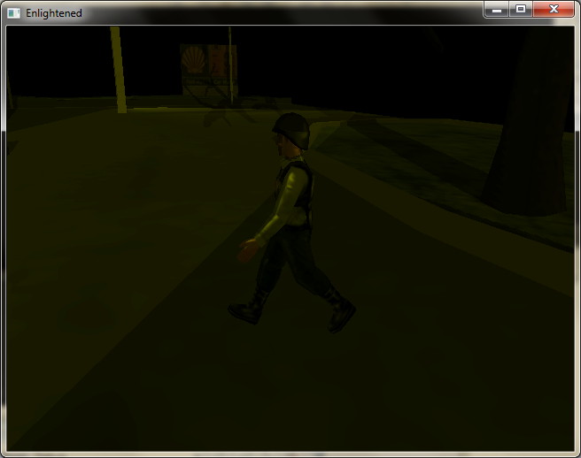

BillBoarding
Firstly a rectangle was drawn onto the scene by hijacking the rendernode code and using a vertex declaration. Next a tree texture was applied to this surface. In the scene update function, code was added to modify the rotate and transformation matrices of the node in order to always face the camera. Primarily of interest is the function:
float angle = atan2(direction.x, direction.z);
This returns the yaw rotation in radians of a direction vector from camera to node.
Next a new technique (to preserve the scene) was added to the shader in order to ignore the alpha color of the texture. This leaves us with a tree which always faces the camera.

HeightMapping
A heightmap was created and sampled in order to find the Z positions for the terrain and the character, this was then used to update the scene.

Shader Parameters

g_sunlight
This is used to give additional ambient lighting during the “daytime”. This contains the colour component of the day ambient light

g_time
This contains “time of day” data in order to bias the lighting more effectively depending on the time

g_normalTexture
This accepts a normal texture to use in normal mapping for the shader.

g_worldMatrix, g_worldViewProjectionMatrix,

g_worldInverseTransposeMatrix
Matrices in order to ease computation on the shader

g_materials[]
Struct for carrying diffuse, ambient, specular and attenuation data regarding the materials in use.

g_lights[]
Struct for data referring to the lighting. Contains data such as: color, position, target, direction, radius, outer cone, inner cone for use in giving data about lights.

g_camera
This struct carries relevant camera data for the shader, currently only encompassing position of the camera, but allowing room for advancement later in the development process.

g_lightworldviewprojectionmatrix
This matrix is used to render the scene from the perspective of each light

g_IsBillBoard
Bool for billboard specific code

g_billboardTexture, g_shadowTexture, shadowsampler, billboardsampler
Textures for billboard and shadow and their respective samplers

Statement of Completeness
Items completed:
- All components in original scene
- Billboarded trees that face the player
- Shadows on the scene by all lights

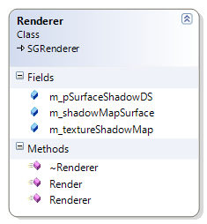
Class Inheritance Structure
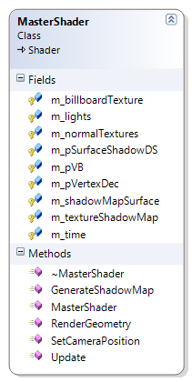
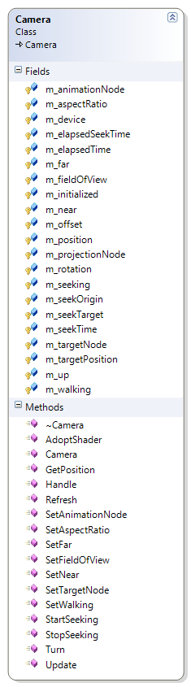Please see attached doxygen output.

Highlights
Custom camera.
Extended renderer to support shadow data.
Billboards with alpha transparency that rotate to face the camera

References

Scene and Shader References
Lecture Material
Tutorial Material
Blackboard Examples for Billboarding, Texture Mapping
MSDN
DXSDK Examples
http://www.riemers.net/eng/Tutorials/XNA/Csharp/Series4/Billboarding.php
http://www.riemers.net/eng/Tutorials/DirectX/Csharp/Series3/Shadow_mapping.php

Model References
Blackboard .X Models for Barney
DXSDK Models
Free models from: http://3d02.com/
Free models from: http://www.the3dstudio.com/
Manual editing of ASCII .X Files were required for multiple portions of this assignment and MSDN was used again here.

