🏆 \*\*Electromate: Innovation for the Visually Impaired\*\*

In the heart of our college's techfest, a competition named Electromate set the stage for an inspiring display of technological prowess and empathy. The challenge was to devise a solution that could enhance the mobility and safety of visually impaired individuals. As part of the robotics club, we rose to the occasion and designed a smart stick that not only helped the blind navigate obstacles but also addressed other critical challenges they face.

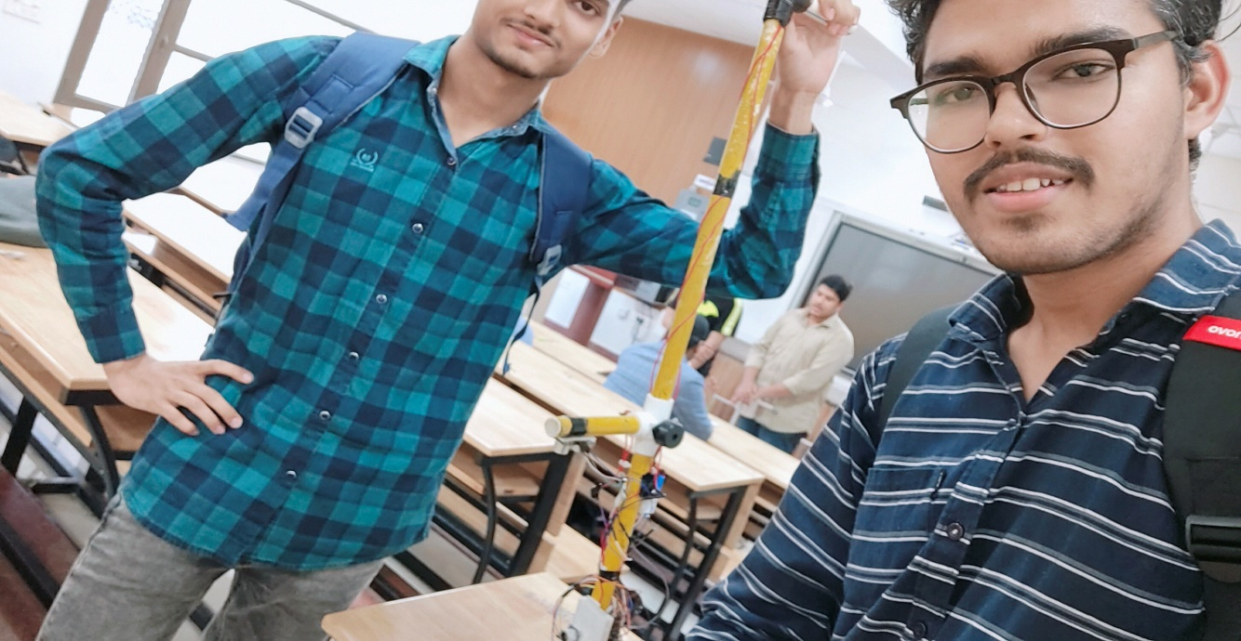

\*\*The Genesis of Innovation: A Simple Stick with a Vision\*\*

Imagine navigating through a world without sight – every step potentially fraught with uncertainty. Our smart stick aimed to empower visually impaired individuals by providing them with a reliable companion for their journeys. We began with a simple pipe that became the foundation of our innovation. Embedded within this unassuming stick were technologies that could detect obstacles and ensure safer travels.

\*\*Sensing the Surroundings: Ultrasonic Sensors for Precision\*\*

The core of our smart stick's technology lay in its four ultrasonic sensors strategically positioned to cover the front, right side, and left side. These sensors acted as the "eyes" of the stick, sending out ultrasonic waves and calculating the distance to objects in their path. Our Arduino-based coding set specific distances for each sensor, such that if an obstacle was detected within that range, a distinct audio signal would be triggered.

\*\*Empowering Depth Perception: The Underside Ultrasonic Sensor\*\*

A common danger for visually impaired individuals is the unpredictability of surface terrain. To mitigate this, we incorporated an additional ultrasonic sensor, pointing downwards. This ingenious addition gauged the depth between the stick and the ground, effectively alerting the user to potential pitfalls like ditches or uneven surfaces.

\*\*A Slip-Free Journey: The Water Surface Circuit\*\*

We didn't stop at obstacle detection alone. Recognizing the risks posed by wet surfaces, we installed a circuit that could detect moisture. This innovative solution helped prevent slips on slick surfaces. By monitoring the conductivity of the surface, our smart stick could alert the user when walking on a wet pathway, thereby enhancing safety even further.

\*\*Distinct Sounds, Clear Direction\*\*

To provide meaningful feedback to the user, we employed distinct audio signals for each type of obstacle or challenge detected. While some may have suggested using a speaker, we opted for simplicity and reliability by utilizing a buzzer. We creatively assigned unique sounds to the front, right, and left sensors, as well as to the water surface circuit. This clever arrangement allowed the user to intuitively discern the nature and direction of the obstacle, leading to more confident navigation.

\*\*Triumphant Conclusion: A Victory for Innovation and Compassion\*\*

Our journey through Electromate was a testament to the power of technology to enhance lives. The smart stick we designed transcended its mechanical components. Through a combination of ultrasonic sensors and ingenious coding, we bridged the gap between sight and sound, enabling our users to navigate their surroundings with greater independence and safety.

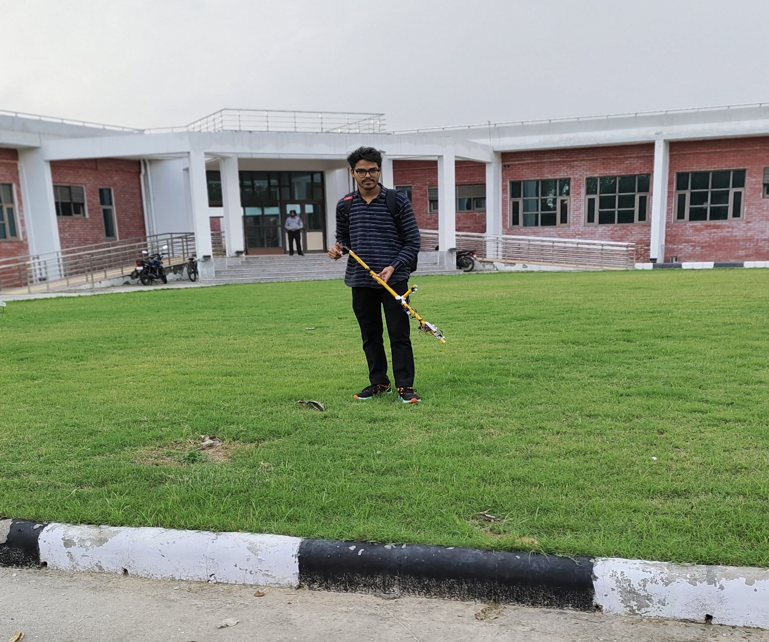

As we proudly stood on the podium, clutching the first prize, we celebrated not just a victory, but a triumph of empathy, innovation, and the unyielding human spirit to make the world a better place for all.

🌟 \*Empowerment through innovation – Electromate 2023.\* 🌟