Pants Down
Team:
Seth Clark: Team Lead
    - Code Architecture
Matt Adams: Creative Lead
    - LevelDesign
    - Storyline
Jerry Hung: Programming Lead
    - HUD Coding
    - Menu Coding
Matt Senn: Quality Assurance Lead
    - Player/Enemy Interaction Code

StoryLine:
The basic story of the game is that you are a wizard who is granted power by the colors of the world. Having spent your life training and gathering power, you are an incredible force. However, a dark force has gathered and has drained the world of all its color, looking to harness the ability of your magic. You must gather your strength and face these hordes of monsters to regain your power and defeat those who would take the power of the world.
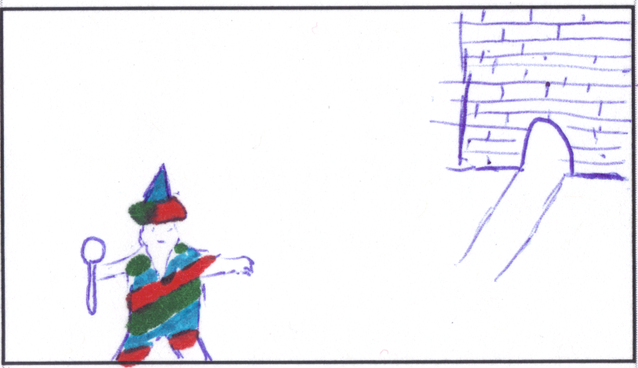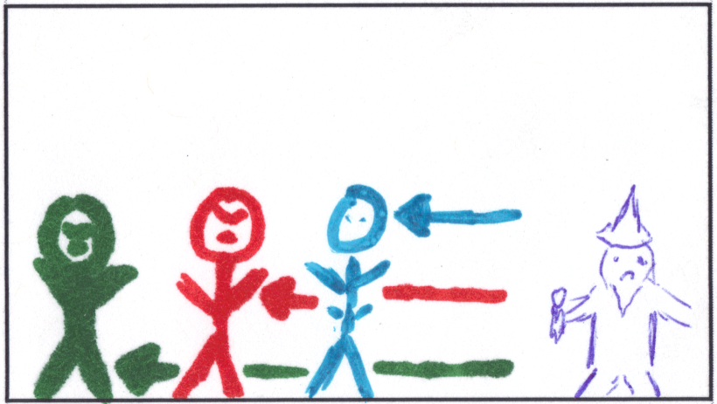
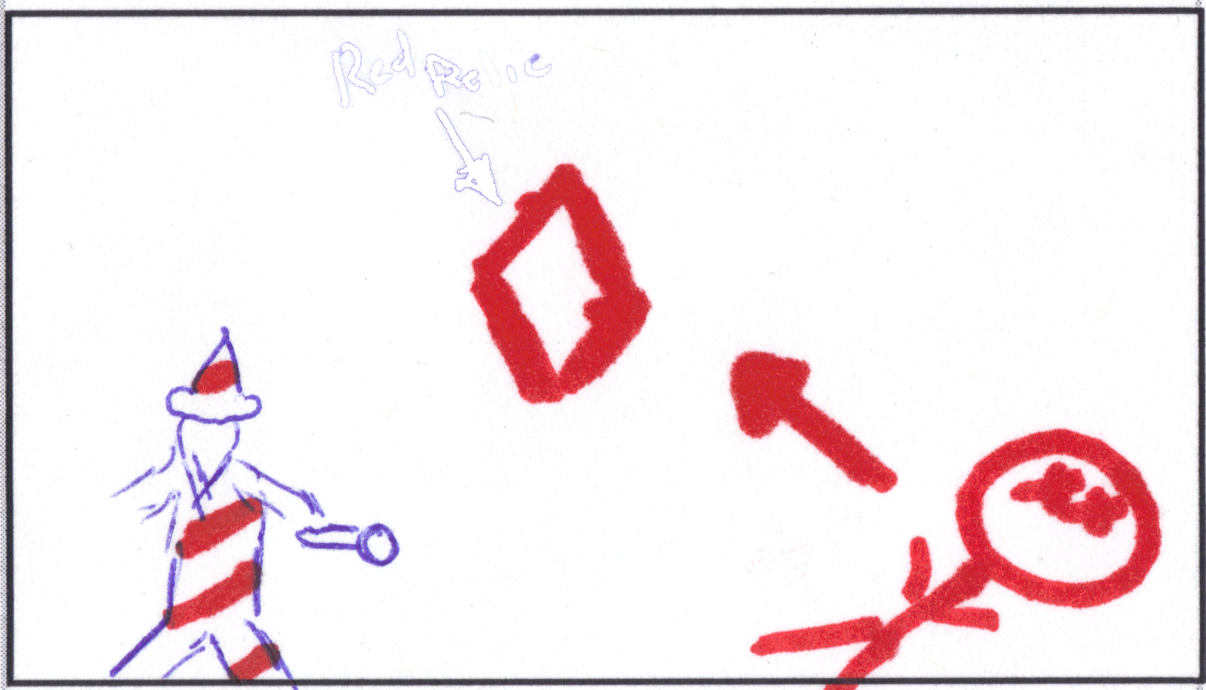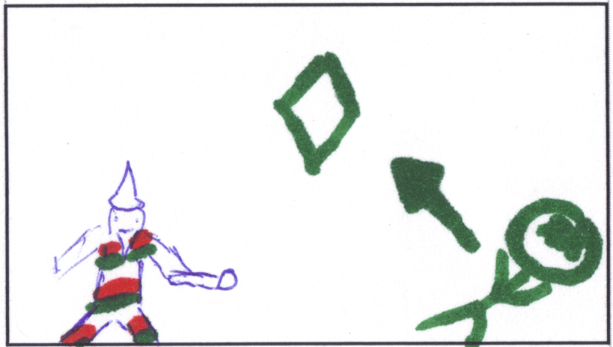
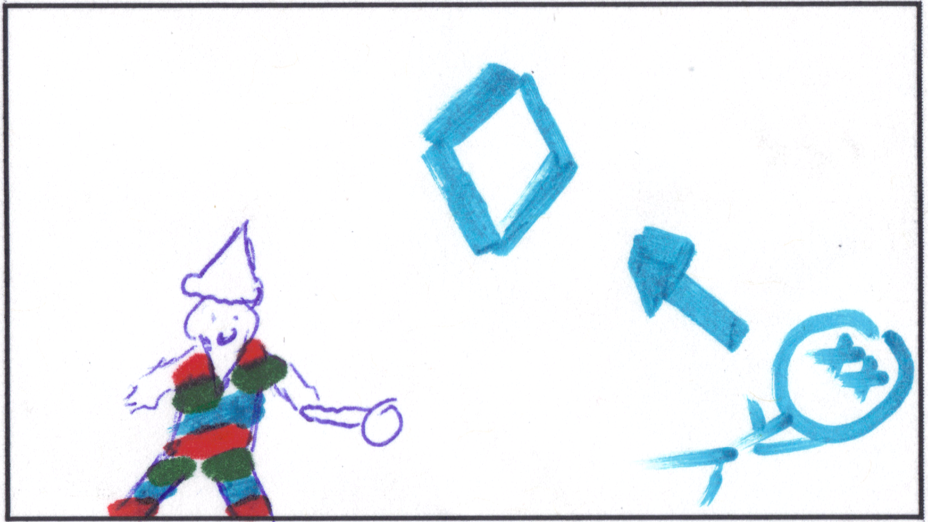

Layers:
Functional Minimum:
-Basic Tile Environment (Draw Tiles)
-First Level (player walks around and collects first color)
-Sprite Animations
-Basic HUD (Player's Health)
-Basic Menu System (Main menu → Game)

Low Target:
-Complete Tile Environment (collision, enemy spawn points)
-Player/Enemy Collision (collision resolution)
-First Player Combat Spell (Fire Attack)
-Fully Functional HUD (health/mana bars)
-Basic Enemy AI (wandering)
-Basic Shader Effects (remove colors)

Desirable Target:
-Complete First Two Levels
-All Player Combat Spells
-Save/Load States
-First Boss Fight
-Sound Effects

High Target:
-Non-Combat Spells (Health spell)
-Unique Enemy AI
-Completed All Levels
-Advanced Shader Effects (unique to each level)

Extras:
-Spell Combos (combine certain spells to create new ones)
-Custom Art
-Custom Sound Effects
-Co-op Mode
-Networked Play
-Implement More Colors
-Storyline with NPCs

Unexpected Snags:

-Changing tile editors 2 weeks into the project.
-Teammate quitting a few days ago.

