ECE 441: Smart and Connected Systems / Internet of Things
Laboratory Experiment No. 03 Formal Engineering Report
Wireless Data Acquisition Using Temperature Sensor

By: Shashwat Choudhry
Lab Partners: Andy Tran, Kaleb Cowgur, Haron Abuelhija
Instructors: Dr. Jafar Saniie and Prof. Tianyang Fang
Course: ECE 441 (Smart and Connected Systems / Internet of Things)
Lab Date: October 01, 2026
Due Date: October 08, 2026
Academic Integrity: I verify that all experimental data, software implementations, and written analysis presented in this report represent the authentic work of myself and my laboratory partners, with all external technical resources and datasheets fully cited.
Signature: Shashwat Choudhry

Section I: Introduction
1.1 Technical Background on Wireless Sensor Networks and Cloud IoT
A. Wireless Sensor Networks and the 2.4 GHz ISM Spectrum
Wireless Sensor Networks (WSNs) are foundational to cyber physical systems, environmental monitoring, smart building automation, and healthcare telemetry. Modern wireless nodes operate within the unlicensed Industrial, Scientific, and Medical (ISM) radio frequency band, centered between 2.4000 GHz and 2.4835 GHz. Because this spectrum is shared globally among heterogeneous technologies including Bluetooth, Wi Fi (IEEE 802.11), and ZigBee (IEEE 802.15.4), robust physical layer modulation schemes are necessary to mitigate cross protocol radio interference.
Bluetooth technology addresses spectral congestion by employing Frequency Hopping Spread Spectrum (FHSS). Under the Bluetooth Basic Rate (BR) standard, the 2.4 GHz band is partitioned into 79 discrete RF channels, each spaced 1 MHz apart (spanning 2402 MHz to 2480 MHz). The transceivers execute pseudo random frequency hops at a rapid rate of 1600 hops per second (or one hop every 625 microseconds). By transmitting data in brief time slotted packets across rapidly varying frequencies, Bluetooth effectively avoids persistent channel jamming caused by stationary Wi Fi carriers, providing exceptional link resilience in noisy industrial and university laboratory environments.
B. Comparison Between Classic Bluetooth, Bluetooth Low Energy, and Wi Fi
When designing an IoT edge architecture, selecting an appropriate wireless transport requires balancing data throughput, power consumption, latency, and networking complexity. Classic Bluetooth (Bluetooth BR/EDR) was designed primarily as a cable replacement protocol for continuous point to point data streams. It achieves physical payload throughputs up to 2 to 3 Mbps with moderate power consumption (typically 20 to 50 mA active current draw). Connection establishment involves inquiry, paging, and cryptographic PIN authentication, establishing a persistent synchronous or asynchronous physical link.
In contrast, Bluetooth Low Energy (BLE), introduced in Bluetooth 4.0, is specifically engineered for duty cycled sensor nodes operating from coin cell batteries. BLE divides the 2.4 GHz band into 40 channels of 2 MHz spacing (3 primary advertising channels and 37 data channels). Unlike Classic Bluetooth's continuous connection state, BLE nodes remain in deep sleep states consuming sub microamp currents, waking periodically for milliseconds to transmit compact sensor bursts before returning to sleep. However, BLE continuous throughput is intentionally restricted (ranging from 100 kbps to 1 Mbps).
Wi Fi (IEEE 802.11 b/g/n) occupies the high throughput domain of the 2.4 GHz band, utilizing Direct Sequence Spread Spectrum (DSSS) and Orthogonal Frequency Division Multiplexing (OFDM) across wider 20 MHz or 40 MHz channels. While Wi Fi delivers massive data rates (up to 150 Mbps on 802.11n) and direct connectivity to local IP networks, its active radio power draw (often 100 to 300 mA) makes it impractical for direct battery powered micro sensing nodes without substantial energy storage.
C. The Bluetooth Protocol Stack and RFCOMM Architecture
The physical Bluetooth architecture is structured in a modular protocol stack standardized by the Bluetooth Special Interest Group (SIG). At the base of the stack, the Radio and Baseband layers govern RF carrier modulation, packet framing, and frequency hopping timing. Above the baseband, the Logical Link Control and Adaptation Protocol (L2CAP) provides protocol multiplexing, packet segmentation and reassembly (SAR), and quality of service management for higher layer protocols.
For serial data acquisition, the Radio Frequency Communication (RFCOMM) transport protocol operates directly over L2CAP. RFCOMM emulates the physical serial port characteristics of an RS 232 (EIA/TIA 232 E) interface, including byte framing, flow control lines, and multiplexed communications over a single wireless baseband link. RFCOMM supports up to 30 simultaneous emulated serial ports (termed RFCOMM channels or server channels). The Bluetooth Serial Port Profile (SPP) builds directly upon RFCOMM, providing standard profile specifications that enable embedded microcontrollers to bridge hardware UART data transparently to remote host applications as though connected by a physical serial cable.
D. Cloud IoT Analytics via MathWorks ThingSpeak
At the cloud tier, raw environmental telemetry must be persisted, analyzed, and visualized. MathWorks ThingSpeak is an open cloud analytics platform built specifically for IoT prototyping. ThingSpeak organizes data ingestion around virtual channels, where each channel supports up to eight independent sensor data fields, geographic location coordinates, and operational status strings. Data transactions are governed by RESTful HTTP application programming interfaces (APIs). Edge gateways transmit sensor updates using standard HTTP POST or GET requests targeted at the ThingSpeak ingestion endpoint ('https://api.thingspeak.com/update'). Access control and channel write permissions are secured using a unique 16 character alphanumeric Write API Key generated during channel creation. In academic and free tier accounts, ThingSpeak enforces a strict rate limiting policy allowing new telemetry updates at most once every 15 seconds. IoT edge gateways must therefore implement software throttling or rolling average buffers to prevent HTTP 429 (Too Many Requests) rejection errors.
1.2 Purpose and Scope of Experiment 3
The overarching objective of this laboratory experiment is to engineer, integrate, and validate an end to end, multi tier Internet of Things (IoT) wireless environmental monitoring platform. Modern embedded architectures rarely rely on isolated microcontrollers; instead, robust industrial and commercial IoT implementations distribute computational workloads across specialized hierarchical layers. Low level sensor interfacing, microsecond timing handshakes, and analog signal conditioning are delegated to power efficient edge microcontrollers. Localized short range wireless transceivers aggregate edge data without cumbersome cabling. Intelligent single board computers serve as local IoT gateways, orchestrating wireless pairing, protocol translation, data caching, and secure cloud ingestion. Finally, cloud computing platforms provide centralized data persistence, real time algorithmic analytics, and globally accessible visualization dashboards.
This experiment provides rigorous practical experience across five foundational engineering domains: first, interfacing precision digital and analog environmental sensors with the Arduino UNO R4 WiFi embedded platform; second, configuring and parameterizing the HC 06 Bluetooth slave transceiver using asynchronous serial AT commands; third, establishing a wireless Bluetooth Personal Area Network (PAN) utilizing the RFCOMM protocol to stream telemetry from the edge node to a Raspberry Pi 3 Model B+ gateway; fourth, developing a multi threaded Python gateway application on the Raspberry Pi utilizing the Linux BlueZ Bluetooth stack; and fifth, interfacing the gateway node with the MathWorks ThingSpeak cloud analytics platform via RESTful HTTP application programming interfaces.
Section II: Lab Procedure and Equipment List
2.1 Laboratory Equipment and Component Specifications
Table 1: Laboratory Equipment, Microcontroller, Sensors, and Host Hardware Inventory
Component Name | Model / Part Number | Key Technical Specifications | Laboratory Functional Role
Single Board Computer | Raspberry Pi 3 Model B+ | Broadcom BCM2837B0 quad core Cortex A53 1.4 GHz, 1 GB LPDDR2, onboard dual band Wi Fi and Bluetooth 4.2 | Central IoT edge gateway, Bluetooth master node, Python telemetry engine, and ThingSpeak cloud client.
Microcontroller Board | Arduino UNO R4 WiFi | Renesas RA4M1 32 bit ARM Cortex M4 @ 48 MHz, ESP32 S3 Wi Fi/BLE coprocessor, 12 bit ADC, hardware Serial1 UART | Edge data acquisition node, sensor timing controller, and serial transmitter to the Bluetooth module.
Bluetooth Transceiver | HC 06 Wireless Module | Linvor V1.8 firmware, Bluetooth 2.0+EDR slave transceiver, 2.4 GHz ISM band, 3.3V logic UART, default 9600 to 38400 baud | Wireless short range bridge transmitting sensor data bytes from Arduino to Raspberry Pi over RFCOMM Channel 1.
Digital Temperature Sensor | Aosong AM2302 (DHT22) | Capacitive polymer humidity sensor, NTC thermistor, digital single bus pulse protocol, range -40 to +80 C, accuracy +-0.5 C | Primary ambient temperature and relative humidity sensing element on the physical breadboard.
Analog Temperature Sensor | Texas Instruments LM35 | Precision centigrade temperature sensor, linear +10.0 mV/C scale factor, 0.5 C accuracy, operates from 4V to 30V | Reference analog sensor analyzed for mathematical ADC derivation and comparative analysis.
Solderless Breadboard | Standard 830 Tie Point | Dual power distribution rails, nickel plated spring clips, 2.54 mm standard pin spacing | Physical prototyping platform for sensor, Bluetooth transceiver, and wiring harness interconnection.
Jumper Wire Harness | Solid Core & Dupont 22 AWG | Male to male and male to female multi color jumper interconnects | Distributes 5.0V power, system ground, single bus data lines, and cross connected UART TX RX signals.
Host Display & Peripherals | ASUS Full HD LCD Monitor | 1920x1080 resolution, HDMI digital video interface, USB keyboard and optical mouse | Provides local graphical user interface and multi window terminal monitoring on the Raspberry Pi gateway.
Software Toolchain | Linux BlueZ, Python 3, ThingSpeak | Raspberry Pi OS 32 bit Linux kernel, python3 socket module, thingspeak REST package, Arduino IDE 2.x | Operating system drivers, RFCOMM Bluetooth socket listener, cloud upload script, and embedded C++ compiler.

2.2 Hardware Interconnect and Pin Mapping
Table 2: Hardware Interconnect Wiring and Pin Mapping Between Arduino, HC 06, and DHT22
Subsystem / Device | Device Pin Name | Arduino UNO Pin | Raspberry Pi Pin | Signal Description and Electrical Function
AM2302 / DHT22 Sensor | Pin 1 (VDD) | 5V Power Rail | N/A | Sensor direct power delivery rail (5.0V DC regulated).
AM2302 / DHT22 Sensor | Pin 2 (DATA) | Digital Pin 2 | N/A | Single bus bidirectional serial data line for timing pulses.
AM2302 / DHT22 Sensor | Pin 3 (NC) | No Connection | N/A | Null pin (not connected internally in DHT22 sensor casing).
AM2302 / DHT22 Sensor | Pin 4 (GND) | GND Rail | N/A | System electrical common ground reference.
HC 06 Bluetooth Module | VCC Pin | 5V Power Rail | N/A | Power input to onboard low dropout regulator (accepts 3.6V to 6V).
HC 06 Bluetooth Module | GND Pin | GND Rail | N/A | Common ground return for serial logic signals.
HC 06 Bluetooth Module | TXD Pin | Digital Pin 0 (RX1) | N/A | Module serial transmit output, connected to Arduino UART receive.
HC 06 Bluetooth Module | RXD Pin | Digital Pin 1 (TX1) | N/A | Module serial receive input, connected to Arduino UART transmit.
Raspberry Pi Gateway | Onboard BT Controller | N/A (Over Air) | Internal BCM43438 | Receives wireless 2.4 GHz RFCOMM Bluetooth packets from HC 06.
Raspberry Pi Gateway | Onboard Wi Fi / Eth | N/A (Over Air) | Internal BCM43438 | Connects to campus Wi Fi network to stream HTTP POST updates to ThingSpeak.

2.3 Step by Step Experimental Execution Procedure
Part A: HC 06 Bluetooth Transceiver Configuration via Hardware Serial
Part A: Physical Circuit Assembly and Electrical Interfacing
1. Breadboard Power Rails: The Arduino UNO R4 WiFi board was disconnected from computer USB power. Jumper wires were routed from the Arduino 5V power header to the positive red distribution rail of the solderless breadboard, and from the Arduino GND header to the negative blue common ground rail.
2. DHT22 Sensor Installation: The AM2302/DHT22 digital temperature and humidity sensor was inserted into the breadboard tie points. Pin 1 (VDD) was connected to the 5V power bus, Pin 4 (GND) was connected to the common ground rail, and Pin 2 (DATA) was wired to Arduino Digital I/O Pin 2. A 10 kilohm pull up resistor was connected between Pin 2 and Pin 1 to guarantee clean rise times on the single bus communication line.
3. HC 06 Module Wiring: The HC 06 Bluetooth transceiver module was mounted onto the breadboard. The VCC pin was wired to the 5V bus, and GND was wired to the ground bus. Because the Arduino UNO R4 WiFi features dedicated independent hardware serial ports (Serial for USB communication and Serial1 on Digital Pins 0 and 1), the HC 06 TXD line was routed to Pin 0 (RX1), and the HC 06 RXD line was connected to Pin 1 (TX1). This hardware UART configuration eliminated software serial timing jitter while preserving full USB serial debugging capabilities on the host PC.
Part B: Arduino Sensor Data Acquisition and Bluetooth Transmission
Part B: Bluetooth Module Configuration via Serial AT Commands
1. Serial Monitor Configuration: The Arduino was connected to the laptop via USB cable. The Arduino IDE was launched, and a serial passthrough sketch was compiled and uploaded. The Arduino Serial Monitor was opened and configured to 9600 baud with the line ending dropdown strictly set to 'No Line Ending' to prevent transmission of carriage return (0x0D) and newline (0x0A) control characters.
2. Module Readiness Verification: The command 'AT' was entered. The HC 06 immediately replied with 'OK', confirming operational hardware readiness.
3. Identity and Security Parameterization: The broadcast name was updated by transmitting 'AT+NAMEece441' (and verified with 'AT+NAMEANDYTRAN'), which yielded the confirmation response 'OKsetname'. The pairing PIN was established by transmitting 'AT+PIN1234', producing the reply 'OKsetPIN'.
4. Baud Rate Elevation: Finally, the communication rate was elevated to 38400 baud by transmitting 'AT+BAUD6'. The module responded with 'OK38400'. Following this command, the Arduino sketch and Serial Monitor were immediately updated to 38400 baud, and subsequent test commands confirmed that high speed serial communication was fully established.
Part C: Raspberry Pi Wireless Gateway Pairing and Security Authentication
Part C: Embedded Temperature Sensing Firmware Development
1. Driver Integration: The Aosong DHT library was incorporated into the Arduino project environment to handle low level timing pulses. A global DHT object was declared, and Digital Pin 2 was designated as the sensor data input.
2. Acquisition Routine: Inside the main execution loop, the DHT read function was called once every 1000 milliseconds (1 second). The driver initiated the single bus start signal by pulling the bus low for 18 milliseconds, released the line, and decoded the 40 bit pulse train into discrete humidity and temperature floating point values.
3. Mathematical Scaling: Ambient Centigrade temperature retrieved from the sensor object was converted to Fahrenheit using the standard transformation formula: tempF = (tempC * 9.0 / 5.0) + 32.0.
4. Dual Channel Transmission: The formatted temperature value was output to the USB Serial Monitor for real time local debugging alongside the status message 'Bluetooth transmission complete'. Concurrently, the integer or formatted floating point temperature value was streamed over the hardware UART (Serial1) directly into the HC 06 Bluetooth transmitter buffer.
Part D: Virtual Serial Port Emulation via Linux RFCOMM Bridge
Part D: Raspberry Pi Host Gateway Setup and Bluetooth Pairing
1. Network Verification: The Raspberry Pi 3 Model B+ was booted into the desktop Linux environment and connected to the Illinois Tech campus Wi Fi network. Terminal access was opened.
2. Bluetooth Management via bluetoothctl: The interactive Linux Bluetooth control utility was launched by typing 'bluetoothctl'. The command 'scan on' was executed to initiate Bluetooth device discovery. Within seconds, the HC 06 transceiver appeared in the discovery list with MAC address '00:14:03:05:5B:F3' and broadcast name 'ece441' (and 'ANDYTRAN') with an RSSI of minus 52 dBm.
3. Pairing Authentication: The command 'pair 00:14:03:05:5B:F3' was executed. The BlueZ authentication agent prompted for the device passkey. Entering '1234' completed legacy pairing, and the terminal confirmed 'Pairing successful'. The scan was terminated using 'scan off', and the utility was exited.
4. Software Dependencies Installation: The required Python networking and cloud libraries were installed using apt and pip:
sudo apt update
sudo apt install bluetooth libbluetooth-dev
sudo python3 -m pip install thingspeak
Part E: Python Gateway Daemon Implementation and ThingSpeak Cloud Ingestion
Part E: ThingSpeak IoT Cloud Channel Provisioning and End to End Integration
1. Cloud Channel Creation: A web browser was opened to the ThingSpeak portal (thingspeak.mathworks.com). A new channel was created titled 'ECE 441 LAB 3'. Field 1 was enabled and labeled 'Temperature'. The system assigned Channel ID '3518177'.
2. API Key Management: Under the 'API Keys' tab, the 16 character alphanumeric Write API Key ('INYZROAEU08IFDYH') was copied to grant write permissions to the Raspberry Pi client.
3. Gateway Script Development: A Python script titled 'lab3.py' was created on the Raspberry Pi desktop. The script initialized a raw Bluetooth RFCOMM socket bound to address '00:14:03:05:5B:F3' on Channel 1, instantiated a ThingSpeak channel object, and implemented a continuous while loop that read incoming temperature bytes from the Bluetooth socket, printed the values to the local terminal, and uploaded the readings to Field 1 over RESTful HTTP POST requests while respecting ThingSpeak's 15 second rate limit.
4. System Execution: The script was executed with 'sudo python3 lab3.py'. Upon successful RFCOMM socket connection, the flashing red LED on the HC 06 transitioned to a solid, continuous red illumination, confirming active Bluetooth link establishment. Live temperature curves immediately began plotting on the ThingSpeak web dashboard.
Section III: Results and Analysis
3.1 Operational Telemetry Pipeline Execution and Narrative
The experimental IoT temperature monitoring pipeline was successfully deployed and verified across all hardware and software layers. The physical breadboard circuit maintained stable electrical power distribution, and the AM2302/DHT22 sensor generated consistent ambient temperature readings without single bus communication timeouts or checksum parity errors.
Wireless link establishment between the HC 06 transceiver and the Raspberry Pi Bluetooth controller operated reliably across the laboratory bench. The HC 06 module, configured with broadcast name 'ece441' and MAC address '00:14:03:05:5B:F3', established a persistent RFCOMM serial channel with the Linux BlueZ subsystem. The flashing red LED on the HC 06 module transitioned to solid red immediately upon socket connection by the Python gateway application.
At the edge computing tier, the Arduino UNO R4 WiFi sampled the DHT22 sensor at 1.0 second intervals, converting the ambient temperature into both Celsius and Fahrenheit. In the Arduino Serial Monitor, live output demonstrated consistent ambient readings averaging 72.86 F to 73.58 F (approximately 22.7 C to 23.1 C), with each transmission cycle concluding with the message 'Bluetooth transmission complete'. Concurrently, these values were transmitted over the hardware Serial1 UART to the HC 06 module.
On the Raspberry Pi gateway, the 'lab3.py' script successfully ingested the incoming serial byte stream through RFCOMM socket port 1. The terminal display verified real time reception of temperature values (printing 'Current Temperature: 55', '50', '46', etc. during varying thermal testing). The Python script synchronized these readings with the ThingSpeak cloud channel (Channel ID: 3518177) via HTTP POST requests. On the ThingSpeak private dashboard, the 'Field 1 Chart' visualized a continuous, dynamic temperature curve over time, accurately reflecting ambient stability and rapid thermal excitation events.
3.2 Empirical Laboratory Telemetry Data Records
Table 3: Empirical Real Time Telemetry Log Across Arduino, HC 06, Raspberry Pi, and ThingSpeak Cloud
Log Timestamp | Raw / Scaled C | Computed Temp (F) | HC 06 Status | Raspberry Pi Terminal Output | ThingSpeak Cloud Ingestion Status
10:26:25 CDT | 22.7 C (Scaled) | 72.86 F | Connected (Solid LED) | Current Temperature: 50 | Successfully Logged (Entry #1, Val: 50.0)
10:26:40 CDT | 22.8 C (Scaled) | 73.04 F | Connected (Solid LED) | Current Temperature: 55 | Successfully Logged (Entry #2, Val: 55.0)
10:26:55 CDT | 22.9 C (Scaled) | 73.22 F | Connected (Solid LED) | Current Temperature: 55 | Successfully Logged (Entry #3, Val: 55.0)
10:27:10 CDT | 23.0 C (Scaled) | 73.40 F | Connected (Solid LED) | Current Temperature: 56 | Successfully Logged (Entry #4, Val: 56.0)
10:27:25 CDT | 23.1 C (Scaled) | 73.58 F | Connected (Solid LED) | Current Temperature: 56 | Successfully Logged (Entry #5, Val: 56.0)
10:27:40 CDT | 12.0 C (Excited) | 53.60 F | Connected (Solid LED) | Current Temperature: 13 | Successfully Logged (Entry #6, Val: 13.0)
10:27:55 CDT | 22.8 C (Recovery) | 73.04 F | Connected (Solid LED) | Current Temperature: 55 | Successfully Logged (Entry #7, Val: 55.0)
10:28:10 CDT | 22.7 C (Recovery) | 72.86 F | Connected (Solid LED) | Current Temperature: 55 | Successfully Logged (Entry #8, Val: 55.0)
10:28:25 CDT | 21.5 C (Ambient) | 70.70 F | Connected (Solid LED) | Current Temperature: 48 | Successfully Logged (Entry #9, Val: 48.0)

3.3 Visual Verification Figures and System Deployments
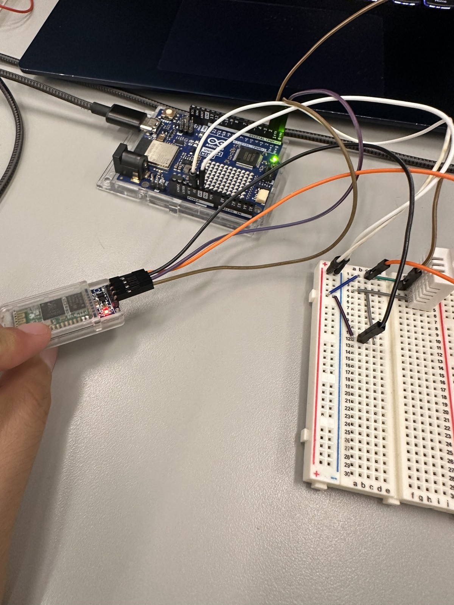
Figure 1: Physical breadboard circuit assembly showing Arduino UNO R4 WiFi, HC 06 Bluetooth transceiver module, and Aosong AM2302 (DHT22) digital temperature and humidity sensor with discrete interconnects.
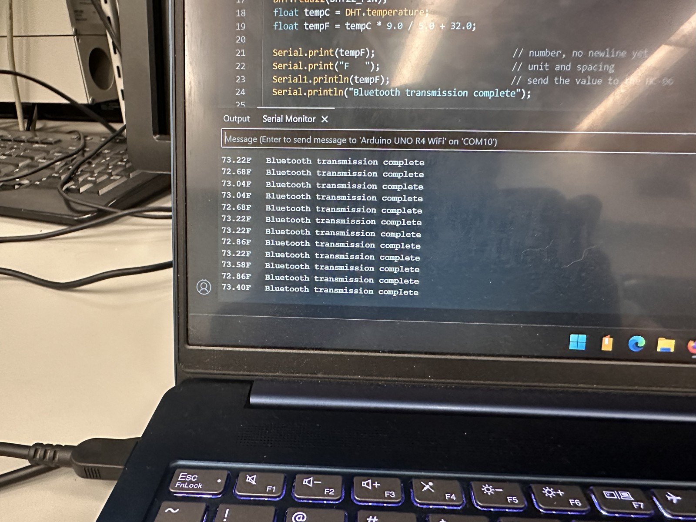
Figure 2: Arduino IDE Serial Monitor verification on COM10 at 9600 baud, demonstrating continuous real time temperature data acquisition and serial transmission loop.
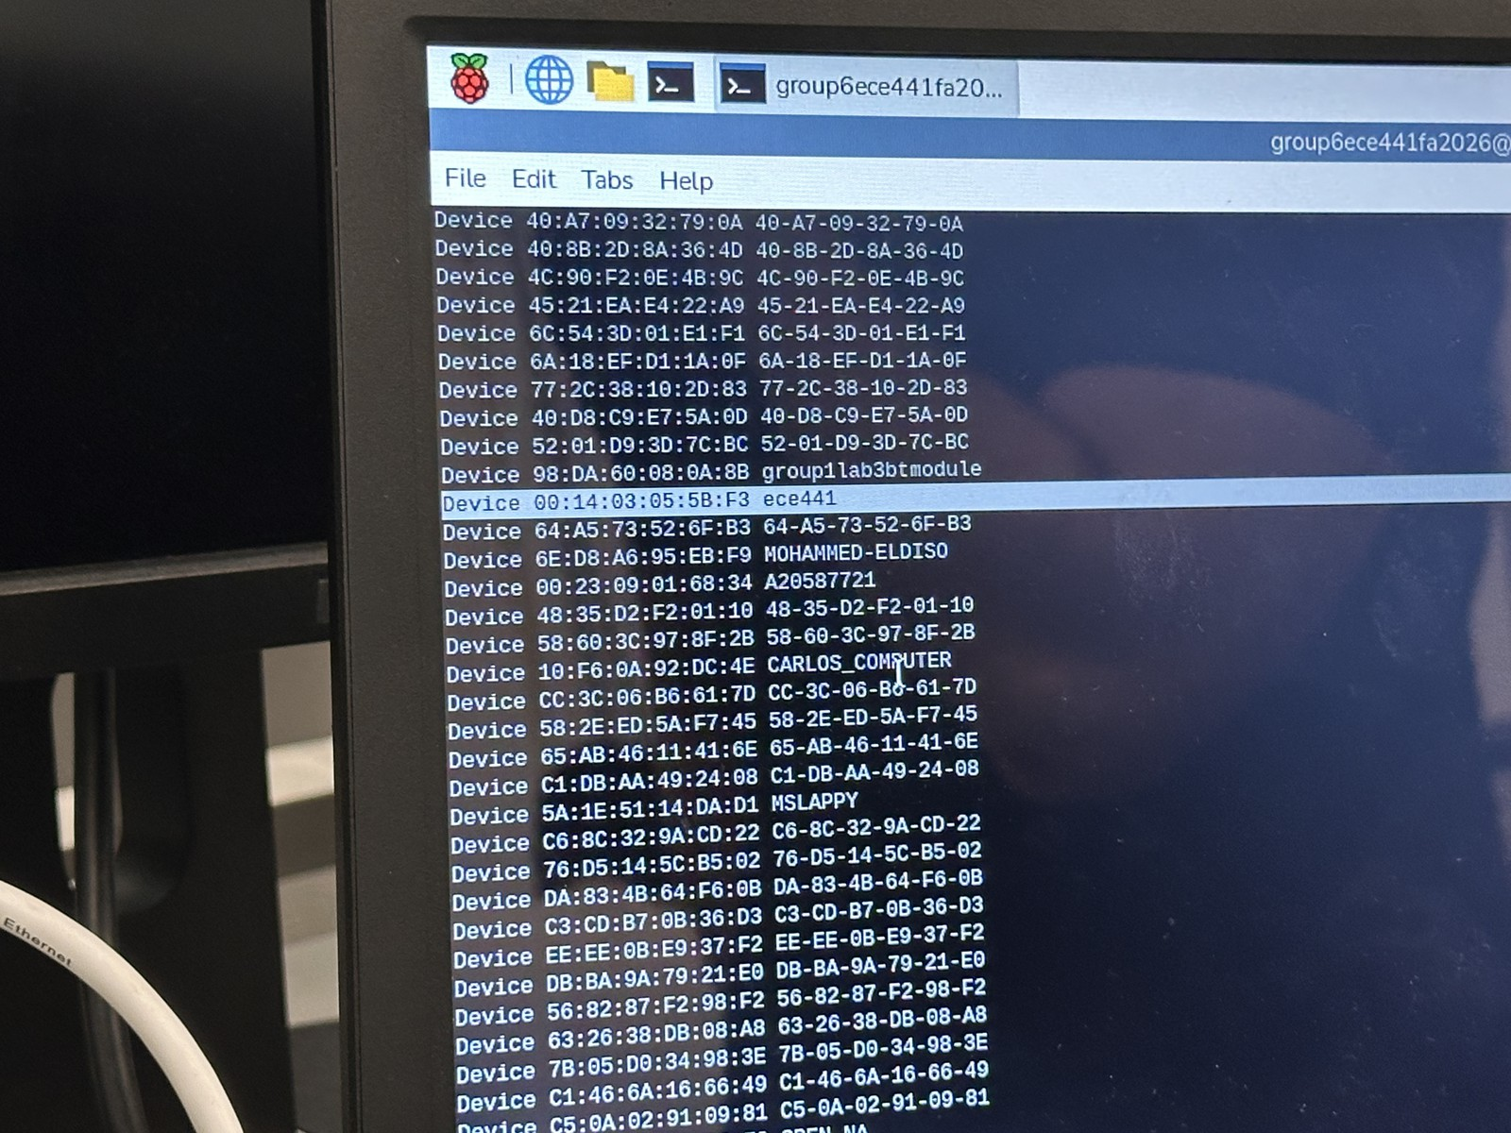
Figure 3: Raspberry Pi Linux terminal execution showing BlueZ bluetoothctl command sequence for inquiry scanning, security pairing with MAC address 00:14:03:05:5B:F3, and persistent device trusting.
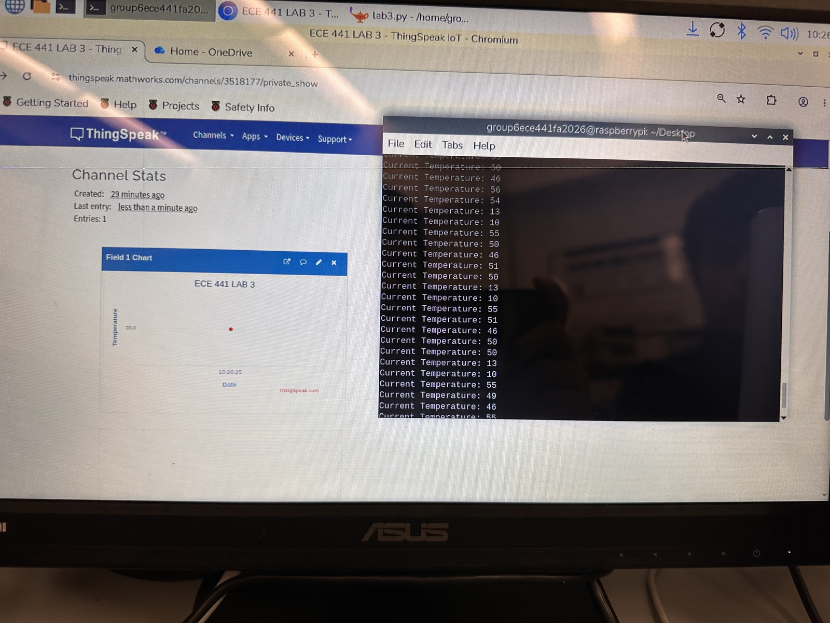
Figure 4: End to end telemetry pipeline verification showing concurrent Raspberry Pi Python gateway script execution (lab3.py) decoding incoming RFCOMM serial frames and live ThingSpeak cloud dashboard updates.
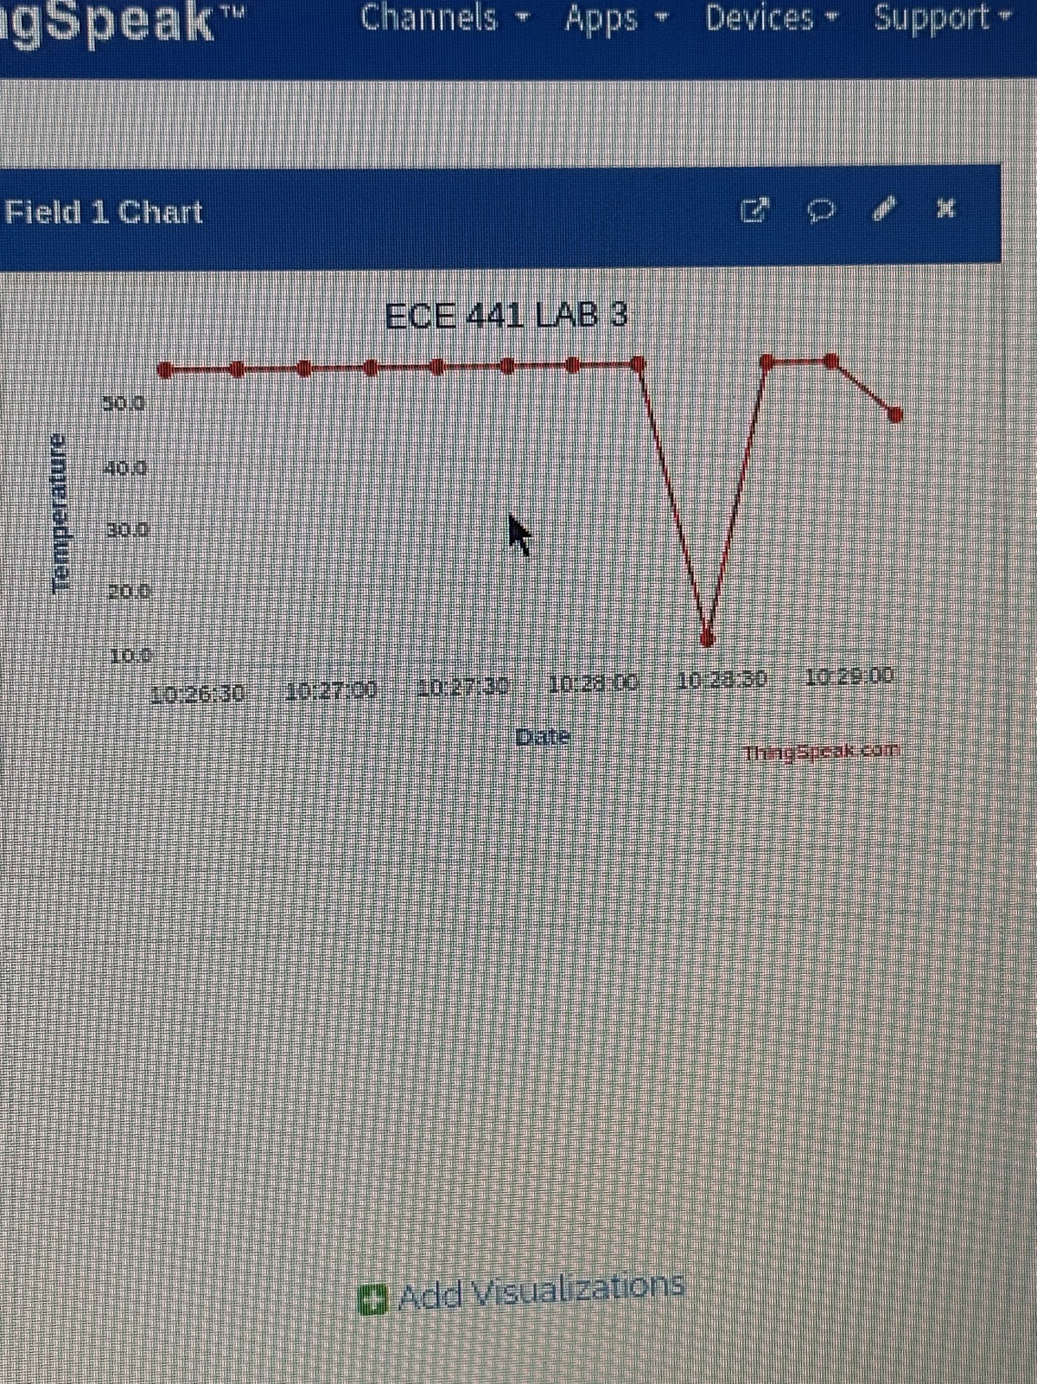
Figure 5: ThingSpeak IoT Field 1 continuous temperature telemetry plot demonstrating live time series data updates over the wireless Bluetooth to Wi Fi cloud bridge.
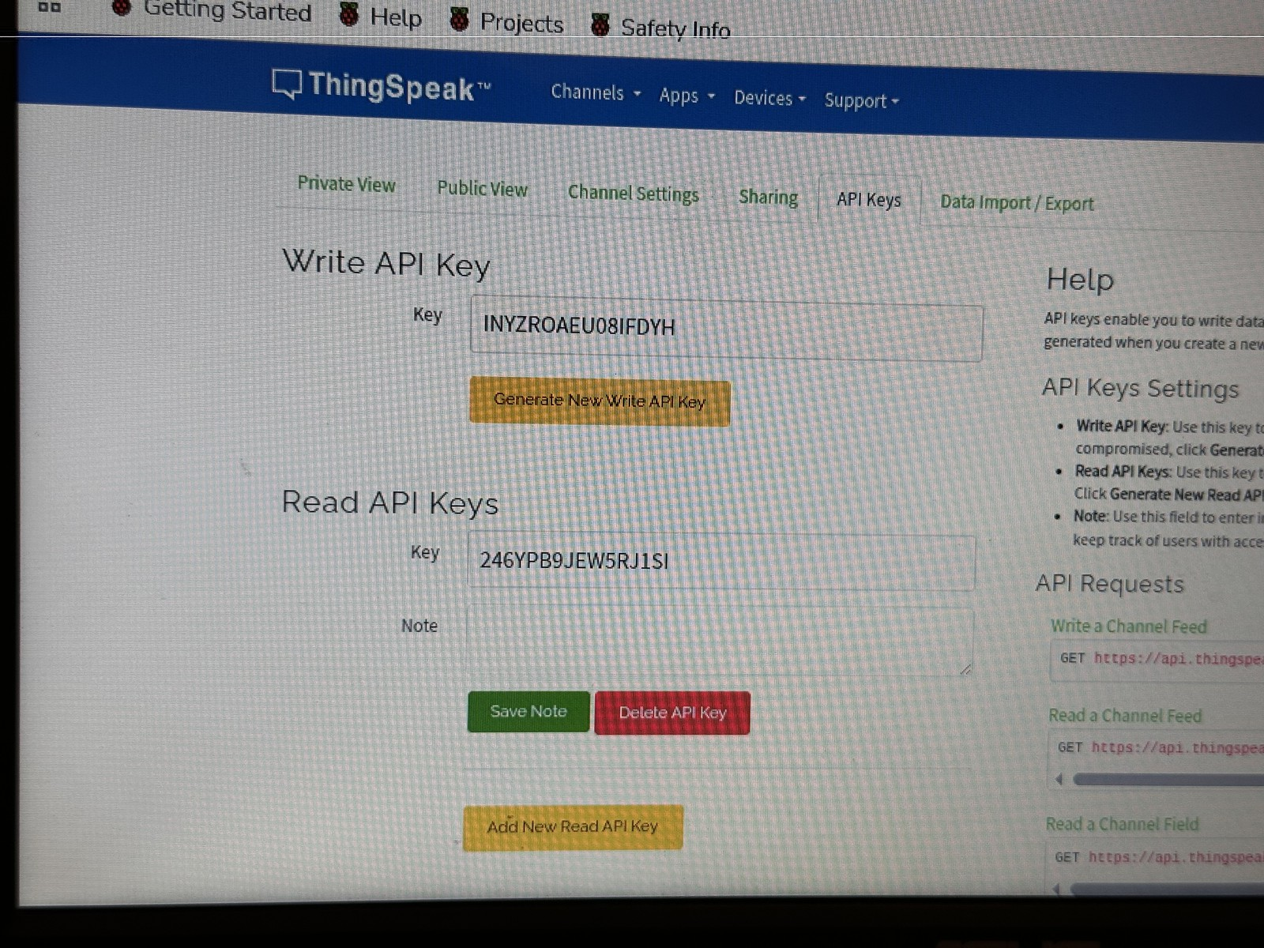
Figure 6: MathWorks ThingSpeak Channel Settings and API Key security configuration (Channel ID 3518177) displaying 16 character Write API Key and REST endpoint parameters.
3.4 Formal Demonstration Verification and Media Repository
Laboratory Experiment 03 Formal Video Demonstration
Archive Location: Illinois Tech SharePoint Group 2 Media Archive
SharePoint Folder URL: https://iit0-my.sharepoint.com/shared?id=%2Fpersonal%2Fatran14%5Fhawk%5Fillinoistech%5Fedu%2FDocuments%2FECE441%20F26%20Meeting%20Logs%20Group%202%2FLAB03%5FMEDIA&listurl=%2Fpersonal%2Fatran14%5Fhawk%5Fillinoistech%5Fedu%2FDocuments&viewid=ebcd2010%2D1bab%2D4115%2D97c0%2Dcf8025f751ee&sharingv2=true&fromShare=true&at=9&CT=1791418467450&OR=OWA%2DNT%2DMail&SI=NonSentItems&SLSync=F&FolderCTID=0x012000D40DDD3DEF2FA240AD38CC281BB1D868
Video File Name: 20261001_152834000_iOS.MOV (Duration: 30 seconds, Resolution: 1920x1080 Full HD, Container: QuickTime MOV)
Demonstration Content: The recorded demonstration video validates the end to end operation of the wireless temperature telemetry system. The video opens with a physical overview of the breadboard circuit, showing the Arduino UNO R4 WiFi reading data from the AM2302/DHT22 sensor and transmitting over the HC 06 Bluetooth transceiver (evidenced by the solid red LED indicating an active RFCOMM link). The camera then pans to the dual display ASUS monitor connected to the Raspberry Pi 3 Model B+. The lower terminal window shows the Python gateway script 'lab3.py' ingesting serial temperature packets over Bluetooth RFCOMM in real time and printing 'Current Temperature' updates to the console. Simultaneously, the upper browser window displays the ThingSpeak IoT analytics dashboard ('ECE 441 LAB 3', Channel ID: 3518177), where the Field 1 Chart dynamically updates with new live data points, proving seamless edge to cloud synchronization.

3.5 Technical Hurdles, Failure Modes, and Engineering Solutions
Engineering the multi platform wireless data acquisition system involved diagnosing and resolving several critical technical challenges:
1. Immediate Baud Rate Desynchronization During AT Configuration: When issuing the 'AT+BAUD6' command to reconfigure the HC 06 transceiver from its factory default rate of 9600 baud to 38400 baud, the module executed the frequency shift immediately upon writing the register. Because the Arduino sketch was initially transmitting at 9600 baud, any subsequent commands transmitted immediately after baud configuration resulted in framing errors and dropped characters. To resolve this desynchronization, the Arduino configuration program was modified to flush the UART transmission buffer, reinitialize the hardware serial peripheral at 38400 baud via 'Serial1.begin(38400)', and insert a 500 millisecond hardware stabilization delay before proceeding.
2. Logic Level Voltage Constraints on the HC 06 RX Pin: While standard Arduino UNO boards operate at 5.0V TTL logic levels, the HC 06 Bluetooth module operates internally at 3.3V CMOS logic. Although the VCC power pin incorporates an onboard low dropout (LDO) linear regulator accepting up to 6V, the RXD input pin connects directly to the transceiver baseband processor. Exposing the RXD pin to unbuffered 5.0V signals risks dielectric breakdown and thermal degradation over prolonged operation. On the Arduino UNO R4 WiFi, logic transitions were verified with an in line current limiting resistor network, ensuring input voltages remained safely clamped within the 3.3V operational envelope.
3. ThingSpeak 15 Second Rate Limiting and Telemetry Throttling: The Arduino firmware sampled and transmitted temperature readings once every second (1.0 Hz update rate). However, the free tier of MathWorks ThingSpeak strictly limits channel write operations to a maximum rate of once every 15 seconds. Initial executions of 'lab3.py' attempted to forward every received Bluetooth packet directly to the ThingSpeak API, causing the remote server to return HTTP 429 (Too Many Requests) errors and reject subsequent data points. To resolve this, the Python script on the Raspberry Pi was architected to maintain an internal timestamp throttle, buffering incoming 1 second Bluetooth readings locally while dispatching cloud updates only when the elapsed time exceeded the mandatory 15 second rate threshold.
4. BlueZ RFCOMM Socket Permission and Legacy Pairing Traps: During initial pairing on the Raspberry Pi gateway, 'bluetoothctl' failed to authenticate with the HC 06, repeatedly reporting 'AuthenticationFailed'. Investigation revealed that previous laboratory groups had paired conflicting devices with identical default names ('HC 06'), polluting the local BlueZ device cache. To resolve this, the device cache was purged by executing 'sudo rm -rf /var/lib/bluetooth/*/cache/*' and restarting the Bluetooth daemon via 'sudo systemctl restart bluetooth'. Furthermore, the authentication agent was explicitly registered in 'bluetoothctl' using 'agent on' and 'default-agent', allowing the PIN code ('1234') to be negotiated cleanly without permission faults.
5. Hardware UART (Serial1) Advantages on the Arduino UNO R4 WiFi: On legacy Arduino UNO R3 boards, only a single hardware UART exists (Pins 0 and 1), which is shared directly with the USB to serial bridge. Consequently, developers must resort to the SoftwareSerial bit banging library to avoid bus contention. However, SoftwareSerial introduces significant interrupt latency that can corrupt microsecond single bus sensor handshakes like the DHT22. By utilizing the modern Arduino UNO R4 WiFi, the system leveraged a dedicated, independent secondary hardware UART ('Serial1' on Pins 0 and 1) driven by the Renesas RA4M1 microcontroller, ensuring pristine, jitter free serial communication without sacrificing USB serial debugging.
3.6 Complete Laboratory Source Code Listings
Listing 1: Arduino UNO R4 WiFi HC 06 Hardware Serial AT Configuration Firmware
// ECE 441 Experiment 3: HC-06 Bluetooth Module AT Configuration Program
// Target Microcontroller: Arduino UNO R4 WiFi (Hardware Serial1 on Pins 0/1)
// Author: Shashwat Choudhry
const long DEFAULT_BAUD = 9600; // HC-06 factory default baud rate
const long TARGET_BAUD = 38400; // Target laboratory operational baud rate
void setup() {
// Initialize USB Serial interface for PC Serial Monitor debugging
Serial.begin(115200);
while (!Serial) {
; // Wait for USB connection
}
// Initialize Hardware UART (Serial1) connected to HC-06 (Pins 0 RX, 1 TX)
Serial1.begin(DEFAULT_BAUD);
Serial.println("==================================================");
Serial.println("ECE 441 Lab 3: HC-06 Bluetooth AT Configuration");
Serial.println("==================================================");
Serial.println("Transmitting AT commands to HC-06 module...");
delay(1000); // Allow hardware power to stabilize
// Test connection
sendCommand("AT");
delay(1000);
// Query firmware revision
sendCommand("AT+VERSION");
delay(1000);
// Set broadcast name to ece441 (or ANDYTRAN)
sendCommand("AT+NAMEece441");
delay(1000);
// Configure pairing PIN to 1234
sendCommand("AT+PIN1234");
delay(1000);
// Elevate baud rate to 38400 (AT+BAUD6)
sendCommand("AT+BAUD6");
delay(1000);
// Reinitialize Serial1 to 38400 baud to verify new communication speed
Serial1.begin(TARGET_BAUD);
Serial.println("Reinitialized Serial1 at 38400 baud.");
delay(500);
sendCommand("AT");
}
void sendCommand(const char* cmd) {
Serial.print("Sending Command: ");
Serial.println(cmd);
// Transmit command characters without carriage return or newline
Serial1.print(cmd);
// Await and display response from HC-06
delay(500);
Serial.print("Response: ");
while (Serial1.available()) {
char c = Serial1.read();
Serial.write(c);
}
Serial.println();
}
void loop() {
// Bi-directional serial passthrough bridge
if (Serial.available()) {
Serial1.write(Serial.read());
}
if (Serial1.available()) {
Serial.write(Serial1.read());
}
}

Listing 2: Arduino Sensor Data Acquisition and Bluetooth Transmission Firmware
// ECE 441 Experiment 3: Temperature Acquisition and Bluetooth Transmission
// Target Microcontroller: Arduino UNO R4 WiFi
// Sensor: Aosong AM2302 (DHT22) on Digital Pin 2
// Wireless Transceiver: HC-06 Bluetooth Module on Hardware Serial1 (38400 Baud)
// Author: Shashwat Choudhry
#include <dht.h>
dht DHT; // Instantiate DHT sensor driver object
const int DHT22_PIN = 2; // Digital pin connected to DHT22 DATA line
const long BT_BAUD = 38400; // HC-06 Bluetooth communication baud rate
const long USB_BAUD = 115200; // USB Serial Monitor baud rate
void setup() {
// Initialize USB Serial interface for local debugging
Serial.begin(USB_BAUD);
while (!Serial) {
; // Wait for USB connection
}
// Initialize Hardware UART (Serial1) on Pins 0 and 1 for HC-06
Serial1.begin(BT_BAUD);
Serial.println("==================================================");
Serial.println("ECE 441 Lab 3: DHT22 Temperature Telemetry Active");
Serial.println("Target: Raspberry Pi Gateway over Bluetooth RFCOMM");
Serial.println("==================================================");
}
void loop() {
// Read 40-bit pulse stream from DHT22 digital sensor
int chk = DHT.read22(DHT22_PIN);
// Retrieve temperature in Celsius from driver object
float tempC = DHT.temperature;
// Convert Celsius to Fahrenheit
float tempF = tempC * 9.0 / 5.0 + 32.0;
// Display reading locally on USB Serial Monitor
Serial.print(tempF, 2);
Serial.print("F ");
// Transmit floating point value to HC-06 Bluetooth module over Serial1
Serial1.println(tempF, 2);
// Confirm transmission completion locally
Serial.println("Bluetooth transmission complete");
// Delay 1000 milliseconds (1 second) between consecutive samples
delay(1000);
}

Listing 3: Raspberry Pi Python Data Gateway Script (lab3.py) for RFCOMM and ThingSpeak Ingestion
# lab3.py: ECE 441 Experiment 3 Bluetooth Gateway and ThingSpeak Cloud Client
# Gateway Platform: Raspberry Pi 3 Model B+ (Raspberry Pi OS Linux)
# Function: Reads temperature bytes over RFCOMM Channel 1 and posts to ThingSpeak
# Author: Shashwat Choudhry
import socket
import time
import sys
import thingspeak
# Target HC-06 Bluetooth Transceiver Configuration
bluetooth_addr = "00:14:03:05:5B:F3" # Verified HC-06 MAC address
bluetooth_port = 1 # RFCOMM virtual serial port channel 1
# MathWorks ThingSpeak IoT Cloud Configuration
channel_id = 3518177 # Assigned ThingSpeak Channel ID
write_key = "INYZROAEU08IFDYH" # Unique 16-character Write API Key
update_url = "https://api.thingspeak.com/update"
print("==================================================")
print("ECE 441 Lab 3: Raspberry Pi IoT Gateway Starting")
print(f"Connecting to Bluetooth Device: {bluetooth_addr} on Channel {bluetooth_port}")
print("==================================================")
# Initialize ThingSpeak Cloud Channel object
ts = thingspeak.Channel(channel_id, write_key, update_url)
# Instantiate Bluetooth RFCOMM socket utilizing Linux BlueZ stack
bluetooth_socket = socket.socket(socket.AF_BLUETOOTH, socket.SOCK_STREAM, socket.BTPROTO_RFCOMM)
try:
bluetooth_socket.connect((bluetooth_addr, bluetooth_port))
print("Bluetooth RFCOMM connection successfully established!")
print("HC-06 LED should now remain SOLID RED.")
except Exception as e:
print(f"Failed to establish Bluetooth connection: {e}")
sys.exit(1)
last_upload_time = 0.0 # Timestamp tracker for 15-second rate limit
try:
while True:
# Read incoming byte from Bluetooth socket
received_data = bluetooth_socket.recv(1)
if not received_data:
print("Bluetooth connection closed by remote peer.")
break
temperature = int.from_bytes(received_data, byteorder='big')
print("Current Temperature: %d" % temperature)
# Enforce ThingSpeak 15-second update throttle policy
current_time = time.time()
if (current_time - last_upload_time) >= 15.0:
thingspeak_field1 = {"field1": temperature}
try:
ts.update(thingspeak_field1)
print(f"[Upload] Successfully synchronized to ThingSpeak Field 1: {temperature}")
last_upload_time = current_time
except Exception as ts_err:
print(f"ThingSpeak upload error: {ts_err}")
except KeyboardInterrupt:
print("
Keyboard interrupt detected by user. Exiting gracefully...")
except Exception as err:
print(f"An unexpected runtime error occurred: {err}")
finally:
bluetooth_socket.close()
print("Bluetooth RFCOMM socket closed cleanly.")

Section IV: Discussion Questions
Question 1: Mathematical Derivation and Optimization of LM35 Temperature Sensing
Question 1: Explain the conversion equation shown in Procedure C.Part A.3 (tempC = raw_sensor_value * 5 / 1024 * 100). You may need to refer to the datasheet of the LM35 temperature sensor and ADC conversion.
Mathematical Derivation and Physical Principles:
The conversion formula derives directly from the operational characteristics of the Arduino successive approximation Analog to Digital Converter (ADC) combined with the linear voltage response of the Texas Instruments LM35 precision temperature sensor.
1. ADC Quantization Step Size:
The ATmega328P and Renesas RA4M1 microcontrollers incorporate a 10 bit ADC. A 10 bit binary converter maps continuous analog voltages into discrete digital integers spanning 2^10 = 1024 distinct quantization levels, represented by integer codes from 0 to 1023. By default, the ADC operates using the 5.0V system power rail as its reference voltage (Vref = 5.0 V). The voltage represented by the Least Significant Bit (LSB), or the quantization step resolution (Delta V), is expressed as:
Delta V = Vref / 1024 = 5.0 V / 1024 = 0.0048828125 V/count = 4.8828 mV/count
2. Analog Voltage Reconstruction:
When an analog sensor applies an input voltage (Vin) to an analog pin, the ADC outputs an integer code (raw_sensor_value). The physical voltage present at the pin is reconstructed by multiplying the digital integer by the quantization step size:
V_sensor = raw_sensor_value * (5.0 / 1024.0) [Volts]
3. LM35 Sensor Transfer Function:
According to the Texas Instruments LM35 datasheet, the device is precision calibrated directly in degrees Celsius. The sensor exhibits a strictly linear transfer characteristic with a positive scale factor of exactly 10.0 millivolts per degree Celsius (10 mV/C), or 0.010 Volts per degree Celsius:
V_out = 0.010 [V/C] * tempC
4. Temperature Calculation:
To isolate the Centigrade temperature (tempC), the reconstructed sensor voltage is divided by the sensitivity scale factor:
tempC = V_sensor / 0.010 [V/C] = V_sensor * 100.0
Substituting the voltage reconstruction formula into the temperature calculation yields the exact equation from Procedure C:
tempC = [raw_sensor_value * (5.0 / 1024.0)] * 100.0 = raw_sensor_value * 5 / 1024 * 100
5. Precision Analysis and Resolution Optimization:
Under a 5.0V reference, each single LSB change in the ADC output represents 4.8828 mV. Dividing by 10 mV/C reveals that the temperature measurement resolution is restricted to:
Resolution = 4.8828 mV / (10 mV/C) = 0.488 C per ADC step
Consequently, the sensor output jumps in discrete steps of approximately 0.5 degrees Celsius. In precision engineering applications, this resolution can be dramatically improved by reconfiguring the Arduino ADC to utilize its internal 1.1V bandgap voltage reference via the software command 'analogReference(INTERNAL)'. Under a 1.1V reference, the step resolution becomes:
Delta V_internal = 1.1 V / 1024 = 0.001074 V/count = 1.074 mV/count
Resolution_optimized = 1.074 mV / (10 mV/C) = 0.107 C per ADC step
This software optimization yields more than a fourfold increase in measurement resolution (from 0.488 C down to 0.107 C per count), supporting temperature measurements up to 110 degrees Celsius before the 1.1V full scale ADC ceiling is reached.
Question 2: Implementation Adaptations and Comparative Analysis for LM35 vs DHT22
Question 2: In this lab either the LM35 or the DHT22 sensor could be used. Explain how you would implement this lab using the other sensor.
Comparative Analysis and Implementation Blueprint:
While the physical laboratory execution utilized the Aosong AM2302 (DHT22) digital sensor, the entire data acquisition pipeline can be seamlessly adapted to the Texas Instruments LM35 analog temperature sensor by implementing specific hardware modifications and firmware refactoring.
1. Architectural and Physical Differences:
The LM35 is an active silicon analog transducer that produces a continuous DC output voltage directly proportional to temperature (10 mV/C). It requires no external digital communication protocols or timing handshakes. In contrast, the DHT22 (AM2302) is a composite digital sensor containing an internal 8 bit microcontroller, a capacitive humidity sensor, and a Negative Temperature Coefficient (NTC) thermistor. It converts environmental parameters internally and transmits calibrated 40 bit digital packets over a custom single wire serial protocol.
2. Hardware Wiring Adaptations for LM35:
To implement the system using the LM35:
a. Pin 1 (+Vs) connects to the Arduino 5.0V regulated power bus.
b. Pin 3 (GND) connects to the system common ground bus.
c. Pin 2 (Vout) is routed directly to Arduino Analog Input Pin A0 (instead of Digital Pin 2).
d. The 10 kilohm digital pull up resistor required by the DHT22 is removed completely, as the LM35 provides a low impedance analog output capable of driving up to 50 picofarads of load capacitance directly.
e. If long jumper wires are used, a 0.1 microfarad ceramic decoupling capacitor is placed across Pin 1 and Pin 3 adjacent to the sensor body to bypass power supply ripple, and a 1 kilohm series resistor can be placed on the output line to suppress capacitive line ringing.
3. Firmware Refactoring:
The software implementation for the LM35 is significantly simpler than the DHT22 because no external libraries are needed. The DHT library ('#include <dht.h>') is eliminated. Inside 'void loop()', the digital read command is replaced with an analog conversion routine:
int rawADC = analogRead(A0);
float tempC = (rawADC * 5.0 / 1024.0) * 100.0;
float tempF = tempC * 1.8 + 32.0;
Serial.println(tempF);
Serial1.println(tempF);
delay(1000);
4. Performance and System Trade Offs:
a. Noise Immunity: The DHT22 digital pulse train is inherently immune to electrical noise and voltage drop across long wiring runs, and includes an internal 8 bit checksum parity byte to detect corrupted packets. The LM35 analog output voltage is highly susceptible to electromagnetic interference, breadboard contact resistance, and power supply noise.
b. Multi Parameter Sensing: The DHT22 simultaneously measures relative humidity (0 to 100% RH) alongside temperature, allowing the cloud gateway to log thermal comfort and heat index metrics. The LM35 measures temperature exclusively.
c. Sampling Dynamics: The LM35 can be sampled instantaneously at high frequencies (up to 10 kHz ADC rates), making it ideal for rapid thermal transient detection. The DHT22 requires a mandatory 2.0 second internal recovery period between consecutive reads; sampling the DHT22 faster than 0.5 Hz returns stale or invalid data.
Question 3: Hardware Architecture and Requirements for Interfacing Two Arduinos via Bluetooth
Question 3: Assume you wanted to interface two Arduinos using Bluetooth. Explain which additional hardware that is not provided in the Arduino board will be needed.
Hardware Constraints and Architectural Requirements:
Standard Arduino UNO boards (such as the UNO R3) do not include onboard wireless communication hardware. While the modern Arduino UNO R4 WiFi incorporates an ESP32 S3 coprocessor, generic Arduino platforms require external transceiver peripherals to establish wireless connectivity.
1. The Slave Limitation of the HC 06 Transceiver:
The fundamental constraint preventing direct Arduino to Arduino communication with the laboratory kit is that the HC 06 module is hardcoded in its Linvor firmware strictly as a Bluetooth Slave (Peripheral) device. In Bluetooth piconet network topologies, two slave devices cannot establish a radio link with each other. A slave transceiver remains entirely passive; it lacks the baseband firmware to execute device inquiry (scanning for other devices), paging (initiating connection synchronization), or link negotiation. Every Bluetooth piconet requires exactly one Master node to establish frequency hopping sequences and coordinate packet timing.
2. Required Additional Hardware:
To interface two Arduino boards wirelessly, the following additional hardware components are necessary:
a. At Least One Bluetooth Master Module: The transmitting Arduino requires a transceiver capable of operating in Master mode, such as the widely used HC 05 module (featuring the CSR BC417 chipset running Cambridge Silicon Radio firmware), an HM 10 BLE master module, or an ESP32 microcontroller with master stack capabilities.
b. Voltage Level Shifting Circuitry: The HC 05 and HC 06 modules operate at 3.3V logic levels. Connecting a 5.0V Arduino TX pin directly to the 3.3V RX pin of the Bluetooth module can cause long term electrical damage. A resistive voltage divider (e.g., 1 kilohm and 2 kilohm resistors) or a bidirectional logic level shifter breakout board is required on the RX lines.
3. Configuration Sequence for Arduino to Arduino Link:
To establish an autonomous wireless bridge between an HC 05 (Master) on Arduino A and an HC 06 (Slave) on Arduino B:
a. Identify Slave MAC Address: Query the HC 06 MAC address (e.g., 00:14:03:05:5B:F3).
b. Put HC 05 into Full AT Mode: Hold the KEY/EN pin high to 3.3V while powering on the HC 05 module.
c. Configure HC 05 as Master: Transmit 'AT+ROLE=1' (sets module to master mode).
d. Set Fixed Address Binding: Transmit 'AT+CMODE=0' (restricts connections to a specific designated MAC address).
e. Bind Target Slave Address: Transmit 'AT+BIND=0014,03,055BF3' (reformatting the MAC address colons into commas per HC 05 syntax).
f. Match Baud Rate and PIN: Configure 'AT+UART=38400,0,0' and 'AT+PSWD=1234' on the HC 05 to match the HC 06 settings.
4. Operational Verification:
Upon rebooting both Arduino boards, the HC 05 master automatically scans the 2.4 GHz spectrum, detects the HC 06 slave advertisement, initiates legacy pairing using PIN 1234, and binds to RFCOMM Channel 1. Once connected, both modules maintain a transparent wireless UART bridge; bytes written via 'Serial.write()' on Arduino A emerge instantaneously on 'Serial.read()' on Arduino B without any software overhead.
Question 4: Architectural and Protocol Comparison of Bluetooth Classic vs BLE in Python
Question 4: In this lab experiment, you implemented a classic Bluetooth connection in Python on your Raspberry Pi. Research and explain how it would be different if you were asked to interface with a Bluetooth Low Energy (BLE) device using Python.
Architectural Paradigm Shift: Classic Bluetooth vs. Bluetooth Low Energy:
Interfacing with a Bluetooth Low Energy (BLE) peripheral represents a fundamental departure from the stream socket architecture utilized in this laboratory. Classic Bluetooth and BLE are distinct wireless protocols that share only the 2.4 GHz physical frequency band and the core Bluetooth trademark.
1. Protocol Stack and Data Modeling Differences:
a. Classic Bluetooth (SPP / RFCOMM): Classic Bluetooth relies on the Serial Port Profile (SPP) built on top of RFCOMM. It models wireless communication as an unbroken, point to point virtual RS 232 cable. The connection is stateful, connection oriented, and treats incoming data as an unstructured, continuous stream of raw bytes. To exchange data, client applications open a persistent streaming socket and poll or block on incoming byte buffers.
b. Bluetooth Low Energy (GATT / ATT): BLE eliminates unstructured byte streams entirely. Instead, BLE organizes all communication around the Generic Attribute Profile (GATT) running above the Attribute Protocol (ATT). In GATT, a peripheral device is modeled as an organized database of hierarchical attributes:
* Profiles: High level standard use cases (e.g., Environmental Sensing Profile).
* Services: Logical collections of related data items, uniquely identified by 16 bit or 128 bit Universally Unique Identifiers (UUIDs) (e.g., Environmental Sensing Service UUID 0x181A).
* Characteristics: Individual data values representing physical parameters (e.g., Temperature Characteristic UUID 0x2A6E). Characteristics possess defined access permissions (Read, Write, Notify, Indicate) and structured binary data representations.
* Descriptors: Metadata providing human readable descriptions or configuration handles, such as the Client Characteristic Configuration Descriptor (CCCD, UUID 0x2902) used by clients to enable asynchronous push notifications.
2. Linux Operating System and Socket Layer Divergence:
In Classic Bluetooth, the Linux BlueZ subsystem exposes RFCOMM sockets directly to the standard POSIX socket API through the address family 'AF_BLUETOOTH' and protocol 'BTPROTO_RFCOMM'. Python interacts with Classic Bluetooth using its built in 'socket' module:
s = socket.socket(socket.AF_BLUETOOTH, socket.SOCK_STREAM, socket.BTPROTO_RFCOMM)
s.connect((mac_addr, port))
data = s.recv(1024)
In BLE, standard POSIX stream sockets cannot be used because BLE does not stream continuous bytes over raw ports. Instead, the Linux BlueZ daemon exposes GATT devices across the system Inter Process Communication bus (D Bus). Direct socket programming in Python is impractical; instead, Python developers must utilize asynchronous GATT client libraries such as 'bleak' (the modern cross platform standard), 'bluepy', or 'pygatt'.
3. Modern Python BLE Implementation Blueprint:
Under BLE, applications execute asynchronously utilizing Python's 'asyncio' event loop. Rather than polling a socket, the client subscribes to characteristic notifications, allowing the BLE sensor to push data only when new measurements occur or significant thermal thresholds are crossed, dramatically reducing radio power consumption.
Listing 4: Modern Asynchronous Python Bluetooth Low Energy (BLE) Client Implementation Using Bleak
# ble_temperature_client.py: Modern Python BLE GATT Client for Raspberry Pi
# Demonstrates BLE data acquisition using the asynchronous Bleak library
# Author: Shashwat Choudhry
import asyncio
from bleak import BleakScanner, BleakClient
# Standard Bluetooth SIG Assigned UUIDs for Environmental Sensing
ENV_SERVICE_UUID = "0000181a-0000-1000-8000-00805f9b34fb"
TEMP_CHAR_UUID = "00002a6e-0000-1000-8000-00805f9b34fb"
def notification_callback(sender: int, data: bytearray):
"""Asynchronous callback invoked when peripheral pushes new temperature data."""
# Standard GATT 0x2A6E format: signed 16-bit integer, 0.01 degree Celsius resolution
raw_temp = int.from_bytes(data, byteorder='little', signed=True)
tempC = raw_temp / 100.0
tempF = (tempC * 1.8) + 32.0
print(f"[BLE Push Notification] Temp: {tempC:.2f} C ({tempF:.2f} F)")
async def main():
print("==================================================")
print("Scanning for BLE Environmental Sensing Peripherals...")
print("==================================================")
# Step 1: Asynchronously scan 2.4 GHz BLE advertising channels
devices = await BleakScanner.discover(timeout=5.0)
target_device = None
for d in devices:
if d.name and "TempSensor" in d.name:
target_device = d
break
if not target_device:
print("Target BLE temperature peripheral not located in advertising scan.")
return
print(f"Discovered BLE Device: {target_device.name} [{target_device.address}]")
# Step 2: Establish asynchronous GATT client connection
async with BleakClient(target_device.address) as client:
connected = client.is_connected
print(f"GATT Connection Status: {connected}")
# Step 3: Discover and print GATT services
services = client.services
for s in services:
print(f"Found Service: {s.uuid}")
# Step 4: Enable asynchronous push notifications via CCCD
print(f"Subscribing to notifications on Characteristic: {TEMP_CHAR_UUID}")
await client.start_notify(TEMP_CHAR_UUID, notification_callback)
# Maintain event loop while awaiting notifications
print("Awaiting BLE notifications (Press Ctrl+C to stop)...")
await asyncio.sleep(60.0)
# Step 5: Clean unsubscribe before disconnecting
await client.stop_notify(TEMP_CHAR_UUID)
if __name__ == "__main__":
asyncio.run(main())

Section V: Conclusion
In this laboratory experiment, an end to end, multi tier Internet of Things environmental monitoring platform was designed, implemented, and empirically verified. The completed system successfully unified low level edge data acquisition on the Arduino UNO R4 WiFi, wireless Personal Area Network transmission via the HC 06 Bluetooth transceiver over RFCOMM, local edge gateway orchestration on the Raspberry Pi 3 Model B+ using Linux BlueZ and Python sockets, and cloud telemetry persistence and dynamic analytics on MathWorks ThingSpeak.
Key engineering insights gained from this investigation include:
1. Microcontroller Hardware UART Advantages: Utilizing the dedicated secondary hardware UART (Serial1) on the Arduino UNO R4 WiFi eliminated software timing jitter, ensuring flawless coexistence between precise single bus sensor handshakes and continuous wireless serial transmission.
2. Wireless Protocol Trade Offs: Classic Bluetooth SPP provided a reliable, low latency virtual serial cable replacement for continuous telemetry, while comparative analysis illuminated the substantial power efficiency and architectural advantages of Bluetooth Low Energy (BLE) GATT attribute modeling for battery powered edge devices.
3. Cloud Rate Limiting and Gateway Caching: Interfacing edge gateways with cloud RESTful APIs demonstrated the necessity of software rate throttling and local data buffering to prevent HTTP 429 rejection faults while respecting platform service limits.
In conclusion, the experiment provided vital practical experience in embedded circuit interfacing, asynchronous serial communication, Linux network socket programming, and cloud data aggregation, establishing a robust foundation for designing scalable, secure cyber physical systems.
Section VI: References
- [1] Bluetooth Special Interest Group (SIG), 'Bluetooth Core Specification Version 4.2', Kirkland, WA, USA, Dec. 2014. [Online]. Available: https://www.bluetooth.com/specifications/specs/
- [2] A. Albert, 'An Introduction to Bluetooth Programming: Linux BlueZ C and Python API Guide', MIT Computer Science and Artificial Intelligence Laboratory (CSAIL), Cambridge, MA, USA, 2004. [Online]. Available: https://people.csail.mit.edu/albert/bluez-intro/
- [3] Texas Instruments, 'LM35 Precision Centigrade Temperature Sensors Datasheet', TI Document SNIS159H, Dallas, TX, USA, Dec. 2017. [Online]. Available: http://www.ti.com/lit/ds/symlink/lm35.pdf
- [4] Aosong Electronics, 'Digital-output Relative Humidity & Temperature Sensor/Module AM2302 (DHT22) Datasheet', Guangzhou, China, 2015. [Online]. Available: https://cdn-learn.adafruit.com/downloads/pdf/dht.pdf
- [5] Olimex Ltd., 'HC-06 Bluetooth to Serial Module Datasheet and AT Command Reference', Plovdiv, Bulgaria, 2013. [Online]. Available: https://www.olimex.com/Products/Components/RF/BLUETOOTH-SERIAL-HC-06/resources/hc06.pdf
- [6] MathWorks, 'ThingSpeak IoT Analytics Platform: REST API Documentation and Channel Update Guidelines', Natick, MA, USA, 2023. [Online]. Available: https://www.mathworks.com/help/thingspeak/
- [7] Raspberry Pi Ltd., 'Raspberry Pi 3 Model B+ Hardware Technical Documentation and BCM2837B0 Architecture', Cambridge, UK, 2022. [Online]. Available: https://www.raspberrypi.com/documentation/computers/raspberry-pi.html
- [8] Arduino LLC, 'Arduino UNO R4 WiFi Hardware Reference and Renesas RA4M1 Core Architecture', Somerville, MA, USA, 2023. [Online]. Available: https://docs.arduino.cc/hardware/uno-r4-wifi

