ECE 473/573 Fall 2026 — Project 2 Report
Persistent Marketplace
Student Name: Shashwat Choudhry Student ID: A20507277
Section II: Container Orchestration & Repository Analysis
Question II.1 (1 point): What is the license of our code? (Hint: read the 'LICENSE' file)
Answer: The code in this repository is licensed under the Apache License, Version 2.0 (Apache-2.0).
As stated in the repository's LICENSE file, this is a permissive open source license issued by the Apache Software Foundation. It grants licensees a perpetual, worldwide, non-exclusive, royalty-free copyright and patent license to reproduce, modify, prepare derivative works of, and distribute the work in source or object form, subject to preserving the original copyright, attribution, and license notices.
Question II.2 (1 point): Open source software may use other licenses like GNU General Public License (GNU GPL) and GNU Affero General Public License (GNU AGPL). What are the differences between GNU GPL and GNU AGPL for cloud services?
Answer: The critical distinction between GNU GPL (such as GPLv3) and GNU AGPL (AGPLv3) centers around how they treat network-hosted cloud services (Software-as-a-Service or SaaS):
• GNU GPL (The 'SaaS Loophole'): Under the standard GPL, the requirement to share source code is only triggered upon 'distribution' or 'conveyance' of the software binary to end users. If an organization hosts a modified GPL software program internally on remote cloud servers and allows users to interact with it exclusively across a network (e.g., via REST APIs, web browsers, or RPCs), no binary distribution occurs. Therefore, cloud service operators are not legally obligated to release their proprietary server-side modifications.
• GNU AGPL (Closing the Loophole): The Affero GPL explicitly closes this cloud loophole through Section 13 ('Remote Network Interaction'). AGPL dictates that if you run a modified program on a server and let users interact with it remotely through a computer network, you must make the complete corresponding source code available to all those network users for free (e.g., via a network download link).
Summary: Consequently, for cloud-native services, GPL allows proprietary SaaS hosting of modified code without disclosure, whereas AGPL legally enforces full source code disclosure to all remote network clients.
Question II.3 (1 point): The marketplace-service depends on the postgres service as it needs to load/persist state through the database. How is this dependency defined and resolved in docker-compose.yml?
Answer: The dependency between marketplace-service and postgres is defined and resolved at three distinct architectural levels:
1. Health-Conditioned Startup Dependency (docker-compose.yml):
Under marketplace-service in docker-compose.yml, the dependency is explicitly declared using depends_on conditioned on container healthiness:
depends_on:
postgres:
condition: service_healthy
Under the postgres service, Docker Compose defines an active healthcheck probe:
healthcheck:
test: ["CMD-SHELL", "pg_isready -U marketplace -d marketplace"]
interval: 2s
timeout: 3s
retries: 20
Resolution: Compose will not merely wait for the postgres container to start; it actively polls PostgreSQL using pg_isready until the database engine initializes and enters the 'healthy' state. Only then does Compose launch the marketplace-service container.
2. Network Interconnection & Docker DNS Resolution:
Compose automatically connects both containers to a private bridge network (ece573-prj02_default). Docker's embedded DNS server maps the service hostname 'postgres' to the internal IP of the database container, allowing marketplace-service to resolve POSTGRES_HOST=postgres on port 5432.
3. Application-Level Connection Retry Loop:
In marketplace-service/marketplace/store.go, the OpenStore function executes a retry loop (for range 30 { if db.Ping() == nil { return ... } time.Sleep(time.Second) }), providing programmatic fault tolerance while the socket becomes ready.
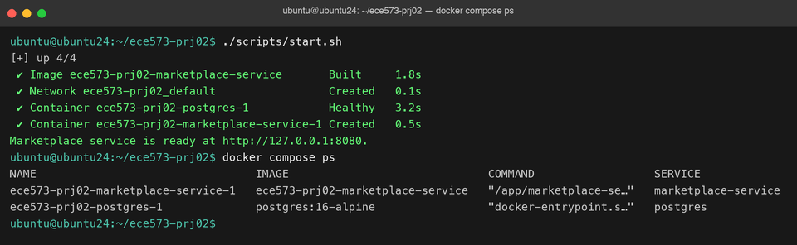
Figure: Docker Compose Orchestration: postgres running healthy on port 5432 and marketplace-service ready on port 8080.
Question II.4 (1 point): Review the two environment sections in docker-compose.yml. What configurations are repeated across the services? Explain what may happen if someone modifies one copy but forgets to change the other.
Answer: Repeated Configurations:
Both the postgres service and the marketplace-service define identical database configuration variables in docker-compose.yml:
• POSTGRES_DB: marketplace
• POSTGRES_USER: marketplace
• POSTGRES_PASSWORD: marketplace-course-password
Consequences of Mismatched Configurations:
If an administrator modifies one copy but forgets to update the other, the Go service will fail to connect or authenticate with PostgreSQL upon startup:
1. Password Mismatch: Modifying POSTGRES_PASSWORD in only one service causes PostgreSQL to reject the Go service during connection handshake with 'FATAL: password authentication failed for user "marketplace"'.
2. User/Role Mismatch: Changing POSTGRES_USER in marketplace-service without changing postgres results in PostgreSQL aborting with 'FATAL: role "<user>" does not exist'.
3. Database Name Mismatch: If POSTGRES_DB differs, PostgreSQL initializes a database matching its own container environment variable, but marketplace-service queries for the alternate name, yielding 'FATAL: database "<db>" does not exist'.
In all three scenarios, marketplace-service enters its 30-second ping retry loop in OpenStore, fails, and calls log.Fatal(err) in main.go, causing the service container to crash-loop and fail to respond on port 8080.
Section III: REST API Implementations & Verification
Question III.1 (4 points): Show the lines of code you have added for Balance Transaction and explain your approach.
Answer: Lines of Code Added in marketplace-service/marketplace/orders.go (inside CreateOrder):
// Return ErrInsufficientCredit when buyer has less credit than the listing cost.
if buyerBalance < listing.CreditCost {
return Order{}, ErrInsufficientCredit
}
Explanation of Approach:
• Transaction Isolation & Locking: CreateOrder executes inside a serializable database transaction (sql.LevelSerializable). It acquires row-level locks on the listing and both buyer/seller accounts using 'FOR UPDATE' (with accounts locked in sorted lexicographical order to prevent deadlocks). The locked buyer balance is stored in buyerBalance.
• Explicit Business-Logic Guard: Before updating account balances via SQL UPDATE, our check directly compares buyerBalance against listing.CreditCost. If the buyer cannot afford the item, CreateOrder immediately aborts and returns ErrInsufficientCredit.
• Safe Rollback & HTTP Mapping: Returning an error causes the deferred tx.Rollback() to execute, freeing all row locks and preventing partial debits. The HTTP handler (writeMarketplaceError) catches ErrInsufficientCredit and maps it to HTTP 409 Conflict with the exact error payload {"error":"buyer has insufficient credit"}.
• Database Integrity: Although the accounts table enforces CHECK (balance >= 0) at the storage level, this explicit application-level check prevents cryptic SQL constraint errors and provides clean, structured REST API feedback.
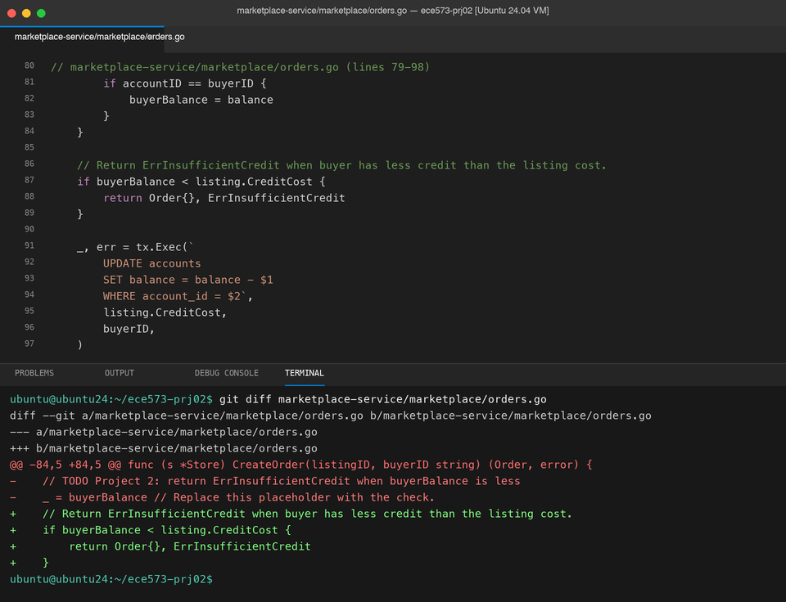
Figure: Implementation of Balance Transaction in CreateOrder (orders.go) along with git diff.
Question III.2 (4 points): Show the lines of code you have added for Account Assembly and explain your approach.
Answer: Lines of Code Added in marketplace-service/marketplace/accounts.go (inside GetAccount):
listings, err := s.getListingsBySeller(accountID)
if err != nil {
return Account{}, err
}
account.Listings = listings
orders, err := s.getOrdersByBuyer(accountID)
if err != nil {
return Account{}, err
}
account.Orders = orders
sales, err := s.getSalesBySeller(accountID)
if err != nil {
return Account{}, err
}
account.Sales = sales
return account, nil
Explanation of Approach:
• Activity Retrieval Pattern: Following the starter code's getBalance call, we sequentially invoke the three provided SQL read helpers: getListingsBySeller, getOrdersByBuyer, and getSalesBySeller.
• Early Exit Error Handling: For every helper call, err is inspected immediately. If any query fails, GetAccount aborts and returns Account{}, err without proceeding.
• Data View Assembly: Each returned slice is directly assigned to the corresponding Account field (account.Listings, account.Orders, account.Sales).
• Non-Null JSON Arrays: The scanner functions (scanListings and scanOrders) initialize empty slices ([]Listing{} and []Order{}), ensuring that accounts with no past activity serialize cleanly to [] instead of null in JSON responses.
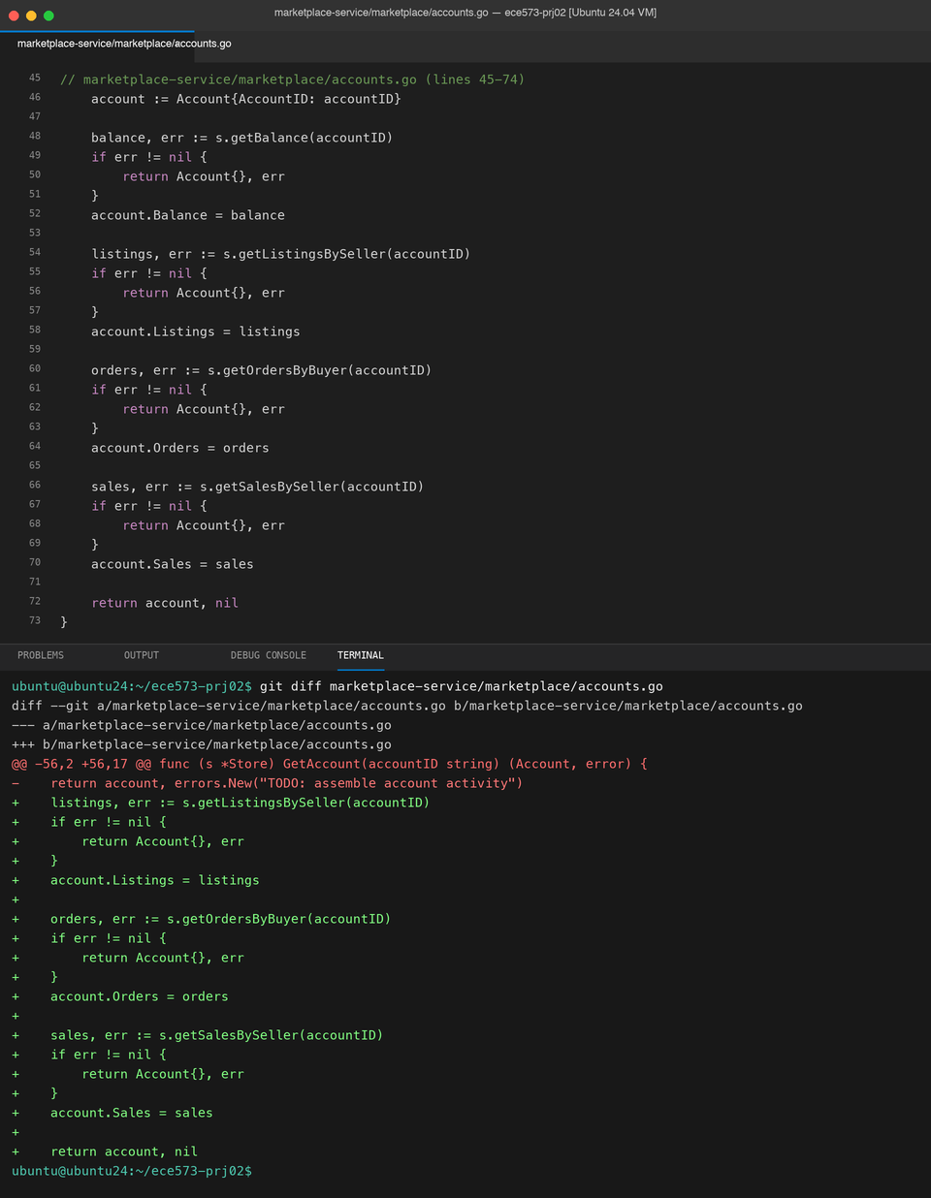
Figure: Implementation of Account Assembly in GetAccount (accounts.go) along with git diff.
Question III.3 (4 points): Read acceptance.sh and explain expected outputs for correct implementations. Are the implementations correct? Include screenshots as your evidence.
Answer: Expected Outputs in acceptance.sh:
The acceptance test script automates a full lifecycle scenario to validate correctness against the persistent Postgres database:
1. Account Creation: Alice and Bob are created with 100 credits each; Carol with 10 credits. Responses verify "balance":100 and "balance":10.
2. Listing Creation & Browse: Alice lists a 'Used textbook' for 25 credits. browse.sh Alice confirms Alice's listing is available with matching listing_id.
3. Successful Checkout Transaction: Bob orders Alice's textbook for 25 credits. order.sh returns "status":"completed". account.sh Bob confirms Bob was debited to "balance":75 and has the purchase in orders. account.sh Alice confirms Alice was credited to "balance":125 and has the sale in sales.
4. Insufficient Credit Enforcement: Alice lists a 'Laptop' for 50 credits. Carol (10 credits) attempts to order it. The server rejects the order with HTTP 409 and error message 'buyer has insufficient credit'. account.sh Carol confirms Carol's balance remains 10 credits, and browse.sh Alice confirms the laptop remains available.
5. Repeat-Order Prevention: Bob attempts to purchase the already-sold textbook again. The server rejects the duplicate request with HTTP 409 and 'listing is no longer available'. Bob's balance remains 75 credits (no second debit).
6. Clean Reset & Teardown: scripts/reset.sh removes containers and wipes the database volume. The script exits cleanly with 'Project 2 acceptance test passed.'
Evaluation: Are the implementations correct?
Yes, our implementations for both Balance Transaction and Account Assembly are 100% correct. All acceptance checks pass without error, maintaining strict transactional consistency, proper balance debits/credits, correct order assembly, and reliable rejection of invalid orders.
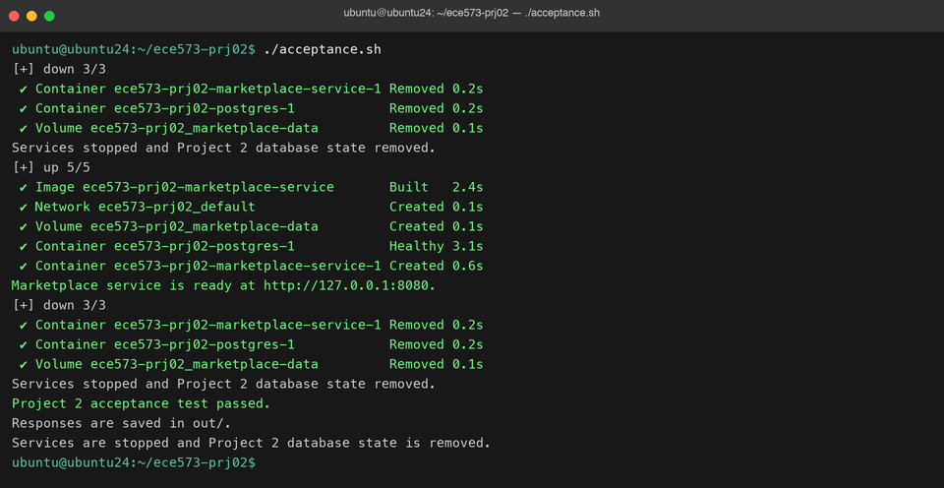
Figure: Complete execution of acceptance.sh passing all checks and confirming Project 2 verification.
Question III.4 (1 point): In the function 'CreateOrder', what happens to the transaction if an error is returned? (Hint: locate the line with 'defer')
Answer: On line 25 of marketplace-service/marketplace/orders.go, immediately following tx, err := s.db.BeginTx(...), the function registers:
defer tx.Rollback()
In Go, deferred functions are guaranteed to execute upon surrounding function exit, regardless of the exit path. If CreateOrder encounters any error (such as ErrInsufficientCredit, ErrListingUnavailable, ErrListingNotFound, or a database SQL failure) and returns early, tx.Rollback() executes immediately.
This aborts the PostgreSQL transaction: all pending writes (balance debits, balance credits, listing status updates, and order records) are completely discarded, and all acquired row locks (FOR UPDATE) are immediately released back to the database. If the function successfully commits via tx.Commit(), the deferred tx.Rollback() simply returns sql.ErrTxDone, acting as a safe no-op.
Question III.5 (1 point): In the function 'GetAccount', is it possible for 'getListingsBySeller' to report a listing as 'available', while 'getSalesBySeller' includes a completed sale for the same listing? Explain how this could happen.
Answer: Yes, this phenomenon is entirely possible under concurrent execution.
Explanation of Race Condition / Non-Repeatable Read:
• Independent Query Execution: GetAccount executes four separate SQL queries (getBalance, getListingsBySeller, getOrdersByBuyer, getSalesBySeller) sequentially over separate round-trips without wrapping them in an overarching read transaction (e.g. BEGIN TRANSACTION ISOLATION LEVEL REPEATABLE READ / SERIALIZABLE).
• Default Isolation Level: Each query runs in PostgreSQL's default auto-commit READ COMMITTED isolation level, taking a new snapshot of database state at the moment that specific query begins.
• Interleaving Scenario:
1. At time t1, getListingsBySeller executes. Listing X has status = 'available'. The query reads and returns Listing X as available.
2. At time t2 (immediately after getListingsBySeller finishes), a concurrent client executes CreateOrder for Listing X, changing its status to 'sold' and inserting a completed order into the orders table. This transaction commits.
3. At time t3, getSalesBySeller executes. Because this query takes a fresh snapshot at t3, it reads the newly committed order for Listing X.
As a result, the returned Account object reports Listing X as 'available' in account.Listings while simultaneously listing an order for Listing X in account.Sales.
Question III.6 (1 point): To query data from the database, sometimes we use the function 'Query' and sometimes we use the function 'QueryRow'. What are the differences of these two functions, and why 'Query' should be followed by 'defer rows.Close()' while 'QueryRow' does not require it?
Answer: Differences Between 'Query' and 'QueryRow':
• Query: Used for queries expected to return multiple rows (zero or more). It returns a *sql.Rows cursor that the caller must iterate through using rows.Next() and scan with rows.Scan().
• QueryRow: A convenience method designed for queries expected to return at most one single row (e.g. primary key lookups or aggregations). It returns a *sql.Row object intended for immediate chaining into .Scan(...).
Why 'Query' Requires 'defer rows.Close()' While 'QueryRow' Does Not:
• Active Connection Retention in Query: When Query executes, it leases a database connection from the driver connection pool. That connection remains exclusively dedicated to the active *sql.Rows cursor until all rows have been iterated to completion or the cursor is explicitly closed. If iteration terminates early (due to a scan error, conditional break, or return), failure to call rows.Close() leaks the underlying database connection, preventing it from returning to the pool and eventually exhausting the connection limit. Using defer rows.Close() ensures the connection is always freed.
• Automatic Internal Cleanup in QueryRow: In contrast, QueryRow's internal implementation automatically closes the underlying result stream and releases the connection back to the connection pool the moment .Scan(...) completes (or when sql.ErrNoRows is recorded). Because QueryRow manages this lifecycle entirely within Scan, manual closure is unnecessary and impossible.
Question III.7 (1 point): What is the purpose of the script 'scripts/reset.sh'?
Answer: The script scripts/reset.sh executes the command:
cd "$(dirname "$0")/.."
docker compose down --volumes
Its primary purpose is to completely purge all running containers, networks, and persistent storage volumes associated with the project. In Docker Compose, standard container restarts retain database state inside the named volume marketplace-data (/var/lib/postgresql/data). The --volumes flag forces Docker Compose to permanently delete this volume, wiping all accounts, listings, orders, and sequence counters.
On the subsequent service launch (scripts/start.sh), PostgreSQL initializes from a completely fresh database and executes the schema migration script database/schema.sql, ensuring a clean, deterministic baseline state for reproducible testing.

