BARANGAY BUILDING PERMIT
BARANGAY OFFICIALS:
HON. KIM A. GALANG
Barangay Captain

BARANGAY COUNCILORS:
HON. IVY D. AMBULO
Chairman, Committee on Livelihood, Agriculture & Economic Affairs

HON. PLACIDO P. REYES
Chairman, Committee on Peace and Order & Public Safety

HON. JEMFELSON A. ZAPANTA
Chairman, Committee on Agriculture & Environmental Protection

HON. NELSON A. GONZAGA
Chairman, Committee on Health and Social Welfare

HON. JAIME J. TOLEDO
Chairman, Committee on Finance, Budget and Appropriation
HON. ALVIN R. VILLANUEVA
Chairman, Committee on Education and Culture

HON. ARIEL B. BIATON
Chairman, Committee on Public Works/Infrastructure

HON. JOHN PAOLO R. LOYOLA
SK Chairman

EMILINA T. ESTRADA
Barangay Treasurer

RIZZA JOY A. CAMARCE
Barangay Secretary

{d.date}
Date
COMM. TAX#: _________
ISSUED ON: ___________
ISSUED AT: ____________

________________
Signature

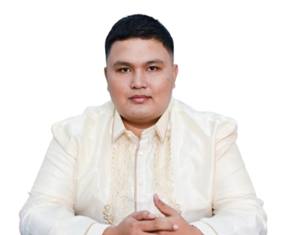
*** NOT VALID WITHOUT BARANGAY BILUSO DRY SEAL ***
(VALID ONY FOR 90 DAYS)

TO WHOM IT MAY CONCERN:

This permit is hereby granted to {d.full_name}, {d.age} years old, {d.sex}, a resident of {d.address} to build a {d.project_type} located at Barangay Biluso, Silang, Cavite provided that the General Orders and ordinances of the Barangay are strictly obeyed and adhered.
Given this {d.day} day of {d.month}, {d.year} at Barangay Biluso, Silang, Cavite, Philippines.

APPROVED BY:

HON. KIM A. GALANG
Punong Barangay

