CERTIFICATE OF INDIGENCY
BARANGAY OFFICIALS:
HON. KIM A. GALANG
Barangay Captain

BARANGAY COUNCILORS:
HON. IVY D. AMBULO
Chairman, Committee on Livelihood, Agriculture & Economic Affairs

HON. PLACIDO P. REYES
Chairman, Committee on Peace and Order & Public Safety

HON. JEMFELSON A. ZAPANTA
Chairman, Committee on Agriculture & Environmental Protection

HON. NELSON A. GONZAGA
Chairman, Committee on Health and Social Welfare

HON. JAIME J. TOLEDO
Chairman, Committee on Finance, Budget and Appropriation
HON. ALVIN R. VILLANUEVA
Chairman, Committee on Education and Culture

HON. ARIEL B. BIATON
Chairman, Committee on Public Works/Infrastructure

HON. JOHN PAOLO R. LOYOLA
SK Chairman

EMILINA T. ESTRADA
Barangay Treasurer

RIZZA JOY A. CAMARCE
Barangay Secretary

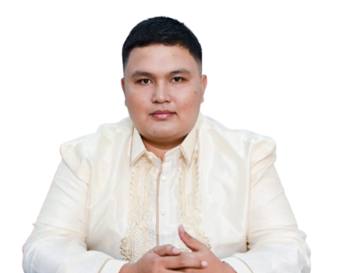
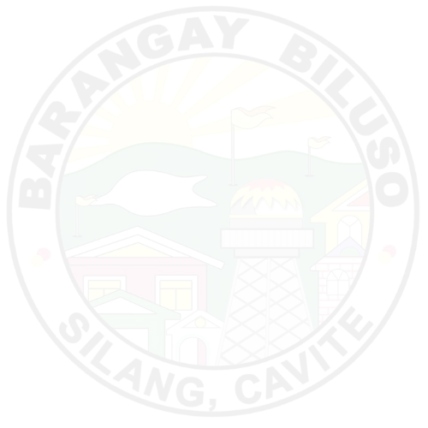
APPROVED BY:

HON. KIM A. GALANG
Punong Barangay
TO WHOM IT MAY CONCERN:

THIS IS TO CERTIFY that {d.full_name}, {d.age} years old, a resident of Barangay Biluso, Silang, Cavite belongs to a poor or indigent group of our society. Further certifies that his/her family earns a measly income and can hardly support their basic and other needs.

This certification is issued upon request of the subject person for {d.purpose} purposes.

Issued this {d.day} day of {d.month}, {d.year}.

*** NOT VALID WITHOUT BARANGAY BILUSO DRY SEAL ***
(VALID ONY FOR 90 DAYS)

