B A R A N G A Y C L E A R A N C E
BARANGAY OFFICIALS:
HON. KIM A. GALANG
Barangay Captain

BARANGAY COUNCILORS:
HON. IVY D. AMBULO
Chairman, Committee on Livelihood, Agriculture & Economic Affairs

HON. PLACIDO P. REYES
Chairman, Committee on Peace and Order & Public Safety

HON. JEMFELSON A. ZAPANTA
Chairman, Committee on Agriculture & Environmental Protection

HON. NELSON A. GONZAGA
Chairman, Committee on Health and Social Welfare

HON. JAIME J. TOLEDO
Chairman, Committee on Finance, Budget and Appropriation
HON. ALVIN R. VILLANUEVA
Chairman, Committee on Education and Culture

HON. ARIEL B. BIATON
Chairman, Committee on Public Works/Infrastructure

HON. JOHN PAOLO R. LOYOLA
SK Chairman

EMILINA T. ESTRADA
Barangay Treasurer

RIZZA JOY A. CAMARCE
Barangay Secretary

{d.date}
Date

TO WHOM IT MAY CONCERN:

THIS IS TO CERTIFY that {d.full_name}, {d.age} years old, {d.civil_status}, {d.citizenship}, is a registered resident of this Barangay and has no derogatory record on file as of the date of issuance.

This Barangay Clearance is issued upon the request of the above-named
person for the purpose of {d.purpose}.

Issued this {d.day} day of {d.month}, {d.year} at Barangay Biluso,
Municipality of Silang, Province of Cavite.


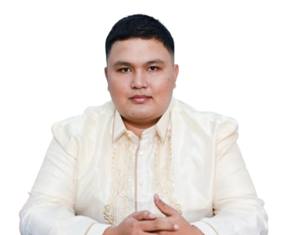
________________
Signature
COMM. TAX#: _________
ISSUED ON: ___________
ISSUED AT: ____________

*** NOT VALID WITHOUT BARANGAY BILUSO DRY SEAL ***
(VALID ONY FOR 90 DAYS)
APPROVED BY:

HON. KIM A. GALANG
Punong Barangay

