CERTIFICATE OF GOOD MORAL CHARACTER
BARANGAY OFFICIALS:
HON. KIM A. GALANG
Barangay Captain

BARANGAY COUNCILORS:
HON. IVY D. AMBULO
Chairman, Committee on Livelihood, Agriculture & Economic Affairs

HON. PLACIDO P. REYES
Chairman, Committee on Peace and Order & Public Safety

HON. JEMFELSON A. ZAPANTA
Chairman, Committee on Agriculture & Environmental Protection

HON. NELSON A. GONZAGA
Chairman, Committee on Health and Social Welfare

HON. JAIME J. TOLEDO
Chairman, Committee on Finance, Budget and Appropriation
HON. ALVIN R. VILLANUEVA
Chairman, Committee on Education and Culture

HON. ARIEL B. BIATON
Chairman, Committee on Public Works/Infrastructure

HON. JOHN PAOLO R. LOYOLA
SK Chairman

EMILINA T. ESTRADA
Barangay Treasurer

RIZZA JOY A. CAMARCE
Barangay Secretary

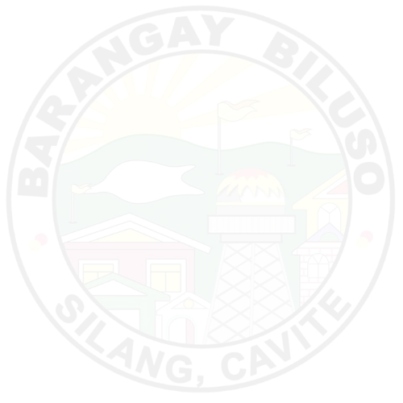
________________
Signature
Prepared by:
TO WHOM IT MAY CONCERN:

THIS IS TO CERTIFY that {d.full_name}, of legal age, {d.civil_status}, and a resident of Barangay Biluso, Silang, Cavite is known to be of good moral character and reputation in the community. He/She is a peaceful and law-abiding citizen.
As per records available in the files of this office, said subject has never been convicted nor accused of any crime whatsoever nor is he a member of any subversive organization.
This certification is issued upon request of the above-mentioned name for whatever legal purpose it may serve.
Issued this {d.day} day of {d.month}, {d.year} at Biluso, Silang, Cavite for whatever legal purpose it may serve.

*** NOT VALID WITHOUT BARANGAY BILUSO DRY SEAL ***
(VALID ONY FOR 90 DAYS)

MRS. RIZZA JOY A. CAMARCE
Barangay Secretary
APPROVED BY:

HON. KIM A. GALANG
Punong Barangay

