**本周工作：**

学习了Graphics View Framework。

  Graphics View provides a **surface** for managing and interacting with a large number of custom-made 2D graphical items, and a **view**widget for visualizing the items, with support for zooming and rotation.

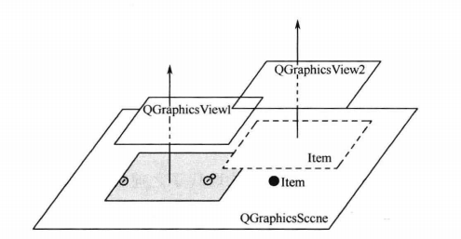

QGraphicsScene 、QGraphicsView 、QGraphicsItem

Step1: Scene与背景图片大小相同，显示观察坐标系中原点坐标在背景坐标系中的坐标。

Step2:加入旋转、缩放功能，使用slider控件。

