Demo of UDPClient-UDPServer interaction.

Server:

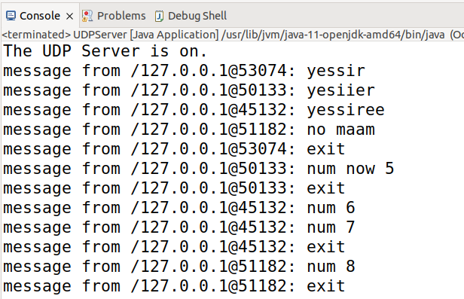

Client 1:

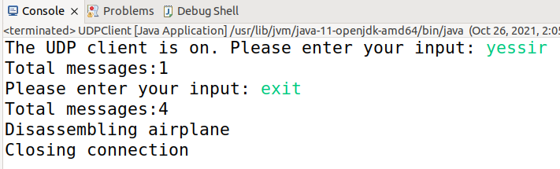

Client 2:

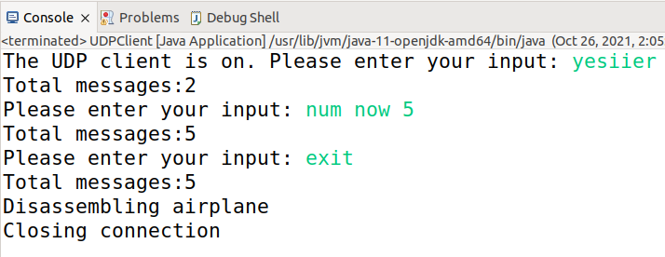

Client 3:

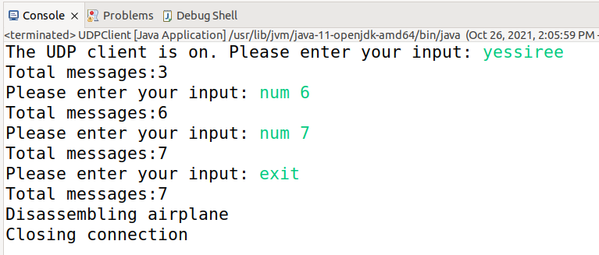

Client 4:

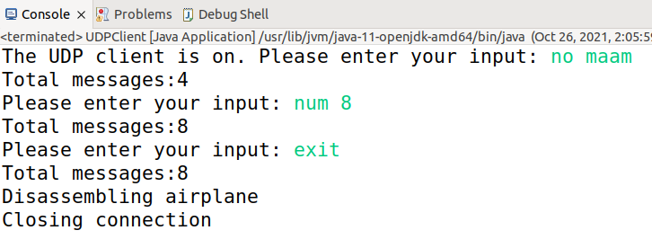

If you follow the order of the messages on the first screen shot you will see that the number incrementing is working properly and that the clients don’t compete for the server.