ESiWACE2

Container Hackathon for Modellers

### Application Description

This project implements a workflow for parallel deep learning to predict the 2m temperature based on a [master's thesis](https://b2drop.eudat.eu/s/RmTd8K3pLsDMFw6) in JSC.

The study focuses on applying data-driven deep learning methodologies to the field of weather forecasting, specifically for air temperature over Europe. A future frame prediction model from the computer vision field is trained with the three input variables -- air temperature, surface pressure, and the 500 hPa geopotential -- in order to predict the air temperature itself. Future frame prediction models generate the next frame(s) from a given number of preceding frames.

The workflow consists of a sequence of steps (Data Extraction, Data Preprocessing, Training and Data Postprocess) to implement video prediction, and in each step tries to perform the whole prediction process in parallel.

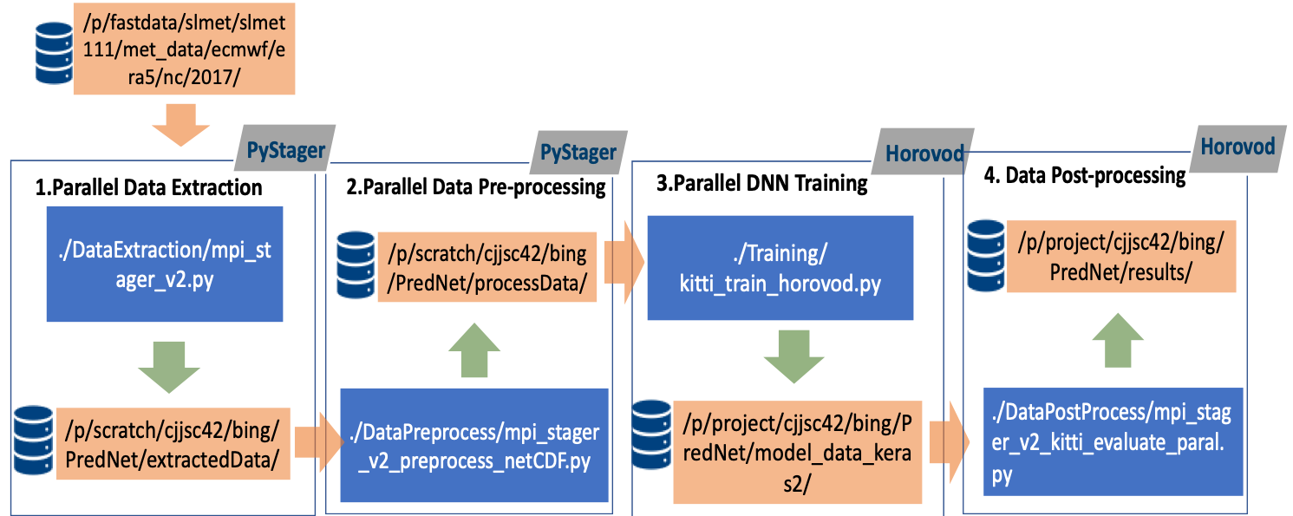

### Containerisation Approach

We have decided to set up a container on 3 different machines (1 Mac and 2 Linux) and to containerize two tasks, both different parts of the Workflow for frame prediction: 1. training and 2. pyStager. Bing and Jan worked on Task 1 and Amirpasha worked on Task 2.

### Day 1 (03/12/2019) Summary

After the break, we started a docker-file for the Task1 and Task 2, by building a base. We have created the docker-file based on the needs of the project.

**Task 1:**

After setting up Docker on all machines and getting familiar with its usage, we tried to cointainerize our Python application.

As we use Tensorflow, Keras and Horovod for the Python scripts, we used a pretty complete base image already including Horovod and all its dependencies. We built the container image with:

docker build -t wfppdl/parallel_training:v1.0 -f ../docker/Dockerfile_parallel ../docker

in the source code directory.

However, that image was designed to work with GPUs, and, as we don't have GPUs on our Laptops,the script did not work in the Container as it was looking for Cuda on the host system, which did not exist.

**Task 2:**

We have executed the docker images with

sudo docker images

We dhanged the entrypoint of the docker:

sudo docker run -ti --entrypoint "sh" wfppdl/pystager:v1.0

We bound a mount to the docker image (<https://docs.docker.com/storage/bind-mounts/>)

$ docker run -d \

-it \

--name devtest \

--mount type=bind,source="$(pwd)"/target,target=/app \

Nginx:latest

Task 2 was then able to be run on Docker.

**Notes on Containerization**

This is a short description of how a docker image works.

* The container sits on top of the kernel
* VM: hypervisor is running on top of the kernel and thus the OS
* VM has two levels ( full and partial VM)
* Containers take advantage of the C-groups and namespaces to isolate the jobs based on the resources.
* The advantage of the Containers over the VM is that it requires fewer layers ( OS and hypervisor ) which means it can be faster while it could be a security threat.
* Docker CLi → Docker daemon produces the instantiation of the program
* Docker daemon can pull it from the registry or we build it with CLI
* The build image needs a docker file. This text file that builds an image, which is subsequently run within another Docker container.

**Dockerfile:**

The idea is for the base image is to be as small as possible. It can use one of two strategies: (1) choose the image that is the closest to what we need already included, or (2) to use the only what is needed and then manually add whatever else needed subsequently.

Docker images can have versions and they are documented as tags.

### Day 2 (04/12/2019) Summary

**Task1:**

We tried to build our own base image from an existing Dockerfile in the Horovod Repo that was designed for CPU-only usage. When using the correct python, tensorflow, keras and ubuntu version this image could be built. After resolving all dependency issues it worked to build the final container using only CPUs instead of GPUs. Running this container image worked both locally using Docker and on Piz Daint using Sarus.

We built the non-working image from yesterday using Sarus on Piz Daint where GPUs exist and this worked after we fixed all dependency issues.

**Successfully run code(non_parallel version) in container by the following steps:**

|  |
| --- |
| 1.go to the source directory of local machine and run the following:  $ docker build -t wfppdl/parallel_training:v1.0 -f ../docker/Dockerfile_parallel .  2.Run for test  $ docker run -ti wfppdl/parallel_training:v1.0  3. Save the image to tar and transfer to the Daint supercomputer  $ docker save -o wffppdl-training.tar wfppdl/parallel_training:v1.0  4. copy to daint  $ scp wffppdl-training.tar hck04@daint:/users/hck04  5. log in the supercomputer :  $ ssh hck04@daint  6. transfer the tar file to daint and extract  $ sarus load wffppdl-training.tar wffppdl/trainingV1.0  7 Reserve the resource  $ salloc -C gpu --reservation=esiwace_1 --time=00:20:00  8 run the container  $ srun -C gpu sarus run --mount=type=bind,source=/users/hck04/splits,destination=/splits load/wffppdl/trainingV1.0  9 Export the files to the host  $ srun -C gpu sarus run --mount=type=bind,source=/users/hck04/splits,destination=/splits --mount=type=bind,source=/users/hck04/results/model_data_keras2,destination=/src/model_data_keras2 load/wffppdl/trainingV1.0 |

**Task2:**

We managed to install the sarus locally and we checked the ability to pull from the docker hub. We created an account in the docker hub and pushed the docker image that we made yesterday, Now we wanted to pull it directly to sarus and run it in the sarus.

Sample data is uploaded to Daint to have the data mounted into the container for testing the synching process.

We faced the issue that the stager logger was logging inside the container and therefore, the logs disappeared after the execution of the container. The source code was adopted to generate the log file as standard output (stdout) as well, which can be accessed after the container is finished.

### Day 3 (05/12/2019) Summary

**Task1:**

**Check open MPI version inside container:**

#docker run --entrypoint=bash -ti wfppdl/parallel_training:v2.0

On Day 2 we tried to containerize the non-parallel training part “kitti_train.py”, and it was successful. The main task today is to use the parallel training version “kitti_train_horovod.py” which is based on horovod and keras framework for containerization.

The issue we faced was that the openMPI version is not compatible with the system. We tried two strategies to address it: a) Replace/downgrade the openMPI version from 4.0 to 3.1.4 in base image, and b) downgrade openMPI in our image “dockerfile_parallel_v2.1”. In the end approach a) worked and the container could now run with an arbitrary number of GPUs (one GPU per Node) in parallel.

The container can be found here:

<https://hub.docker.com/repository/docker/janvog/parallel_training>

In this DL training process, we used 15 number epochs, 5090 training samples, 8 images/frames for each sample, with 128*160*3 for dimensions for each frame. The batch size was 15, and 500 per epoch for each training (on one GPU). We tested the training performance by varying the GPUs numbers, and the results are demonstrated in the table and figure below.

Performance testing

|  |  |  |
| --- | --- | --- |
| Num of GPUs | (day, sec,microseconds) | Time (Seconds) |
| 1 | (0,390,870491) | 390.870 |
| 2 | (0,204,208980) | 204.209 |
| 4 | (0,124,669368) | 124.669 |
| 8 | (0, 76, 48956) | 76.049 |
| 16 | (0,54,76208) | 54.076 |
| 32 | (0,41,135555) | 41.136 |
| 64 | (0,37,546803) | 37.547 |

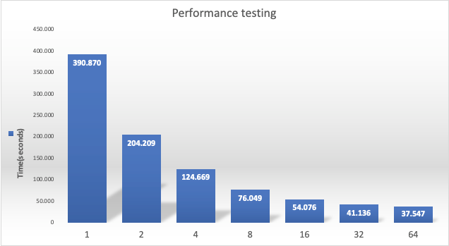

**Task2:**

The Task 2 docker image was built again with Ubuntu base image, and we were able to build all the dependencies in the new image and managed to run it local (it was pushed to Github). Then the image was uploaded to the Daint, and we were able to run it, but we had an issue with “get.size function” to identify the number of processors to be used for load balancing. We managed to address the issues with the code and run the Pystager in the container, even though a problem in the configuration file prevented us from running the code until the end. But in general, we were successful at porting the code with all the dependencies and managed to run it on the Dain throught Sarus.

**Shared Notes:**

### Final Conclusion and comments

See Day 3 Summary.

### Useful Links

Dockerfile reference:

<https://docs.docker.com/engine/reference/builder/>

Docker run reference:

<https://docs.docker.com/engine/reference/run/>

Horovod example of Dockerfile:

<https://hub.docker.com/r/horovod/horovod/tags?page=1&name=0.16.2>

Horovod examples:

<https://sarus.readthedocs.io/en/latest/cookbook/tensorflow_horovod/tf_hvd.html>

[**https://github.com/horovod/horovod/blob/master/Dockerfile.test.cpu**](https://github.com/horovod/horovod/blob/master/Dockerfile.test.cpu)

Some extra links and tricks:

* ***Vagrant*** to make the environment build more easily, <https://www.vagrantup.com/>
* Docker vs. VM: [**https://geekflare.com/docker-vs-virtual-machine/**](https://geekflare.com/docker-vs-virtual-machine/)
* “sudo !!” Is running the previous cmd with sudo privileges
* Sarus in Daint reference: <https://user.cscs.ch/tools/containers/sarus/>