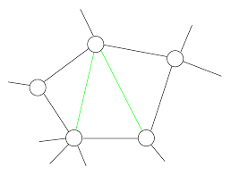

*t*

time

*tn-2*

*tn-1*

*tn*

*tn+1*

*tn+2*

*…*

*…*

Regularization: parameter values of θ*(t)* should be similar if they are close in time

*time-persistent/metastable models*

Regularization: parameter values of θ*(s)* should be similar if they are close on the graph

*graph-persistent/metastable models*