CS39440 Related Websites Analysis:
A Web-Based Restaurant Ordering System

G401 Computer Science (with integrated year in industry)
Aberystwyth University

Student:
Ethan Swain (ets6)
Supervisor:
Emmanuel Isibor (emi3)

4th February 2026
Version 1.0 (Release)

Uber Eats

What The Website Is About
Uber Eats (2026) is a delivery platform that allows users to order from both restaurants and supermarkets. It focuses heavily on logistics, using Uber’s existing mapping technology to provide precise delivery estimates and the ability to track the driver. It uses recommendation algorithms to personalise the home screen for every user, separating stores into categories like “Burgers” or “Groceries”.

Why I Like It
I like the ability to see the driver’s location moving in real-time as it adds a layer of transparency and trust that you know the driver is definitely going the right way and how long they’re going to take. I also like the group order functionality, which allows multiple users to add items to a single cart from different devices. This solves a real-world problem of having to pass one phone around for everyone to take turns deciding what they want to order. Furthermore, I like that you can order from a restaurant and then have the option to also add extra grocery items from a supermarket of your choice for no additional fee. This incentivises the user to spend more on the platform but also can be very convenient for the user.
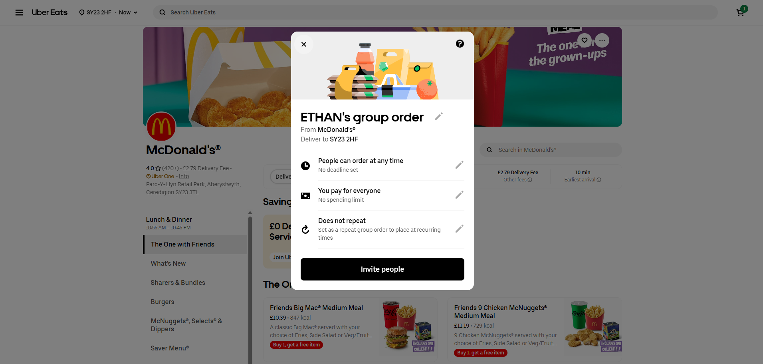
Figure 1: Uber Eats Group Order Feature (Uber Eats, 2026).

What I Would Like to Change on The Website
The interface can become very cluttered with sponsored content (stores advertising themselves to be at the top of the page). Therefore, it is often difficult to distinguish between the best-rated restaurants and the ones that have paid to appear at the top of the list, which can feel deceptive. Furthermore, the “Service Fee”, “Delivery Fee”, and “Small Order Fee” are only calculated at the final step of the checkout, which can add a lot of additional extra costs on the price, catching the user by surprise and potentially causing them to order on a cheaper platform.
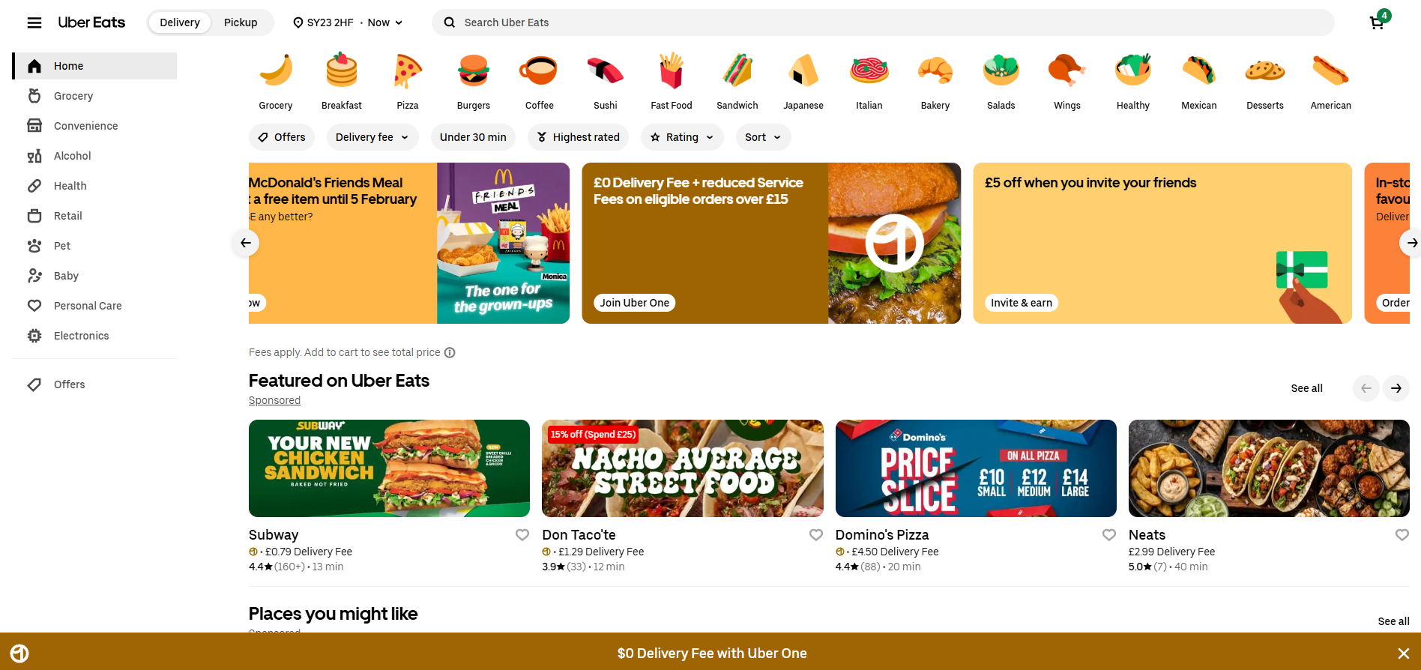
Figure 2: Uber Eats Sponsored Content on Home Page (Uber Eats, 2026).
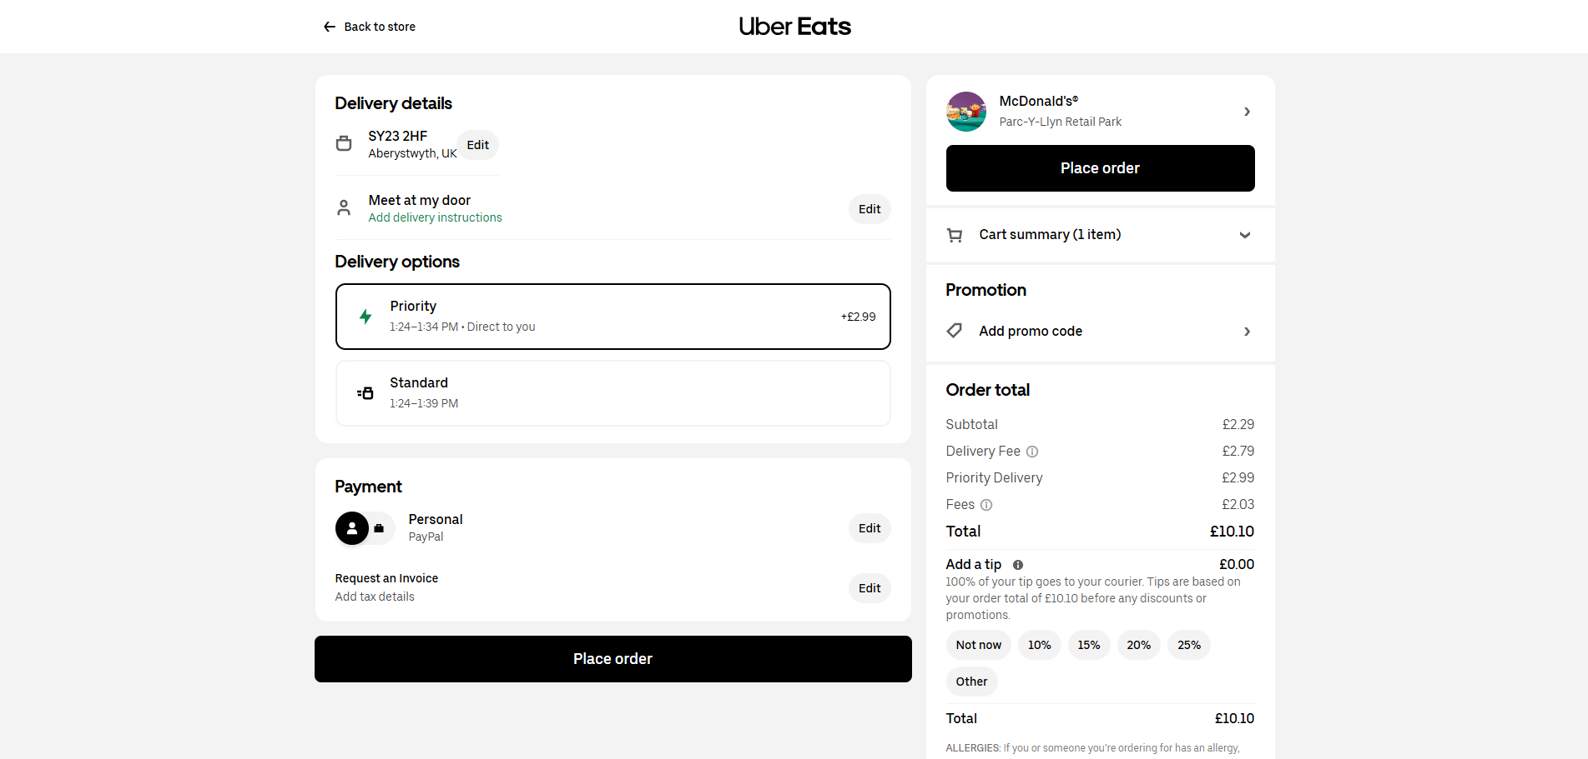
Figure 3: Uber Eats Fees Added on at Checkout (Uber Eats, 2026).

What Inspiration Am I Taking from It for My Project
I am inspired by the feature that always remembers your basket. On Uber Eats, if you add items to your basket and then accidentally close the browser or refresh the page, your items are still there when you return. I could do this in my project by saving the basket to ‘localStorage’ in the browser. I would also like to implement the ability to track the driver’s location when I start working on the Google Maps API functionality, however, this is a bit more difficult. Both of these features significantly improve the user experience.

Domino’s Pizza

What The Website Is About
Domino’s Pizza (2026) is a platform designed for high-volume, customisable food ordering that is delivered straight to the customer as soon as possible. Unlike Uber Eats, the site focuses entirely on one brand but has much more depth when customising they’re products. They are well known for their “Pizza Builder” and “Pizza Tracker” technology that provides visuals and updates whilst waiting for the order.

Why I Like It
I like the “Pizza Builder” feature as it uses a highly interactive visual interface where toppings appear on the pizza graphic in real-time as you select them. This provides immediate visual feedback where you can see what your pizza is going to look like, instead of just a text list. The “Pizza Tracker” progress bar is also great for the user experience, as it reduces the anxiety from the customer by showing exactly what stage the order is in (e.g. Prep, Bake, Delivery).
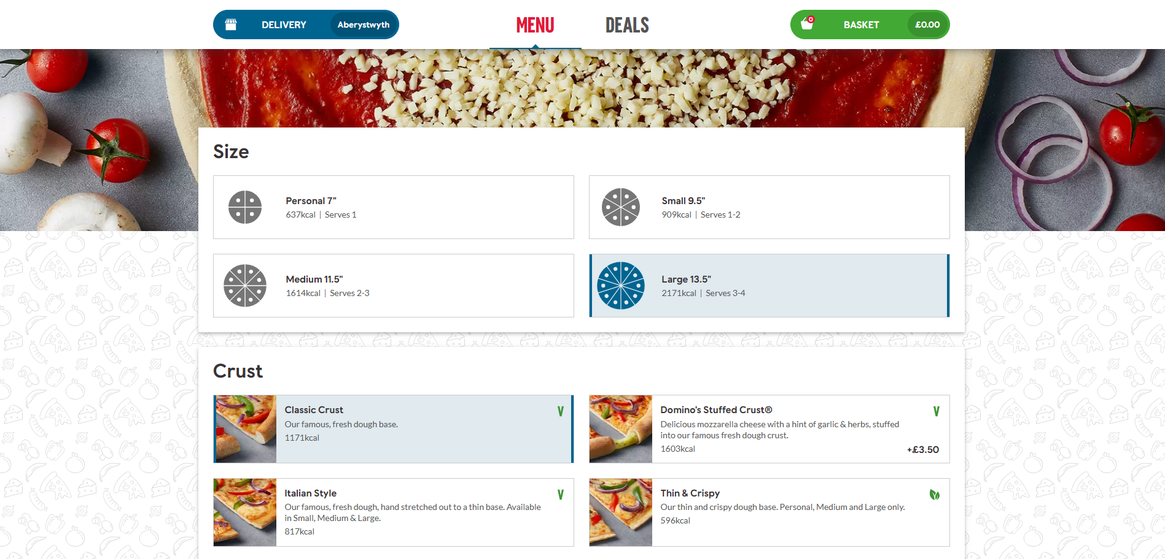
Figure 4: Domino’s Pizza Builder UI (Domino’s, 2026).
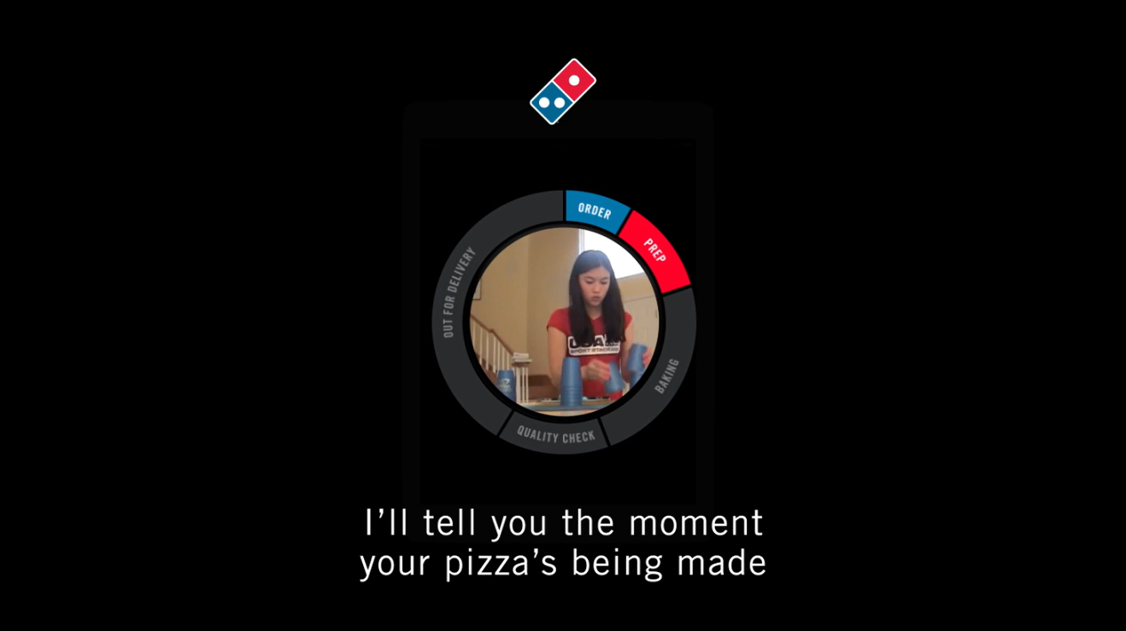
Figure 5: Domino’s Pizza Tracker UI (Domino’s, 2026).

What I Would Like to Change on The Website
The most annoying part of the Domino’s website is the constant large number of deals and coupons available, which often makes ordering quite confusing. Users frequently build a pizza and then struggle to apply the deal afterwards, often finding that their pizza or order doesn’t qualify. The interface also feels cluttered with lots of aggressive upsell pop-ups (e.g. asking for extra sides or drinks) before the checkout, adding lots of unnecessary clicks to the process.
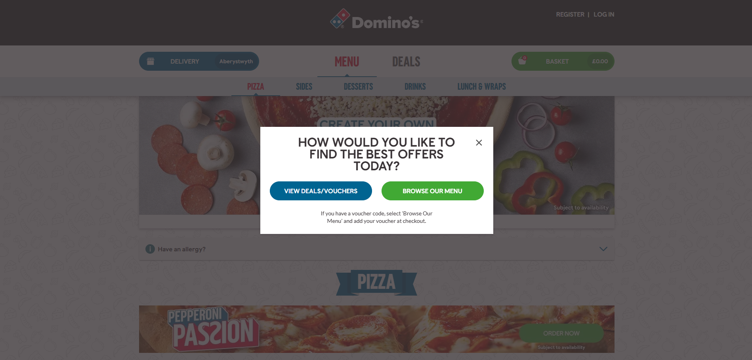
Figure 6: Domino’s Pizza Offers Popup (Domino’s, 2026).
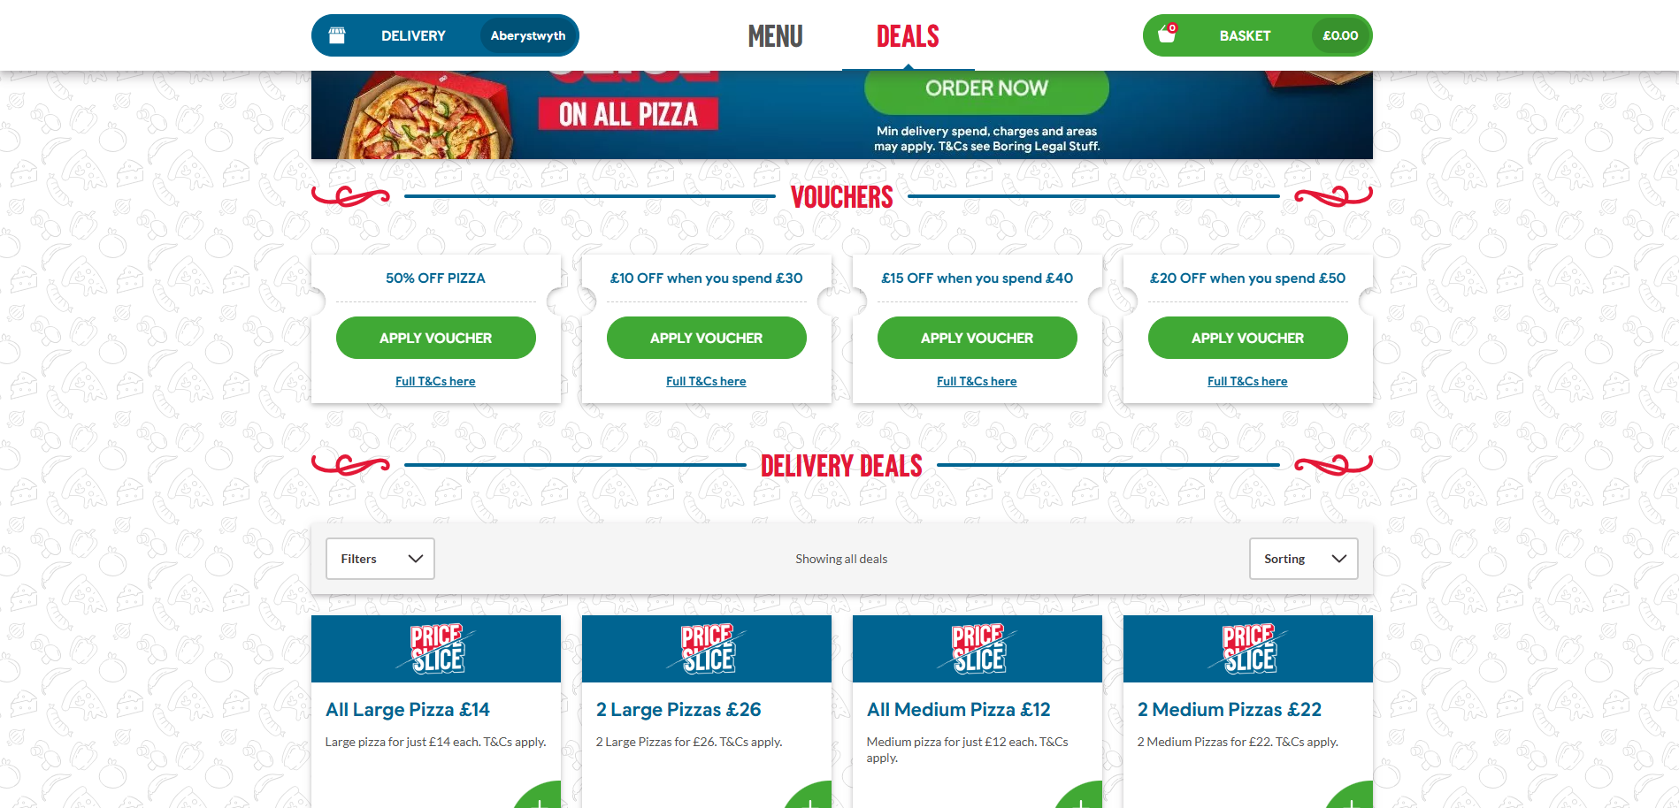
Figure 7: Domino’s Pizza Large List of Vouchers and Deals (Domino’s, 2026).

What Inspiration Am I Taking from It for My Project
I am taking inspiration from their “Pizza Tracker” feature. In my project, I would like to build a component that tracks the order status (e.g. Order Received -> Cooking -> Out for Delivery -> Order Delivered). I would be able to use a polling mechanism in Node.js to update this status in real-time so that users can see their order progress without needing to refresh the page.

The Shalimar (My Local Independent Takeaway)

What The Website Is About
The Shalimar (The Shalimar Takeaway, 2026) is my local independent takeaway at home in Shrewsbury. Unlike the massive companies like Uber Eats or Domino’s, the site is designed solely for serving local customers directly. It features a digital version of their menu, and a pick-up or delivery option. This system allows them to avoid the high commission fees charged by third-party delivery apps.

Why I Like It
I like that it is straightforward, and you don’t get overwhelmed with algorithms, sponsored content, or upselling; it just presents the food. The pick-up or delivery option is very clear as soon as you load the page, preventing any mistake of accidentally ordering pick-up instead of delivery. It also allows the Popular Dishes and Set Meals to be highlighted much better than a third-party app does, allowing the restaurant to showcase their best items.
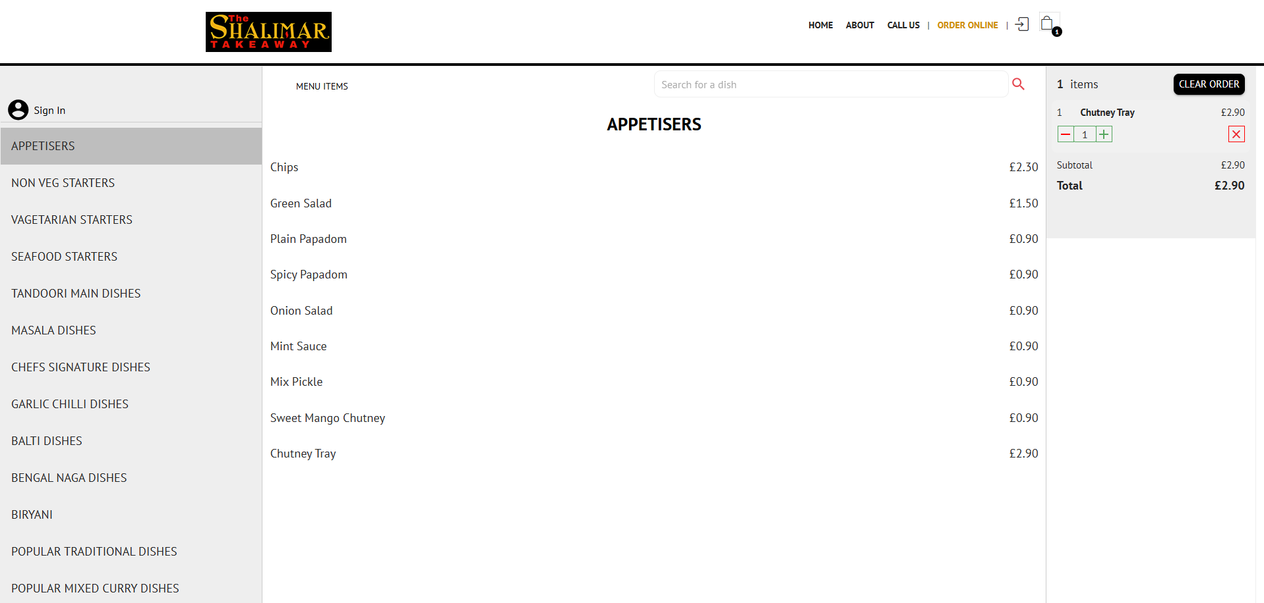
Figure 8: Shalimar Takeaway Ordering UI (The Shalimar Takeaway, 2026).

What I Would Like to Change on The Website
The user interface is slightly dated and generic, it is just the menu items categorised on a white background. I would add some photos of the food, add some colour coordination (i.e. to make it easier to separate starters, mains, desserts, and drinks) and symbols (i.e. spice level, vegetarian, vegan, gluten-free, etc.). I would also add a screen that tells the user the status of their order so that they know if it’s out for delivery or if it’s almost ready to pick-up, etc.

What Inspiration Am I Taking from It for My Project
I am taking inspiration from their menu categorisation. I will implement a sidebar or navigation bar that allows users to jump between different sections (e.g. starters, mains, desserts). This significantly improves navigation for large menus. I also plan to implement a “Collection or Delivery” option in the UI state that updates the final price when toggled (i.e. removing delivery fees).

References
Uber Eats. (2026). Uber Eats UK. [Online]. Available at: https://www.ubereats.com/gb (Accessed: 4th February 2026).
Domino’s Pizza. (2026). Domino’s Pizza UK. [Online]. Available at: https://www.dominos.co.uk/ (Accessed: 4th February 2026).
The Shalimar Takeaway. (2026). The Shalimar Takeaway Shrewsbury. [Online]. Available at: https://shalimarshrewsbury.co.uk/ (Accessed: 4th February 2026).

