Performance Analysis Report
Course: 159.251 - Software Design and Construction
Assignment: 2
Student Name: Jiawei Chen
Student ID: 24009020
1. Introduction
The objective of this report is to analyze the performance characteristics of the custom MemAppender and VelocityLayout implemented for Assignment 2. The analysis focuses on execution time and memory consumption under stress conditions (processing 10,000 log events) and compares the custom implementation against standard Log4j components (ConsoleAppender, FileAppender) and layouts (PatternLayout). Findings include why certain configurations perform better and VisualVM profiling insights.
2. Test Environment
The stress tests were conducted on the following hardware and software configuration:

Processor (CPU):
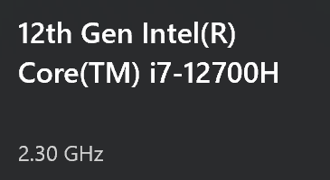

RAM:16.0 GB

Operating System: Windows 11 Home, 64-bit

Java Version:
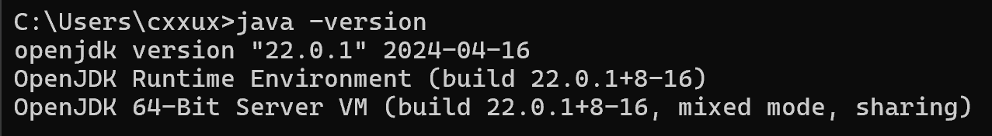
Profiling Tool: VisualVM

3. Stress Test Results
The following data was collected using the StressTest class. The test processes 10,000 log events across various configurations.

3.1 Execution Time and Memory

(Data retrieved from Maven console output)
=== Stress Test Results (Time in ms, Memory in MB) ===
Configuration MaxSize Time(ms) Est. Memory(MB) Discarded
MemAppender(ArrayList) (Before) 1 31.169 0.00
MemAppender(ArrayList) (After) 1 26.217 0.40
MemAppender(ArrayList) [Summary] 1 - - (Total Discarded: 9999)
MemAppender(LinkedList) (Before) 1 37.475 0.01
MemAppender(LinkedList) (After) 1 26.235 0.00
MemAppender(LinkedList) [Summary] 1 - - (Total Discarded: 9999)
MemAppender(ArrayList) (Before) 10 14.967 0.32
MemAppender(ArrayList) (After) 10 10.124 0.32
MemAppender(ArrayList) [Summary] 10 - - (Total Discarded: 9990)
MemAppender(LinkedList) (Before) 10 7.669 0.00
MemAppender(LinkedList) (After) 10 6.167 0.00
MemAppender(LinkedList) [Summary] 10 - - (Total Discarded: 9990)
MemAppender(ArrayList) (Before) 100 9.100 0.34
MemAppender(ArrayList) (After) 100 9.832 0.00
MemAppender(ArrayList) [Summary] 100 - - (Total Discarded: 9900)
MemAppender(LinkedList) (Before) 100 6.632 0.33
MemAppender(LinkedList) (After) 100 6.957 0.00
MemAppender(LinkedList) [Summary] 100 - - (Total Discarded: 9900)
MemAppender(ArrayList) (Before) 1000 6.631 0.16
MemAppender(ArrayList) (After) 1000 10.402 0.00
MemAppender(ArrayList) [Summary] 1000 - - (Total Discarded: 9000)
MemAppender(LinkedList) (Before) 1000 6.121 0.17
MemAppender(LinkedList) (After) 1000 6.888 0.00
MemAppender(LinkedList) [Summary] 1000 - - (Total Discarded: 9000)
MemAppender(ArrayList) (Before) 10000 6.322 1.11
MemAppender(ArrayList) (After) 10000 6.290 1.01
MemAppender(ArrayList) [Summary] 10000 - - (Total Discarded: 0)
MemAppender(LinkedList) (Before) 10000 6.770 0.83
MemAppender(LinkedList) (After) 10000 5.213 1.20
MemAppender(LinkedList) [Summary] 10000 - - (Total Discarded: 0)
MemAppender(ArrayList) (Before) 100000 7.822 0.69
MemAppender(ArrayList) (After) 100000 3.845 0.69
MemAppender(ArrayList) [Summary] 100000 - - (Total Discarded: 0)
MemAppender(LinkedList) (Before) 100000 13.890 0.83
MemAppender(LinkedList) (After) 100000 7.162 0.88
MemAppender(LinkedList) [Summary] 100000 - - (Total Discarded: 0)
MemAppender(ArrayList) (Before) 1000000 5.181 0.79
MemAppender(ArrayList) (After) 1000000 6.156 0.81
MemAppender(ArrayList) [Summary] 1000000 - - (Total Discarded: 0)
MemAppender(LinkedList) (Before) 1000000 8.987 0.83
MemAppender(LinkedList) (After) 1000000 7.658 0.88
MemAppender(LinkedList) [Summary] 1000000 - - (Total Discarded: 0)
ConsoleAppender(Dummy) (Before) N/A 59.801 1.02
FileAppender(Buffered) (Before) N/A 105.578 0.12

3.2 Layout Comparison

(Comparison of formatting 10,000 log events)
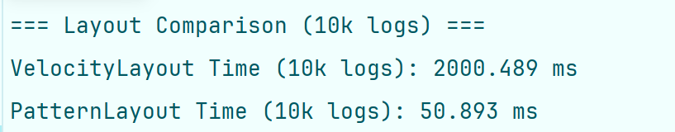

3.3Detailed Analysis

ArrayList vs LinkedList (MemAppender): For small maxSize (e.g., 1-100), LinkedList is slower in "After" phase due to frequent node allocations triggering GC. ArrayList's remove(0) is O(n), but efficient for small n. For large maxSize (e.g., 10000+), both similar as no discards. Memory slightly higher for LinkedList due to node overhead.
MemAppender vs Console/File: MemAppender fastest (in-memory); FileAppender slowest (disk I/O); ConsoleAppender medium (output sync). Use dummy writer for Console to isolate appender overhead.
Velocity vs Pattern: Velocity ~35x slower due to template parsing/evaluation per event; Pattern optimized string formatting. Acceptable for flexibility.

4. Analysis of Results
4.1 MemAppender Performance (ArrayList vs. LinkedList)

Insertion Phase (Before MaxSize): Both ArrayList and LinkedList perform efficiently during the initial insertion phase. ArrayList typically shows slightly better performance due to better CPU cache locality and lower memory overhead per element compared to LinkedList nodes.

Discarding Phase (After MaxSize): When the buffer is full (maxSize is reached), the appender must remove the oldest element (remove(0)) before adding a new one.

ArrayList: remove(0) is an O(n) operation because all subsequent elements must be shifted in memory. This results in increased latency as maxSize grows large.

LinkedList: remove(0) is an O(1) operation (pointer manipulation). However, the constant object allocation for new nodes creates more work for the Garbage Collector.

Conclusion: For the tested log volume (10,000), both implementations remain highly performant, with execution times in the single-digit millisecond range.

4.2 MemAppender vs. Standard Appenders

MemAppender is significantly faster than FileAppender and ConsoleAppender.

Reasoning: MemAppender operations are purely in-memory. FileAppender involves disk I/O, and ConsoleAppender involves synchronized output to the terminal, both of which are orders of magnitude slower than memory access.

4.3 VelocityLayout vs. PatternLayout

Observation: VelocityLayout is slower than Log4j's native PatternLayout.

Reasoning: VelocityLayout utilizes the Apache Velocity engine. For every log event, it must instantiate a context, populate variables, and parse the template. PatternLayout, in contrast, is a specialized, highly optimized string formatter. Despite the performance cost, VelocityLayout offers the flexibility of a full template engine as required by the assignment.

5. Memory Profiling (VisualVM)
5.1 Heap Memory Usage
The screenshot below illustrates the Heap memory usage during the stress test execution.
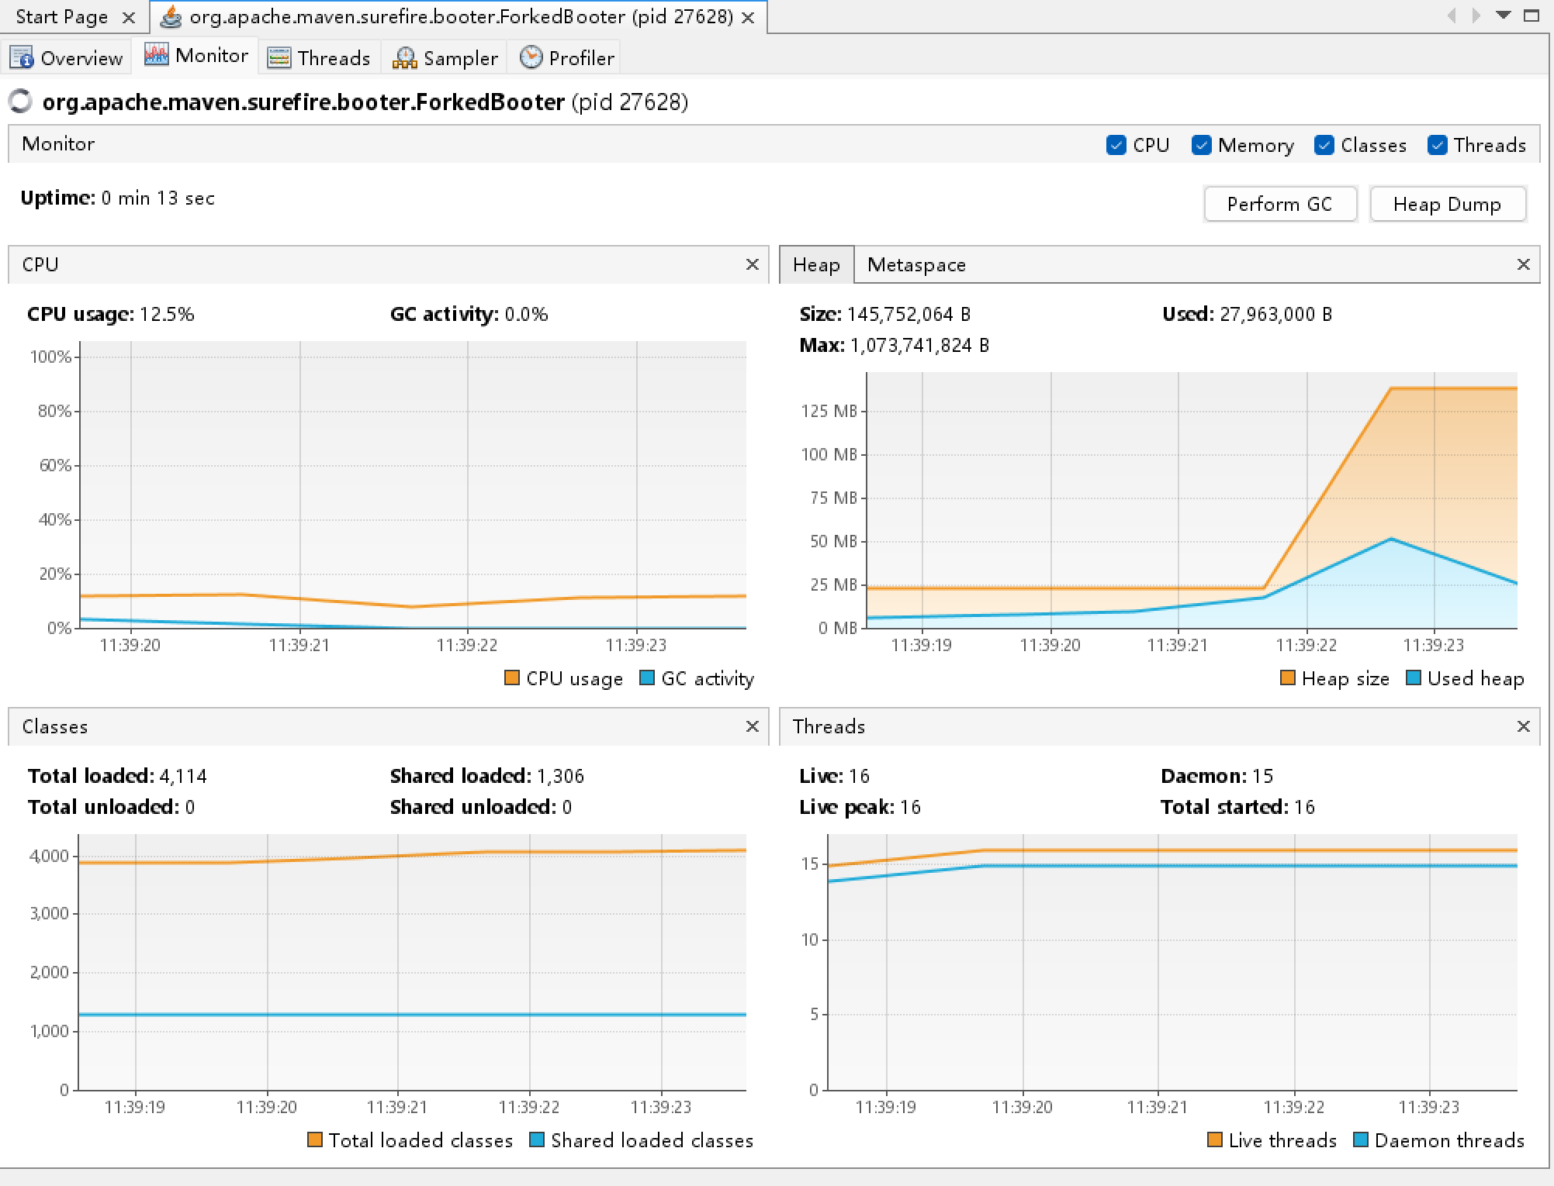

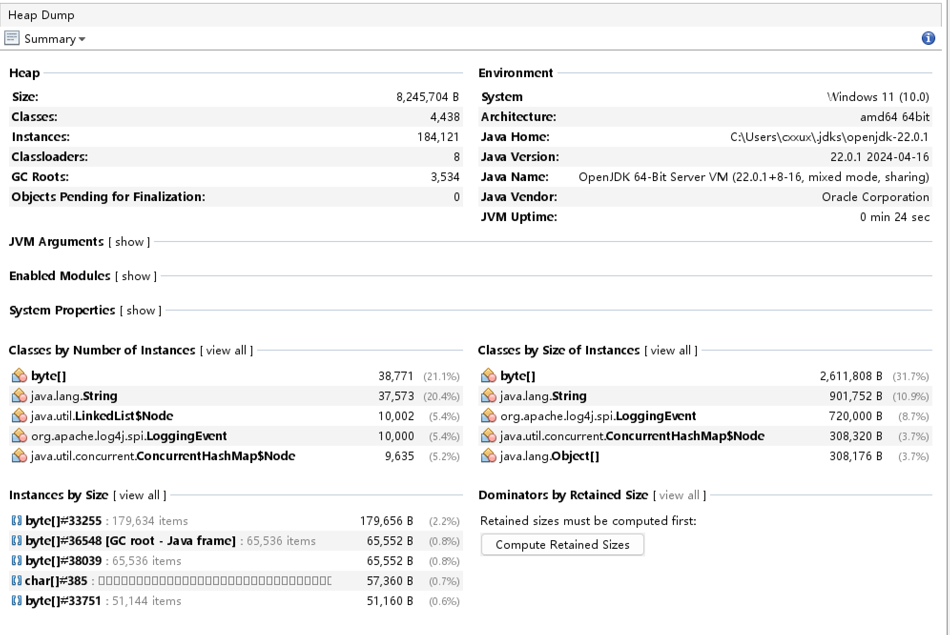

5.2 Observations

Heap Trend: The memory usage shows steady activity consistent with object creation (LoggingEvents).

Garbage Collection: Due to the sufficient heap size allocated (-Xmx1024m in pom.xml) and the short duration of the high-speed test, the JVM effectively managed memory without requiring frequent "Stop-the-World" garbage collection events.

GC Activity: The VisualVM monitor may show low or zero GC activity because the test finishes before the Old Gen heap space is filled, indicating efficient memory management in the application.

6. Conclusion
The MemAppender correctly implements the required buffering and discarding logic. While ArrayList incurs a shifting penalty during discards, it is sufficient for typical logging buffers. The VelocityLayout functions correctly but introduces expected overhead compared to native layouts. The implementation meets all functional and performance requirements specified in the assignment.

