CPA Physics · Fitchburg High School · 2026–2027
Unit 1 — How fast and where will it arrive?
Kinematics · Newton's three laws · contact forces
◆ NASA / PLANETARY DEFENSE BRIEFING — DAY 1
An object — designated 2026-XJ — has been detected on a trajectory toward Earth.
Projected arrival: approximately your graduation day.
Current data is uncertain. Its speed, its path, its size, and what it is made of are all only roughly known. Over this year, you will build the physics to understand this object — and to evaluate whether anything can be done.
This is fiction. The physics is real.
MA Standards: HS-PS2-1, HS-PS2-10(MA)
22 meetings · opens the year (Aug 25)
Name: ______________________________ Class period: __________ Date received: __________
"We have a year to figure this out."

Day 1 — The Briefing: Something is Coming

Today's Target
I can describe what we currently know and don't know about 2026-XJ, and identify what physics tools I would need to learn more.
ASTEROID THREAD
What we know about 2026-XJ today: Nothing yet — you walk in cold today. This is the day the briefing arrives.
How today connects: Today you receive the NASA briefing, react to it, and begin generating the questions that will drive the entire year.

NOTICE AND WONDER
Look at the briefing on the cover of this packet. What do you NOTICE? What do you WONDER? Write, list, or sketch — whatever helps you think.
I notice ____________________________
I wonder ____________________________

MY ONE BIG QUESTION FOR THE YEAR
EXIT TICKET — Day 1
Write ONE question you have about the asteroid that you really want answered this year.

Today's Targets — Rate Yourself
1 = Not Yet (I can't do this without help) 2 = Almost (I can do this with some help or some errors) 3 = Got It (I can do this independently and explain it)
Help? Check the box if you want to talk with me about this target — even if you marked yourself a 3.
Target | 1 | 2 | 3 | Help?
I can describe what we know and don't know about 2026-XJ. | ○ | ○ | ○ | ☐
I can name a physics tool I'd need to learn more about its motion. | ○ | ○ | ○ | ☐

Day 2 — How Do We Talk About Motion?

Today's Target
I can use precise vocabulary (position, distance, displacement) to describe motion, and I can tell the difference between scalar and vector quantities.
ASTEROID THREAD
What we know about 2026-XJ today: An object is approaching Earth. We know roughly its position and velocity, but with real uncertainty.
How today connects: To predict WHERE the asteroid goes, we need precise language for position and motion. Today builds the vocabulary the whole year relies on.

VOCAB · DISPLACEMENT
Definition: The change in position — how far AND in what direction you ended up from the start.
Example: A runner does one full lap of a 400 m track. Distance = 400 m. Displacement = 0 m (they ended where they started).
Cognates: Sp. desplazamiento · Pt. deslocamento · HC deplasman
Watch out: Displacement is NOT the same as distance. Distance is total path length (no direction); displacement has direction.

DOODLE ZONE
Draw a path from the door to your desk and back. Mark the total DISTANCE you walked and your DISPLACEMENT. Use arrows for direction.
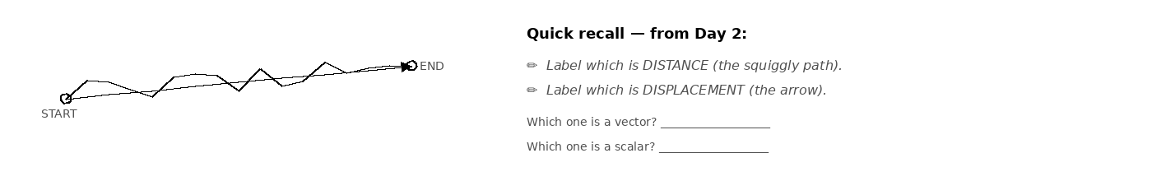

Fill in the frame:
We can't describe the asteroid's motion as just 'distance traveled' because the asteroid has ________________________________________________________, and direction tells us whether it moves ________________________________________________________ Earth or ________________________________________________________ Earth.
EXIT TICKET — Day 2
Explain in one sentence why we can't just describe the asteroid's motion as 'distance traveled' — why do we need displacement?

Today's Targets — Rate Yourself
1 = Not Yet (I can't do this without help) 2 = Almost (I can do this with some help or some errors) 3 = Got It (I can do this independently and explain it)
Help? Check the box if you want to talk with me about this target — even if you marked yourself a 3.
Target | 1 | 2 | 3 | Help?
I can define position, distance, and displacement in physics terms. | ○ | ○ | ○ | ☐
I can tell the difference between a scalar and a vector. | ○ | ○ | ○ | ☐
I can explain why direction matters for the asteroid. | ○ | ○ | ○ | ☐

Day 3 — Velocity: Motion with Direction · Investigation 1.1

Today's Target
I can capture a position–time graph with a Vernier motion detector and explain what its slope tells me about velocity.
ASTEROID THREAD
What we know about 2026-XJ today: We have position data for 2026-XJ but need to describe how it changes over time.
How today connects: NASA's trajectory data IS a position–time graph at a huge scale. Today you read the same kind of graph by walking in front of a motion detector.

LAB SETUP — INVESTIGATION 1.1
Driving question: What does motion 'look like' as a position–time graph?
Equipment:
- Vernier motion detector (1 per group of 4–5)
- Laptop with Logger Pro / Graphical Analysis
- Open floor space in front of the detector
What you do:
1. Stand in front of the detector and watch the live position–time graph as you move.
2. Try to MATCH a target graph the teacher displays — predict, attempt, observe, refine.
3. Start with constant velocity; build up to changing direction (negative velocity).
────────────────────────────────────────────────────────────
Safety: Watch for trip hazards and other groups while walking. Move at a safe, controlled pace.
How this lab serves the year's question: The asteroid's trajectory is a position–time graph through space — you're learning to read it.
DATA — MATCH-THE-GRAPH ATTEMPTS
Trial | Target graph (sketch/describe) | How I moved | How close? (1–5)
1
2
3
4
DOODLE BREAK
Quick recall — what does the SLOPE of a position–time graph mean?
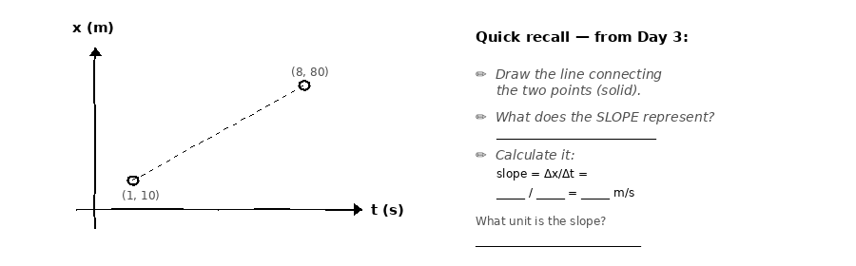

OBSERVATION & ANALYSIS
What pattern do you see between how you moved and the graph's slope?

What does the SLOPE of a position–time graph tell you?
The slope tells me the object's __________, because a steeper slope means __________.
Asteroid connection: how does this serve the year's question?

Fill in the frame:
On a position–time graph, a steeper slope means the object is moving ________________________________________________________, and a flat horizontal line means the object is ________________________________________________________.
EXIT TICKET — Day 3
Sketch a position–time graph for an object moving at constant velocity AWAY from the origin. Label the axes and the slope.

Today's Targets — Rate Yourself
1 = Not Yet (I can't do this without help) 2 = Almost (I can do this with some help or some errors) 3 = Got It (I can do this independently and explain it)
Help? Check the box if you want to talk with me about this target — even if you marked yourself a 3.
Target | 1 | 2 | 3 | Help?
I can capture a position–time graph with a motion detector. | ○ | ○ | ○ | ☐
I can explain that the slope of a position–time graph is velocity. | ○ | ○ | ○ | ☐
I can read whether an object is moving toward or away from the start. | ○ | ○ | ○ | ☐

Day 4 — Velocity-Time Graphs and Vector Thinking

Today's Target
I can read a velocity-time graph and break a 2-D velocity into its toward-Earth and perpendicular components.
ASTEROID THREAD
What we know about 2026-XJ today: We now know 2026-XJ's velocity is about 8,500 m/s at 15° toward Earth.
How today connects: "At 15°" means the velocity has two parts — one toward Earth, one sideways. You need both to predict where it ends up.

VOCAB · COMPONENT
Definition: One of the two pieces a vector splits into — usually a horizontal part and a vertical part.
Example: A velocity of 8,500 m/s at 15° splits into ~8,210 m/s toward Earth and ~2,200 m/s sideways.
Cognates: Sp. componente · Pt. componente · HC konpozan
Watch out: The two components are smaller than the whole vector — they add up to it, tip-to-tail.

DOODLE ZONE
Fill in the components: trace the dashed lines and write vₓ (toward Earth) and v_y (sideways).
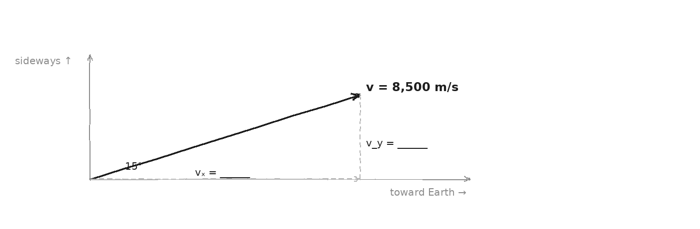

WORKED EXAMPLE — splitting a velocity
A drone flies at 50 m/s at 30° above the ground. Find its horizontal and vertical components.
GIVEN | v = 50 m/s · angle = 30°
EQUATION | vₓ = v·cos(θ) · v_y = v·sin(θ)
WORK | vₓ = 50·cos30° = 43.3 m/s · v_y = 50·sin30° = 25 m/s
ANSWER | Horizontal ≈ 43.3 m/s, vertical = 25 m/s.

EXIT TICKET — Day 4
Why does it matter that we calculate the toward-Earth and sideways parts of the asteroid's velocity separately?

Today's Targets — Rate Yourself
1 = Not Yet (I can't do this without help) 2 = Almost (I can do this with some help or some errors) 3 = Got It (I can do this independently and explain it)
Help? Check the box if you want to talk with me about this target — even if you marked yourself a 3.
Target | 1 | 2 | 3 | Help?
I can read a velocity-time graph. | ○ | ○ | ○ | ☐
I can split a 2-D velocity into two components. | ○ | ○ | ○ | ☐
I can explain why both components matter for the asteroid. | ○ | ○ | ○ | ☐

Day 5 — Predicting Position Using Velocity

Today's Target
I can use velocity and time to predict an object's future position, and I can express uncertainty in a prediction.
ASTEROID THREAD
What we know about 2026-XJ today: We know 2026-XJ's current position (1.2 × 10⁸ km from Earth) and its velocity components from Day 4.
How today connects: Today is the first day you do real asteroid physics: predict where 2026-XJ will be in six months — and say how certain you are.

VOCAB · UNCERTAINTY
Definition: The range of possible values when a measurement is not exact.
Example: Position measured as 1.2 × 10⁸ km, give or take 50,000 km. The uncertainty is ± 50,000 km.
Cognates: Sp. incertidumbre · Pt. incerteza · HC ensètitid
Watch out: Uncertainty is NOT a guess. It is a measured limit of precision.

DOODLE ZONE
Visualize 2026-XJ's trajectory. Complete the drawing. Add your own labels if it helps.
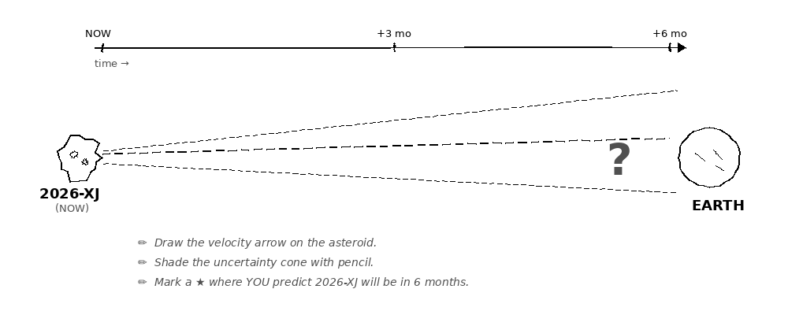

WORKED EXAMPLE — predicting position
A drone flies east at 30 m/s. It is now 100 m east of you. Where is it in 5 s?
GIVEN | v = 30 m/s east · x₀ = 100 m · t = 5 s
EQUATION | x = x₀ + v·t
WORK | x = 100 + (30)(5) = 250 m east
ANSWER | 250 m east of you.

YOUR TURN — predict 2026-XJ's position
2026-XJ is 1.2 × 10⁸ km away, moving toward Earth at 8,210 m/s. Where will it be in 6 months (≈ 1.6 × 10⁷ s)? Watch units — convert km to m.
GIVEN
EQUATION
WORK
ANSWER

★ | Uncertainty is not a flaw. It is an honest report of how well we know what we measured. Real scientists publish it with every number.

Fill in the frame:
My prediction has a window of possible positions because the measured ________________________________________________________ has an uncertainty of ________________________________________________________, and over 6 months that grows to ________________________________________________________.
EXIT TICKET — Day 5
In your own words, why does our prediction have a 'window' of possible positions instead of one exact location?

Today's Targets — Rate Yourself
1 = Not Yet (I can't do this without help) 2 = Almost (I can do this with some help or some errors) 3 = Got It (I can do this independently and explain it)
Help? Check the box if you want to talk with me about this target — even if you marked yourself a 3.
Target | 1 | 2 | 3 | Help?
I can use velocity and time to predict a future position. | ○ | ○ | ○ | ☐
I can express uncertainty as a range, not a single number. | ○ | ○ | ○ | ☐
I can explain why uncertainty grows over time. | ○ | ○ | ○ | ☐

Day 6 — Vector Addition and Decomposition

Today's Target
I can add two vectors tip-to-tail and break a vector into components with simple trig.
ASTEROID THREAD
What we know about 2026-XJ today: Same as Day 5 — today we sharpen the math we used loosely yesterday.
How today connects: Vector math is the language of trajectory prediction. Every unit ahead uses it.

WORKED EXAMPLE — tip-to-tail addition
Add a velocity of 8,210 m/s toward Earth and 2,200 m/s sideways. What is the resultant speed?
GIVEN | a = 8,210 m/s · b = 2,200 m/s (perpendicular)
EQUATION | R = √(a² + b²)
WORK | R = √(8210² + 2200²) ≈ √(7.22×10⁷)
ANSWER | R ≈ 8,500 m/s — the asteroid's full velocity.

DOODLE ZONE
Trace the dashed resultant R from the start of A to the tip of B. Use a ruler.
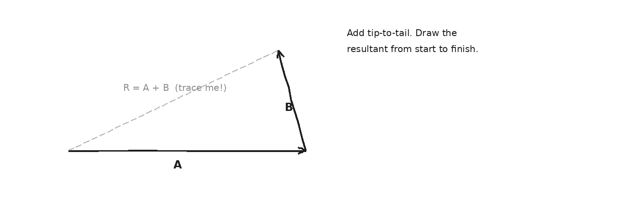

YOUR TURN — decompose a vector
A force of 100 N pulls at 40° above horizontal. Find its horizontal and vertical components. (Adjacent uses cos; opposite uses sin.)
GIVEN
EQUATION
WORK
ANSWER

EXIT TICKET — Day 6
What is the difference between a vector's MAGNITUDE and its COMPONENTS?

Today's Targets — Rate Yourself
1 = Not Yet (I can't do this without help) 2 = Almost (I can do this with some help or some errors) 3 = Got It (I can do this independently and explain it)
Help? Check the box if you want to talk with me about this target — even if you marked yourself a 3.
Target | 1 | 2 | 3 | Help?
I can add two vectors tip-to-tail. | ○ | ○ | ○ | ☐
I can decompose a vector into components with cos and sin. | ○ | ○ | ○ | ☐
I can choose the right trig function for each component. | ○ | ○ | ○ | ☐

Day 7 — Acceleration: When Velocity Changes

Today's Target
I can define acceleration as the rate of change of velocity and calculate it from velocity-time data.
ASTEROID THREAD
What we know about 2026-XJ today: We've treated 2026-XJ's velocity as constant — but gravity will slowly change it.
How today connects: Acceleration describes how velocity changes. It's what makes orbits work — and it's central to Unit 2.

VOCAB · ACCELERATION
Definition: How quickly velocity changes — measured in meters per second, per second (m/s²).
Example: A car going 0 to 27 m/s in 6 s accelerates at about 4.5 m/s².
Cognates: Sp. aceleración · Pt. aceleração · HC akselerasyon
Watch out: Acceleration is NOT the same as 'speeding up.' Slowing down is also acceleration (negative).

WORKED EXAMPLE — finding acceleration
A car slows from 30 m/s to 0 m/s in 5 s. What is its acceleration?
GIVEN | v₀ = 30 m/s · v = 0 · t = 5 s
EQUATION | a = (v − v₀) / t
WORK | a = (0 − 30) / 5 = −6 m/s²
ANSWER | −6 m/s² (negative = slowing down).

EXIT TICKET — Day 7
A car traveling 30 m/s slows to 0 m/s in 5 s. What's its acceleration? Show your work.

Today's Targets — Rate Yourself
1 = Not Yet (I can't do this without help) 2 = Almost (I can do this with some help or some errors) 3 = Got It (I can do this independently and explain it)
Help? Check the box if you want to talk with me about this target — even if you marked yourself a 3.
Target | 1 | 2 | 3 | Help?
I can define acceleration in my own words. | ○ | ○ | ○ | ☐
I can calculate acceleration from a change in velocity. | ○ | ○ | ○ | ☐
I can tell when acceleration is negative. | ○ | ○ | ○ | ☐

Day 8 — Constant Acceleration Problem-Solving

Today's Target
I can pick and use the right equation of motion for a constant-acceleration problem.
ASTEROID THREAD
What we know about 2026-XJ today: Same as Day 7 — today is a skill-building day for the math Unit 2 will need.
How today connects: Real asteroids accelerate as they near Earth. These equations are the tools for that.

✎ | Strategy: every problem starts the same way — list what's GIVEN, list what's ASKED, then pick the equation that connects them.

WORKED EXAMPLE — choosing an equation
A train accelerates from rest at 1.2 m/s² for 20 s. How far does it travel?
GIVEN | v₀ = 0 · a = 1.2 m/s² · t = 20 s · find x
EQUATION | x = v₀t + ½at²
WORK | x = 0 + ½(1.2)(20²) = ½(1.2)(400) = 240 m
ANSWER | 240 m.

YOUR TURN
A ball is thrown straight up at 15 m/s (a = −9.8 m/s²). How high does it go? (Hint: at the top, v = 0. Use v² = v₀² + 2a·x.)
GIVEN
EQUATION
WORK
ANSWER

EXIT TICKET — Day 8
Solve one problem of your choice from today. Show every step and label units.

Today's Targets — Rate Yourself
1 = Not Yet (I can't do this without help) 2 = Almost (I can do this with some help or some errors) 3 = Got It (I can do this independently and explain it)
Help? Check the box if you want to talk with me about this target — even if you marked yourself a 3.
Target | 1 | 2 | 3 | Help?
I can list what's given and asked before solving. | ○ | ○ | ○ | ☐
I can choose the right equation of motion. | ○ | ○ | ○ | ☐
I can solve a constant-acceleration problem with units. | ○ | ○ | ○ | ☐

Day 9 — Newton's 1st Law: Inertia

Today's Target
I can explain Newton's 1st Law in my own words and find everyday examples of inertia.
ASTEROID THREAD
What we know about 2026-XJ today: 2026-XJ keeps moving through empty space.
How today connects: Newton's 1st Law explains why: no friction in space, so it keeps going unless a force changes it. Good for predicting; hard for stopping.

VOCAB · INERTIA
Definition: An object's resistance to a change in its motion. More mass means more inertia.
Example: A loaded shopping cart is harder to start and stop than an empty one.
Cognates: Sp. inercia · Pt. inércia · HC inèsi
Watch out: Inertia is NOT a force. It's the tendency to keep doing what you're already doing.

DOODLE ZONE
Answer the prompt: why do the cups stay put when the cloth is yanked? (Hint: inertia.)
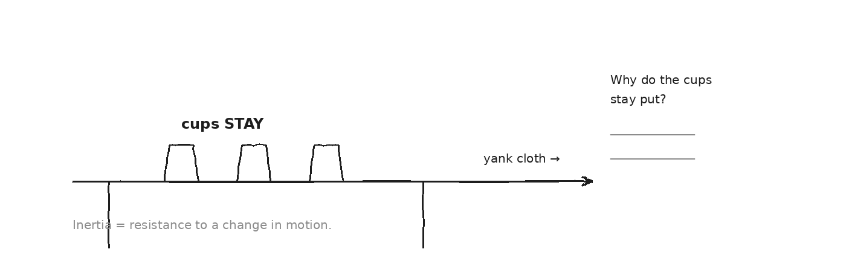

Fill in the frame:
A deflection mission must apply a ________________________________________________________ to the asteroid, because Newton's 1st Law says it will keep moving unless ________________________________________________________.
EXIT TICKET — Day 9
Explain why a deflection mission must apply a FORCE to the asteroid — what does Newton's 1st Law tell us about why it keeps coming?

Today's Targets — Rate Yourself
1 = Not Yet (I can't do this without help) 2 = Almost (I can do this with some help or some errors) 3 = Got It (I can do this independently and explain it)
Help? Check the box if you want to talk with me about this target — even if you marked yourself a 3.
Target | 1 | 2 | 3 | Help?
I can state Newton's 1st Law in my own words. | ○ | ○ | ○ | ☐
I can give an everyday example of inertia. | ○ | ○ | ○ | ☐
I can explain why the asteroid keeps moving in space. | ○ | ○ | ○ | ☐

Day 10 — Forces: What Pushes and Pulls

Today's Target
I can identify the types of force in a scenario (gravity, normal, friction, applied, tension) and draw them as arrows.
ASTEROID THREAD
What we know about 2026-XJ today: The asteroid keeps coming because no force is stopping it.
How today connects: To deflect it, we must ADD a force we control. Today we learn the language of force.

VOCAB · FORCE
Definition: A push or a pull, measured in newtons (N). A force is a vector — it has size and direction.
Example: 1 N is about the weight of a small apple. Gravity, friction, and tension are all forces.
Cognates: Sp. fuerza · Pt. força · HC fòs
Watch out: Velocity and inertia are NOT forces. A force is something acting ON an object right now.

DOODLE ZONE
Label the two faint arrows on the box: which is the applied force, which is friction?
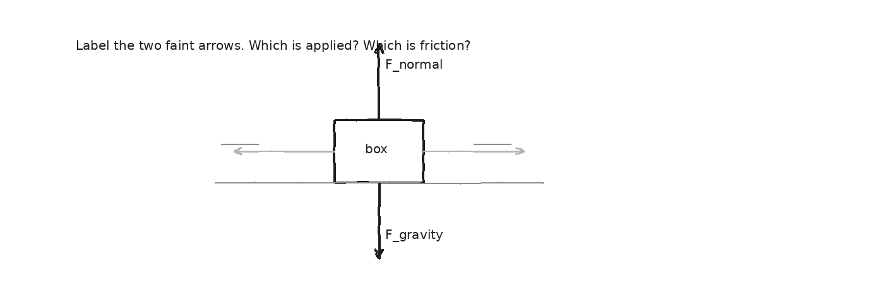

EXIT TICKET — Day 10
List every force acting on a car coasting down a hill (no engine, no brakes).

Today's Targets — Rate Yourself
1 = Not Yet (I can't do this without help) 2 = Almost (I can do this with some help or some errors) 3 = Got It (I can do this independently and explain it)
Help? Check the box if you want to talk with me about this target — even if you marked yourself a 3.
Target | 1 | 2 | 3 | Help?
I can name the five common force types. | ○ | ○ | ○ | ☐
I can draw forces as labeled arrows. | ○ | ○ | ○ | ☐
I can list the forces on the asteroid right now. | ○ | ○ | ○ | ☐

Day 11 — Newton's 2nd Law: F = ma · Investigation 1.2 (Vary Mass)

Today's Target
I can measure how acceleration changes when I change mass at constant force.
ASTEROID THREAD
What we know about 2026-XJ today: The asteroid's mass is huge (~3.5 × 10¹¹ kg).
How today connects: To deflect it we need either a huge force or a small force over a long time. F = ma is the math behind every strategy — and today you'll find it in your own data.

LAB SETUP — INVESTIGATION 1.2
Driving question: What happens to acceleration when we change mass at constant force?
Equipment:
- Dynamics cart + track
- Motion detector + laptop
- Hanging mass (constant force) + pulley
- Extra masses to add to the cart
What you do:
1. Keep the hanging mass (force) the SAME the whole time.
2. For each cart mass: release, capture the v-t graph, read acceleration from the slope.
3. Record mass vs. acceleration. Then plot a vs. mass.
────────────────────────────────────────────────────────────
Safety: Catch the cart before it hits the pulley. Keep fingers clear of the falling mass.
How this lab serves the year's question: This is the law that decides how hard the asteroid is to deflect.
DATA — VARY MASS (constant force)
Trial | Cart mass (kg) | Acceleration (m/s²)
1
2
3
4
Trend
OBSERVATION & ANALYSIS
As mass got bigger, what happened to acceleration?

What is the relationship between mass and acceleration at constant force?
When mass goes up, acceleration goes __________. So acceleration is __________ proportional to mass.
Asteroid connection: how does this serve the year's question?

EXIT TICKET — Day 11
If you doubled the cart's mass but kept the force the same, what would happen to the acceleration?

Today's Targets — Rate Yourself
1 = Not Yet (I can't do this without help) 2 = Almost (I can do this with some help or some errors) 3 = Got It (I can do this independently and explain it)
Help? Check the box if you want to talk with me about this target — even if you marked yourself a 3.
Target | 1 | 2 | 3 | Help?
I can collect clean mass-vs-acceleration data. | ○ | ○ | ○ | ☐
I can see that acceleration drops as mass rises. | ○ | ○ | ○ | ☐
I can connect this to why a massive asteroid is hard to deflect. | ○ | ○ | ○ | ☐

Day 12 — Newton's 2nd Law: F = ma · Investigation 1.3 (Vary Force)

Today's Target
I can measure how acceleration changes when I change the force at constant mass — and combine it with Day 11 to get F = ma.
ASTEROID THREAD
What we know about 2026-XJ today: Yesterday: acceleration depends on mass. Today: how it depends on force.
How today connects: Combine both and F = ma falls out — the equation that governs every deflection mission.

LAB SETUP — INVESTIGATION 1.3
Driving question: What happens to acceleration when we change the force at constant mass?
Equipment:
- Same cart + track + motion detector
- Several hanging masses (to change the force)
What you do:
1. Keep the cart mass the SAME.
2. For each hanging mass: weight (N) ≈ mass(kg) × 9.8. Release, capture v-t, read acceleration.
3. Record force vs. acceleration. Plot a vs. F.
────────────────────────────────────────────────────────────
Safety: Same as Investigation 1.2 — catch the cart, mind the falling mass.
How this lab serves the year's question: Once you have F = ma, you can do real deflection calculations.
DATA — VARY FORCE (constant mass)
Trial | Hanging mass (kg) | Force (N) | Acceleration (m/s²)
1
2
3
4
Trend
OBSERVATION & ANALYSIS
As force got bigger, what happened to acceleration?

Combine Day 11 and Day 12: how do force, mass, and acceleration relate?
Acceleration is __________ proportional to force and __________ proportional to mass — so F = __________.
Asteroid connection: how does this serve the year's question?

EXIT TICKET — Day 12
If you doubled the force but kept the mass the same, what would happen to the acceleration?

Today's Targets — Rate Yourself
1 = Not Yet (I can't do this without help) 2 = Almost (I can do this with some help or some errors) 3 = Got It (I can do this independently and explain it)
Help? Check the box if you want to talk with me about this target — even if you marked yourself a 3.
Target | 1 | 2 | 3 | Help?
I can collect clean force-vs-acceleration data. | ○ | ○ | ○ | ☐
I can see that acceleration rises with force. | ○ | ○ | ○ | ☐
I can state F = ma and explain where it came from. | ○ | ○ | ○ | ☐

Day 13 — F = ma in Practice

Today's Target
I can use F = ma to solve problems — always finding the NET force first.
ASTEROID THREAD
What we know about 2026-XJ today: F = ma is now our central equation.
How today connects: Every asteroid problem in Units 2–4 uses it. Today is about fluency.

VOCAB · NET FORCE
Definition: The single force you get by adding up all the forces on an object, with direction.
Example: 20 N pushing forward and 5 N of friction backward give a net force of 15 N forward.
Cognates: Sp. fuerza neta · Pt. força resultante · HC fòs nèt
Watch out: F = ma uses the NET force — not just one of the forces.

WORKED EXAMPLE — net force first
A 5 kg box is pulled forward with 20 N while 5 N of friction resists. Find its acceleration.
GIVEN | m = 5 kg · applied = 20 N · friction = 5 N
EQUATION | F_net = ΣF · a = F_net / m
WORK | F_net = 20 − 5 = 15 N · a = 15 / 5 = 3 m/s²
ANSWER | 3 m/s² forward.

YOUR TURN
A 1,500 kg car must slow from 30 m/s to 0 in 5 s. What net force is needed? (First find a, then use F = ma.)
GIVEN
EQUATION
WORK
ANSWER

EXIT TICKET — Day 13
Solve one F = ma problem. Self-check: did you find the NET force first?

Today's Targets — Rate Yourself
1 = Not Yet (I can't do this without help) 2 = Almost (I can do this with some help or some errors) 3 = Got It (I can do this independently and explain it)
Help? Check the box if you want to talk with me about this target — even if you marked yourself a 3.
Target | 1 | 2 | 3 | Help?
I can find the net force before using F = ma. | ○ | ○ | ○ | ☐
I can solve for force, mass, or acceleration. | ○ | ○ | ○ | ☐
I can label units throughout. | ○ | ○ | ○ | ☐

Day 14 — Newton's 3rd Law: Action & Reaction · Investigation 1.4

Today's Target
I can identify Newton's 3rd Law force pairs and explain why they don't cancel.
ASTEROID THREAD
What we know about 2026-XJ today: A deflection spacecraft would hit the asteroid.
How today connects: When it does, the asteroid pushes back just as hard. Newton's 3rd Law is built into every kinetic-impactor mission.

LAB SETUP — INVESTIGATION 1.4
Driving question: When two objects push or pull on each other, what's the same and what's different?
Equipment:
- Two Vernier force sensors
- A short rope or hook to connect them
- One laptop showing both readings
What you do:
1. Connect the two sensors. Two students pull against each other.
2. Try a hard pull, a soft pull, one student much stronger, and jerky pulls.
3. Watch both readings each time. Record what you see.
────────────────────────────────────────────────────────────
Safety: Pull steadily; don't let the sensors snap back. Keep the rope short.
How this lab serves the year's question: This is exactly why hitting the asteroid with a smaller spacecraft can still move it.
DATA — TUG-OF-WAR
Trial | Type of pull | Sensor A (N) | Sensor B (N)
1
2
3
4
OBSERVATION & ANALYSIS
Compare Sensor A and Sensor B in every trial. What do you notice?

Why don't the two forces in a pair cancel each other out?
The two forces are equal and __________, but they act on __________ objects, so they don't cancel.
Asteroid connection: how does this serve the year's question?

EXIT TICKET — Day 14
When you push against a wall, what pushes back on you with equal force?

Today's Targets — Rate Yourself
1 = Not Yet (I can't do this without help) 2 = Almost (I can do this with some help or some errors) 3 = Got It (I can do this independently and explain it)
Help? Check the box if you want to talk with me about this target — even if you marked yourself a 3.
Target | 1 | 2 | 3 | Help?
I can identify a Newton's 3rd Law force pair. | ○ | ○ | ○ | ☐
I can explain why the pair doesn't cancel. | ○ | ○ | ○ | ☐
I can connect it to how a kinetic impactor works. | ○ | ○ | ○ | ☐

Day 15 — Free Body Diagrams, Part 1

Today's Target
I can draw a free body diagram showing all forces on one object, with arrows sized to the forces.
ASTEROID THREAD
What we know about 2026-XJ today: We've covered all three of Newton's laws.
How today connects: A free body diagram (FBD) is the visual language of force — the tool for analyzing any deflection scenario.

✎ | FBD rules: (1) draw just the object; (2) one arrow per force ON it; (3) arrow points the way the force pushes; (4) longer = stronger; (5) label each; (6) never draw forces the object exerts on other things.

DOODLE ZONE
Draw the FBD for a box pulled by a rope with friction resisting. Use the faint guides; label F_gravity, F_normal, F_applied, F_friction.
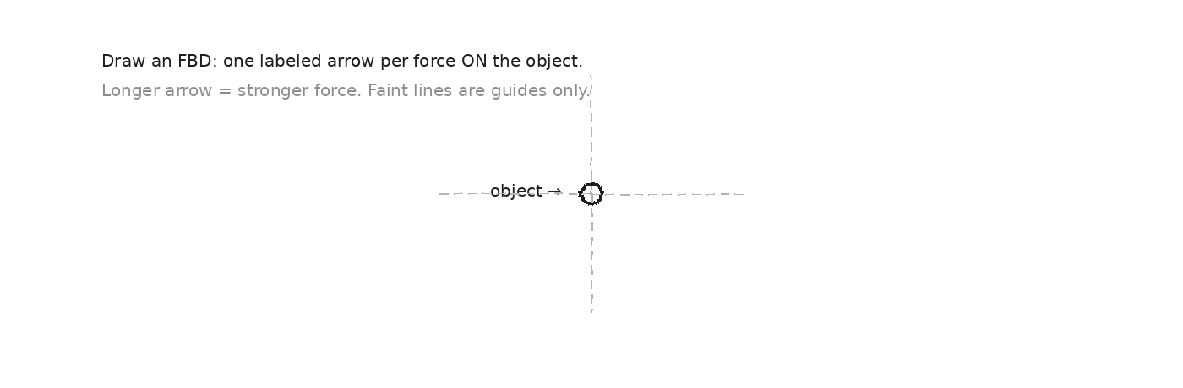

EXIT TICKET — Day 15
Draw an FBD for a book resting on a table. Label the two forces and make the arrows the right relative size.

Today's Targets — Rate Yourself
1 = Not Yet (I can't do this without help) 2 = Almost (I can do this with some help or some errors) 3 = Got It (I can do this independently and explain it)
Help? Check the box if you want to talk with me about this target — even if you marked yourself a 3.
Target | 1 | 2 | 3 | Help?
I can draw all the forces on one object. | ○ | ○ | ○ | ☐
I can size arrows to force strength. | ○ | ○ | ○ | ☐
I can avoid drawing forces the object exerts on others. | ○ | ○ | ○ | ☐

Day 16 — Free Body Diagrams, Part 2 — Net Force

Today's Target
I can find the net force on an object from its FBD and use it to find acceleration.
ASTEROID THREAD
What we know about 2026-XJ today: Yesterday we drew FBDs.
How today connects: Once you have an FBD, F_net = ma turns the picture into a prediction.

WORKED EXAMPLE — net force from an FBD
A 10 kg box on a floor is pushed with 50 N forward; friction is 15 N. Find the net force and the acceleration.
GIVEN | m = 10 kg · push = 50 N · friction = 15 N
EQUATION | F_net = ΣF · a = F_net / m
WORK | F_net = 50 − 15 = 35 N · a = 35 / 10 = 3.5 m/s²
ANSWER | Net force 35 N forward; acceleration 3.5 m/s².

YOUR TURN
A 2 kg book is pushed across a desk with 12 N; friction is 4 N. Find the net force, then the acceleration.
GIVEN
EQUATION
WORK
ANSWER

EXIT TICKET — Day 16
Find the net force on a 10 kg box pushed with 50 N forward against 15 N of friction.

Today's Targets — Rate Yourself
1 = Not Yet (I can't do this without help) 2 = Almost (I can do this with some help or some errors) 3 = Got It (I can do this independently and explain it)
Help? Check the box if you want to talk with me about this target — even if you marked yourself a 3.
Target | 1 | 2 | 3 | Help?
I can add forces to get the net force. | ○ | ○ | ○ | ☐
I can use F_net = ma to find acceleration. | ○ | ○ | ○ | ☐
I can keep track of direction (signs). | ○ | ○ | ○ | ☐

Day 17 — Friction: The Force That Resists Motion (class demo)

Today's Target
I can explain friction as a force that depends on the surfaces and the normal force, and tell static from kinetic friction.
ASTEROID THREAD
What we know about 2026-XJ today: The asteroid is in space — no friction at all.
How today connects: No friction is GOOD for deflection (a small push keeps adding up) and BAD for impact (nothing slows the asteroid down).

◐ | Today is a short class demo, not a full lab. Watch the force-sensor reading as we drag a block across different surfaces — that reading IS the friction force.

VOCAB · FRICTION
Definition: A force that resists sliding between two surfaces in contact.
Example: Static friction holds a box still until you push hard enough; kinetic friction acts once it's sliding.
Cognates: Sp. fricción · Pt. atrito / fricção · HC friksyon
Watch out: Friction isn't always 'bad' — it's also what lets you walk without slipping.

DOODLE ZONE
Label which arrow is static vs. kinetic friction, and note: friction points opposite the motion.
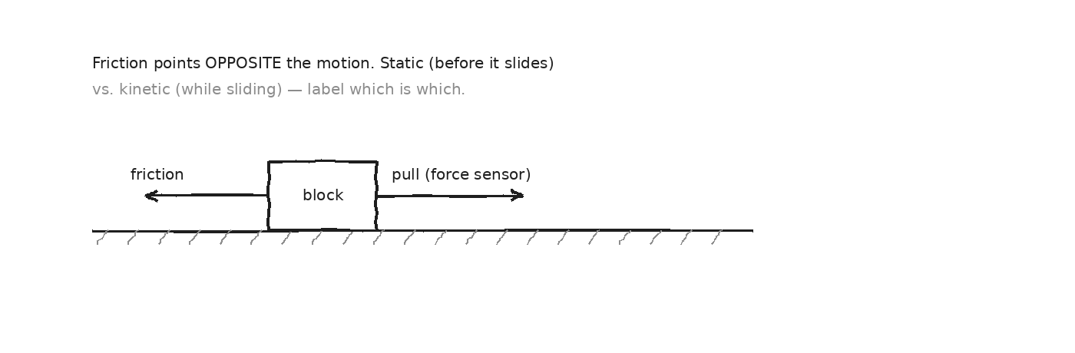

EXIT TICKET — Day 17
Why does space being frictionless make asteroid deflection both easier AND harder?

Today's Targets — Rate Yourself
1 = Not Yet (I can't do this without help) 2 = Almost (I can do this with some help or some errors) 3 = Got It (I can do this independently and explain it)
Help? Check the box if you want to talk with me about this target — even if you marked yourself a 3.
Target | 1 | 2 | 3 | Help?
I can explain what friction depends on. | ○ | ○ | ○ | ☐
I can tell static from kinetic friction. | ○ | ○ | ○ | ☐
I can explain why no-friction space cuts both ways for the asteroid. | ○ | ○ | ○ | ☐

Day 18 — Equilibrium: When Forces Balance

Today's Target
I can recognize when ΣF = 0 and use that to find an unknown force.
ASTEROID THREAD
What we know about 2026-XJ today: In deep space, solar gravity slowly accelerates the asteroid — it's not truly in balance.
How today connects: But over short times the acceleration is tiny, so we treated its velocity as constant on Day 5. Today: the special case where forces balance exactly.

VOCAB · EQUILIBRIUM
Definition: The state where all forces balance, so the net force is zero (ΣF = 0).
Example: A book resting on a desk: gravity down equals the normal force up. Net force = 0.
Cognates: Sp. equilibrio · Pt. equilíbrio · HC ekilib
Watch out: Equilibrium doesn't mean 'not moving' — constant velocity also has ΣF = 0.

WORKED EXAMPLE — a hanging lamp
A 5 kg lamp hangs from a single rope. What is the tension in the rope?
GIVEN | m = 5 kg · g = 9.8 m/s² · at rest (ΣF = 0)
EQUATION | T = m·g
WORK | T = 5 × 9.8 = 49 N
ANSWER | Tension = 49 N.

EXIT TICKET — Day 18
A 5 kg lamp hangs from one rope. What is the tension? Explain why.

Today's Targets — Rate Yourself
1 = Not Yet (I can't do this without help) 2 = Almost (I can do this with some help or some errors) 3 = Got It (I can do this independently and explain it)
Help? Check the box if you want to talk with me about this target — even if you marked yourself a 3.
Target | 1 | 2 | 3 | Help?
I can recognize when forces are balanced. | ○ | ○ | ○ | ☐
I can write ΣF = 0 for a situation. | ○ | ○ | ○ | ☐
I can solve for an unknown force in equilibrium. | ○ | ○ | ○ | ☐

Day 19 — Workshop and Revision Day

Today's Target
I can find my own weak spots from Unit 1 and work to fix them before the transfer task.
ASTEROID THREAD
What we know about 2026-XJ today: We've built the whole Unit 1 toolkit.
How today connects: Before the transfer task, today you decide where YOU need work — and do something about it.

Today's Targets — Rate Yourself
1 = Not Yet (I can't do this without help) 2 = Almost (I can do this with some help or some errors) 3 = Got It (I can do this independently and explain it)
Help? Check the box if you want to talk with me about this target — even if you marked yourself a 3.
Target | 1 | 2 | 3 | Help?
Distance vs. displacement; scalars vs. vectors (Day 2) | ○ | ○ | ○ | ☐
Reading position-time and velocity-time graphs (Days 3–4) | ○ | ○ | ○ | ☐
Decomposing and adding vectors (Days 4, 6) | ○ | ○ | ○ | ☐
Predicting position with uncertainty (Day 5) | ○ | ○ | ○ | ☐
Acceleration and equations of motion (Days 7–8) | ○ | ○ | ○ | ☐
Newton's three laws (Days 9, 12, 14) | ○ | ○ | ○ | ☐
Free body diagrams and net force (Days 15–16) | ○ | ○ | ○ | ☐
Friction and equilibrium (Days 17–18) | ○ | ○ | ○ | ☐

WORKSHOP MENU — CHOOSE WHAT TO WORK ON TODAY
Check the box for what you commit to working on today:
☐ Re-do the F = ma practice problems (Days 11–13)
☐ Re-practice vector decomposition with the Recipe Card (Day 6)
☐ Re-work free body diagrams and net force (Days 15–16)
☐ Re-watch a mini-lecture (F = ma, vectors, or FBDs)
☐ Sign up for 5 minutes of teacher coaching
☐ Work with a peer who is strong in your weak area
What I commit to today: ___________________________________________
MY WORKSHOP WORK
EXIT TICKET — Day 19
What target do you still feel weakest on, and what's your plan to fix it before the transfer task?

Day 20 — Synthesis: 2026-XJ Through the Full Physics Lens

Today's Target
I can apply all of Unit 1's tools — vectors, F = ma, FBDs, equilibrium — to the asteroid in one integrated analysis.
ASTEROID THREAD
What we know about 2026-XJ today: Everything from Unit 1, plus the prep you did yesterday.
How today connects: The final dress rehearsal: we walk through the whole asteroid picture together, then you try a version in your group.

CASE STUDY — TODAY'S CLASS SCENARIO
2026-XJ is in deep space, 1.2 × 10⁸ km away, moving at 8,500 m/s at 15° toward Earth. Solar gravity dominates; Earth's gravity is tiny; there is no friction. Work through the steps below as a class.
DOODLE ZONE
STEP 1 — Complete the FBD for 2026-XJ: confirm solar gravity (big) and Earth's gravity (small). No friction in space.
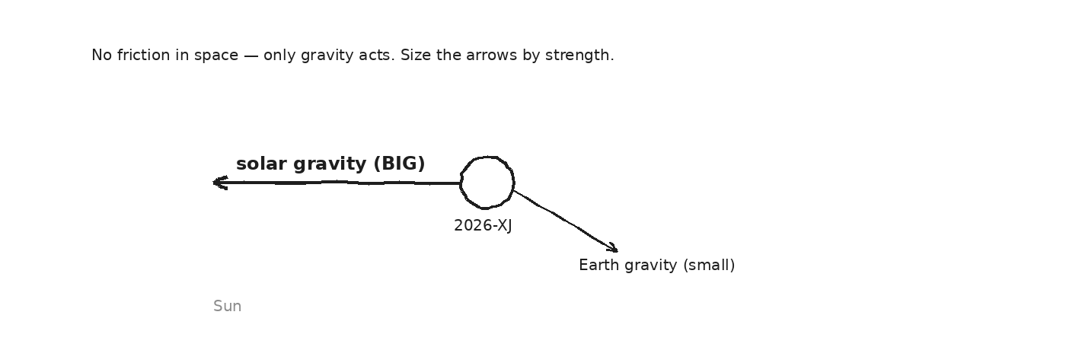

STEP 2 — decompose the velocity & predict position
Break the 8,500 m/s velocity into toward-Earth and sideways components, then predict the position in 6 months (≈ 1.6 × 10⁷ s).
GIVEN
EQUATION
WORK
ANSWER

GROUP PROBLEM — your group's modified scenario
EXIT TICKET — Day 20
What's the one tool from this unit you most need to have ready for the transfer task?

Today's Targets — Rate Yourself
1 = Not Yet (I can't do this without help) 2 = Almost (I can do this with some help or some errors) 3 = Got It (I can do this independently and explain it)
Help? Check the box if you want to talk with me about this target — even if you marked yourself a 3.
Target | 1 | 2 | 3 | Help?
I can draw the asteroid's FBD. | ○ | ○ | ○ | ☐
I can decompose its velocity and predict position. | ○ | ○ | ○ | ☐
I can connect all the unit's tools in one analysis. | ○ | ○ | ○ | ☐

Day 21 — Transfer Task — Day 1: Receive, Plan, Begin

ASTEROID THREAD
What we know about 2026-XJ today: Today's disclosure: refined NASA trajectory data. 2026-XJ will make a close pass before its final approach.
How today connects: This IS the asteroid work. You'll predict where 2026-XJ will be in six months, with uncertainty — exactly what NASA analysts do.

TRANSFER TASK — UNIT 1 · DAY 21: Predicting 2026-XJ's Position
You are a junior analyst. Using the refined trajectory data provided, predict where 2026-XJ will be in six months and report how certain that prediction is. Work independently. You may use your Vector Recipe Card and a calculator. Keep your work in this packet.
What you produce:
☐ Vector decomposition of the asteroid's velocity into components
☐ A numerical prediction of position after 6 months (show work, label units)
☐ An uncertainty analysis — the range of possible positions
☐ A labeled position-vs-time graph with uncertainty bounds
☐ A short public-facing paragraph explaining your findings honestly
HOW THIS WILL BE SCORED — 4 DIMENSIONS, EACH 0–4
Dimension | What a strong (3–4) response shows
Science | Correct physics: vectors, kinematics, units.
Reasoning | Sound method; uncertainty explained, not just stated.
Communication | Work shown, units labeled, organized, readable.
Transfer-to-Asteroid | Honest public-facing connection to 2026-XJ.
MY PLAN & WORK — DAY 1

Day 22 — Transfer Task — Day 2: Complete, Defend, Submit

ASTEROID THREAD
What we know about 2026-XJ today: Same scenario as Day 21 — the close-pass data.
How today connects: Today you finish, defend your reasoning to a peer using the rubric, revise, and submit the year's first complete asteroid analysis.

MY WORK — DAY 2 (finish the task)
PEER DEFENSE — 5 MINUTES EACH
Explain your whole task to a partner while they hold the rubric. They ask 2–3 questions and tell you one specific thing to improve. Then switch.
One thing my partner said I should improve: ____________________________________
FINAL SELF-RATING — WHERE DO YOU THINK YOU LANDED? (circle one per row)
Dimension | 0 1 2 3 4
Science | 0 1 2 3 4
Reasoning | 0 1 2 3 4
Communication | 0 1 2 3 4
Transfer-to-Asteroid | 0 1 2 3 4

Mastery Growth Chart — Unit 1
Each day, transfer your Marzano 1-2-3 rating onto the chart. Use a different mark or color for each target you track. By the end of the unit you'll have a visible record of your growth.
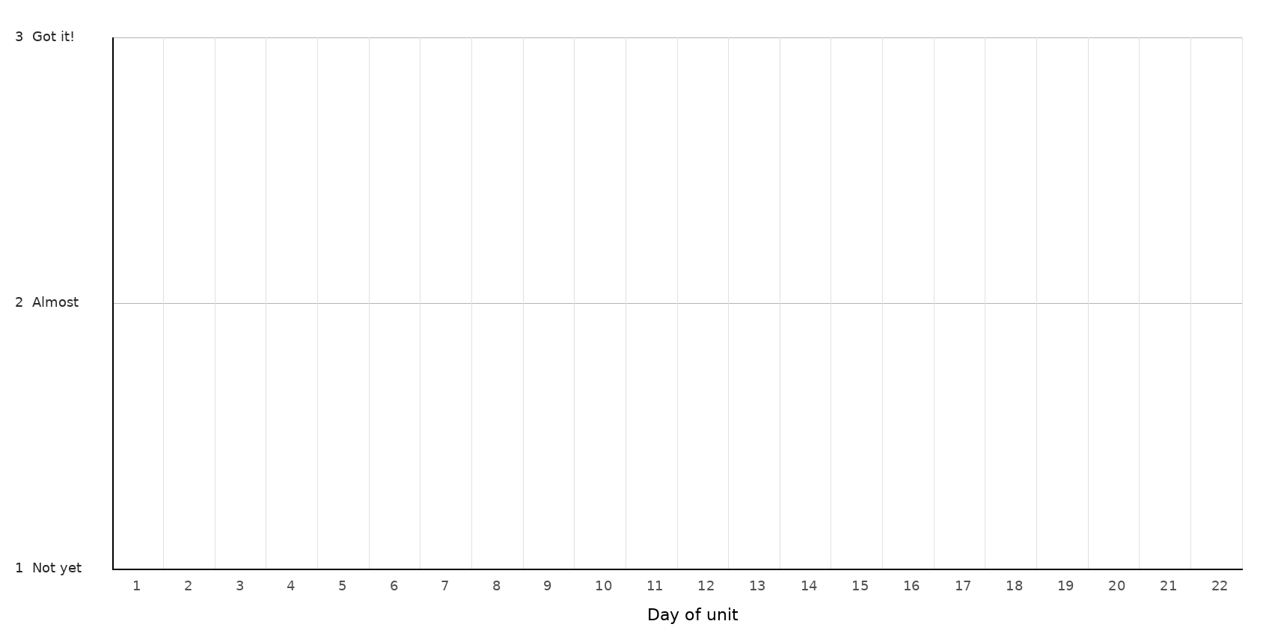
LEGEND — WHICH MARK / COLOR = WHICH TARGET
Mark: ______ Target: __________________________________________________________________
Mark: ______ Target: __________________________________________________________________
Mark: ______ Target: __________________________________________________________________
NOTES — END-OF-UNIT REFLECTION

