CPA Physics · Fitchburg High School · 2026–2027
Unit 2 — Why does 2026-XJ's path bend?
Universal gravitation · gravitational fields · projectile motion · circular motion · orbits
◆ NASA / PLANETARY DEFENSE BRIEFING — UPDATE 2
Since Unit 1 closed, NASA has refined 2026-XJ's orbit using three more weeks of radar tracking.
The earlier Unit 1 prediction assumed the asteroid's velocity stayed constant. It does not. Gravity bends its path. The new orbit solution treats 2026-XJ as a Sun-orbiting body governed by Newton's law of universal gravitation.
Refined parameters released to you today: semi-major axis a ≈ 1.42 AU · eccentricity e ≈ 0.31 · current heliocentric distance ≈ 1.18 AU and closing.
The new question: where does its orbit CROSS Earth's? And — load-bearing — will both objects arrive at the crossing at the SAME TIME? Unit 2 builds the physics to answer this.
This is fiction. The physics — and the equations — are real.
MA Standards: HS-PS2-4, HS-ESS1-4
16 meetings · Fall 2026 (Oct 13 – Nov 5)
Name: ______________________________ Class period: __________ Date received: __________
"Unit 1 told us how fast. Unit 2 tells us why."
Table of Contents
Day-type key: A = Anchor · S = Standard · L = Lab · T = Transfer
Section | Type | Page
Cover | — | 1
Table of Contents | — | 2
Phase 1 — Re-anchor & local gravity | —
Day 1 — Re-anchoring: what makes 2026-XJ move? | A | 3
Day 2 — Free fall: everything falls at g | S | 6
Day 3 — Weight as F = mg (local gravity) | S | 9
Phase 2 — Universal gravitation & gravitational fields | —
Day 4 — Newton's law of universal gravitation | S | 13
Day 5 — F = Gm₁m₂/r² calculation day | S | 16
Day 6 — Gravitational fields: g as field strength | S | 20
Day 7 — g varies with altitude → orbit preview | S | 24
Day 8 — Vernier free-fall lab: measure g | L | 27
Phase 3 — Projectile motion | —
Day 9 — Projectile motion: two independent dimensions | S | 31
Day 10 — Horizontal projectile launches | S | 34
Day 11 — Angled projectile launches | S | 37
Phase 4 — Circular motion & orbits | —
Day 12 — Circular motion + centripetal force | S | 40
Day 13 — Newton's cannon: orbits as continuous falling | L | 44
Day 14 — Kepler's three laws | S | 48
Phase 5 — Asteroid payoff & transfer task | —
Day 15 — When does 2026-XJ arrive? | S | 52
Day 16 — Unit 2 transfer task (assessment) | T | 56
Equation Reference Card | — | 59
Mastery Growth Chart | — | 60

Day 1 — Re-anchoring: What Makes 2026-XJ Move?

Today's Target
I can explain why 2026-XJ's velocity won't stay constant, and I can name the force that bends its path.
ASTEROID THREAD
What we know about 2026-XJ today: NASA has refined 2026-XJ's orbit using 3 more weeks of radar. Semi-major axis a ≈ 1.42 AU, eccentricity e ≈ 0.31, currently closing.
How today connects: Unit 1 answered HOW FAST. Unit 2 answers WHY — and that means a force. Today we name that force and frame the unit's question: does the asteroid's path bend enough to bring it to Earth?

NOTICE AND WONDER
Watch the demo: book vs. flat paper, then book vs. crumpled paper. What did you NOTICE? What do you WONDER about gravity? Write, list, or sketch.
I notice ____________________________
I wonder ____________________________

DOODLE ZONE
Predict before the demo runs. Circle which one(s) you think will hit first. Then write WHY.
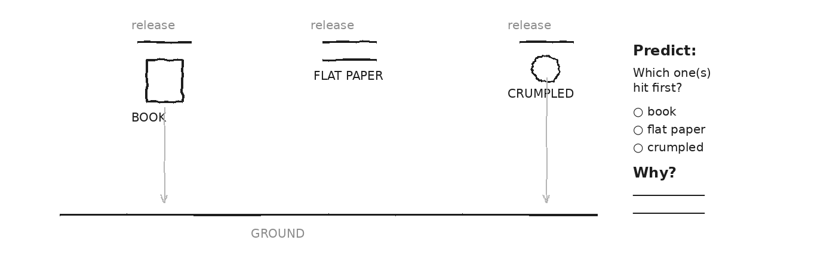

MY ONE QUESTION ABOUT GRAVITY
EXIT TICKET — Day 1
Why doesn't 2026-XJ just drift off into space at constant velocity? What pulls on it?

Today's Targets — Rate Yourself
1 = Not Yet (I can't do this without help) 2 = Almost (I can do this with some help or some errors) 3 = Got It (I can do this independently and explain it)
Help? Check the box if you want to talk with me about this target — even if you marked yourself a 3.
Target | 1 | 2 | 3 | Help?
I can explain why constant velocity is the WRONG assumption for an asteroid. | ○ | ○ | ○ | ☐
I can name the force that bends 2026-XJ's path. | ○ | ○ | ○ | ☐

Day 2 — Free Fall: Everything Falls at g

Today's Target
I can describe free fall as constant acceleration g, read g off a v-t slope, and calculate fall times for short drops.
ASTEROID THREAD
What we know about 2026-XJ today: 2026-XJ would fall at g if it were close enough to Earth.
How today connects: g is a NUMBER (9.81 m/s² near Earth). Today you read it off a Vernier graph and use it. Same g for a coin, a feather, and an asteroid.

VOCAB · FREE FALL
Definition: Motion under gravity only — no air resistance, no other forces.
Example: A ball dropped 1 m takes about 0.45 s to fall (ignoring air). All objects fall the same.
Cognates: Sp. caída libre · Pt. queda livre · HC chit lib
Watch out: Free fall doesn't mean 'floating.' It means gravity is the ONLY force. Falling IS the motion.

DOODLE ZONE
Read the slope. Fill the blanks for Δv and the slope. What value should g be near Earth?
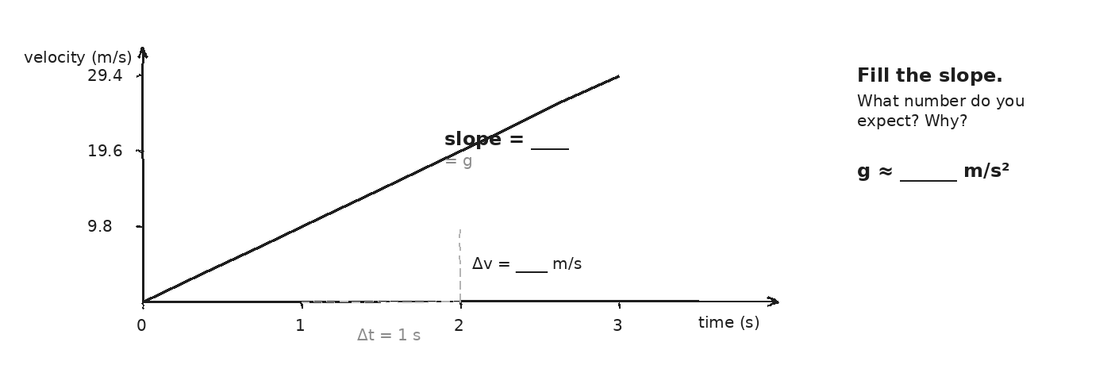

WORKED EXAMPLE — how long to fall 10 m?
A coin is dropped from rest off a 10 m balcony. How long until it hits the ground? (Ignore air. Use y = ½g·t².)
GIVEN | y = 10 m · v₀ = 0 · g = 9.81 m/s²
EQUATION | y = ½·g·t²
WORK | 10 = ½·(9.81)·t² → t² = 20/9.81 ≈ 2.04 → t ≈ 1.43 s
ANSWER | ≈ 1.43 s. The coin falls for about a second and a half.

YOUR TURN — fall from 100 m
A pebble is dropped from a 100 m bridge. How long until it hits the water? Show your work.
GIVEN
EQUATION
WORK
ANSWER

Fill in the frame:
On the v-t graph for a falling object, the slope is ________________________________________________________, because v increases by ________________________________________________________ every second.
EXIT TICKET — Day 2
How long does it take a coin to fall 1 m from rest, ignoring air? Show your work.

Today's Targets — Rate Yourself
1 = Not Yet (I can't do this without help) 2 = Almost (I can do this with some help or some errors) 3 = Got It (I can do this independently and explain it)
Help? Check the box if you want to talk with me about this target — even if you marked yourself a 3.
Target | 1 | 2 | 3 | Help?
I can state that g ≈ 9.81 m/s² near Earth. | ○ | ○ | ○ | ☐
I can read g as the slope of a v-t graph. | ○ | ○ | ○ | ☐
I can calculate a fall time from a height. | ○ | ○ | ○ | ☐

Day 3 — Weight as F = mg (Local Gravity)

Today's Target
I can distinguish mass from weight, calculate weight on different worlds with F = mg, and explain why weight changes but mass does not.
ASTEROID THREAD
What we know about 2026-XJ today: 2026-XJ's mass is the same everywhere. Its weight depends on WHERE it is.
How today connects: Set up the question: if 2026-XJ stood on Earth's surface, what would it weigh? Tomorrow we get the equation that gives g on any world.

VOCAB · MASS
Definition: How much MATTER is in an object. Same everywhere in the universe.
Example: You have the same mass on Earth, on the Moon, and on 2026-XJ. Measured in kg.
Cognates: Sp. masa · Pt. massa · HC mas
Watch out: Mass is NOT weight. Mass doesn't change — your weight does.

VOCAB · WEIGHT
Definition: The FORCE of gravity pulling on a mass. Depends on local g.
Example: A 70 kg student weighs 686 N on Earth, 113 N on the Moon, 260 N on Mars.
Cognates: Sp. peso · Pt. peso · HC pwa
Watch out: Weight is a FORCE (newtons), not a quantity of stuff. Your bathroom scale measures force.

DOODLE ZONE
Pick your own mass (be honest). Fill in your weight on each world using F = m·g.
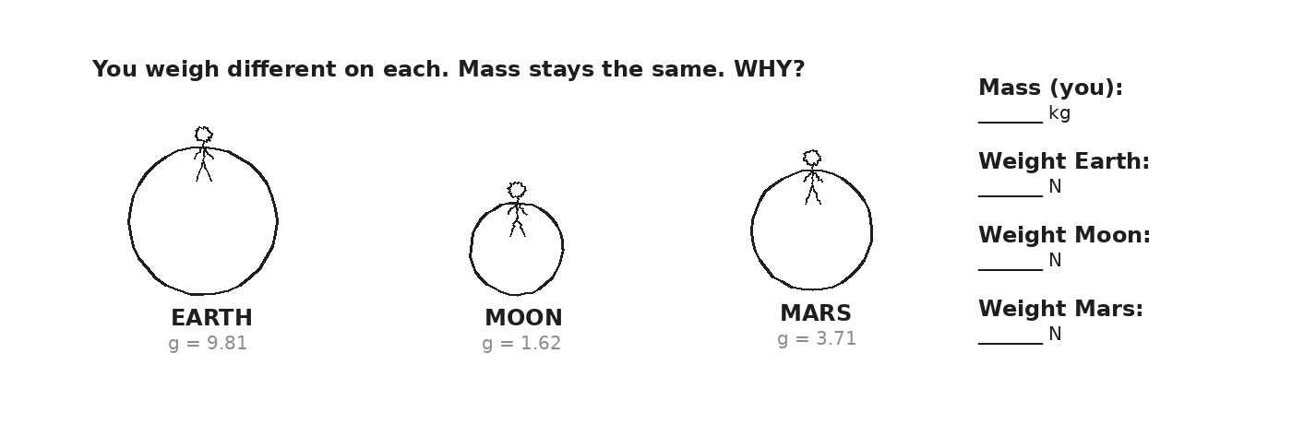

WORKED EXAMPLE — your weight on the Moon
A 70 kg student stands on the Moon. What is their weight? (g_Moon = 1.62 m/s²)
GIVEN | m = 70 kg · g_Moon = 1.62 m/s²
EQUATION | F_w = m·g
WORK | F_w = 70 × 1.62 = 113.4 N
ANSWER | 113 N. About 1/6 their Earth weight, but their mass is unchanged.

YOUR TURN — weight on Mars
If you weigh 600 N on Earth, find your mass first. Then calculate your weight on Mars (g_Mars = 3.71 m/s²).
GIVEN
EQUATION
WORK
ANSWER

★ | Cognate alert: peso = weight (Sp.), masa = mass (Sp.). Don't mix them up.

EXIT TICKET — Day 3
If you weigh 600 N on Earth, what is your mass? What would you weigh on a planet with g = 25 m/s²?

Today's Targets — Rate Yourself
1 = Not Yet (I can't do this without help) 2 = Almost (I can do this with some help or some errors) 3 = Got It (I can do this independently and explain it)
Help? Check the box if you want to talk with me about this target — even if you marked yourself a 3.
Target | 1 | 2 | 3 | Help?
I can explain the difference between mass and weight. | ○ | ○ | ○ | ☐
I can use F = m·g to find weight on Earth, Moon, Mars, or any g. | ○ | ○ | ○ | ☐
I can find mass when given weight and g. | ○ | ○ | ○ | ☐

Day 4 — Newton's Law of Universal Gravitation

Today's Target
I can write F = G·m₁·m₂/r², explain what each symbol means, and reason about how F changes when masses or distance change.
ASTEROID THREAD
What we know about 2026-XJ today: The asteroid feels gravity from the Sun and (weakly) Earth.
How today connects: THIS is the equation we've been building toward. The 1/r² geometry decides how steeply gravity grows as 2026-XJ approaches.

VOCAB · UNIVERSAL GRAVITATION
Definition: Every mass pulls on every other mass with a force F = G·m₁·m₂/r².
Example: Earth pulls the Moon. The Moon pulls Earth back (tides). You pull your neighbor — tiny but real.
Cognates: Sp. gravitación universal · Pt. gravitação universal
Watch out: Gravity is NOT just 'Earth pulling things down.' Every pair of masses attracts.

DOODLE ZONE
Fill in r (a number that's reasonable for an asteroid). Then predict: if r doubles, what happens to F? Write the factor.
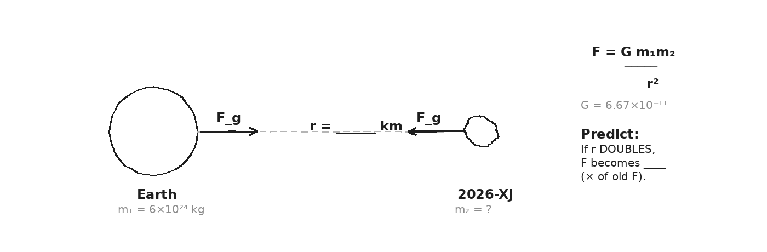

EQUATION · ANATOMY
F = G · m₁ · m₂ / r²
F = the gravitational force between the two masses (newtons)
G = 6.67 × 10⁻¹¹ N·m²/kg² (always the same — that's why we call it universal)
m₁ = mass of one object (kg)
m₂ = mass of the other object (kg)
r = distance between the centers of the two objects (meters)
r² = r SQUARED. Doubling r makes F drop to 1/4. Tripling r makes F drop to 1/9.
⚠ | r is between CENTERS, not between surfaces. For Earth-asteroid, r ≈ Earth–asteroid distance + Earth's radius.

EXIT TICKET — Day 4
If 2026-XJ doubles its distance from Earth, what happens to F_gravity? Triples?

Today's Targets — Rate Yourself
1 = Not Yet (I can't do this without help) 2 = Almost (I can do this with some help or some errors) 3 = Got It (I can do this independently and explain it)
Help? Check the box if you want to talk with me about this target — even if you marked yourself a 3.
Target | 1 | 2 | 3 | Help?
I can identify each symbol in F = G·m₁·m₂/r². | ○ | ○ | ○ | ☐
I can reason: if r doubles, F drops to ¼; if r triples, F drops to 1/9. | ○ | ○ | ○ | ☐
I can explain why gravity is weak between human-scale objects. | ○ | ○ | ○ | ☐

Day 5 — F = Gm₁m₂/r² Calculation Day

Today's Target
I can compute the gravitational force between two masses given their distance, and I can reason about how F scales when any input changes.
ASTEROID THREAD
What we know about 2026-XJ today: 2026-XJ's mass: roughly 3.5 × 10¹¹ kg (estimate). Sun's mass: 1.99 × 10³⁰ kg.
How today connects: Today you compute real Earth–Moon, Earth–Sun, Earth–asteroid forces. The biggest force in 2026-XJ's life is the SUN.

DOODLE ZONE
Fill in: at 2r, F = ____ of F₀. At 3r, F = ____ of F₀. (Use the 1/r² rule.)
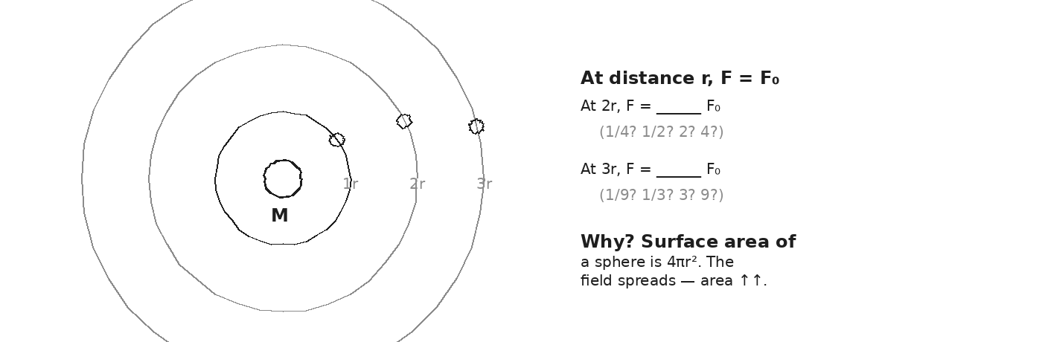

WORKED EXAMPLE — Earth-Moon gravitational force
Find F between Earth (m₁ = 5.97 × 10²⁴ kg) and Moon (m₂ = 7.35 × 10²² kg) at r = 3.84 × 10⁸ m.
GIVEN | m₁ = 5.97×10²⁴ kg · m₂ = 7.35×10²² kg · r = 3.84×10⁸ m · G = 6.67×10⁻¹¹
EQUATION | F = G·m₁·m₂ / r²
WORK | F = (6.67×10⁻¹¹)(5.97×10²⁴)(7.35×10²²) / (3.84×10⁸)²  F = (2.93×10³⁷) / (1.47×10¹⁷)  F ≈ 1.99 × 10²⁰ N
ANSWER | ≈ 2.0 × 10²⁰ N — gigantic, but felt by a gigantic Moon.

YOUR TURN — Earth and 2026-XJ
Find F between Earth (m₁ = 5.97 × 10²⁴ kg) and 2026-XJ (m₂ = 3.5 × 10¹¹ kg) at r = 1.0 × 10¹⁰ m (about 26 lunar distances).
GIVEN
EQUATION
WORK
ANSWER

YOUR TURN — at half the distance
If 2026-XJ moves to r = 5.0 × 10⁹ m (half the previous distance), what is F now? You can SCALE rather than recompute: F_new = F_old × (factor).
GIVEN
EQUATION
WORK
ANSWER

EXIT TICKET — Day 5
If 2026-XJ is currently at 5 lunar distances from Earth and gets to 1 lunar distance, how many times larger is the gravitational force?

Today's Targets — Rate Yourself
1 = Not Yet (I can't do this without help) 2 = Almost (I can do this with some help or some errors) 3 = Got It (I can do this independently and explain it)
Help? Check the box if you want to talk with me about this target — even if you marked yourself a 3.
Target | 1 | 2 | 3 | Help?
I can compute F using F = G·m₁·m₂/r² with scientific notation. | ○ | ○ | ○ | ☐
I can SCALE F when r changes (r×2 → F×¼; r×½ → F×4). | ○ | ○ | ○ | ☐
I can keep my units straight throughout. | ○ | ○ | ○ | ☐

Day 6 — Gravitational Fields — g as Field Strength

Today's Target
I can compute g(r) = G·M/r² at any distance from a body, and I can explain g as a field that lives in space — force per unit mass.
ASTEROID THREAD
What we know about 2026-XJ today: Earth makes a gravitational field everywhere in space.
How today connects: As 2026-XJ moves through Earth's field, the strength at its location changes. The field IS the bridge between 'Earth's mass' and 'force on the asteroid.'

VOCAB · GRAVITATIONAL FIELD
Definition: A region of space where a mass would feel a gravitational force; its strength is g(r) at each point.
Example: At Earth's surface, g = 9.81 N/kg. At ISS altitude (~400 km up), g ≈ 8.7 N/kg.
Cognates: Sp. campo gravitatorio · Pt. campo gravitacional · HC chan gravitasyonèl
Watch out: N/kg and m/s² are the SAME unit. The field strength IS the acceleration a mass would feel.

DOODLE ZONE
Where the arrows are FAINT, make them shorter. Where they're DARK, make them longer. Gravity weakens with distance.
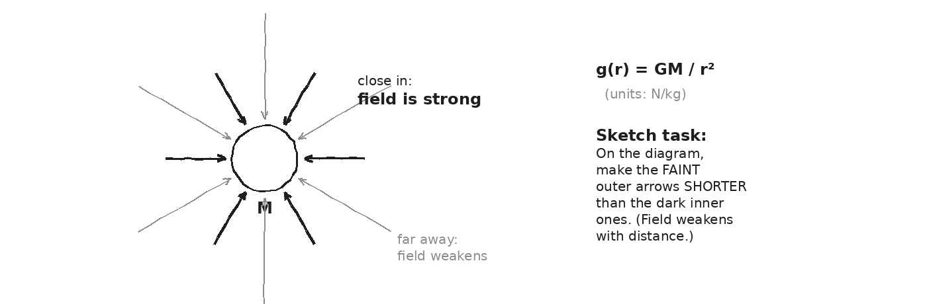

WORKED EXAMPLE — g at Earth's surface (check)
Compute g at Earth's surface using G·M_Earth / R_Earth². Show that you get 9.81 m/s².
GIVEN | G = 6.67×10⁻¹¹ · M_Earth = 5.97×10²⁴ kg · R_Earth = 6.37×10⁶ m
EQUATION | g(R) = G·M / R²
WORK | g = (6.67×10⁻¹¹)(5.97×10²⁴) / (6.37×10⁶)²  g = (3.98×10¹⁴) / (4.06×10¹³)  g ≈ 9.81 m/s²
ANSWER | 9.81 m/s². The number matches what we measure in lab — the equation works.

YOUR TURN — g at ISS altitude
Compute g at the ISS (altitude 400 km, so r = R_Earth + 400 km = 6.77 × 10⁶ m). Then explain in one sentence why astronauts float anyway.
GIVEN
EQUATION
WORK
ANSWER

⚠ | "Zero gravity" in space is a myth. At the ISS, g is about 89% of surface g. Astronauts float because they are FALLING with the station — that's an orbit.

Fill in the frame:
Astronauts on the ISS float NOT because g is zero, but because they and the station are both ________________________________________________________ around Earth, so they fall ________________________________________________________.
EXIT TICKET — Day 6
Why is the ISS NOT 'in zero gravity' even though astronauts float? Compute g at ISS altitude in your answer.

Today's Targets — Rate Yourself
1 = Not Yet (I can't do this without help) 2 = Almost (I can do this with some help or some errors) 3 = Got It (I can do this independently and explain it)
Help? Check the box if you want to talk with me about this target — even if you marked yourself a 3.
Target | 1 | 2 | 3 | Help?
I can compute g(r) at any altitude from G·M/r². | ○ | ○ | ○ | ☐
I can explain g as a field with N/kg units (= m/s²). | ○ | ○ | ○ | ☐
I can dispel the 'no gravity in space' misconception with a number. | ○ | ○ | ○ | ☐

Day 7 — g Varies with Altitude — Preview to Orbits

Today's Target
I can graph g vs. altitude, read the curve, and explain qualitatively why weightlessness in orbit is FREE FALL — not the absence of gravity.
ASTEROID THREAD
What we know about 2026-XJ today: 2026-XJ's distance is changing, so the g it feels is changing.
How today connects: g(r) is the function that lets us compute the force on the asteroid at ANY distance — not just at Earth's surface.

DOODLE ZONE
On the graph, MARK where g drops to half. Mark where g drops to 1/10. Why doesn't ISS fall straight down? Write 2 sentences.
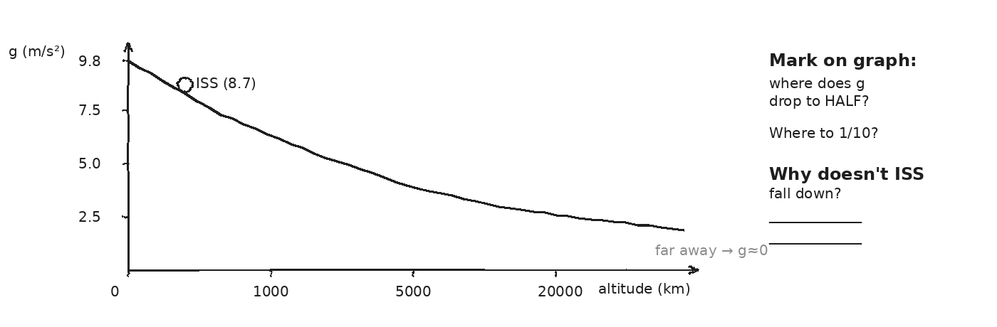

WORKED EXAMPLE — g at the Moon's orbit (radius)
Find Earth's g at the Moon's average orbital distance (r = 3.84 × 10⁸ m). Compare to surface g.
GIVEN | M_Earth = 5.97×10²⁴ kg · r = 3.84×10⁸ m
EQUATION | g(r) = G·M / r²
WORK | g = (6.67×10⁻¹¹)(5.97×10²⁴) / (3.84×10⁸)²  g = (3.98×10¹⁴) / (1.47×10¹⁷)  g ≈ 0.0027 m/s²
ANSWER | ≈ 0.0027 m/s² — about 1/3600 of surface g. The Moon still feels Earth's pull.

YOUR TURN — at what altitude does g drop to half?
Find the altitude above Earth's surface where g = 4.9 m/s² (half of surface g). Hint: solve g = G·M/r² for r. Then subtract R_Earth.
GIVEN
EQUATION
WORK
ANSWER

EXIT TICKET — Day 7
Explain the difference between (a) 'no gravity in orbit' and (b) 'falling freely in orbit.' Which one is true?

Today's Targets — Rate Yourself
1 = Not Yet (I can't do this without help) 2 = Almost (I can do this with some help or some errors) 3 = Got It (I can do this independently and explain it)
Help? Check the box if you want to talk with me about this target — even if you marked yourself a 3.
Target | 1 | 2 | 3 | Help?
I can read g off a g-vs-altitude graph. | ○ | ○ | ○ | ☐
I can compute g at any r. | ○ | ○ | ○ | ☐
I can explain weightlessness as free fall, not as 'no gravity.' | ○ | ○ | ○ | ☐

Day 8 — Vernier Free-Fall Lab: Measure g · Investigation 2.1

Today's Target
I can capture a v-t graph for a falling ball with a Vernier motion detector and find g from the slope.
ASTEROID THREAD
What we know about 2026-XJ today: We've been USING g = 9.81 m/s² for a week. Today we MEASURE it.
How today connects: If our lab number matches theory, the F = G·m₁·m₂/r² framework we'll apply to 2026-XJ stands on tested ground.

LAB SETUP — INVESTIGATION 2.1
Driving question: How close can we come to measuring g = 9.81 m/s² in this room?
Equipment:
- Vernier motion detector + LabQuest (1 per pair)
- Logger Pro or Graphical Analysis on a laptop
- A drop ball (≥ 4 cm diameter — bigger is better for the sensor)
- Tape measure (to set drop height)
- Clear floor zone (head and toes out of the drop path)
What you do:
1. Point the motion detector UP. Hold the ball at a known height above it.
2. Start data collection. Release the ball cleanly (no toss).
3. On the v-t graph, the falling portion is a straight line. Fit it. Slope = g.
4. Repeat for 3 trials. Average. Compare to 9.81 m/s².
────────────────────────────────────────────────────────────
Safety: Catch the ball before it hits the sensor. Keep hands and faces clear of the drop path. Don't release toward another group.
How this lab serves the year's question: If the lab confirms g near Earth, the equations we use for 2026-XJ are trustworthy.
DOODLE ZONE
Sketch your lab setup. Record h (drop height) on the diagram. Fill the trial slopes on the right.
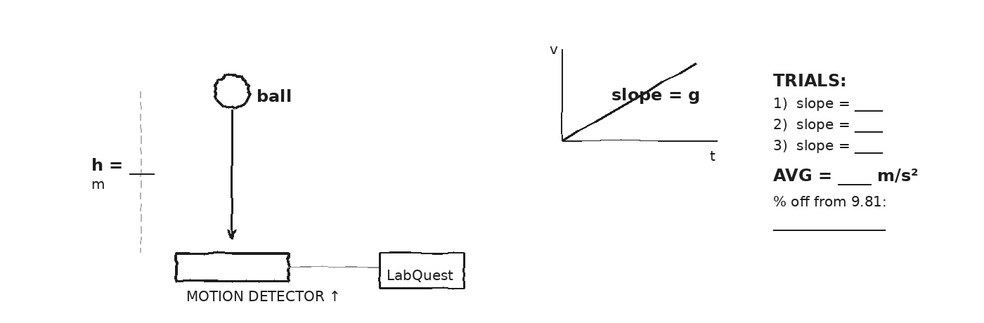

DATA — VERNIER FREE-FALL TRIALS
Trial | Drop height (m) | Slope of v-t (m/s²) | Notes (release? ball wobble?)
1
2
3
4
Class avg
OBSERVATION & ANALYSIS
How close is your AVERAGE to 9.81 m/s²?

If your value is LOW, what in your setup might cause that? If HIGH, what might?
My measured g was __________ m/s². The accepted value is 9.81 m/s². My percent error was __________. I think the biggest source of error was __________.
Asteroid connection: how does this serve the year's question?

Fill in the frame:
If F = G·m₁·m₂/r² gives g = 9.81 at Earth's surface, AND we measured g = ____ in the lab, then the framework is ________________________________________________________ trustworthy for the asteroid.
EXIT TICKET — Day 8
Write a claim-evidence-reasoning paragraph: "From my data, I claim g = ____ m/s². My evidence is _____. This is _____% off from 9.81 m/s². I think the difference is because _____."

Today's Targets — Rate Yourself
1 = Not Yet (I can't do this without help) 2 = Almost (I can do this with some help or some errors) 3 = Got It (I can do this independently and explain it)
Help? Check the box if you want to talk with me about this target — even if you marked yourself a 3.
Target | 1 | 2 | 3 | Help?
I can run a Vernier free-fall trial and fit a line to the v-t graph. | ○ | ○ | ○ | ☐
I can find g from the slope. | ○ | ○ | ○ | ☐
I can identify a credible source of error in my measurement. | ○ | ○ | ○ | ☐

Day 9 — Projectile Motion: Two Independent Dimensions

Today's Target
I can decompose a projectile's motion into independent horizontal and vertical pieces, and I can explain why a side-pushed ball and a dropped ball hit the ground at the same time.
ASTEROID THREAD
What we know about 2026-XJ today: An asteroid in flight is technically a projectile — gravity bends its path.
How today connects: What you learn about projectiles in 3 days scales straight up to orbits. The math is the same; only the distances grow.

VOCAB · PROJECTILE
Definition: Any object moving under gravity alone after launch — no engine, no air force.
Example: A thrown baseball. A horizontally-fired bullet. An asteroid in free fall.
Cognates: Sp. proyectil · Pt. projétil · HC pwojektil
Watch out: A projectile is NOT under thrust. Once it leaves your hand, only gravity acts on it (in our model).

DOODLE ZONE
Fill the blanks for vₓ and v_y after 1 s and 2 s. Then circle which prediction the monkey-and-hunter experiment confirms.
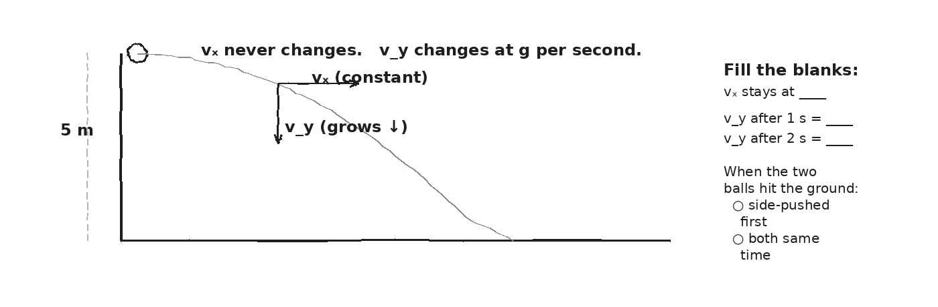

EQUATION · ANATOMY — independent motion
Horizontal: x = vₓ · t Vertical: y = y₀ − ½·g·t²
Horizontal velocity NEVER changes (no horizontal force).
Vertical velocity changes at g per second (gravity acts here).
The two pieces are INDEPENDENT — time is the only link.
★ | Drop one ball. Push another sideways at the same instant. They hit the ground at the SAME time. Time is set by the VERTICAL motion alone.

EXIT TICKET — Day 9
Why does a side-pushed ball NOT take longer to fall than a ball that's just dropped? Use the word 'independent' in your answer.

Today's Targets — Rate Yourself
1 = Not Yet (I can't do this without help) 2 = Almost (I can do this with some help or some errors) 3 = Got It (I can do this independently and explain it)
Help? Check the box if you want to talk with me about this target — even if you marked yourself a 3.
Target | 1 | 2 | 3 | Help?
I can decompose a projectile's motion into independent x and y pieces. | ○ | ○ | ○ | ☐
I can write y = y₀ − ½·g·t² for the vertical motion. | ○ | ○ | ○ | ☐
I can explain why horizontal motion doesn't affect fall time. | ○ | ○ | ○ | ☐

Day 10 — Horizontal Projectile Launches

Today's Target
I can solve a horizontal-launch projectile problem: find fall time from height, then find horizontal range.
ASTEROID THREAD
What we know about 2026-XJ today: 2026-XJ has both horizontal and vertical velocity (with respect to Earth).
How today connects: Cliff problems are the small-scale version. The 1-step recipe (find t first, then x) is the same recipe orbit problems use.

DOODLE ZONE
Pick numbers for h and vₓ. Trace the parabola lightly with a pencil. Then label the range x.
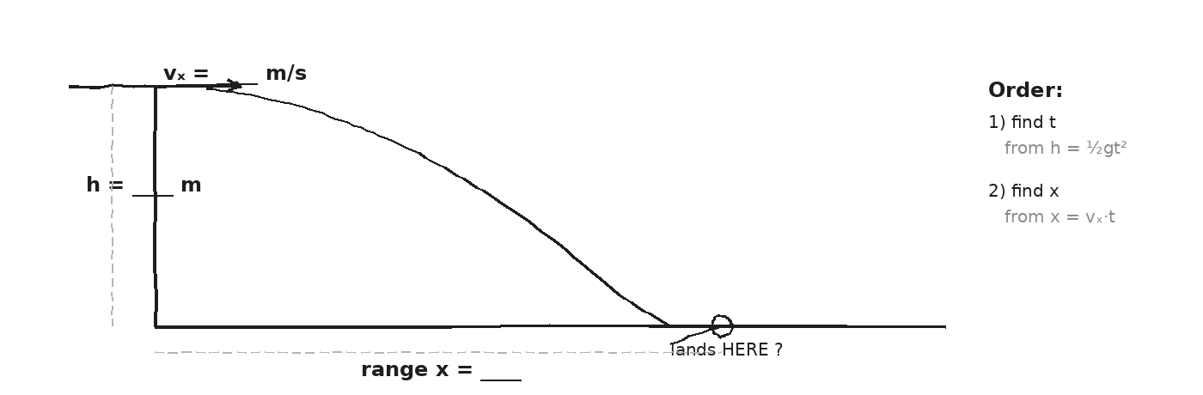

WORKED EXAMPLE — 5 m cliff at vₓ = 10 m/s
A ball is fired horizontally from a 5 m cliff at vₓ = 10 m/s. (a) How long until it hits the ground? (b) How far from the cliff base?
GIVEN | h = 5 m · vₓ = 10 m/s · g = 9.81 m/s²
EQUATION | (1) h = ½·g·t² (2) x = vₓ·t
WORK | (1) 5 = ½·(9.81)·t² → t² = 10/9.81 → t ≈ 1.01 s  (2) x = 10 × 1.01 ≈ 10.1 m
ANSWER | t ≈ 1.0 s, lands ≈ 10 m from the cliff.

YOUR TURN — 45 m cliff at 15 m/s
A ball is fired horizontally from a 45 m cliff at vₓ = 15 m/s. (a) Find fall time. (b) Find horizontal range.
GIVEN
EQUATION
WORK
ANSWER

✎ | Strategy every time: FIND TIME FIRST from the vertical motion. Then plug t into x = vₓ·t.

EXIT TICKET — Day 10
From a 20 m cliff at vₓ = 8 m/s, where does the ball land? Show both steps.

Today's Targets — Rate Yourself
1 = Not Yet (I can't do this without help) 2 = Almost (I can do this with some help or some errors) 3 = Got It (I can do this independently and explain it)
Help? Check the box if you want to talk with me about this target — even if you marked yourself a 3.
Target | 1 | 2 | 3 | Help?
I can find fall time from h = ½·g·t². | ○ | ○ | ○ | ☐
I can find horizontal range from x = vₓ·t. | ○ | ○ | ○ | ☐
I can order the steps: time first, range second. | ○ | ○ | ○ | ☐

Day 11 — Angled Projectile Launches

Today's Target
I can decompose a launch velocity into vₓ = v cos θ and v_y = v sin θ, compute flight time, and explain why 45° maximizes range on level ground.
ASTEROID THREAD
What we know about 2026-XJ today: 2026-XJ's velocity has both horizontal and angled components in Earth's frame.
How today connects: If the asteroid entered the atmosphere, this is the math we'd use to predict the impact point.

DOODLE ZONE
Pick v (a launch speed). Trace the 45° arc with a pen. Why does it go farthest? Write a 1-sentence reason.
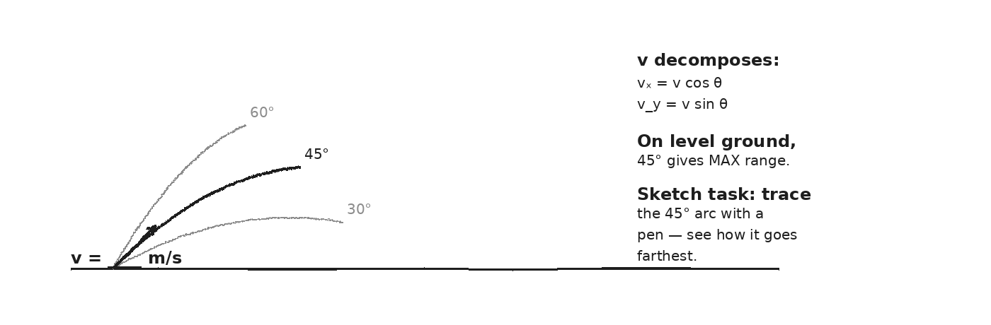

WORKED EXAMPLE — 20 m/s at 30° on level ground
A ball launches at 20 m/s at 30° above level ground. Find (a) vₓ, (b) v_y, (c) flight time, (d) range.
GIVEN | v = 20 m/s · θ = 30° · level ground · g = 9.81 m/s²
EQUATION | vₓ = v cos θ · v_y = v sin θ · t_flight = 2·v_y/g · x = vₓ·t_flight
WORK | vₓ = 20·cos30° ≈ 17.3 m/s  v_y = 20·sin30° = 10.0 m/s  t_flight = 2·10.0 / 9.81 ≈ 2.04 s  x = 17.3 × 2.04 ≈ 35.3 m
ANSWER | ≈ 35 m. (Try 45° — you'll get ≈ 40.8 m, the maximum on level ground.)

YOUR TURN — 20 m/s at 60°
Same launch speed, but now θ = 60°. Predict: will the range be bigger, smaller, or the same as 30°? Compute it.
GIVEN
EQUATION
WORK
ANSWER

Fill in the frame:
On level ground, 45° gives max range because at 45° the launch speed is split ________________________________________________________ between horizontal and vertical, balancing ________________________________________________________ in the air with ________________________________________________________ across the ground.
EXIT TICKET — Day 11
Why does 45° give max range on level ground? Reason it physically (not just algebraically).

Today's Targets — Rate Yourself
1 = Not Yet (I can't do this without help) 2 = Almost (I can do this with some help or some errors) 3 = Got It (I can do this independently and explain it)
Help? Check the box if you want to talk with me about this target — even if you marked yourself a 3.
Target | 1 | 2 | 3 | Help?
I can decompose a launch velocity into vₓ and v_y. | ○ | ○ | ○ | ☐
I can find flight time from v_y and g. | ○ | ○ | ○ | ☐
I can explain why 45° is the optimal angle on level ground. | ○ | ○ | ○ | ☐

Day 12 — Circular Motion + Centripetal Force

Today's Target
I can compute a_c = v²/r and F_c = m·v²/r for an object in circular motion and explain why F_c always points toward the center.
ASTEROID THREAD
What we know about 2026-XJ today: An orbit IS circular motion. The force that holds an orbit is gravity.
How today connects: Today we get the centripetal math. Tomorrow we connect it to gravity and discover that orbits ARE FALLING.

VOCAB · CENTRIPETAL FORCE
Definition: The NET inward force that keeps an object on a circular path; F_c = m·v²/r.
Example: A car turning a corner: friction is the centripetal force. A satellite orbiting: gravity is.
Cognates: Sp. fuerza centrípeta · Pt. força centrípeta · HC fòs santipèt
Watch out: Centripetal force is NOT a new kind of force. It's the ROLE played by an existing force (friction, gravity, tension) that points toward the center.

DOODLE ZONE
On the diagram, color the F_c arrow with one mark and the v arrow with a different mark. What direction does the ball go if the string cuts?
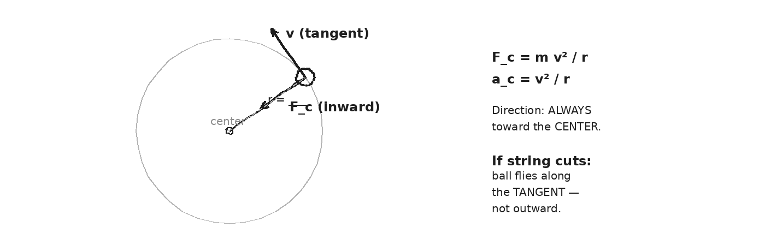

WORKED EXAMPLE — car on a curve
A 1500 kg car rounds a 50 m radius curve at 20 m/s. What centripetal force must friction provide?
GIVEN | m = 1500 kg · v = 20 m/s · r = 50 m
EQUATION | F_c = m·v² / r
WORK | F_c = 1500 × (20)² / 50  F_c = 1500 × 400 / 50  F_c = 12,000 N
ANSWER | 12,000 N inward. Friction has to provide all of it — if it can't, the car skids out.

YOUR TURN — ball on a string
A 0.2 kg ball moves in a horizontal circle at 4 m/s on a 1 m string. What is the centripetal force? What provides it?
GIVEN
EQUATION
WORK
ANSWER

⚠ | When the string cuts, the ball flies along the TANGENT — not outward. There's no 'centrifugal force' pushing it outward; the inward force just disappears.

EXIT TICKET — Day 12
A ball on a 1 m string moves in a horizontal circle at 4 m/s; mass 0.2 kg. What's the centripetal force? Show your work.

Today's Targets — Rate Yourself
1 = Not Yet (I can't do this without help) 2 = Almost (I can do this with some help or some errors) 3 = Got It (I can do this independently and explain it)
Help? Check the box if you want to talk with me about this target — even if you marked yourself a 3.
Target | 1 | 2 | 3 | Help?
I can compute F_c = m·v²/r given m, v, r. | ○ | ○ | ○ | ☐
I can identify what FORCE plays the centripetal role in a scenario. | ○ | ○ | ○ | ☐
I can explain why a cut string sends the ball tangent — not outward. | ○ | ○ | ○ | ☐

Day 13 — Newton's Cannon: Orbits as Continuous Falling · Investigation 2.2 (PhET)

Today's Target
I can explain an orbit as continuous free fall, and I can use the PhET Gravity and Orbits sim to find what launch speed produces a circular orbit at a given altitude.
ASTEROID THREAD
What we know about 2026-XJ today: Two orbits (Earth's and 2026-XJ's) can cross. The question is timing.
How today connects: Today we discover that an orbit IS falling — at exactly the speed that lets the ground curve away as fast as you fall toward it.

LAB SETUP — INVESTIGATION 2.2 — PhET
Driving question: What launch speed produces a CIRCULAR orbit at a given altitude?
Equipment:
- Laptop with the PhET Gravity and Orbits sim loaded
- Calculator
- Today's data table (next page)
What you do:
1. Open PhET Gravity and Orbits. Place a satellite near Earth at a chosen altitude.
2. Try a small launch velocity. What happens? (Crashes.)
3. Increase the velocity. Find a speed that makes a CIRCULAR orbit.
4. Then compute v_orbit = √(G·M/r) for that altitude. Compare.
────────────────────────────────────────────────────────────
Safety: No physical hazards. Sit upright; eyes on the screen.
How this lab serves the year's question: 2026-XJ is on a Sun-orbit. The same v_orbit equation applies — only the central mass changes.
DOODLE ZONE
Label which path is 'slow', which is 'faster', and which is 'orbit speed.' Write the key idea sentence using the words 'falling' and 'horizontal'.
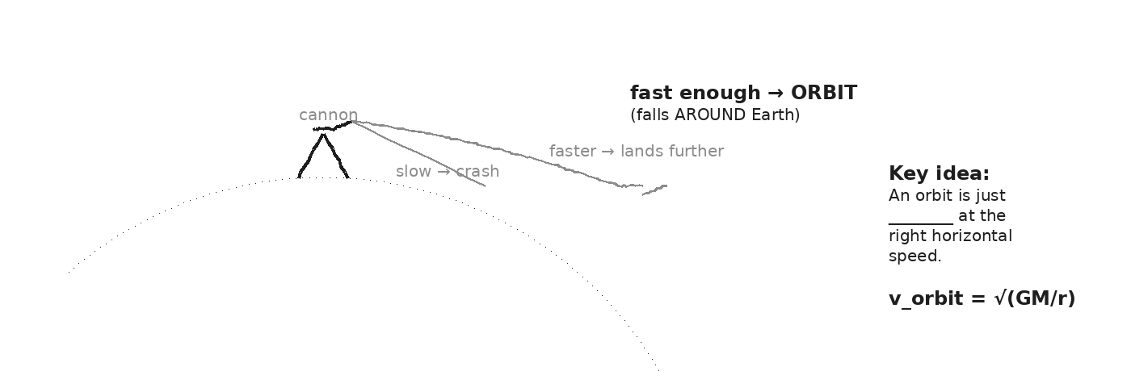

DATA — CIRCULAR ORBIT SEARCH
Trial | Altitude (km) | Launch v (m/s) | Result (crash / oval / circle / escape)
1
2
3
4
5
WORKED EXAMPLE — derive v_orbit = √(GM/r)
For a circular orbit, gravity IS the centripetal force. Set F_gravity = F_centripetal and solve for v. Show every step.
GIVEN | Circular orbit at radius r around mass M
EQUATION | F_g = G·M·m/r² ; F_c = m·v²/r ; set them equal
WORK | G·M·m / r² = m·v² / r  G·M / r² = v² / r (cancel m)  G·M / r = v² (multiply both sides by r)  v = √(G·M / r)
ANSWER | v_orbit = √(G·M / r). The orbit speed depends on the CENTRAL mass and the radius — not on the satellite's mass.

OBSERVATION & ANALYSIS
What was the launch speed for a CLEAN circular orbit at 400 km altitude?

Compare your sim value to v_orbit = √(G·M_Earth / r) at r = R_Earth + 400 km. Match?
The launch speed for a circular orbit at 400 km is about __________ m/s. Theory predicts __________ m/s. The sim agrees __________.
Asteroid connection: how does this serve the year's question?

EXIT TICKET — Day 13
In 2-3 sentences, explain why the ISS doesn't fall straight down. Use the words 'falling', 'horizontal', and 'curves away'.

Today's Targets — Rate Yourself
1 = Not Yet (I can't do this without help) 2 = Almost (I can do this with some help or some errors) 3 = Got It (I can do this independently and explain it)
Help? Check the box if you want to talk with me about this target — even if you marked yourself a 3.
Target | 1 | 2 | 3 | Help?
I can use PhET to find a circular-orbit launch speed at a given altitude. | ○ | ○ | ○ | ☐
I can derive v_orbit = √(G·M/r) by setting F_g = F_c. | ○ | ○ | ○ | ☐
I can explain an orbit as continuous free fall. | ○ | ○ | ○ | ☐

Day 14 — Kepler's Three Laws

Today's Target
I can state Kepler's three laws in my own words and use Kepler's third law to compare orbital periods.
ASTEROID THREAD
What we know about 2026-XJ today: 2026-XJ's semi-major axis a ≈ 1.42 AU (refined orbit).
How today connects: Kepler's third law gives 2026-XJ's PERIOD — and that's the timing we need to answer Phase 5's question: WHEN does it next cross Earth's orbit?

VOCAB · ELLIPSE
Definition: An oval-shaped closed curve with TWO foci. The orbit of every planet is an ellipse, with the central body at one focus.
Example: Earth's orbit is nearly circular (e ≈ 0.017). A comet's orbit is highly elliptical (e ≈ 0.9).
Cognates: Sp. elipse · Pt. elipse · HC elips
Watch out: An ellipse has TWO foci. The central body sits at ONE of them (not at the center).

VOCAB · PERIOD (T)
Definition: The time for one full orbit.
Example: Earth's period around the Sun = 1 year. Moon's period around Earth ≈ 27.3 days.
Cognates: Sp. periodo · Pt. período · HC peryòd
Watch out: Period is NOT speed. A longer period means a longer orbit, not a slower object.

DOODLE ZONE
MARK the point on the orbit where the object moves FASTEST (perihelion). Mark the slowest (aphelion). Why?
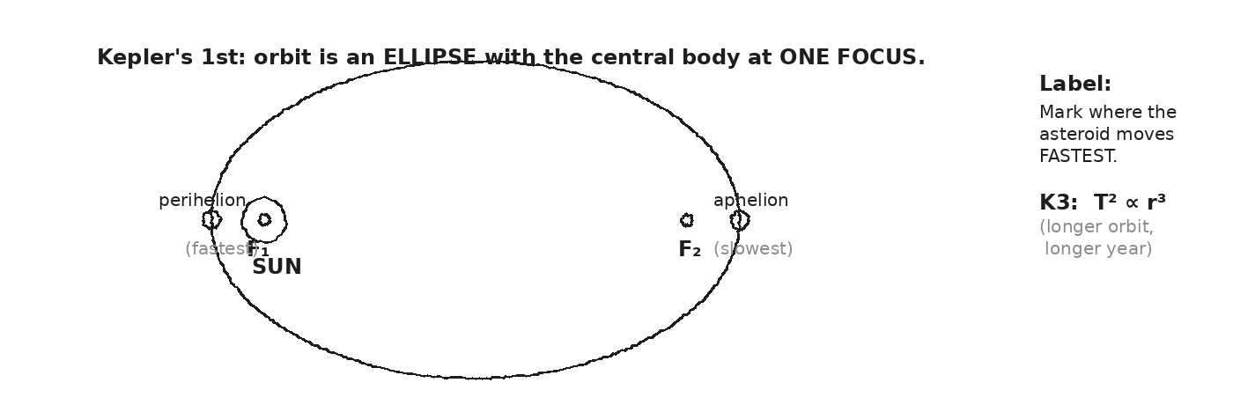

EQUATION · ANATOMY — Kepler's third law (Sun-orbits)
T² = a³ (T in years, a in AU, around the Sun)
T = orbital period (years)
a = semi-major axis (AU; 1 AU = average Earth–Sun distance)
Bigger orbit → much longer year (because T² grows as a³).
WORKED EXAMPLE — Mars's year
Mars has a semi-major axis a = 1.52 AU. Find its period in years using Kepler's third law.
GIVEN | a = 1.52 AU · use T² = a³ (Sun-orbit, T in years)
EQUATION | T² = a³ → T = √(a³)
WORK | T² = (1.52)³ = 3.51  T = √3.51 ≈ 1.87 years
ANSWER | ≈ 1.87 Earth-years. (Real value: 1.88. Match.)

YOUR TURN — 2026-XJ's period
2026-XJ has a = 1.42 AU. Find its period in years. (This number tells us how often it could return to its current location.)
GIVEN
EQUATION
WORK
ANSWER

EXIT TICKET — Day 14
Write each of Kepler's three laws in ONE sentence in your own words.

Today's Targets — Rate Yourself
1 = Not Yet (I can't do this without help) 2 = Almost (I can do this with some help or some errors) 3 = Got It (I can do this independently and explain it)
Help? Check the box if you want to talk with me about this target — even if you marked yourself a 3.
Target | 1 | 2 | 3 | Help?
I can state Kepler's three laws plainly. | ○ | ○ | ○ | ☐
I can use T² = a³ for orbits around the Sun. | ○ | ○ | ○ | ☐
I can predict the period of an asteroid given its semi-major axis. | ○ | ○ | ○ | ☐

Day 15 — When Does 2026-XJ Arrive?

Today's Target
I can use Kepler's third law and universal gravitation to compute 2026-XJ's period, its perihelion distance, and whether/when its orbit crosses Earth's.
ASTEROID THREAD
What we know about 2026-XJ today: Refined parameters (from the cover briefing): a = 1.42 AU, e = 0.31, currently closing.
How today connects: This is the day the unit pays off. We use EVERY tool we built — universal gravitation, fields, orbits, Kepler — to answer: when does 2026-XJ next cross Earth's path?

DOODLE ZONE
Compute the asteroid's period using T² = a³. Compute perihelion = a(1-e). Will the perihelion bring it INSIDE Earth's orbit? Write yes/no and one sentence.
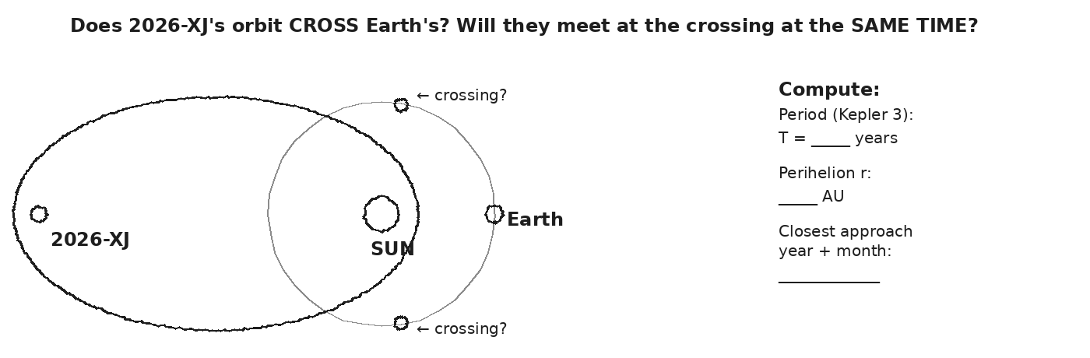

STEP 1 — period from Kepler's third
Use T² = a³ with a = 1.42 AU. Find 2026-XJ's orbital period in years.
GIVEN | a = 1.42 AU (heliocentric, around the Sun)
EQUATION | T² = a³ → T = √(a³)
WORK | T² = (1.42)³ = 2.86  T = √2.86 ≈ 1.69 years
ANSWER | ≈ 1.69 Earth-years — about 20 months for one full orbit of the Sun.

STEP 2 — perihelion and aphelion distances
Use perihelion = a(1−e) and aphelion = a(1+e) with a = 1.42 AU and e = 0.31. Compute both distances in AU.
GIVEN | a = 1.42 AU · e = 0.31
EQUATION | r_peri = a(1−e) ; r_apo = a(1+e)
WORK | r_peri = 1.42 × (1 − 0.31) = 1.42 × 0.69 ≈ 0.98 AU  r_apo = 1.42 × (1 + 0.31) = 1.42 × 1.31 ≈ 1.86 AU
ANSWER | Perihelion ≈ 0.98 AU; aphelion ≈ 1.86 AU. PERIHELION IS INSIDE EARTH'S ORBIT (1.00 AU).

STEP 3 — does it cross Earth's orbit? When?
Since 2026-XJ's perihelion is 0.98 AU and Earth's orbit is 1.00 AU, the asteroid CROSSES Earth's orbit twice per pass — once going in, once going out. Use your period (≈ 1.69 yr) to estimate WHEN it next reaches perihelion. (Use any reasonable assumption about its current position in the orbit; show your reasoning.)
GIVEN
EQUATION
WORK
ANSWER

★ | This is what NASA actually does. The math you ran here is the same kind they run on real near-Earth objects — the constants are real, the equations are real, only the asteroid is fictional.

Fill in the frame:
Compared to Unit 1's prediction, this answer is more trustworthy because Unit 1 assumed ________________________________________________________, but we now know that ________________________________________________________ depends on r. The new tools we used were ________________________________________________________ and ________________________________________________________.
EXIT TICKET — Day 15
Write one sentence to a non-physics friend explaining when (year + roughly what month) 2026-XJ next crosses Earth's orbit — and whether being at the SAME PLACE in space at the SAME TIME is likely. Be honest about the uncertainty.

Today's Targets — Rate Yourself
1 = Not Yet (I can't do this without help) 2 = Almost (I can do this with some help or some errors) 3 = Got It (I can do this independently and explain it)
Help? Check the box if you want to talk with me about this target — even if you marked yourself a 3.
Target | 1 | 2 | 3 | Help?
I can use T² = a³ to find an orbital period. | ○ | ○ | ○ | ☐
I can find perihelion and aphelion from a and e. | ○ | ○ | ○ | ☐
I can apply Kepler + gravitation to reason about 2026-XJ's closest approach to Earth. | ○ | ○ | ○ | ☐
I can compare today's prediction to Unit 1's and explain why this one is more trustworthy. | ○ | ○ | ○ | ☐

Day 16 — Unit 2 Transfer Task — Assessment Day

ASTEROID THREAD
What we know about 2026-XJ today: Every tool from Unit 2 is in your hands: free fall, F = mg, universal gravitation, field strength g(r), projectiles, centripetal force, orbits, Kepler.
How today connects: One of the 4 transfer problems anchors in 2026-XJ — compute F_gravity between Earth and the asteroid at a specific separation and reason about how F changes.

TRANSFER TASK — UNIT 2 · DAY 16
Today you receive the Unit 2 Transfer Task on a separate sheet. It is 4 multi-part problems. You will work independently for ~40 minutes.
• Problem 1 — Universal gravitation. Compute F between Earth and 2026-XJ at a given r. Then reason about how F changes if r is halved.
• Problem 2 — Projectile motion. A ball is launched at 25° from a 30 m cliff at 18 m/s. Find time of flight, range, and max height.
• Problem 3 — Orbital speed. Given the ISS altitude and Earth's mass, compute v_orbit.
• Problem 4 — Kepler's third law. Given a Sun-orbiting asteroid's semi-major axis, find its period; reason about its closest approach to Earth.
HOW THIS WILL BE SCORED — 4 DIMENSIONS, EACH 0–4
Dimension | What a strong (3–4) response shows
Science | Correct physics: vectors, kinematics, units.
Reasoning | Sound method; uncertainty explained, not just stated.
Communication | Work shown, units labeled, organized, readable.
Transfer-to-Asteroid | Honest public-facing connection to 2026-XJ.
MY WORK — DAY 16
AFTER THE TASK — FINAL UNIT MARZANO (rate each Unit 2 target)
Today's Targets — Rate Yourself
1 = Not Yet (I can't do this without help) 2 = Almost (I can do this with some help or some errors) 3 = Got It (I can do this independently and explain it)
Help? Check the box if you want to talk with me about this target — even if you marked yourself a 3.
Target | 1 | 2 | 3 | Help?
K1 — Universal gravitation as an inverse-square law. | ○ | ○ | ○ | ☐
K2 — Gravitational field strength g(r) = G·M/r². | ○ | ○ | ○ | ☐
K3 — Projectile motion as independent horizontal + vertical motion. | ○ | ○ | ○ | ☐
K4 — Kepler's three laws of orbits. | ○ | ○ | ○ | ☐
K5 — An orbit is continuous free fall around a central body. | ○ | ○ | ○ | ☐
S1 — Compute F = G·m₁·m₂/r². | ○ | ○ | ○ | ☐
S3 — Compute centripetal force and acceleration. | ○ | ○ | ○ | ☐
S4 — Use a Vernier motion detector to measure g. | ○ | ○ | ○ | ☐
R1 — Reason about how F scales with mass and distance. | ○ | ○ | ○ | ☐
R2 — Predict projectile landing given launch conditions. | ○ | ○ | ○ | ☐
R3 — Compare g across distances and bodies. | ○ | ○ | ○ | ☐
R4 — Apply gravitation + orbits to predict closest approach. | ○ | ○ | ○ | ☐

Equation Reference — Unit 2
Keep this page open while you work. Every equation below is on the MCAS Equation Sheet — you do NOT need to memorize them. You DO need to recognize when each one applies.
Concept | Equation | When to use it
Free fall (near Earth) | v = g·t · y = ½g·t² | Object dropped near Earth's surface. g ≈ 9.81 m/s². Slope of v-t graph = g.
Weight (local gravity) | F_w = m·g | Weight depends on LOCAL g. Mass is universal. On Earth g = 9.81; on Moon g = 1.62; on Mars g = 3.71 N/kg.
Newton's universal gravitation | F = G·m₁·m₂ / r² | G = 6.67 × 10⁻¹¹ N·m²/kg². Force between TWO masses. Distance r is center-to-center.
Gravitational field strength | g(r) = G·M / r² | Field at distance r from a body of mass M. Units: N/kg (same as m/s²). At Earth's surface, g(R_E) ≈ 9.81.
Projectile — horizontal | x = vₓ·t · y = y₀ − ½g·t² | Horizontal velocity stays constant. Vertical motion is free fall. Find time from the vertical equation, then plug into the horizontal.
Projectile — angled launch | vₓ = v·cos θ · v_y = v·sin θ | Decompose launch velocity into independent x and y components. On level ground, 45° gives MAX range.
Centripetal acceleration | a_c = v² / r | Toward the CENTER of the circle. Speed can be constant — direction is changing, and that's still acceleration.
Centripetal force | F_c = m·v² / r | Net force toward the center. For an orbit, this IS gravity.
Orbital speed (circular) | v_orbit = √(G·M / r) | Set F_gravity = F_centripetal and solve. Works for ANY circular orbit.
Kepler's third law | T² ∝ r³ | Or T²/r³ = constant for orbits around the SAME central body. If r is in AU and T in years (around Sun): T² = r³.
Constants you'll use this unit:
G = 6.67 × 10⁻¹¹ N·m²/kg² · g_Earth ≈ 9.81 m/s² · M_Earth = 5.97 × 10²⁴ kg · R_Earth = 6.37 × 10⁶ m · M_Sun = 1.99 × 10³⁰ kg · 1 AU = 1.50 × 10¹¹ m
Mastery Growth Chart — Unit 2
Each day, transfer your Marzano 1-2-3 rating onto the chart. Use a different mark or color for each target you track. By the end of the unit you'll have a visible record of your growth.
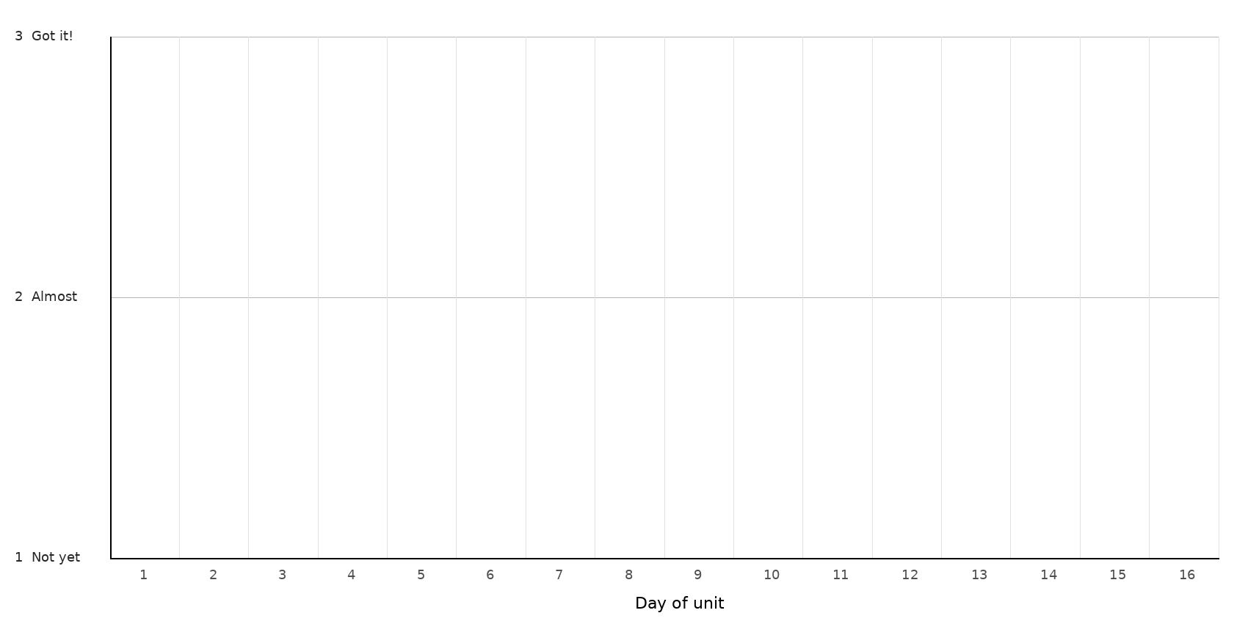
LEGEND — WHICH MARK / COLOR = WHICH TARGET
Mark: ______ Target: __________________________________________________________________
Mark: ______ Target: __________________________________________________________________
Mark: ______ Target: __________________________________________________________________
NOTES — END-OF-UNIT REFLECTION

