CPA Physics · Fitchburg High School · 2026–2027
Unit 3 — What if 2026-XJ hits, and can we nudge it?
Momentum · impulse · conservation · collisions · asteroid deflection (DART)
◆ NASA / PLANETARY DEFENSE BRIEFING — UPDATE 3
Unit 2 closed with you computing 2026-XJ's closest-approach date. The number was uncomfortably close. NASA has now run high-precision ephemeris simulations and confirmed: at current trajectory, 2026-XJ and Earth will arrive at the orbit-crossing point within HOURS of each other.
Refined closest-approach distance: somewhere between 40,000 and 100,000 km, depending on remaining orbital uncertainties. For reference, Earth's radius is 6,371 km, and the Moon orbits Earth at about 384,000 km. So: not a definite impact — but uncomfortably INSIDE the Moon's orbit.
The two questions Unit 3 must answer: (1) WHAT IF IT DOES HIT — what does the physics say about the impact? (2) CAN WE NUDGE IT — is there a way to push the asteroid OFF course before it gets here?
Precedent on the table: in 2022, NASA's DART mission deliberately crashed a 600-kg spacecraft into a small asteroid called Dimorphos and changed its orbital period by 32 minutes. The math behind DART is exactly the math you'll learn this unit.
This is fiction. The physics — and the equations — are real.
MA Standards: HS-PS2-2, HS-PS2-3, HS-ETS1-2
14 meetings · Fall 2026 (Nov 9 – Dec 1)
Name: ______________________________ Class period: __________ Date received: __________
"Unit 2 told us WHERE. Unit 3 asks: what then — and is there anything we can do?"
Table of Contents
Day-type key: A = Anchor · S = Standard · L = Lab · T = Transfer
Section | Type | Page
Cover | — | 1
Table of Contents | — | 2
Phase 1 — From orbits to collisions | —
Day 1 — Re-anchoring: what if it hits, can we nudge it? | A | 4
Day 2 — Momentum p = mv | S | 7
Day 3 — Impulse: J = FΔt = Δp | S | 11
Day 4 — Why impulse matters: airbags, follow-through | S | 15
Phase 2 — Conservation & collision types | —
Day 5 — Conservation: explosions + recoil | S | 19
Day 6 — Three flavors of collision | S | 23
Day 7 — Vernier collision lab | L | 27
Day 8 — Inelastic worked examples | S | 31
Day 9 — Elastic worked examples | S | 35
Phase 3 — Two dimensions & the DART case | —
Day 10 — 2D collisions: glancing blows | S | 39
Day 11 — DART case study: nudging an asteroid | S | 43
Phase 4 — Asteroid impact branch | —
Day 12 — Asteroid impact: what momentum says | S | 47
Day 13 — Two-branch analysis: deflect or impact | S | 51
Phase 5 — Transfer task | —
Day 14 — Unit 3 transfer task (assessment) | T | 56
Equation Reference Card | — | 59
Mastery Growth Chart | — | 61

Day 1 — Re-anchoring — What If It Hits, And Can We Nudge It?

Today's Target
I can name the two things that make a moving object hard to stop, and I can frame the two questions Unit 3 must answer about 2026-XJ.
ASTEROID THREAD
What we know about 2026-XJ today: From Unit 2: 2026-XJ and Earth arrive at the orbit-crossing point within HOURS of each other. Closest-approach distance: 40,000–100,000 km — inside the Moon.
How today connects: Unit 2 told us WHERE 2026-XJ is going. Today we open Unit 3 with two new questions: (1) IF it hits, what does the physics say? (2) Could we PUSH it off course before it gets here, like NASA's DART mission did in 2022?

NOTICE AND WONDER
Watch the demo: Hot Wheels car gently into a cardboard wall vs. the SAME car going FAST vs. a HEAVIER cart at the slow speed. What did you NOTICE? What do you WONDER?
I notice ____________________________
I wonder ____________________________

DOODLE ZONE
Circle the cases where the wall MOVES. What do A & B tell you? What do A & C tell you? What TWO things matter?
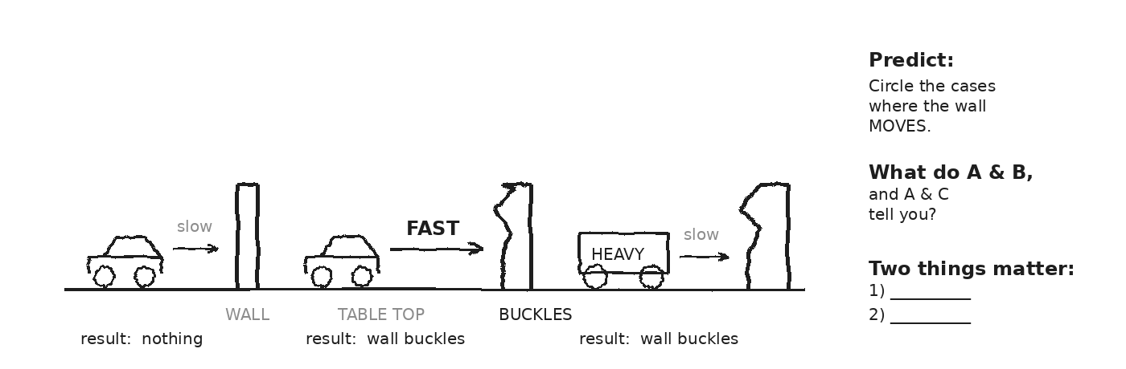

MY ONE QUESTION ABOUT DEFLECTING (OR SURVIVING) AN ASTEROID
EXIT TICKET — Day 1
Between (a) a 1500-kg car at 30 m/s and (b) a 0.05-kg bullet at 400 m/s, which would be HARDER to stop with your hand? Why? (Both have honest defenses — name the trade-off.)

Today's Targets — Rate Yourself
1 = Not Yet (I can't do this without help) 2 = Almost (I can do this with some help or some errors) 3 = Got It (I can do this independently and explain it)
Help? Check the box if you want to talk with me about this target — even if you marked yourself a 3.
Target | 1 | 2 | 3 | Help?
I can name TWO properties that make a moving object hard to stop. | ○ | ○ | ○ | ☐
I can state the two Unit 3 questions in my own words. | ○ | ○ | ○ | ☐

Day 2 — Momentum p = m·v

Today's Target
I can write p = m·v, give the units (kg·m/s), compute momentum for a moving object, and explain why momentum is a VECTOR (sign and direction matter).
ASTEROID THREAD
What we know about 2026-XJ today: 2026-XJ's mass is ~10⁹ kg, its speed (with respect to Earth) is ~30 km/s.
How today connects: Today we put a NUMBER on what makes the asteroid hard to stop. Spoiler: the number is enormous, and the rest of Unit 3 figures out what to do with that fact.

VOCAB · MOMENTUM (P)
Definition: A measure of how hard it is to stop a moving object. p = m·v. Vector — has the same direction as the velocity.
Example: A 1500-kg car at 30 m/s has p = 45,000 kg·m/s. A 0.05-kg bullet at 400 m/s has p = 20 kg·m/s. The car wins.
Cognates: Sp. cantidad de movimiento (or momento lineal) · Pt. quantidade de movimento · HC kantite mouvman
Watch out: Momentum is NOT the same as speed. A slow heavy thing can have MORE momentum than a fast light thing.

DOODLE ZONE
Compute p for each row. Then rank from biggest to smallest momentum. Look at the spread.
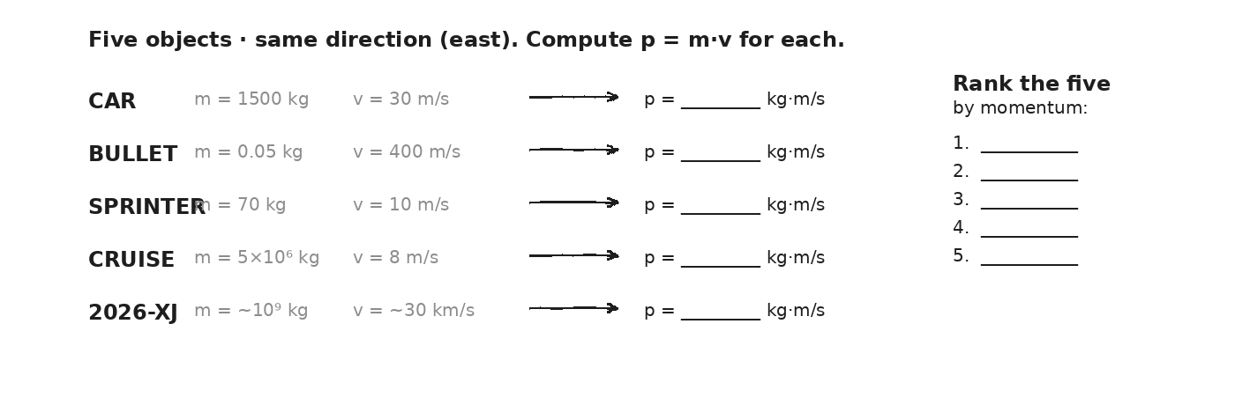

WORKED EXAMPLE — momentum of a car
A 1500-kg car moves east at 30 m/s. Find its momentum (magnitude AND direction).
GIVEN | m = 1500 kg · v = 30 m/s east
EQUATION | p = m·v
WORK | p = 1500 × 30 = 45,000 kg·m/s  p = 4.5 × 10⁴ kg·m/s east
ANSWER | 4.5 × 10⁴ kg·m/s east. (East matters — p is a vector.)

YOUR TURN — momentum of 2026-XJ
2026-XJ has mass m = 1.0 × 10⁹ kg and approaches at v = 3.0 × 10⁴ m/s toward Earth. Find its momentum.
GIVEN
EQUATION
WORK
ANSWER

YOUR TURN — Δp on a baseball (force the sign)
A 0.15-kg baseball moves east at 40 m/s, meets the bat, and bounces back west at 50 m/s. What is the CHANGE in its momentum, Δp = p_f − p_i? (Hint: pick east = positive, so v_f = −50.)
GIVEN
EQUATION
WORK
ANSWER

⚠ | Sign matters. If you ignore the negative on v_f, your Δp will look like 1.5 kg·m/s. The real Δp is −13.5 kg·m/s — almost 10× bigger. The direction of Δp is opposite v_i.

Fill in the frame:
Momentum is bigger for the cruise ship than the bullet because, even though the ship is ________________________________________________________, its ________________________________________________________ is overwhelmingly larger.
EXIT TICKET — Day 2
A 0.15-kg baseball moves east at 40 m/s. After the bat, it goes WEST at 50 m/s. Find Δp. Force the sign.

Today's Targets — Rate Yourself
1 = Not Yet (I can't do this without help) 2 = Almost (I can do this with some help or some errors) 3 = Got It (I can do this independently and explain it)
Help? Check the box if you want to talk with me about this target — even if you marked yourself a 3.
Target | 1 | 2 | 3 | Help?
I can compute p = m·v with correct units. | ○ | ○ | ○ | ☐
I can identify momentum as a vector and assign signs to opposite directions. | ○ | ○ | ○ | ☐
I can compute Δp using signed velocities. | ○ | ○ | ○ | ☐

Day 3 — Impulse: J = F·Δt = Δp

Today's Target
I can derive FΔt = Δp from F = ma, name FΔt as impulse, and use the equation to find force, time, or change in momentum given the other two.
ASTEROID THREAD
What we know about 2026-XJ today: To CHANGE 2026-XJ's momentum we need to apply a force OVER A TIME.
How today connects: Today's equation IS the DART equation. A small spacecraft, hitting an asteroid for a tiny instant, delivers a Δp — same math we use for a bat hitting a ball.

VOCAB · IMPULSE (J)
Definition: The product of force and the time it acts: J = F·Δt. Equals the change in momentum Δp.
Example: A 0.002-s bat-hit at 6,750 N delivers J = 13.5 N·s of impulse to the baseball.
Cognates: Sp. impulso · Pt. impulso · HC enpilsyon
Watch out: Impulse is NOT just force. It's force × TIME. Half the force for twice the time gives the same impulse.

DOODLE ZONE
Fill the Δp blank. Then use J = F·Δt to find the force during contact. Bigger than you expected? Why?
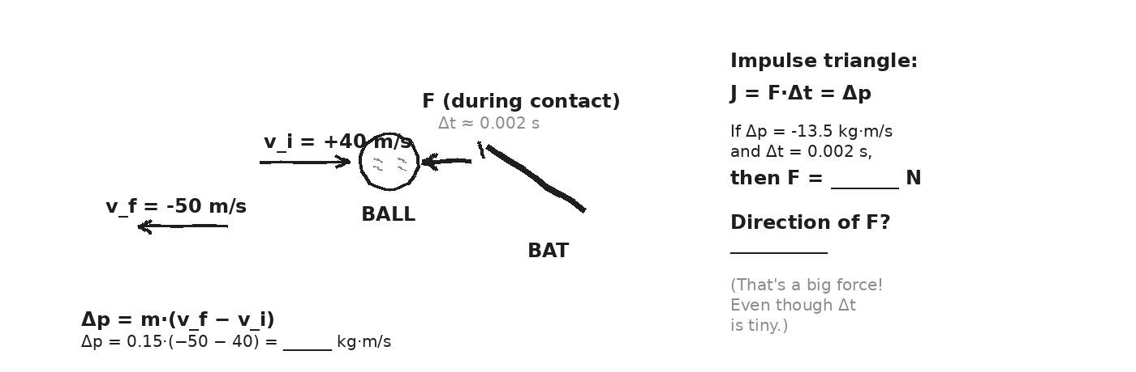

DERIVATION — where FΔt = Δp comes from
Start: F = m·a = m·(Δv/Δt)
Multiply both sides by Δt: F·Δt = m·Δv = Δp
Name F·Δt = J (impulse). Then: J = Δp. Units: N·s = kg·m/s.
WORKED EXAMPLE — force during a bat-ball hit
A 0.15-kg baseball moves east at 40 m/s, then rebounds WEST at 50 m/s. Bat-ball contact lasts 0.002 s. Find (a) Δp, (b) the average force.
GIVEN | m = 0.15 kg · v_i = +40 m/s · v_f = −50 m/s · Δt = 0.002 s
EQUATION | Δp = m·(v_f − v_i) ; F = Δp / Δt
WORK | Δp = 0.15·(−50 − 40) = 0.15·(−90) = −13.5 kg·m/s  F = −13.5 / 0.002 = −6750 N
ANSWER | Δp = −13.5 kg·m/s (westward). F ≈ −6750 N (westward, applied BY the bat ON the ball).

YOUR TURN — DART's punch
DART hit Dimorphos for about 0.05 s with an average force of about 8 × 10⁵ N. What change in asteroid momentum did it deliver?
GIVEN
EQUATION
WORK
ANSWER

★ | The same J can come from BIG F over a SHORT Δt or SMALL F over a LONG Δt. That choice is tomorrow's payoff.

EXIT TICKET — Day 3
DART hit its target for 0.05 s with an average 8×10⁵ N. What Δp did it deliver to the asteroid?

Today's Targets — Rate Yourself
1 = Not Yet (I can't do this without help) 2 = Almost (I can do this with some help or some errors) 3 = Got It (I can do this independently and explain it)
Help? Check the box if you want to talk with me about this target — even if you marked yourself a 3.
Target | 1 | 2 | 3 | Help?
I can derive FΔt = Δp from F = ma. | ○ | ○ | ○ | ☐
I can compute impulse given F and Δt. | ○ | ○ | ○ | ☐
I can find force given Δp and Δt. | ○ | ○ | ○ | ☐

Day 4 — Why Impulse Matters — Airbags, Follow-through, Padding

Today's Target
I can explain why extending Δt reduces the force needed to deliver the same Δp, and I can apply this to airbags, padded floors, follow-through, and asteroid deflection.
ASTEROID THREAD
What we know about 2026-XJ today: To deflect 2026-XJ we want the LARGEST Δp possible — either short-and-hard (DART) or long-and-soft (gravity tractor).
How today connects: Same physics that saves lives in a car crash (long Δt, small F) shapes how planetary defense engineers design asteroid pushers.

VOCAB · CRUMPLE ZONE / CUSHION
Definition: A region designed to DEFORM during impact, extending Δt and so reducing peak force.
Example: Modern car fronts are designed to crumple. Same Δp, but Δt × 5 means F ÷ 5.
Cognates: Sp. zona de absorción · Pt. zona de deformação · HC zòn dezespere
Watch out: A crumple zone doesn't 'absorb momentum.' Δp is the same. It SPREADS THE TIME so peak F drops.

DOODLE ZONE
Compare the F arrows in both panels. Same Δp; different Δt. Fill the blank: if Δt × 10, F goes to ____ of original.
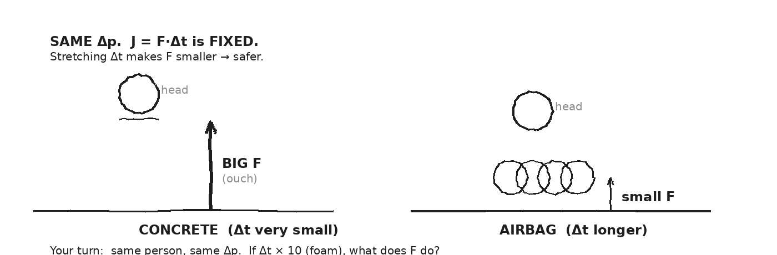

WORKED EXAMPLE — sprinter into concrete vs. into foam
An 80-kg sprinter at 9 m/s stops in (a) 0.05 s on concrete, or (b) 0.5 s into a foam pit. Compute the average force in each case.
GIVEN | m = 80 kg · Δv = 9 m/s (he stops) · Δt_a = 0.05 s · Δt_b = 0.5 s
EQUATION | Δp = m·Δv ; F = Δp / Δt
WORK | Δp = 80·9 = 720 kg·m/s (same for both)  F_a = 720 / 0.05 = 14,400 N (concrete)  F_b = 720 / 0.5 = 1,440 N (foam — 10× smaller!)
ANSWER | Concrete: 14.4 kN. Foam: 1.44 kN. Stretching Δt by 10× cut F by 10×.

YOUR TURN — case-study reasoning
Pick one: airbag, helmet, boxing glove, gymnastics mat, parkour roll, or follow-through on a tennis swing. Explain how it uses LONGER Δt to reduce F for the SAME Δp. Be specific about what extends the contact time.
GIVEN
EQUATION
WORK
ANSWER

★ | The SAME logic, with a different sign: a baseball hitter wants MORE Δp delivered to the ball. Follow-through extends Δt. Bigger J = bigger Δp = ball goes farther.

Fill in the frame:
A boxer 'rolls with the punch' so that ________________________________________________________ stays roughly the same but ________________________________________________________ gets larger — which makes ________________________________________________________ smaller.
EXIT TICKET — Day 4
Why does a boxer 'roll with the punch'? Use 'Δp', 'Δt', and 'F' in your answer.

Today's Targets — Rate Yourself
1 = Not Yet (I can't do this without help) 2 = Almost (I can do this with some help or some errors) 3 = Got It (I can do this independently and explain it)
Help? Check the box if you want to talk with me about this target — even if you marked yourself a 3.
Target | 1 | 2 | 3 | Help?
I can explain why stretching Δt reduces F for the same Δp. | ○ | ○ | ○ | ☐
I can apply impulse reasoning to a real-world safety device. | ○ | ○ | ○ | ☐
I can predict how a sport technique uses impulse to its advantage. | ○ | ○ | ○ | ☐

Day 5 — Conservation of Momentum — Explosions and Recoil

Today's Target
I can state conservation of momentum (Σp_before = Σp_after) and its condition (no net external force), and I can use it to solve recoil/explosion problems.
ASTEROID THREAD
What we know about 2026-XJ today: When DART hit Dimorphos, total momentum BEFORE = total momentum AFTER. The asteroid sped up; the spacecraft slowed (and was destroyed).
How today connects: Today's rule is the BIG one of the unit. The next eight days are all special cases of it.

VOCAB · CONSERVATION OF MOMENTUM
Definition: If the NET external force on a system is zero, the TOTAL momentum of the system stays constant: Σp_before = Σp_after.
Example: A rifle at rest fires a bullet east. The bullet goes east; the rifle recoils west. Total p stays zero.
Cognates: Sp. conservación del momento · Pt. conservação do momento · HC konsèvasyon mouvman
Watch out: The rule isn't 'no force acts on the objects.' Internal forces (between bullet and rifle) are fine. The rule needs no NET EXTERNAL force.

VOCAB · RECOIL
Definition: When an object at rest splits into two pieces (or expels mass), the pieces move in opposite directions so total p stays the same.
Example: A swimmer pushes a kickboard east; she drifts west. Total p = 0 stays 0.
Cognates: Sp. retroceso · Pt. recuo · HC rekil
Watch out: The smaller mass moves FASTER. m₁v₁ = m₂v₂ in size, opposite sign. A tiny bullet recoils a heavy gun only a little.

DOODLE ZONE
Use Σp_before = 0 = m₁v₁ + m₂v₂ to predict v₂. Smaller cart moves faster (or slower?). Why?
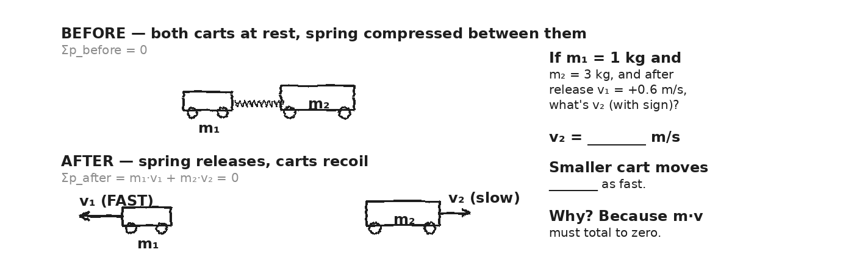

WORKED EXAMPLE — ice skater throws a ball
A 70-kg ice skater (initially at rest) throws a 5-kg ball east at 8 m/s. What is the skater's recoil velocity?
GIVEN | m_skater = 70 kg · m_ball = 5 kg · v_ball = +8 m/s east · both at rest before
EQUATION | Σp_before = Σp_after → 0 = m_skater·v_skater + m_ball·v_ball
WORK | 0 = 70·v_skater + 5·(+8)  0 = 70·v_skater + 40  v_skater = −40/70 ≈ −0.57 m/s
ANSWER | Skater drifts WEST at about 0.57 m/s. (Small, because she's 14× heavier than the ball.)

YOUR TURN — firework explosion
A 0.5-kg firework at REST explodes into two pieces: a 0.3-kg chunk goes east at 12 m/s. The other piece (0.2 kg) goes — what direction and how fast?
GIVEN
EQUATION
WORK
ANSWER

⚠ | Forces between the pieces during the explosion are INTERNAL — they don't break conservation. Only EXTERNAL forces (like gravity, friction) can change total p.

Fill in the frame:
Total momentum stays the same because the only forces during the explosion are ________________________________________________________ (between the pieces), which means no NET ________________________________________________________ force.
EXIT TICKET — Day 5
A 0.5-kg firework at rest explodes into a 0.3-kg piece moving east at 12 m/s and a 0.2-kg piece moving — what direction and how fast?

Today's Targets — Rate Yourself
1 = Not Yet (I can't do this without help) 2 = Almost (I can do this with some help or some errors) 3 = Got It (I can do this independently and explain it)
Help? Check the box if you want to talk with me about this target — even if you marked yourself a 3.
Target | 1 | 2 | 3 | Help?
I can state Σp_before = Σp_after and its condition. | ○ | ○ | ○ | ☐
I can solve recoil problems with signed velocities. | ○ | ○ | ○ | ☐
I can identify what counts as INTERNAL vs. EXTERNAL force in a system. | ○ | ○ | ○ | ☐

Day 6 — Three Flavors of Collision

Today's Target
I can distinguish elastic, inelastic, and perfectly inelastic collisions, and I can identify which real-world collisions fit each category.
ASTEROID THREAD
What we know about 2026-XJ today: An asteroid striking Earth would be PERFECTLY INELASTIC — it becomes part of Earth (after vaporizing). A pure gravity flyby (no contact) is ELASTIC. DART was somewhere in between.
How today connects: Once you know which TYPE you have, you know which equations to use.

VOCAB · ELASTIC COLLISION
Definition: A collision where both MOMENTUM and KINETIC ENERGY are conserved. Objects bounce off without losing energy.
Example: Superball off concrete. Newton's cradle. Billiard balls (approximately). Gravity flybys.
Cognates: Sp. colisión elástica · Pt. colisão elástica · HC kolizyon elastik
Watch out: No real collision is 100% elastic — some energy always goes to heat/sound. But many problems treat them as elastic.

VOCAB · INELASTIC COLLISION
Definition: A collision where MOMENTUM is conserved but KINETIC ENERGY is NOT — some KE goes to heat, sound, deformation.
Example: Most car crashes. A dropped clay ball that flattens but doesn't stick. Bouncing tennis ball (slightly inelastic).
Cognates: Sp. colisión inelástica · Pt. colisão inelástica · HC kolizyon inelastik
Watch out: The momentum is STILL conserved. Only the kinetic ENERGY decreases. Don't say 'momentum is lost.'

VOCAB · PERFECTLY INELASTIC COLLISION
Definition: A collision where the objects STICK TOGETHER after impact. Momentum conserved; maximum KE lost.
Example: Clay ball into wall. Bullet into wooden block (ballistic pendulum). Asteroid impact.
Cognates: Sp. perfectamente inelástica · Pt. perfeitamente inelástica · HC perfekteman inelastik
Watch out: 'Perfectly' is a technical word — it doesn't mean ideal/good. It means 'stuck together completely.'

DOODLE ZONE
Add ONE more real example to each column from your own life. Circle the ones you've seen.
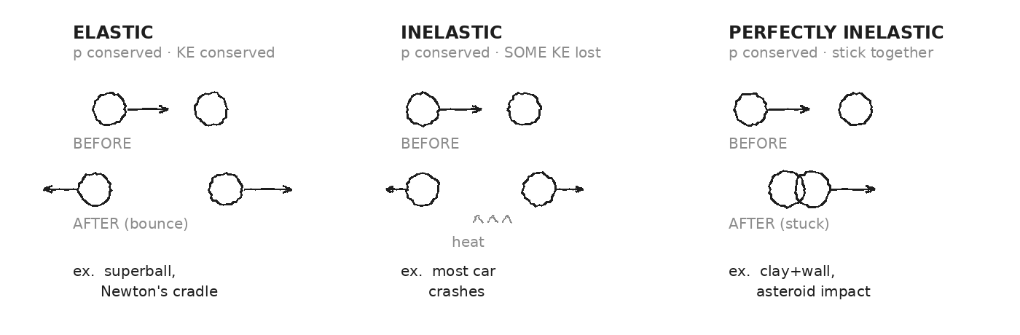

CLASSIFICATION DRILL
Classify each as elastic (E), inelastic (I), or perfectly inelastic (PI). Be ready to defend.
CLASSIFY EACH
Two billiard balls bouncing off each other ........................ ____
A car rear-ends a stalled truck, bumpers lock ..................... ____
Football tackle — players grip each other and tumble .............. ____
Bullet hits a wood block and sticks ................................ ____
Two magnets repel each other and bounce apart without touching .... ____
Asteroid hits Earth ............................................... ____
Newton's cradle — end ball stops, opposite end ball moves ......... ____
Wet clay ball thrown against a wall, sticks ....................... ____
⚠ | ALL THREE types conserve momentum. Only ELASTIC conserves kinetic energy. Don't confuse 'energy lost' with 'momentum lost.' They're different rules.

EXIT TICKET — Day 6
A meteorite buries itself in the desert. What kind of collision is this? Where did its kinetic energy go?

Today's Targets — Rate Yourself
1 = Not Yet (I can't do this without help) 2 = Almost (I can do this with some help or some errors) 3 = Got It (I can do this independently and explain it)
Help? Check the box if you want to talk with me about this target — even if you marked yourself a 3.
Target | 1 | 2 | 3 | Help?
I can define elastic, inelastic, and perfectly inelastic collisions. | ○ | ○ | ○ | ☐
I can identify which conservation law(s) apply to each type. | ○ | ○ | ○ | ☐
I can classify real-world collisions confidently. | ○ | ○ | ○ | ☐

Day 7 — Vernier Collision Lab — Verify Conservation · Investigation 3.1

Today's Target
I can run elastic and perfectly inelastic cart collisions with photogates, compute Σp_before and Σp_after, and report the % difference with one credible source of error.
ASTEROID THREAD
What we know about 2026-XJ today: We've been STATING that Σp is conserved for 7 days. Today we MEASURE it.
How today connects: If our lab carts confirm conservation, we can trust the same rule for asteroids. Days 11–13 depend on it.

LAB SETUP — INVESTIGATION 3.1
Driving question: How well does Σp_before match Σp_after in our lab carts? And does it work for BOTH elastic and perfectly inelastic collisions?
Equipment:
- Vernier dynamics track (1 per pair) + 2 carts
- Magnetic bumpers on each cart (for the elastic trial)
- Velcro pads on each cart (for the perfectly inelastic trial)
- 2 photogates + LabQuest + Logger Pro or Graphical Analysis
- Balance to weigh each cart (record m₁ and m₂ first)
What you do:
1. Level the track. Weigh both carts and record m₁, m₂.
2. ELASTIC trials (magnet bumpers): cart 2 at rest. Push cart 1 gently. Photogates read v₁ᵢ, v₁f, and v₂f.
3. Compute Σp_before = m₁v₁ᵢ and Σp_after = m₁v₁f + m₂v₂f. Compare.
4. PERFECTLY INELASTIC trials (Velcro): cart 2 at rest. Push cart 1; carts stick.
5. Compute Σp_after = (m₁+m₂)·v_combined. Compare to Σp_before.
6. Two trials of each type. Compute % difference for each.
────────────────────────────────────────────────────────────
Safety: Cart speeds gentle. Photogates clamped firmly. Hands clear of cart paths.
How this lab serves the year's question: If conservation holds in carts within a few percent, the asteroid Days 11–13 stand.
DOODLE ZONE
Sketch your setup. Record m₁ and m₂ on the diagram. Fill v_before and v_after numbers as you go.
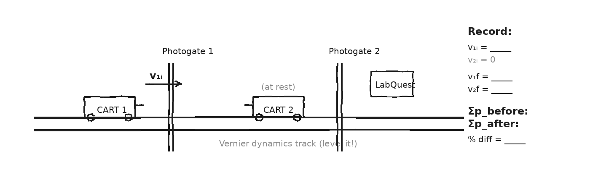

DATA — ELASTIC TRIALS (magnet bumpers, cart 2 at rest)
Trial | v₁ᵢ (m/s) | v₁f (m/s) | v₂f (m/s) | Σp_before | Σp_after | % diff
1
2
DATA — PERFECTLY INELASTIC TRIALS (Velcro, cart 2 at rest)
Trial | v₁ᵢ (m/s) | v_combined (m/s) | Σp_before | Σp_after | % diff | Notes
1
2
OBSERVATION & ANALYSIS
In your trials, did Σp_after match Σp_before? Within what %?

If there's a difference, what physical thing leaked momentum out? Was it the same for elastic and inelastic trials?
My elastic Σp matched within __________ %; my perfectly inelastic Σp matched within __________ %. The biggest source of error was __________.
Asteroid connection: how does this serve the year's question?

Fill in the frame:
Conservation of momentum predicts Σp_after = Σp_before. My elastic trials confirmed this within ____ %; my inelastic trials within ____ %. The asteroid math on Days 11–13 is ________________________________________________________.
EXIT TICKET — Day 7
Write a one-sentence CLAIM about what your lab showed, then one sentence of EVIDENCE (your numbers), then one sentence of REASONING (why the % difference is small).

Today's Targets — Rate Yourself
1 = Not Yet (I can't do this without help) 2 = Almost (I can do this with some help or some errors) 3 = Got It (I can do this independently and explain it)
Help? Check the box if you want to talk with me about this target — even if you marked yourself a 3.
Target | 1 | 2 | 3 | Help?
I can run a Vernier two-cart elastic collision. | ○ | ○ | ○ | ☐
I can run a Vernier two-cart perfectly inelastic collision. | ○ | ○ | ○ | ☐
I can compute Σp before and after and report % difference. | ○ | ○ | ○ | ☐
I can name a credible source of error. | ○ | ○ | ○ | ☐

Day 8 — Inelastic Collisions — Stick-Together Worked Examples

Today's Target
I can solve a 1D perfectly inelastic collision using m₁v₁ + m₂v₂ = (m₁+m₂)v_f, with correct signs and units.
ASTEROID THREAD
What we know about 2026-XJ today: An asteroid impact is the planetary version of 'stick together.' Today's math is what we'd use to estimate Earth's velocity change from a 2026-XJ strike.
How today connects: Same equation. Different scale. The arithmetic generalizes.

VOCAB · BALLISTIC PENDULUM
Definition: A classic stick-together problem: a small fast object embeds in a larger object at rest. Use conservation of momentum.
Example: A 0.05-kg bullet at 400 m/s into a 5-kg block at rest. After impact: (bullet + block) move together at v_f ≈ 4 m/s.
Cognates: Sp. péndulo balístico · Pt. pêndulo balístico
Watch out: Don't try ½mv² = ½(M+m)v_f² — that's kinetic energy, which IS NOT conserved here. Use momentum: mv = (M+m)v_f.

DOODLE ZONE
Use Σp to find v_f. Direction same as bullet. Then circle which conservation law you used: momentum / energy. (Hint: only ONE works here.)
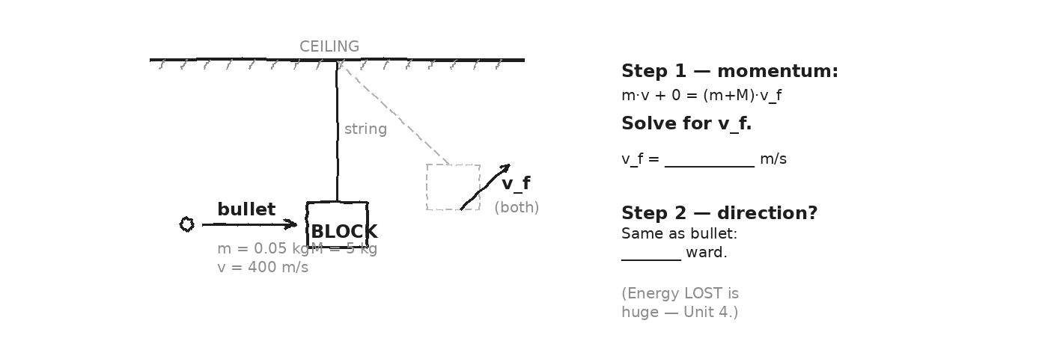

WORKED EXAMPLE — ballistic pendulum
A 0.05-kg bullet moving east at 400 m/s embeds itself in a 5-kg block at rest. Find the velocity of the bullet+block immediately after impact.
GIVEN | m = 0.05 kg · v = +400 m/s · M = 5 kg · V = 0
EQUATION | m·v + M·V = (m + M)·v_f
WORK | (0.05)(400) + (5)(0) = (0.05 + 5)·v_f  20 = 5.05·v_f  v_f = 20/5.05 ≈ 3.96 m/s
ANSWER | v_f ≈ 3.96 m/s east. The block + bullet move together at about 4 m/s.

WORKED EXAMPLE — head-on car collision (force signs)
A 1200-kg car going east at 25 m/s collides head-on with an 1800-kg car going west at 15 m/s. They lock together. Find the final velocity.
GIVEN | m₁ = 1200 kg, v₁ = +25 m/s (east)  m₂ = 1800 kg, v₂ = −15 m/s (west)
EQUATION | m₁v₁ + m₂v₂ = (m₁ + m₂)·v_f
WORK | (1200)(25) + (1800)(−15) = (3000)·v_f  30,000 + (−27,000) = 3000·v_f  3,000 = 3000·v_f  v_f = +1.0 m/s
ANSWER | +1.0 m/s — the wreckage drifts EAST slowly. The heavier westbound car lost out narrowly.

YOUR TURN — rear-end collision
A 1000-kg car going east at 20 m/s rear-ends a 2000-kg stalled truck. They lock together. Find the final velocity.
GIVEN
EQUATION
WORK
ANSWER

⚠ | ALWAYS write the sign convention before you compute. East = + (or whatever you pick). Then assign signs to every v BEFORE you sum.

EXIT TICKET — Day 8
A 1000-kg car at 20 m/s east rear-ends a 2000-kg stalled truck. They lock. What's the final velocity?

Today's Targets — Rate Yourself
1 = Not Yet (I can't do this without help) 2 = Almost (I can do this with some help or some errors) 3 = Got It (I can do this independently and explain it)
Help? Check the box if you want to talk with me about this target — even if you marked yourself a 3.
Target | 1 | 2 | 3 | Help?
I can write the perfectly-inelastic equation correctly. | ○ | ○ | ○ | ☐
I can assign signs to opposite-direction velocities. | ○ | ○ | ○ | ☐
I can solve a ballistic-pendulum-style problem. | ○ | ○ | ○ | ☐

Day 9 — Elastic Collisions — Bounce-Apart Worked Examples

Today's Target
I can solve a 1D elastic collision using conservation of momentum AND conservation of kinetic energy, and I can apply the equal-mass and one-at-rest simplifications.
ASTEROID THREAD
What we know about 2026-XJ today: A gravity flyby (no contact) is essentially elastic — both p and KE conserved.
How today connects: The math here is what we'd use to predict an asteroid's path AFTER a gravity-assist swing-by.

VOCAB · ELASTIC — ONE AT REST
Definition: Special case: object 1 (mass m₁, speed v₁ᵢ) strikes object 2 (mass m₂, at rest). Result: v₁f and v₂f from simple formulas.
Example: v₁f = ((m₁−m₂)/(m₁+m₂))·v₁ᵢ ; v₂f = (2m₁/(m₁+m₂))·v₁ᵢ. Both directly from the two conservation rules.
Cognates: Sp. (caso especial) un cuerpo en reposo · Pt. um corpo em repouso
Watch out: If m₁ = m₂: v₁f = 0, v₂f = v₁ᵢ. The mover STOPS, the resting one takes off (Newton's cradle).

DOODLE ZONE
Why does only the END ball move? Use the equal-mass formula to predict v₁f and v₂f. What does the formula say?
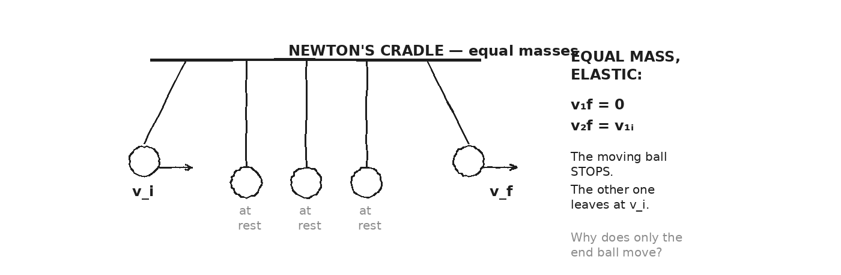

EQUATION · ANATOMY — the elastic pair
p: m₁v₁ᵢ + m₂v₂ᵢ = m₁v₁f + m₂v₂f
KE: ½m₁v₁ᵢ² + ½m₂v₂ᵢ² = ½m₁v₁f² + ½m₂v₂f²
Two equations. Two unknowns (v₁f, v₂f). Solvable. When m₂ is at rest, use the simplified formulas in the vocab box above.
WORKED EXAMPLE — 0.5 kg hits 1.0 kg at rest
A 0.5-kg ball at 4 m/s east strikes a 1.0-kg ball at rest, elastically. Find v₁f and v₂f.
GIVEN | m₁ = 0.5 kg, v₁ᵢ = +4 m/s · m₂ = 1.0 kg, v₂ᵢ = 0
EQUATION | v₁f = ((m₁−m₂)/(m₁+m₂))·v₁ᵢ ; v₂f = (2m₁/(m₁+m₂))·v₁ᵢ
WORK | v₁f = ((0.5 − 1.0)/(0.5 + 1.0))·(4) = (−0.5/1.5)·4 ≈ −1.33 m/s  v₂f = (2·0.5/1.5)·(4) = (1/1.5)·4 ≈ 2.67 m/s
ANSWER | v₁f ≈ −1.33 m/s (bounces BACK west). v₂f ≈ 2.67 m/s east.

PATTERN-FINDING
Use the simplified one-at-rest formulas to predict each case. Sketch a quick before/after to check your intuition.
PREDICT EACH
(a) m₁ = m₂ (equal masses): v₁f = _______, v₂f = _______
(b) m₁ ≫ m₂ (big hits small): v₁f ≈ _______ (continues forward, almost unchanged?), v₂f ≈ _______
(c) m₁ ≪ m₂ (small hits big): v₁f ≈ _______ (bounces back?), v₂f ≈ _______ (barely moves?)
YOUR TURN — equal-mass superballs
A 0.2-kg superball moving east at 5 m/s strikes a 0.2-kg superball at rest, elastically. Use the equal-mass result to predict v₁f and v₂f.
GIVEN
EQUATION
WORK
ANSWER

★ | Newton's cradle uses the equal-mass rule. The moving ball stops; an identical ball on the far end leaves at the original speed. Conservation of both p AND KE forces it.

EXIT TICKET — Day 9
A 0.2-kg superball at 5 m/s east strikes a 0.2-kg ball at rest, elastically. What happens to each?

Today's Targets — Rate Yourself
1 = Not Yet (I can't do this without help) 2 = Almost (I can do this with some help or some errors) 3 = Got It (I can do this independently and explain it)
Help? Check the box if you want to talk with me about this target — even if you marked yourself a 3.
Target | 1 | 2 | 3 | Help?
I can apply the one-at-rest simplified formulas. | ○ | ○ | ○ | ☐
I can predict equal-mass / big-hits-small / small-hits-big patterns. | ○ | ○ | ○ | ☐
I can solve a 1D elastic collision. | ○ | ○ | ○ | ☐

Day 10 — 2D Collisions — Glancing Blows

Today's Target
I can apply conservation of momentum SEPARATELY to the x- and y-components, and I can solve a 2D glancing collision.
ASTEROID THREAD
What we know about 2026-XJ today: An asteroid that's nudged doesn't just slow down — it DEFLECTS sideways.
How today connects: 2D momentum is the framework for asking 'how much sideways?' Tomorrow's DART analysis depends on it.

VOCAB · COMPONENT-WISE CONSERVATION
Definition: Total momentum is a VECTOR. Conservation applies separately to its x- and y-components: Σp_x_before = Σp_x_after AND Σp_y_before = Σp_y_after.
Example: A cue ball east strikes a stationary ball; afterward both move at angles. Σp_x and Σp_y each balance.
Cognates: Sp. componentes (x, y) · Pt. componentes (x, y)
Watch out: ONE conservation equation isn't enough in 2D. Use TWO (one per direction). They give two equations for the two unknowns.

DOODLE ZONE
Use the equations on the right to find v₂ and θ. Hint: equal masses cancel out.
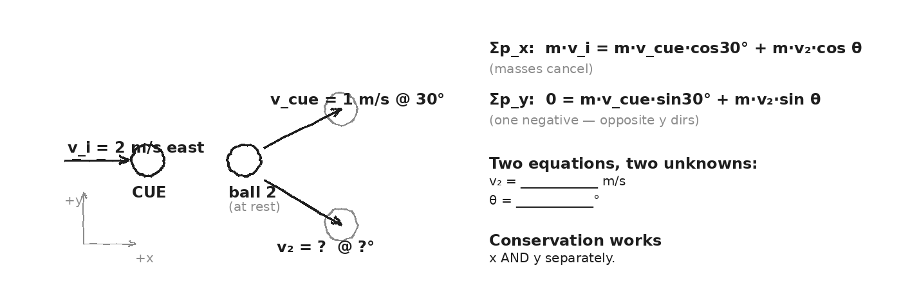

WORKED EXAMPLE — billiards glancing collision
A 0.16-kg cue ball moves east at 2 m/s and strikes a 0.16-kg ball at rest. Afterward, the cue ball moves at 1 m/s, 30° north of east. Find the second ball's speed and direction.
GIVEN | m₁ = m₂ = 0.16 kg (cancels) · v_cue_i = +2 m/s east · v_cue_f = 1 m/s @ +30° · v₂_i = 0
EQUATION | Σp_x: m·v_i = m·v_cue_f·cos30° + m·v₂·cos θ  Σp_y: 0 = m·v_cue_f·sin30° − m·v₂·sin θ
WORK | Drop the masses (cancel):  x: 2 = 1·cos30° + v₂·cos θ → v₂·cos θ = 2 − 0.866 = 1.134  y: 0 = 1·sin30° − v₂·sin θ → v₂·sin θ = 0.500  tan θ = 0.500/1.134 → θ ≈ 23.8° (south of east)  v₂ = 0.500/sin23.8° ≈ 1.24 m/s
ANSWER | Ball 2: ≈ 1.24 m/s at ≈ 23.8° south of east.

YOUR TURN — different angle
Same setup, but now the cue ball goes 1.5 m/s at 45° north of east after impact. Find the second ball's speed and direction.
GIVEN
EQUATION
WORK
ANSWER

⚠ | The y-components must SUM TO ZERO if the cue ball was originally moving only along x. If one ball goes 'north', the other must go 'south' (in the y-component).

Fill in the frame:
We can't just balance the total momentum magnitudes. We need to balance x and y ________________________________________________________, because momentum is a ________________________________________________________.
EXIT TICKET — Day 10
Why must p_x and p_y each be conserved separately, not just total p? Use the word 'vector' in your answer.

Today's Targets — Rate Yourself
1 = Not Yet (I can't do this without help) 2 = Almost (I can do this with some help or some errors) 3 = Got It (I can do this independently and explain it)
Help? Check the box if you want to talk with me about this target — even if you marked yourself a 3.
Target | 1 | 2 | 3 | Help?
I can split momentum into x and y components. | ○ | ○ | ○ | ☐
I can apply conservation to each axis independently. | ○ | ○ | ○ | ☐
I can solve a 2D glancing collision for the unknown ball's velocity. | ○ | ○ | ○ | ☐

Day 11 — DART Case Study — Nudging an Asteroid

Today's Target
I can use conservation of momentum to compute the Δv DART gave to Dimorphos, and I can apply the same calculation to 2026-XJ to estimate what it would take to deflect it.
ASTEROID THREAD
What we know about 2026-XJ today: On Sept 26, 2022, NASA's DART spacecraft (~600 kg, ~6 km/s) crashed into a small asteroid called Dimorphos (~5 × 10⁹ kg). It changed Dimorphos's orbital period by 32 minutes.
How today connects: This is the day the unit pays off. Today's math is the math we'd use on 2026-XJ. If the Δv we need is DART-scale, deflection is on the table. If not, we'd need a much bigger push (or a different strategy).

VOCAB · DART (DOUBLE ASTEROID REDIRECTION TEST)
Definition: NASA's 2022 mission that deliberately crashed a 600-kg spacecraft into a small asteroid to test whether kinetic impact can change its trajectory.
Example: DART hit Dimorphos at ~6 km/s, delivering only ~3 mm/s of Δv to the asteroid — but that tiny push, accumulated over time, shifts its position by km and km.
Cognates: Sp. (misión DART) · Pt. (missão DART) · HC misyon DART
Watch out: The Δv from DART is TINY (mm/s). But that tiny shift, over years of orbital motion, produces a measurable position change. The 'small Δv × long time' equation is the key.

DOODLE ZONE
Plug the DART numbers into Δv = m·v / M. Get the answer in m/s, then convert to mm/s. Tiny — but enough to matter.
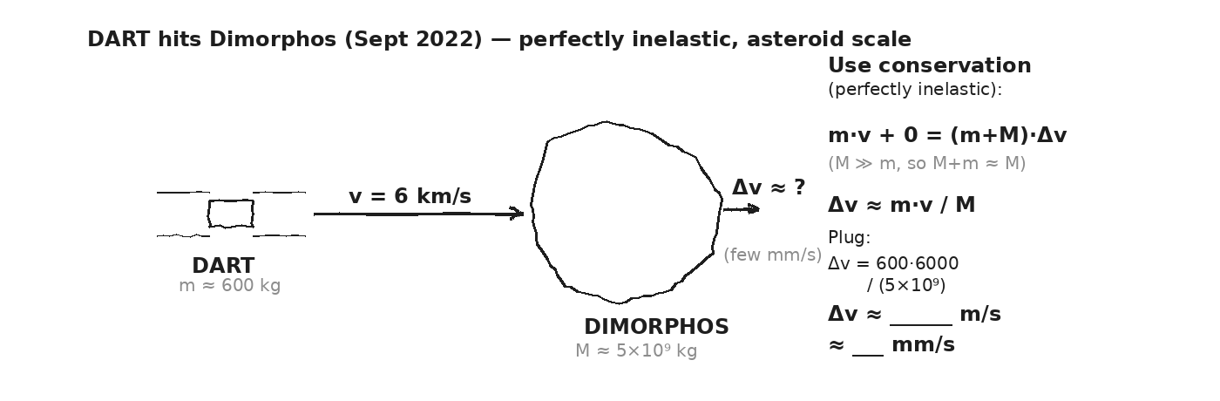

WORKED EXAMPLE — what Δv did DART give Dimorphos?
DART (m = 600 kg) hit Dimorphos (M = 5 × 10⁹ kg) at v = 6 × 10³ m/s, treating the impact as perfectly inelastic. Find the velocity change Δv of the asteroid. (Hint: M ≫ m, so (m+M) ≈ M.)
GIVEN | m = 600 kg · v = 6000 m/s · M = 5×10⁹ kg · M_asteroid initially at rest in DART's frame
EQUATION | m·v + M·0 = (m + M)·Δv ≈ M·Δv (since M ≫ m)  Δv ≈ m·v / M
WORK | Δv ≈ (600 × 6000) / (5 × 10⁹)  Δv ≈ 3.6 × 10⁶ / 5 × 10⁹  Δv ≈ 7.2 × 10⁻⁴ m/s ≈ 0.72 mm/s  (NASA measured ≈ 2.7 mm/s with momentum enhancement from ejecta — same order of magnitude.)
ANSWER | ≈ 0.72 mm/s (less than a millimeter per second). Tiny — but it adds up.

WHY DOES A TINY Δv MATTER?
Δv × time = position offset
If Δv ≈ 1 mm/s and we have 1 year (3.15 × 10⁷ s) of lead time:
offset = (10⁻³ m/s) × (3.15 × 10⁷ s) ≈ 3.15 × 10⁴ m ≈ 31.5 km
More lead time = more offset. More Δv = more offset. Linear in both.
YOUR TURN — what Δv to deflect 2026-XJ by an Earth-radius?
2026-XJ has mass M ≈ 1 × 10⁹ kg and will pass Earth in 6 months (t ≈ 1.5 × 10⁷ s). We need to shift its position by R_Earth ≈ 6.4 × 10⁶ m to miss us. What Δv does it need? Then: would a DART-scale strike (say a 600-kg, 6-km/s spacecraft) deliver it?
GIVEN
EQUATION
WORK
ANSWER

★ | When you compute the required Δv and compare to what a single DART would give: the gap tells you whether one impactor is enough, or whether we'd need many — or sooner.

Fill in the frame:
To deflect 2026-XJ by one Earth-radius in 6 months, we need Δv ≈ ________________________________________________________. A single DART-class strike would give about ________________________________________________________. So we'd need ________________________________________________________ DARTs (or more lead time).
EXIT TICKET — Day 11
Why doesn't NASA need a HUGE Δv to deflect an asteroid? Use the words 'lead time' and 'small change in velocity' in your answer.

Today's Targets — Rate Yourself
1 = Not Yet (I can't do this without help) 2 = Almost (I can do this with some help or some errors) 3 = Got It (I can do this independently and explain it)
Help? Check the box if you want to talk with me about this target — even if you marked yourself a 3.
Target | 1 | 2 | 3 | Help?
I can apply Σp_before = Σp_after to a DART-style impact. | ○ | ○ | ○ | ☐
I can compute the required Δv from a desired position shift and lead time. | ○ | ○ | ○ | ☐
I can compare a needed Δv to what a real spacecraft could deliver. | ○ | ○ | ○ | ☐

Day 12 — Asteroid Impact — What Momentum Says About Damage

Today's Target
I can compute the average force of an asteroid impact using F = Δp/Δt and explain why Earth's velocity changes negligibly even though the impact is catastrophic locally.
ASTEROID THREAD
What we know about 2026-XJ today: If deflection fails, momentum gives our FIRST picture of the impact. Earth gains almost no velocity (we outmass the asteroid 10¹⁵ to 1). But the asteroid delivers all of its momentum in 0.1 s.
How today connects: Today is the OTHER branch of the unit. Yesterday: deflect. Today: what if we don't?

VOCAB · LOCAL VS. GLOBAL MOMENTUM
Definition: In a planetary collision, the asteroid's momentum is transferred to a SMALL local region of Earth in a SHORT time. Earth as a whole barely moves.
Example: 2026-XJ at 30 km/s carries p ≈ 3×10¹³ kg·m/s. Earth (6×10²⁴ kg) would gain Δv ≈ 5×10⁻¹² m/s — utterly undetectable. The impact site, though, absorbs the entire force.
Cognates: Sp. local vs. global · Pt. local vs. global
Watch out: Conservation says Earth's CENTER-OF-MASS velocity barely changes. But the LOCAL force at the impact site is enormous. Both are true at once.

DOODLE ZONE
Compute p, then F = p / 0.1 s. Compare F to the weight of Hoover Dam (≈ 6 × 10⁹ N). How many Hoover Dams of force?
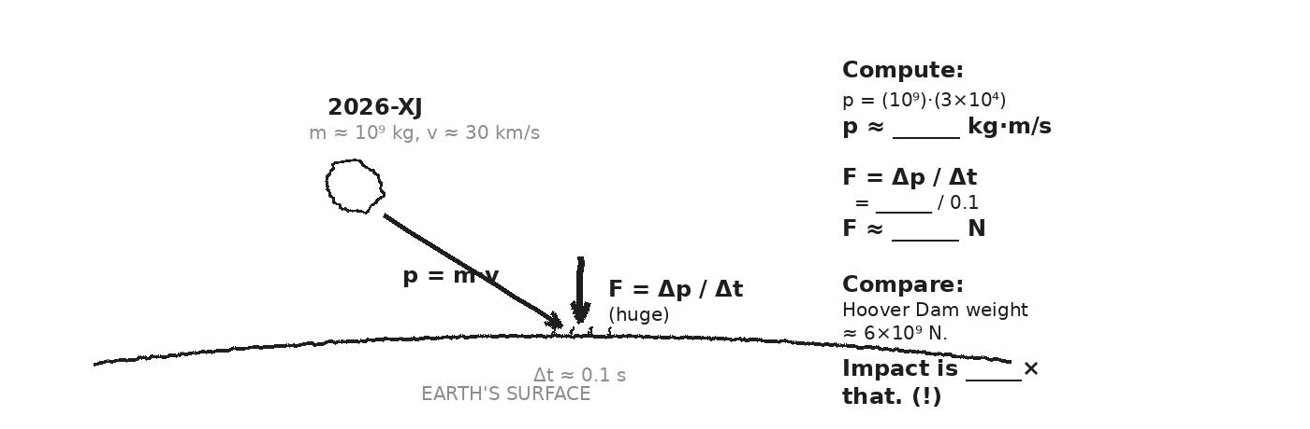

WORKED EXAMPLE — 2026-XJ impact force
If 2026-XJ (m = 1 × 10⁹ kg) hits Earth at v = 3 × 10⁴ m/s and stops in Δt ≈ 0.1 s, what is the AVERAGE force during impact?
GIVEN | m = 1 × 10⁹ kg · v = 3 × 10⁴ m/s · v_f = 0 · Δt = 0.1 s
EQUATION | Δp = m·(v_f − v_i) = −m·v_i ; F = Δp / Δt
WORK | Δp = −(1 × 10⁹)(3 × 10⁴) = −3 × 10¹³ kg·m/s  F = −3 × 10¹³ / 0.1 = −3 × 10¹⁴ N
ANSWER | ≈ 3 × 10¹⁴ N of force. About 50,000 × the weight of Hoover Dam, applied in a tenth of a second.

WORKED EXAMPLE — Earth's velocity change (almost zero)
Using conservation of momentum, find Earth's velocity change after a 2026-XJ impact. (M_Earth = 5.97 × 10²⁴ kg.)
GIVEN | p_asteroid = 3 × 10¹³ kg·m/s · M_Earth = 5.97 × 10²⁴ kg
EQUATION | p_asteroid + 0 = (M_Earth)·Δv_Earth (asteroid essentially absorbed)  Δv_Earth = p_asteroid / M_Earth
WORK | Δv_Earth = (3 × 10¹³) / (5.97 × 10²⁴)  Δv_Earth ≈ 5 × 10⁻¹² m/s
ANSWER | ≈ 5 × 10⁻¹² m/s — utterly undetectable. Earth doesn't 'move.' But the impact site catches the full force.

⚠ | Momentum gives us the FORCE. It does NOT capture the energy (heat, shockwave, crater). That comes in Unit 4. Today's number is one PART of the disaster picture.

Fill in the frame:
Earth's velocity barely changes after impact because Earth's ________________________________________________________ is roughly 10¹⁵ times the asteroid's. But the LOCAL force at the impact site is enormous because ________________________________________________________ is delivered in a very short ________________________________________________________.
EXIT TICKET — Day 12
Why is Earth's velocity change after an asteroid impact essentially zero, even though the impact is catastrophic locally?

Today's Targets — Rate Yourself
1 = Not Yet (I can't do this without help) 2 = Almost (I can do this with some help or some errors) 3 = Got It (I can do this independently and explain it)
Help? Check the box if you want to talk with me about this target — even if you marked yourself a 3.
Target | 1 | 2 | 3 | Help?
I can compute the AVERAGE force of an asteroid impact using F = Δp/Δt. | ○ | ○ | ○ | ☐
I can compute Earth's negligible Δv from a conservation argument. | ○ | ○ | ○ | ☐
I can explain why a tiny Earth Δv coexists with a catastrophic local force. | ○ | ○ | ○ | ☐

Day 13 — Two-Branch Analysis — Deflect or Impact?

Today's Target
I can run a full 2026-XJ analysis on both branches (deflection and impact) and articulate which two ideas from the unit were load-bearing for the conclusion.
ASTEROID THREAD
What we know about 2026-XJ today: We have every tool we need. Days 11 and 12 each gave us a branch. Today the class does both, compiles, and reports.
How today connects: Tomorrow is the transfer task. Today is the rehearsal — done in groups, with talk and revision.

DOODLE ZONE
On the LEFT branch, list the physics tools you'll use. On the RIGHT branch, do the same. Then circle one tool that shows up in BOTH.
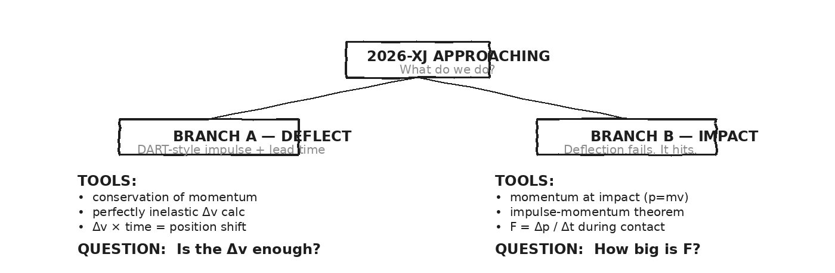

STATION 1 — DEFLECTION (asteroid + DART-style impactor)
Given: 2026-XJ has M = 1 × 10⁹ kg, will pass Earth in t = 1.5 × 10⁷ s (6 months). We need to shift its position by 6.4 × 10⁶ m (one Earth-radius). A DART-class impactor has m = 600 kg at v = 6 × 10³ m/s. (a) Find the Δv from ONE DART-class impactor. (b) Find the Δv we NEED (using Δv = shift / time). (c) How many DART impactors would it take?
GIVEN
EQUATION
WORK
ANSWER

STATION 2 — IMPACT (what we'd live through)
Given: 2026-XJ at v = 3 × 10⁴ m/s, M = 1 × 10⁹ kg, hits Earth and stops in Δt = 0.1 s. (a) Find the asteroid's momentum at impact. (b) Find the average impact force. (c) Compare F to: Hoover Dam weight (6 × 10⁹ N), Burj Khalifa weight (5 × 10⁹ N), or an earthquake's typical peak force.
GIVEN
EQUATION
WORK
ANSWER

CLASS CONSENSUS — what do we tell NASA?
After both stations, compare answers across groups. Write a 2-sentence consensus statement about (a) whether DART-scale deflection is realistic and (b) what the impact branch would mean.
OUR CLASS CONSENSUS
★ | Real planetary defense analysts do exactly this kind of two-branch reasoning. Your numbers are within an order of magnitude of NASA's. The fictional asteroid; the math is real.

Fill in the frame:
Of all the ideas from Unit 3, the TWO most load-bearing for today's analysis were ________________________________________________________ (used in deflection) and ________________________________________________________ (used in impact). Both rely on conservation of ________________________________________________________.
EXIT TICKET — Day 13
Of all the things you learned in Unit 3, which TWO ideas were load-bearing for today's analysis? Why?

Today's Targets — Rate Yourself
1 = Not Yet (I can't do this without help) 2 = Almost (I can do this with some help or some errors) 3 = Got It (I can do this independently and explain it)
Help? Check the box if you want to talk with me about this target — even if you marked yourself a 3.
Target | 1 | 2 | 3 | Help?
I can run the deflection-branch calculation start to finish. | ○ | ○ | ○ | ☐
I can run the impact-branch calculation start to finish. | ○ | ○ | ○ | ☐
I can articulate which two unit ideas were load-bearing for the conclusion. | ○ | ○ | ○ | ☐

Day 14 — Unit 3 Transfer Task — Assessment Day

ASTEROID THREAD
What we know about 2026-XJ today: Every tool from Unit 3 is in your hands: p = mv, J = FΔt = Δp, conservation, three collision types, 2D components, and the DART/impact branches.
How today connects: One of the 4 transfer problems anchors in 2026-XJ — given a DART-style Δv, compute the lead time required for an Earth-radius lateral shift.

TRANSFER TASK — UNIT 3 · DAY 14
Today you receive the Unit 3 Transfer Task on a separate sheet. It is 4 multi-part problems. You will work independently for ~40 minutes.
• Problem 1 — Momentum + impulse. A baseball-bat collision: given m, v_i, v_f, and contact time, find Δp and the average force.
• Problem 2 — Ballistic pendulum (perfectly inelastic). Given bullet mass, bullet speed, and block mass, find the combined velocity. Then find the kinetic energy lost (preview to Unit 4).
• Problem 3 — 2D billiards. Given m₁, m₂, v_cue_i, and the cue ball's final speed + angle, find the second ball's final speed and direction.
• Problem 4 — Asteroid deflection. Given the Δv from a DART-style impactor and a target lateral shift of 6,400 km, how much lead time is needed?
HOW THIS WILL BE SCORED — 4 DIMENSIONS, EACH 0–4
Dimension | What a strong (3–4) response shows
Science | Correct physics: vectors, kinematics, units.
Reasoning | Sound method; uncertainty explained, not just stated.
Communication | Work shown, units labeled, organized, readable.
Transfer-to-Asteroid | Honest public-facing connection to 2026-XJ.
MY WORK — DAY 14
AFTER THE TASK — FINAL UNIT MARZANO (rate each Unit 3 target)
Today's Targets — Rate Yourself
1 = Not Yet (I can't do this without help) 2 = Almost (I can do this with some help or some errors) 3 = Got It (I can do this independently and explain it)
Help? Check the box if you want to talk with me about this target — even if you marked yourself a 3.
Target | 1 | 2 | 3 | Help?
K1 — Momentum as a vector p = m·v. | ○ | ○ | ○ | ☐
K2 — Impulse-momentum theorem J = F·Δt = Δp. | ○ | ○ | ○ | ☐
K3 — Conservation of momentum and its condition. | ○ | ○ | ○ | ☐
K4 — Elastic vs. inelastic vs. perfectly inelastic. | ○ | ○ | ○ | ☐
S1 — Compute momentum, Δp, and impulse. | ○ | ○ | ○ | ☐
S2 — Solve a perfectly inelastic 1D problem. | ○ | ○ | ○ | ☐
S3 — Solve a 1D elastic problem (general + special cases). | ○ | ○ | ○ | ☐
S4 — Run a Vernier collision experiment and report % difference. | ○ | ○ | ○ | ☐
R1 — Reason about how Δt trades off with F for the same Δp. | ○ | ○ | ○ | ☐
R2 — Apply 2D conservation to glancing collisions. | ○ | ○ | ○ | ☐
R3 — Reason about asteroid deflection using Δv × time. | ○ | ○ | ○ | ☐

Equation Reference — Unit 3
Keep this page open while you work. Every equation below is on the MCAS Equation Sheet — you do NOT need to memorize them. You DO need to recognize when each one applies.
Concept | Equation | When to use it
Momentum | p = m·v | Units kg·m/s. Vector — same direction as v. Big mass × big speed = big p.
Impulse-momentum | J = F·Δt = Δp | Units N·s = kg·m/s. The bridge from FORCE (Unit 1) to MOMENTUM. Same Δp can come from big F·short Δt OR small F·long Δt.
Conservation of momentum | Σp_before = Σp_after | Holds when no NET external force acts on the system. Applies in EVERY collision type.
Perfectly inelastic (stick) | m₁v₁ + m₂v₂ = (m₁+m₂)v_f | Objects stick together after impact. ONE unknown, v_f. Asteroid impact and ballistic pendulum are this case.
Elastic — general | Σp and ΣKE both conserved | Two equations: m₁v₁ᵢ + m₂v₂ᵢ = m₁v₁f + m₂v₂f AND ½m₁v₁ᵢ² + ½m₂v₂ᵢ² = ½m₁v₁f² + ½m₂v₂f². No KE lost. Bouncing superball, Newton's cradle, gravity flyby.
Elastic — m₂ at rest | v₁f = ((m₁−m₂)/(m₁+m₂))·v₁ᵢ  v₂f = (2m₁/(m₁+m₂))·v₁ᵢ | Special case shortcut. Predict equal-mass (v₁f=0, v₂f=v₁ᵢ — Newton's cradle), small hits big (bounces back), big hits small.
2D conservation | Σp_x_before = Σp_x_after  Σp_y_before = Σp_y_after | Vector momentum splits into COMPONENTS. Conservation applies to x and y SEPARATELY. Two equations, often two unknowns.
Asteroid deflection | Δv ≈ m_DART·v_DART / M_asteroid | From conservation, perfectly inelastic, M ≫ m approximation. Tiny per-strike Δv accumulates over years.
Constants and reference quantities:
M_Earth = 5.97×10²⁴ kg · R_Earth = 6.37×10⁶ m (≈ 6371 km) · Earth orbital speed ≈ 3.0×10⁴ m/s · DART: m ≈ 600 kg, v ≈ 6 km/s · Dimorphos M ≈ 5×10⁹ kg · 2026-XJ m ≈ 10⁹ kg, v ≈ 3×10⁴ m/s
Mastery Growth Chart — Unit 3
Each day, transfer your Marzano 1-2-3 rating onto the chart. Use a different mark or color for each target you track. By the end of the unit you'll have a visible record of your growth.
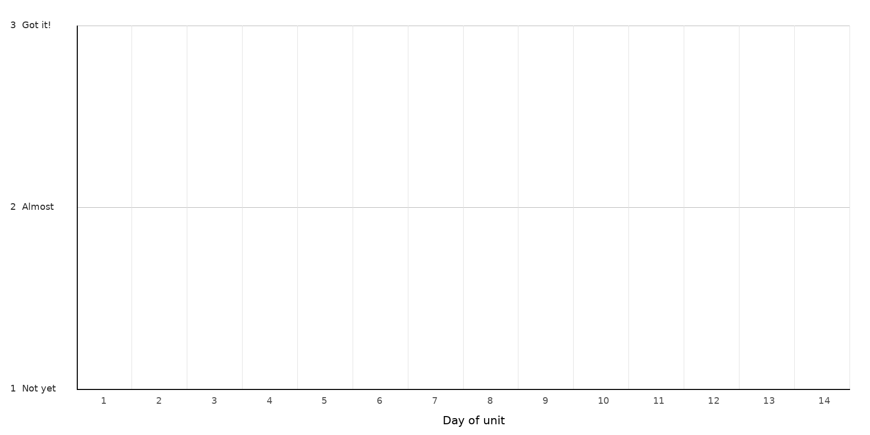
LEGEND — WHICH MARK / COLOR = WHICH TARGET
Mark: ______ Target: __________________________________________________________________
Mark: ______ Target: __________________________________________________________________
Mark: ______ Target: __________________________________________________________________
NOTES — END-OF-UNIT REFLECTION

