CPA Physics · Fitchburg High School · 2026–2027
Unit 4 — How bad would 2026-XJ actually be?
Work · kinetic and potential energy · conservation · springs · power · TNT yield · escape velocity
◆ NASA / PLANETARY DEFENSE BRIEFING — UPDATE 4
The Unit 3 DART feasibility analysis came back INCONCLUSIVE. The required Δv depends sensitively on lead time — and we may not have lead time. So now Unit 4 has to answer the OTHER branch: if 2026-XJ does impact, HOW BAD IS IT ACTUALLY?
Reports talk about "Tunguska-scale" or "Chicxulub-scale" events — but those are TNT-equivalent yields. To compute a yield, we need a framework we don't have yet: ENERGY. Specifically, the asteroid's KINETIC ENERGY at impact, converted into the same units the public uses for nuclear weapons and historical impacts.
Unit 4 builds that framework. Day 19 is the payoff — we put a number on 2026-XJ and place it on the same scale as Hiroshima, Tunguska, Chelyabinsk, and Chicxulub.
And there's a parallel question we owe ourselves: could 2026-XJ have ESCAPED — slipped past Earth and out of the system — if it had been moving faster, or if we'd pushed it sooner? That's escape velocity. The same energy framework answers both questions.
This is fiction. The physics — and the equations — are real.
MA Standards: HS-PS3-1, HS-PS3-2, HS-PS3-3, HS-PS3-4, HS-ETS1-2
22 meetings · Fall 2026 (Dec 2 – Jan 16)
Name: ______________________________ Class period: __________ Date received: __________
"Unit 3 gave us force. Unit 4 gives us damage — in the units the world uses."
Table of Contents
Day-type key: A = Anchor · S = Standard · L = Lab · T = Transfer
Section | Type | Page
Cover | — | 1
Table of Contents | — | 2
Phase 1 — Re-anchor: the impact answer needs energy | —
Day 1 — Re-anchoring: damage isn't just force | A | 3
Day 2 — Work: W = F·d | S | 6
Day 3 — Work at an angle + negative work | S | 9
Phase 2 — Kinetic energy | —
Day 4 — Kinetic energy: KE = ½mv² | S | 12
Day 5 — Work-energy theorem: worked examples | S | 15
Day 6 — Vernier KE lab | L | 18
Phase 3 — Potential energy | —
Day 7 — Gravitational PE near Earth: U = mgh | S | 22
Day 8 — When mgh fails: g changes with altitude | S | 25
Day 9 — Universal PE: U = −GMm/r | S | 28
Phase 4 — Conservation of mechanical energy | —
Day 10 — Conservation: KE + PE = const | S | 31
Day 11 — Rolling, sliding, swinging | S | 34
Day 12 — Roller coaster + pendulum | S | 37
Day 13 — Vernier ramp lab | L | 40
Phase 5 — Springs and power | —
Day 14 — Hooke's law: F = −kx | S | 44
Day 15 — Spring PE: ½kx² | S | 47
Day 16 — Power: P = W/t = F·v | S | 50
Phase 6 — Energy in collisions revisited | —
Day 17 — KE in elastic vs. inelastic collisions | S | 53
Day 18 — Heat as the missing energy (Unit 5 bridge) | S | 56
Phase 7 — Asteroid payoff | —
Day 19 — TNT yield: 2026-XJ on the impact scale | S★ | 59
Day 20 — Escape velocity | S | 62
Phase 8 — Composition & assessment | —
Day 21 — Three-branch energy budget | S | 65
Day 22 — Unit 4 transfer task | T | 69
Equation Reference Card | — | 72
Mastery Growth Chart | — | 74

Day 1 — Re-anchoring — Damage Isn't Just Force

Today's Target
I can articulate why MOMENTUM gave us force at impact, but didn't give us a DAMAGE answer — and I can predict that something involving SPEED-SQUARED is doing the work.
ASTEROID THREAD
What we know about 2026-XJ today: From Unit 3: 2026-XJ's momentum at impact is enormous, and the AVERAGE force of impact is ~10¹⁴ N. But "force" doesn't tell us crater size, fire radius, or tsunami height.
How today connects: What people quote for asteroid impacts is the asteroid's KINETIC ENERGY in TNT-equivalents. Unit 4 builds that framework. Day 19 cashes it in.

NOTICE AND WONDER
Watch the drop demo: tennis ball from waist, tennis ball from head, baseball from head. Rank "how hard did the floor get hit" 1-2-3. What did you NOTICE? What do you WONDER?
I notice ____________________________
I wonder ____________________________

DOODLE ZONE
Rank the three drops 1-2-3. What stays the same A vs. B? What changes? Same question for B vs. C. What TWO things matter for damage?
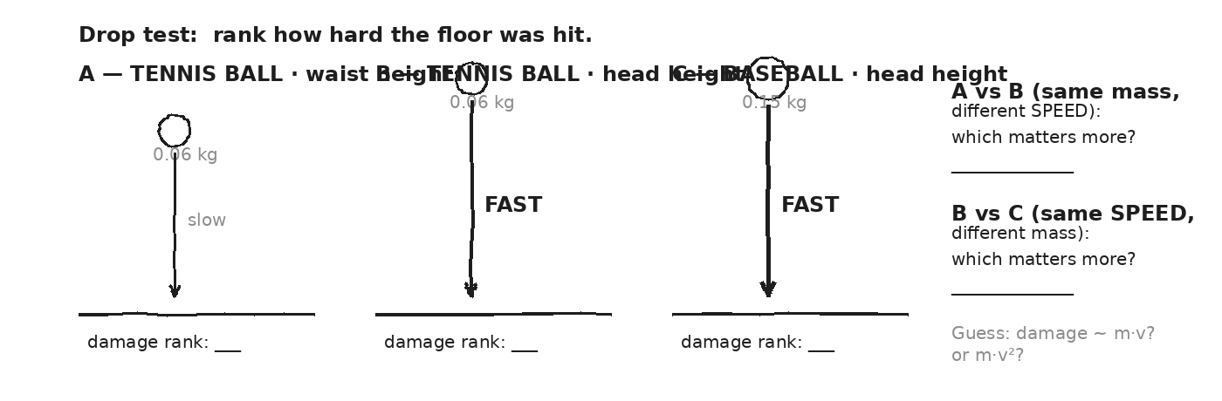

MY GUESS — DOES DAMAGE GROW LIKE m·v, OR FASTER?
★ | Spoiler: the answer is KINETIC ENERGY = ½ · m · v² — and that SQUARED v is the load-bearing feature of the entire unit. We don't formalize it today; we feel it.

EXIT TICKET — Day 1
If you DOUBLE a moving car's SPEED, does the damage in a crash double, or more than double? Why might that be? (One sentence, your best guess.)

Today's Targets — Rate Yourself
1 = Not Yet (I can't do this without help) 2 = Almost (I can do this with some help or some errors) 3 = Got It (I can do this independently and explain it)
Help? Check the box if you want to talk with me about this target — even if you marked yourself a 3.
Target | 1 | 2 | 3 | Help?
I can explain why momentum isn't a damage answer. | ○ | ○ | ○ | ☐
I can predict that doubling speed gives MORE than double the damage. | ○ | ○ | ○ | ☐
I can name the two questions Unit 4 must answer (impact yield, escape). | ○ | ○ | ○ | ☐

Day 2 — Work: W = F · d

Today's Target
I can write W = F·d, give units (Joules = N·m), compute work in 1D, and identify cases where work is ZERO even though a force is applied.
ASTEROID THREAD
What we know about 2026-XJ today: Earth's gravity does WORK on 2026-XJ as it falls. That work is what increases the asteroid's energy.
How today connects: Work is the bridge between FORCE (Unit 1, Unit 3) and ENERGY (today on). It's how energy MOVES from one object to another.

VOCAB · WORK (W)
Definition: Energy transferred to (or from) an object via a force applied along its motion. W = F·d.
Example: Pushing a 50-N box 4 m → W = 200 J. Lifting a 20-N book 1.5 m → W = 30 J.
Cognates: Sp. trabajo · Pt. trabalho · HC travay
Watch out: Work is NOT the same as effort. If you push a wall and it doesn't move, you've done ZERO work — even though you got tired. (Your body did work, but not on the wall.)

VOCAB · JOULE (J)
Definition: The unit of work and energy. 1 Joule = 1 Newton · 1 meter.
Example: Lifting an apple (~1 N) up 1 m takes about 1 J of work.
Cognates: Sp. julio · Pt. joule · HC joul
Watch out: A Joule is small. A snack bar has ~10⁶ J. The asteroid's KE is ~10¹⁷ J. You'll see scientific notation a lot this unit.

DOODLE ZONE
Compute W for the pushed box. Then write zero for each zero-work case and EXPLAIN why (one phrase each).
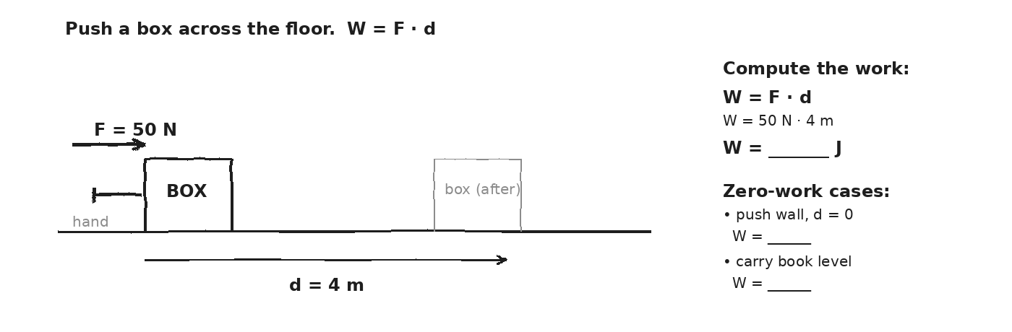

WORKED EXAMPLE — pushing a box
You push a 50-N box 4 m across the floor with a constant horizontal force. How much work do you do?
GIVEN | F = 50 N (along motion) · d = 4 m
EQUATION | W = F · d
WORK | W = 50 · 4  W = 200 J
ANSWER | 200 J of work done on the box.

YOUR TURN — lifting a book
You lift a 20-N book straight up 1.5 m at constant speed. How much work do you do AGAINST gravity?
GIVEN
EQUATION
WORK
ANSWER

YOUR TURN — three zero-work cases
For each case, write W and explain in ONE phrase why it's zero. (a) You push hard on a wall; the wall doesn't move. (b) You carry a 20-N book level across a 5-m room. (c) A satellite in CIRCULAR orbit moves around Earth.
GIVEN
EQUATION
WORK
ANSWER

⚠ | Work needs BOTH a force AND motion in the direction of that force. Lose either one → W = 0.

Fill in the frame:
Carrying a book level across the room does NO WORK on the book because the force is ________________________________________________________ and the motion is ________________________________________________________ — and the angle between them is ________________________________________________________°.
EXIT TICKET — Day 2
You lift a 20-N book 1.5 m, then walk 3 m holding the book at that height. How much work did you do TOTAL on the book?

Today's Targets — Rate Yourself
1 = Not Yet (I can't do this without help) 2 = Almost (I can do this with some help or some errors) 3 = Got It (I can do this independently and explain it)
Help? Check the box if you want to talk with me about this target — even if you marked yourself a 3.
Target | 1 | 2 | 3 | Help?
I can compute W = F·d with correct units. | ○ | ○ | ○ | ☐
I can identify zero-work cases and explain why. | ○ | ○ | ○ | ☐
I can compute work done against gravity when lifting. | ○ | ○ | ○ | ☐

Day 3 — Work at an Angle + Negative Work

Today's Target
I can compute W = F·d·cos θ for an angled force, and I can assign the correct SIGN of work for forces that aid or oppose motion.
ASTEROID THREAD
What we know about 2026-XJ today: If 2026-XJ enters our atmosphere, air drag does NEGATIVE work on it — taking energy AWAY.
How today connects: That's why meteors GLOW. Their KE is converting to heat and light because atmospheric friction did massive negative work.

VOCAB · WORK AT AN ANGLE
Definition: When the force F makes an angle θ with the direction of motion d, only the COMPONENT of F along d does work: W = F · d · cos θ.
Example: Pulling a suitcase with a 100-N handle force at 30° above horizontal over 10 m: W = 100·10·cos30° ≈ 866 J.
Cognates: Sp. trabajo con ángulo · Pt. trabalho com ângulo · HC travay ak ang
Watch out: At θ = 90°, cos θ = 0 and W = 0 — even though there's a big force.

VOCAB · NEGATIVE WORK
Definition: Work done by a force that opposes the motion (θ between 90° and 180°). cos θ is negative, so W is negative — energy is taken AWAY from the object.
Example: Friction always does negative work on a sliding object. cos180° = −1.
Cognates: Sp. trabajo negativo · Pt. trabalho negativo · HC travay negatif
Watch out: "Negative work" doesn't mean "no work." It means energy is being REMOVED, not added.

DOODLE ZONE
Compute the work done by the 100-N pull. Then compute the friction's work. Net?
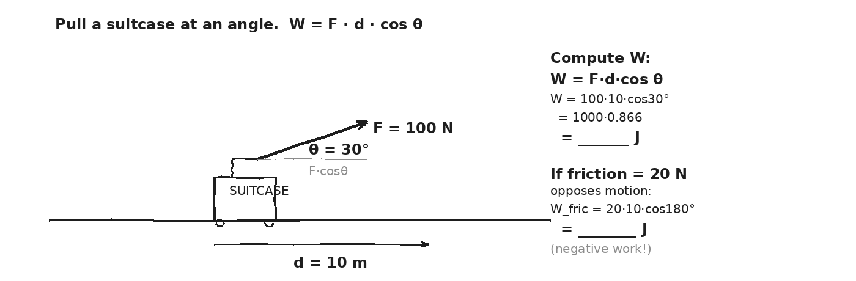

WORKED EXAMPLE — pulling a suitcase at angle
You pull a 100-N handle force on a suitcase 10 m at 30° above the horizontal. Friction opposes the motion with 20 N. Find: (a) work done by you, (b) work done by friction, (c) NET work.
GIVEN | F_you = 100 N, θ_you = 30° · F_fric = 20 N, θ_fric = 180°  d = 10 m
EQUATION | W = F · d · cos θ (for each force)
WORK | W_you = 100·10·cos30° = 1000·0.866 = 866 J  W_fric = 20·10·cos180° = 200·(-1) = -200 J  W_net = 866 + (-200) = 666 J
ANSWER | You did 866 J of POSITIVE work. Friction did 200 J of NEGATIVE work. Net: 666 J.

YOUR TURN — push across the floor
You push a 30-N box 4 m across the floor at constant speed against 12 N of friction. (a) What work did YOU do? (b) What work did friction do? (c) What's the NET work?
GIVEN
EQUATION
WORK
ANSWER

⚠ | ALWAYS write the angle BEFORE you compute. θ between F and d, NOT between F and the floor. cos180° = −1, cos90° = 0, cos0° = 1.

Fill in the frame:
Friction does NEGATIVE work because the friction force points ________________________________________________________ to the motion, so cos θ = ________________________________________________________, so W comes out ________________________________________________________.
EXIT TICKET — Day 3
You push a 30-N box 4 m at constant speed against 12 N of friction. What's the NET work?

Today's Targets — Rate Yourself
1 = Not Yet (I can't do this without help) 2 = Almost (I can do this with some help or some errors) 3 = Got It (I can do this independently and explain it)
Help? Check the box if you want to talk with me about this target — even if you marked yourself a 3.
Target | 1 | 2 | 3 | Help?
I can apply W = F·d·cos θ for an angled force. | ○ | ○ | ○ | ☐
I can assign the correct sign to work done by aiding vs. opposing forces. | ○ | ○ | ○ | ☐
I can sum positive and negative works to find NET work. | ○ | ○ | ○ | ☐

Day 4 — Kinetic Energy + the Squared-v Reveal

Today's Target
I can write KE = ½mv², compute KE for moving objects across mass and speed scales, and state the work-energy theorem W_net = ΔKE.
ASTEROID THREAD
What we know about 2026-XJ today: The DAMAGE number for asteroids is their KINETIC ENERGY at impact, not their momentum.
How today connects: Today's equation is the heart of Unit 4. By Day 19, we plug 2026-XJ into it and get its yield in tons of TNT.

VOCAB · KINETIC ENERGY (KE)
Definition: The energy of motion. KE = ½ · m · v². Units: Joules (kg·m²/s²). Always positive, regardless of direction.
Example: A 1500-kg car at 30 m/s has KE = ½·1500·900 = 675,000 J. At 60 m/s: KE = 2,700,000 J — FOUR times as much.
Cognates: Sp. energía cinética · Pt. energia cinética · HC enèji sinetik
Watch out: The squared v matters. KE is NOT proportional to v — it's proportional to v². Doubling speed quadruples KE.

VOCAB · WORK-ENERGY THEOREM
Definition: The NET work done on an object equals the change in its KE: W_net = ΔKE = KE_f − KE_i.
Example: A 1-kg cart at rest gets 50 J of net work → KE_f = 50 J → v_f = √(2·50/1) = 10 m/s.
Cognates: Sp. teorema del trabajo-energía · Pt. teorema do trabalho-energia
Watch out: It's the NET work that matters — sum of ALL forces' contributions, not just one.

DOODLE ZONE
Compute KE at each speed using ½mv². Confirm: doubling v gives 4× KE; tripling v gives 9×.
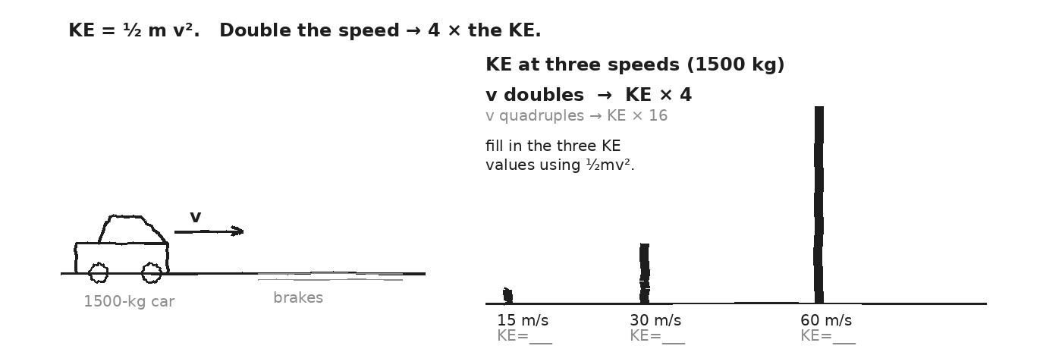

WORKED EXAMPLE — KE of a car at two speeds
A 1500-kg car moves at (a) 30 m/s, (b) 60 m/s. Find the KE in each case.
GIVEN | m = 1500 kg · v_a = 30 m/s · v_b = 60 m/s
EQUATION | KE = ½ · m · v²
WORK | KE_a = ½ · 1500 · 30² = ½ · 1500 · 900 = 675,000 J  KE_b = ½ · 1500 · 60² = ½ · 1500 · 3600 = 2,700,000 J  KE_b / KE_a = 4 (matches: v doubled → KE × 4)
ANSWER | At 30 m/s: 6.75 × 10⁵ J. At 60 m/s: 2.7 × 10⁶ J — FOUR times the energy.

YOUR TURN — KE of 2026-XJ
2026-XJ has m = 1 × 10⁹ kg and impact speed v = 3 × 10⁴ m/s. Find its KE at impact.
GIVEN
EQUATION
WORK
ANSWER

YOUR TURN — work-energy theorem
A 2-kg ball moves at 3 m/s. A net 27 J of work is done on it. What's its final speed? (Use W_net = ΔKE.)
GIVEN
EQUATION
WORK
ANSWER

★ | Highway speeds aren't twice as dangerous as 30 mph. They're FOUR TIMES. This is the squared v at work — and it's why 2026-XJ matters.

Fill in the frame:
Doubling a car's speed ________________________________________________________ the kinetic energy, because KE depends on v ________________________________________________________ (not just v).
EXIT TICKET — Day 4
A 2-kg ball at 3 m/s has 9 J of KE. If a net 27 J of work is done on it, what's its final speed?

Today's Targets — Rate Yourself
1 = Not Yet (I can't do this without help) 2 = Almost (I can do this with some help or some errors) 3 = Got It (I can do this independently and explain it)
Help? Check the box if you want to talk with me about this target — even if you marked yourself a 3.
Target | 1 | 2 | 3 | Help?
I can compute KE = ½mv² with correct units. | ○ | ○ | ○ | ☐
I can predict the ratio of KEs when speed changes. | ○ | ○ | ○ | ☐
I can apply W_net = ΔKE to find final speed. | ○ | ○ | ○ | ☐

Day 5 — Work-Energy Theorem — Worked Examples

Today's Target
I can apply W_net = ΔKE as a shortcut to find stopping distance, final speed, or net force without solving for time.
ASTEROID THREAD
What we know about 2026-XJ today: Gravity does work on the falling asteroid. That work IS its impact KE.
How today connects: The work-energy theorem lets us skip time-history of the fall and go straight from forces to impact speed. That's tomorrow's lab.

VOCAB · W_NET = ΔKE (SHORTCUT FORM)
Definition: When forces are CONSTANT, W_net = F_net · d · cosθ = ½m·v_f² − ½m·v_i². Three knowns → one unknown.
Example: A 1500-kg car at 30 m/s, brakes apply 9000 N. Stopping distance? W_net = -F·d = 0 − ½mv² → d = ½·1500·900/9000 = 75 m.
Cognates: Sp. teorema trabajo-energía aplicado · Pt. teorema aplicado
Watch out: W_net is the work of the NET force, not any single force. Add up ALL the works (with signs) first.

DOODLE ZONE
Solve for v_f using W_net = ΔKE. Show why this is faster than kinematics.
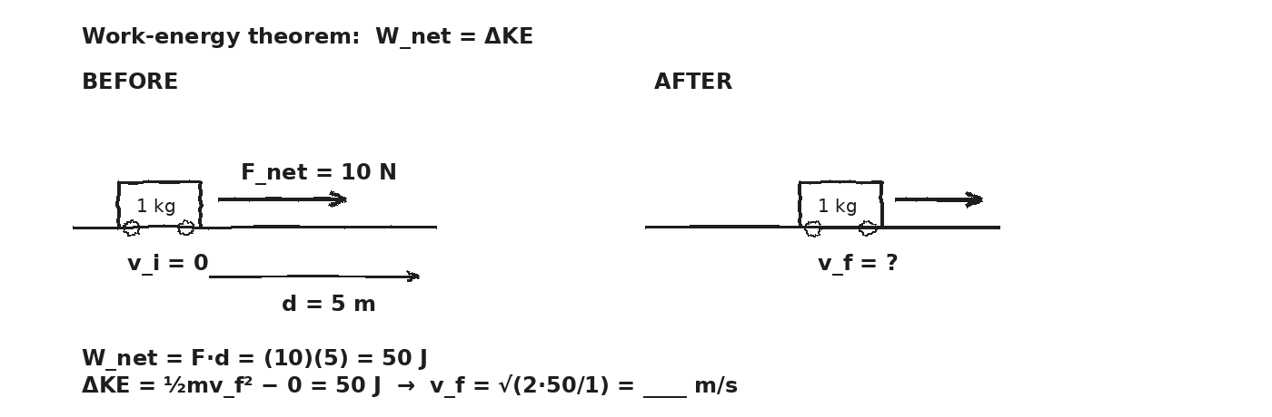

WORKED EXAMPLE — stopping distance of a car
A 1500-kg car at 30 m/s brakes to rest. The brakes apply 9000 N (constant). How far does the car travel before stopping?
GIVEN | m = 1500 kg · v_i = 30 m/s · v_f = 0 · F_brake = 9000 N (opposes motion)
EQUATION | W_net = ΔKE → −F·d = 0 − ½m·v_i²
WORK | −9000 · d = − ½ · 1500 · 30²  −9000 · d = − 675,000  d = 675,000 / 9000 = 75 m
ANSWER | The car travels 75 m before stopping.

WORKED EXAMPLE — roller-coaster: from gravity work to bottom speed
A 100-kg coaster cart starts at rest at the top of a 10-m incline. Friction-free. What's its speed at the bottom?
GIVEN | m = 100 kg · v_i = 0 · h = 10 m · g = 9.81 m/s²
EQUATION | W_grav = m·g·h AND W_net = ΔKE = ½m·v_f²
WORK | W_grav = 100 · 9.81 · 10 = 9810 J  9810 = ½ · 100 · v_f²  v_f² = 196.2  v_f ≈ 14 m/s
ANSWER | ≈ 14 m/s at the bottom. Faster than kinematics — no time needed.

YOUR TURN — spring-launched ball
A 0.5-kg ball is fired from a spring that does 8 J of work on it. The ball starts at rest. What's its speed leaving the spring?
GIVEN
EQUATION
WORK
ANSWER

★ | If you KNOW the forces and DISTANCES, skip kinematics. Compute the work, set it equal to ΔKE, solve.

Fill in the frame:
The work-energy theorem is faster than kinematics when I already know the ________________________________________________________ and the ________________________________________________________, but not the ________________________________________________________.
EXIT TICKET — Day 5
A 0.5-kg ball is fired from a spring that does 8 J of work on it. The ball starts at rest. What's its speed?

Today's Targets — Rate Yourself
1 = Not Yet (I can't do this without help) 2 = Almost (I can do this with some help or some errors) 3 = Got It (I can do this independently and explain it)
Help? Check the box if you want to talk with me about this target — even if you marked yourself a 3.
Target | 1 | 2 | 3 | Help?
I can apply W_net = ΔKE to find stopping distance. | ○ | ○ | ○ | ☐
I can apply W_net = ΔKE to find final speed from gravity work. | ○ | ○ | ○ | ☐
I can choose between kinematics and the work-energy theorem. | ○ | ○ | ○ | ☐

Day 6 — Vernier KE Lab — Confirm W_net = ΔKE · Investigation 4.1

Today's Target
I can run a Vernier dynamics-cart trial with a hanging-mass pull, compute predicted v from W_net = ΔKE, measure v with a photogate, and report the % difference with one credible source of error.
ASTEROID THREAD
What we know about 2026-XJ today: We've stated W_net = ΔKE. Today we measure it.
How today connects: If our cart confirms the theorem, we can trust it for asteroid energy on Day 19.

LAB SETUP — INVESTIGATION 4.1
Driving question: Does the predicted final speed of a cart (from W_net = ΔKE) match the measured speed from the photogate? Across 3 trials with different hanging masses?
Equipment:
- Vernier dynamics track (1 per pair) + 1 cart
- Pulley clamped at end of track + string
- Hanging masses (50 g, 100 g, 150 g)
- 1 photogate + LabQuest + Logger Pro or Graphical Analysis
- Balance to weigh cart (record m_cart) and meter stick for d
What you do:
1. Level the track. Weigh the cart and record m_cart.
2. Set up pulley + string. Hang first mass m_h. Compute F_pull = m_h · g.
3. Mark the cart's starting position. Measure d to the photogate.
4. Release. Photogate reads v_measured.
5. Compute W_net = F_pull · d, predict v from W_net = ½m_cart·v². Compare to measured.
6. Repeat with the other two hanging masses. Three trials total. Compute % difference.
────────────────────────────────────────────────────────────
Safety: Hanging masses below knee level. Catch them at end of run. Photogates clamped firmly.
How this lab serves the year's question: If the theorem holds in our carts, the Day 19 yield calculation is on solid ground.
DOODLE ZONE
Sketch your setup. Record m_cart and m_h on the diagram. Fill v_predicted and v_measured as you go.
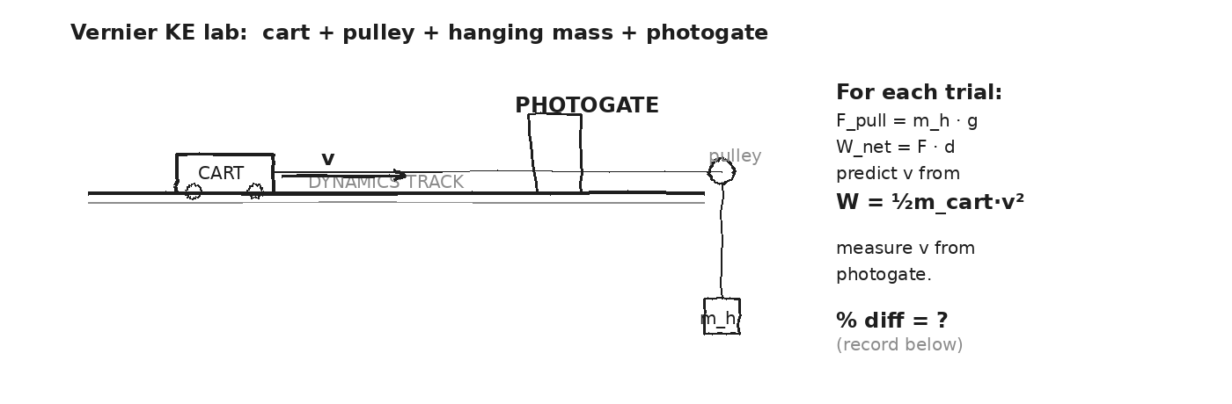

DATA — three trials
Trial | m_h (kg) | F_pull (N) | d (m) | W_net (J) | v_pred (m/s) | v_meas (m/s) | % diff
1
2
3
OBSERVATION & ANALYSIS
Did v_predicted match v_measured? Across all 3 trials, within what %?

If there's a gap, what physical thing did NEGATIVE work that we didn't count? Is the gap bigger for smaller or larger hanging masses?
My v values matched within __________ %. The most likely source of error was __________, because it would __________ the cart's KE.
Asteroid connection: how does this serve the year's question?

Fill in the frame:
W_net = ΔKE predicts v from W = ½m·v². My trials confirmed this within ____ %. The biggest source of error was ________________________________________________________.
EXIT TICKET — Day 6
Write a one-sentence CLAIM about what the lab showed, then one sentence of EVIDENCE (your numbers), then one sentence of REASONING (why the % difference is small).

Today's Targets — Rate Yourself
1 = Not Yet (I can't do this without help) 2 = Almost (I can do this with some help or some errors) 3 = Got It (I can do this independently and explain it)
Help? Check the box if you want to talk with me about this target — even if you marked yourself a 3.
Target | 1 | 2 | 3 | Help?
I can set up a Vernier dynamics-cart + pulley + photogate. | ○ | ○ | ○ | ☐
I can predict v from W_net = ΔKE. | ○ | ○ | ○ | ☐
I can compute % difference and name a credible source of error. | ○ | ○ | ○ | ☐

Day 7 — Gravitational PE near Earth: U = mgh

Today's Target
I can write U = mgh, compute PE relative to a chosen reference, and explain that only DIFFERENCES in PE are physically meaningful.
ASTEROID THREAD
What we know about 2026-XJ today: 2026-XJ has gravitational PE relative to Earth. As it falls, that PE converts to KE.
How today connects: Near the surface, U = mgh is the cleanest formula. By Day 9, we'll meet its more general cousin for asteroid distances.

VOCAB · GRAVITATIONAL PE (NEAR SURFACE)
Definition: The energy stored by lifting a mass m against gravity to height h above a reference level. U = m · g · h.
Example: A 2-kg book on a 1-m desk: U = 2·9.81·1 ≈ 20 J (above floor). Same book on the floor: U = 0 (relative to floor).
Cognates: Sp. energía potencial gravitatoria · Pt. energia potencial gravitacional · HC enèji potansyèl gravite
Watch out: PE depends on the CHOICE of zero height. Two answers can both be "right" if they use different references.

VOCAB · REFERENCE HEIGHT
Definition: The chosen zero level for PE. Usually the floor, ground, or some convenient surface.
Example: A book on a desk has PE = 20 J relative to floor, but PE = 0 relative to the desktop.
Cognates: Sp. altura de referencia · Pt. altura de referência
Watch out: Only DIFFERENCES in PE matter physically. The choice of zero is for our convenience.

DOODLE ZONE
Compute U at h = 1.0 m and h = 1.5 m. Then ΔU when lifting from 1.0 to 1.5.
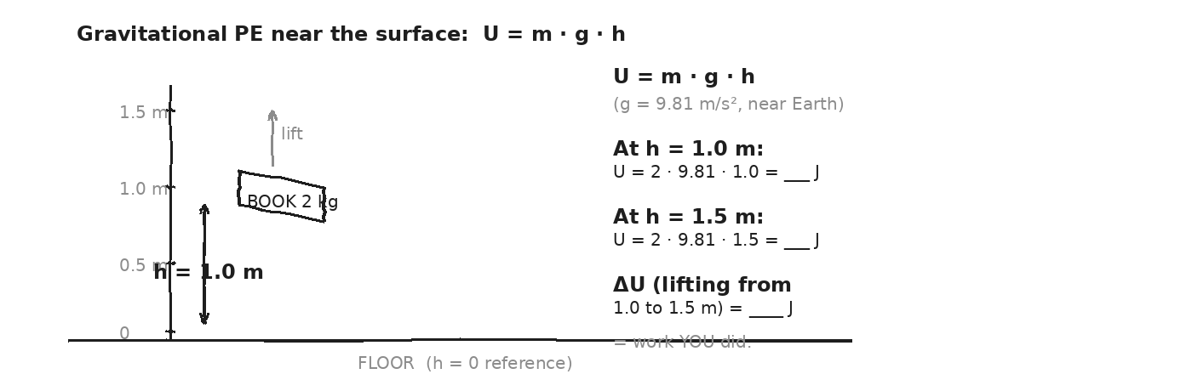

WORKED EXAMPLE — book on a desk
A 2-kg book sits on a desk 1.0 m above the floor. Find its PE (a) relative to the floor, (b) relative to the desktop.
GIVEN | m = 2 kg · g = 9.81 m/s² · h_floor = 1.0 m · h_desk = 0
EQUATION | U = m · g · h
WORK | U_floor = 2 · 9.81 · 1.0 = 19.6 J  U_desk = 2 · 9.81 · 0 = 0 J
ANSWER | Both answers are correct — they just use different zero levels.

YOUR TURN — person on top of a building
A 70-kg person stands at the top of a 100-m building, relative to the street. Find their PE.
GIVEN
EQUATION
WORK
ANSWER

YOUR TURN — cart on a ramp
A 50-kg cart sits at the top of an 8-m ramp. Find its PE relative to the bottom of the ramp.
GIVEN
EQUATION
WORK
ANSWER

⚠ | Always STATE your reference. "PE = 20 J" is meaningless without saying "above what?"

Fill in the frame:
The book on the desk has PE = 20 J above ________________________________________________________, but PE = 0 above ________________________________________________________. Both are correct — physics cares about ________________________________________________________.
EXIT TICKET — Day 7
A 2-kg book on a desk 1.0 m above the floor. PE relative to floor? PE relative to desktop?

Today's Targets — Rate Yourself
1 = Not Yet (I can't do this without help) 2 = Almost (I can do this with some help or some errors) 3 = Got It (I can do this independently and explain it)
Help? Check the box if you want to talk with me about this target — even if you marked yourself a 3.
Target | 1 | 2 | 3 | Help?
I can compute U = mgh given m, g, h. | ○ | ○ | ○ | ☐
I can choose a reference height and state it clearly. | ○ | ○ | ○ | ☐
I can explain why only ΔU is physically meaningful. | ○ | ○ | ○ | ☐

Day 8 — When mgh Fails — g changes with altitude

Today's Target
I can explain why U = mgh assumes constant g and breaks at altitudes comparable to Earth's radius, and I can preview U = −GMm/r as the fix.
ASTEROID THREAD
What we know about 2026-XJ today: 2026-XJ is currently 40,000–100,000 km out. At that distance, g is NOT 9.81 m/s².
How today connects: If we used mgh for the asteroid's PE, we'd get a hilariously wrong answer. Today we see WHY and preview the fix.

VOCAB · G VARIES WITH R
Definition: From Unit 2: g(r) = G·M / r². At Earth's surface (r ≈ 6,371 km) g ≈ 9.81. At 100,000 km out, g ≈ 0.04.
Example: The Moon (r ≈ 384,000 km from Earth) feels g_Earth ≈ 0.003 m/s². Almost nothing.
Cognates: Sp. g varía · Pt. g varia
Watch out: On Earth's surface, g feels constant only because we don't move far enough vertically. Across asteroid distances, g changes by orders of magnitude.

DOODLE ZONE
On the curve, mark where g = 9.8 (surface). Mark where g ≈ 0.04 (asteroid distance). What's the ratio? What does that mean for mgh?
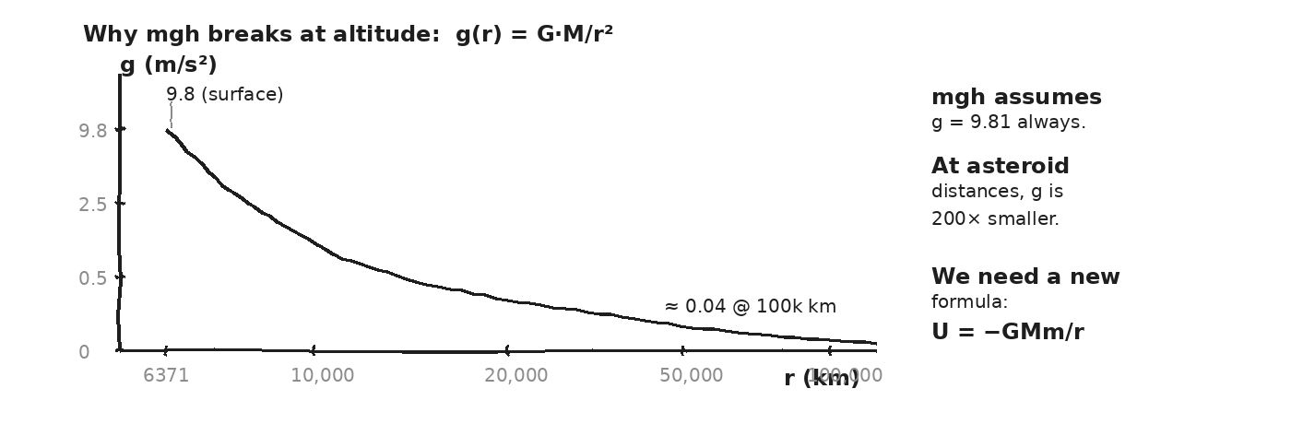

WORKED PROBE — what mgh would say at altitude
Using U = mgh with g = 9.81 m/s² (the surface value), find the PE of a 1000-kg object at h = 100,000 km altitude. Then compute g at that altitude using g(r) = GM/r² with r = 6.4×10⁶ + 1×10⁸ m. Comment on the error.
GIVEN | m = 1000 kg · h = 1 × 10⁸ m · g_surface = 9.81 m/s²  G = 6.67×10⁻¹¹ · M_Earth = 6 × 10²⁴ kg
EQUATION | U_mgh = m · g · h AND g(r) = G·M / r²
WORK | U_mgh = 1000 · 9.81 · 10⁸ = 9.81 × 10¹¹ J  r ≈ 1.06 × 10⁸ m  g(r) = (6.67e-11)(6e24)/(1.06e8)² ≈ 0.036 m/s²  So mgh OVERESTIMATES by a factor of 9.81 / 0.036 ≈ 270×
ANSWER | The mgh number is 270 times too big. We need a formula that uses g(r), not g_surface.

THE FIX — coming Day 9: U = − G · M · m / r
PE = 0 at INFINITY. PE is NEGATIVE everywhere closer (because gravity does positive work pulling things in — they LOSE potential as they fall).
★ | The negative sign is correct and important: closer = MORE negative PE; farther = closer to zero. This lets us cleanly write KE_at_infinity = 0 = KE_surface + U_surface, which gives escape velocity.

Fill in the frame:
U = mgh fails when h is comparable to ________________________________________________________, because g is not ________________________________________________________. We need U = ________________________________________________________ to be accurate across altitudes.
EXIT TICKET — Day 8
At Earth's surface, what's the PE of a 1-kg object using U = -GMm/r? Compare to U = mgh with h = 0. (Different — that's OK. Why?)

Today's Targets — Rate Yourself
1 = Not Yet (I can't do this without help) 2 = Almost (I can do this with some help or some errors) 3 = Got It (I can do this independently and explain it)
Help? Check the box if you want to talk with me about this target — even if you marked yourself a 3.
Target | 1 | 2 | 3 | Help?
I can state the assumption behind U = mgh (constant g). | ○ | ○ | ○ | ☐
I can show numerically that mgh fails at altitude. | ○ | ○ | ○ | ☐
I can preview U = −GMm/r and predict its sign. | ○ | ○ | ○ | ☐

Day 9 — Universal Gravitational PE: U = − G·M·m / r

Today's Target
I can apply U = −GMm/r to compute the PE of an asteroid at different distances and compute ΔU as it falls (= KE gained).
ASTEROID THREAD
What we know about 2026-XJ today: 2026-XJ's PE depends on its distance from Earth. As it gets closer, U becomes MORE NEGATIVE — meaning the asteroid is GAINING kinetic energy.
How today connects: ΔU as the asteroid falls is the KE it brings to impact. Day 19 puts a number on this.

VOCAB · U = − G·M·M / R
Definition: The universal gravitational PE between two masses M and m separated by distance r. PE = 0 at infinity; negative everywhere closer.
Example: A 1-kg object at Earth's surface (r = 6.37×10⁶ m): U = -(6.67e-11)(6e24)(1)/(6.37e6) ≈ -6.28 × 10⁷ J.
Cognates: Sp. energía potencial gravitacional universal · Pt. energia potencial gravitacional universal
Watch out: Negative U doesn't mean "missing energy." It means the object is in a gravitational well — you'd have to do work to lift it out to infinity.

DOODLE ZONE
Plug in numbers for U at the Moon's distance and at impact. The DIFFERENCE = the KE the asteroid gains as it falls.
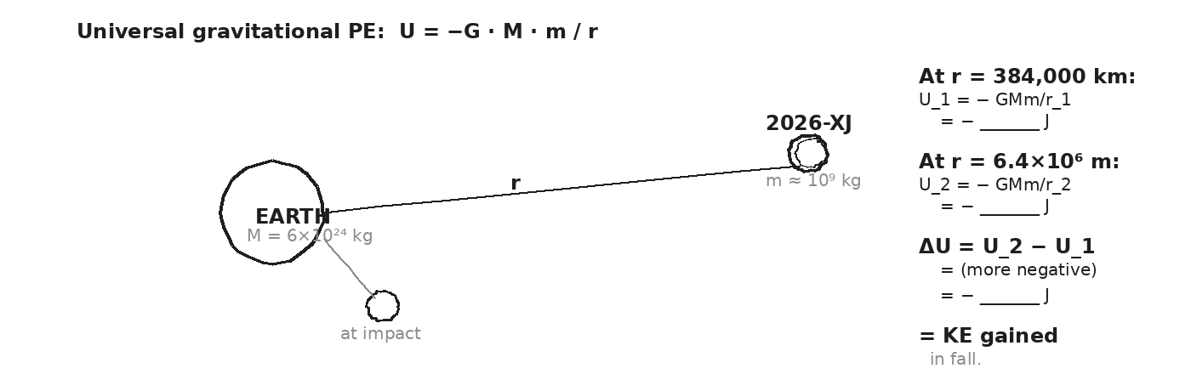

WORKED EXAMPLE — PE of an asteroid at three distances
A 1000-kg test mass at (a) 384,000 km from Earth's center, (b) Earth's surface (6,371 km), (c) at infinity. Find U at each, then ΔU from (a) to (b).
GIVEN | m = 1000 kg · G = 6.67×10⁻¹¹ · M = 5.97 × 10²⁴ kg  r_a = 3.84 × 10⁸ m · r_b = 6.37 × 10⁶ m · r_c = ∞
EQUATION | U = − G · M · m / r
WORK | U_a = − (6.67e-11)(5.97e24)(1000)/(3.84e8) ≈ -1.04 × 10⁹ J  U_b = − (6.67e-11)(5.97e24)(1000)/(6.37e6) ≈ -6.25 × 10¹⁰ J  U_c = 0 J  ΔU (a → b) = U_b − U_a ≈ -6.15 × 10¹⁰ J
ANSWER | The 1000-kg mass GAINS 6.15 × 10¹⁰ J of KE falling from Moon's distance to surface.

YOUR TURN — KE gained from infinity
A 500-kg meteorite falls from infinity to Earth's surface (no air friction). How much KE does it gain?
GIVEN
EQUATION
WORK
ANSWER

★ | A 500-kg meteorite from infinity hits Earth at v ≈ 11.2 km/s — Earth's escape velocity. Same number, two derivations. Day 20 confirms.

Fill in the frame:
An asteroid GAINS kinetic energy as it falls because its U becomes ________________________________________________________ (more negative). The total ME stays constant, so ________________________________________________________ goes up by the same amount.
EXIT TICKET — Day 9
A 500-kg object falls from infinity to Earth's surface (no air drag). What KE does it gain?

Today's Targets — Rate Yourself
1 = Not Yet (I can't do this without help) 2 = Almost (I can do this with some help or some errors) 3 = Got It (I can do this independently and explain it)
Help? Check the box if you want to talk with me about this target — even if you marked yourself a 3.
Target | 1 | 2 | 3 | Help?
I can apply U = −GMm/r at any distance. | ○ | ○ | ○ | ☐
I can compute ΔU and interpret it as KE gained. | ○ | ○ | ○ | ☐
I can predict that falling from infinity = escape-velocity KE. | ○ | ○ | ○ | ☐

Day 10 — Conservation of Mechanical Energy

Today's Target
I can state that KE + PE = constant when only conservative forces act, and apply it to a simple drop.
ASTEROID THREAD
What we know about 2026-XJ today: An asteroid in free fall (no air) obeys ME conservation perfectly.
How today connects: This is the big rule of Phase 4. Days 11-13 are all special cases. Day 19 uses it to convert PE to impact KE.

VOCAB · MECHANICAL ENERGY (ME)
Definition: The sum of KE and PE: ME = KE + PE. When only conservative forces act (gravity, springs), ME stays constant.
Example: A ball dropped from 5 m: at top, ME = 0 + mg·5. At bottom, ME = ½mv² + 0. Setting them equal gives v.
Cognates: Sp. energía mecánica · Pt. energia mecânica · HC enèji mekanik
Watch out: Friction is NOT conservative. When friction acts, ME is NOT conserved — it leaks to thermal energy.

VOCAB · CONSERVATIVE FORCE
Definition: A force whose work depends only on START and END positions, not the path. Gravity, springs. (Friction is NOT.)
Example: Walking up a ramp or a vertical lift to the same height: gravity does the SAME work.
Cognates: Sp. fuerza conservativa · Pt. força conservativa
Watch out: "Conservative" is a math word here. It doesn't mean "saves" or "preserves." It means the work is path-independent.

DOODLE ZONE
Fill the KE / PE bars at top, middle, bottom. Their SUM should be the same at every level. Solve for v at the bottom.
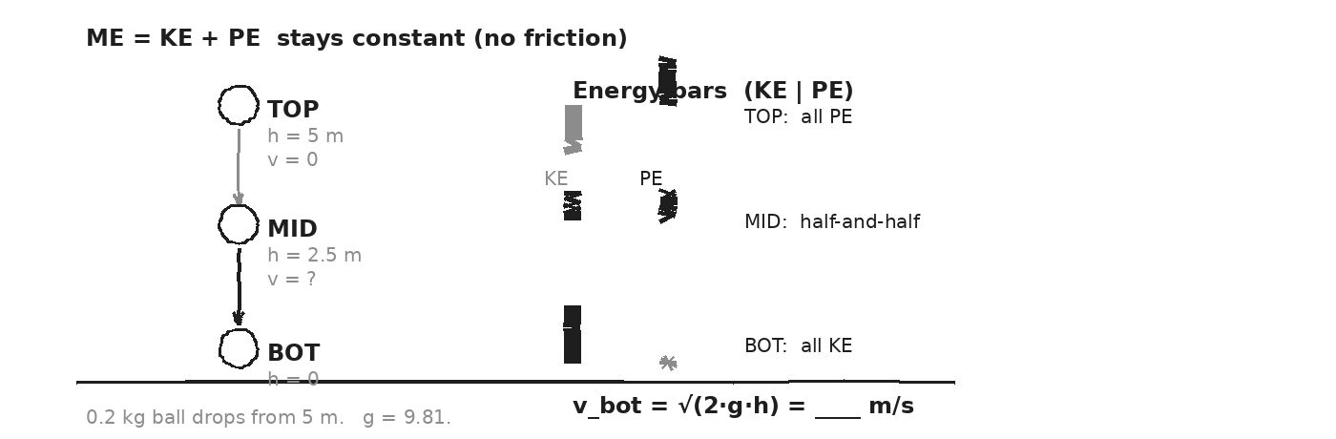

WORKED EXAMPLE — ball dropped from 5 m
A 0.2-kg ball is dropped (from rest) from 5 m above the floor. What's its speed at the floor?
GIVEN | m = 0.2 kg · v_top = 0 · h = 5 m · g = 9.81
EQUATION | KE_top + PE_top = KE_bot + PE_bot  0 + m·g·h = ½·m·v² + 0
WORK | m·g·h = ½ · m · v² (m cancels)  v = √(2 · g · h) = √(2 · 9.81 · 5)  v = √98.1 ≈ 9.9 m/s
ANSWER | ≈ 9.9 m/s at impact. Mass canceled — the answer only depends on h.

YOUR TURN — drop from 1.8 m
A 0.5-kg ball is dropped from 1.8 m (friction-free). Find its speed at impact.
GIVEN
EQUATION
WORK
ANSWER

⚠ | ME conservation only works when ALL forces are conservative. If friction or air drag acts, you must include their work — which is NEGATIVE.

Fill in the frame:
The ball's KE at the bottom equals its ________________________________________________________ at the top, because total ________________________________________________________ is conserved when only gravity acts.
EXIT TICKET — Day 10
A 0.2-kg ball is dropped from 1.8 m. Speed at impact?

Today's Targets — Rate Yourself
1 = Not Yet (I can't do this without help) 2 = Almost (I can do this with some help or some errors) 3 = Got It (I can do this independently and explain it)
Help? Check the box if you want to talk with me about this target — even if you marked yourself a 3.
Target | 1 | 2 | 3 | Help?
I can state KE + PE = const and its condition. | ○ | ○ | ○ | ☐
I can apply it to a simple drop and solve for v. | ○ | ○ | ○ | ☐
I can identify when ME is NOT conserved (friction). | ○ | ○ | ○ | ☐

Day 11 — Conservation — Rolling, Sliding, Swinging

Today's Target
I can apply KE + PE = const to pendulums, slides, roller coasters, and drops — and recognize that the technique is the same regardless of path shape.
ASTEROID THREAD
What we know about 2026-XJ today: Path SHAPE doesn't change the energy answer — only the heights.
How today connects: That's why we don't need to know the asteroid's exact trajectory. Just its starting and ending heights (effectively, its r values).

DOODLE ZONE
For each station: identify the high-PE and low-PE points. Set ME equal. Solve.
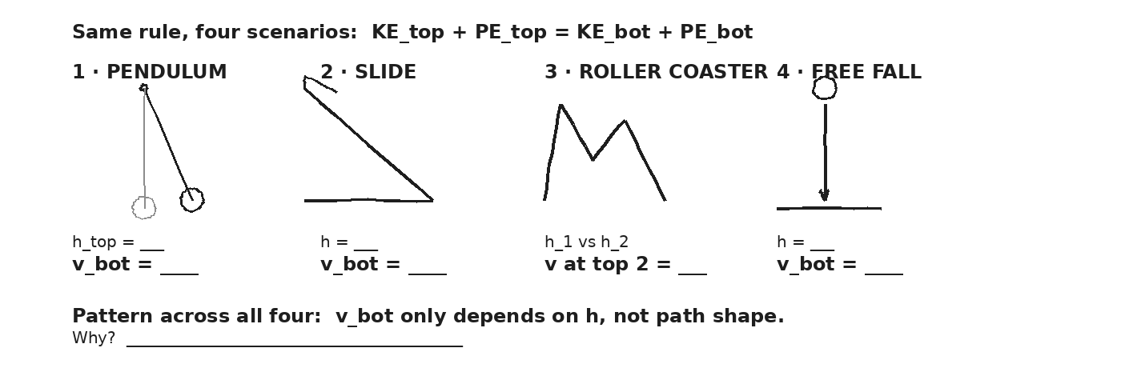

WORKED EXAMPLE — sled down a hill
A 50-kg sled starts at rest at the top of a 12-m hill. Friction-free. Find the speed at the bottom.
GIVEN | m = 50 kg · v_top = 0 · h = 12 m · g = 9.81
EQUATION | m·g·h = ½·m·v² (m cancels)
WORK | 9.81 · 12 = ½ · v²  v² = 235.4  v ≈ 15.3 m/s
ANSWER | ≈ 15.3 m/s — same number for any sled mass.

STATION ROTATION — pendulum / coaster / slide / drop
At each station, identify the HIGH-PE point and LOW-PE point. Set ME_high = ME_low. Solve for the unknown.
STATIONS — fill in as you rotate
STATION 1 — PENDULUM: released from h = 0.6 m above the bottom. v at the bottom = __________ m/s
STATION 2 — SLIDE: ramp height 2.0 m, length 5 m, frictionless. v at bottom = __________ m/s
STATION 3 — ROLLER COASTER: starts from rest at h_1 = 30 m, then rides to top of next hill at h_2 = 18 m. v at top of h_2 = __________ m/s
STATION 4 — FREE FALL: 10-kg rock dropped from 7 m. v at impact = __________ m/s
★ | Across all four: the answer depends ONLY on the HEIGHT difference. Path shape doesn't matter. That's the magic of conservative forces.

Fill in the frame:
Across all four stations, v at the bottom depended only on ________________________________________________________ — not on the ________________________________________________________. That's why we say gravity is ________________________________________________________.
EXIT TICKET — Day 11
A 0.3-kg pendulum bob is released from 0.6 m above its lowest point (friction-free). What's its speed at the bottom?

Today's Targets — Rate Yourself
1 = Not Yet (I can't do this without help) 2 = Almost (I can do this with some help or some errors) 3 = Got It (I can do this independently and explain it)
Help? Check the box if you want to talk with me about this target — even if you marked yourself a 3.
Target | 1 | 2 | 3 | Help?
I can identify high-PE and low-PE points in any scenario. | ○ | ○ | ○ | ☐
I can solve for v using ME conservation. | ○ | ○ | ○ | ☐
I can explain why path shape doesn't matter. | ○ | ○ | ○ | ☐

Day 12 — Roller Coaster + Pendulum

Today's Target
I can solve a multi-hill roller-coaster problem using ME conservation and find a pendulum's speed at the bottom from its release angle.
ASTEROID THREAD
What we know about 2026-XJ today: 2026-XJ in an elliptical orbit IS a roller coaster — KE and PE trade off periodically. Faster at perihelion (low U), slower at aphelion (high U).
How today connects: Same equation, different scale. The bookkeeping is identical.

VOCAB · PENDULUM HEIGHT FORMULA
Definition: For a pendulum of length L released from angle θ, the bob's height above its lowest point is h = L − L·cos θ = L(1 − cos θ).
Example: A 1-m pendulum released at 60° above vertical: h = 1·(1 − cos60°) = 1·(1 − 0.5) = 0.5 m.
Cognates: Sp. altura de péndulo · Pt. altura do pêndulo
Watch out: Don't use the string length L as the height. Use L(1 − cosθ).

DOODLE ZONE
Coaster: find v at top of hill 2 (starts from rest at top of hill 1, h_1 = 30, h_2 = 18). Pendulum: find h and v_bottom for the 60° release.
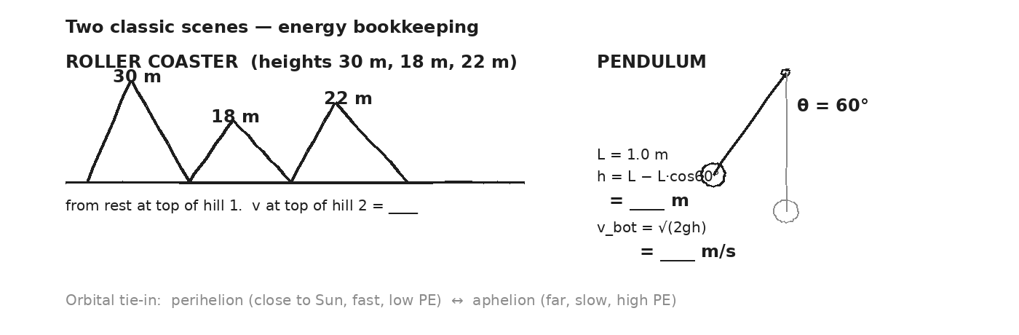

WORKED EXAMPLE — three-hill roller coaster
A coaster cart starts from rest at the top of hill 1 (h_1 = 30 m). Frictionless. Find its speed at the top of hill 2 (h_2 = 18 m) and hill 3 (h_3 = 22 m).
GIVEN | v_1 = 0 · h_1 = 30 m · h_2 = 18 m · h_3 = 22 m
EQUATION | ME_1 = ME_2 = ME_3 → ½v² + gh = ½v_1² + gh_1 = gh_1
WORK | At hill 2: v_2² = 2g(h_1 − h_2) = 2·9.81·12 = 235.4  v_2 ≈ 15.3 m/s  At hill 3: v_3² = 2g(h_1 − h_3) = 2·9.81·8 = 157  v_3 ≈ 12.5 m/s
ANSWER | v_2 ≈ 15.3 m/s, v_3 ≈ 12.5 m/s. Higher hill → slower cart.

WORKED EXAMPLE — pendulum released at 60°
A 1-kg pendulum bob on a 1-m string is released from θ = 60° above vertical. Find the bob's speed at the bottom of its swing.
GIVEN | m = 1 kg · L = 1 m · θ = 60° · friction-free
EQUATION | h = L(1 − cosθ) AND mgh = ½mv²
WORK | h = 1·(1 − cos60°) = 1·(1 − 0.5) = 0.5 m  v = √(2gh) = √(2·9.81·0.5) = √9.81  v ≈ 3.13 m/s
ANSWER | ≈ 3.13 m/s at the bottom of the swing.

YOUR TURN — coaster bottom from 40 m
A coaster cart starts from rest at the top of a 40-m hill. Frictionless. What's its speed at the bottom?
GIVEN
EQUATION
WORK
ANSWER

★ | An asteroid in elliptical orbit: KE and PE trade. Faster near the Sun, slower far away. Same physics as a roller coaster — just on cosmic scale.

Fill in the frame:
A pendulum at angle θ has height h = ________________________________________________________ above its lowest point. The bottom speed is v = ________________________________________________________ .
EXIT TICKET — Day 12
A coaster cart starts from rest at the top of a 40-m hill. What's its speed at the bottom?

Today's Targets — Rate Yourself
1 = Not Yet (I can't do this without help) 2 = Almost (I can do this with some help or some errors) 3 = Got It (I can do this independently and explain it)
Help? Check the box if you want to talk with me about this target — even if you marked yourself a 3.
Target | 1 | 2 | 3 | Help?
I can solve a multi-hill coaster using ME conservation. | ○ | ○ | ○ | ☐
I can find pendulum speed at the bottom from release angle. | ○ | ○ | ○ | ☐
I can connect orbital motion (perihelion/aphelion) to coaster physics. | ○ | ○ | ○ | ☐

Day 13 — Vernier Ramp Lab — PE → KE · Investigation 4.2

Today's Target
I can release a cart from a measured height, predict v at the bottom from mgh = ½mv², measure v with a photogate, and confirm ME conservation across 3 trials.
ASTEROID THREAD
What we know about 2026-XJ today: ME conservation is the rule we'll use Day 19 to convert asteroid PE to impact KE.
How today connects: Today we confirm the rule. If our cart's measured v matches the predicted v, the Day 19 yield calculation rests on solid ground.

LAB SETUP — INVESTIGATION 4.2
Driving question: Does v at the bottom of an incline (predicted from mgh = ½mv²) match the photogate's measured v, across 3 release heights? Can we recover g from a plot of v² vs. h?
Equipment:
- Vernier dynamics track + cart + tilt apparatus
- Photogate + LabQuest + Logger Pro
- Meter stick + protractor (or pre-measured incline angle)
- Balance for cart mass
What you do:
1. Set incline at ~15°. Measure incline angle and length.
2. Release cart from h = 10 cm (above photogate). Record measured v.
3. Compute predicted v = √(2gh). Compare to measured. Compute % difference.
4. Repeat at h = 20 cm. Then h = 30 cm. Three trials total.
5. Plot v_measured² vs. h. Slope should be 2g — does it match?
────────────────────────────────────────────────────────────
Safety: Hands clear of cart at the bottom. Catch the cart. Photogate clamped firmly.
How this lab serves the year's question: If our lab confirms PE → KE at small scale, we trust it at asteroid scale on Day 19.
DOODLE ZONE
Sketch your incline + photogate. Record h_1, h_2, h_3 as you run trials.
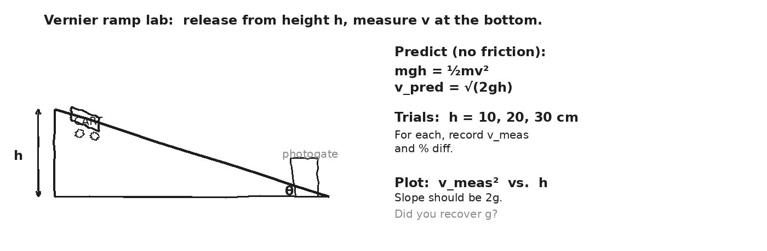

DATA — three release heights
Trial | h (m) | v_pred (m/s) | v_meas (m/s) | % diff | v_meas² (m²/s²) | Notes
1
2
3
OBSERVATION & ANALYSIS
Did v_predicted match v_measured? Within what %? Was the gap larger or smaller at higher h?

If you plotted v_meas² vs. h, what was the slope? Did 2g ≈ 19.6 match?
My trials confirmed mgh = ½mv² within __________ %. The biggest source of error was __________. From my slope, I estimated g ≈ __________ m/s².
Asteroid connection: how does this serve the year's question?

Fill in the frame:
If ME is conserved, v² should be proportional to h with slope 2g. My slope was ________________________________________________________, implying g ≈ ________________________________________________________. Compared to 9.81, my measurement was ________________________________________________________.
EXIT TICKET — Day 13
Write a CLAIM about what your lab showed, then EVIDENCE (your slope or one % diff), then REASONING (why the slope is approximately 2g).

Today's Targets — Rate Yourself
1 = Not Yet (I can't do this without help) 2 = Almost (I can do this with some help or some errors) 3 = Got It (I can do this independently and explain it)
Help? Check the box if you want to talk with me about this target — even if you marked yourself a 3.
Target | 1 | 2 | 3 | Help?
I can set up a ramp lab with photogate. | ○ | ○ | ○ | ☐
I can compute predicted v from mgh = ½mv². | ○ | ○ | ○ | ☐
I can compute % difference and infer g from a v² vs. h plot. | ○ | ○ | ○ | ☐

Day 14 — Hooke's Law: F_spring = −k · x

Today's Target
I can write F_spring = −kx, compute the spring constant k from a measured stretch + load, and predict the force at any other displacement.
ASTEROID THREAD
What we know about 2026-XJ today: Springs are the textbook template for ELASTIC restoring forces.
How today connects: Spring physics shows up in crumple zones (Unit 3 callback), in atomic bonds, and in any system that wants to return to equilibrium.

VOCAB · HOOKE'S LAW
Definition: The force a spring exerts is proportional to its displacement from equilibrium, in the OPPOSITE direction. F_spring = − k · x.
Example: A spring with k = 200 N/m, compressed 0.08 m: F = −200·0.08 = −16 N (force pushes BACK toward equilibrium).
Cognates: Sp. ley de Hooke · Pt. lei de Hooke · HC lwa Hooke
Watch out: The negative sign is a DIRECTION marker — the force always opposes the displacement. Magnitude is k·|x|.

VOCAB · SPRING CONSTANT (K)
Definition: A property of the spring measuring its stiffness. Units: N/m. Bigger k = stiffer spring.
Example: A car suspension spring might have k ≈ 30,000 N/m. A toy slinky might have k ≈ 1 N/m.
Cognates: Sp. constante del resorte · Pt. constante da mola
Watch out: k is a property of the spring, not of the load. Same spring, same k, regardless of how much you stretch it.

DOODLE ZONE
Compute k from case B (1 kg, x = 5 cm). Then PREDICT the force in case C (12 cm). Compare to 2.4·g.
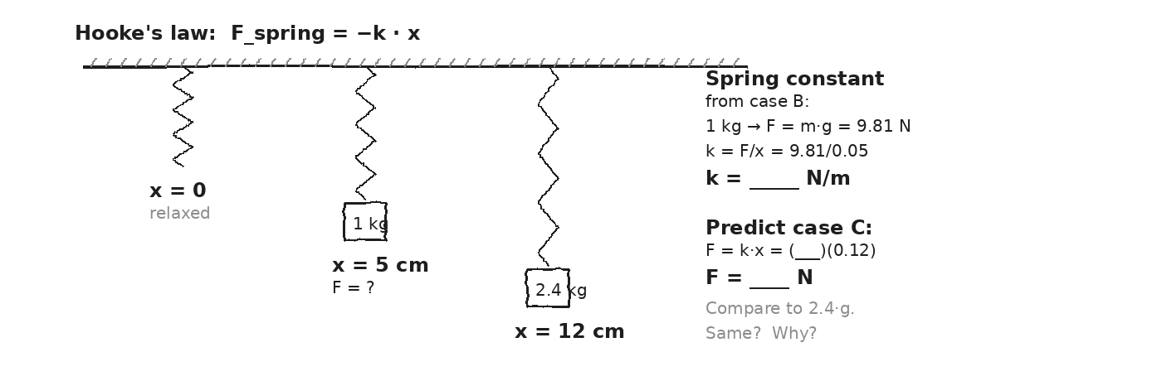

WORKED EXAMPLE — finding k
A spring stretches 5 cm (0.05 m) when a 1-kg mass hangs from it. Find the spring constant. Then: what force does the same spring exert if stretched 12 cm?
GIVEN | m = 1 kg · x_1 = 0.05 m · g = 9.81  Find k. Then F at x_2 = 0.12 m.
EQUATION | In equilibrium: F_spring = m·g → k·x = m·g → k = m·g/x
WORK | k = (1)(9.81) / 0.05 = 196.2 N/m  F at x_2 = k · x_2 = 196.2 · 0.12 = 23.5 N
ANSWER | k ≈ 196 N/m. At 12 cm stretch, F ≈ 23.5 N.

YOUR TURN — spring under compression
A spring with k = 200 N/m is compressed 0.08 m. What force does it exert? Which direction?
GIVEN
EQUATION
WORK
ANSWER

⚠ | Hooke's law is a LINEAR approximation. Real springs deviate from it once you stretch them too far ("elastic limit"). For our problems we stay linear.

Fill in the frame:
Hooke's law says the spring force is PROPORTIONAL to ________________________________________________________ and OPPOSITE to the ________________________________________________________ direction. The proportionality constant is ________________________________________________________.
EXIT TICKET — Day 14
A spring with k = 200 N/m is compressed 0.08 m. What force does it exert?

Today's Targets — Rate Yourself
1 = Not Yet (I can't do this without help) 2 = Almost (I can do this with some help or some errors) 3 = Got It (I can do this independently and explain it)
Help? Check the box if you want to talk with me about this target — even if you marked yourself a 3.
Target | 1 | 2 | 3 | Help?
I can compute k from a measured load and stretch. | ○ | ○ | ○ | ☐
I can predict spring force at any displacement. | ○ | ○ | ○ | ☐
I can identify the direction of the restoring force. | ○ | ○ | ○ | ☐

Day 15 — Spring Potential Energy: U_spring = ½ · k · x²

Today's Target
I can write U_spring = ½kx², compute spring PE for a given compression, and apply ½kx² = ½mv² (or = mgh) to launch problems.
ASTEROID THREAD
What we know about 2026-XJ today: Spring PE and KE have IDENTICAL mathematical structure: both are ½·constant·squared.
How today connects: A spring-launched projectile is a clean model for any device that stores energy and releases it as motion.

VOCAB · SPRING PE
Definition: The energy stored in a compressed or stretched spring: U_spring = ½ · k · x². Always positive.
Example: A spring with k = 500 N/m compressed 0.2 m stores U = ½·500·0.04 = 10 J.
Cognates: Sp. energía potencial elástica · Pt. energia potencial elástica · HC enèji potansyèl resò
Watch out: It's ½kx², not kx². The ½ comes from averaging force as it grows from 0 to kx during compression.

DOODLE ZONE
Compute U stored in the compressed spring. Set = ½mv² and solve for v.
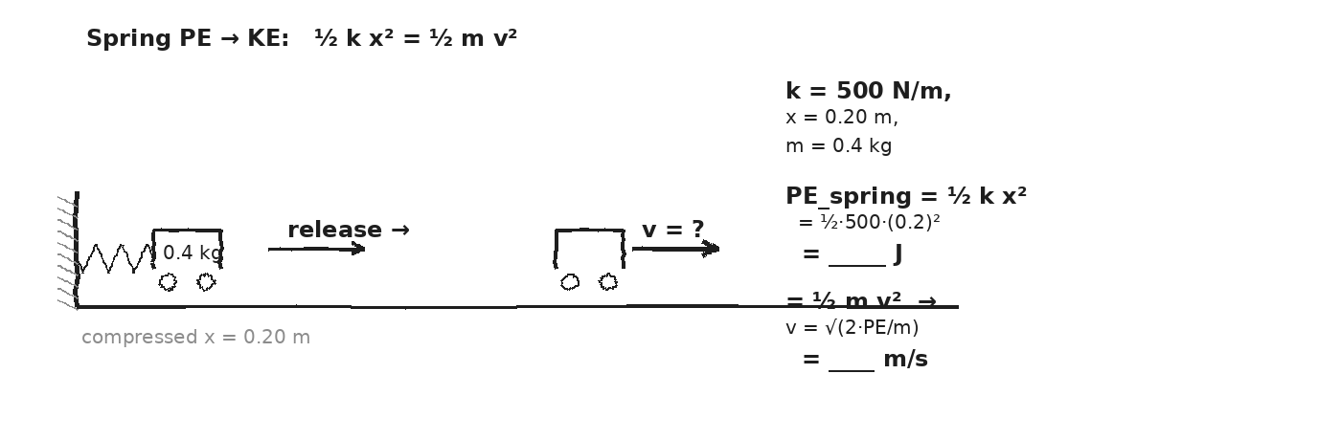

DERIVATION — where ½ comes from
The spring force grows LINEARLY from 0 (at x = 0) to k·x (at compression x).
Work = AVERAGE force × distance. Average force = ½ · (0 + kx) = ½kx.
Therefore: W = ½kx · x = ½ · k · x². That stored work IS the spring PE.
WORKED EXAMPLE — spring launches a cart
A spring (k = 500 N/m) is compressed 0.20 m, then released. A 0.4-kg cart sits against the spring, free to slide on a frictionless track. Find the cart's speed when it leaves the spring.
GIVEN | k = 500 N/m · x = 0.20 m · m = 0.4 kg · horizontal, frictionless
EQUATION | U_spring = ½ · k · x² = KE_cart = ½ · m · v²
WORK | U = ½ · 500 · (0.2)² = ½ · 500 · 0.04 = 10 J  ½ · 0.4 · v² = 10  v² = 50  v ≈ 7.07 m/s
ANSWER | ≈ 7.07 m/s. All 10 J of spring PE became cart KE.

YOUR TURN — vertical launch
A spring with k = 800 N/m is compressed 5 cm (0.05 m). It launches a 0.1-kg ball straight up (friction-free). How high does the ball go?
GIVEN
EQUATION
WORK
ANSWER

★ | ½kx² has the SAME structure as ½mv². Both are ½ · (a property) · (a quantity)². That's not a coincidence — both come from integrating a linearly-growing force.

Fill in the frame:
A spring launches the cart because the spring's ________________________________________________________ is fully converted into the cart's ________________________________________________________. The total energy is conserved.
EXIT TICKET — Day 15
A spring (k = 800 N/m) compressed 5 cm launches a 0.1-kg ball straight up. How high does the ball go (friction-free)?

Today's Targets — Rate Yourself
1 = Not Yet (I can't do this without help) 2 = Almost (I can do this with some help or some errors) 3 = Got It (I can do this independently and explain it)
Help? Check the box if you want to talk with me about this target — even if you marked yourself a 3.
Target | 1 | 2 | 3 | Help?
I can compute U_spring = ½kx². | ○ | ○ | ○ | ☐
I can set ½kx² = ½mv² and solve for v. | ○ | ○ | ○ | ☐
I can set ½kx² = mgh and solve for vertical height. | ○ | ○ | ○ | ☐

Day 16 — Power: P = W / t = F · v

Today's Target
I can compute power as work-per-time, apply P = F·v for instantaneous power, and convert between Watts and horsepower.
ASTEROID THREAD
What we know about 2026-XJ today: Asteroid impact delivers HUGE energy in MICROSECONDS — that's the catastrophic POWER.
How today connects: It's not just the energy. The same energy delivered slowly (a billion years) vs. fast (a millisecond) means lava flow vs. extinction event.

VOCAB · POWER (P)
Definition: The rate of energy transfer. P = W / t. Units: Watts (1 W = 1 J/s).
Example: A 700-N person climbs a 4-m staircase in 5 s. P = (700·4)/5 = 560 W.
Cognates: Sp. potencia · Pt. potência · HC pisans
Watch out: Power is NOT energy. Power is the RATE of energy transfer. Big power = fast transfer.

VOCAB · P = F · V
Definition: An instantaneous form of power: force times the speed of the point of application. Derived from P = W/t = F·d/t = F·v.
Example: A car engine at 75 kW propels the car at 27 m/s. Driving force F = P/v = 75,000/27 ≈ 2,780 N.
Cognates: Sp. potencia instantánea · Pt. potência instantânea
Watch out: Use P = F·v when you know force and speed simultaneously. Use P = W/t when you know work over time.

DOODLE ZONE
Compute W done by the climber. Then divide by 5 s to get power. Compare to a 100-W bulb.
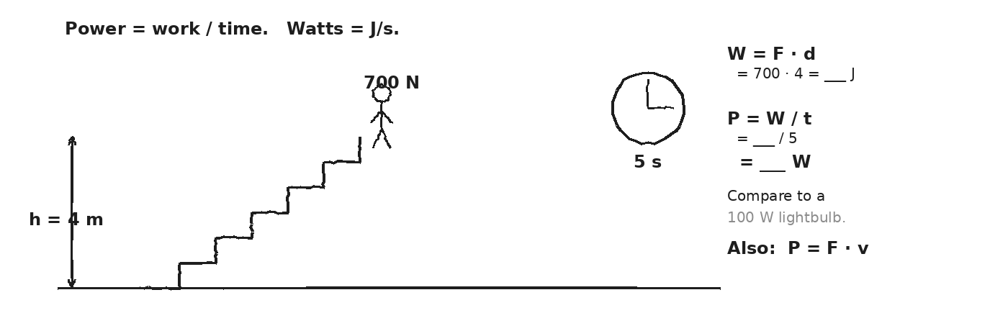

WORKED EXAMPLE — climbing stairs
A 700-N student climbs a 4-m staircase in 5 s. What's their power output?
GIVEN | F = 700 N · d = 4 m · t = 5 s
EQUATION | P = W / t = (F · d) / t
WORK | W = 700 · 4 = 2800 J  P = 2800 / 5 = 560 W
ANSWER | 560 W — about 5.6 light-bulbs of power, briefly.

WORKED EXAMPLE — car engine power
A car engine outputs 100 hp (about 75,000 W) while driving at 27 m/s (≈ 60 mph). What's the driving force?
GIVEN | P = 75,000 W · v = 27 m/s
EQUATION | P = F · v → F = P / v
WORK | F = 75,000 / 27 ≈ 2,780 N
ANSWER | ≈ 2,780 N of driving force — balanced by drag + rolling resistance at steady speed.

YOUR TURN — lift power
A 2-kg ball is lifted 1.5 m in 0.3 s. What power does the lifter generate?
GIVEN
EQUATION
WORK
ANSWER

★ | Asteroid impact: ~10¹⁷ J in ~0.1 s. Power ≈ 10¹⁸ W. The Sun outputs ~4×10²⁶ W. For a tenth of a second, an asteroid impact is a millionth-of-the-Sun bright at the impact site.

Fill in the frame:
Power is the rate of ________________________________________________________ transfer. Two devices can do the same work, but the one with more power does it ________________________________________________________.
EXIT TICKET — Day 16
A 2-kg ball is lifted 1.5 m in 0.3 s. What power did the lifter generate?

Today's Targets — Rate Yourself
1 = Not Yet (I can't do this without help) 2 = Almost (I can do this with some help or some errors) 3 = Got It (I can do this independently and explain it)
Help? Check the box if you want to talk with me about this target — even if you marked yourself a 3.
Target | 1 | 2 | 3 | Help?
I can compute power as P = W/t. | ○ | ○ | ○ | ☐
I can apply P = F·v. | ○ | ○ | ○ | ☐
I can compare powers across human, machine, and natural scales. | ○ | ○ | ○ | ☐

Day 17 — KE in Collisions — Elastic vs. Inelastic

Today's Target
I can compute KE_before and KE_after for an elastic and a perfectly inelastic collision, and explain WHERE the missing KE went.
ASTEROID THREAD
What we know about 2026-XJ today: An asteroid impact is perfectly inelastic. The KE doesn't disappear — it converts to heat, sound, light, mechanical deformation.
How today connects: That's the missing piece: ALL of the asteroid's KE becomes 'damage' in an inelastic event. Day 19 will measure that KE in TNT-equivalents.

VOCAB · KE LOST
Definition: In a perfectly inelastic collision, KE_before > KE_after. The DIFFERENCE = the KE converted to other forms (heat, sound, deformation).
Example: 1-kg ball at 6 m/s hits a 1-kg ball at rest, they stick. KE_before = 18 J. KE_after = 9 J. Lost: 9 J → heat/sound.
Cognates: Sp. energía cinética perdida · Pt. energia cinética perdida
Watch out: "KE was lost" doesn't mean "energy disappeared." Energy is ALWAYS conserved. The KE just transferred to a different form.

DOODLE ZONE
Compute KE_before and KE_after. Subtract. Where did that energy go? (Squiggles!)
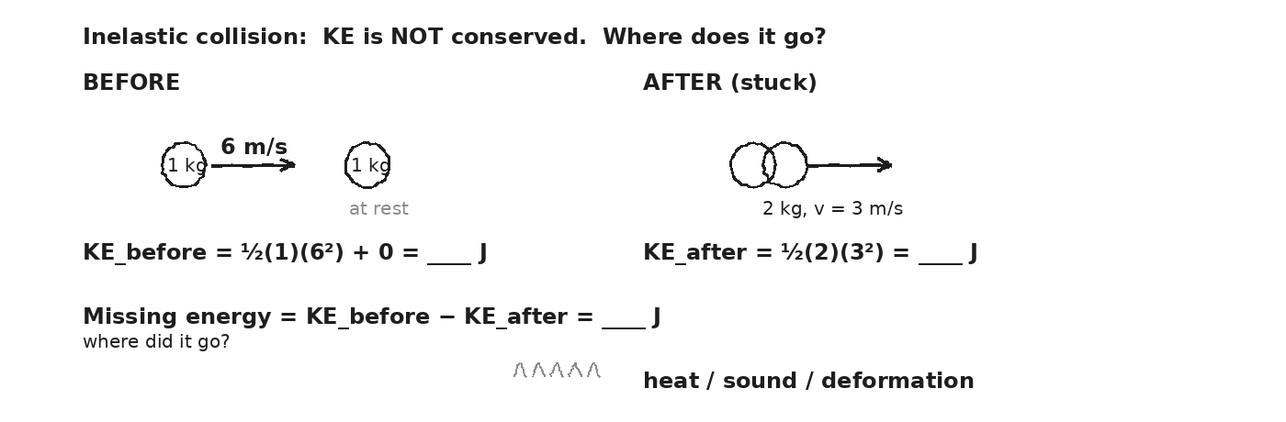

WORKED EXAMPLE — equal-mass perfectly inelastic
A 1-kg ball at 6 m/s east strikes an identical ball at rest. They stick. Find: (a) v_f from momentum conservation, (b) KE_before, (c) KE_after, (d) KE lost.
GIVEN | m_1 = m_2 = 1 kg · v_1i = 6 m/s · v_2i = 0
EQUATION | m_1·v_1 = (m_1+m_2)·v_f ; KE = ½·m·v²
WORK | v_f = (1·6) / (1+1) = 3 m/s  KE_before = ½·1·6² + 0 = 18 J  KE_after = ½·2·3² = 9 J  KE_lost = 18 − 9 = 9 J
ANSWER | Half of the original KE became heat, sound, deformation. The other half stayed as motion.

WORKED EXAMPLE — bullet into block
A 0.05-kg bullet at 400 m/s embeds in a 5-kg block (ballistic pendulum from Unit 3). Find v_f, KE_before, KE_after, KE_lost.
GIVEN | m_1 = 0.05 kg · v_1 = 400 m/s · M = 5 kg · V = 0
EQUATION | m·v = (m+M)·v_f ; KE = ½·m·v²
WORK | v_f = (0.05·400)/(5.05) ≈ 3.96 m/s  KE_before = ½·0.05·400² = 4000 J  KE_after = ½·5.05·3.96² ≈ 39.6 J  KE_lost ≈ 3960 J (over 99% lost!)
ANSWER | Over 99% of the bullet's KE was "lost" — became heat in the wood, deformation, sound.

YOUR TURN — clay onto stationary block
A 0.5-kg ball at 10 m/s strikes a 1.5-kg stationary block; they stick. How much KE was lost?
GIVEN
EQUATION
WORK
ANSWER

⚠ | Momentum is conserved in EVERY collision. KE is only conserved in elastic ones. Don't confuse 'energy lost' with 'momentum lost.' Different rules.

Fill in the frame:
In a perfectly inelastic collision, momentum is ________________________________________________________ but kinetic energy is ________________________________________________________. The missing KE becomes ________________________________________________________.
EXIT TICKET — Day 17
A 0.5-kg ball at 10 m/s strikes a 1.5-kg stationary block; they stick. How much KE was lost?

Today's Targets — Rate Yourself
1 = Not Yet (I can't do this without help) 2 = Almost (I can do this with some help or some errors) 3 = Got It (I can do this independently and explain it)
Help? Check the box if you want to talk with me about this target — even if you marked yourself a 3.
Target | 1 | 2 | 3 | Help?
I can compute KE_before and KE_after for any collision. | ○ | ○ | ○ | ☐
I can quantify the KE lost in a perfectly inelastic collision. | ○ | ○ | ○ | ☐
I can name the destinations of "lost" KE. | ○ | ○ | ○ | ☐

Day 18 — Heat as the Missing Energy · Bridge to Unit 5

Today's Target
I can state that total energy (KE + PE + thermal + ...) is ALWAYS conserved, and identify thermal energy as the destination of "lost" ME from friction or inelastic collisions.
ASTEROID THREAD
What we know about 2026-XJ today: 2026-XJ's impact KE becomes heat — enough to vaporize rock, raise tsunamis, ignite forests.
How today connects: Unit 5 picks up here. Today's bridge: heat is the form that ME usually becomes when it's "lost."

VOCAB · THERMAL (HEAT) ENERGY
Definition: The energy of random molecular motion. When friction or inelastic collisions "remove" ME, that energy goes into raising the temperature of the objects involved.
Example: Rubbing your hands together: 50 N of friction over 0.5 m → 25 J of thermal energy → hands warm.
Cognates: Sp. energía térmica · Pt. energia térmica · HC enèji tèmik
Watch out: Heat is NOT temperature. Heat is the ENERGY that flows; temperature is the AVERAGE motion of molecules.

VOCAB · TOTAL ENERGY CONSERVATION
Definition: The grand principle: SUM of all energy forms (KE + PE + thermal + radiant + sound + chemical + ...) is conserved in any closed system. ALWAYS.
Example: A sled slides down a hill and stops. PE_top = thermal generated by friction. (Plus a tiny bit of sound.)
Cognates: Sp. conservación de energía total · Pt. conservação da energia total
Watch out: ME conservation is a SPECIAL CASE — when no friction. Total energy conservation is the broader rule.

DOODLE ZONE
Compute PE at the top. After sled stops at bottom, all of it became thermal. How much?
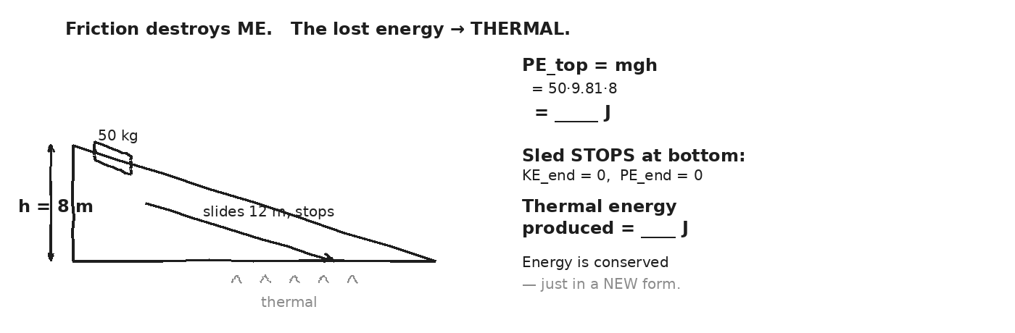

WORKED EXAMPLE — sled slides and stops
A 50-kg sled at the top of a hill (h = 8 m, friction-free start) slides 12 m down a snowy slope and stops at the bottom (friction at the end zone). How much heat was generated?
GIVEN | m = 50 kg · h = 8 m · g = 9.81 · v_top = v_bot = 0
EQUATION | Total energy: PE_top + KE_top = KE_bot + PE_bot + Q_thermal
WORK | 50 · 9.81 · 8 + 0 = 0 + 0 + Q  Q = 50 · 9.81 · 8 ≈ 3924 J
ANSWER | ≈ 3924 J of heat generated. All the starting PE became thermal energy.

YOUR TURN — friction on a hand-rub
You rub your hands together. The friction force averages 50 N, you move them 0.5 m of relative distance, back and forth 10 times. How much heat do you generate? (Hint: total distance = 10 × 0.5 m × 2 each pass.)
GIVEN
EQUATION
WORK
ANSWER

★ | Unit 5 will tell us how MUCH temperature rise a given heat input produces — and that depends on the material. Steel needs much less heat per °C than water.

Fill in the frame:
When a sled slides to a stop, the "missing" energy became ________________________________________________________. Total energy is ________________________________________________________ — just in a different ________________________________________________________.
EXIT TICKET — Day 18
A 50-kg sled slides 12 m down a hill (8 m drop) and stops. How much heat was generated by friction?

Today's Targets — Rate Yourself
1 = Not Yet (I can't do this without help) 2 = Almost (I can do this with some help or some errors) 3 = Got It (I can do this independently and explain it)
Help? Check the box if you want to talk with me about this target — even if you marked yourself a 3.
Target | 1 | 2 | 3 | Help?
I can state total energy conservation. | ○ | ○ | ○ | ☐
I can compute thermal energy generated when an object stops. | ○ | ○ | ○ | ☐
I can connect ME loss to thermal gain. | ○ | ○ | ○ | ☐

Day 19 — Asteroid Impact Yield — 2026-XJ in TNT Equivalents

Today's Target
I can compute 2026-XJ's KE at impact, convert it to TNT-equivalent tons (1 ton TNT = 4.184 × 10⁹ J), and place the result on the Hiroshima / Tunguska / Chicxulub scale.
ASTEROID THREAD
What we know about 2026-XJ today: Today the entire unit cashes out. We have all the tools: KE = ½mv², the asteroid's mass, its impact velocity from Unit 2.
How today connects: Today's number IS the answer to the impact-branch question from UPDATE 4. After today, the question 'how bad is 2026-XJ?' has a real answer in the same units NASA uses for everything else.

VOCAB · TNT YIELD
Definition: The standard unit for comparing energetic events. 1 ton TNT = 4.184 × 10⁹ J. Used for bombs, asteroids, earthquakes.
Example: Hiroshima ≈ 15 kilotons = 1.5×10⁴ tons. Chicxulub ≈ 100 million megatons = 10¹⁴ tons.
Cognates: Sp. equivalente en TNT · Pt. equivalente em TNT
Watch out: "TNT-equivalent" means "this much energy, expressed in the units of how-much-TNT-it-would-take." The actual asteroid is rock, not TNT.

DOODLE ZONE
Compute 2026-XJ's yield in tons. Mark its bar on the log scale. Where does it fall? Closer to Hiroshima? Tunguska? Or much higher?
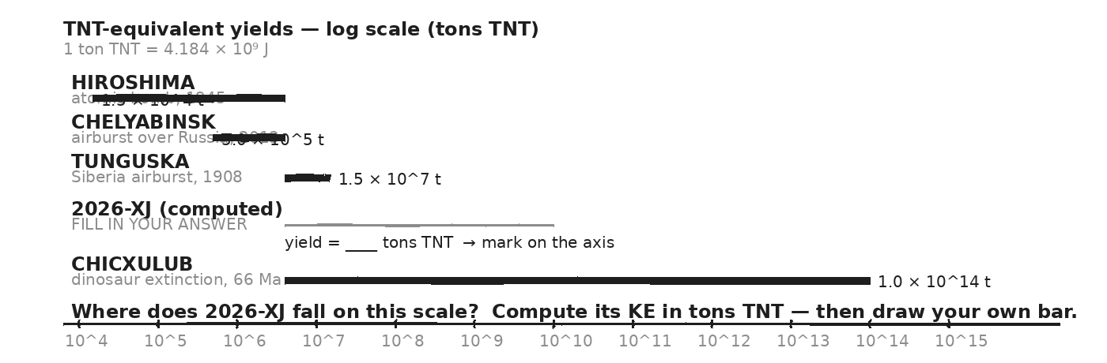

THE BIG COMPUTATION — STEP 1: KE at impact
2026-XJ: m = 1 × 10⁹ kg, impact velocity v = 3 × 10⁴ m/s. Compute its kinetic energy at impact.
GIVEN | m = 1 × 10⁹ kg · v = 3 × 10⁴ m/s
EQUATION | KE = ½ · m · v²
WORK | KE = ½ · (1 × 10⁹) · (3 × 10⁴)²  KE = ½ · (1 × 10⁹) · (9 × 10⁸)  KE = ½ · 9 × 10¹⁷  KE = 4.5 × 10¹⁷ J
ANSWER | ≈ 4.5 × 10¹⁷ Joules of kinetic energy at impact.

STEP 2: convert to TNT-equivalent tons
Convert your KE to TNT-equivalent tons. 1 ton TNT = 4.184 × 10⁹ J.
GIVEN | KE = 4.5 × 10¹⁷ J · 1 ton TNT = 4.184 × 10⁹ J
EQUATION | yield (tons) = KE / (4.184 × 10⁹)
WORK | yield = (4.5 × 10¹⁷) / (4.184 × 10⁹)  yield ≈ 1.075 × 10⁸ tons TNT  yield ≈ 108 million tons TNT  yield ≈ 108 MEGATONS
ANSWER | ≈ 1.08 × 10⁸ tons TNT ≈ 108 megatons. (Roughly 7000 Hiroshimas.)

STEP 3: place 2026-XJ on the comparison scale
WHERE DOES 2026-XJ FALL? (your answer in context)
• Hiroshima 1.5 × 10⁴ t atomic bomb, 1945 · destroyed a city
• Chelyabinsk 5 × 10⁵ t Russia airburst, 2013 · broke windows 100 km out
• Tunguska 1.5 × 10⁷ t Siberia airburst, 1908 · flattened 2,000 km² of forest
► 2026-XJ (you) ≈ 10⁸ t your answer · a regional-to-continental event
• Chicxulub 1 × 10¹⁴ t 66 Ma · killed the dinosaurs
⚠ | The asteroid is fictional. The math is real. NASA's Planetary Defense Coordination Office does exactly this kind of yield calculation for every newly-discovered Near-Earth Object.

DISCUSSION — what does ≈10⁸ tons MEAN physically?
DAMAGE SCALE — match to your computed yield
• 10⁴-10⁵ tons: city-block destruction (Hiroshima-class)
• 10⁶-10⁷ tons: regional flattening (Tunguska-class — 2,000 km²)
• 10⁸-10⁹ tons: multi-continent thermal pulse + months-long climate dimming
• 10¹⁰-10¹² tons: mass-extinction event begins (smaller K-Pg analog)
• 10¹³-10¹⁴ tons: Chicxulub — 75% of species extinct, dinosaurs gone
Fill in the frame:
2026-XJ would deliver about ________________________________________________________ tons of TNT-equivalent energy. That's roughly ________________________________________________________ Hiroshimas, and would correspond to ________________________________________________________ -scale damage.
EXIT TICKET — Day 19
Write one sentence stating 2026-XJ's TNT-equivalent yield. Then one sentence comparing it to a historical event. Then one sentence about what that means physically.

Today's Targets — Rate Yourself
1 = Not Yet (I can't do this without help) 2 = Almost (I can do this with some help or some errors) 3 = Got It (I can do this independently and explain it)
Help? Check the box if you want to talk with me about this target — even if you marked yourself a 3.
Target | 1 | 2 | 3 | Help?
I can compute the asteroid's KE at impact. | ○ | ○ | ○ | ☐
I can convert KE to TNT-equivalent tons. | ○ | ○ | ○ | ☐
I can place the asteroid on the historical-event scale. | ○ | ○ | ○ | ☐
I can describe in plain language what the yield means physically. | ○ | ○ | ○ | ☐

Day 20 — Escape Velocity: v_esc = √(2·G·M / r)

Today's Target
I can derive v_esc from KE = |U|, compute Earth's escape velocity, and compare it to other bodies (Moon, Mars).
ASTEROID THREAD
What we know about 2026-XJ today: If 2026-XJ had been moving FASTER than the local escape velocity, it could have slipped past Earth (or the Sun) and never come back.
How today connects: Same energy framework as the impact yield — but instead of asking 'how much PE did the asteroid gain falling in,' we ask 'how much KE does it need to climb back out.'

VOCAB · ESCAPE VELOCITY
Definition: The minimum speed at distance r from a body of mass M such that the object can reach infinity with KE ≥ 0. v_esc = √(2GM/r).
Example: Earth's surface escape velocity: ≈ 11.2 km/s (≈ 25,000 mph). Moon's: ≈ 2.4 km/s.
Cognates: Sp. velocidad de escape · Pt. velocidade de escape · HC vitès chape
Watch out: Escape velocity doesn't depend on the escaping object's mass. m cancels out.

DOODLE ZONE
Derive v_esc by setting ½mv² = G·M·m/r (kinetic energy = magnitude of PE at surface). Solve for v_esc.
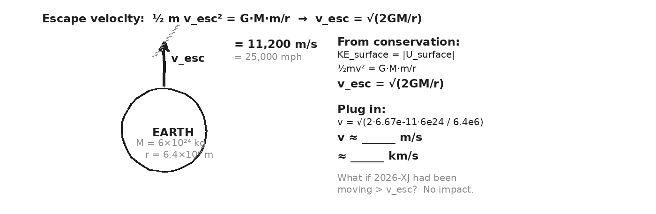

DERIVATION — where v_esc comes from
Setup: object at surface (r), mass m, given some launch speed v. At infinity, we want the object to JUST barely have KE_∞ = 0 (any extra is wasted).
Conservation of total energy: KE_surface + U_surface = KE_∞ + U_∞
½·m·v_esc² + (− G·M·m/r) = 0 + 0
½·v_esc² = G·M/r → v_esc = √(2·G·M/r)
Mass m cancels. Escape velocity is a property of the BODY, not the escapee.
WORKED EXAMPLE — Earth's escape velocity
Compute v_esc at Earth's surface.
GIVEN | G = 6.67 × 10⁻¹¹ · M = 5.97 × 10²⁴ kg · r = 6.37 × 10⁶ m
EQUATION | v_esc = √(2 · G · M / r)
WORK | v_esc = √(2 · 6.67e-11 · 5.97e24 / 6.37e6)  = √(2 · 6.67e-11 · 9.37 × 10¹⁷)  = √(1.25 × 10⁸)  ≈ 1.12 × 10⁴ m/s ≈ 11.2 km/s
ANSWER | ≈ 11.2 km/s ≈ 25,000 mph. Any slower → eventually falls back to Earth.

YOUR TURN — Mars escape velocity
Compute v_esc at Mars's surface. M_Mars = 6.4×10²³ kg, r_Mars = 3.39×10⁶ m.
GIVEN
EQUATION
WORK
ANSWER

YOUR TURN — Moon escape velocity
Compute v_esc at the Moon's surface. M_Moon = 7.35×10²² kg, r_Moon = 1.74×10⁶ m. (This explains why Apollo astronauts could leave the Moon with a small ascent stage.)
GIVEN
EQUATION
WORK
ANSWER

★ | Small bodies (Moon, Pluto, asteroids) have LOW escape velocities. That's why they don't hold atmospheres — gas molecules at typical room temperatures easily exceed v_esc and drift away.

Fill in the frame:
Earth holds an atmosphere because the speed of a typical air molecule at room temperature is ________________________________________________________ Earth's escape velocity. The Moon doesn't because its v_esc is ________________________________________________________.
EXIT TICKET — Day 20
Compute v_esc on Mars. M_Mars = 6.4×10²³ kg, r_Mars = 3.39×10⁶ m.

Today's Targets — Rate Yourself
1 = Not Yet (I can't do this without help) 2 = Almost (I can do this with some help or some errors) 3 = Got It (I can do this independently and explain it)
Help? Check the box if you want to talk with me about this target — even if you marked yourself a 3.
Target | 1 | 2 | 3 | Help?
I can derive v_esc = √(2GM/r) from conservation. | ○ | ○ | ○ | ☐
I can compute v_esc for Earth, Moon, Mars. | ○ | ○ | ○ | ☐
I can explain why small bodies don't hold atmospheres. | ○ | ○ | ○ | ☐

Day 21 — Three-Branch Energy Budget — Impact / Deflection / Escape

Today's Target
I can run a complete 2026-XJ energy analysis on all three branches (impact yield, deflection feasibility, escape) and articulate which TWO unit ideas were load-bearing.
ASTEROID THREAD
What we know about 2026-XJ today: We have every tool: KE, PE (local + universal), conservation, springs, power, TNT yield, escape velocity.
How today connects: Today is the rehearsal for Day 22's transfer task. Done in groups, compiled as a class, written down in your packet.

DOODLE ZONE
Fill in each branch's TOOLS and ANSWER box. Then circle ONE tool that shows up in TWO branches.
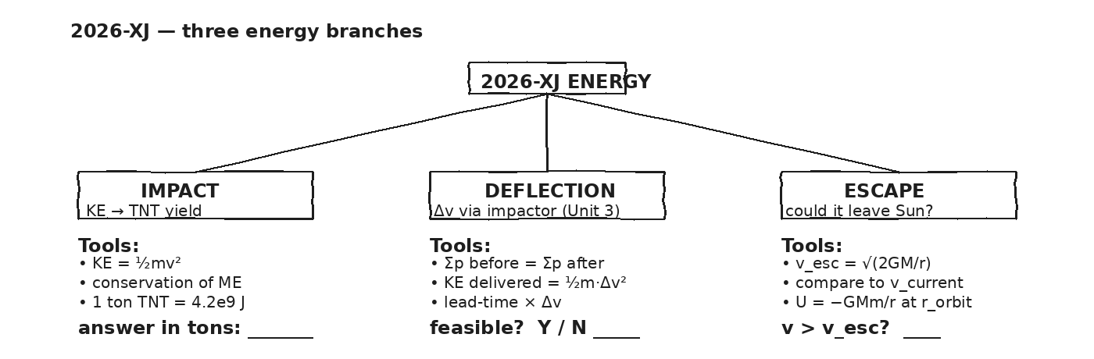

STATION 1 — IMPACT YIELD (revisit Day 19)
Given: 2026-XJ has m = 1×10⁹ kg, impact velocity v = 3×10⁴ m/s. (a) Compute KE at impact. (b) Convert to TNT-equivalent tons. (c) Identify it on the Hiroshima/Tunguska/Chicxulub scale.
GIVEN
EQUATION
WORK
ANSWER

STATION 2 — DEFLECTION ENERGY (revisit Unit 3 DART)
Given: Unit 3 said a single DART-class impactor (600 kg at 6 km/s) delivers about Δv ≈ 7 × 10⁻⁴ m/s to a 5×10⁹ kg asteroid. (a) Compute the KE of a single DART spacecraft at launch. (b) That energy translated into Δv on the asteroid — what KE does the asteroid GAIN in its new (slightly faster) state? (Hint: ΔKE_asteroid ≈ M · v · Δv, where v is asteroid's prior speed.) (c) Comment on whether this is energy-feasible.
GIVEN
EQUATION
WORK
ANSWER

STATION 3 — ESCAPE FROM THE SUN
Given: 2026-XJ currently orbits the Sun at v ≈ 3×10⁴ m/s (comparable to Earth). Escape velocity from the Sun at Earth's orbital distance (r = 1.5×10¹¹ m) is v_esc ≈ √(2·G·M_Sun/r), with M_Sun = 2×10³⁰ kg. (a) Compute v_esc. (b) Compare to 2026-XJ's current speed. (c) Could 2026-XJ escape the solar system at its current speed?
GIVEN
EQUATION
WORK
ANSWER

CLASS CONSENSUS — what's our energy report?
Compile across groups. Write two sentences: one about the impact yield, one about whether deflection AND escape are feasible.
OUR CLASS CONSENSUS — 2026-XJ ENERGY BUDGET
★ | Real planetary defense reports include all three branches. Your numbers are within an order of magnitude of NASA's actual analyses.

Fill in the frame:
Of all the ideas from Unit 4, the TWO most load-bearing for today's analysis were ________________________________________________________ (used in impact) and ________________________________________________________ (used in deflection/escape). Both rest on conservation of ________________________________________________________.
EXIT TICKET — Day 21
Of all the things you learned in Unit 4, which TWO ideas were MOST load-bearing for the three-branch analysis? Why?

Today's Targets — Rate Yourself
1 = Not Yet (I can't do this without help) 2 = Almost (I can do this with some help or some errors) 3 = Got It (I can do this independently and explain it)
Help? Check the box if you want to talk with me about this target — even if you marked yourself a 3.
Target | 1 | 2 | 3 | Help?
I can run the impact-yield branch start to finish. | ○ | ○ | ○ | ☐
I can run the deflection-energy branch start to finish. | ○ | ○ | ○ | ☐
I can run the escape-velocity branch start to finish. | ○ | ○ | ○ | ☐
I can articulate which two ideas tied the unit together. | ○ | ○ | ○ | ☐

Day 22 — Unit 4 Transfer Task — Assessment Day

ASTEROID THREAD
What we know about 2026-XJ today: Every tool from Unit 4 is in your hands: W = Fd (and W = Fd cosθ), KE, U (mgh and -GMm/r), conservation, springs, power, TNT yield, escape velocity.
How today connects: One of the 5 transfer problems is the asteroid yield problem. Another is escape velocity from a body you've never seen. The rest test technique.

TRANSFER TASK — UNIT 4 · DAY 22
Today you receive the Unit 4 Transfer Task on a separate sheet. It is 5 multi-part problems. You will work independently for ~40 minutes.
• Problem 1 — Work + work-energy theorem. A braking car: given m, v_i, braking force, find the stopping distance using W_net = ΔKE.
• Problem 2 — Conservation of ME. A roller coaster: given heights and a starting speed, find the speed at multiple points. Account for friction in one part.
• Problem 3 — Spring-launched projectile. Given spring constant + compression + launch angle, use ½kx² → KE + (mgh as needed) to find launch speed and max height.
• Problem 4 — Power. An elevator lifting a known mass at a given rate. Compute power required.
• Problem 5 — Asteroid impact yield IN TONS TNT + escape velocity from an unfamiliar body. Asteroid mass + impact speed given; convert KE to TNT tons and place on the scale. Then: compute v_esc for a body with given M and r.
HOW THIS WILL BE SCORED — 4 DIMENSIONS, EACH 0–4
Dimension | What a strong (3–4) response shows
Science | Correct physics: vectors, kinematics, units.
Reasoning | Sound method; uncertainty explained, not just stated.
Communication | Work shown, units labeled, organized, readable.
Transfer-to-Asteroid | Honest public-facing connection to 2026-XJ.
MY WORK — DAY 22
AFTER THE TASK — FINAL UNIT MARZANO (rate each Unit 4 target)
Today's Targets — Rate Yourself
1 = Not Yet (I can't do this without help) 2 = Almost (I can do this with some help or some errors) 3 = Got It (I can do this independently and explain it)
Help? Check the box if you want to talk with me about this target — even if you marked yourself a 3.
Target | 1 | 2 | 3 | Help?
K1 — Work as energy transfer · W = F·d and W = F·d·cosθ. | ○ | ○ | ○ | ☐
K2 — Kinetic energy KE = ½mv². | ○ | ○ | ○ | ☐
K3 — Gravitational PE · mgh (local) and −GMm/r (universal). | ○ | ○ | ○ | ☐
K4 — Work-energy theorem W_net = ΔKE. | ○ | ○ | ○ | ☐
K5 — Conservation of mechanical energy. | ○ | ○ | ○ | ☐
K6 — Power P = W/t = F·v. | ○ | ○ | ○ | ☐
K7 — Hooke's law and spring PE ½kx². | ○ | ○ | ○ | ☐
K8 — Thermal energy as the destination of "lost" ME. | ○ | ○ | ○ | ☐
S1 — Compute work in 1D and at angles. | ○ | ○ | ○ | ☐
S2 — Compute KE for any mass and speed. | ○ | ○ | ○ | ☐
S3 — Compute PE near surface and universal. | ○ | ○ | ○ | ☐
S4 — Apply W_net = ΔKE. | ○ | ○ | ○ | ☐
S5 — Apply ME conservation across scenarios. | ○ | ○ | ○ | ☐
S6 — Compute power and energy from rates. | ○ | ○ | ○ | ☐
S7 — Apply Hooke's law and spring PE. | ○ | ○ | ○ | ☐
S8 — Compute escape velocity. | ○ | ○ | ○ | ☐
S9 — Vernier energy measurement (KE lab + ramp lab). | ○ | ○ | ○ | ☐
R1 — Reason about sign of work. | ○ | ○ | ○ | ☐
R2 — Track energy transformations through collisions. | ○ | ○ | ○ | ☐
R4 — Apply energy framework to asteroid impact (TNT yield). | ○ | ○ | ○ | ☐
R5 — Reason about escape velocity using energy conservation. | ○ | ○ | ○ | ☐

Equation Reference — Unit 4
Keep this page open while you work. Every equation below is on the MCAS Equation Sheet — you do NOT need to memorize them. You DO need to recognize when each one applies.
Concept | Equation | When to use it
Work (force along motion) | W = F · d | Units: Joules (N·m). For force directly along the direction of motion. Carrying a book level = zero work (force perpendicular to motion).
Work at an angle | W = F · d · cos θ | θ = angle between F and d. θ = 0 → full work. θ = 90° → zero. θ > 90° → negative work (friction).
Kinetic energy | KE = ½ · m · v² | Units: Joules. The squared v is what makes KE non-linear in speed. Double v → 4× KE. The asteroid yield calculation depends on this.
Work-energy theorem | W_net = ΔKE | Net work done on an object equals change in its KE. Skip kinematics — go straight from forces to final speed.
Gravitational PE (near surface) | U = m · g · h | Near Earth's surface (g ≈ 9.81). Reference height matters — only DIFFERENCES in PE are physical.
Gravitational PE (universal) | U = − G · M · m / r | For any altitude. PE = 0 at infinity, negative everywhere closer. Use when h is comparable to Earth's radius (asteroid distances).
Conservation of ME | KE + PE = constant | Holds when only conservative forces act (gravity, springs). Friction breaks this — that energy becomes thermal.
Hooke's law | F_spring = − k · x | Spring force, where k = spring constant (N/m), x = displacement from equilibrium. Negative because force restores toward equilibrium.
Spring PE | U_spring = ½ · k · x² | Energy stored in a compressed/stretched spring. Area under F-vs-x curve (triangle, ½·base·height).
Power | P = W / t = F · v | Rate of energy transfer. Units: Watts (J/s). 1 hp ≈ 746 W. Instantaneous form: P = F·v.
Escape velocity | v_esc = √(2 · G · M / r) | Speed needed at distance r from a body of mass M to escape its gravity well (reach infinity with v ≥ 0). Earth: ≈11.2 km/s.
TNT-equivalent conversion | 1 ton TNT = 4.184 × 10⁹ J | Divide an event's KE in Joules by this to get its TNT yield in tons. The unit Hiroshima, Tunguska, Chicxulub are reported in.
Constants and reference quantities:
G = 6.67 × 10⁻¹¹ N·m²/kg² · M_Earth = 5.97 × 10²⁴ kg · R_Earth = 6.37 × 10⁶ m (6,371 km) · g_surface ≈ 9.81 m/s² · 1 ton TNT = 4.184 × 10⁹ J · 1 hp ≈ 746 W · 2026-XJ: m ≈ 10⁹ kg, v_impact ≈ 3 × 10⁴ m/s
TNT-EQUIVALENT YIELDS — for comparison on Day 19
Event | TNT-equivalent yield | Context
Hiroshima | 1.5 × 10⁴ tons (15 kilotons) | Atomic bomb, August 1945. Destroyed a city.
Chelyabinsk | 5 × 10⁵ tons (0.5 megaton) | Russia, 2013. Airburst. Shattered windows for 100+ km.
Tunguska | 1.5 × 10⁷ tons (15 megatons) | Siberia, 1908. Flattened 2,000 km² of forest.
2026-XJ (compute) | ??? tons (your Day 19 answer) | Your job: place this on the scale.
Chicxulub | 1 × 10¹⁴ tons (100 million Mt) | 66 million years ago. Killed the dinosaurs.
Mastery Growth Chart — Unit 4
Each day, transfer your Marzano 1-2-3 rating onto the chart. Use a different mark or color for each target you track. Unit 4 has the most targets (15+) of any unit so far — track at least your top three.
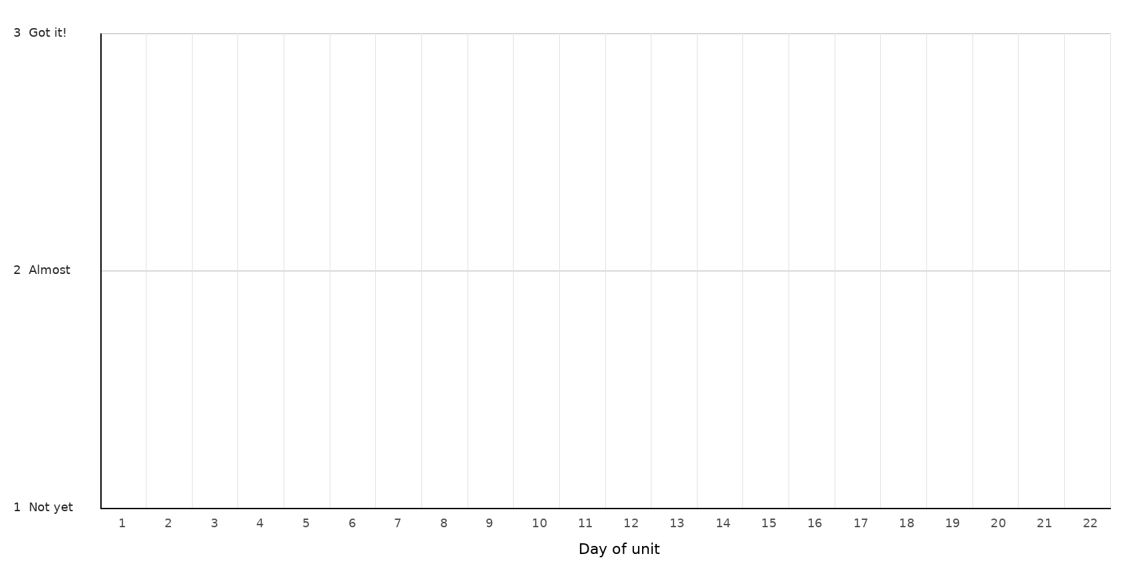
LEGEND — WHICH MARK / COLOR = WHICH TARGET
Mark: ______ Target: __________________________________________________________________
Mark: ______ Target: __________________________________________________________________
Mark: ______ Target: __________________________________________________________________
Mark: ______ Target: __________________________________________________________________
NOTES — END-OF-UNIT REFLECTION

