CPA Physics · Fitchburg High School · 2026–2027
Unit 5 — The Damage Was Mostly HEAT
thermal energy vs. temperature · specific heat · phase changes · first and second laws · heat engines · atmospheric entry · impact thermal damage
◆ NASA / PLANETARY DEFENSE BRIEFING — UPDATE 5
The Unit 4 yield number — 2026-XJ KE ≈ 4.5 × 10¹⁷ J ≈ 108 megatons TNT ≈ "7000 Hiroshimas" — is real, but INCOMPLETE. A shockwave alone doesn't account for the full damage profile. What people remember about asteroid impacts — Tunguska's flattened forest, Chelyabinsk's broken windows — is largely THERMAL. The fireball. The infrared pulse. The atmospheric entry glow that's hot enough to ignite vegetation kilometers away from where the rock lands.
Today there are THREE new pieces of data on our desks:
(1) At 2026-XJ's size, does the atmosphere actually slow it down enough to matter? Most asteroids burn up before they hit. Where's the size threshold?
(2) If it does reach the ground, how does its KE partition into vaporized rock vs. shockwave vs. thermal radiation? Each component has a different damage radius.
(3) Closer to home: the Unit 4 yield calculation assumed a clean energy-to-shockwave conversion. The yield is REAL, but the FRAMEWORK was missing heat. Unit 5 builds it.
The two payoff days are Day 10 (atmospheric entry — the burn-up question) and Day 11 (impact thermal damage — the damage-by-distance map). The Day 12 transfer task asks the burn-up question for a sample pebble-sized rock.
This is fiction. The physics — and the equations — are real.
MA Standards: HS-PS3-1, HS-PS3-2, HS-PS3-3, HS-PS3-4
12 meetings · Fall 2026 (Jan 21 – Feb 6)
Name: ______________________________ Class period: __________ Date received: __________
"Unit 4 gave us the yield. Unit 5 tells us how the yield BURNS."
Table of Contents
Day-type key: A = Anchor · S = Standard · L = Lab · T = Transfer
Section | Type | Page
Cover | — | 1
Table of Contents | — | 2
Phase 1 — Re-anchor + specific heat | —
Day 1 — Heat is energy, but it's NOT temperature | A | 3
Day 2 — Specific heat: Q = m · c · ΔT | S | 6
Phase 2 — Heat transfer + phase changes | —
Day 3 — Three modes: conduction · convection · radiation | S | 9
Day 4 — Phase changes + latent heat: Q = m · L | S | 12
Day 5 — Vernier calorimetry lab | L | 15
Phase 3 — Kinetic theory | —
Day 6 — Temperature is molecular KE | S | 19
Phase 4 — Laws of thermodynamics | —
Day 7 — First law: ΔU = Q − W | S | 22
Day 8 — Second law: heat hot → cold; entropy | S | 25
Day 9 — Heat engines + efficiency | S | 28
Phase 5 — Asteroid payoff + assessment | —
Day 10 — Atmospheric entry: why pebbles burn up | S★ | 31
Day 11 — Impact thermal damage map (centerpiece) | S★ | 34
Day 12 — Unit 5 transfer task | T | 37
Equation Reference Card | — | 40
Mastery Growth Chart | — | 42

Day 1 — Heat is Energy — but it is NOT Temperature

Today's Target
I can distinguish THERMAL ENERGY (total molecular KE), TEMPERATURE (intensive — average per molecule), and HEAT (thermal energy that TRANSFERS) — and explain why a bathtub at 40 °C has MORE thermal energy than a thimble at 100 °C.
ASTEROID THREAD
What we know about 2026-XJ today: From Unit 4: 2026-XJ delivers ~4.5 × 10¹⁷ J ≈ 108 megatons. That's the YIELD. But yield isn't damage — damage is what the energy DOES.
How today connects: The damage MECHANISM is heat. Day 10 explains atmospheric burn-up. Day 11 builds the impact thermal damage map. Today we untangle the words.

NOTICE AND WONDER
Demo: a thimble of boiling water (100 °C) next to a bathtub of warm bathwater (40 °C). Which has MORE thermal energy? Same question for a match flame vs. a campfire. What did you NOTICE? What do you WONDER?
I notice ____________________________
I wonder ____________________________

DOODLE ZONE
Compare A (thimble, 100 °C) and B (bathtub, 40 °C). Which has more thermal energy? Which has higher temperature? Why are these DIFFERENT questions?
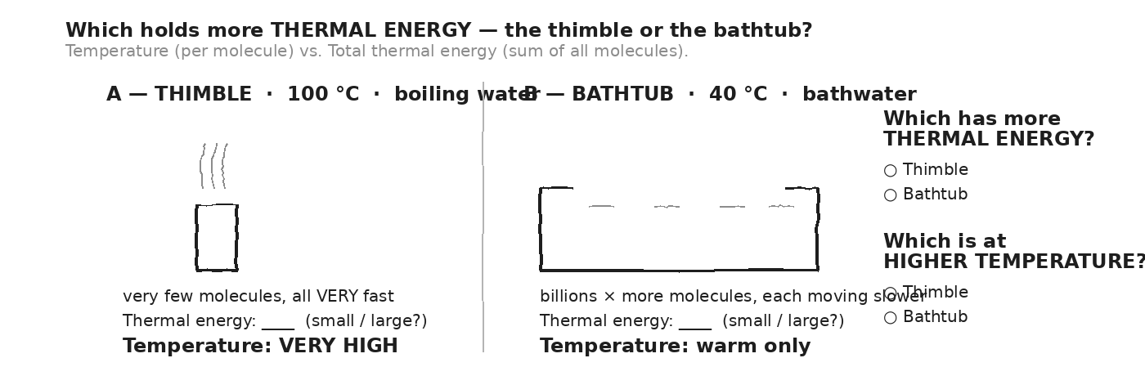

VOCAB · THERMAL ENERGY
Definition: The TOTAL kinetic energy of all the molecules in an object. Extensive — depends on HOW MANY molecules. Units: Joules.
Example: A bathtub of warm water has billions of times more molecules than a thimble of boiling water — so its thermal energy is far larger, even though it's cooler.
Cognates: Sp. energía térmica · Pt. energia térmica · HC enèji tèmik
Watch out: Thermal energy ≠ temperature. A cool ocean has VASTLY more thermal energy than a cup of hot tea.

VOCAB · TEMPERATURE
Definition: The AVERAGE kinetic energy PER molecule. Intensive — doesn't depend on how much stuff. Units: °C or K.
Example: 100 °C boiling water has hotter molecules per piece than 40 °C bathwater — regardless of how much water there is.
Cognates: Sp. temperatura · Pt. temperatura · HC tanperati
Watch out: "Hot" means high temperature (fast molecules). It doesn't say anything about how much total energy is there.

VOCAB · HEAT (Q)
Definition: Thermal energy that is TRANSFERRED from one object to another, because of a temperature difference. Units: Joules. Symbol: Q.
Example: Putting your hand on a cold ice cube — heat (Q) flows from your hand to the ice. The ice warms; your hand cools.
Cognates: Sp. calor · Pt. calor · HC chalè
Watch out: Heat is energy IN TRANSIT. Once it arrives, it's just the receiving object's thermal energy. Don't say "the object has heat" — say "thermal energy."

MY GUESS — which would burn me worse: a teaspoon of boiling water spilled on my hand, or my hand in a bathtub at 40 °C? Why?
★ | Unit 5 has TWO payoff days: Day 10 (atmospheric burn-up — the size threshold) and Day 11 (impact damage map — the unit's centerpiece). Both require Q = mcΔT and Q = mL. We get those tomorrow and Day 4.

EXIT TICKET — Day 1
Which contains MORE THERMAL ENERGY: a cup of hot coffee at 80 °C, or a cold lake at 5 °C? Which is at HIGHER TEMPERATURE? In two sentences, explain why these are different questions.

Today's Targets — Rate Yourself
1 = Not Yet (I can't do this without help) 2 = Almost (I can do this with some help or some errors) 3 = Got It (I can do this independently and explain it)
Help? Check the box if you want to talk with me about this target — even if you marked yourself a 3.
Target | 1 | 2 | 3 | Help?
I can distinguish thermal energy, temperature, and heat. | ○ | ○ | ○ | ☐
I can predict which of two objects has more thermal energy from mass + temperature. | ○ | ○ | ○ | ☐
I can name the two Unit 5 payoff questions (burn-up and impact damage). | ○ | ○ | ○ | ☐

Day 2 — Specific Heat: Q = m · c · ΔT

Today's Target
I can write Q = mcΔT, identify each piece with units, look up c from a table, and solve for any one variable given the other three.
ASTEROID THREAD
What we know about 2026-XJ today: Asteroids are mostly rock (c ≈ 800 J/kg·°C). Oceans are water (c ≈ 4186). Water's c is 5× rock's.
How today connects: When 2026-XJ heats up entering atmosphere, the same energy raises rock temperature 5× more than it would water. That asymmetry sets the atmospheric burn-up threshold on Day 10.

VOCAB · SPECIFIC HEAT (C)
Definition: The energy needed to raise 1 kg of a material by 1 °C. Units: J/kg·°C. Material-specific.
Example: Water: c = 4186 J/kg·°C — to raise 1 kg by 1 °C takes 4186 J. Aluminum: c = 900. Copper: 387.
Cognates: Sp. calor específico · Pt. calor específico · HC chalè espesifik
Watch out: Different materials need different amounts of energy. Water needs the MOST per kg per °C — that's why it heats slowly.

VOCAB · Q = M · C · ΔT
Definition: Heat needed to change a mass m by ΔT, with material specific heat c. Q in J, m in kg, ΔT in °C.
Example: 0.5 kg of water raised by 20 °C: Q = 0.5 · 4186 · 20 = 41,860 J.
Cognates: Sp. ecuación de calor · Pt. equação de calor
Watch out: ΔT can be negative (cooling). Then Q is negative — meaning heat OUT of the object.

DOODLE ZONE
Compare the bars for water, aluminum, rock, copper. If you give each 1000 J, which warms by the LEAST? Why?
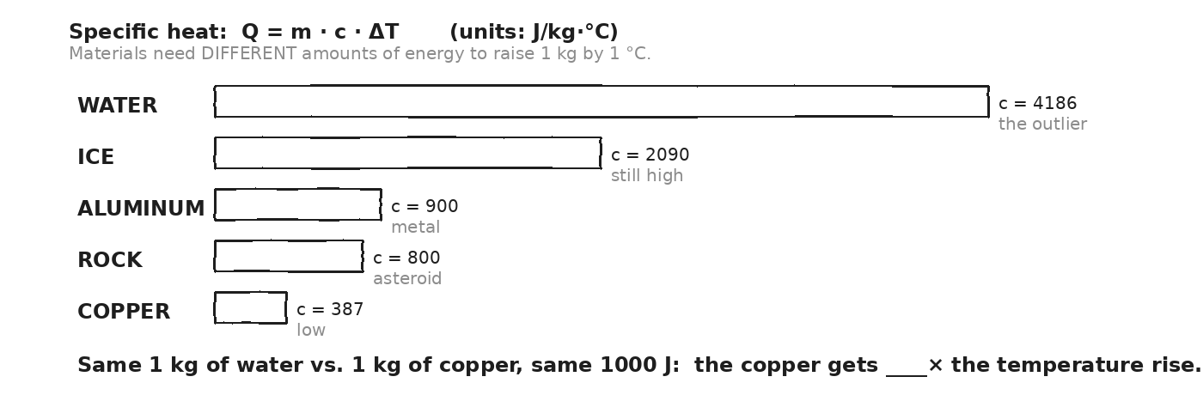

WORKED EXAMPLE — heat 0.5 kg of water by 20 °C
How much heat is required to raise 0.5 kg of water from 20 °C to 40 °C?
GIVEN | m = 0.5 kg · c_water = 4186 J/kg·°C · ΔT = 40 − 20 = 20 °C
EQUATION | Q = m · c · ΔT
WORK | Q = 0.5 · 4186 · 20  Q = 0.5 · 83,720  Q = 41,860 J
ANSWER | ≈ 4.2 × 10⁴ J ≈ 42 kJ to heat 0.5 kg of water by 20 °C.

WORKED EXAMPLE — same energy, different metal
Apply the same 41,860 J of energy to 0.5 kg of aluminum (c = 900). What's the temperature rise?
GIVEN | Q = 41,860 J · m = 0.5 kg · c_Al = 900 J/kg·°C
EQUATION | Q = m · c · ΔT → ΔT = Q / (m · c)
WORK | ΔT = 41,860 / (0.5 · 900)  ΔT = 41,860 / 450  ΔT ≈ 93 °C
ANSWER | ≈ 93 °C — the aluminum heats almost 5× as much as the water did with the same energy.

YOUR TURN — heat 2 kg of copper
How much heat is needed to raise 2 kg of copper from 20 °C to 80 °C? (c_Cu = 387 J/kg·°C.)
GIVEN
EQUATION
WORK
ANSWER

YOUR TURN — solve for c (identify a metal)
A 0.20-kg metal sample receives 1800 J and warms by 50 °C. What's its specific heat? Use the table to identify the metal.
GIVEN
EQUATION
WORK
ANSWER

★ | Water's high c is why beach sand burns your feet but the ocean still feels cool — same sun, but the sand (low c) heats fast while the water (high c) barely budges. It's also why oceans are Earth's thermostat.

Fill in the frame:
Water has a c that is ________________________________________________________ times bigger than rock's. Given the same energy, water heats ________________________________________________________ than rock does. This is why ________________________________________________________.
EXIT TICKET — Day 2
How much heat is needed to raise 2 kg of copper from 20 °C to 80 °C? (c_Cu = 387 J/kg·°C.)

Today's Targets — Rate Yourself
1 = Not Yet (I can't do this without help) 2 = Almost (I can do this with some help or some errors) 3 = Got It (I can do this independently and explain it)
Help? Check the box if you want to talk with me about this target — even if you marked yourself a 3.
Target | 1 | 2 | 3 | Help?
I can apply Q = m·c·ΔT with correct units. | ○ | ○ | ○ | ☐
I can solve for any one unknown given the other three. | ○ | ○ | ○ | ☐
I can explain why water's high c shapes climate and lab procedure. | ○ | ○ | ○ | ☐

Day 3 — Three Modes of Heat Transfer — Conduction · Convection · Radiation

Today's Target
I can distinguish CONDUCTION (direct molecular contact), CONVECTION (fluid currents), and RADIATION (electromagnetic waves), and identify the dominant mode in real scenarios.
ASTEROID THREAD
What we know about 2026-XJ today: During atmospheric entry, the asteroid loses heat by ALL three modes — friction (conduction at its surface), convection (heated air swept around), and radiation (the asteroid GLOWS).
How today connects: Radiation is the one that reaches OBSERVERS — what we see as a meteor's glow. Day 11's damage map uses radiation only to compute the burn radius.

VOCAB · CONDUCTION
Definition: Heat transfer by direct molecular contact. Fast-moving molecules bump slower-moving neighbors and pass energy along. No bulk motion of matter.
Example: A metal spoon in hot soup. The handle warms because molecules at the soup end transfer KE up the spoon.
Cognates: Sp. conducción · Pt. condução · HC kondiksyon
Watch out: Conduction needs DIRECT CONTACT. Metals conduct well; air and styrofoam do not.

VOCAB · CONVECTION
Definition: Heat transfer by FLUID CURRENTS. Warmer (less dense) fluid rises; cooler (denser) fluid sinks. Bulk motion of the fluid carries energy.
Example: Boiling water — hot bubbles rise, cool water replaces them at the bottom. House heating — warm air rises from radiators.
Cognates: Sp. convección · Pt. convecção · HC konveksyon
Watch out: Convection needs a FLUID (liquid or gas). Solids don't convect.

VOCAB · RADIATION (THERMAL)
Definition: Heat transfer by ELECTROMAGNETIC WAVES (especially infrared). No medium needed — works through a vacuum.
Example: The Sun warms Earth across 150 million km of vacuum. A meteor's glow reaches your eye through air.
Cognates: Sp. radiación · Pt. radiação · HC radyasyon
Watch out: Radiation here is THERMAL RADIATION (light/infrared). Not the same as nuclear radiation.

DOODLE ZONE
For each panel, write ONE sentence about HOW energy moves from hot to less-hot. Bottom: which TWO modes carry heat AWAY from an asteroid entering the atmosphere?
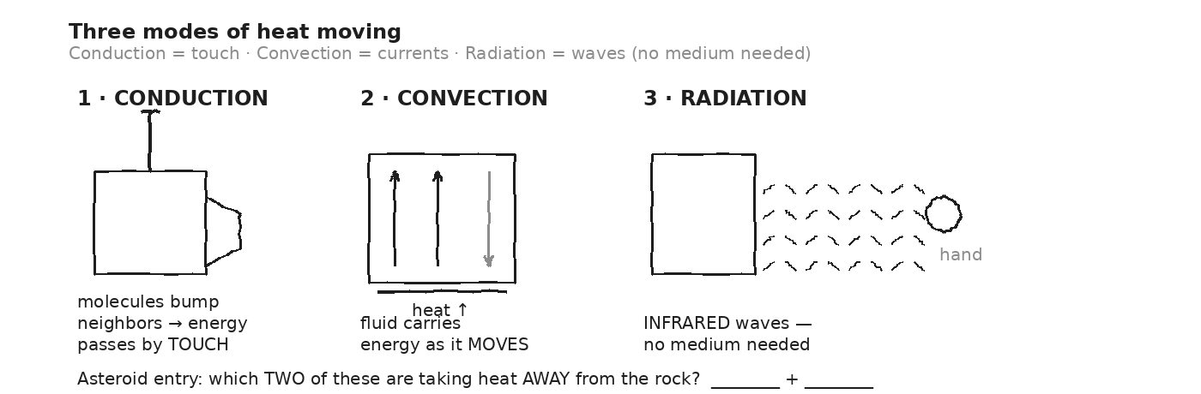

WORKED EXAMPLE — classify 6 scenarios
For each, write the dominant mode: (a) Sun warms Earth. (b) Hot drink in your hand. (c) Convection oven. (d) Wind chill. (e) Asteroid glow seen from the ground. (f) Microwave heats food.
GIVEN | —
EQUATION | (no equation — name the mode for each)
WORK | (a) Sun → Earth: RADIATION (vacuum, EM waves)  (b) Hot mug → hand: CONDUCTION (direct contact)  (c) Convection oven: CONVECTION (forced hot air currents)  (d) Wind chill: CONVECTION (moving air sweeps heat off skin)  (e) Meteor glow: RADIATION (EM waves through air/vacuum)  (f) Microwave: RADIATION (microwaves are EM waves)
ANSWER | 3 radiation, 2 convection, 1 conduction.

YOUR TURN — your turn 4 more
Classify each: (a) ice cube melts on a metal plate. (b) Lake surface freezes from the top down in winter. (c) You feel a hot stove without touching. (d) A thermos with vacuum gap.
GIVEN
EQUATION
WORK
ANSWER

⚠ | A vacuum thermos defeats CONDUCTION and CONVECTION (no air to transfer through) but NOT radiation — so the inside is shiny to reflect IR. The vacuum is the key engineering trick.

Fill in the frame:
An asteroid burns up in the atmosphere because ________________________________________________________ (mode) heats its surface, then ________________________________________________________ (mode) carries heat away as the rock glows. Only one of these can happen through a vacuum.
EXIT TICKET — Day 3
You see a glowing meteor cross the sky. By which mode does the meteor lose energy to YOU on the ground? Why is that the only possible mode?

Today's Targets — Rate Yourself
1 = Not Yet (I can't do this without help) 2 = Almost (I can do this with some help or some errors) 3 = Got It (I can do this independently and explain it)
Help? Check the box if you want to talk with me about this target — even if you marked yourself a 3.
Target | 1 | 2 | 3 | Help?
I can define each of the three heat transfer modes. | ○ | ○ | ○ | ☐
I can classify a real-world scenario by its dominant mode. | ○ | ○ | ○ | ☐
I can explain why a vacuum gap blocks two modes but not the third. | ○ | ○ | ○ | ☐

Day 4 — Phase Changes + Latent Heat: Q = m · L

Today's Target
I can compute the heat needed to phase-change a mass using Q = mL, explain why temperature is constant during phase changes, and add multiple Q's across a full heating curve (ice → water → steam).
ASTEROID THREAD
What we know about 2026-XJ today: 2026-XJ doesn't just heat up at impact — it MELTS rock, then VAPORIZES rock. Each transition takes enormous energy.
How today connects: The crater's heat doesn't just raise rock temperature; it phases rock into vapor. Day 11 uses latent heat values to compute the vaporization energy at the impact site.

VOCAB · PHASE CHANGE
Definition: A transition between solid ⇄ liquid ⇄ gas. Temperature stays CONSTANT during the change while energy goes into breaking molecular bonds (not into KE).
Example: Pure ice at 0 °C absorbs heat → stays at 0 °C while it melts → only AFTER it's all liquid does the temperature rise.
Cognates: Sp. cambio de fase · Pt. mudança de fase · HC chanjman faz
Watch out: During a phase change, you're adding energy but the thermometer doesn't move. The energy is breaking bonds, not raising avg KE.

VOCAB · LATENT HEAT (L)
Definition: Energy per kg required for a phase change at the transition temperature. L_f = latent heat of FUSION (melt/freeze). L_v = latent heat of VAPORIZATION (boil/condense). Units: J/kg.
Example: Water L_f = 334,000 J/kg. To melt 1 kg of ice: Q = 1 · 334,000 = 334 kJ. Water L_v = 2,260,000 J/kg — boiling needs 7× more energy than melting!
Cognates: Sp. calor latente · Pt. calor latente · HC chalè latant
Watch out: "Latent" means hidden — the energy is going somewhere (breaking bonds) but isn't showing up as temperature.

DOODLE ZONE
Label each segment with its equation (Q = mcΔT or Q = mL). Mark where T stays constant. Which flat segment is LONGER — melting or boiling? Why?
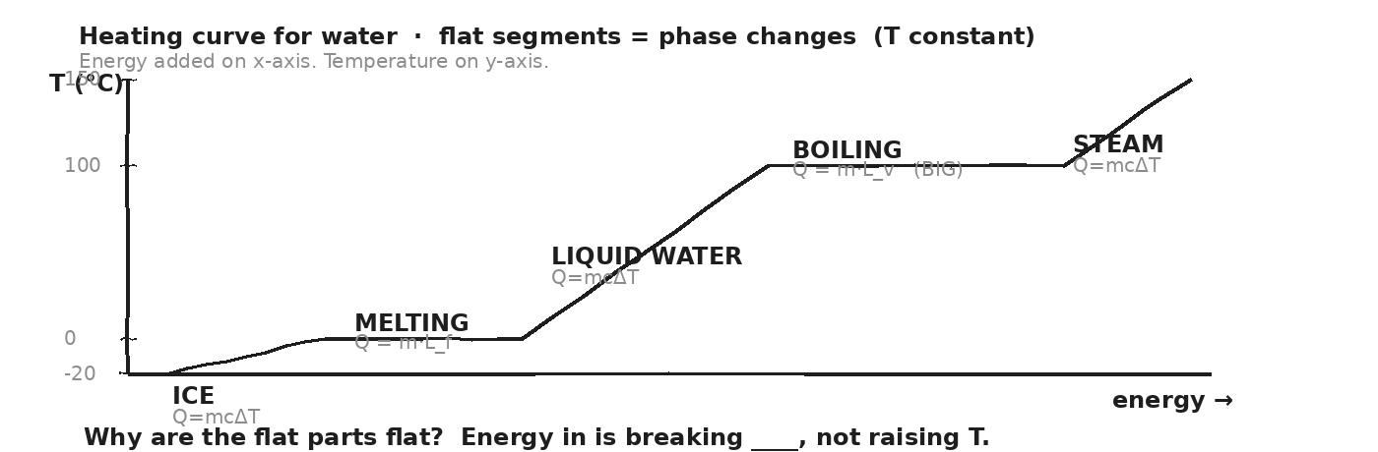

WORKED EXAMPLE — melt 0.5 kg of ice
How much heat is needed to melt 0.5 kg of ice at 0 °C? (L_f = 334 kJ/kg.)
GIVEN | m = 0.5 kg · L_f = 334,000 J/kg
EQUATION | Q = m · L_f
WORK | Q = 0.5 · 334,000  Q = 167,000 J  Q = 167 kJ
ANSWER | 167 kJ — and the ice stays at 0 °C the whole time.

WORKED EXAMPLE — full curve: ice at -10 °C to steam at 110 °C
Total heat to convert 0.5 kg of ice at -10 °C to steam at 110 °C? Five sub-steps. Add them up.
GIVEN | m = 0.5 kg · c_ice = 2090 · c_water = 4186 · c_steam = 2010  L_f = 334,000 · L_v = 2,260,000
EQUATION | Q_total = Q_warm_ice + Q_melt + Q_warm_water + Q_boil + Q_warm_steam
WORK | Q₁ = 0.5 · 2090 · 10 = 10,450 J (warm ice -10 → 0)  Q₂ = 0.5 · 334,000 = 167,000 J (MELT at 0)  Q₃ = 0.5 · 4186 · 100 = 209,300 J (warm water 0 → 100)  Q₄ = 0.5 · 2,260,000 = 1,130,000 J (BOIL at 100)  Q₅ = 0.5 · 2010 · 10 = 10,050 J (warm steam 100 → 110)  Q_total ≈ 1,526,800 J ≈ 1.5 × 10⁶ J
ANSWER | ≈ 1.5 × 10⁶ J. The BOILING step alone is ~75% of the total energy.

YOUR TURN — vaporize 0.2 kg of water
How much heat is needed to vaporize 0.2 kg of water already at 100 °C? (L_v = 2,260,000 J/kg.)
GIVEN
EQUATION
WORK
ANSWER

★ | This is why sweating cools you: every drop of sweat that evaporates carries off 2,260 kJ/kg of body heat. The high L_v of water is a survival adaptation.

Fill in the frame:
During a phase change, temperature stays ________________________________________________________ because energy is going into ________________________________________________________, not into ________________________________________________________. Boiling water requires ________________________________________________________× more energy than melting the same mass of ice.
EXIT TICKET — Day 4
How much heat to vaporize 0.2 kg of water at 100 °C? (Use L_v = 2,260,000 J/kg.)

Today's Targets — Rate Yourself
1 = Not Yet (I can't do this without help) 2 = Almost (I can do this with some help or some errors) 3 = Got It (I can do this independently and explain it)
Help? Check the box if you want to talk with me about this target — even if you marked yourself a 3.
Target | 1 | 2 | 3 | Help?
I can compute Q = mL for melting and boiling. | ○ | ○ | ○ | ☐
I can add Q's across a full heating curve. | ○ | ○ | ○ | ☐
I can explain why T is constant during a phase change. | ○ | ○ | ○ | ☐

Day 5 — Vernier Calorimetry Lab · Q_lost = Q_gained

Today's Target
I can mix hot + cold water using styrofoam-cup calorimetry, predict T_final using Q_lost = Q_gained, measure T_final with a Vernier probe, and identify an unknown metal by its specific heat with one credible source of error noted.
ASTEROID THREAD
What we know about 2026-XJ today: We've stated Q = mcΔT and the calorimetry balance Q_lost = Q_gained. Today we measure them.
How today connects: If we trust the equation in our cups, we can trust it for the planetary-scale calculations on Day 11 (impact vaporization).

LAB SETUP — INVESTIGATION 5.1
Driving question: Does the predicted final temperature of mixed hot + cold water match the measured value within 5%? Then: can we identify an unknown metal from its measured c?
Equipment:
- Vernier temperature probe + LabQuest (or Graphical Analysis)
- Two styrofoam cups (insulated calorimeter) + lid with hole for probe
- Hot-water source (~70 °C) and ice-cooled water (~20 °C)
- Balance (read m_water to 0.1 g)
- Unknown metal samples labeled 'A' and 'B' (aluminum + copper)
- Hot plate or pre-heated water bath to bring metals to ~95 °C
- Tongs (HOT METAL — do not touch with bare hands)
What you do:
1. TRIAL A — mix two waters. Mass cup empty. Add 100 mL hot water; record m_h and T_h. Pour in 100 mL cold water; record m_c and T_c. Cover. Stir gently. Watch probe. Record T_final when steady.
2. Predict T_f using m_h·c·(T_h − T_f) = m_c·c·(T_f − T_c). Compare to measured. % diff.
3. Repeat Trial A two more times with different mass ratios. Three rows of data.
4. TRIAL B — identify a metal. Heat a known mass of metal A to ~95 °C in a hot bath. Drop into a fresh cup of cold water. Record T_final.
5. Compute Q_gained_water = m_w·c_w·(T_f − T_c) and set = -Q_lost_metal = m_m·c_m·(T_f − T_m_initial). Solve for c_m. Compare to table.
6. Repeat for metal B. Identify both samples.
────────────────────────────────────────────────────────────
Safety: HOT WATER and HOT METAL. Use tongs. Pour with care. Goggles always.
How this lab serves the year's question: A successful Q_lost = Q_gained check confirms calorimetry works — the foundation for the impact vaporization calculation on Day 11.
DOODLE ZONE
Sketch your setup for BOTH trials. Label masses and starting temperatures on the diagram. Fill in T_final after each trial.
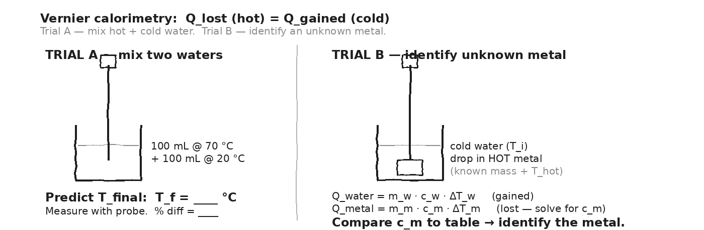

TRIAL A — mix hot + cold water (three trials)
Trial | m_h (g) | T_h (°C) | m_c (g) | T_c (°C) | T_f predicted (°C) | T_f measured (°C) | % diff
1
2
3
TRIAL B — identify the unknown metal
Sample | m_metal (g) | T_metal_i (°C) | m_water (g) | T_water_i (°C) | T_f (°C) | c_metal computed | identified as
1
2
OBSERVATION & ANALYSIS
In Trial A, did T_predicted match T_measured? Across all 3 trials, within what %?

In Trial B, which metals did A and B turn out to be? Did c land within 10% of the table value? If not, what physical thing did we miss?
My T_f predictions agreed within __________ %. Metal A came out closest to __________ (with c = __________). The biggest source of error was __________.
Asteroid connection: how does this serve the year's question?

Fill in the frame:
Calorimetry works because the energy LOST by the hot water equals the energy GAINED by the ________________________________________________________. The cup is styrofoam to MINIMIZE ________________________________________________________.
EXIT TICKET — Day 5
Write a one-sentence CLAIM about what the lab confirmed, then one sentence of EVIDENCE (your numbers), then one sentence of REASONING (why the % difference is small — or not).

Today's Targets — Rate Yourself
1 = Not Yet (I can't do this without help) 2 = Almost (I can do this with some help or some errors) 3 = Got It (I can do this independently and explain it)
Help? Check the box if you want to talk with me about this target — even if you marked yourself a 3.
Target | 1 | 2 | 3 | Help?
I can set up a styrofoam-cup calorimeter and use a Vernier probe. | ○ | ○ | ○ | ☐
I can predict T_final using Q_lost = Q_gained. | ○ | ○ | ○ | ☐
I can solve for an unknown metal's c and identify the material. | ○ | ○ | ○ | ☐
I can compute % difference and name a credible source of error. | ○ | ○ | ○ | ☐

Day 6 — Kinetic Theory — Temperature IS Molecular KE

Today's Target
I can state that temperature is proportional to the average KE per molecule (KE_avg = 3/2 · k · T), explain phase changes as bond-breaking at the molecular level, and predict what happens to molecular speed as T changes.
ASTEROID THREAD
What we know about 2026-XJ today: From Day 1: thermal energy is total molecular KE. From Day 4: phase changes happen at constant T.
How today connects: The molecular picture explains BOTH. Temperature is avg KE per molecule. During a phase change, added energy goes into breaking bonds — not into raising avg KE. So T stays put while the bonds break.

VOCAB · KINETIC THEORY
Definition: Matter is made of molecules in constant motion. In a gas, they fly randomly. In a liquid, they jostle. In a solid, they vibrate in place. Temperature measures the AVERAGE KE per molecule.
Example: At room temperature, an N₂ molecule moves at ~500 m/s on average. Heat the gas, molecules speed up. Cool it, they slow down.
Cognates: Sp. teoría cinética · Pt. teoria cinética · HC teyori sinetik
Watch out: ALL molecules move (even in solids — they vibrate). Absolute zero (0 K = -273 °C) is the theoretical floor where motion is minimum.

VOCAB · KE_AVG = (3/2) · K · T
Definition: The average kinetic energy per molecule of a gas, where k = Boltzmann's constant (1.38 × 10⁻²³ J/K) and T is in Kelvin.
Example: At T = 300 K: KE_avg = 1.5 · 1.38e-23 · 300 ≈ 6.2 × 10⁻²¹ J per molecule. Multiply by ~10²³ molecules per mole → ~620 J per mole.
Cognates: Sp. energía cinética promedio · Pt. energia cinética média
Watch out: T must be in KELVIN, not Celsius. Add 273 to °C to get K.

VOCAB · PHASE CHANGE AT THE MOLECULAR LEVEL
Definition: Adding heat breaks intermolecular BONDS. Energy goes into breaking bonds, not into faster motion. So T stays constant.
Example: At 0 °C, ice molecules vibrate. Add heat: molecules break loose into liquid — same average speed as the ice they came from. T stays at 0 °C until all the ice is melted.
Cognates: Sp. ruptura de enlaces · Pt. ruptura de ligações
Watch out: The latent heat from Day 4 is exactly the energy that goes into BOND-BREAKING, not into avg KE.

DOODLE ZONE
Compare the three panels. Where are molecules FASTEST on average? Where do they have the MOST freedom of position? Why does temperature stay constant during a phase change?
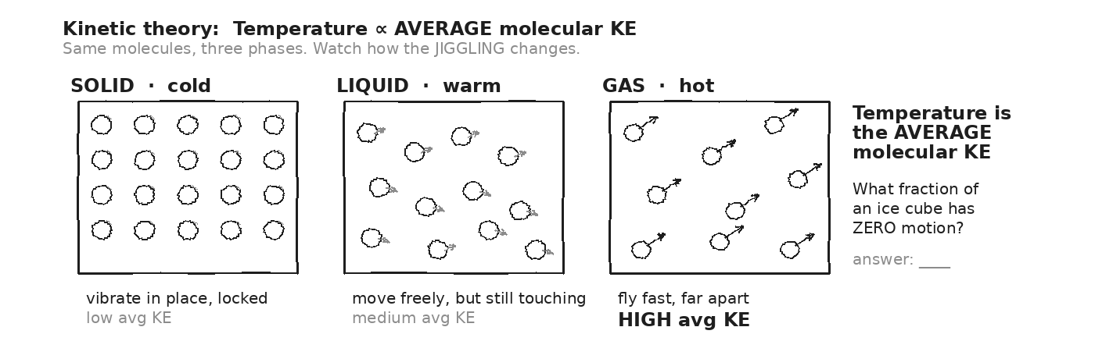

WORKED EXAMPLE — KE per molecule at room temp
Compute the average KE per molecule for a gas at room temperature (T = 300 K). Use k = 1.38 × 10⁻²³ J/K.
GIVEN | T = 300 K · k = 1.38 × 10⁻²³ J/K
EQUATION | KE_avg = (3/2) · k · T
WORK | KE_avg = 1.5 · 1.38e-23 · 300  KE_avg = 1.5 · 4.14e-21  KE_avg ≈ 6.2 × 10⁻²¹ J per molecule
ANSWER | ≈ 6.2 × 10⁻²¹ J per molecule — a tiny number, but multiply by ~10²³ molecules and you get the gas's thermal energy.

YOUR TURN — molecular speed at 600 K
If you double the Kelvin temperature (300 K → 600 K), what happens to the average molecular KE? What happens to the average molecular SPEED? (Hint: KE = ½mv².)
GIVEN
EQUATION
WORK
ANSWER

★ | PhET States of Matter sim: heat solid argon. Watch molecular motion increase. See solid → liquid → gas transitions. Look for the moments when T plateaus (phase change in progress).

Fill in the frame:
Temperature is the ________________________________________________________ kinetic energy per molecule. During a phase change, added heat goes into ________________________________________________________ instead of raising avg KE — so the thermometer doesn't move.
EXIT TICKET — Day 6
Why does temperature stay constant during a phase change, even though heat is being added? Answer in terms of where the energy is GOING at the molecular level.

Today's Targets — Rate Yourself
1 = Not Yet (I can't do this without help) 2 = Almost (I can do this with some help or some errors) 3 = Got It (I can do this independently and explain it)
Help? Check the box if you want to talk with me about this target — even if you marked yourself a 3.
Target | 1 | 2 | 3 | Help?
I can state KE_avg = (3/2)kT. | ○ | ○ | ○ | ☐
I can predict how molecular speed changes when T doubles. | ○ | ○ | ○ | ☐
I can explain phase-change constant-T using bond-breaking. | ○ | ○ | ○ | ☐

Day 7 — First Law of Thermodynamics: ΔU = Q − W

Today's Target
I can apply ΔU = Q − W to gas systems, assign correct signs to Q (heat in = +) and W (work BY system = +), and predict ΔU in heating, cooling, expansion, and compression cases.
ASTEROID THREAD
What we know about 2026-XJ today: After impact, the fireball is a high-temperature gas EXPANDING against the surrounding atmosphere — a thermodynamic system.
How today connects: The first law describes how the fireball's internal energy converts to WORK pushing on the surrounding air — that's the shockwave. Day 11 will partition the impact KE using this framework.

VOCAB · INTERNAL ENERGY (U)
Definition: The total energy contained inside a system — sum of all molecules' KE and bond PE. Symbol: U. Units: Joules.
Example: Heating a gas raises U. Cooling lowers U. Compressing it without heat exchange ALSO raises U (work done on the system).
Cognates: Sp. energía interna · Pt. energia interna · HC enèji entèn
Watch out: U is the system's OWN energy. Q and W are how energy MOVES across the boundary. ΔU = what stays.

VOCAB · FIRST LAW: ΔU = Q − W
Definition: Change in internal energy = heat added to the system MINUS work done BY the system on the surroundings. Energy conservation, written for gases.
Example: 500 J of heat IN, gas does 200 J of work expanding → ΔU = 500 − 200 = 300 J. Internal energy rises by 300 J.
Cognates: Sp. primera ley · Pt. primeira lei
Watch out: SIGN CONVENTIONS: Q > 0 if heat ENTERS the system (heating). W > 0 if the system EXPANDS / DOES work on the surroundings. Reverse both → reverse signs.

DOODLE ZONE
Label Q, W, and ΔU on the diagram. Sketch the signs for: (1) heat enters and gas expands, (2) heat enters and gas is held still, (3) bike pump compresses gas with no heat exchange.
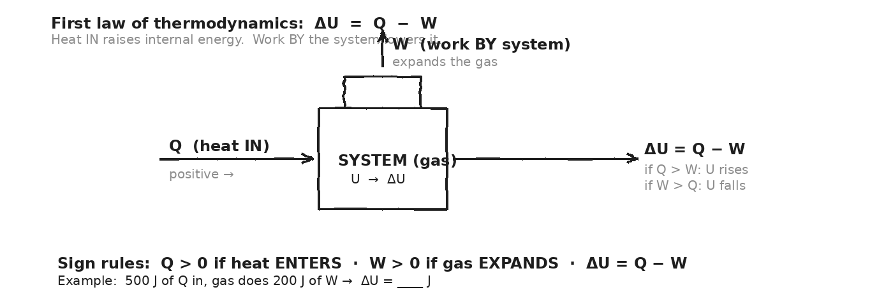

WORKED EXAMPLE — heat a gas, it expands
500 J of heat is added to a gas. The gas does 200 J of work as it expands. What is ΔU?
GIVEN | Q = +500 J (heat IN) · W = +200 J (work BY system, expansion)
EQUATION | ΔU = Q − W
WORK | ΔU = 500 − 200  ΔU = +300 J
ANSWER | Internal energy rises by 300 J. Some heat became work; the rest stayed.

WORKED EXAMPLE — bike pump (adiabatic compression)
You compress air in a bike pump. 300 J of work is done ON the gas (so W = -300 J from the system's perspective). No heat is exchanged (adiabatic; Q = 0). What is ΔU? Why does the pump get warm?
GIVEN | Q = 0 (adiabatic — no heat in) · W = -300 J (work done ON the gas)
EQUATION | ΔU = Q − W
WORK | ΔU = 0 − (-300)  ΔU = +300 J
ANSWER | Internal energy rises by 300 J → temperature rises. That's why the pump is warm.

YOUR TURN — system does more work than heat added
100 J of heat enters a system. The system does 150 J of work on the surroundings. What is ΔU? What's happening physically?
GIVEN
EQUATION
WORK
ANSWER

⚠ | SIGNS, SIGNS, SIGNS. Stop on every problem and ask: is heat going IN or OUT? Is work being done BY the system or ON it? Get these right and the math is easy.

Fill in the frame:
When the bike pump warms up, the work I do ON the gas becomes ________________________________________________________. With Q = 0 and W negative (work done ON the gas), ΔU is ________________________________________________________ — so T ________________________________________________________.
EXIT TICKET — Day 7
100 J heat enters a system. The system does 150 J of work. What is ΔU? What does the sign tell you?

Today's Targets — Rate Yourself
1 = Not Yet (I can't do this without help) 2 = Almost (I can do this with some help or some errors) 3 = Got It (I can do this independently and explain it)
Help? Check the box if you want to talk with me about this target — even if you marked yourself a 3.
Target | 1 | 2 | 3 | Help?
I can write ΔU = Q − W with correct sign conventions. | ○ | ○ | ○ | ☐
I can compute ΔU given Q and W. | ○ | ○ | ○ | ☐
I can explain why an adiabatic compression warms a gas. | ○ | ○ | ○ | ☐

Day 8 — Second Law: Heat Hot → Cold · Entropy Increases

Today's Target
I can state the second law (heat flows spontaneously HOT → COLD; entropy of the universe always increases), and classify everyday processes as spontaneous (entropy-increasing) or requiring an external energy input.
ASTEROID THREAD
What we know about 2026-XJ today: 2026-XJ's KE at impact becomes thermal energy — a HIGH-entropy state.
How today connects: There's no natural process that converts that heat back into organized motion. The impact is IRREVERSIBLE — it can't be undone. The second law tells us why.

VOCAB · SECOND LAW (CLAUSIUS)
Definition: Heat NEVER spontaneously flows from cold to hot. To move heat backward, you must do external work (a refrigerator).
Example: Coffee never spontaneously gets hotter sitting in a cool room. It always cools.
Cognates: Sp. segunda ley · Pt. segunda lei
Watch out: "Spontaneous" doesn't mean fast — it means happens WITHOUT external help. Refrigerators violate the first part because they're PUMPING heat using electricity.

VOCAB · ENTROPY (S)
Definition: A measure of disorder. The number of ways the molecules in a system can be arranged. Higher entropy = more disorder = more possible arrangements.
Example: An organized deck of cards has LOW entropy. Shuffled, it has HIGH entropy. Spontaneous processes (shuffling, mixing, cooling) always INCREASE entropy.
Cognates: Sp. entropía · Pt. entropia
Watch out: Entropy doesn't always increase LOCALLY — your fridge cools, lowering its entropy. But the room outside the fridge heats more than the fridge cools — so the universe's TOTAL entropy increases.

VOCAB · ARROW OF TIME
Definition: The reason we feel time as moving forward — it's the direction of increasing entropy. Broken eggs don't un-break.
Example: A movie of an ice cube melting looks normal. Reversed (cold water spontaneously freezing into a cube), it looks bizarre — even though physics doesn't forbid the molecular motion. Statistically, it just never happens.
Cognates: Sp. flecha del tiempo · Pt. seta do tempo
Watch out: The first law doesn't forbid heat flowing cold → hot (energy would still be conserved). The SECOND law does.

DOODLE ZONE
Mark the ALLOWED direction of spontaneous heat flow. Mark the FORBIDDEN direction. Bottom: why can't you cool a room by leaving the fridge door open?
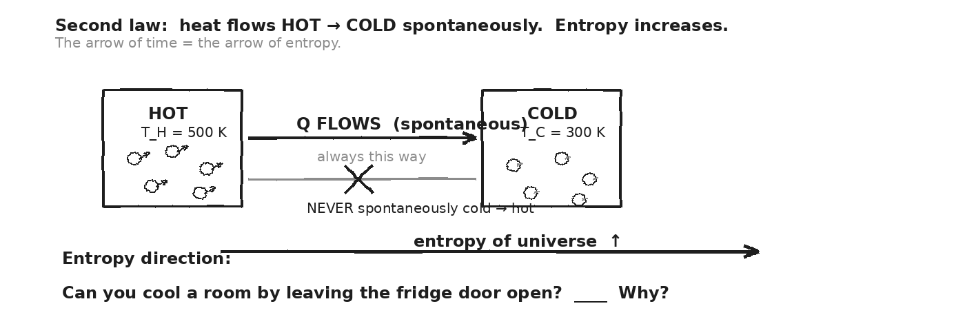

WORKED EXAMPLE — classify 6 processes
For each, write SPONTANEOUS (entropy increases) or REQUIRES INPUT (entropy decreases locally): (a) hot coffee cools. (b) egg breaks. (c) sugar dissolves in water. (d) iron rusts. (e) refrigerator cools food. (f) battery being charged.
GIVEN | —
EQUATION | (no equation — classify each)
WORK | (a) coffee cools: SPONTANEOUS (entropy ↑)  (b) egg breaks: SPONTANEOUS (entropy ↑)  (c) sugar dissolves: SPONTANEOUS (entropy ↑)  (d) iron rusts: SPONTANEOUS (entropy ↑ slowly)  (e) refrigerator cools food: REQUIRES INPUT (electricity from outlet)  (f) battery charges: REQUIRES INPUT (electrical work)
ANSWER | All natural processes go entropy ↑. Reversing them costs energy.

YOUR TURN — fridge with door open
You leave the fridge door open hoping to cool your kitchen. Will the room get colder? Explain using the second law. (Hint: where does the heat removed from inside the fridge GO?)
GIVEN
EQUATION
WORK
ANSWER

★ | A refrigerator pumps heat from inside (cool) to outside (warmer). With the door open, the kitchen is BOTH inside and outside the fridge — so the kitchen heats up (because the fridge motor adds work, which becomes heat).

Fill in the frame:
Heat flows from hot to cold spontaneously because that direction ________________________________________________________ entropy. Going the other way requires ________________________________________________________. A refrigerator does this by ________________________________________________________.
EXIT TICKET — Day 8
Why can't you cool your kitchen by leaving the refrigerator door open? Use the second law in your answer.

Today's Targets — Rate Yourself
1 = Not Yet (I can't do this without help) 2 = Almost (I can do this with some help or some errors) 3 = Got It (I can do this independently and explain it)
Help? Check the box if you want to talk with me about this target — even if you marked yourself a 3.
Target | 1 | 2 | 3 | Help?
I can state the Clausius form of the second law. | ○ | ○ | ○ | ☐
I can classify spontaneous vs. input-required processes. | ○ | ○ | ○ | ☐
I can explain why an open-door fridge heats the room. | ○ | ○ | ○ | ☐

Day 9 — Heat Engines + Efficiency: η = W / Q_hot

Today's Target
I can describe a heat engine cycle (heat in from hot reservoir → some work out → waste heat to cold reservoir), compute efficiency from Q_hot and W, and compare to the Carnot limit η_max = 1 − T_cold/T_hot.
ASTEROID THREAD
What we know about 2026-XJ today: The expanding fireball after impact is a NATURAL heat engine — it converts some thermal energy to mechanical work (the shockwave).
How today connects: No engine — not even an impact fireball — converts 100% of heat to work. The second law forbids it. Day 11's KE partition (vaporization + shockwave + thermal radiation) reflects exactly this limit.

VOCAB · HEAT ENGINE
Definition: A device that takes heat IN from a hot reservoir, converts SOME to useful work, and DUMPS the rest as waste heat to a cold reservoir.
Example: Car engine: gasoline combustion (hot) → piston work (W) → exhaust heat (Q_cold to outside). Power plant: steam (hot) → turbine work → cooling tower (cold).
Cognates: Sp. máquina térmica · Pt. máquina térmica · HC machin a chalè
Watch out: The cold reservoir is REQUIRED. Without a cold side, the engine can't work — the second law mandates waste heat.

VOCAB · EFFICIENCY Η
Definition: The fraction of heat input that becomes useful work. η = W / Q_hot = 1 − Q_cold/Q_hot. Always < 1.
Example: Power plant: 1000 J in, 400 J of work, 600 J waste → η = 400/1000 = 40%. Car: ~25%. Human body: ~25%.
Cognates: Sp. eficiencia · Pt. eficiência · HC efikasite
Watch out: η is dimensionless (between 0 and 1, or 0% and 100%). 1 (100%) is impossible.

VOCAB · CARNOT LIMIT Η_MAX
Definition: The MAXIMUM possible efficiency for an engine between hot reservoir at T_H (Kelvin) and cold reservoir at T_C (Kelvin). η_max = 1 − T_C/T_H. Real engines are always below this.
Example: Power plant with T_H = 600 K, T_C = 300 K → η_max = 1 − 300/600 = 0.50 = 50%. Real plant gets 40% — below the limit.
Cognates: Sp. límite de Carnot · Pt. limite de Carnot
Watch out: USE KELVIN ALWAYS. T_C/T_H is a ratio — only Kelvin gives the right ratio. Don't use °C.

DOODLE ZONE
Label Q_hot, Q_cold, and W on the diagram. Compute efficiency for the example. Then compute the Carnot limit at T_H = 500 K, T_C = 300 K and compare.
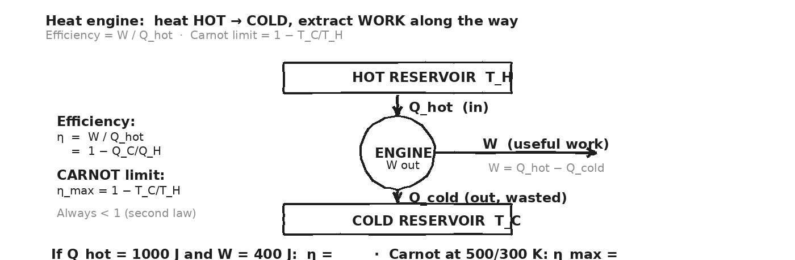

WORKED EXAMPLE — power plant efficiency
A power plant takes 1000 J of heat from steam at 600 K, produces 400 J of useful work, and dumps 600 J as waste heat to a 300-K cooling tower. (a) Real efficiency? (b) Carnot limit at these temperatures? (c) Is the real engine doing OK?
GIVEN | Q_hot = 1000 J · W = 400 J · Q_cold = 600 J · T_H = 600 K · T_C = 300 K
EQUATION | η = W/Q_hot AND η_max = 1 − T_C/T_H
WORK | η = 400 / 1000 = 0.40 = 40%  η_max = 1 − 300/600 = 1 − 0.5 = 0.50 = 50%  Real / Carnot = 40 / 50 = 80% of the limit.
ANSWER | 40% efficient. Carnot limit is 50%. The plant is at 80% of the theoretical max.

YOUR TURN — car engine
A car engine receives 1500 J of heat per cycle and produces 400 J of work. (a) Efficiency? (b) How much heat is wasted to exhaust?
GIVEN
EQUATION
WORK
ANSWER

YOUR TURN — Carnot for a steam engine
A steam engine runs between T_H = 450 K (steam) and T_C = 300 K (condenser). What is the maximum possible efficiency?
GIVEN
EQUATION
WORK
ANSWER

⚠ | The Carnot limit is set by the TEMPERATURES alone — not by the working fluid or the engine design. You can never beat it. You can only get closer to it.

Fill in the frame:
An engine's efficiency is bounded by η_max = ________________________________________________________, which depends only on the hot and cold ________________________________________________________ (in ________________________________________________________). Real engines fall ________________________________________________________ this limit because of friction and other losses.
EXIT TICKET — Day 9
A car engine receives 1500 J of heat per cycle and produces 400 J of work. What's its efficiency?

Today's Targets — Rate Yourself
1 = Not Yet (I can't do this without help) 2 = Almost (I can do this with some help or some errors) 3 = Got It (I can do this independently and explain it)
Help? Check the box if you want to talk with me about this target — even if you marked yourself a 3.
Target | 1 | 2 | 3 | Help?
I can describe a heat engine's cycle and identify Q_hot, Q_cold, W. | ○ | ○ | ○ | ☐
I can compute η = W/Q_hot. | ○ | ○ | ○ | ☐
I can compute the Carnot limit η_max = 1 − T_C/T_H (Kelvin). | ○ | ○ | ○ | ☐
I can compare a real engine to its Carnot limit. | ○ | ○ | ○ | ☐

Day 10 — Atmospheric Entry — Why Pebbles Burn Up, Boulders Don't

Today's Target
I can compare an asteroid's KE to the energy required to vaporize its mass and explain why surface-area-to-mass ratio sets the size threshold for atmospheric burn-up.
ASTEROID THREAD
What we know about 2026-XJ today: 2026-XJ is HUGE (m ≈ 10⁹ kg, r ≈ 50 m). The Chelyabinsk meteor was tiny (m ≈ 10⁴ kg) — it burst in the atmosphere with no crater.
How today connects: Today's question: at 2026-XJ's size, does the atmosphere matter at all? Where's the size threshold between 'burns up' and 'reaches ground'?

VOCAB · ATMOSPHERIC DRAG
Definition: A friction-like force that air exerts on a fast-moving object. Does NEGATIVE work — takes KE away. The KE removed becomes HEAT at the object's surface.
Example: A satellite re-entering at 7.8 km/s heats its surface to ~2000 °C from drag — this is why re-entry shielding matters.
Cognates: Sp. arrastre atmosférico · Pt. arrasto atmosférico
Watch out: Drag converts KE → heat. The faster the object, the MORE drag per second (drag ∝ v² roughly).

VOCAB · SURFACE-AREA-TO-MASS RATIO
Definition: For a sphere, A/m = 3/(ρ·r). SMALL rocks have HIGH A/m → lots of drag per kg → vaporize. BIG rocks have LOW A/m → little drag per kg → survive.
Example: A 1-kg pebble has ~1000× more A/m than a 10⁹-kg asteroid. The pebble burns away entirely. The asteroid loses < 1% of its mass to ablation.
Cognates: Sp. área/masa · Pt. área/massa
Watch out: It's not the rock's TOTAL drag force — it's the drag force PER KG of rock. Big rocks have lots of drag too, but they have even more mass.

VOCAB · ABLATION
Definition: The process by which a rock's outer layer vaporizes during atmospheric entry, carrying heat AWAY from the rock as molten/vapor mass.
Example: The Apollo capsules used ablative heat shields — designed to char and vaporize, carrying heat away rather than letting it into the spacecraft.
Cognates: Sp. ablación · Pt. ablação
Watch out: Ablation HELPS — vaporized material removes heat. Without it, big asteroids would heat all the way through.

DOODLE ZONE
Compare the three rocks. Why does the 1-kg pebble vaporize completely? Why does the 10⁹-kg asteroid arrive at full mass? Mark the size threshold on the diagram.
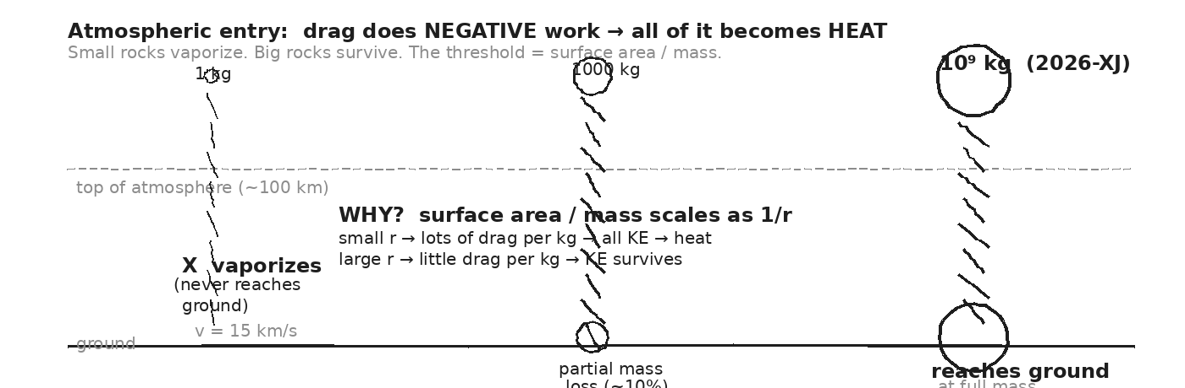

THE BIG COMPARISON — KE vs. vaporization energy
Three rocks at v = 15 km/s. For each, compute (1) KE = ½mv² and (2) energy to vaporize: E_vap = m · (c_rock · ΔT + L_v_rock) where c_rock ≈ 800 J/kg·°C, ΔT ≈ 2000 °C, L_v ≈ 7 × 10⁶ J/kg. Compare ratios.
GIVEN | v = 1.5 × 10⁴ m/s · c_rock = 800 · ΔT ≈ 2000 · L_v ≈ 7 × 10⁶  E_vap per kg = (800·2000) + (7 × 10⁶) = 1.6 × 10⁶ + 7 × 10⁶ ≈ 8.6 × 10⁶ J/kg
EQUATION | KE = ½ m v² AND E_vap = m · 8.6 × 10⁶ J/kg
WORK | ROCK A: m = 1 kg  KE = 0.5 · 1 · (1.5e4)² = 1.125 × 10⁸ J  E_vap = 1 · 8.6e6 = 8.6 × 10⁶ J  ratio KE / E_vap ≈ 13 → KE is 13× more than needed to vaporize. BURNS UP.  ROCK B: m = 1000 kg  KE = 0.5 · 1000 · (1.5e4)² = 1.125 × 10¹¹ J  E_vap = 1000 · 8.6e6 = 8.6 × 10⁹ J  ratio = 13 → same ratio per kg — but most heat goes into the surface,  not the core. Only OUTER ~10% vaporizes.  ROCK C: m = 10⁹ kg (2026-XJ)  KE = 0.5 · 1e9 · (1.5e4)² ≈ 1.125 × 10¹⁷ J  E_vap = 1e9 · 8.6e6 = 8.6 × 10¹⁵ J  ratio = 13 → surface ablation is < 1% of mass. REACHES GROUND.
ANSWER | Small rocks: ALL surface, vaporize entirely. Big rocks: surface ablates, core survives. The ratio per kg is the SAME — it's geometry (A/m) that decides.

YOUR TURN — would a 10-kg rock survive?
A 10-kg rock at v = 15 km/s. Compute KE, E_vap, and the ratio. Will it reach the ground intact? Why?
GIVEN
EQUATION
WORK
ANSWER

★ | The Chelyabinsk meteor (Feb 2013) was ~10⁴ kg — small enough that it AIRBURST 30 km up. No crater. Just a shockwave that broke 100,000 windows and injured 1500 people. Big rocks behave differently — Day 11 explains how.

Fill in the frame:
A small rock burns up because its surface area per kg is ________________________________________________________, so drag per kg is ________________________________________________________ and ALL its KE becomes heat at the surface. 2026-XJ's surface area per kg is ________________________________________________________, so only ________________________________________________________ % ablates and the rest reaches the ground.
EXIT TICKET — Day 10
Why does a 1-kg rock burn up but a 10⁹-kg asteroid reach the ground? Reason in terms of surface-area-to-mass ratio.

Today's Targets — Rate Yourself
1 = Not Yet (I can't do this without help) 2 = Almost (I can do this with some help or some errors) 3 = Got It (I can do this independently and explain it)
Help? Check the box if you want to talk with me about this target — even if you marked yourself a 3.
Target | 1 | 2 | 3 | Help?
I can compute KE of an entering rock and compare to its vaporization energy. | ○ | ○ | ○ | ☐
I can explain the size threshold using surface-area-to-mass ratio. | ○ | ○ | ○ | ☐
I can predict whether a given rock survives atmospheric entry. | ○ | ○ | ○ | ☐

Day 11 — Impact Thermal Damage Map — 2026-XJ Centerpiece

Today's Target
I can partition 2026-XJ's impact KE into vaporization, shockwave, and thermal radiation; use I = E/(4πr²) with the threshold values to compute the wildfire-ignition and third-degree-burn radii; and build a damage-by-distance map.
ASTEROID THREAD
What we know about 2026-XJ today: From Unit 4 Day 19: 2026-XJ's impact KE ≈ 4.5 × 10¹⁷ J ≈ 108 megatons TNT. That's the YIELD. Today the unit PAYS OFF: where does that energy GO thermally?
How today connects: A shockwave alone doesn't explain Tunguska's flattened forest (mostly thermal!) or Chelyabinsk's burning eyes (UV pulse). The fireball is doing damage at HUGE distances. Today: how far?

VOCAB · ENERGY PARTITION
Definition: At impact, KE doesn't all become one thing. It splits roughly into thirds: vaporized rock, atmospheric shockwave, and thermal radiation (fireball glow + infrared pulse).
Example: For 2026-XJ: vaporization ≈ 1.5 × 10¹⁷ J · shockwave ≈ 1.5 × 10¹⁷ J · radiation ≈ 1.5 × 10¹⁷ J.
Cognates: Sp. partición de energía · Pt. partição de energia
Watch out: The exact partition depends on impact angle, target type, and asteroid composition. ~⅓ each is a useful first estimate.

VOCAB · THERMAL RADIATION INTENSITY
Definition: The thermal energy per area received at distance r from a point source emitting energy E. I = E / (4π·r²). Falls off as 1/r².
Example: 2026-XJ radiates ~1.5 × 10¹⁷ J. At r = 10 km: I = 1.5e17 / (4π·(10⁴)²) ≈ 1.2 × 10⁸ J/m² ≈ 2900 cal/cm². At r = 100 km: ~29 cal/cm². At r = 500 km: ~1.1 cal/cm² (still enough to ignite paper).
Cognates: Sp. intensidad de radiación · Pt. intensidade de radiação
Watch out: The 4π comes from a SPHERICAL surface at distance r. Energy spreads out over the whole sphere.

VOCAB · DAMAGE THRESHOLDS
Definition: Energy-per-area values for specific thermal damage. 0.4 cal/cm² = paper ignites. 5 cal/cm² = third-degree burns. Below ~0.1 cal/cm² = felt but not damaging.
Example: Set I = threshold, solve for r: r = √(E / (4π · threshold)).
Cognates: Sp. umbrales de daño · Pt. limiares de dano
Watch out: 1 cal/cm² = 4.184 × 10⁴ J/m². Convert carefully.

DOODLE ZONE
This is the centerpiece of the unit. Fill in the radii (R1, R2, R3, R4, R5) using the calculations on the next page. Each ring is a different damage mode.
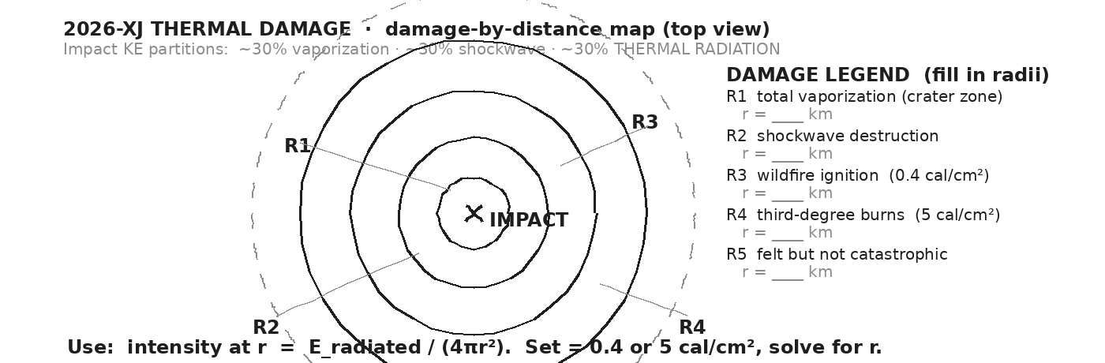

STEP 1 — partition 2026-XJ's impact KE
2026-XJ delivers 4.5 × 10¹⁷ J at impact. Partition it: 30% to vaporized rock, 30% to shockwave KE, 30% to thermal radiation, 10% other.
GIVEN | KE_total = 4.5 × 10¹⁷ J
EQUATION | E_x = (fraction) · KE_total
WORK | E_vap = 0.30 · 4.5e17 ≈ 1.35 × 10¹⁷ J  E_shock = 0.30 · 4.5e17 ≈ 1.35 × 10¹⁷ J  E_rad = 0.30 · 4.5e17 ≈ 1.35 × 10¹⁷ J  (other = 0.10 · 4.5e17 ≈ 4.5 × 10¹⁶ J — ground heating, sound, light losses)
ANSWER | Each major channel gets ~1.35 × 10¹⁷ J. Thermal radiation is the one with the LONGEST reach.

STEP 2 — compute R1, the total-vaporization radius (crater)
Using E_vap = 1.35 × 10¹⁷ J, and energy to vaporize rock = 8.6 × 10⁶ J/kg, plus ρ_rock = 2700 kg/m³, compute the mass of rock vaporized and the spherical radius it occupies (assume rock is vaporized from a hemisphere).
GIVEN | E_vap = 1.35 × 10¹⁷ J · e_per_kg = 8.6 × 10⁶ J/kg · ρ = 2700 kg/m³
EQUATION | m = E_vap / e_per_kg · V = m / ρ · V = ⅔πR1³ → R1
WORK | m_vap = 1.35e17 / 8.6e6 ≈ 1.57 × 10¹⁰ kg  V = 1.57e10 / 2700 ≈ 5.8 × 10⁶ m³  R1 = (V · 3 / (2π))^(1/3) ≈ (2.77 × 10⁶)^(1/3) ≈ 140 m
ANSWER | R1 ≈ 140 m. Inside this hemisphere: total rock vaporization (the crater core).

STEP 3 — compute R3, the wildfire-ignition radius (0.4 cal/cm²)
Using E_rad = 1.35 × 10¹⁷ J, compute the radius at which intensity drops to 0.4 cal/cm² = 1.67 × 10⁴ J/m².
GIVEN | E_rad = 1.35 × 10¹⁷ J · I_paper = 1.67 × 10⁴ J/m²
EQUATION | I = E / (4π·r²) → r = √(E / (4π·I))
WORK | r² = 1.35e17 / (4π · 1.67e4)  r² = 1.35e17 / 2.10e5  r² ≈ 6.43 × 10¹¹  r = √(6.43 × 10¹¹) ≈ 8.0 × 10⁵ m ≈ 800 km
ANSWER | R3 ≈ 800 km. Inside this ring, paper and dry vegetation can spontaneously ignite. That's a continent-scale wildfire zone.

STEP 4 — compute R4, the third-degree burn radius (5 cal/cm²)
Using E_rad = 1.35 × 10¹⁷ J, compute the radius at which intensity drops to 5 cal/cm² = 2.09 × 10⁵ J/m².
GIVEN | E_rad = 1.35 × 10¹⁷ J · I_3rdburn = 2.09 × 10⁵ J/m²
EQUATION | r = √(E / (4π·I))
WORK | r² = 1.35e17 / (4π · 2.09e5)  r² = 1.35e17 / 2.63e6  r² ≈ 5.14 × 10¹⁰  r = √(5.14 × 10¹⁰) ≈ 2.27 × 10⁵ m ≈ 227 km
ANSWER | R4 ≈ 227 km. Inside this ring, anyone with exposed skin gets third-degree burns from the thermal pulse alone — no contact required.

DAMAGE-BY-DISTANCE MAP — 2026-XJ THERMAL DAMAGE
► R1 ~140 m Total vaporization (crater zone) everything melted/vapor
► R2 ~5 km Shockwave destruction (Day 19 reference) all structures flattened
► R3 ~800 km Wildfire ignition (0.4 cal/cm²) paper + vegetation burn
► R4 ~227 km Third-degree burns (5 cal/cm²) exposed skin burns
► R5 ~ thousands of km Felt but not catastrophic windows broken; bright flash
⚠ | The R3 wildfire radius (~800 km) is HIGHER than R4 (~227 km) and even the shockwave radius (R2 ~5 km). Thermal radiation has the LONGEST reach — which is why historical impacts are remembered for their fires.

Fill in the frame:
2026-XJ's impact does damage by THREE main mechanisms: ________________________________________________________ (out to ~140 m), ________________________________________________________ (out to ~5 km), and ________________________________________________________ (out to ~800 km). The thermal pulse has the ________________________________________________________ reach.
EXIT TICKET — Day 11
Of vaporization, shockwave, and thermal radiation — which damage mode reaches the FURTHEST from a 108-megaton impact? Why? Write two sentences.

Today's Targets — Rate Yourself
1 = Not Yet (I can't do this without help) 2 = Almost (I can do this with some help or some errors) 3 = Got It (I can do this independently and explain it)
Help? Check the box if you want to talk with me about this target — even if you marked yourself a 3.
Target | 1 | 2 | 3 | Help?
I can partition impact KE into vaporization / shockwave / thermal radiation. | ○ | ○ | ○ | ☐
I can apply I = E / (4πr²) to compute a damage radius from a threshold. | ○ | ○ | ○ | ☐
I can build a damage-by-distance map and order the radii. | ○ | ○ | ○ | ☐
I can identify which damage mode reaches the furthest. | ○ | ○ | ○ | ☐

Day 12 — Unit 5 Transfer Task — Assessment Day

ASTEROID THREAD
What we know about 2026-XJ today: Every Unit 5 tool is in your hands: Q = mcΔT, Q = mL, calorimetry balance, ΔU = Q − W, efficiency, Carnot, atmospheric entry energy comparison.
How today connects: Problem 4 is the burn-up question — for a small pebble. You will decide whether a sample asteroid reaches the ground or vaporizes in flight.

TRANSFER TASK — UNIT 5 · DAY 12
Today you receive the Unit 5 Transfer Task on a separate sheet. It is 4 multi-part problems. You will work independently for ~40 minutes.
• Problem 1 — CALORIMETRY. Mix two known water samples at different temperatures. Predict T_f using Q_lost = Q_gained. Verify with the value you'd MEASURE if you had a probe.
• Problem 2 — PHASE CHANGE. Total heat to convert 0.5 kg of ice at -10 °C to steam at 110 °C. Five-step calculation. Identify which step is the LARGEST and explain why.
• Problem 3 — HEAT ENGINE. Given Q_hot, Q_cold, T_H, T_C: compute real efficiency. Compute Carnot limit. Comment on the engine's performance relative to its theoretical max.
• Problem 4 — ATMOSPHERIC ENTRY (R3 reasoning). Given a pebble's mass (2 kg) and speed (20 km/s), compute its KE. Then compute the energy to vaporize it entirely (use c_rock + L_v_rock). Compare the two. Does the rock reach the ground? Justify your conclusion.
DOODLE ZONE
Four problems, four physics ideas. Identify the equation you'll use for each before you start.
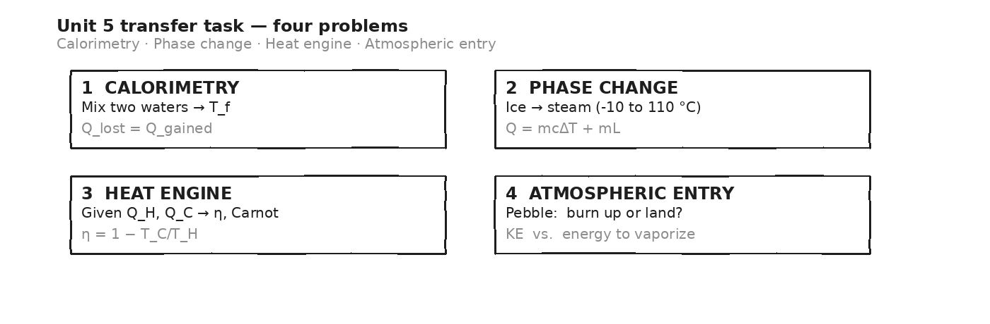

HOW THIS WILL BE SCORED — 4 DIMENSIONS, EACH 0–4
Dimension | What a strong (3–4) response shows
Science | Correct physics: vectors, kinematics, units.
Reasoning | Sound method; uncertainty explained, not just stated.
Communication | Work shown, units labeled, organized, readable.
Transfer-to-Asteroid | Honest public-facing connection to 2026-XJ.
MY WORK — DAY 12 (use additional paper as needed)
AFTER THE TASK — FINAL UNIT MARZANO (rate each Unit 5 target)
Today's Targets — Rate Yourself
1 = Not Yet (I can't do this without help) 2 = Almost (I can do this with some help or some errors) 3 = Got It (I can do this independently and explain it)
Help? Check the box if you want to talk with me about this target — even if you marked yourself a 3.
Target | 1 | 2 | 3 | Help?
K1 — Distinguish thermal energy, temperature, and heat. | ○ | ○ | ○ | ☐
K2 — Specific heat: Q = m·c·ΔT. | ○ | ○ | ○ | ☐
K3 — Three modes of heat transfer: conduction, convection, radiation. | ○ | ○ | ○ | ☐
K4 — Phase changes + latent heat: Q = m·L. | ○ | ○ | ○ | ☐
K5 — Kinetic theory: temperature = avg molecular KE. | ○ | ○ | ○ | ☐
K6 — First law of thermodynamics: ΔU = Q − W. | ○ | ○ | ○ | ☐
K7 — Second law of thermodynamics + entropy. | ○ | ○ | ○ | ☐
K8 — Heat engines + efficiency + Carnot limit. | ○ | ○ | ○ | ☐
S1 — Compute Q = m·c·ΔT for any material. | ○ | ○ | ○ | ☐
S2 — Compute Q = m·L for a phase change. | ○ | ○ | ○ | ☐
S3 — Compute efficiency given Q_hot, W (and Carnot from temperatures). | ○ | ○ | ○ | ☐
S4 — Vernier calorimetry to identify an unknown material. | ○ | ○ | ○ | ☐
R1 — Reason about spontaneous vs. input-required processes (second law). | ○ | ○ | ○ | ☐
R3 — Apply thermal framework to predict atmospheric burn-up and impact thermal damage. | ○ | ○ | ○ | ☐

Equation Reference — Unit 5
Keep this page open while you work. Every equation below is on the MCAS Equation Sheet — you do NOT need to memorize them. You DO need to recognize when each one applies.
Concept | Equation | When to use it
Specific heat | Q = m · c · ΔT | Heat needed to change temperature without changing phase. c is material-specific (J/kg·°C). Water's c is huge — that's why oceans buffer climate.
Latent heat of fusion | Q = m · L_f | Heat needed to MELT (or freeze) a mass at its melting point. T stays constant. Water L_f = 334 kJ/kg.
Latent heat of vaporization | Q = m · L_v | Heat needed to BOIL (or condense) a mass at its boiling point. T stays constant. Water L_v = 2260 kJ/kg — 7× the fusion value!
Calorimetry balance | Q_lost = Q_gained | When hot meets cold in an insulated cup, energy lost by one equals energy gained by the other. The basis of every mixing problem.
First law of thermodynamics | ΔU = Q − W | Change in internal energy = heat IN minus work BY the system. Q > 0 = heat enters; W > 0 = gas expands. Conservation of energy for gases.
Efficiency (any engine) | η = W / Q_hot = 1 − Q_cold/Q_hot | Useful work divided by heat from the hot reservoir. Always < 1. Real engines below this. Power plant ~40%, car ~25%.
Carnot limit (ideal) | η_max = 1 − T_cold / T_hot | Best efficiency possible between T_H and T_C (Kelvin). Real engines can only approach this. Imposed by second law.
Kinetic theory (advanced) | KE_avg = (3/2) · k · T | Average KE per gas molecule. k = Boltzmann constant. Connects temperature to molecular motion.
Atmospheric entry — drag work | W_drag ≈ ½ · ρ · v² · A · d | Work done by atmospheric drag becomes heat at the rock's surface. Compare to the rock's mass × c × ΔT_vaporize to see if it burns up.
Thermal radiation intensity | I = E / (4π · r²) | Energy per area at distance r from a point source. Set I equal to the damage threshold to solve for the damage radius.
SPECIFIC HEAT TABLE (c, units = J/kg·°C)
Material | c (J/kg·°C) | Note
Water (liquid) | 4186 | the outlier — 5× higher than rock
Ice | 2090 | lower than liquid water, still high
Steam | 2010 | similar to ice
Aluminum | 900 | everyday metal
Rock (typical) | 800 | asteroid / Earth's crust
Copper | 387 | warms quickly per Joule
Iron | 450
Gold | 129 | very low
LATENT HEAT TABLE (energy per kg for phase change)
Phase transition | Latent heat | Note
Water — fusion (melt/freeze) | L_f = 334 kJ/kg | Required to melt 1 kg of ice at 0 °C.
Water — vaporization (boil/condense) | L_v = 2260 kJ/kg | Required to boil 1 kg of water at 100 °C — almost 7× the melt value.
Rock — fusion (typical) | L_f ≈ 270 kJ/kg | Igneous rock melting point ≈ 1200 °C.
Rock — vaporization (typical) | L_v ≈ 7000 kJ/kg | Used in asteroid impact crater calculations.
THERMAL DAMAGE THRESHOLDS (for Day 11 damage map)
Effect | Energy / area threshold | Note
Paper ignites | 0.4 cal/cm² | Vegetation, paper, fabric — start of wildfire ring.
Wood ignites | 1.0 cal/cm² | Structures begin to burn.
Third-degree burns | 5.0 cal/cm² | Exposed skin — full-thickness burn radius.
Total vaporization | varies (mL_v) | Inside the crater — rock turns to vapor.
Constants and reference quantities:
Boltzmann constant: k = 1.38 × 10⁻²³ J/K · 1 calorie = 4.184 J · 1 cal/cm² = 4.184 × 10⁴ J/m² · 0 °C = 273.15 K · Avogadro: 6.02 × 10²³ /mol · 2026-XJ impact KE ≈ 4.5 × 10¹⁷ J (from Unit 4 Day 19)
Mastery Growth Chart — Unit 5
Each day, transfer your Marzano 1-2-3 rating onto the chart. Use a different mark or color for each target you track. Unit 5 has ~8-10 targets across 12 tight days — track at least your top three.
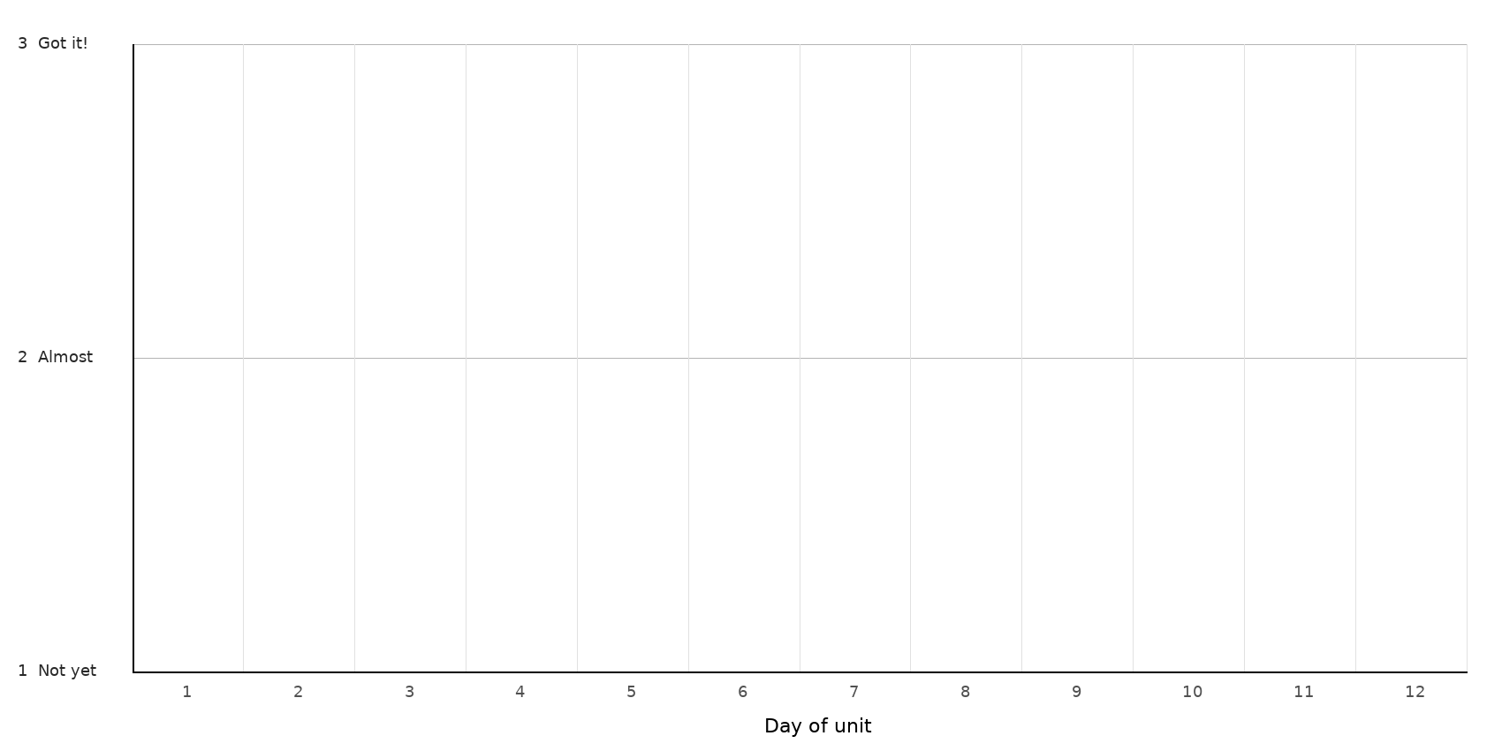
LEGEND — WHICH MARK / COLOR = WHICH TARGET
Mark: ______ Target: __________________________________________________________________
Mark: ______ Target: __________________________________________________________________
Mark: ______ Target: __________________________________________________________________
Mark: ______ Target: __________________________________________________________________
NOTES — END-OF-UNIT REFLECTION

