CPA Physics · Fitchburg High School · 2026–2027
Unit 6 — Waves, Sound & Light
wave properties · v = fλ · reflection · refraction · diffraction · interference · sound · resonance · Doppler · EM spectrum · mirrors + lenses · RADAR · Wien's law · seismic + tsunami
◆ NASA / PLANETARY DEFENSE BRIEFING — UPDATE 6
For five units, you have been computing things about 2026-XJ. Distance. Velocity. Mass. Trajectory. Impact yield. Damage radii. Every one of those numbers had to come from a measurement.
But HOW did NASA measure them? You haven't been told. The answer is RADAR.
For decades, NASA's planetary radar network has tracked near-Earth asteroids by sending out radio pulses and timing the return. The TIME tells distance. The frequency SHIFT tells velocity (Doppler effect). The signal STRENGTH tells size. Every number you've used was derived from bounced radio waves.
Unit 6 reveals the measurement chain. By Day 15, you will walk through the FULL chain — radar pulse out, radar echo back, what each piece of the signal tells us about 2026-XJ.
Two new pieces of data this unit:
(1) 2026-XJ has a 70% chance of impacting OCEAN, not land. Earth is 70% water. If it splashes down instead of landing, the damage mechanism shifts from thermal-pulse-and-shockwave to TSUNAMI. Day 17 builds the tsunami physics.
(2) Meteor color tells temperature. The atmospheric-entry glow from Day 10 of Unit 5 is yellow-white. Why not red, why not blue? Wien's law connects color directly to temperature. Day 16 explains.
This is fiction. The physics — and the equations — are real.
MA Standards: HS-PS4-1, HS-PS4-2, HS-PS4-3, HS-PS4-4, HS-PS4-5
18 meetings · Fall 2026 (Feb 9 – Mar 6)
Name: ______________________________ Class period: __________ Date received: __________
"Every number we have used about 2026-XJ came from bounced radio waves."
Table of Contents
Day-type key: A = Anchor · S = Standard · L = Lab · T = Transfer · ★ = Asteroid payoff
Section | Type | Page
Cover | — | 1
Table of Contents | — | 2
Phase 1 — Wave fundamentals | —
Day 1 — Waves carry energy, not matter (re-anchor) | A | 3
Day 2 — Wave anatomy: f, λ, A, T | S | 6
Day 3 — The wave equation: v = fλ | S | 9
Phase 2 — Wave behavior | —
Day 4 — Reflection at boundaries | S | 12
Day 5 — Refraction: bending at a boundary | S | 15
Day 6 — Diffraction: bending around obstacles | S | 18
Day 7 — Interference + standing waves | S | 21
Phase 3 — Sound | —
Day 8 — Sound as longitudinal wave | S | 24
Day 9 — Speed of sound + resonance | S | 27
Day 10 — Vernier echo lab | L | 30
Day 11 — Intensity, decibels, Doppler | S | 33
Phase 4 — Light + EM | —
Day 12 — EM spectrum: light is a wave | S | 36
Day 13 — Plane mirrors + virtual images | S | 39
Day 14 — Lenses qualitatively | S | 42
Phase 5 — Asteroid payoff | —
Day 15 — ★ RADAR — the reveal | S★ | 45
Day 16 — Meteor color (Wien's law) | S★ | 48
Day 17 — Seismic + tsunami damage at distance | S★ | 51
Phase 6 — Assessment | —
Day 18 — Unit 6 transfer task | T | 54
Equation Reference Card | — | 57
Mastery Growth Chart | — | 59

Day 1 — Waves Carry Energy — Not Matter (Re-anchor + Unit Preview)

Today's Target
I can describe how a wave carries ENERGY and INFORMATION through a medium without carrying matter, and name the unit's three payoff days (Day 15 radar, Day 16 meteor color, Day 17 seismic + tsunami).
ASTEROID THREAD
What we know about 2026-XJ today: From Units 1–5: 2026-XJ — distance, velocity, mass, impact yield, damage radii. But every NUMBER had to come from a measurement.
How today connects: The measurement was RADAR. Radio waves SENT, BOUNCED, RECEIVED — and Doppler-shifted by the moving asteroid. Unit 6 is the framework that makes radar work. Day 15 is the reveal.

NOTICE AND WONDER
Demo: a slinky stretched along the floor. Two students hold the ends. Pulse the slinky side-to-side (transverse). Then push-pull (longitudinal). Watch CAREFULLY. What TRAVELED down the slinky? What did NOT travel?
I notice ____________________________
I wonder ____________________________

DOODLE ZONE
Trace what happens to a single coil during each kind of pulse. Does any coil move all the way across the slinky? What DOES travel from end to end?
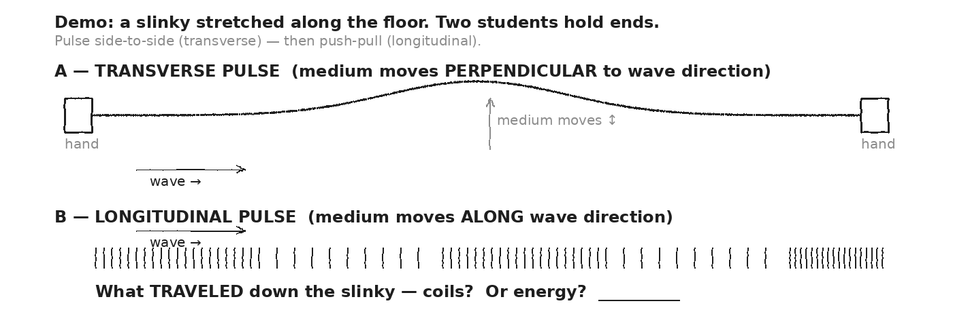

VOCAB · WAVE
Definition: A disturbance that transfers ENERGY (and information) through a medium without transferring matter. The medium oscillates in place; only the pattern moves.
Example: A floating cork bobs up and down as an ocean wave passes — but doesn't move with the wave. Sound makes air molecules wiggle in place; the COMPRESSION pattern travels.
Cognates: Sp. onda · Pt. onda · HC vag
Watch out: The medium does NOT travel. Only the DISTURBANCE travels. A wave can move kilometers; the water molecules barely shift.

VOCAB · TRANSVERSE WAVE
Definition: The medium oscillates PERPENDICULAR to the direction the wave travels.
Example: A rope shaken up and down. Light waves. Seismic S-waves.
Cognates: Sp. onda transversal · Pt. onda transversal · HC vag transvèsal
Watch out: Picture the wave moving →, but the medium wiggling ↕. Two different directions.

VOCAB · LONGITUDINAL WAVE
Definition: The medium oscillates PARALLEL to the direction the wave travels. Compressions and rarefactions.
Example: Sound waves in air. A slinky pushed-and-pulled along its length. Seismic P-waves.
Cognates: Sp. onda longitudinal · Pt. onda longitudinal · HC vag longitidinal
Watch out: A wave's TYPE (transverse / longitudinal) is about how the medium moves, NOT about what carries the wave.

MY GUESS — if a wave can transfer energy without transferring matter, how could a SIGNAL from Earth ever measure something millions of km away? (Day 15 is the answer.)
★ | Unit 6 has THREE payoff days. Day 15: RADAR — every 2026-XJ number traces to bounced radio waves. Day 16: METEOR COLOR — Wien's law connects glow color to temperature. Day 17: SEISMIC + TSUNAMI — mechanical waves carry impact damage across the planet.

EXIT TICKET — Day 1
You wave the end of a rope. A pulse travels down the rope. What's moving through the rope: rope material, energy, or both? Explain in two sentences.

Today's Targets — Rate Yourself
1 = Not Yet (I can't do this without help) 2 = Almost (I can do this with some help or some errors) 3 = Got It (I can do this independently and explain it)
Help? Check the box if you want to talk with me about this target — even if you marked yourself a 3.
Target | 1 | 2 | 3 | Help?
I can describe what travels in a wave (energy + info — not matter). | ○ | ○ | ○ | ☐
I can distinguish transverse vs. longitudinal. | ○ | ○ | ○ | ☐
I can name the three Unit 6 payoff days. | ○ | ○ | ○ | ☐

Day 2 — Wave Anatomy: Frequency · Wavelength · Amplitude · Period

Today's Target
I can identify f, λ, A, and T on a wave diagram, give correct units for each, and use f = 1/T to convert between frequency and period.
ASTEROID THREAD
What we know about 2026-XJ today: Radar uses radio waves around f ≈ 10⁹ Hz (gigahertz). At c = 3×10⁸ m/s, that's λ ≈ 0.3 m wavelength.
How today connects: Today: the vocabulary that lets us describe radar precisely. Day 3: the equation that connects them.

VOCAB · WAVELENGTH (Λ)
Definition: Distance from one crest to the next crest (or any equivalent point). A SPACE measurement. Units: m, mm, nm.
Example: Visible light ≈ 500 nm. Sound (at 440 Hz, A4) ≈ 0.78 m. Ocean swell ≈ 30 m. Radio FM ≈ 3 m.
Cognates: Sp. longitud de onda · Pt. comprimento de onda · HC longè vag
Watch out: λ is in METERS, not seconds. It's a distance. The Greek letter looks like a wishbone.

VOCAB · AMPLITUDE (A)
Definition: Maximum displacement from the rest position. A SPACE measurement. Units: m for transverse, Pa for sound pressure.
Example: A loud sound has bigger A than a soft sound at the same pitch. Bright light has bigger A than dim light at the same color.
Cognates: Sp. amplitud · Pt. amplitude · HC anplitid
Watch out: A is the MAX displacement, not crest-to-trough. The full peak-to-peak is 2A.

VOCAB · PERIOD (T)
Definition: Time for ONE complete cycle. A TIME measurement. Units: seconds (s).
Example: A 440 Hz tuning fork has T = 1/440 ≈ 0.00227 s. Earth's orbit: T = 1 year.
Cognates: Sp. período · Pt. período · HC peryòd
Watch out: T is SECONDS PER CYCLE. f is CYCLES PER SECOND. They are reciprocals.

VOCAB · FREQUENCY (F)
Definition: Number of cycles per second. Units: hertz (Hz). f = 1/T.
Example: A 440 Hz tuning fork vibrates 440 times per second. FM radio at 95.7 MHz vibrates 9.57 × 10⁷ times per second.
Cognates: Sp. frecuencia · Pt. frequência · HC fwekans
Watch out: Higher f = MORE cycles per second = shorter T. For sound: higher f = higher pitch.

DOODLE ZONE
Label each property — λ, A, T — on the sine wave with arrows. Then identify which label is a SPACE measurement and which is a TIME measurement.
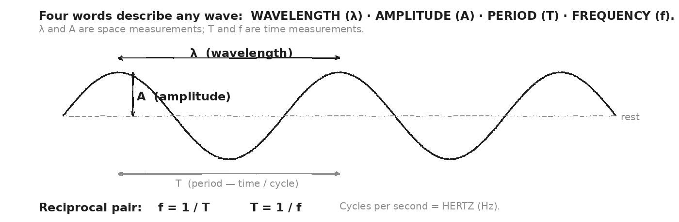

WORKED EXAMPLE — convert T to f
A wave has period T = 0.004 s. What's its frequency?
GIVEN | T = 0.004 s
EQUATION | f = 1 / T
WORK | f = 1 / 0.004  f = 250 Hz
ANSWER | f = 250 Hz (250 cycles per second).

WORKED EXAMPLE — convert f to T
A tuning fork has f = 440 Hz. What's its period?
GIVEN | f = 440 Hz
EQUATION | T = 1 / f
WORK | T = 1 / 440  T ≈ 0.00227 s  T ≈ 2.27 ms
ANSWER | T ≈ 2.27 milliseconds.

YOUR TURN — period of a radar pulse
A radar transmitter operates at f = 2.4 GHz = 2.4 × 10⁹ Hz. What's its period (in seconds and nanoseconds)?
GIVEN
EQUATION
WORK
ANSWER

★ | ONE 2.4 GHz radio pulse takes about 0.42 nanoseconds per cycle. In a 1 μs pulse, that's 2400 cycles. Day 15 will show why pulses contain THOUSANDS of cycles — for precise distance + Doppler measurement.

Fill in the frame:
f tells us ________________________________________________________ per second. T tells us seconds per ________________________________________________________. They are reciprocals, so high f means ________________________________________________________ T.
EXIT TICKET — Day 2
A wave has f = 250 Hz. What's its period? Show one line of work.

Today's Targets — Rate Yourself
1 = Not Yet (I can't do this without help) 2 = Almost (I can do this with some help or some errors) 3 = Got It (I can do this independently and explain it)
Help? Check the box if you want to talk with me about this target — even if you marked yourself a 3.
Target | 1 | 2 | 3 | Help?
I can label λ, A, T, f on a wave diagram. | ○ | ○ | ○ | ☐
I can convert between f and T using f = 1/T. | ○ | ○ | ○ | ☐
I can give correct units for each property. | ○ | ○ | ○ | ☐

Day 3 — The Wave Equation: v = f · λ

Today's Target
I can apply v = fλ to compute any one of v, f, or λ given the other two, and explain WHY a wave changing media keeps the same f but changes λ.
ASTEROID THREAD
What we know about 2026-XJ today: Radar pulses travel at v = c = 3×10⁸ m/s. The round-trip time tells distance.
How today connects: Today's equation IS the radar equation in disguise. Once you trust v = fλ for everyday waves, you trust d = c·Δt/2 for radar.

VOCAB · V = F · Λ
Definition: Speed of a wave equals frequency times wavelength. Same equation for water, sound, light, radio.
Example: Sound at 440 Hz with λ = 0.78 m: v = 440 · 0.78 ≈ 343 m/s (sound in air).
Cognates: Sp. v = f · λ · Pt. v = f · λ (universal symbols)
Watch out: v depends on the MEDIUM. f is set by the SOURCE. λ adjusts: λ = v/f. Same source, different medium → different λ.

DOODLE ZONE
Two snapshots of the same wave, one period apart. Mark a single crest in both. How far did it travel? Write the relationship: speed = distance / time.
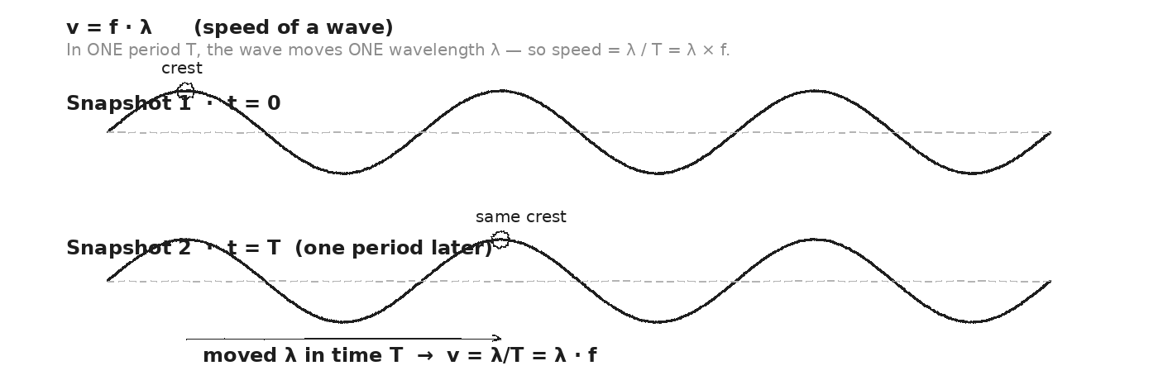

WORKED EXAMPLE — sound's wavelength in air at A4
An A4 tuning fork at 440 Hz makes sound that travels at v = 343 m/s in air. What's the wavelength?
GIVEN | f = 440 Hz · v = 343 m/s
EQUATION | v = f · λ → λ = v / f
WORK | λ = 343 / 440  λ ≈ 0.78 m
ANSWER | λ ≈ 0.78 m ≈ 78 cm.

WORKED EXAMPLE — FM radio wavelength
An FM radio station broadcasts at f = 100 MHz = 10⁸ Hz. Radio waves travel at c = 3 × 10⁸ m/s. What's the wavelength?
GIVEN | f = 10⁸ Hz · c = 3 × 10⁸ m/s
EQUATION | λ = c / f
WORK | λ = (3 × 10⁸) / 10⁸  λ = 3 m
ANSWER | λ = 3 m. An FM antenna sized at λ/4 ≈ 75 cm captures these waves efficiently.

YOUR TURN — A4 in water
The same A4 tuning fork (f = 440 Hz) sounds underwater. Sound in water moves at v ≈ 1480 m/s. What's the new wavelength?
GIVEN
EQUATION
WORK
ANSWER

YOUR TURN — radar wavelength
NASA's planetary radar transmits at f = 2.4 GHz = 2.4 × 10⁹ Hz. Radio in vacuum travels at c = 3 × 10⁸ m/s. What's λ?
GIVEN
EQUATION
WORK
ANSWER

★ | Same source, two media. Same FREQUENCY (set by the source). But because v differs in each medium, the WAVELENGTH adjusts to fit. This is exactly why refraction (Day 5) happens at a boundary.

Fill in the frame:
When a wave enters a new medium, the SOURCE doesn't change. So f stays the ________________________________________________________. But v changes, so by v = fλ, the ________________________________________________________ must change. If v decreases, λ ________________________________________________________.
EXIT TICKET — Day 3
An FM radio wave has f = 95 MHz. What's its wavelength? (Use c = 3 × 10⁸ m/s.)

Today's Targets — Rate Yourself
1 = Not Yet (I can't do this without help) 2 = Almost (I can do this with some help or some errors) 3 = Got It (I can do this independently and explain it)
Help? Check the box if you want to talk with me about this target — even if you marked yourself a 3.
Target | 1 | 2 | 3 | Help?
I can apply v = fλ in any direction (solve for v, f, or λ). | ○ | ○ | ○ | ☐
I can explain why f is unchanged across media but λ changes. | ○ | ○ | ○ | ☐
I can compute λ for radio and sound at given frequencies. | ○ | ○ | ○ | ☐

Day 4 — Reflection at Boundaries: θᵢ = θᵣ (from the normal)

Today's Target
I can apply the law of reflection to predict the reflected angle, measuring angles from the NORMAL — not from the surface — and explain why the law holds for sound, light, and radar.
ASTEROID THREAD
What we know about 2026-XJ today: Radar works because radio waves REFLECT off the asteroid. Without reflection, no echo, no distance, no Doppler.
How today connects: Today: the law that says EVERY wave reflects with equal angles. Day 15 applies this to the radar echo from 2026-XJ.

VOCAB · LAW OF REFLECTION
Definition: The angle of incidence equals the angle of reflection. Both angles are measured from the NORMAL (perpendicular to the surface).
Example: Light at 35° from normal reflects at 35° from normal — on the OTHER side of the normal. Same for radar off an asteroid.
Cognates: Sp. ley de reflexión · Pt. lei da reflexão · HC lwa refleksyon
Watch out: Measure from the NORMAL, not the surface. A common mistake: "35° from the mirror" — that's actually 55° from the normal.

VOCAB · NORMAL
Definition: A line perpendicular to the surface at the point where the wave hits.
Example: On a flat tabletop, the normal points straight up. On a curved mirror, the normal is perpendicular to the tangent at that point.
Cognates: Sp. normal · Pt. normal · HC nòmal
Watch out: "Normal" in physics means perpendicular — not "usual".

VOCAB · TRANSMISSION (VS. REFLECTION)
Definition: When a wave hits a boundary, SOME reflects and SOME transmits into the new medium. The fraction depends on the impedance contrast between the two media.
Example: A wave hits a brick wall → almost all reflects. Hits a curtain → much passes through. Light through window → most transmits.
Cognates: Sp. transmisión · Pt. transmissão · HC transmisyon
Watch out: Reflection + transmission together conserve the wave's energy (minus any absorbed).

DOODLE ZONE
Mark angle of incidence (θᵢ) and angle of reflection (θᵣ) — both from the NORMAL, not from the mirror surface. Verify the angles are equal.
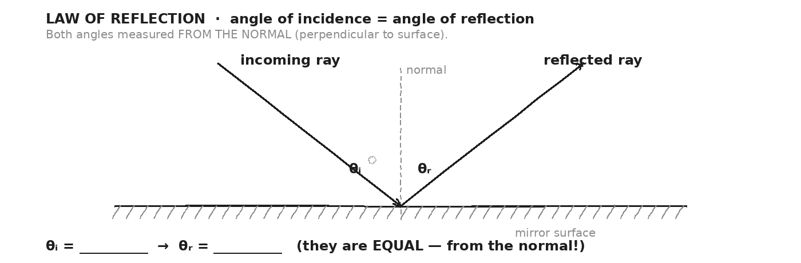

WORKED EXAMPLE — laser off a mirror
You shine a laser at a mirror so the beam makes a 35° angle with the NORMAL. At what angle does it reflect?
GIVEN | θᵢ = 35° (from normal)
EQUATION | θᵣ = θᵢ
WORK | θᵣ = 35°
ANSWER | The beam reflects at 35° from the normal, on the OTHER side of the normal.

WORKED EXAMPLE — angle given from surface
A radar beam strikes a flat asteroid surface at 20° from the SURFACE (i.e., a glancing hit). At what angle from the surface does it reflect?
GIVEN | 20° from surface → 70° from normal
EQUATION | θᵣ (from normal) = θᵢ (from normal) = 70°
WORK | θᵣ (from surface) = 90° − 70° = 20°
ANSWER | 20° from the surface — same as it came in. (Always convert to angle-from-normal first.)

YOUR TURN — sound off a wall
A sound wave hits a wall at 50° from the normal. At what angle does the echo return? What if measured from the wall surface?
GIVEN
EQUATION
WORK
ANSWER

★ | A perfectly mirrored asteroid would reflect the radar straight back if hit head-on. Real asteroids have ROUGH surfaces — radar scatters in many directions. The echo we detect is whatever reflects toward Earth. Signal strength × distance² ≈ size estimate (Day 15).

Fill in the frame:
When a wave hits a flat surface, the angle measured from the ________________________________________________________ on the way IN equals the angle on the way OUT. We never measure from the ________________________________________________________ itself.
EXIT TICKET — Day 4
You shine a laser at a mirror at 35° from the normal. At what angle does it reflect? If you accidentally measured 35° from the mirror surface, what would the reflected angle be in that frame?

Today's Targets — Rate Yourself
1 = Not Yet (I can't do this without help) 2 = Almost (I can do this with some help or some errors) 3 = Got It (I can do this independently and explain it)
Help? Check the box if you want to talk with me about this target — even if you marked yourself a 3.
Target | 1 | 2 | 3 | Help?
I can apply the law of reflection from the normal. | ○ | ○ | ○ | ☐
I can convert between angle-from-normal and angle-from-surface. | ○ | ○ | ○ | ☐
I can explain WHY radar works (waves reflect). | ○ | ○ | ○ | ☐

Day 5 — Refraction: Speed Change → Direction Change

Today's Target
I can predict whether a wave bends TOWARD or AWAY from the normal as it enters a new medium, given which medium is faster.
ASTEROID THREAD
What we know about 2026-XJ today: Radio waves don't refract much in vacuum, but they DO refract in Earth's atmosphere. Sound from a distant impact refracts in air (sound bends toward cooler air).
How today connects: The pencil-in-water effect IS refraction. Same rule explains why distant thunder can be heard around hills.

VOCAB · REFRACTION
Definition: The BENDING of a wave at a boundary, caused by a change in wave SPEED. Slower medium → bends TOWARD normal. Faster medium → bends AWAY.
Example: Light going from air (faster) into water (slower) bends TOWARD the normal. That's why a pencil in a glass of water looks broken at the surface.
Cognates: Sp. refracción · Pt. refração · HC refraksyon
Watch out: Refraction needs a SPEED CHANGE, not just a boundary. If two media have the same wave speed, no refraction occurs.

VOCAB · INDEX OF REFRACTION (N) — ADVANCED
Definition: A ratio: n = c / v_in_medium. Higher n = slower wave. Air ≈ 1.00, water ≈ 1.33, glass ≈ 1.50.
Example: In glass (n = 1.5), light travels at 2 × 10⁸ m/s — two-thirds of c.
Cognates: Sp. índice de refracción · Pt. índice de refração
Watch out: Big n = SLOWER medium. The bigger the n, the more the wave slows and the more it bends toward normal.

DOODLE ZONE
The pencil enters water at an angle. Draw the normal at the air-water boundary. Which way does the wave bend? Mark θ₁ (above) and θ₂ (below).
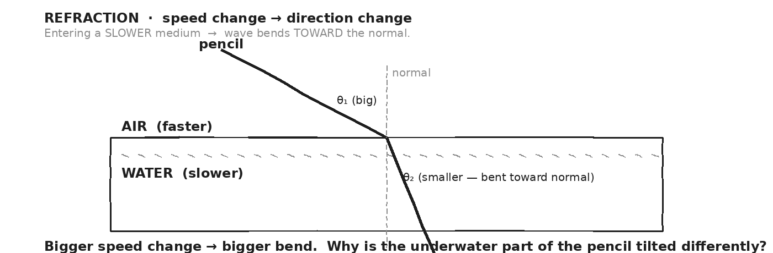

WORKED EXAMPLE — predict the bend direction
Light enters water from air. Does it bend TOWARD or AWAY from the normal? Why?
GIVEN | Light in air: v ≈ c (faster) · Light in water: v ≈ 0.75c (slower)
EQUATION | Slower medium → bends TOWARD normal
WORK | Water is the slower medium.  Therefore the light bends TOWARD the normal in water.  θ₂ (in water) < θ₁ (in air).
ANSWER | Bends TOWARD normal. The refracted ray is closer to vertical than the incident ray.

WORKED EXAMPLE — coming back out
A swimmer underwater shines a flashlight UP through the water surface into the air. Does the beam bend toward or away from the normal as it exits water into air?
GIVEN | Light leaves water (slow) and enters air (fast).
EQUATION | Faster medium → bends AWAY from normal
WORK | Air is the faster medium.  Therefore the light bends AWAY from the normal as it leaves water.
ANSWER | AWAY from the normal. The beam tilts further from vertical as it exits.

YOUR TURN — radio in atmosphere
Radio waves enter Earth's atmosphere from space. The ionosphere slows them slightly compared to vacuum. Which way would the waves bend?
GIVEN
EQUATION
WORK
ANSWER

⚠ | Marching-band analogy: a row of soldiers marching at angle into mud. The side hitting mud first slows; the row twists. Same with waves entering the slower medium. The geometry follows.

Fill in the frame:
When a wave enters a SLOWER medium, the side that hits the boundary first ________________________________________________________ first. That makes the wavefront ________________________________________________________, bending it ________________________________________________________ the normal.
EXIT TICKET — Day 5
Light enters glass (n = 1.5) from air (n = 1.0). Does it bend toward or away from the normal? In one sentence, explain why.

Today's Targets — Rate Yourself
1 = Not Yet (I can't do this without help) 2 = Almost (I can do this with some help or some errors) 3 = Got It (I can do this independently and explain it)
Help? Check the box if you want to talk with me about this target — even if you marked yourself a 3.
Target | 1 | 2 | 3 | Help?
I can predict bend direction from speed change. | ○ | ○ | ○ | ☐
I can apply the rule to light + sound + radar. | ○ | ○ | ○ | ☐
I can explain refraction with the marching-band analogy. | ○ | ○ | ○ | ☐

Day 6 — Diffraction: Waves Bend Around Obstacles + Through Openings

Today's Target
I can predict how much diffraction occurs given the ratio of wavelength to obstacle size, and explain why we can HEAR around a corner but not SEE around one.
ASTEROID THREAD
What we know about 2026-XJ today: Long-wavelength radar diffracts around mountains (over-the-horizon radar). Short-wavelength radar doesn't diffract around small objects — better RESOLUTION for asteroid imaging.
How today connects: Engineers CHOOSE the radar wavelength based on what they want to detect. Diffraction sets the trade-off.

VOCAB · DIFFRACTION
Definition: The spreading of a wave as it passes by an obstacle or through an opening. More diffraction when the opening is comparable to or smaller than the wavelength.
Example: Sound (λ ≈ 1 m) diffracts easily around doorways. Visible light (λ ≈ 500 nm) barely diffracts around everyday objects — that's why we get sharp shadows.
Cognates: Sp. difracción · Pt. difração · HC difraksyon
Watch out: More diffraction when λ ≈ obstacle size. If obstacle is much BIGGER than λ, the wave just passes straight (light through a window) or stops (light by a wall).

VOCAB · RESOLUTION (IN RADAR / IMAGING) — PREVIEW
Definition: The minimum size of detail you can distinguish. Limited by diffraction — you can't resolve features smaller than ~λ.
Example: Optical telescope (λ ≈ 500 nm) can see details down to nm-scale on a microscope. Radar at λ ≈ 0.1 m can resolve asteroid features down to ~0.1 m.
Cognates: Sp. resolución · Pt. resolução · HC rezolisyon
Watch out: Shorter wavelength = better resolution. That's why X-ray crystallography (λ ≈ 0.1 nm) can image molecules.

DOODLE ZONE
Compare the wide slit vs. narrow slit. Which produces a wave-fan? Why? What sets the amount of fanning — the slit size, the wavelength, or BOTH?
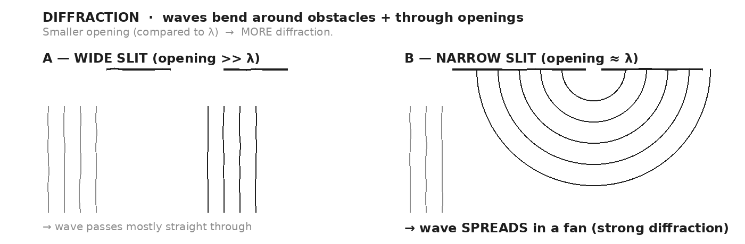

WORKED EXAMPLE — why you hear but don't see around a corner
Sound has λ ≈ 1 m. Visible light has λ ≈ 500 nm = 5 × 10⁻⁷ m. A doorway is 1 m wide. Compare each wave's λ-to-opening ratio. Which diffracts strongly through the doorway?
GIVEN | λ_sound = 1 m · λ_light = 5 × 10⁻⁷ m · opening width = 1 m
EQUATION | ratio = λ / opening → compare
WORK | λ_sound / 1 m = 1 (comparable)  λ_light / 1 m = 5 × 10⁻⁷ (tiny)  Sound: ratio ≈ 1, strong diffraction.  Light: ratio ≈ 10⁻⁷, essentially no diffraction.
ANSWER | Sound diffracts → you HEAR around the doorway. Light doesn't diffract → you can't SEE around the doorway.

YOUR TURN — pick a radar wavelength
You want to image an asteroid the size of a city block (~100 m across) but resolve features ~1 m in size. Should you use long-wavelength radio (~10 m) or short-wavelength radar (~0.1 m)? Explain.
GIVEN
EQUATION
WORK
ANSWER

★ | Radio telescopes can see HUGE features in galaxies that optical telescopes can't — long wavelengths diffract around the dust clouds blocking visible light. Different wavelengths = different VIEWS of the universe.

Fill in the frame:
Diffraction happens when a wave passes through an opening or around an obstacle whose size is comparable to its ________________________________________________________. The bigger the ratio of λ to obstacle size, the MORE the wave ________________________________________________________.
EXIT TICKET — Day 6
Why can you hear a conversation around a corner but not see the speaker? Answer with wavelengths.

Today's Targets — Rate Yourself
1 = Not Yet (I can't do this without help) 2 = Almost (I can do this with some help or some errors) 3 = Got It (I can do this independently and explain it)
Help? Check the box if you want to talk with me about this target — even if you marked yourself a 3.
Target | 1 | 2 | 3 | Help?
I can predict diffraction strength from λ vs. obstacle size. | ○ | ○ | ○ | ☐
I can explain hear-vs-see-around-corner using wavelengths. | ○ | ○ | ○ | ☐
I can explain the radar wavelength trade-off. | ○ | ○ | ○ | ☐

Day 7 — Interference + Standing Waves: When Two Waves Meet, They ADD

Today's Target
I can predict constructive vs. destructive interference based on whether two waves are in phase, and identify a standing wave as the interference of a wave with its reflection.
ASTEROID THREAD
What we know about 2026-XJ today: Modern radar uses INTERFEROMETRY — combining signals from multiple receivers to resolve fine asteroid details much smaller than a single antenna could see.
How today connects: Day 9 builds on standing waves to explain how guitar strings + organ pipes (and Earth's seismic resonances on Day 17) work.

VOCAB · INTERFERENCE
Definition: When two waves meet, their displacements ADD at each point. Same-direction crests → bigger crest (CONSTRUCTIVE). Opposite displacements → cancellation (DESTRUCTIVE).
Example: Two stones dropped in a pond — ripples meet and create bright + dark patterns. Noise-canceling headphones produce a sound exactly opposite to incoming noise — they CANCEL.
Cognates: Sp. interferencia · Pt. interferência · HC entèfewans
Watch out: Interference doesn't destroy energy. In destructive zones, the energy is just shifted to constructive zones elsewhere.

VOCAB · CONSTRUCTIVE INTERFERENCE
Definition: Two waves IN PHASE: crests align with crests, troughs with troughs. Net displacement = sum (bigger).
Example: Two speakers playing the same tone reinforce each other at certain spots = LOUD.
Cognates: Sp. interferencia constructiva · Pt. interferência construtiva
Watch out: In phase doesn't mean identical — it means crests align in TIME and SPACE.

VOCAB · DESTRUCTIVE INTERFERENCE
Definition: Two waves OUT OF PHASE by half a wavelength: crests align with troughs. Net displacement = 0 (cancellation).
Example: Noise-canceling headphones detect incoming noise and play the EXACT OPPOSITE — they cancel at your eardrum.
Cognates: Sp. interferencia destructiva · Pt. interferência destrutiva
Watch out: Energy isn't destroyed — it's redistributed. At dark fringes the energy is zero; at bright fringes it's doubled.

VOCAB · STANDING WAVE
Definition: A wave interfering with its own reflection. Produces fixed NODES (no motion) and ANTINODES (max motion). The wave LOOKS stationary.
Example: A guitar string fixed at both ends. Pluck it — a standing wave forms. The fundamental has nodes at the ends and one antinode in the middle.
Cognates: Sp. onda estacionaria · Pt. onda estacionária · HC vag estasyonè
Watch out: A standing wave is REAL motion of the medium — the wave just doesn't TRANSLATE left-right. It oscillates up-down at fixed locations.

DOODLE ZONE
TOP: two waves IN PHASE — sum. BOTTOM: two waves OUT OF PHASE — sum. Mark the amplitudes (in phase = double, out of phase = zero).
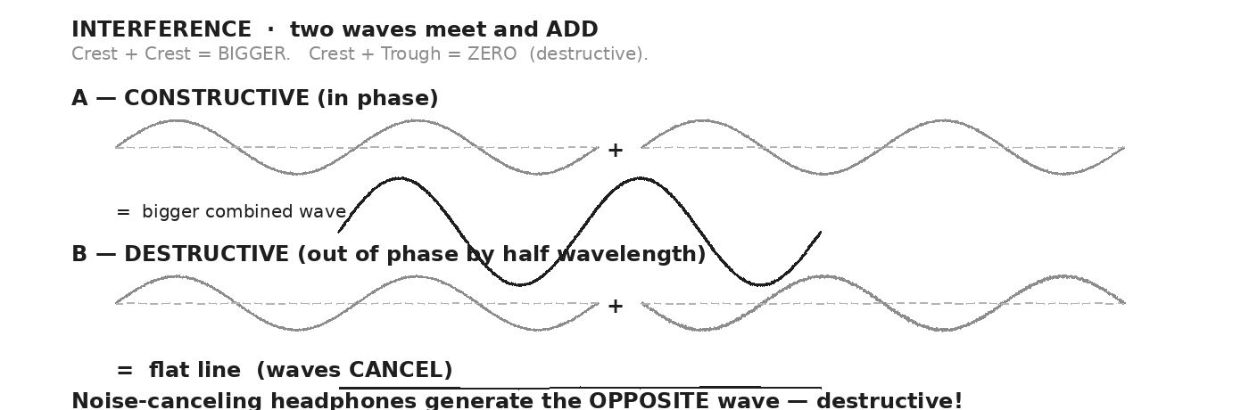

WORKED EXAMPLE — noise-canceling headphones
Incoming engine noise enters as a 200 Hz wave with amplitude A = 1 (relative units). The headphones detect it and produce a 200 Hz wave with amplitude A = 1, but SHIFTED by half a wavelength. What's the net amplitude at your eardrum?
GIVEN | Both waves: 200 Hz, A = 1. Headphone wave shifted by λ/2 (opposite phase).
EQUATION | A_net = A₁ + A₂ (where A₂ is OPPOSITE-signed)
WORK | At every instant: A_net = (+1) + (−1) = 0  Continuously for both waves → silence at the eardrum.
ANSWER | A_net = 0 → silence. (Headphones never PERFECTLY cancel — but ~30 dB attenuation is real.)

WORKED EXAMPLE — guitar string fundamental
A guitar string is 0.65 m long. The wave speed along the string is 80 m/s. What's the fundamental (lowest) standing-wave frequency?
GIVEN | L = 0.65 m · v = 80 m/s · n = 1 (fundamental)
EQUATION | f₁ = v / (2L)
WORK | f₁ = 80 / (2 · 0.65)  f₁ = 80 / 1.30  f₁ ≈ 61.5 Hz
ANSWER | f₁ ≈ 61.5 Hz. The second harmonic (n = 2) would be 123 Hz, third 184.5, etc.

YOUR TURN — pipe organ
A 1.0-m-long pipe organ tube, open at both ends, supports standing waves. Sound in air is 343 m/s. What's the fundamental frequency? (Use f₁ = v/(2L).)
GIVEN
EQUATION
WORK
ANSWER

★ | The frequencies a guitar string + pipe organ + bell + Earth's crust + even an asteroid PRODUCE are set by their geometry — which standing waves fit. That's why a long string has a low fundamental and a short string a high one.

Fill in the frame:
Two waves in phase produce ________________________________________________________ interference. Two waves out of phase by λ/2 produce ________________________________________________________ interference. A standing wave is what happens when a wave interferes with its own ________________________________________________________.
EXIT TICKET — Day 7
Noise-canceling headphones produce a sound wave OPPOSITE to incoming noise. Why does this cancel? Where does the noise energy go? Answer in two sentences.

Today's Targets — Rate Yourself
1 = Not Yet (I can't do this without help) 2 = Almost (I can do this with some help or some errors) 3 = Got It (I can do this independently and explain it)
Help? Check the box if you want to talk with me about this target — even if you marked yourself a 3.
Target | 1 | 2 | 3 | Help?
I can predict constructive vs. destructive interference. | ○ | ○ | ○ | ☐
I can identify a standing wave and locate nodes + antinodes. | ○ | ○ | ○ | ☐
I can compute f_n = nv/(2L) for a fixed-end string. | ○ | ○ | ○ | ☐

Day 8 — Sound is a Longitudinal Wave · Pitch = f · Loudness = A

Today's Target
I can describe sound as a longitudinal mechanical wave, identify pitch with frequency and loudness with amplitude, and explain why sound needs a MEDIUM (no sound in space).
ASTEROID THREAD
What we know about 2026-XJ today: An asteroid impact generates HUGE atmospheric shockwaves and INFRASOUND (< 20 Hz). The infrasound from the 2013 Chelyabinsk impact traveled around the entire planet — twice.
How today connects: Today: the foundation. Day 17 applies sound + seismic-wave physics to predict the damage and detection range from an asteroid strike.

VOCAB · SOUND (AS A WAVE)
Definition: A longitudinal mechanical wave — compressions and rarefactions in a medium (air, water, solid). Cannot travel through vacuum.
Example: A tuning fork pushes air molecules forward (compression), then pulls them back (rarefaction). The pattern travels outward at v ≈ 343 m/s in air.
Cognates: Sp. sonido · Pt. som · HC son
Watch out: Sound is NOT made of moving air. Air molecules wiggle in place; only the COMPRESSION pattern moves. No medium = no sound.

VOCAB · PITCH
Definition: Our perception of a sound's frequency. Higher f = higher pitch. Units: Hz.
Example: Middle C ≈ 262 Hz. A4 = 440 Hz. Soprano high note ≈ 1500 Hz. Bass drum ≈ 50 Hz.
Cognates: Sp. tono · Pt. altura · HC ton
Watch out: Pitch is the PERCEPTUAL name; frequency is the physical quantity. Same idea, but pitch is what your brain hears.

VOCAB · LOUDNESS
Definition: Our perception of a sound's amplitude (or intensity). Bigger A = louder. Often measured in decibels on a logarithmic scale.
Example: A whisper has small A; a rock concert has large A. Doubling the AMPLITUDE more than doubles loudness perception.
Cognates: Sp. intensidad · Pt. intensidade · HC fòs
Watch out: Loudness is logarithmic in our ears. +10 dB feels about twice as loud, even though it's ×10 intensity.

VOCAB · INFRASOUND + ULTRASOUND
Definition: INFRASOUND is sound below 20 Hz (we can't hear it). ULTRASOUND is above 20 kHz (we can't hear it). Both are real sound waves; just outside our range.
Example: Asteroid impacts produce powerful infrasound. Bats use ultrasound for echolocation. Medical ultrasound imaging operates near 1 MHz.
Cognates: Sp. infrasonido / ultrasonido · Pt. infrassom / ultrassom
Watch out: Infra = below; ultra = above. Both are bands we don't hear, but other animals (and instruments) do.

DOODLE ZONE
Pattern shows alternating dense + sparse vertical lines. Label one COMPRESSION and one RAREFACTION. Mark the direction the SOUND travels — is it the same as the molecule motion, or perpendicular?
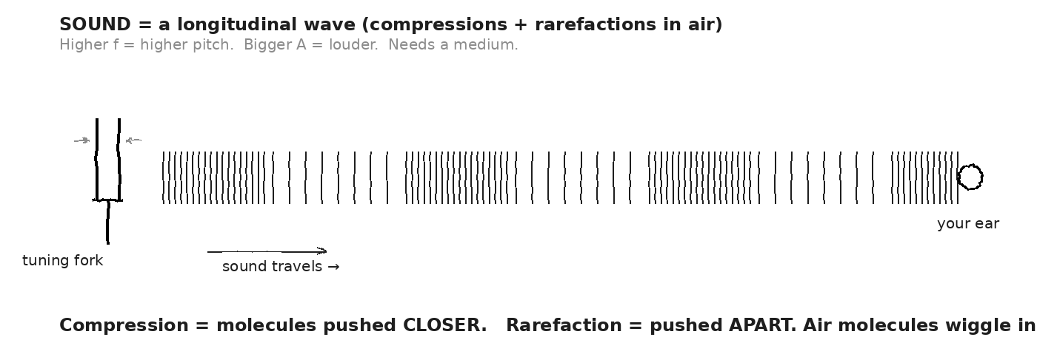

WORKED EXAMPLE — why no sound in space
In a sci-fi movie, an explosion in space is shown with a loud BOOM. From a physics perspective, what's wrong?
GIVEN | Sound = compression wave needing a medium
EQUATION | (qualitative — no equation needed)
WORK | Space between objects is nearly vacuum.  Sound needs molecules to compress + rarefy.  No molecules → no compressions → no sound wave.
ANSWER | The boom can't propagate. Realistic space explosions are SILENT.

WORKED EXAMPLE — same source, two media
A 1000 Hz tuning fork is held just above the surface of a lake. What are the WAVELENGTHS of the sound (a) in air (v = 343 m/s) and (b) in water (v = 1480 m/s)?
GIVEN | f = 1000 Hz · v_air = 343 · v_water = 1480
EQUATION | λ = v / f
WORK | (a) λ_air = 343 / 1000 = 0.343 m  (b) λ_water = 1480 / 1000 = 1.48 m  Same f, but λ in water is 4.3× larger.
ANSWER | Air: 0.343 m. Water: 1.48 m. Same f, faster medium → longer λ.

YOUR TURN — period of a tuning fork
A 512 Hz tuning fork is struck. What's the period of one cycle? (Use T = 1/f.)
GIVEN
EQUATION
WORK
ANSWER

★ | Infrasound is the asteroid impact's long-distance signature. Below 20 Hz, sound waves travel thousands of km with little attenuation. NOAA's infrasound monitoring network has detected every major asteroid airburst since 2000.

Fill in the frame:
Sound is a ________________________________________________________ wave (compressions + rarefactions). Pitch is the perception of ________________________________________________________. Loudness is the perception of ________________________________________________________. Without a medium, sound cannot ________________________________________________________.
EXIT TICKET — Day 8
Why is there no sound in outer space, even from a violent event? Answer in two sentences using the word 'medium'.

Today's Targets — Rate Yourself
1 = Not Yet (I can't do this without help) 2 = Almost (I can do this with some help or some errors) 3 = Got It (I can do this independently and explain it)
Help? Check the box if you want to talk with me about this target — even if you marked yourself a 3.
Target | 1 | 2 | 3 | Help?
I can describe sound as a longitudinal wave. | ○ | ○ | ○ | ☐
I can connect frequency to pitch + amplitude to loudness. | ○ | ○ | ○ | ☐
I can explain why sound needs a medium. | ○ | ○ | ○ | ☐

Day 9 — Speed of Sound + Resonance — Why Instruments Sound the Way They Do

Today's Target
I can predict the speed of sound in different media (air, water, solid) and apply f_n = nv/(2L) to find the fundamental + harmonics of a standing wave instrument.
ASTEROID THREAD
What we know about 2026-XJ today: Earth has natural resonant frequencies — when a major impact (or earthquake) happens, the planet 'rings' at characteristic frequencies.
How today connects: Day 17's seismic waves are launched at these resonances. A 2026-XJ impact would excite them measurably from the other side of the planet.

VOCAB · SPEED OF SOUND (V_SOUND)
Definition: The speed at which compression waves travel through a medium. Faster in stiff media, slower in compressible ones. Increases with temperature in gases.
Example: Air at 20 °C: ≈ 343 m/s. Water: ≈ 1480 m/s. Steel: ≈ 5960 m/s. Adding 1 °C to air adds about 0.6 m/s.
Cognates: Sp. velocidad del sonido · Pt. velocidade do som · HC vitès son
Watch out: A stiff medium (steel) transmits sound FASTER, not slower. Stiff = fast restoring force = fast wave.

VOCAB · RESONANCE
Definition: When you drive a system at one of its natural standing-wave frequencies, energy builds up. The system 'sings' loudly at that frequency.
Example: Push a kid on a swing at exactly the swing's natural period → they go very high. Hit the right note near a wine glass → it shatters. Earth rings at low-Hz frequencies after large earthquakes.
Cognates: Sp. resonancia · Pt. ressonância · HC rezonans
Watch out: Resonance requires MATCHING the natural frequency. Wrong frequency → energy doesn't build up.

DOODLE ZONE
Three rows show n = 1, 2, 3 standing waves on a fixed-end string. For n = 1, λ = ____. Compute f₁ using v = 80 m/s, L = 0.65 m.
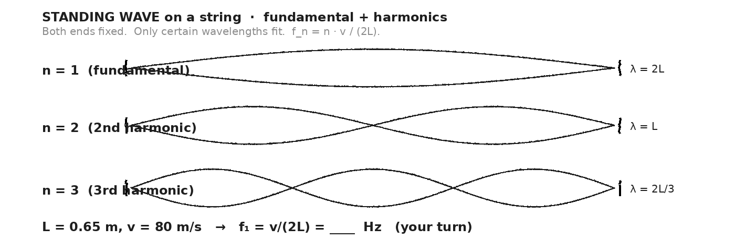

WORKED EXAMPLE — guitar string fundamental
A guitar string is 0.65 m long. Wave speed on the string is 80 m/s. What's the fundamental frequency?
GIVEN | L = 0.65 m · v = 80 m/s · n = 1
EQUATION | f_n = n · v / (2L)
WORK | f₁ = 1 · 80 / (2 · 0.65)  f₁ = 80 / 1.30  f₁ ≈ 61.5 Hz
ANSWER | f₁ ≈ 61.5 Hz (close to a low B on a bass guitar).

WORKED EXAMPLE — echo distance from 3-second delay
You shout into a canyon and hear the echo 3.0 s later. How far away is the canyon wall? (v_sound in air = 343 m/s.)
GIVEN | Δt_round_trip = 3.0 s · v = 343 m/s
EQUATION | d = v · Δt / 2 (round-trip → one-way)
WORK | d = 343 · 3.0 / 2  d = 1029 / 2  d ≈ 514 m
ANSWER | ≈ 514 m. (Quick rule: 1 second of echo delay ≈ 170 m to wall.)

YOUR TURN — harmonics of an open pipe
A 0.85-m pipe organ tube, open at both ends, has v_sound = 343 m/s. Compute f₁ and f₂.
GIVEN
EQUATION
WORK
ANSWER

★ | The 1960 Chilean earthquake (9.5 magnitude) rang Earth like a bell for weeks. Some of its longest-period oscillations had T ≈ 54 minutes — below 1 mHz infrasound. Day 17 returns to seismic resonance.

Fill in the frame:
A standing wave's frequency depends on the medium speed ________________________________________________________ and the geometry ________________________________________________________ — specifically, f₁ = v/(2L). The harmonics are multiples of ________________________________________________________.
EXIT TICKET — Day 9
A guitar string is 65 cm long. The wave speed on the string is 80 m/s. What's the fundamental frequency? Show one line of work.

Today's Targets — Rate Yourself
1 = Not Yet (I can't do this without help) 2 = Almost (I can do this with some help or some errors) 3 = Got It (I can do this independently and explain it)
Help? Check the box if you want to talk with me about this target — even if you marked yourself a 3.
Target | 1 | 2 | 3 | Help?
I can apply f_n = nv/(2L) to a fixed-end string. | ○ | ○ | ○ | ☐
I can predict sound speed in different media. | ○ | ○ | ○ | ☐
I can compute echo distance from round-trip time. | ○ | ○ | ○ | ☐

Day 10 — Vernier Echo Lab · Measuring v_sound by Timing the Echo

Today's Target
I can use a Vernier microphone + LabQuest to time the delay between a clap and its echo from a known distance, compute v_sound = 2L/Δt, and compare to the accepted value with one credible source of error noted.
ASTEROID THREAD
What we know about 2026-XJ today: We've stated v_sound ≈ 343 m/s in air. Today we measure it ourselves.
How today connects: If we trust v = fλ + echo timing for everyday sound, we trust the same logic for radar pulse + Doppler analysis on Day 15.

LAB SETUP — INVESTIGATION 6.1
Driving question: Can we measure the speed of sound in our classroom by clapping toward a wall and timing the echo with a Vernier microphone?
Equipment:
- Vernier LabQuest + microphone (one per pair)
- Tape measure or laser distance finder
- Wall (or large flat surface) at least 10 m away
- Thermometer (room temp affects v_sound)
- Spreadsheet or LoggerPro for waveform analysis
What you do:
1. Choose a wall and measure L (one-way distance) to ±0.05 m. Record.
2. Set LabQuest sample rate to at least 10 kHz so the clap waveform is clean.
3. Have one partner clap sharply near the microphone. The other partner triggers data capture.
4. On the captured waveform, identify the clap peak + the echo peak. Read off Δt between them.
5. Compute v_sound = 2L / Δt. Round-trip distance is 2L.
6. Repeat for 3 trials. Average. Note room temperature.
7. Compare to expected 343 m/s + temperature correction (about +0.6 m/s per °C above 20 °C).
────────────────────────────────────────────────────────────
Safety: Loud claps near the microphone can damage hearing if amplified — keep volume low and don't clap directly at someone's ear.
How this lab serves the year's question: If our v_sound is accurate to within 2% from a simple clap, NASA's Doppler radar (timing nanosecond pulses) achieves accuracy thousands of times better. Same physics, scaled.
DOODLE ZONE
Setup: clapper + Vernier mic + wall + tape measure. Label L. The waveform shows two peaks; mark Δt between them. Compute v_sound = 2L/Δt.
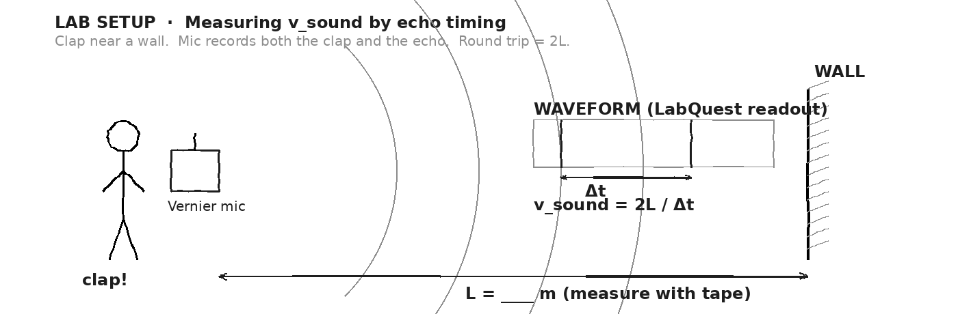

DATA TABLE — Clap-Echo Timing
Trial | L (m) | Δt (s) | v_sound (m/s) | Notes
1
2
3
4
Mean v_sound:
OBSERVATION & ANALYSIS
How close did your average come to 343 m/s? What's the percent difference? Was the room warmer or cooler than 20 °C?

If you could only improve ONE of (L precision, Δt precision, room temperature control) — which would shrink your error the most?

Asteroid connection: how does this serve the year's question?

⚠ | A 10 m wall + a 0.06 s round trip means Δt is small. Use a sample rate ≥ 10 kHz, or use a longer corridor (15-20 m) to spread the peaks apart.

Fill in the frame:
We measured v_sound = ________________________________________________________ m/s. The accepted value at room temperature is ________________________________________________________ m/s. Our percent difference is ________________________________________________________ %. The main source of error was likely ________________________________________________________.
EXIT TICKET — Day 10
If you measured v_sound = 350 m/s and your wall was 10.0 m away, what Δt did you record? Show one line of work.

Today's Targets — Rate Yourself
1 = Not Yet (I can't do this without help) 2 = Almost (I can do this with some help or some errors) 3 = Got It (I can do this independently and explain it)
Help? Check the box if you want to talk with me about this target — even if you marked yourself a 3.
Target | 1 | 2 | 3 | Help?
I can run the echo-timing procedure correctly. | ○ | ○ | ○ | ☐
I can compute v_sound from L + Δt. | ○ | ○ | ○ | ☐
I can identify the largest source of error. | ○ | ○ | ○ | ☐

Day 11 — Intensity · Decibels · Doppler Effect

Today's Target
I can apply I ∝ 1/r² for a point source, convert intensity to decibels using dB = 10·log₁₀(I/I₀), and predict whether a Doppler-shifted frequency rises or falls based on relative motion.
ASTEROID THREAD
What we know about 2026-XJ today: Doppler is HOW radar measures asteroid velocity. The echo's frequency shift from the transmit frequency tells the line-of-sight speed.
How today connects: Today: Doppler on a familiar scale (ambulance siren). Day 15: Doppler applied to 2026-XJ's radar return.

VOCAB · INTENSITY (I)
Definition: Power per unit area. Units: W/m². Drops as 1/r² for a point source (energy spread over a 4πr² sphere).
Example: A 1 W bulb 1 m away delivers I = 1/(4π) ≈ 0.080 W/m². At 2 m, only ¼ as much (0.020 W/m²).
Cognates: Sp. intensidad · Pt. intensidade · HC entansite
Watch out: Double the distance → ¼ the intensity, not ½. Inverse SQUARE law.

VOCAB · DECIBEL (DB)
Definition: A logarithmic measure of intensity. dB = 10 · log₁₀(I / I₀), with I₀ = 10⁻¹² W/m² (threshold of hearing). Every +10 dB = ×10 in intensity.
Example: 0 dB hearing threshold. 60 dB normal conversation. 120 dB pain. A rock concert (110 dB) is 10¹¹ times more intense than the threshold.
Cognates: Sp. decibelio · Pt. decibel · HC desibèl
Watch out: dB is LOG scale. +20 dB ≠ +2× intensity — it's +100× intensity. Hearing damage starts around 85 dB with prolonged exposure.

VOCAB · DOPPLER EFFECT
Definition: When a wave SOURCE moves relative to an observer, the observed frequency SHIFTS. Approach → higher f. Recede → lower f.
Example: An ambulance siren goes from high pitch to low pitch as it passes you. Train horn rises in pitch as it approaches.
Cognates: Sp. efecto Doppler · Pt. efeito Doppler · HC efè Doppler
Watch out: Doppler is about RELATIVE motion. The SOURCE moving toward you gives the same shift as YOU moving toward the source.

DOODLE ZONE
An ambulance moves right. Wavefronts AHEAD of it are compressed (higher f for the approaching listener). Wavefronts BEHIND it are stretched (lower f for the receder). Label which side hears HIGHER pitch.
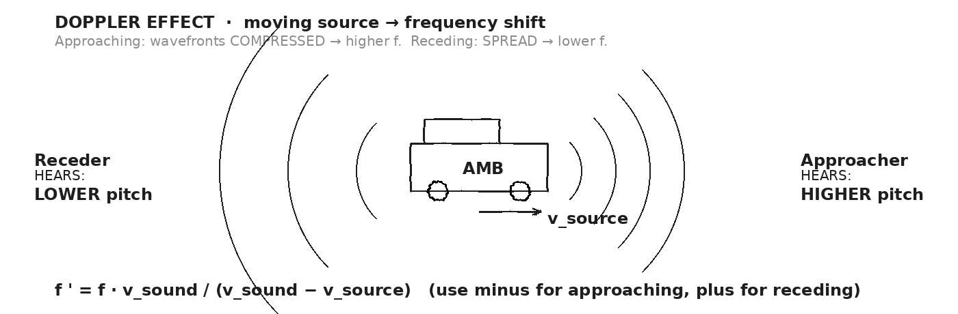

WORKED EXAMPLE — Doppler shift, ambulance approaching
An ambulance siren emits at f = 800 Hz. The ambulance approaches you at v_source = 30 m/s. Sound in air: v = 343 m/s. What frequency do you hear?
GIVEN | f = 800 Hz · v = 343 m/s · v_source = 30 m/s (toward listener)
EQUATION | f ' = f · v / (v − v_source)
WORK | f ' = 800 · 343 / (343 − 30)  f ' = 800 · 343 / 313  f ' = 274 400 / 313  f ' ≈ 877 Hz
ANSWER | You hear ≈ 877 Hz — about a half-step higher in pitch.

WORKED EXAMPLE — decibel ratio
A whisper measures 30 dB. A motorcycle measures 100 dB. The motorcycle is how many times more INTENSE than the whisper?
GIVEN | ΔdB = 100 − 30 = 70 dB
EQUATION | ratio = 10^(ΔdB / 10)
WORK | ratio = 10^(70 / 10)  ratio = 10⁷  ratio = 10 000 000
ANSWER | The motorcycle is 10 million times more INTENSE than the whisper. (Perceived loudness rises slower than intensity.)

YOUR TURN — train horn receding
A train at 600 Hz horn moves AWAY from you at 20 m/s. What frequency do you hear? (v_sound = 343 m/s. Use plus sign for receding: f ' = f · v / (v + v_source).)
GIVEN
EQUATION
WORK
ANSWER

★ | Same Doppler logic, scaled to radar: 2026-XJ at v_source returns radar with a tiny frequency shift Δf. NASA detects shifts as small as 0.01 Hz on a 2.4 GHz carrier. That's 4 parts in 10¹². Day 15 walks through the full chain.

Fill in the frame:
A source moving TOWARD you compresses wavefronts → higher ________________________________________________________. Moving AWAY stretches them → lower ________________________________________________________. The dB scale is ________________________________________________________ in intensity: every +10 dB is ________________________________________________________× more intense.
EXIT TICKET — Day 11
A train at 600 Hz horn moves at 20 m/s. You stand on the platform as it APPROACHES. What frequency do you hear? (Use v_sound = 343 m/s.) Show your work.

Today's Targets — Rate Yourself
1 = Not Yet (I can't do this without help) 2 = Almost (I can do this with some help or some errors) 3 = Got It (I can do this independently and explain it)
Help? Check the box if you want to talk with me about this target — even if you marked yourself a 3.
Target | 1 | 2 | 3 | Help?
I can apply f' = f · v / (v ∓ v_source) for approach vs. recession. | ○ | ○ | ○ | ☐
I can interpret the dB scale (logarithmic). | ○ | ○ | ○ | ☐
I can connect Doppler to radar velocity measurement. | ○ | ○ | ○ | ☐

Day 12 — Electromagnetic Spectrum · Light Is a Wave

Today's Target
I can identify the bands of the EM spectrum in order (radio → gamma), explain that all travel at c in vacuum, and compute λ from f using c = fλ for any band.
ASTEROID THREAD
What we know about 2026-XJ today: Radar (radio band) and the meteor's atmospheric-entry GLOW (visible) are the SAME kind of wave family. Different f, same physics.
How today connects: Day 16 makes this concrete — the meteor's GLOW color (visible light) tells us its temperature (Wien's law).

VOCAB · ELECTROMAGNETIC WAVE
Definition: A transverse wave of oscillating electric + magnetic fields. Travels at c = 3 × 10⁸ m/s in vacuum. No medium needed.
Example: Light. Radio. X-rays. Microwaves. All the same kind of wave, different frequencies.
Cognates: Sp. onda electromagnética · Pt. onda eletromagnética · HC onn elektwomayetik
Watch out: EM waves are NOT mechanical — they need no medium. That's why they cross vacuum from the Sun to Earth.

VOCAB · EM SPECTRUM
Definition: The full range of EM frequencies, from low-f radio (km wavelengths) up to high-f gamma rays (sub-nm wavelengths).
Example: Radio (km), microwave (cm), infrared (μm), VISIBLE (400-700 nm), UV (10s of nm), X-ray (nm), gamma (sub-nm).
Cognates: Sp. espectro electromagnético · Pt. espectro eletromagnético
Watch out: The bands shade into each other — there's no sharp edge between, say, radio and microwave. The names are conventions.

VOCAB · VISIBLE LIGHT
Definition: The narrow band of EM the human eye detects, from ~400 nm (violet) to ~700 nm (red). The Sun emits its peak intensity here.
Example: ROYGBIV. Red has the longest visible λ; violet the shortest. Color = wavelength.
Cognates: Sp. luz visible · Pt. luz visível · HC limyè vizib
Watch out: "Visible" is just our species' window. Other animals see UV (bees), IR (some snakes), etc.

DOODLE ZONE
Walk left-to-right through the EM bands. Which band has the LONGEST wavelength? The HIGHEST frequency? Where does our radar fall? Where does visible light fall?
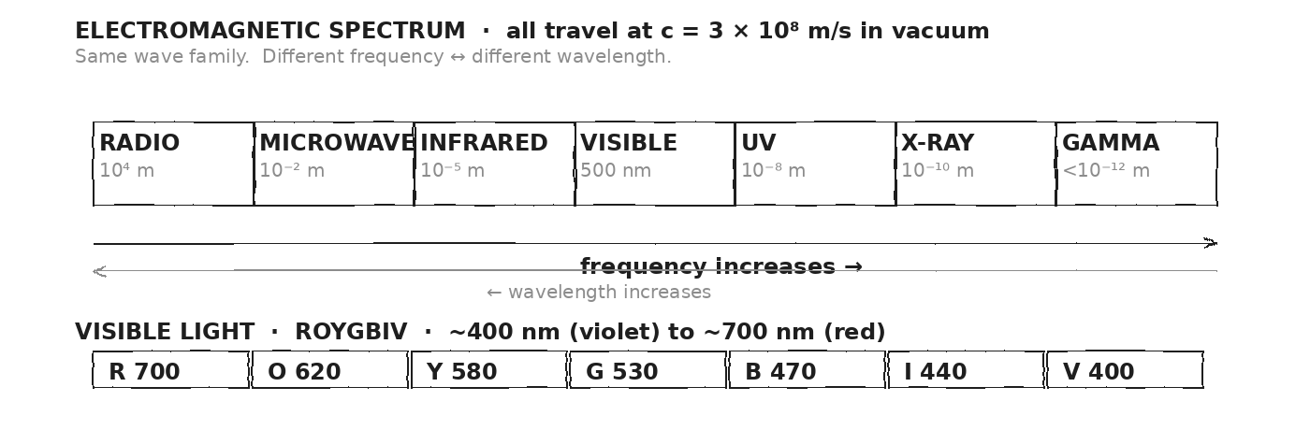

WORKED EXAMPLE — microwave wavelength
Your microwave oven operates at f = 2.4 GHz = 2.4 × 10⁹ Hz. What's its wavelength? Which EM band is this?
GIVEN | f = 2.4 × 10⁹ Hz · c = 3 × 10⁸ m/s
EQUATION | λ = c / f
WORK | λ = (3 × 10⁸) / (2.4 × 10⁹)  λ = 0.125 m  λ = 12.5 cm
ANSWER | λ ≈ 12.5 cm. This is in the MICROWAVE band — sized to make food molecules absorb.

WORKED EXAMPLE — visible green light
Green light has λ ≈ 530 nm. What's its frequency?
GIVEN | λ = 530 nm = 5.30 × 10⁻⁷ m · c = 3 × 10⁸ m/s
EQUATION | f = c / λ
WORK | f = (3 × 10⁸) / (5.30 × 10⁻⁷)  f = 5.66 × 10¹⁴ Hz
ANSWER | f ≈ 5.66 × 10¹⁴ Hz ≈ 566 THz — about a half-quadrillion cycles per second.

YOUR TURN — X-ray frequency
An X-ray has λ ≈ 1.0 × 10⁻¹⁰ m. What's its frequency?
GIVEN
EQUATION
WORK
ANSWER

★ | Why is X-ray imaging dangerous but visible-light imaging safe? Energy per photon depends on frequency. Higher f = higher-energy photons. X-rays can ionize molecules (break bonds). Visible photons can't.

Fill in the frame:
All EM waves travel at ________________________________________________________ in vacuum. The EM spectrum is ordered from longest wavelength (________________________________________________________) to shortest (________________________________________________________). Visible light is just one narrow band, from ~________________________________________________________ nm to ~________________________________________________________ nm.
EXIT TICKET — Day 12
What's the wavelength of a microwave oven's 2.4 GHz radiation? (Use c = 3 × 10⁸.) Which EM band is this?

Today's Targets — Rate Yourself
1 = Not Yet (I can't do this without help) 2 = Almost (I can do this with some help or some errors) 3 = Got It (I can do this independently and explain it)
Help? Check the box if you want to talk with me about this target — even if you marked yourself a 3.
Target | 1 | 2 | 3 | Help?
I can identify EM spectrum bands in order. | ○ | ○ | ○ | ☐
I can apply c = fλ across any band. | ○ | ○ | ○ | ☐
I can connect color of visible light to wavelength. | ○ | ○ | ○ | ☐

Day 13 — Plane Mirrors · Virtual Images Behind the Mirror

Today's Target
I can construct a ray diagram for a plane mirror, locate the virtual image at equal distance behind the mirror, and explain why the image is upright + same size.
ASTEROID THREAD
What we know about 2026-XJ today: Radio telescopes are giant CURVED mirrors that focus radio waves to a detector. The Day 4 reflection law applies directly.
How today connects: Today the FLAT-mirror case. Day 14 generalizes to curves (lenses). Day 15 mentions parabolic radio dishes that combine both ideas.

VOCAB · PLANE MIRROR
Definition: A flat reflecting surface. Light obeys the law of reflection (Day 4). Produces VIRTUAL images behind the mirror at equal distance from the object.
Example: Your bathroom mirror. A glass storefront. A still pond surface.
Cognates: Sp. espejo plano · Pt. espelho plano · HC miwa plat
Watch out: "Plane" means flat — not like an airplane. Curved mirrors (concave, convex) behave differently and are not on the CPA scope.

VOCAB · VIRTUAL IMAGE
Definition: An image that LIGHT DOES NOT ACTUALLY REACH. The brain TRACES light rays backward and locates the image at the convergence point. Cannot be projected on a screen.
Example: Your mirror image — the light reflects off the mirror and into your eye. The image APPEARS to be behind the mirror, but no light is actually there.
Cognates: Sp. imagen virtual · Pt. imagem virtual · HC imaj vityèl
Watch out: A virtual image cannot be 'caught' on a screen. A real image CAN. Plane mirrors always make virtual images.

DOODLE ZONE
Object on the left of the mirror. Draw two rays from the object's tip — through the law of reflection. Trace each reflected ray BACKWARD (dashed). They converge at the VIRTUAL image, equal distance behind the mirror.
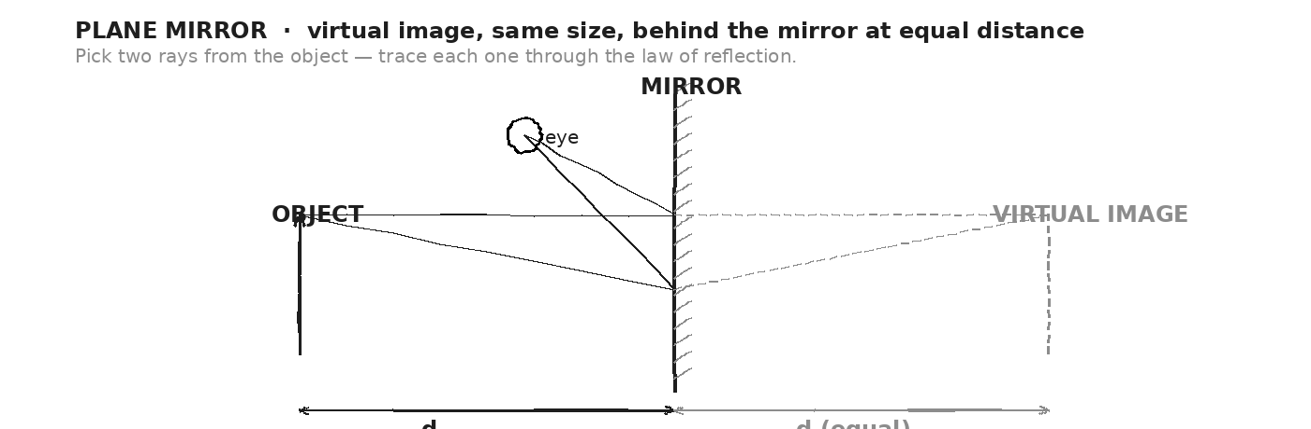

WORKED EXAMPLE — image location
A 2.0-m-tall person stands 1.5 m from a flat mirror. Where is their image? How tall does it appear?
GIVEN | height = 2.0 m · d_object = 1.5 m from mirror
EQUATION | d_image = d_object · h_image = h_object (plane mirror)
WORK | d_image = 1.5 m behind the mirror.  h_image = 2.0 m tall.  Image is upright + virtual + same size.
ANSWER | 1.5 m behind the mirror, 2.0 m tall, upright.

WORKED EXAMPLE — closing the distance
You walk 0.5 m closer to a mirror. By how much do you and your image close on each other?
GIVEN | You move 0.5 m toward mirror. Mirror is stationary.
EQUATION | d_you = − 0.5 m → d_image = + 0.5 m closer also (mirror)
WORK | Your distance to mirror: ↓ 0.5 m  Image's distance to mirror (= your distance): ↓ 0.5 m  Image moves 0.5 m TOWARD mirror also.  Total closing: 1.0 m.
ANSWER | You and your image close on each other by 1.0 m total.

YOUR TURN — shortest mirror to see yourself
What's the shortest mirror that lets you see your full body (top of head to feet)? Hint: trace two rays — one from your eyes to your feet, one from your eyes to the top of your head. The mirror only needs to cover the midpoints.
GIVEN
EQUATION
WORK
ANSWER

★ | The answer to the YOUR TURN problem: a mirror HALF your height, mounted at the right height (top edge at eye level + half of forehead, bottom edge at feet midpoint), shows you head-to-toe regardless of how far away you stand.

Fill in the frame:
A plane mirror produces a ________________________________________________________ image (light doesn't actually reach it). The image is the same ________________________________________________________ as the object, located the same ________________________________________________________ behind the mirror as the object is in front. It is ________________________________________________________ (upright/inverted).
EXIT TICKET — Day 13
A 2-m-tall person stands 1.5 m from a flat mirror. Where is their image? How tall does it appear? Answer in one line.

Today's Targets — Rate Yourself
1 = Not Yet (I can't do this without help) 2 = Almost (I can do this with some help or some errors) 3 = Got It (I can do this independently and explain it)
Help? Check the box if you want to talk with me about this target — even if you marked yourself a 3.
Target | 1 | 2 | 3 | Help?
I can construct a ray diagram for a plane mirror. | ○ | ○ | ○ | ☐
I can identify virtual vs. real images. | ○ | ○ | ○ | ☐
I can predict image location + size for a plane mirror. | ○ | ○ | ○ | ☐

Day 14 — Lenses Qualitatively · Convex Converges · Concave Diverges

Today's Target
I can distinguish convex (converging) from concave (diverging) lenses by their shape and ray behavior, and identify whether the image is REAL or VIRTUAL.
ASTEROID THREAD
What we know about 2026-XJ today: Optical telescopes combine MIRRORS (objective) + LENSES (eyepiece) to magnify distant objects. Asteroid optical telescopes are limited by diffraction (Day 6) and lens / mirror size.
How today connects: Day 15 will mention that NASA's Goldstone radar dish is a parabolic reflector — a giant curved mirror for radio.

VOCAB · CONVEX LENS
Definition: A lens that is THICKER in the middle than at the edges. Refraction at the curved surfaces makes parallel rays CONVERGE to a focal point F at distance f from the lens.
Example: A magnifying glass. A camera lens. The eye's lens.
Cognates: Sp. lente convexa · Pt. lente convexa · HC lant konvèks
Watch out: "Convex" = bulging outward. "Converging" = brings rays together. Both apply.

VOCAB · CONCAVE LENS
Definition: A lens THINNER in the middle. Refraction makes parallel rays DIVERGE outward; tracing them back gives a virtual focal point on the incoming side.
Example: Eyeglasses for nearsightedness (myopia). A peephole. A door viewer (wide-angle).
Cognates: Sp. lente cóncava · Pt. lente côncava · HC lant konkav
Watch out: Concave lenses ALWAYS make virtual images — they spread rays out, can't focus them onto a screen.

VOCAB · FOCAL LENGTH (F)
Definition: Distance from a lens (or mirror) to its focal point. Shorter f = stronger converging. Convex: real F; Concave: virtual F.
Example: A magnifying glass with f = 10 cm has its focal point 10 cm from the lens. The Sun's rays focused to a tiny spot at this point can ignite paper.
Cognates: Sp. distancia focal · Pt. distância focal · HC distans fokal
Watch out: The 'f' in focal length is NOT the same as the 'f' for frequency. Context.

VOCAB · REAL VS. VIRTUAL IMAGE
Definition: REAL image: light rays actually converge to the image point. CAN be caught on a screen. VIRTUAL image: rays only APPEAR to converge (after tracing back). Cannot be caught on a screen.
Example: Movie projector → REAL image on the screen. Magnifying glass close to small print → VIRTUAL magnified image (you see it through the lens).
Cognates: Sp. imagen real/virtual · Pt. imagem real/virtual
Watch out: Real ↔ catchable on a screen. Virtual ↔ only seen by an eye/camera looking through the lens.

DOODLE ZONE
TOP: parallel rays hit a convex lens — converge to focal point F. BOTTOM: same rays hit a concave lens — diverge outward; trace back (dashed) to a virtual F. Which lens is in a magnifying glass? In nearsighted glasses?
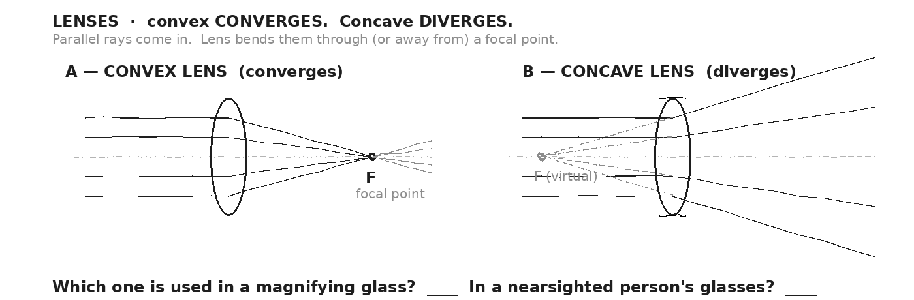

WORKED EXAMPLE — classify each application
For each application, identify the lens type (convex/concave) and image type (real/virtual): (a) magnifying glass; (b) camera; (c) movie projector; (d) nearsighted glasses; (e) door peephole.
GIVEN | —
EQUATION | (qualitative reasoning — no equation)
WORK | (a) magnifying glass: CONVEX, VIRTUAL (close to object)  (b) camera: CONVEX, REAL (image on sensor)  (c) movie projector: CONVEX, REAL (image on screen)  (d) nearsighted glasses: CONCAVE, VIRTUAL (diverges focus)  (e) peephole: CONCAVE, VIRTUAL (wide-angle view)
ANSWER | 3 convex (2 real, 1 virtual), 2 concave (both virtual).

YOUR TURN — burn paper with the Sun
You hold a magnifying glass (convex, f = 10 cm) above a piece of dry paper on a sunny day. At what distance above the paper do you hold the lens to focus the Sun's image and ignite the paper?
GIVEN
EQUATION
WORK
ANSWER

⚠ | That last one is real — kids burn ants with magnifying glasses for a reason. The focused Sun's image at the focal point has roughly 1000× the intensity of unfocused sunlight. Inverse-square-law (Day 11) in reverse: small area → concentrated power.

Fill in the frame:
A ________________________________________________________ lens brings parallel rays to a real focal point — it CONVERGES light. A ________________________________________________________ lens spreads them out, producing only virtual images. The KIND of image depends on the lens shape and the object's ________________________________________________________.
EXIT TICKET — Day 14
Why does looking through a magnifying glass make small print bigger? In one sentence, say what kind of lens it is + what kind of image is formed.

Today's Targets — Rate Yourself
1 = Not Yet (I can't do this without help) 2 = Almost (I can do this with some help or some errors) 3 = Got It (I can do this independently and explain it)
Help? Check the box if you want to talk with me about this target — even if you marked yourself a 3.
Target | 1 | 2 | 3 | Help?
I can distinguish convex vs. concave lenses by shape and behavior. | ○ | ○ | ○ | ☐
I can identify real vs. virtual images. | ○ | ○ | ○ | ☐
I can match common applications to lens type. | ○ | ○ | ○ | ☐

Day 15 — ★ RADAR — How NASA Measured 2026-XJ (The Reveal)

Today's Target
I can trace the FULL radar measurement chain: send a pulse, time the round trip for DISTANCE (d = c·Δt/2), measure the frequency SHIFT for VELOCITY (v = (Δf/f)·c), and estimate SIZE from signal strength.
ASTEROID THREAD
What we know about 2026-XJ today: For five units we've USED 2026-XJ numbers. Today we see WHERE THEY CAME FROM.
How today connects: Every Unit 6 idea is required: v = fλ (Day 3), reflection (Day 4), Doppler (Day 11), EM waves (Day 12), mirrors (Day 13). Today they combine into the radar measurement chain.

★ THE REVEAL · WHERE THE NUMBERS CAME FROM
Since Unit 1 you have used these 2026-XJ numbers: distance from Earth, closing velocity, mass, trajectory, impact KE, damage radii. Every one had to be MEASURED. The instrument is RADAR — specifically NASA's Goldstone (California) and Arecibo-era (Puerto Rico) planetary radar systems. Modern planetary radar transmits 2.4 GHz radio pulses at very high power, listens for the echo from the asteroid, and extracts three pieces of information from the return:
► DISTANCE: from the round-trip TIME Δt: d = c · Δt / 2. At c = 3×10⁸ m/s, a Δt = 2.5 s means the asteroid is 375 000 km away.
► VELOCITY (line-of-sight): from the DOPPLER SHIFT Δf: v = (Δf / f) · c. A 5 kHz shift on a 2.4 GHz carrier means v ≈ 312 m/s closing (or receding).
► SIZE (estimate): from signal STRENGTH vs. distance: a stronger echo means a larger radar cross-section. Combined with an assumed albedo + density, size and mass estimates fall out — with uncertainty.
DOODLE ZONE
The unit's centerpiece. Trace the full chain. Mark Δt (round-trip time). Compare outgoing wave (f_T) to returning wave (f_R) — does it look compressed or stretched? What does that tell you about asteroid motion?
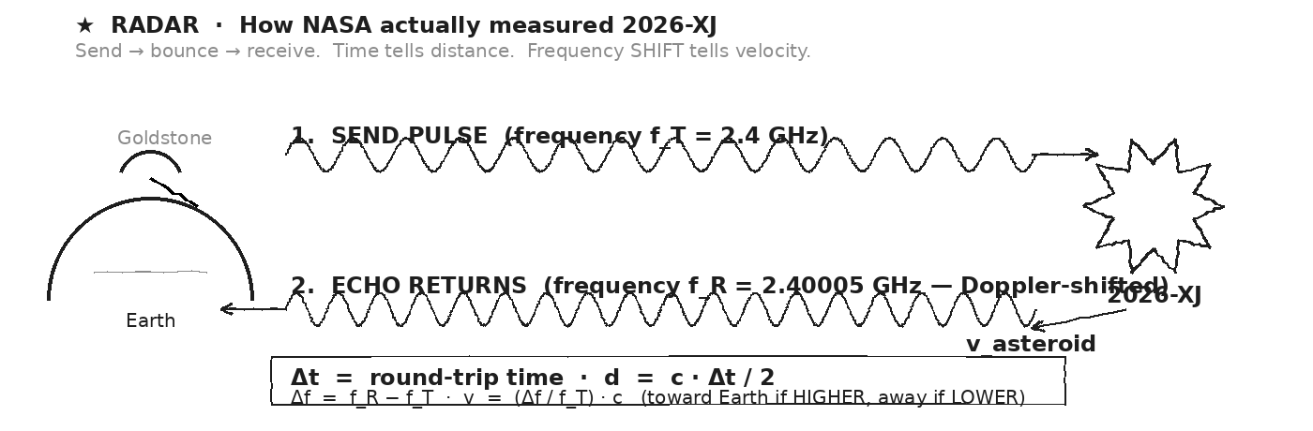

STEP 1 — DISTANCE from round-trip time
A radar pulse is sent toward 2026-XJ. The echo returns Δt = 2.5 s later. How far away is the asteroid?
GIVEN | Δt = 2.5 s · c = 3.00 × 10⁸ m/s
EQUATION | d = c · Δt / 2 (round trip → one way)
WORK | d = (3.00 × 10⁸) · 2.5 / 2  d = 7.5 × 10⁸ / 2  d = 3.75 × 10⁸ m  d = 375 000 km
ANSWER | d ≈ 375 000 km — about the distance to the Moon. Real-world precision: ±100 m.

STEP 2 — VELOCITY from the Doppler shift
The transmitted radar pulse is at f_T = 2.4 GHz. The echo returns at f_R = 2.40005 GHz (5 kHz HIGHER). What's the asteroid's line-of-sight velocity? Is it approaching or receding?
GIVEN | f_T = 2.4 × 10⁹ Hz · f_R = 2.400005 × 10⁹ Hz · Δf = 5 000 Hz · c = 3 × 10⁸ m/s
EQUATION | v = (Δf / f_T) · c (HIGHER echo → APPROACHING)
WORK | v = (5000 / 2.4 × 10⁹) · 3 × 10⁸  v = (2.08 × 10⁻⁶) · 3 × 10⁸  v ≈ 625 m/s
ANSWER | v ≈ 625 m/s, APPROACHING (echo frequency was higher than transmitted). Modern systems detect Δf down to 0.01 Hz — ~mm/s velocity precision.

STEP 3 — SIZE estimate from signal strength
The echo's STRENGTH (energy per square meter back at Earth) depends on (a) how far the wave traveled (1/r⁴ — out AND back), and (b) the asteroid's RADAR CROSS-SECTION (effective area). Why does the signal weaken as 1/r⁴, not just 1/r²?
GIVEN | Wave travels: Earth → asteroid → Earth. Two legs, each inverse-square.
EQUATION | I ∝ 1 / (r² × r²) = 1 / r⁴
WORK | Outgoing wave to asteroid: I drops as 1/r² (Day 11).  After reflecting, echo wave back to Earth: ANOTHER 1/r² drop.  Total: 1/r⁴. So radar at TWICE the distance is 16× weaker.
ANSWER | 1/r⁴ is brutal — that's why planetary radar transmits MEGAWATT pulses. Larger asteroid → larger cross-section → stronger echo → size estimate.

★ | The numbers we've been using are REAL outputs of this chain. The 2026-XJ mass estimate has the largest uncertainty (depends on assumed albedo + density). The velocity is precise to mm/s. The distance is precise to meters. That's WHY the impact KE has uncertainty — not because the physics is wrong, but because the measurement is bounded by what radar can resolve.

Fill in the frame:
Radar measures asteroid distance from ________________________________________________________ (the round-trip time times c, halved). Radar measures velocity from ________________________________________________________ (the Doppler frequency shift). Higher echo frequency → asteroid is ________________________________________________________; lower → receding. Mass uncertainty comes from the fact that signal STRENGTH only gives a ________________________________________________________ estimate of size.
EXIT TICKET — Day 15
Why does NASA need MULTIPLE radar observations of the same asteroid (over weeks or months) to predict its orbit precisely?

Today's Targets — Rate Yourself
1 = Not Yet (I can't do this without help) 2 = Almost (I can do this with some help or some errors) 3 = Got It (I can do this independently and explain it)
Help? Check the box if you want to talk with me about this target — even if you marked yourself a 3.
Target | 1 | 2 | 3 | Help?
I can apply d = c·Δt/2 to compute asteroid distance from radar. | ○ | ○ | ○ | ☐
I can apply v = (Δf/f)·c to compute Doppler-derived velocity. | ○ | ○ | ○ | ☐
I can explain why radar power falls as 1/r⁴ for an echo. | ○ | ○ | ○ | ☐
I can identify which 2026-XJ quantity has the biggest measurement uncertainty. | ○ | ○ | ○ | ☐

Day 16 — Meteor Color · Wien's Law: Hotter Objects Glow at Shorter λ

Today's Target
I can apply Wien's law qualitatively (and the constant 2.9 × 10⁻³ m·K quantitatively if stretched) to predict the COLOR of a thermally radiating object — meteor, star, stovetop — from its TEMPERATURE.
ASTEROID THREAD
What we know about 2026-XJ today: A meteor's atmospheric-entry glow (Unit 5 Day 10) heats it to 5000–10 000 K. It glows yellow-white, sometimes blue-white.
How today connects: Wien's law explains WHY. Same rule that classifies stars by color. Both 2026-XJ's entry glow AND the impact fireball follow this law.

VOCAB · BLACKBODY RADIATION
Definition: The EM radiation emitted by ALL warm objects, with a spectrum determined entirely by temperature. Hotter object = higher peak frequency.
Example: A red-hot iron, a glowing meteor, the Sun, the Cosmic Microwave Background — all blackbodies at different T.
Cognates: Sp. radiación de cuerpo negro · Pt. radiação de corpo negro
Watch out: A blackbody doesn't have to look black. It's an idealization. Real objects approximate it well at high T.

VOCAB · WIEN'S LAW
Definition: The peak wavelength of a blackbody's emission is inversely proportional to its temperature: λ_max · T = 2.9 × 10⁻³ m·K. Higher T → shorter λ_max (toward blue).
Example: The Sun at T ≈ 6000 K → λ_max ≈ 500 nm (yellow-green). A red-hot iron at 1000 K → λ_max ≈ 3 μm (mostly infrared; only the longest visible reds are seen).
Cognates: Sp. ley de Wien · Pt. lei de Wien
Watch out: At very high T (10 000 K+), the peak shifts into UV — but visible RED + blue together look BLUE-WHITE to us.

VOCAB · COLOR TEMPERATURE
Definition: A way of expressing the COLOR of a thermally radiating object as a temperature (in Kelvin). Used in photography, astronomy, lighting design.
Example: Incandescent bulb: 2700 K (warm yellow). Sunlight: 5500-6500 K (white). Cloudy sky: 10 000 K (blue tint).
Cognates: Sp. temperatura de color · Pt. temperatura de cor
Watch out: Higher color temperature looks BLUER. Counterintuitive: "warm" light is LOWER T; "cool" light is HIGHER T.

DOODLE ZONE
Order from coolest to hottest: red-hot iron, yellow flame, the Sun, atmospheric meteor, blue star. Each step UP in temperature shifts peak emission toward SHORTER wavelengths.
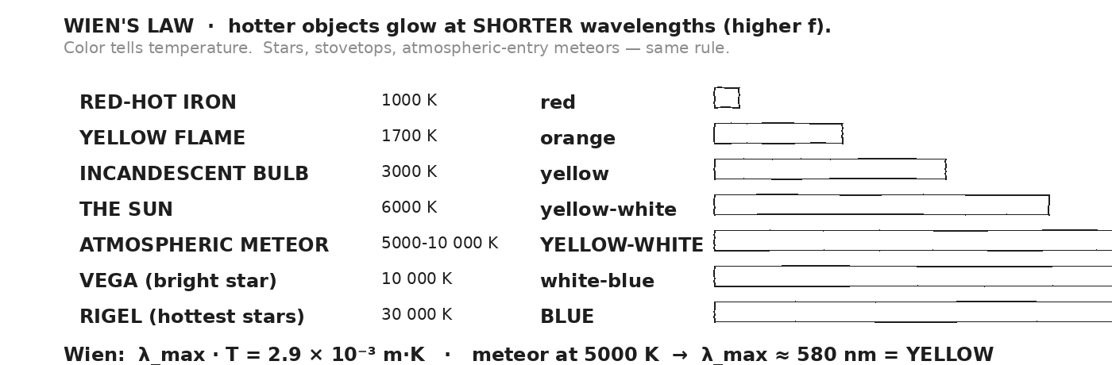

WORKED EXAMPLE — meteor peak wavelength
A meteor at atmospheric entry is heated to T ≈ 5000 K. Compute the peak emission wavelength using Wien's law: λ_max · T = 2.9 × 10⁻³ m·K. What color does this correspond to?
GIVEN | T = 5000 K · b = 2.9 × 10⁻³ m·K
EQUATION | λ_max = b / T
WORK | λ_max = (2.9 × 10⁻³) / 5000  λ_max = 5.8 × 10⁻⁷ m  λ_max = 580 nm
ANSWER | λ_max ≈ 580 nm — YELLOW. (The peak's in yellow; the wings reach red + green, making the meteor look YELLOW-WHITE.)

WORKED EXAMPLE — extreme entry speed
A faster meteor (or an asteroid at high entry speed) can heat to T ≈ 10 000 K. What's the peak λ? What color?
GIVEN | T = 10 000 K · b = 2.9 × 10⁻³ m·K
EQUATION | λ_max = b / T
WORK | λ_max = (2.9 × 10⁻³) / 10 000  λ_max = 2.9 × 10⁻⁷ m  λ_max = 290 nm
ANSWER | λ_max ≈ 290 nm — UV. The visible part looks BLUE-WHITE (heavily weighted toward blue + violet).

YOUR TURN — classify by color
A red-hot iron glows at T ≈ 1000 K. What's λ_max? Why does it look RED to us (despite λ_max being beyond visible)?
GIVEN
EQUATION
WORK
ANSWER

★ | Astronomers measure star COLOR to estimate surface temperature. Cool stars (M-class, 3000 K) are RED. Sun-like stars (G-class, 6000 K) are YELLOW. Hot stars (O-class, 30 000 K) are BLUE. Same physics as the meteor glow.

Fill in the frame:
Hotter object → peak emission at ________________________________________________________ wavelength. The Sun (6000 K) peaks at ________________________________________________________ nm. A 10 000 K meteor peaks at ________________________________________________________ nm — in the ________________________________________________________ band. Visible color combines the WHOLE spectrum, weighted by intensity.
EXIT TICKET — Day 16
A meteor entering at extreme speed could heat to 10 000 K. What color would it glow? How does this compare to a typical meteor (5000 K)? Give a one-sentence comparison.

Today's Targets — Rate Yourself
1 = Not Yet (I can't do this without help) 2 = Almost (I can do this with some help or some errors) 3 = Got It (I can do this independently and explain it)
Help? Check the box if you want to talk with me about this target — even if you marked yourself a 3.
Target | 1 | 2 | 3 | Help?
I can apply Wien's law to predict peak wavelength from temperature. | ○ | ○ | ○ | ☐
I can connect color to temperature (red cool, yellow warm, blue hot). | ○ | ○ | ○ | ☐
I can explain the meteor's yellow-white glow. | ○ | ○ | ○ | ☐

Day 17 — Seismic + Tsunami · Mechanical-Wave Damage at Continental Scale

Today's Target
I can predict the arrival time of seismic P-waves and S-waves at distant locations, and apply v = √(g·d) to estimate tsunami speed + arrival time at a distant coastline.
ASTEROID THREAD
What we know about 2026-XJ today: 2026-XJ has a 70% chance of impacting OCEAN. If it does, the dominant long-range damage mechanism shifts to TSUNAMI. If it hits land, SEISMIC waves register globally.
How today connects: Today's payoff: both kinds of mechanical waves carry impact damage far beyond the immediate strike zone. Wave physics scales up to planetary geometry.

VOCAB · SEISMIC P-WAVE (PRIMARY)
Definition: A LONGITUDINAL mechanical wave traveling through Earth's crust + mantle. Compressions and rarefactions of rock. ≈ 6 km/s in mantle. FIRST to arrive at a seismograph (hence 'P').
Example: An earthquake or large impact launches P-waves. Diameter of Earth (~12 700 km) / 6 km/s ≈ 35 min — P-waves traverse the whole planet in about half an hour.
Cognates: Sp. onda P · Pt. onda P · HC vag P
Watch out: P-waves are LONGITUDINAL like sound. They can travel through solid AND liquid. They're the only seismic wave that crosses Earth's liquid outer core.

VOCAB · SEISMIC S-WAVE (SECONDARY)
Definition: A TRANSVERSE mechanical wave through Earth's crust + mantle. Side-to-side oscillation of rock. ≈ 4 km/s in mantle. ARRIVES SECOND.
Example: Follows P-wave by minutes. The TIME GAP between P and S arrival is how seismologists triangulate the source distance.
Cognates: Sp. onda S · Pt. onda S · HC vag S
Watch out: S-waves can NOT travel through liquids. That's how we know Earth's outer core is liquid — S-waves don't make it through. P-waves do.

VOCAB · TSUNAMI
Definition: An ocean-surface gravity wave triggered by a sudden displacement of water (impact, undersea earthquake, landslide). Speed v = √(g · d), where d is ocean depth.
Example: A 2026-XJ ocean impact at 4 km depth generates a tsunami moving at v = √(9.8 · 4000) ≈ 200 m/s ≈ 700 km/h. Reaches a coast 1500 km away in about 2 hours.
Cognates: Sp. tsunami · Pt. tsunami · HC tsunami
Watch out: In DEEP water, a tsunami is only ~1 m tall but moves fast. As it reaches SHALLOW water, it slows AND grows tall (energy conservation). Coast is where damage happens.

DOODLE ZONE
Cross-section of the ocean. Tsunami in DEEP water is fast + low. As it reaches the SHALLOW coast, it slows AND amplifies. Where does the most energy build up? What happens at the shoreline?
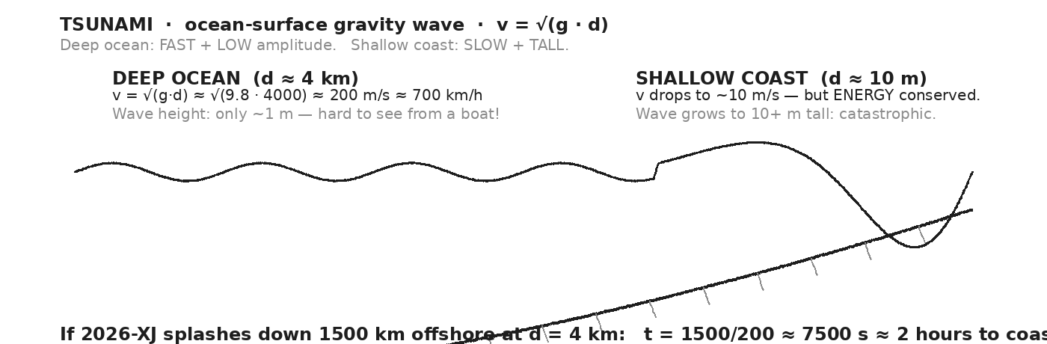

WORKED EXAMPLE — P-wave arrival across Earth
An asteroid impact in Africa launches seismic waves. How long until the P-waves are detected by a seismograph in California, about 13 000 km away through Earth?
GIVEN | d = 13 000 km = 1.3 × 10⁷ m · v_P = 6 km/s = 6000 m/s
EQUATION | t = d / v
WORK | t = 1.3 × 10⁷ / 6000  t = 2167 s  t ≈ 36 minutes
ANSWER | ≈ 36 min after impact. S-waves arrive ~18 minutes later (slower at 4 km/s).

WORKED EXAMPLE — tsunami speed in deep ocean
An ocean impact occurs at d = 4 km depth. What's the tsunami's deep-ocean speed?
GIVEN | g = 9.8 m/s² · d = 4000 m
EQUATION | v = √(g · d)
WORK | v = √(9.8 · 4000)  v = √(39 200)  v ≈ 198 m/s  v ≈ 200 m/s ≈ 700 km/h
ANSWER | ≈ 200 m/s ≈ 700 km/h. As fast as a jet airliner.

WORKED EXAMPLE — arrival time on a distant coast
Continuing the example above: how long until that tsunami reaches a coastline 1500 km away?
GIVEN | d = 1.5 × 10⁶ m · v = 200 m/s
EQUATION | t = d / v
WORK | t = 1.5 × 10⁶ / 200  t = 7500 s  t ≈ 125 min  t ≈ 2.1 hours
ANSWER | ≈ 2 hours warning before impact at the coast. That window is why tsunami early-warning networks (DART buoys + seismic detection) exist.

YOUR TURN — S-wave arrival
After the same African impact, how long until the S-waves arrive in California (13 000 km away, v_S = 4 km/s)? Compute the GAP between P-wave and S-wave arrival.
GIVEN
EQUATION
WORK
ANSWER

WAVE DAMAGE-BY-DISTANCE · 2026-XJ OCEAN IMPACT SCENARIO
► Atmospheric shockwave minutes few hundred km broken windows; flattened forest
► Thermal pulse (Unit 5) seconds ~800 km wildfire ignition radius
► Seismic P-wave ~35 min global (~12 700 km) registers worldwide
► Seismic S-wave ~50 min via mantle (no liquid core) global on land
► Tsunami ~2 hours thousands of km catastrophic at the coast
⚠ | If 2026-XJ splashes down 1500 km from a coast, the THERMAL pulse arrives in seconds, the SEISMIC arrival in ~35 min, but the TSUNAMI takes ~2 hours. That's the warning window. Whether the warning saves lives depends on how fast it's relayed.

Fill in the frame:
Seismic P-waves are ________________________________________________________ (longitudinal/transverse) and travel ~________________________________________________________ km/s. S-waves are ________________________________________________________ and travel ~________________________________________________________ km/s. A tsunami moves at v = √(________________________________________________________), so deeper ocean → ________________________________________________________ tsunami.
EXIT TICKET — Day 17
Why is a tsunami much more dangerous on the shoreline than in deep ocean? Answer in two sentences using the phrase 'energy conservation'.

Today's Targets — Rate Yourself
1 = Not Yet (I can't do this without help) 2 = Almost (I can do this with some help or some errors) 3 = Got It (I can do this independently and explain it)
Help? Check the box if you want to talk with me about this target — even if you marked yourself a 3.
Target | 1 | 2 | 3 | Help?
I can compute P-wave + S-wave arrival times at distant locations. | ○ | ○ | ○ | ☐
I can apply v = √(g·d) to tsunami speed. | ○ | ○ | ○ | ☐
I can predict tsunami arrival time on a distant coast. | ○ | ○ | ○ | ☐
I can explain why a tsunami slows AND amplifies toward shore. | ○ | ○ | ○ | ☐

Day 18 — Unit 6 Transfer Task — Assessment Day

ASTEROID THREAD
What we know about 2026-XJ today: Every Unit 6 tool: v = fλ, reflection, refraction, diffraction, interference, Doppler, dB, EM spectrum, mirrors, lenses, Wien's law, tsunami v = √(g·d), seismic speeds.
How today connects: Problem 5 is the load-bearing R4 prompt: given a radar return + Doppler shift, compute distance + velocity, then predict tsunami arrival on a coast. The whole unit in one problem.

TRANSFER TASK — UNIT 6 · DAY 18
Today you receive the Unit 6 Transfer Task on a separate sheet. It is 5 multi-part problems. You will work independently for ~40 minutes.
• Problem 1 — WAVE EQUATION ACROSS MEDIA. A 1000 Hz sound moves from air (v = 343 m/s) into water (v = 1480 m/s). Compute λ in each medium. Explain what stays the same and what changes (and why).
• Problem 2 — REFLECTION. A flat mirror is 2.0 m from a 1.6-m-tall person. Locate the image and compute its height. State whether real or virtual. Sketch a 2-ray diagram.
• Problem 3 — DOPPLER. A 1000 Hz ambulance siren moves at 25 m/s toward a stationary listener. What frequency is heard? What about the listener BEHIND the ambulance (away)? Use f' = f · v / (v ∓ v_source).
• Problem 4 — EM SPECTRUM. A radio station broadcasts at f = 540 kHz. Compute λ. Which EM band is this? (Use c = 3 × 10⁸ m/s.) Is this AM or FM?
• Problem 5 — ★ ASTEROID SCENARIO. Radar pulse to 2026-XJ: transmitted f_T = 2.4 GHz, round-trip time Δt = 2.4 s, echo received at f_R = 2.40010 GHz (10 kHz higher). (a) Compute distance. (b) Compute approach velocity. (c) If 2026-XJ impacts the ocean 1500 km from a coast (d_ocean = 4 km), how long until the tsunami arrives at the coast?
DOODLE ZONE
Five problems, five physics ideas. Match each problem to its Unit 6 idea BEFORE you begin. Problem 5 is the ★ — it integrates radar + Doppler + tsunami.
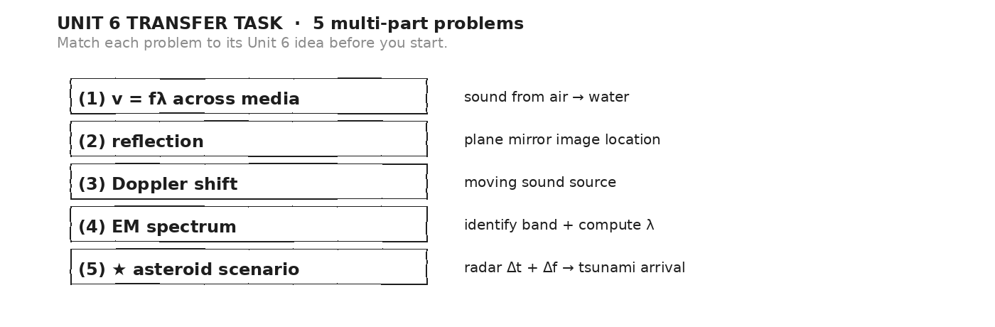

HOW THIS WILL BE SCORED — 4 DIMENSIONS, EACH 0–4
Dimension | What a strong (3–4) response shows
Science | Correct physics: vectors, kinematics, units.
Reasoning | Sound method; uncertainty explained, not just stated.
Communication | Work shown, units labeled, organized, readable.
Transfer-to-Asteroid | Honest public-facing connection to 2026-XJ.
MY WORK — DAY 18 (use additional paper as needed)
AFTER THE TASK — FINAL UNIT MARZANO (rate each Unit 6 target)
Today's Targets — Rate Yourself
1 = Not Yet (I can't do this without help) 2 = Almost (I can do this with some help or some errors) 3 = Got It (I can do this independently and explain it)
Help? Check the box if you want to talk with me about this target — even if you marked yourself a 3.
Target | 1 | 2 | 3 | Help?
K1 — Waves carry energy/info without carrying matter. | ○ | ○ | ○ | ☐
K2 — Wave properties: f, λ, A, T (and f = 1/T). | ○ | ○ | ○ | ☐
K3 — v = f · λ across media. | ○ | ○ | ○ | ☐
K4 — Reflection, refraction, diffraction qualitatively. | ○ | ○ | ○ | ☐
K5 — Interference + standing waves. | ○ | ○ | ○ | ☐
K6 — Sound as longitudinal wave; speed in media. | ○ | ○ | ○ | ☐
K7 — Intensity, inverse-square, decibel scale. | ○ | ○ | ○ | ☐
K8 — Doppler effect. | ○ | ○ | ○ | ☐
K9 — EM spectrum and c = fλ. | ○ | ○ | ○ | ☐
K10 — Mirrors + lenses qualitatively. | ○ | ○ | ○ | ☐
K11 — Wien's law (color ↔ temperature). | ○ | ○ | ○ | ☐
K12 — Seismic + tsunami wave physics. | ○ | ○ | ○ | ☐
S1 — Compute v, f, or λ given the other two. | ○ | ○ | ○ | ☐
S2 — Apply Doppler to compute observed frequency. | ○ | ○ | ○ | ☐
S4 — Use Vernier to measure v_sound by echo. | ○ | ○ | ○ | ☐
R4 — Apply EM-wave framework to radar measurement of 2026-XJ. | ○ | ○ | ○ | ☐

Equation Reference — Unit 6
Keep this page open while you work. Every equation below is on the MCAS Equation Sheet — you do NOT need to memorize them. You DO need to recognize when each one applies.
Concept | Equation | When to use it
Frequency ↔ period | f = 1 / T | Cycles per second is the reciprocal of seconds per cycle. Hz = 1/s.
Wave equation | v = f · λ | Speed = frequency × wavelength. THE central equation of Unit 6. Speed is fixed by medium; the source sets f; λ adjusts to fit.
Law of reflection | θᵢ = θᵣ | Angle of incidence = angle of reflection — both measured from the NORMAL (perpendicular to the surface).
Refraction (qualitative) | slower medium → bend TOWARD normal | Faster medium → bend AWAY from normal. Larger speed change = larger bend. (Snell's law: n₁sinθ₁ = n₂sinθ₂ — see if interested.)
Diffraction (qualitative) | smaller opening (vs. λ) → more spreading | Long λ bends around everyday objects (sound, radio). Short λ does not (light, X-ray).
Sound intensity (inverse square) | I ∝ 1 / r² | Intensity drops as the square of distance from a point source. Twice as far = 1/4 the intensity.
Decibel scale | dB = 10 · log₁₀(I / I₀) | I₀ = 10⁻¹² W/m² (threshold of hearing). Every +10 dB = ×10 in intensity. 0 dB threshold, 60 dB conversation, 120 dB pain.
Doppler shift (sound) | f ' = f · v_sound / (v_sound − v_source) | Moving TOWARD listener: use minus → higher f. Moving AWAY: use plus → lower f. Same idea applies to radar.
Radar distance | d = c · Δt / 2 | Round-trip time × c, then halve. Day 15: 2026-XJ at Δt = 2.5 s → d = 375,000 km.
Radar Doppler velocity | v = (Δf / f) · c | Echo frequency shift divided by transmit frequency, times c. Higher echo f = approaching; lower f = receding.
Wien's law (qualitative) | λ_max · T = 2.9 × 10⁻³ m·K | Hotter object → peak emission at SHORTER wavelength. Cool star red, Sun yellow-white, hot star blue.
Tsunami speed | v = √(g · d) | Ocean-surface gravity wave. d = ocean depth in meters. At d = 4 km, v ≈ 200 m/s ≈ 700 km/h.
Standing wave on a string | f_n = n · v / (2L) | Both ends fixed. n = 1 fundamental, n = 2 second harmonic, etc. Determines pitch of guitar strings + organ pipes.
ELECTROMAGNETIC SPECTRUM — bands and uses
Band | λ (vacuum) | Use
Radio waves | > 1 m | Broadcasting, cell, planetary radar (Day 15).
Microwaves | 1 m to 1 mm | Microwave oven (2.4 GHz), radar.
Infrared (IR) | 1 mm to 700 nm | Heat, night vision, TV remote.
Visible light | 700 to 400 nm | ROYGBIV — what our eyes detect.
Ultraviolet (UV) | 400 to 10 nm | Sunburn, sterilization.
X-rays | 10 to 0.01 nm | Medical imaging.
Gamma rays | < 0.01 nm | Nuclear processes, cosmic events.
WAVE SPEEDS — reference values
Wave + medium | Speed | Note
Light / radio in vacuum | c = 3.00 × 10⁸ m/s | Universal speed limit.
Sound in air (20 °C) | v ≈ 343 m/s | Speeds up about 0.6 m/s per °C warmer.
Sound in water | v ≈ 1480 m/s | About 4× faster than in air.
Sound in steel | v ≈ 5960 m/s | Solids transmit sound fastest.
Seismic P-wave (mantle) | v ≈ 6 km/s | Longitudinal — first to arrive.
Seismic S-wave (mantle) | v ≈ 4 km/s | Transverse — arrives second; can't travel through liquid outer core.
Tsunami (deep ocean, 4 km) | v ≈ 200 m/s ≈ 700 km/h | v = √(g·d) — slows AND amplifies near shore.
DECIBEL REFERENCE — common sound levels
Level | Source
0 dB | Threshold of hearing
30 dB | Quiet library, whisper
60 dB | Normal conversation
85 dB | Heavy traffic — hearing damage with prolonged exposure
100 dB | Loud rock concert, chainsaw
120 dB | Pain threshold, thunderclap
194 dB | Theoretical max in air (atmospheric shockwave)
Constants and reference quantities:
c = 3.00 × 10⁸ m/s · v_sound (air, 20 °C) ≈ 343 m/s · I₀ = 10⁻¹² W/m² · g = 9.8 m/s² · Wien's constant b = 2.9 × 10⁻³ m·K · ROYGBIV: 700 → 400 nm · Earth diameter ≈ 12 700 km
Mastery Growth Chart — Unit 6
Each day, transfer your Marzano 1-2-3 rating onto the chart. Use a different mark or color for each target you track. Unit 6 has ~13 targets across 18 days — track at least your top three.
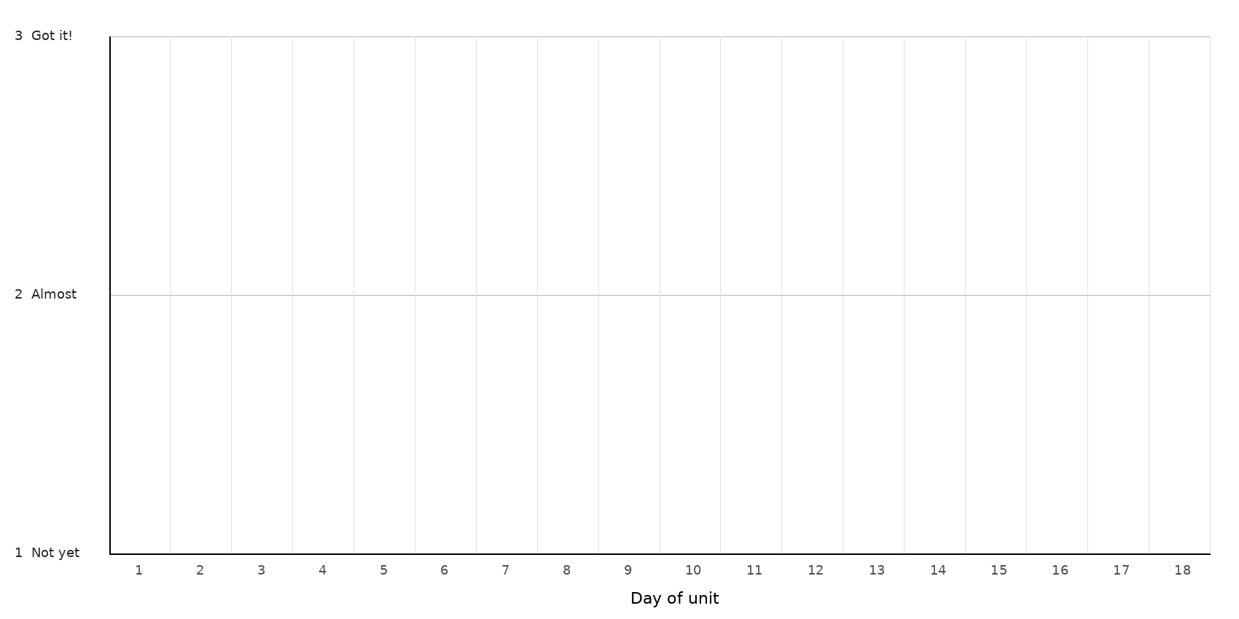
LEGEND — WHICH MARK / COLOR = WHICH TARGET
Mark: ______ Target: __________________________________________________________________
Mark: ______ Target: __________________________________________________________________
Mark: ______ Target: __________________________________________________________________
Mark: ______ Target: __________________________________________________________________
NOTES — END-OF-UNIT REFLECTION

