CPA Physics · Fitchburg High School · 2026–2027
Unit 7 — Electricity & Magnetism
charge · Coulomb's law · electric field · voltage · current · Ohm's law · series + parallel circuits · power · magnetism · Oersted · Faraday · motors · magnetosphere · the BRIDGE to Unit 8
◆ NASA / PLANETARY DEFENSE BRIEFING — UPDATE 7 — FINAL
After a full year of theory, the orbit predictions for 2026-XJ have refined to the point where the impact probability is now BELOW 1 in 10,000 — close enough to be uncomfortable, far enough to be useful for planning. The math you've done was REAL physics applied to a possible scenario, not panic-mongering.
But the asteroid story is closing for ONE reason and opening for another: you've spent a year learning the THEORY. Now Unit 8 has you BUILDING. The Car Project doesn't have an asteroid in it — it's a DC-motor electric car that races down a corridor. But every piece of it comes from somewhere in this year of physics: the gear ratio is Unit 2 mechanical advantage; the impulse force during the start is Unit 3; the kinetic energy at top speed is Unit 4; the heat that the motor dissipates is Unit 5; the radio waves that NASA uses to control real-world planetary defense missions are Unit 6; and the CIRCUIT itself is Unit 7. Theory becomes engineering.
The cosmic side: there's also one new piece of data. Earth's MAGNETOSPHERE — generated by E&M physics you'll meet on Day 12 — is what protected life on this planet long enough for you to exist and learn this curriculum. A large impact could disrupt the magnetosphere temporarily; that's Day 16's content. The same physics that runs the Car Project's motor runs the dynamo at Earth's core that runs the magnetosphere that runs the protection.
This is fiction. The physics — and the equations — are real.
MA Standards: HS-PS2-4, HS-PS2-5, HS-PS3-5
18 meetings · Spring 2027 (Mar 9 – Apr 3)
Name: ______________________________ Class period: __________ Date received: __________
"Theory becomes engineering. Unit 8 awaits."
Table of Contents
Day-type key: A = Anchor · S = Standard · L = Lab · T = Transfer · ★ = Asteroid/Bridge payoff
Section | Type | Page
Cover | — | 1
Table of Contents | — | 2
Phase 1 — Static electricity (charge, field, force) | —
Day 1 — Meet electric charge + Unit 8 preview | A | 3
Day 2 — Coulomb's law: F = kq₁q₂/r² | S | 6
Day 3 — Electric field (qualitative) | S | 9
Phase 2 — Voltage + current | —
Day 4 — Voltage: energy per charge | S | 12
Day 5 — Current: I = q/t | S | 15
Day 6 — Ohm's law: V = IR | S | 18
Phase 3 — Circuits | —
Day 7 — Series circuits | S | 21
Day 8 — Parallel circuits | S | 24
Day 9 — Combination circuits | S | 27
Day 10 — Vernier circuit lab | L | 30
Phase 4 — Power + magnetism | —
Day 11 — Electric power: P = VI | S | 33
Day 12 — Magnetism + Earth's field | S | 36
Day 13 — Oersted: current → magnetic field | S | 39
Phase 5 — Induction + motors | —
Day 14 — Faraday induction | S | 42
Day 15 — Motors + generators | S | 45
Phase 6 — Closing arc + bridge to Unit 8 | —
Day 16 — ★ Magnetosphere + EMP from impact | S★ | 48
Day 17 — ★★ BRIDGE TO THE CAR PROJECT | S★★ | 51
Day 18 — Unit 7 transfer task | T | 55
Equation Reference Card | — | 58
Mastery Growth Chart | — | 60

Day 1 — Meet Electric Charge · And the Bridge to the Car Project

Today's Target
I can describe charge as the FUNDAMENTAL quantity of Unit 7 (analogous to mass in Unit 2, energy in Unit 4), distinguish positive from negative, and name what's coming in the unit — including the Day 17 BRIDGE into Unit 8 Car Project.
ASTEROID THREAD
What we know about 2026-XJ today: UPDATE 7 (final): impact probability is now below 1 in 10,000. The asteroid story is closing. A YEAR of theory is closing too.
How today connects: Unit 7 simultaneously closes the cosmic arc (Day 16: how Earth's magnetosphere protects us) AND opens the engineering arc (Day 17: every Car Project part traces to a unit). Both threads converge.

NOTICE AND WONDER
Demo: rub a balloon on your hair (or a wool sweater), then bring it near a pile of torn paper bits on the table. The bits LEAP UP to the balloon. Force WITHOUT contact. What happened?
I notice ____________________________
I wonder ____________________________

DOODLE ZONE
Sketch what changed when you rubbed the balloon on hair. Did mass appear or disappear? Did energy? Something else moved between the balloon and the hair. What was it?
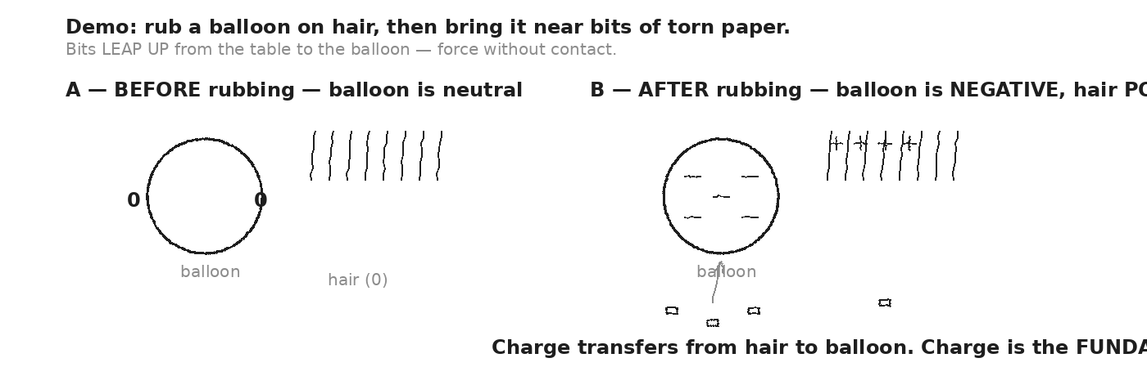

VOCAB · ELECTRIC CHARGE
Definition: A fundamental property of matter, like mass. Comes in two kinds: POSITIVE and NEGATIVE. Like charges repel; unlike charges attract. Measured in coulombs (C).
Example: The electron is the smallest unit: q = −e = −1.6 × 10⁻¹⁹ C. The proton: q = +e = +1.6 × 10⁻¹⁹ C. Rubbing the balloon moves electrons from hair to balloon.
Cognates: Sp. carga eléctrica · Pt. carga elétrica · HC chaj elektrik
Watch out: Charge isn't CREATED by rubbing — it's TRANSFERRED. Total charge is conserved (one of the deepest laws in physics).

VOCAB · CONDUCTOR (VS. INSULATOR)
Definition: A material where charge moves freely (metals — copper, aluminum, gold). Insulators (rubber, glass, plastic, dry air) hold charge in place.
Example: A copper wire is a conductor — that's why circuits use it. Rubber insulation around the wire keeps the charge inside the metal.
Cognates: Sp. conductor · Pt. condutor · HC kondiktè
Watch out: Conductor = lets charge flow. Insulator = blocks it. Semiconductors (silicon) are in-between — basis of all modern electronics.

VOCAB · COULOMB (C)
Definition: The SI unit of electric charge. 1 coulomb = the charge of 6.24 × 10¹⁸ electrons.
Example: A typical lightning bolt transfers about 15 C. A 9V battery delivers about 5 C per minute when running a small motor.
Cognates: Sp. culombio · Pt. coulomb · HC koulonm
Watch out: The charge of ONE electron (−1.6 × 10⁻¹⁹ C) is tiny — 1 C is a HUGE number of electrons. But when current flows, this many pass per second!

MY GUESS — if the balloon picked up extra negative charges, and the paper bits were neutral (zero net charge), WHY did the bits jump UP to the balloon? (Day 3 has the answer.)
★ | Unit 7 has TWO payoff days. Day 16: Earth's MAGNETOSPHERE — generated by E&M physics — is what protects life from cosmic + solar radiation. Day 17: every part of the Car Project (battery, wires, motor, gears, wheels) traces to a unit of this year's physics. Theory becomes engineering.

EXIT TICKET — Day 1
You rub a balloon on your hair. Why does it stick to a wall afterward? Mention CHARGE and ATTRACTION in two sentences.

Today's Targets — Rate Yourself
1 = Not Yet (I can't do this without help) 2 = Almost (I can do this with some help or some errors) 3 = Got It (I can do this independently and explain it)
Help? Check the box if you want to talk with me about this target — even if you marked yourself a 3.
Target | 1 | 2 | 3 | Help?
I can describe charge as the fundamental quantity of E&M. | ○ | ○ | ○ | ☐
I can distinguish positive vs. negative charge. | ○ | ○ | ○ | ☐
I can name the Unit 7 payoff days (16 + 17). | ○ | ○ | ○ | ☐

Day 2 — Coulomb's Law: F = k · q₁ · q₂ / r²

Today's Target
I can apply Coulomb's law to compute the electric force between two point charges, predict the direction (attract vs. repel), and explain why it's an INVERSE-SQUARE law (just like gravity).
ASTEROID THREAD
What we know about 2026-XJ today: From Unit 2: F_grav = G m₁m₂/r². Same inverse-square SHAPE.
How today connects: Today: the electric version. Same equation pattern — different constant, different 'charges' instead of masses. Both fall off as 1/r².

VOCAB · COULOMB'S LAW
Definition: F = k · q₁ · q₂ / r². The electric force between two point charges. k = 9 × 10⁹ N·m²/C² (Coulomb's constant).
Example: Two +1 C charges 1 m apart would repel with F = 9 × 10⁹ N — HUGE. (That's why we usually deal with μC or nC in lab.)
Cognates: Sp. ley de Coulomb · Pt. lei de Coulomb · HC lwa Coulomb
Watch out: The SIGN of the force tells you direction. Same signs (both +, both −) → repel. Different signs → attract. Don't lose the sign in algebra.

VOCAB · INVERSE-SQUARE LAW
Definition: Force falls off as 1/r². Double the distance → ¼ the force. Triple the distance → 1/9 the force.
Example: Gravity (F = Gm₁m₂/r²) and Coulomb force (F = kq₁q₂/r²) are both inverse-square. So is light intensity and sound intensity.
Cognates: Sp. ley del inverso del cuadrado · Pt. lei do inverso do quadrado · HC lwa envès kare
Watch out: The 'square' is in the DENOMINATOR. If r doubles, you divide by 2² = 4. NOT 2.

VOCAB · POINT CHARGE
Definition: An idealization — a charge concentrated at one point with no size. Coulomb's law applies exactly to point charges, approximately to small charged objects.
Example: A charged balloon isn't a point — but at distances much larger than the balloon, it acts like one. Same for electrons + protons.
Cognates: Sp. carga puntual · Pt. carga pontual · HC chaj pwen
Watch out: Real objects have sizes, but at distances >> their size, the point-charge model works well.

DOODLE ZONE
Sketch two charged spheres with the force arrows on each. Show what happens when you DOUBLE the distance between them. (Inverse-square — force drops by 4.)
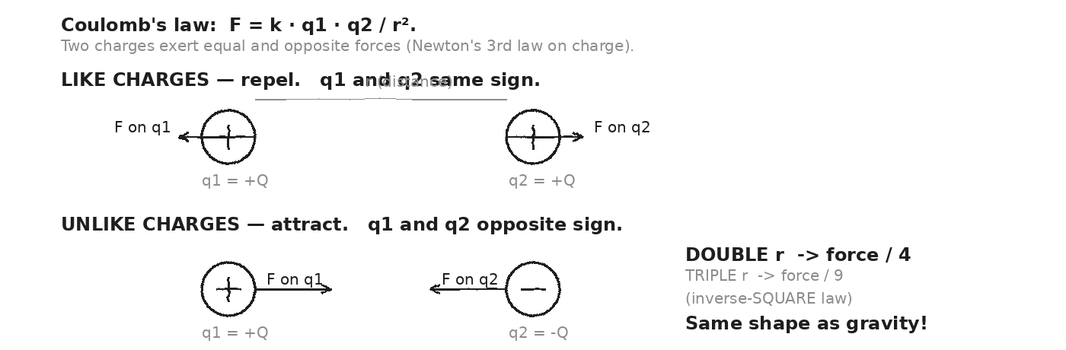

WORKED EXAMPLE — two equal positive charges
Two equal +2 μC charges are 0.30 m apart. Compute the force on each.
GIVEN | q₁ = q₂ = +2 × 10⁻⁶ C · r = 0.30 m · k = 9 × 10⁹ N·m²/C²
EQUATION | F = k · q₁ · q₂ / r²
WORK | F = (9 × 10⁹) · (2 × 10⁻⁶) · (2 × 10⁻⁶) / (0.30)²  F = (9 × 10⁹) · (4 × 10⁻¹²) / 0.09  F = (3.6 × 10⁻²) / 0.09  F = 0.4 N
ANSWER | F = 0.4 N on each charge, pushing them APART (like charges repel).

WORKED EXAMPLE — inverse-square scaling
Same two +2 μC charges, but now 0.60 m apart (double the distance). What's the new force?
GIVEN | r' = 0.60 m = 2 · 0.30 m
EQUATION | F' = F / (r'/r)² = F / 4
WORK | F' = 0.4 / 4  F' = 0.1 N
ANSWER | F' = 0.1 N. Doubling distance → force divided by 4. Inverse-square.

YOUR TURN — proton and electron in a hydrogen atom
A proton (+e) and an electron (−e) are 5.3 × 10⁻¹¹ m apart (Bohr radius). Compute the magnitude of the Coulomb attraction. e = 1.6 × 10⁻¹⁹ C.
GIVEN
EQUATION
WORK
ANSWER

★ | The Coulomb attraction inside an atom is ENORMOUS at that scale — about 10⁸ N when scaled per kg of mass. That's what holds atoms together. Gravity, by contrast, is irrelevant at this distance.

Fill in the frame:
Coulomb's law and Newton's gravity both fall off as ________________________________________________________. The Coulomb constant k is much ________________________________________________________ than the gravitational constant G, so electric forces dominate at the ________________________________________________________ scale; gravity dominates at the ________________________________________________________ scale.
EXIT TICKET — Day 2
Two +3 μC charges are 0.1 m apart. Compute the force. (k = 9 × 10⁹.) Show one line of work.

Today's Targets — Rate Yourself
1 = Not Yet (I can't do this without help) 2 = Almost (I can do this with some help or some errors) 3 = Got It (I can do this independently and explain it)
Help? Check the box if you want to talk with me about this target — even if you marked yourself a 3.
Target | 1 | 2 | 3 | Help?
I can apply F = k q₁q₂/r² to compute electric force. | ○ | ○ | ○ | ☐
I can predict direction from charge signs. | ○ | ○ | ○ | ☐
I can explain why doubling r divides F by 4. | ○ | ○ | ○ | ☐

Day 3 — Electric Field: E = F / q (force per coulomb)

Today's Target
I can interpret electric field lines (out of + charges, into − charges, denser = stronger), use E = F/q to compute force on a charge in a known field, and explain why a NEUTRAL object can still feel a force in an electric field (induced polarization).
ASTEROID THREAD
What we know about 2026-XJ today: Coulomb's law tells us the force between charges. But what if there are MANY charges, or a charge in empty space?
How today connects: Field is the answer to 'how does one charge KNOW about another at a distance?' It's a property of every point in space — what a + test charge would feel.

VOCAB · ELECTRIC FIELD (E)
Definition: A vector quantity at every point in space. E = F/q — the force per unit positive charge. Units: N/C (or V/m).
Example: In a uniform field E = 100 N/C, a +2 C charge feels F = E·q = 200 N in the direction of E.
Cognates: Sp. campo eléctrico · Pt. campo elétrico · HC chan elektrik
Watch out: E is independent of the test charge — it's a property of the SOURCE charges. The test charge tells you what HAPPENS in the field.

VOCAB · FIELD LINES
Definition: Drawn arrows showing E direction at every point. Lines come OUT of + charges, INTO − charges. Denser lines = stronger field.
Example: A single + charge: field lines radiate outward like spokes. A single − charge: field lines point inward. Between + and −: lines arc from + to −.
Cognates: Sp. líneas de campo · Pt. linhas de campo · HC liy chan
Watch out: Field lines are a DRAWING TOOL — there aren't actually 'lines' in space. The field exists at every point.

VOCAB · POLARIZATION (INDUCED)
Definition: A neutral object placed in an electric field rearranges its own charges — the + side faces toward the − source, and vice versa. The object becomes a tiny dipole.
Example: The balloon attracts neutral paper bits because the field POLARIZES the paper. The closer (+) end of the paper feels stronger attraction than the (−) end feels repulsion → net pull toward the balloon.
Cognates: Sp. polarización · Pt. polarização · HC polarizasyon
Watch out: A neutral object STILL feels a force in a non-uniform field — through induced polarization. That's the answer to Day 1's exit question.

DOODLE ZONE
Sketch field lines for: (A) a single + charge alone, (B) a single − charge alone, (C) a + and − together (dipole). Where are the lines most dense? Where is E strongest?
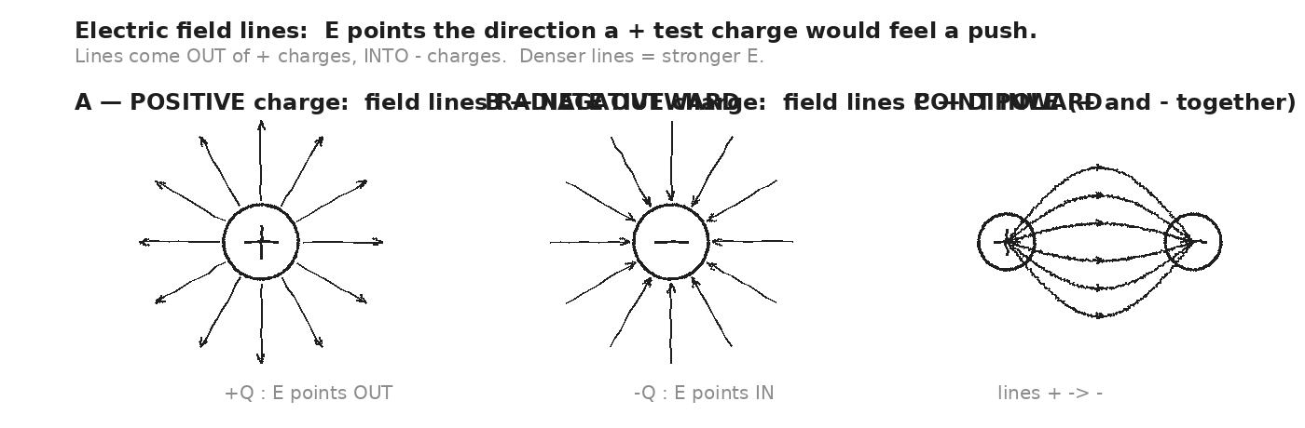

WORKED EXAMPLE — force on a charge in a known field
An electric field E = 50 N/C points to the right (+x). What force does it exert on a +3 C charge placed in it?
GIVEN | E = 50 N/C (in +x direction) · q = +3 C
EQUATION | F = E · q
WORK | F = 50 · 3  F = 150 N (in +x direction)
ANSWER | F = 150 N pointing right (same direction as E, because q is positive).

WORKED EXAMPLE — force on a NEGATIVE charge in the same field
Same field E = 50 N/C in +x. Now place a −2 C charge in it. Compute the force.
GIVEN | E = 50 N/C in +x · q = −2 C
EQUATION | F = E · q
WORK | F = 50 · (−2)  F = −100 N (in +x direction)  F = 100 N pointing in −x (LEFT)
ANSWER | F = 100 N to the LEFT. Negative charges feel force OPPOSITE to E.

YOUR TURN — field from a + charge
A +5 μC point charge is fixed at the origin. What's the electric field magnitude at a point 0.10 m away? (E = kq/r², for a point source.)
GIVEN
EQUATION
WORK
ANSWER

★ | The paper bits leaping to the balloon: the balloon's negative charge creates an E field. The neutral paper polarizes — its + side closer to the balloon — so the attractive force on the + side wins. NEUTRAL objects feel forces in NON-UNIFORM fields.

Fill in the frame:
Electric field lines come OUT of ________________________________________________________ charges, IN to ________________________________________________________ charges. The force on a charge q is F = ________________________________________________________. For a positive q, F points along ________________________________________________________; for a negative q, F points ________________________________________________________.
EXIT TICKET — Day 3
An electric field E = 100 N/C points east. A −1 μC charge sits in the field. What force does it feel? (Magnitude AND direction.) Show one line of work.

Today's Targets — Rate Yourself
1 = Not Yet (I can't do this without help) 2 = Almost (I can do this with some help or some errors) 3 = Got It (I can do this independently and explain it)
Help? Check the box if you want to talk with me about this target — even if you marked yourself a 3.
Target | 1 | 2 | 3 | Help?
I can interpret electric field lines. | ○ | ○ | ○ | ☐
I can use F = E·q to compute force from field. | ○ | ○ | ○ | ☐
I can explain why neutral objects feel forces (induced polarization). | ○ | ○ | ○ | ☐

Day 4 — Voltage: V = U / q (electric potential energy per coulomb)

Today's Target
I can describe voltage as the ENERGY each coulomb of charge carries (J/C), use the water-tank analogy to predict whether charge will flow, and identify the voltage of common sources (AA = 1.5V, 9V battery, household = 120V).
ASTEROID THREAD
What we know about 2026-XJ today: From Unit 4: energy is conserved and can be transferred. From Day 1: charge is the fundamental quantity.
How today connects: Voltage marries them: how much ENERGY each unit of CHARGE carries. The 9V battery in the Car Project (Day 17 preview) carries 9 J per C.

VOCAB · VOLTAGE (V)
Definition: Electric potential difference. The energy carried per coulomb of charge. V = U / q. Units: volts (V) = joules / coulomb.
Example: A 9V battery means 9 J of energy per coulomb of charge that passes through. A 1.5V AA cell: 1.5 J/C.
Cognates: Sp. voltaje · Pt. voltagem · HC voltaj
Watch out: Voltage is energy PER charge, not total energy. A 9V battery has limited TOTAL energy (depends on its size) but the same 9V no matter how full.

VOCAB · ELECTRIC POTENTIAL ENERGY (U)
Definition: The energy a charge has due to its position in an electric field. Like gravitational PE = mgh, but for charge: U = q·V.
Example: A 0.5 C charge in a 9V battery has U = 0.5 · 9 = 4.5 J of potential energy waiting to be released through the circuit.
Cognates: Sp. energía potencial eléctrica · Pt. energia potencial elétrica · HC enèji potansyèl elektrik
Watch out: Potential energy belongs to the CHARGE in the field. Voltage is per-coulomb; energy is total.

VOCAB · EMF (ELECTROMOTIVE FORCE)
Definition: The voltage a battery (or other source) PROVIDES to push charge around a circuit. Confusingly NOT a force — it's a voltage. Symbol: ε. Units: volts.
Example: A fresh 9V battery has EMF ≈ 9V. As it drains, the EMF drops. The 'force' name is historical.
Cognates: Sp. fuerza electromotriz · Pt. força eletromotriz · HC fòs elektwomotè
Watch out: EMF is measured in VOLTS, not newtons. The 'force' word is misleading — it's really a per-charge ENERGY.

DOODLE ZONE
Two water tanks at different heights. Label which is 'high voltage' and which is 'low voltage'. Mark the JOULES PER COULOMB analogy.
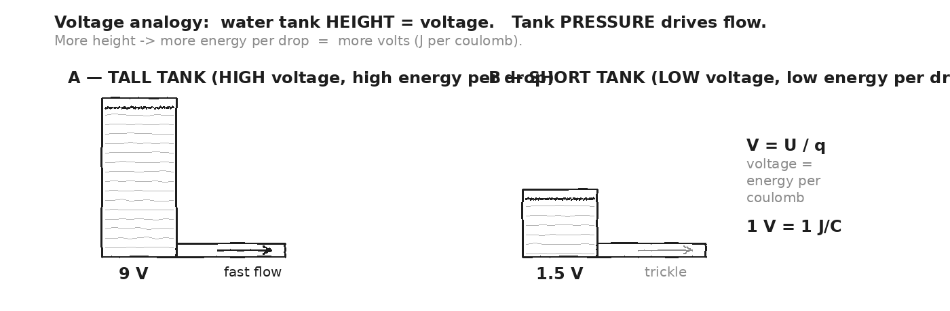

WORKED EXAMPLE — energy delivered by a battery
A 9V battery pushes 0.5 C of charge through a circuit. How much energy did the battery deliver?
GIVEN | V = 9 V · q = 0.5 C
EQUATION | U = q · V
WORK | U = 0.5 · 9  U = 4.5 J
ANSWER | U = 4.5 J of electrical energy delivered to the circuit.

WORKED EXAMPLE — same charge, different battery
The same 0.5 C of charge passes through a 1.5V AA battery. How much energy this time?
GIVEN | V = 1.5 V · q = 0.5 C
EQUATION | U = q · V
WORK | U = 0.5 · 1.5  U = 0.75 J
ANSWER | U = 0.75 J. Same charge, less voltage → less energy. Six times less, because 9/1.5 = 6.

YOUR TURN — charge needed for 100 J
You want a 9V battery to deliver 100 J of energy to a circuit. How many coulombs of charge must flow through?
GIVEN
EQUATION
WORK
ANSWER

★ | Why so many small batteries? AA is 1.5V — too low for most uses. So we stack them in series: 4 AA = 6V, 6 AA = 9V. Voltages in series ADD. The Car Project uses a single 9V (compact rectangular) for simplicity.

Fill in the frame:
Voltage measures ________________________________________________________ per ________________________________________________________. A 9V battery gives ________________________________________________________ J to every coulomb of charge that flows through. To deliver more total energy, you need more ________________________________________________________ (charge to flow).
EXIT TICKET — Day 4
How much energy does a 12V car battery deliver when 1.0 C of charge flows through it? Show one line of work.

Today's Targets — Rate Yourself
1 = Not Yet (I can't do this without help) 2 = Almost (I can do this with some help or some errors) 3 = Got It (I can do this independently and explain it)
Help? Check the box if you want to talk with me about this target — even if you marked yourself a 3.
Target | 1 | 2 | 3 | Help?
I can describe voltage as J per C. | ○ | ○ | ○ | ☐
I can compute energy from V and q (U = qV). | ○ | ○ | ○ | ☐
I can name voltages of common sources. | ○ | ○ | ○ | ☐

Day 5 — Current: I = q / t (charge per second)

Today's Target
I can describe current as the RATE of charge flow (coulombs per second), distinguish conventional current from electron flow, and compute current from charge and time.
ASTEROID THREAD
What we know about 2026-XJ today: From Day 4: voltage = energy per charge.
How today connects: Today: how FAST charge flows. Voltage and current together (Day 6) = power (Day 11) — the framework for predicting the Car motor (Day 17).

VOCAB · ELECTRIC CURRENT (I)
Definition: Rate of charge flow past a point. I = q / t. Units: amperes (A) = coulombs / second.
Example: A 1A current means 1 coulomb of charge passes a given cross-section every second. A USB phone charger ≈ 1 A. The Car motor ≈ 2 A.
Cognates: Sp. corriente eléctrica · Pt. corrente elétrica · HC kouran elektrik
Watch out: Don't confuse current (rate) with charge (amount). 1A flowing for 1s = 1C; flowing for 10s = 10C.

VOCAB · CONVENTIONAL CURRENT (VS. ELECTRON FLOW)
Definition: Conventional current = direction POSITIVE charges would flow (high V to low V). Actual electrons flow OPPOSITE — from low V to high V (− terminal to + terminal).
Example: In a copper wire, electrons drift from − to +. But we draw current arrows from + to − (conventional). Same idea, opposite arrow.
Cognates: Sp. corriente convencional · Pt. corrente convencional · HC kouran konvansyonèl
Watch out: Historical accident — Ben Franklin guessed wrong about which charge moves. We keep the convention. Just remember: conventional current arrow OPPOSITE to electron drift.

VOCAB · AMPERE (A)
Definition: The SI unit of current. 1 A = 1 C/s. Named for André-Marie Ampère.
Example: Phone charger: 1 A. Car headlight: 5–10 A. Microwave: 12 A. Lightning bolt peak: 30,000 A.
Cognates: Sp. amperio · Pt. ampère · HC anpè
Watch out: Don't confuse 'A' (amps) with 'C' (coulombs). A is rate; C is amount. 1A = 1C/s.

DOODLE ZONE
A wire seen in cross-section. Electrons (each carrying −e) flow one way; conventional current is drawn the OPPOSITE way. Label both. How would you count current?
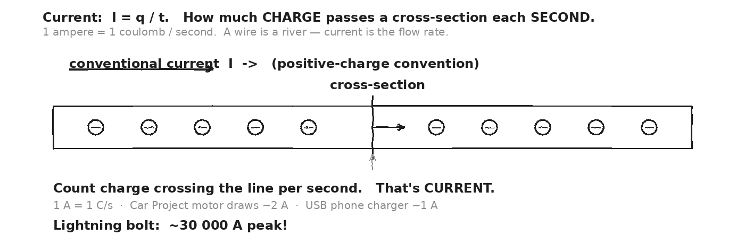

WORKED EXAMPLE — current from charge and time
A 30 C of charge passes through a wire in 10 seconds. What's the current?
GIVEN | q = 30 C · t = 10 s
EQUATION | I = q / t
WORK | I = 30 / 10  I = 3 A
ANSWER | I = 3 A (3 coulombs per second).

WORKED EXAMPLE — charge from current and time
A 2 A current flows for 60 seconds. How much charge passes?
GIVEN | I = 2 A · t = 60 s
EQUATION | q = I · t
WORK | q = 2 · 60  q = 120 C
ANSWER | q = 120 C of charge passes in 1 minute at 2 A.

YOUR TURN — Car motor current (preview)
The Car Project motor pulls about 2 A for the duration of a 15-second race. How much total charge flows through the motor?
GIVEN
EQUATION
WORK
ANSWER

★ | 2 A · 15 s = 30 C of charge through the motor. Each coulomb carries 9 J (from the 9V battery), so total energy delivered = 30 · 9 = 270 J. Day 11 (power) ties this together.

Fill in the frame:
Current is ________________________________________________________ per second. 1 A = 1 ________________________________________________________ / s. Conventional current flows from ________________________________________________________ terminal to ________________________________________________________ terminal. Electrons actually flow the opposite direction.
EXIT TICKET — Day 5
A 0.5 A current flows for 5 minutes. How many coulombs of charge pass? Show one line of work.

Today's Targets — Rate Yourself
1 = Not Yet (I can't do this without help) 2 = Almost (I can do this with some help or some errors) 3 = Got It (I can do this independently and explain it)
Help? Check the box if you want to talk with me about this target — even if you marked yourself a 3.
Target | 1 | 2 | 3 | Help?
I can use I = q/t in both directions. | ○ | ○ | ○ | ☐
I can name typical currents (charger, motor, lightning). | ○ | ○ | ○ | ☐
I can distinguish conventional from electron flow. | ○ | ○ | ○ | ☐

Day 6 — Ohm's Law: V = I · R

Today's Target
I can apply V = IR to compute any one of V, I, or R given the other two; explain RESISTANCE as 'how hard charge has to push through' a component; and use the triangle to read off the formula.
ASTEROID THREAD
What we know about 2026-XJ today: From Day 4: voltage. From Day 5: current. These two are linked by RESISTANCE.
How today connects: Ohm's law is the master equation of every circuit — and the equation that lets us PREDICT the Car motor's current on Day 17 (given V and R).

VOCAB · RESISTANCE (R)
Definition: How much a component opposes the flow of charge. R = V / I. Units: ohms (Ω). 1 Ω = 1 V/A.
Example: A copper wire: R ≈ 0.01 Ω (very low). A motor: R ≈ 3–5 Ω. A lightbulb (incandescent): R ≈ 100 Ω. A toaster element: R ≈ 15 Ω (carries a lot of current).
Cognates: Sp. resistencia · Pt. resistência · HC rezistans
Watch out: High R = LITTLE current at a given V (and vice versa). An open switch is R = infinity (no current). A short circuit is R ≈ 0 (huge current — dangerous).

VOCAB · OHM'S LAW
Definition: V = I · R. Equivalent forms: I = V/R, R = V/I. The TRIANGLE: cover the unknown, read the formula.
Example: 9V across a 3Ω motor → I = V/R = 9/3 = 3 A.
Cognates: Sp. ley de Ohm · Pt. lei de Ohm · HC lwa Ohm
Watch out: Ohm's law works for OHMIC materials — metals at constant temperature. Light bulbs and motors are not strictly ohmic (R changes with temperature), but we use it as an approximation.

VOCAB · OHM (Ω)
Definition: SI unit of resistance. 1 Ω = 1 V/A. Named for Georg Ohm.
Example: Common resistor values: 100 Ω, 1 kΩ, 10 kΩ, 1 MΩ. Sized for the current and voltage of your circuit.
Cognates: Sp. ohmio · Pt. ohm · HC ohm
Watch out: The capital omega is read 'ohm'. The lowercase ω is 'angular frequency' (different concept). Don't confuse.

DOODLE ZONE
Draw the Ohm's triangle. Cover V → read V = IR. Cover I → read I = V/R. Cover R → read R = V/I. Practice each.
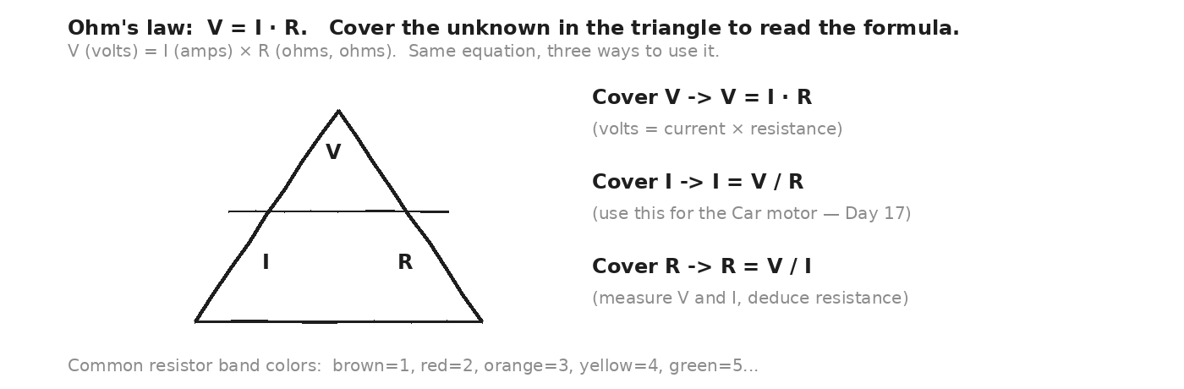

WORKED EXAMPLE — current through a resistor
A 6V battery is connected across a 12Ω resistor. What's the current?
GIVEN | V = 6 V · R = 12 Ω
EQUATION | I = V / R
WORK | I = 6 / 12  I = 0.5 A
ANSWER | I = 0.5 A through the resistor.

WORKED EXAMPLE — resistance from V and I
A circuit measures V = 9V across a component and I = 3 A through it. What's the resistance?
GIVEN | V = 9 V · I = 3 A
EQUATION | R = V / I
WORK | R = 9 / 3  R = 3 Ω
ANSWER | R = 3 Ω.

YOUR TURN — voltage across a component
A current of 2.5 A flows through a 4 Ω resistor. What's the voltage across it?
GIVEN
EQUATION
WORK
ANSWER

YOUR TURN — Car motor current preview
Estimate: the Car Project motor has R ≈ 4 Ω (estimated). Connected to a 9V battery, what current will it draw?
GIVEN
EQUATION
WORK
ANSWER

★ | 9V / 4Ω = 2.25 A. That's the Car motor current PREDICTED from Ohm's law. Day 17 you'll do this prediction in full detail. Day 18 transfer task will ask you to predict again. Day 1 of Unit 8: you'll MEASURE.

Fill in the frame:
Ohm's law says V = ________________________________________________________. To find current, use I = ________________________________________________________. To find resistance, use R = ________________________________________________________. A 'short circuit' has R close to ________________________________________________________, leading to a ________________________________________________________ current.
EXIT TICKET — Day 6
A 12V battery drives 4 A through a wire-wound resistor. What's the resistance? Show one line of work.

Today's Targets — Rate Yourself
1 = Not Yet (I can't do this without help) 2 = Almost (I can do this with some help or some errors) 3 = Got It (I can do this independently and explain it)
Help? Check the box if you want to talk with me about this target — even if you marked yourself a 3.
Target | 1 | 2 | 3 | Help?
I can apply V = IR in any direction. | ○ | ○ | ○ | ☐
I can interpret resistance physically. | ○ | ○ | ○ | ☐
I can predict current for the Car motor. | ○ | ○ | ○ | ☐

Day 7 — Series Circuits: R_series = R₁ + R₂ + R₃ + ...

Today's Target
I can identify a series circuit, add resistances to find the total, compute the SHARED current using V = IR, and explain why an open switch (or broken wire) kills the whole circuit.
ASTEROID THREAD
What we know about 2026-XJ today: From Day 6: V = IR for a single component.
How today connects: Today: what happens when multiple resistances are in a single loop — the SAME current passes through all. Day 8: the other way to wire them.

VOCAB · SERIES CIRCUIT
Definition: One single path for current. Components are connected end-to-end. The SAME current passes through every component.
Example: Three resistors (2Ω, 3Ω, 5Ω) in series across 9V. R_total = 10Ω; I = 0.9 A through all three.
Cognates: Sp. circuito en serie · Pt. circuito em série · HC sikui an seri
Watch out: In series, VOLTAGE divides among components (proportional to each R). Same total V; same current.

VOCAB · R_SERIES (TOTAL RESISTANCE)
Definition: R_series = R₁ + R₂ + R₃ + ... Just add them. Always BIGGER than any one component.
Example: 2Ω + 3Ω + 5Ω = 10Ω total. The current sees the SUM of resistances along its one path.
Cognates: Sp. resistencia total · Pt. resistência total · HC rezistans total
Watch out: Adding resistors in series ALWAYS increases resistance. The opposite (parallel — Day 8) DECREASES resistance.

VOCAB · VOLTAGE DIVIDER
Definition: A series circuit DIVIDES the source voltage across components in proportion to their resistance. V_i = (R_i / R_total) · V_source.
Example: 9V across 2Ω + 3Ω + 5Ω: V_1 = (2/10)·9 = 1.8V, V_2 = (3/10)·9 = 2.7V, V_3 = (5/10)·9 = 4.5V. Sum = 9V ✓.
Cognates: Sp. divisor de voltaje · Pt. divisor de tensão · HC divizè vòltaj
Watch out: Voltages ADD UP TO the source. Currents are EQUAL. Series circuits divide voltage, not current.

DOODLE ZONE
Draw the schematic: battery + three resistors in series. Mark current with an arrow. Mark voltage across each resistor. Verify that V₁ + V₂ + V₃ = V_battery.
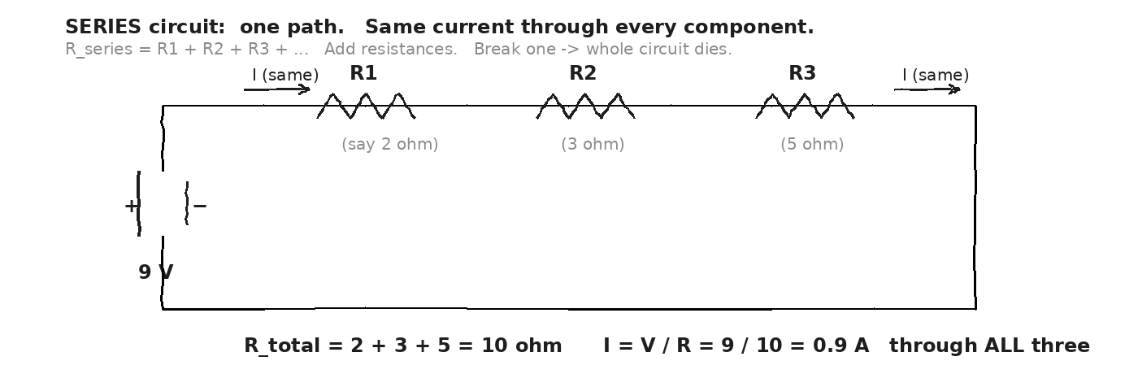

WORKED EXAMPLE — three resistors in series
9V battery across R₁ = 2Ω, R₂ = 3Ω, R₃ = 5Ω in series. Find: R_total, current through each, voltage across each.
GIVEN | V = 9 V · R₁ = 2 Ω · R₂ = 3 Ω · R₃ = 5 Ω
EQUATION | R_series = R₁ + R₂ + R₃ ; I = V / R_total ; V_i = I · R_i
WORK | R_total = 2 + 3 + 5 = 10 Ω  I = 9 / 10 = 0.9 A (through ALL three)  V₁ = 0.9 · 2 = 1.8 V  V₂ = 0.9 · 3 = 2.7 V  V₃ = 0.9 · 5 = 4.5 V  Check: 1.8 + 2.7 + 4.5 = 9.0 V ✓
ANSWER | I = 0.9 A through all. Voltages 1.8 V / 2.7 V / 4.5 V — they add to 9 V.

YOUR TURN — two resistors in series
12V across 4Ω + 8Ω in series. Find R_total, I, and the voltage across each.
GIVEN
EQUATION
WORK
ANSWER

★ | Series Christmas-tree lights from the old days: one bulb burns out → the whole string dies. That's the BREAK-ONE-LOSE-ALL rule of series. Modern strings put bulbs in parallel — Day 8. The Car Project is a SERIES circuit (battery → switch → motor → back to battery).

Fill in the frame:
In a series circuit, the CURRENT is the same through every ________________________________________________________. The VOLTAGES across components ADD up to the ________________________________________________________. Total resistance is the ________________________________________________________ of individual resistances.
EXIT TICKET — Day 7
9V across three 3Ω resistors in series. Find R_total and the current. Show one line of work for each.

Today's Targets — Rate Yourself
1 = Not Yet (I can't do this without help) 2 = Almost (I can do this with some help or some errors) 3 = Got It (I can do this independently and explain it)
Help? Check the box if you want to talk with me about this target — even if you marked yourself a 3.
Target | 1 | 2 | 3 | Help?
I can identify a series circuit. | ○ | ○ | ○ | ☐
I can apply R_series = ΣR_i. | ○ | ○ | ○ | ☐
I can compute the shared current and individual voltage drops. | ○ | ○ | ○ | ☐

Day 8 — Parallel Circuits: 1/R_parallel = 1/R₁ + 1/R₂ + ...

Today's Target
I can identify a parallel circuit, compute total resistance using the reciprocal rule, compute the SHARED voltage and the CURRENT IN EACH BRANCH, and explain why one branch can fail without breaking the others.
ASTEROID THREAD
What we know about 2026-XJ today: From Day 7: series — one path, shared current.
How today connects: Today: multiple paths, shared voltage. Real-world appliances are almost always wired in parallel (so your toaster doesn't die when the microwave is unplugged).

VOCAB · PARALLEL CIRCUIT
Definition: Multiple independent paths between two nodes. The SAME voltage is across each branch.
Example: Your house's wall outlets are in parallel — each receives 120V regardless of what's plugged into the others.
Cognates: Sp. circuito en paralelo · Pt. circuito em paralelo · HC sikui paralèl
Watch out: In PARALLEL, the SAME voltage is across each branch. Current DIVIDES among branches (more current through lower-R branches).

VOCAB · R_PARALLEL (COMBINED)
Definition: 1/R_parallel = 1/R₁ + 1/R₂ + 1/R₃ + ... . Always SMALLER than the smallest individual R. Two equal resistors in parallel: R_p = R/2.
Example: 3Ω || 6Ω: 1/R = 1/3 + 1/6 = 2/6 + 1/6 = 3/6 = 1/2 → R = 2Ω. Smaller than either!
Cognates: Sp. resistencia en paralelo · Pt. resistência em paralelo · HC rezistans paralèl
Watch out: Adding MORE branches in parallel LOWERS the total R (more paths for current to flow). The opposite of series.

VOCAB · CURRENT DIVIDER
Definition: A parallel circuit divides current among branches inversely with resistance. Lower R = more current; higher R = less current.
Example: 9V across 3Ω || 6Ω: each branch sees 9V. I₁ = 9/3 = 3 A; I₂ = 9/6 = 1.5 A. Total I_in = 4.5 A.
Cognates: Sp. divisor de corriente · Pt. divisor de corrente · HC divizè kouran
Watch out: The lower-R branch hogs more current. In the limit of R → 0 (short circuit), ALL current goes there — burning out the wire.

DOODLE ZONE
Draw three resistors in parallel across a battery. Each branch sees the full battery voltage. Mark currents in each branch. Verify I_total = I₁ + I₂ + I₃.
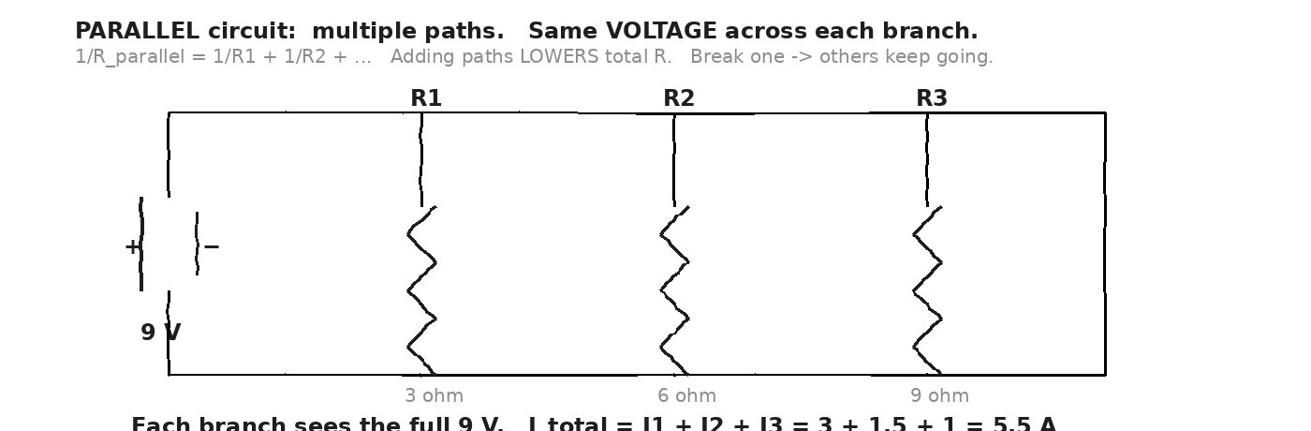

WORKED EXAMPLE — three resistors in parallel
9V battery across R₁ = 3Ω, R₂ = 6Ω, R₃ = 9Ω in parallel. Find: voltage on each, current in each, total current, R_parallel.
GIVEN | V = 9 V · R₁ = 3 Ω · R₂ = 6 Ω · R₃ = 9 Ω (all in parallel)
EQUATION | V is the SAME on each branch ; I_i = V / R_i ; 1/R_p = Σ(1/R_i)
WORK | V₁ = V₂ = V₃ = 9 V  I₁ = 9/3 = 3 A  I₂ = 9/6 = 1.5 A  I₃ = 9/9 = 1.0 A  I_total = 3 + 1.5 + 1.0 = 5.5 A  1/R_p = 1/3 + 1/6 + 1/9 = 6/18 + 3/18 + 2/18 = 11/18  R_p = 18/11 ≈ 1.64 Ω  Check: 9 / 1.64 ≈ 5.5 A ✓
ANSWER | Each branch sees 9V. Currents 3 A / 1.5 A / 1.0 A. R_parallel ≈ 1.64 Ω.

YOUR TURN — two equal resistors in parallel
Two 10Ω resistors in parallel. What's R_parallel? If 12V is applied, what's the current in each branch and total?
GIVEN
EQUATION
WORK
ANSWER

★ | A house has many appliances in parallel. The TV doesn't care if the lamp is on. But every parallel branch DRAWS current from the main supply — too many high-draw devices, and the circuit breaker trips (typically at 15 or 20 A) to prevent wire overheating.

Fill in the frame:
In a parallel circuit, the VOLTAGE is the same across every ________________________________________________________. The CURRENTS in each branch ADD up to the ________________________________________________________ current. Total resistance is ________________________________________________________ than any individual resistance.
EXIT TICKET — Day 8
12V across 4Ω || 6Ω. Find R_parallel and the current in each branch. Show one line of work per quantity.

Today's Targets — Rate Yourself
1 = Not Yet (I can't do this without help) 2 = Almost (I can do this with some help or some errors) 3 = Got It (I can do this independently and explain it)
Help? Check the box if you want to talk with me about this target — even if you marked yourself a 3.
Target | 1 | 2 | 3 | Help?
I can identify a parallel circuit. | ○ | ○ | ○ | ☐
I can apply 1/R_p = Σ(1/R_i). | ○ | ○ | ○ | ☐
I can find current in each branch. | ○ | ○ | ○ | ☐

Day 9 — Combination Circuits · Reduce Piece-by-Piece

Today's Target
I can analyze a circuit that mixes series and parallel by collapsing parallel sections first, then adding remaining series resistors, finding total current at the battery, and working backward to find current/voltage in each branch.
ASTEROID THREAD
What we know about 2026-XJ today: Day 7 (series) and Day 8 (parallel). Each works in isolation.
How today connects: Real circuits mix BOTH. The reduction technique is a Unit 7 problem-solving skill — and shows up on the Day 18 transfer task.

VOCAB · COMBINATION CIRCUIT
Definition: A circuit containing BOTH series and parallel sections. Analyzed by REDUCING — collapse parallel groups first, then add what remains in series.
Example: Battery → R₁ in series → (R₂ || R₃) → back to battery. Step 1: combine R₂ || R₃ → R_eq. Step 2: R_total = R₁ + R_eq.
Cognates: Sp. circuito combinado · Pt. circuito combinado · HC sikui konbine
Watch out: Always reduce INSIDE-OUT — innermost parallel groups first. Then add series. Big-picture currents come from R_total; backward-trace gives branch details.

VOCAB · EQUIVALENT RESISTANCE
Definition: A single value that 'replaces' a complex sub-circuit. Same voltage, same total current.
Example: 3Ω || 6Ω → R_eq = 2Ω. From the rest of the circuit's perspective, it sees ONE 2Ω resistor instead of two in parallel.
Cognates: Sp. resistencia equivalente · Pt. resistência equivalente · HC rezistans ekivalan
Watch out: Equivalent resistance is a calculation tool, not a real component. Use it to simplify, then trace back to find branch details.

VOCAB · REDUCTION STRATEGY
Definition: (1) Identify innermost parallel groups. (2) Replace each with R_eq. (3) Now the circuit is pure series; add up. (4) Use V = IR_total for battery current. (5) Trace backward.
Example: See worked example below — 3-step reduction.
Cognates: Sp. reducción del circuito · Pt. redução do circuito · HC redui sikui a
Watch out: It's tempting to write one huge equation. DON'T. Reduce step by step — fewer errors, easier to check.

DOODLE ZONE
Three steps of the reduction. ORIGINAL → collapse parallel → final series → total. Mark each R, each current direction, and the answers at each step.
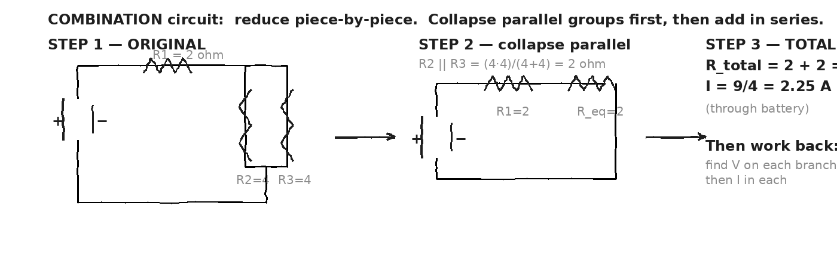

WORKED EXAMPLE — series + parallel combination
9V battery → R₁ = 2Ω in series → (R₂ = 4Ω || R₃ = 4Ω) → back to battery. Find R_total, I_total (battery current), V across each section, and current in each parallel branch.
GIVEN | V = 9 V · R₁ = 2 Ω (series) · R₂ = R₃ = 4 Ω (parallel pair)
EQUATION | STEP 1: R_eq of parallel pair. STEP 2: R_total = R₁ + R_eq. STEP 3: I_total = V/R_total. STEP 4: trace.
WORK | STEP 1: R_eq = (R₂·R₃)/(R₂+R₃) = (4·4)/(4+4) = 16/8 = 2 Ω  STEP 2: R_total = R₁ + R_eq = 2 + 2 = 4 Ω  STEP 3: I_total = 9 / 4 = 2.25 A (through battery + R₁)  STEP 4: V across R₁ = 2.25 · 2 = 4.5 V  V across the parallel pair = 9 − 4.5 = 4.5 V  I₂ = 4.5 / 4 = 1.125 A ; I₃ = 4.5 / 4 = 1.125 A  Check: I₂ + I₃ = 2.25 A = I_total ✓
ANSWER | R_total = 4 Ω · I_total = 2.25 A · V on R₁ = 4.5 V · V on pair = 4.5 V · I in each branch = 1.125 A.

YOUR TURN — mixed reduction
12V → R₁ = 3Ω in series → (R₂ = 6Ω || R₃ = 3Ω) → back. Find R_total, I_total, and current in each parallel branch.
GIVEN
EQUATION
WORK
ANSWER

★ | Inside-out reduction. Identify the deepest parallel group → collapse → then series-add what's left. This is a problem-solving SKILL, not a formula. Practice on a few until it's automatic.

Fill in the frame:
Reduce a combination circuit by collapsing ________________________________________________________ groups first, then adding remaining ________________________________________________________ resistances. Find I_total from ________________________________________________________, then trace BACKWARD to find current in each ________________________________________________________.
EXIT TICKET — Day 9
9V → R₁ = 1Ω in series → (R₂ = 4Ω || R₄ = 4Ω) → back. Find R_total and I_total. Show work for both reduction steps.

Today's Targets — Rate Yourself
1 = Not Yet (I can't do this without help) 2 = Almost (I can do this with some help or some errors) 3 = Got It (I can do this independently and explain it)
Help? Check the box if you want to talk with me about this target — even if you marked yourself a 3.
Target | 1 | 2 | 3 | Help?
I can identify series vs. parallel sections. | ○ | ○ | ○ | ☐
I can reduce a combination circuit step by step. | ○ | ○ | ○ | ☐
I can find branch currents by tracing back. | ○ | ○ | ○ | ☐

Day 10 — Vernier Circuit Lab · Verify Ohm's Law + Circuit Rules

Today's Target
I can wire a circuit with a Vernier voltmeter (parallel) and ammeter (series), read V and I correctly, verify V = IR for a single resistor, and confirm the series rule (same I) and the parallel rule (same V).
ASTEROID THREAD
What we know about 2026-XJ today: Days 6-9 gave us the EQUATIONS. Today we verify them in the lab.
How today connects: If V = IR holds for resistors we measure, we trust it for the Car motor on Day 17.

LAB SETUP — INVESTIGATION 7.1
Driving question: Can we verify Ohm's law (V = IR) and the series + parallel circuit rules using a Vernier voltmeter and ammeter on a small DC circuit?
Equipment:
- Vernier LabQuest + voltage probe + current probe (one set per pair)
- DC power supply or 9V battery + battery holder
- Set of resistors: 100 Ω, 220 Ω, 470 Ω (color bands provided)
- Breadboard + jumper wires
- Switch (push-button or toggle)
What you do:
1. PART A — Ohm's law check. Build: battery → switch → ammeter (in SERIES with one resistor) → back. Voltmeter ACROSS the resistor (in parallel).
2. Choose three resistors (100 Ω, 220 Ω, 470 Ω). For each, close switch, read V and I, compute R_measured = V/I.
3. Compare to nominal R (color-band value). Compute percent error.
4. PART B — Series rule. Build battery → switch → ammeter → R₁ → R₂ → back. Voltmeter across EACH resistor in turn.
5. Check: same I throughout? V₁ + V₂ = V_battery?
6. PART C — Parallel rule. Build battery → switch → split into two branches, R₁ and R₂. Ammeter in each branch separately. Voltmeter across the parallel pair.
7. Check: same V across each branch? I₁ + I₂ = total I (from battery)?
────────────────────────────────────────────────────────────
Safety: Don't short-circuit the battery (positive directly to negative). High current can overheat wires + drain battery in seconds. Use the switch — open before rewiring.
How this lab serves the year's question: If the Ohm's law verification is within 5%, you trust V = IR for the Car motor prediction (Day 17). Same physics, scaled up to a working motor.
DOODLE ZONE
Sketch the lab: battery + switch + resistor in a loop. Ammeter IN SERIES with the resistor. Voltmeter IN PARALLEL across the resistor. Label which probe is which.
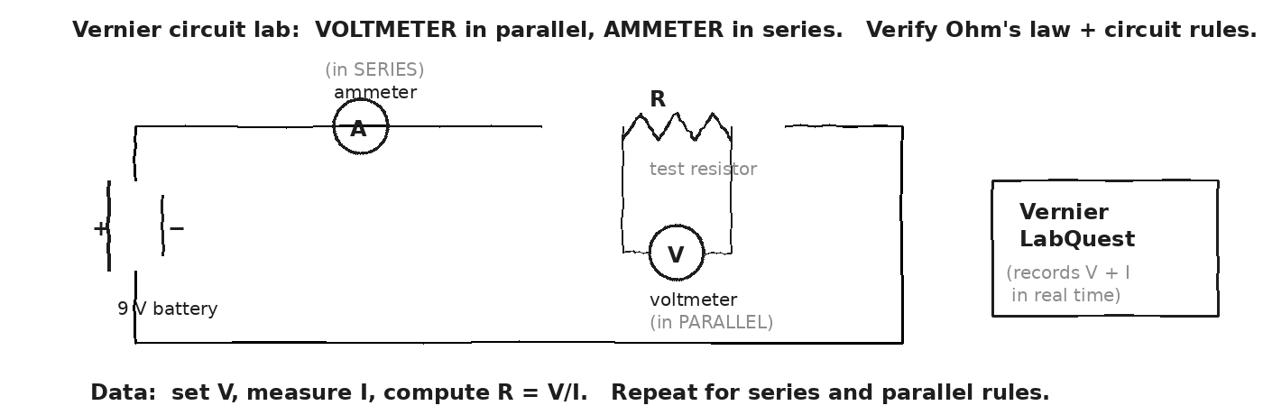

DATA TABLE A — Ohm's Law Verification
R nominal (Ω) | V (V) | I (A) | R_measured = V/I (Ω) | % error
1
2
3
4
Mean % error:
DATA TABLE B — Series Rule (battery V_total)
R₁ + R₂ (Ω) | V₁ (V) | V₂ (V) | V_total (V) | I (A) constant?
1
2
3
V₁ + V₂ vs V_battery:
DATA TABLE C — Parallel Rule
R₁ || R₂ (Ω) | V across pair (V) | I₁ (A) | I₂ (A) | I_total (A)
1
2
3
Sum check: I₁ + I₂ vs I_total:
OBSERVATION & ANALYSIS
In your Ohm's law data (Part A), how well does R_measured match the nominal value? What's the largest source of error — your reading precision, the resistor tolerance, or something else?

In your parallel data (Part C), is I_total ≈ I₁ + I₂? Within what percent? If they DIDN'T match, what would that tell you (about charge conservation)?

Asteroid connection: how does this serve the year's question?

⚠ | Ammeter goes in SERIES (broken into the circuit). Voltmeter goes in PARALLEL (across the component). Hooking them up the wrong way is a common error — and a voltmeter wired in series sees no current, while an ammeter in parallel can short out and damage itself.

Fill in the frame:
We measured R for three resistors. The mean % error was ________________________________________________________ %. Our series-rule data confirmed that the current was ________________________________________________________ throughout. The parallel data confirmed that the voltage was ________________________________________________________ across each branch and I₁ + I₂ = ________________________________________________________.
EXIT TICKET — Day 10
A voltmeter reads 6.0 V across a resistor. An ammeter reads 0.25 A through it. What is R? Show one line of work.

Today's Targets — Rate Yourself
1 = Not Yet (I can't do this without help) 2 = Almost (I can do this with some help or some errors) 3 = Got It (I can do this independently and explain it)
Help? Check the box if you want to talk with me about this target — even if you marked yourself a 3.
Target | 1 | 2 | 3 | Help?
I can wire a voltmeter in parallel and an ammeter in series. | ○ | ○ | ○ | ☐
I can verify Ohm's law from measured V and I. | ○ | ○ | ○ | ☐
I can confirm the series + parallel rules with data. | ○ | ○ | ○ | ☐

Day 11 — Electric Power: P = V · I = I² · R = V² / R

Today's Target
I can compute power dissipated by a resistor using any of the three forms, pick the form matching what's GIVEN, and explain why a motor or resistor heats up when current flows (P = I²R → heat).
ASTEROID THREAD
What we know about 2026-XJ today: Days 4-6: V, I, R individually.
How today connects: Today: power = rate of energy delivery. Same idea as Unit 4 — but now for electricity. P = V·I is the master equation of the Car Project's electrical power.

VOCAB · ELECTRIC POWER (P)
Definition: Rate of energy delivered or dissipated. P = V · I. Units: watts (W) = joules / second.
Example: A 9V battery driving 2 A through a motor: P = 18 W of electrical power. Some becomes mechanical work; some becomes heat.
Cognates: Sp. potencia eléctrica · Pt. potência elétrica · HC pwisans elektrik
Watch out: Power is a RATE (energy per time). Energy is total. Confusing them is a common error.

VOCAB · THREE FORMS OF P
Definition: Substitute Ohm's law into P = VI: P = I²R (when you know I and R), P = V²/R (when you know V and R). All three describe the same thing.
Example: Same 4 Ω resistor in a 9 V circuit. By any form: P = V·I = 9·2.25 = 20.25 W ≈ P = V²/R = 81/4 = 20.25 W ≈ P = I²R = 5.06·4 = 20.25 W ✓
Cognates: Sp. tres formas de P · Pt. três formas de P · HC twa fòm P
Watch out: Pick the form using the variables you KNOW. If you only have V and R, P = V²/R is fastest. If you only have I and R, P = I²R.

VOCAB · WATT (W)
Definition: SI unit of power. 1 W = 1 J/s = 1 V·A. Named for James Watt.
Example: LED bulb: 8 W. Incandescent bulb: 60 W. Toaster: 1000 W. Hair dryer: 1500 W. Microwave: 1100 W.
Cognates: Sp. vatio · Pt. watt · HC wat
Watch out: Watts measure RATE of energy use. Kilowatt-hours (kWh) on your electric bill measure TOTAL energy (kW · hours).

DOODLE ZONE
Sketch a resistor with current flowing through it. Show heat radiating outward (wavy lines). Write the three forms of P next to it. Annotate which form to use with which givens.
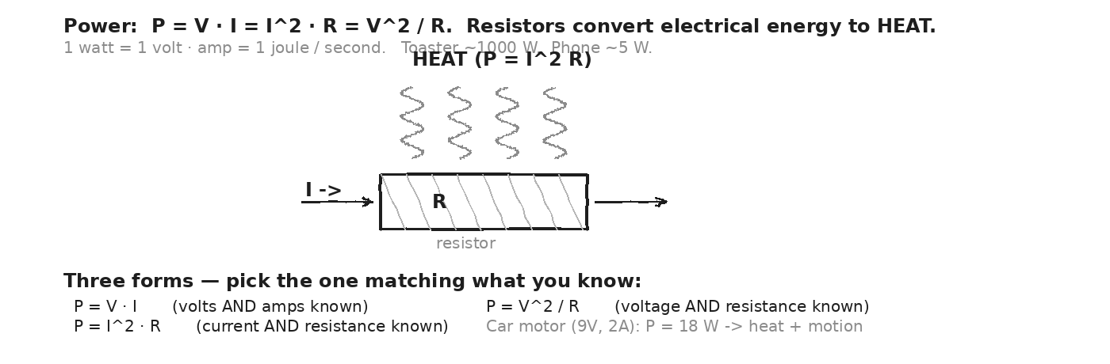

WORKED EXAMPLE — power dissipated by a resistor
A 5 Ω resistor carries 2 A of current. How much power does it dissipate as heat?
GIVEN | I = 2 A · R = 5 Ω
EQUATION | P = I² · R
WORK | P = (2)² · 5  P = 4 · 5  P = 20 W
ANSWER | P = 20 W dissipated as heat in the resistor.

WORKED EXAMPLE — household appliance
A toaster runs on 120 V and draws 8 A. What's its power? How much energy does it use in 5 minutes of operation?
GIVEN | V = 120 V · I = 8 A · t = 5 min = 300 s
EQUATION | P = V · I ; energy = P · t
WORK | P = 120 · 8 = 960 W ≈ 1 kW  U = 960 · 300 = 288 000 J ≈ 288 kJ  Or: 960 W · (5/60 hr) ≈ 0.08 kWh
ANSWER | P ≈ 960 W ≈ 1 kW. 5 min uses ≈ 0.08 kWh of energy.

YOUR TURN — Car motor power
The Car Project motor: V = 9 V, R ≈ 4 Ω. Find I, then power delivered, using P = V²/R AND P = V·I to check yourself.
GIVEN
EQUATION
WORK
ANSWER

★ | The Car Project motor (9V, ~2A) dissipates ~18-20 W. NOT all 18 W becomes mechanical power — most goes to heat (P = I²R loss in the motor's windings). Efficiency of a small DC motor: typically 30-50%. The rest comes out as heat. Touch a motor that's been running — it's WARM.

Fill in the frame:
Power equals voltage times ________________________________________________________, in units of ________________________________________________________. The three forms are P = V·I, P = ________________________________________________________, and P = V²/R. Choose the form by which variables you ________________________________________________________.
EXIT TICKET — Day 11
A 120 V hair dryer draws 12.5 A. How much power does it use? How much energy in 2 minutes of use? Show one line of work for each.

Today's Targets — Rate Yourself
1 = Not Yet (I can't do this without help) 2 = Almost (I can do this with some help or some errors) 3 = Got It (I can do this independently and explain it)
Help? Check the box if you want to talk with me about this target — even if you marked yourself a 3.
Target | 1 | 2 | 3 | Help?
I can compute P from any pair of {V, I, R}. | ○ | ○ | ○ | ☐
I can pick the right form of P for given variables. | ○ | ○ | ○ | ☐
I can connect P to total energy via U = P·t. | ○ | ○ | ○ | ☐

Day 12 — Magnetism · Poles, Fields, Earth as a Giant Magnet

Today's Target
I can identify magnetic poles (N + S), describe magnetic field lines (out of N, into S), and explain why Earth itself is a giant magnet — the magnetosphere generated by Earth's iron core dynamo.
ASTEROID THREAD
What we know about 2026-XJ today: Static charges (Day 1-3) make electric fields. Now: moving charges + magnets make MAGNETIC fields.
How today connects: Today previews Day 16: Earth's magnetosphere — the magnetic shield generated by THIS physics — is what made life on Earth possible.

VOCAB · MAGNETIC POLES (N, S)
Definition: The two ends of a magnet. North poles attract South poles; like poles repel. Free poles ALONE don't exist — cut a magnet, you get two smaller bipolar magnets.
Example: Bar magnet, refrigerator magnet, compass needle — all have N + S. The Earth's geographic NORTH is actually a MAGNETIC SOUTH (a compass N points to it).
Cognates: Sp. polos magnéticos · Pt. polos magnéticos · HC pòl mayetik
Watch out: No 'magnetic monopoles' in nature (so far). Always come in pairs. This is different from electric charges (single + or − exist).

VOCAB · MAGNETIC FIELD (B)
Definition: A vector at every point in space. Drawn as field lines: out of N, into S. Units: tesla (T) — very large. 1 microtesla (μT) is typical for handheld magnets.
Example: A neodymium fridge magnet: B ≈ 0.1 T at the surface. Earth's field: B ≈ 25–65 μT. An MRI machine: B ≈ 1–3 T (HUGE).
Cognates: Sp. campo magnético · Pt. campo magnético · HC chan mayetik
Watch out: B is to magnetism what E is to electricity. Both are fields. Both come from sources. But B comes from MOVING charges or magnetic materials, E from static charges.

VOCAB · EARTH'S MAGNETIC FIELD
Definition: Earth has a magnetic field generated by the molten iron flow ('dynamo') in its outer core. Field strength: 25–65 μT at the surface. Polarity REVERSES on geologic timescales.
Example: The field that makes a compass work — N end of the needle aligns with Earth's magnetic field, pointing to (geographic) North.
Cognates: Sp. campo magnético terrestre · Pt. campo magnético da Terra · HC chan mayetik latè
Watch out: Geographic N pole ≠ magnetic N pole. They're tilted ≈ 11° apart. A compass needle's N points to Earth's magnetic SOUTH (which is near geographic NORTH).

DOODLE ZONE
Bar magnet with field lines (out of N, into S). Earth as a giant bar magnet — show the tilt between magnetic and geographic axes. Mark where a compass would point.
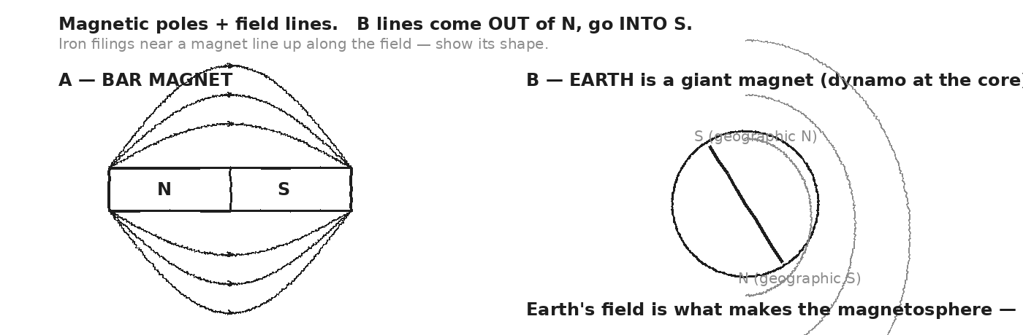

WORKED EXAMPLE — field strength comparison
An MRI machine has B ≈ 1.5 T. Earth's field is ≈ 50 μT. How many TIMES stronger is the MRI field?
GIVEN | B_MRI = 1.5 T · B_Earth = 50 μT = 50 × 10⁻⁶ T
EQUATION | ratio = B_MRI / B_Earth
WORK | ratio = 1.5 / (50 × 10⁻⁶)  ratio = 1.5 / 0.00005  ratio = 30 000
ANSWER | MRI is 30 000 times stronger than Earth's field.

YOUR TURN — compass direction
A compass needle settles pointing approximately to geographic North. Which POLE (N or S) of the needle is pointing 'up' (toward geographic N)? Why?
GIVEN
EQUATION
WORK
ANSWER

★ | Earth's iron-core dynamo generates ≈ 50 μT — small in absolute terms, but it deflects most of the solar wind (charged particles at 400 km/s) before they hit our atmosphere. Without it, the atmosphere would have eroded billions of years ago — and you wouldn't exist. (Day 16.)

Fill in the frame:
Magnetic poles come in ________________________________________________________ — N and S. Like poles ________________________________________________________; unlike poles ________________________________________________________. Earth's magnetic field is generated by the ________________________________________________________ at the core, with strength ≈ ________________________________________________________ μT.
EXIT TICKET — Day 12
What's the source of Earth's magnetic field? Answer in one sentence using the word 'dynamo'.

Today's Targets — Rate Yourself
1 = Not Yet (I can't do this without help) 2 = Almost (I can do this with some help or some errors) 3 = Got It (I can do this independently and explain it)
Help? Check the box if you want to talk with me about this target — even if you marked yourself a 3.
Target | 1 | 2 | 3 | Help?
I can identify magnetic poles N + S. | ○ | ○ | ○ | ☐
I can interpret magnetic field lines. | ○ | ○ | ○ | ☐
I can describe Earth's field and its source. | ○ | ○ | ○ | ☐

Day 13 — Oersted's Discovery · Current Creates a Magnetic Field

Today's Target
I can describe Oersted's 1820 discovery (compass deflects near a current-carrying wire), use the right-hand rule to predict B-field direction around a wire, and explain why a coil of wire (solenoid) acts like a bar magnet.
ASTEROID THREAD
What we know about 2026-XJ today: Day 12: magnets create B-fields.
How today connects: Today: CURRENTS also create B-fields. This was the discovery that unified electricity and magnetism — and made the Car motor (Day 15) possible.

VOCAB · OERSTED'S DISCOVERY (1820)
Definition: Hans Christian Oersted accidentally noticed: a compass needle DEFLECTS when held near a wire carrying current. Conclusion: electric currents create magnetic fields.
Example: The compass needle aligned WITH the new magnetic field, not with Earth's. Removing the current → needle returns to North. This was the first link between electricity and magnetism.
Cognates: Sp. descubrimiento de Oersted · Pt. descoberta de Oersted · HC dekouvèt Oersted
Watch out: Before 1820, electricity and magnetism were seen as separate. Oersted's accidental observation in a Copenhagen classroom started 'electromagnetism' as a single subject.

VOCAB · RIGHT-HAND RULE (STRAIGHT WIRE)
Definition: To find direction of B around a wire: point thumb in direction of current I, fingers CURL in direction of B field.
Example: Current pointing UP: B circles the wire counterclockwise as viewed from above. Current pointing into the page (×): B circles clockwise as viewed from in front.
Cognates: Sp. regla de la mano derecha · Pt. regra da mão direita · HC règ men dwat
Watch out: ALWAYS use your right hand. Left-hand rule does the opposite — confusion-inducing. Even if you're left-handed, the right-hand rule is the convention.

VOCAB · SOLENOID (COILED WIRE = ELECTROMAGNET)
Definition: A wire wrapped into a coil. When current flows, the individual loops' B-fields add up, producing a B-field much like a bar magnet — with N and S poles at the ends.
Example: Doorbells, relays, electromagnets, MRI machines, the speakers in your phone, the inside of a DC motor — all are solenoids in disguise.
Cognates: Sp. solenoide · Pt. solenoide · HC solenoyid
Watch out: A solenoid's strength depends on (number of turns) × (current) × (μ₀). More turns and more current = stronger electromagnet. Switching off current = field vanishes.

DOODLE ZONE
Three parts: (A) straight wire with concentric circular B-lines, (B) right hand showing thumb-along-I, fingers-curling-B, (C) coiled wire = bar-magnet-like B-field.
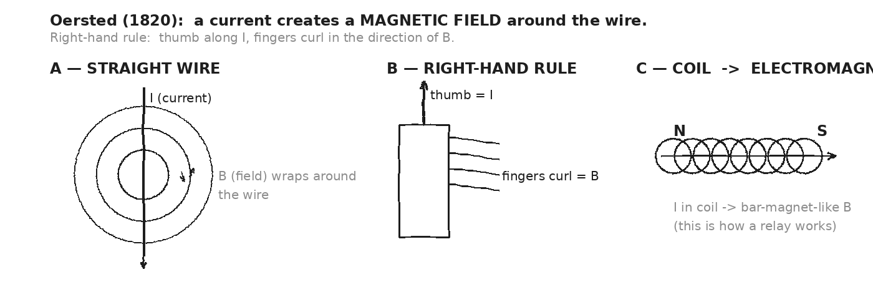

WORKED EXAMPLE — direction of B around a wire
A long straight wire carries current flowing UP. A compass is placed to the EAST of the wire. Which way does the compass needle deflect?
GIVEN | I points UP · compass is to the EAST of the wire
EQUATION | Right-hand rule: thumb UP → fingers curl from N → E → S → W → N (counterclockwise viewed from above)
WORK | To the EAST of the wire, the B field points SOUTH (since fingers curl from East toward South).  Compass N pole aligns with B → compass needle points SOUTH.
ANSWER | Compass deflects to point SOUTH.

YOUR TURN — solenoid polarity
A solenoid (coiled wire) is wound so that — viewed from one end — the current flows COUNTERCLOCKWISE. Use the right-hand rule (curl fingers along current, thumb points to N pole) to determine which end of the solenoid is N.
GIVEN
EQUATION
WORK
ANSWER

★ | Oersted's discovery is the OPENING of electromagnetism. Day 14 will give the REVERSE: changing B-field creates VOLTAGE. Together, these two laws (Oersted + Faraday) make every motor, every generator, every transformer, and every wireless charger work.

Fill in the frame:
Oersted discovered that currents create ________________________________________________________ fields. The right-hand rule says to point your ________________________________________________________ in the direction of current, then your fingers curl in the direction of ________________________________________________________. A coiled wire (solenoid) acts like a ________________________________________________________.
EXIT TICKET — Day 13
A straight wire has current flowing to the RIGHT. Above the wire, which direction does B point? (Use right-hand rule.) Show or describe your work.

Today's Targets — Rate Yourself
1 = Not Yet (I can't do this without help) 2 = Almost (I can do this with some help or some errors) 3 = Got It (I can do this independently and explain it)
Help? Check the box if you want to talk with me about this target — even if you marked yourself a 3.
Target | 1 | 2 | 3 | Help?
I can apply the right-hand rule to a wire. | ○ | ○ | ○ | ☐
I can describe Oersted's discovery. | ○ | ○ | ○ | ☐
I can explain why a solenoid is an electromagnet. | ○ | ○ | ○ | ☐

Day 14 — Faraday's Law · Changing B-Field Creates Voltage

Today's Target
I can describe Faraday's discovery (moving a magnet near a coil induces a voltage and current), predict the direction of induced current using flux change, and explain why generators and transformers all run on this principle.
ASTEROID THREAD
What we know about 2026-XJ today: Day 13: current creates B. Today: the reverse — changing B creates current.
How today connects: Together, Days 13 and 14 are the ENGINE of every motor, generator, and transformer. Day 15 puts both into one machine.

VOCAB · FARADAY'S LAW (1831)
Definition: A CHANGING magnetic flux through a coil INDUCES a voltage (EMF) in the coil. The faster the change, or the more turns of wire, the bigger the induced voltage.
Example: Push a magnet INTO a coil → ammeter swings one way. Pull it OUT → swings the other way. STILL magnet → no current.
Cognates: Sp. ley de Faraday · Pt. lei de Faraday · HC lwa Faraday
Watch out: It's the CHANGE in B that matters, not the value. A constant B-field (even huge) produces NO induced voltage.

VOCAB · MAGNETIC FLUX (Φ)
Definition: The amount of magnetic field passing through a loop. Φ = B · A · cos θ (roughly). Units: webers (Wb) = T·m².
Example: A 0.1 T field through a 0.01 m² loop perpendicular to the field: Φ = 0.001 Wb. Rotate the loop 90° so field is parallel → Φ drops to 0.
Cognates: Sp. flujo magnético · Pt. fluxo magnético · HC fliks mayetik
Watch out: Flux changes when ANY of B, A, or angle changes. Moving the magnet changes B at the loop. Spinning the loop changes the angle. Either induces a current.

VOCAB · GENERATOR
Definition: A machine that converts mechanical motion into electrical voltage by spinning a coil inside a magnetic field. The OPPOSITE of a motor.
Example: Wind turbines, hydroelectric dams, car alternators, hand-crank flashlights — all generators. Each rotation changes flux → induced voltage → current.
Cognates: Sp. generador · Pt. gerador · HC jeneratè
Watch out: A motor and a generator are the SAME machine — just different inputs. Spin the rotor by hand → it's a generator. Push current into it → it's a motor.

DOODLE ZONE
Coil of wire connected to an ammeter. A bar magnet is being PUSHED into the coil. Show the ammeter needle deflecting. Then a second sketch: pulling out → needle deflects the OTHER way.
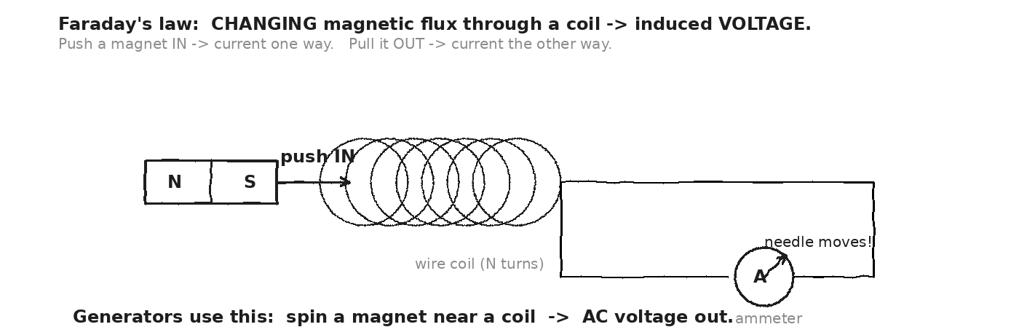

WORKED EXAMPLE — induced voltage from changing flux
A 100-turn coil has a magnetic flux that changes by Φ = 0.005 Wb over Δt = 0.1 s. What's the induced EMF? (ε ≈ N · ΔΦ/Δt.)
GIVEN | N = 100 turns · ΔΦ = 0.005 Wb · Δt = 0.1 s
EQUATION | ε ≈ N · ΔΦ / Δt
WORK | ε = 100 · (0.005 / 0.1)  ε = 100 · 0.05  ε = 5 V
ANSWER | ε = 5 V induced across the coil's ends — drives current if connected to a circuit.

YOUR TURN — faster motion
Same 100-turn coil, same ΔΦ = 0.005 Wb, but you push the magnet TWICE as fast (Δt = 0.05 s). What's the new EMF?
GIVEN
EQUATION
WORK
ANSWER

★ | Generators produce AC (alternating current) because the rotating coil's flux changes sinusoidally — sometimes increasing, sometimes decreasing. The induced voltage alternates direction with each half-rotation. That's why grid power is AC.

Fill in the frame:
Faraday's law says a ________________________________________________________ magnetic flux through a coil induces a ________________________________________________________. The induced voltage is BIGGER when (a) the change is ________________________________________________________, (b) there are ________________________________________________________ turns of wire. A generator works by ________________________________________________________ a coil through a magnetic field.
EXIT TICKET — Day 14
Why does pushing a magnet into a coil light up an attached LED — but holding it still does nothing? Answer in two sentences using the word 'changing'.

Today's Targets — Rate Yourself
1 = Not Yet (I can't do this without help) 2 = Almost (I can do this with some help or some errors) 3 = Got It (I can do this independently and explain it)
Help? Check the box if you want to talk with me about this target — even if you marked yourself a 3.
Target | 1 | 2 | 3 | Help?
I can describe Faraday's discovery. | ○ | ○ | ○ | ☐
I can predict when a current is induced (and when not). | ○ | ○ | ○ | ☐
I can describe how a generator works. | ○ | ○ | ○ | ☐

Day 15 — Motors + Generators · The Car Project's Heart

Today's Target
I can describe how a DC motor uses F = ILB (force on a current in a B-field) to produce torque, and explain why a motor and a generator are the SAME machine running in opposite directions.
ASTEROID THREAD
What we know about 2026-XJ today: Day 13: current → B. Day 14: changing B → voltage.
How today connects: Today combines them. A motor takes voltage IN → mechanical rotation OUT. The actual machine you'll use in Unit 8 next week.

VOCAB · DC MOTOR
Definition: A machine that converts electrical energy to MECHANICAL rotation. Current flows through a coil in a magnetic field; the field pushes the coil sideways (F = I·L·B); the coil spins.
Example: The Car Project motor: 9V input, ≈ 2A current, ≈ 18W of power. Spins the output shaft at thousands of RPM. Gears reduce the speed and increase the torque.
Cognates: Sp. motor DC · Pt. motor DC · HC motè DC
Watch out: DC means 'direct current' — current flows steadily one direction (battery). AC motors are different (oscillating current). The Car Project uses DC.

VOCAB · FORCE ON A CURRENT-CARRYING WIRE IN B (QUALITATIVE)
Definition: A wire with current I, length L, in a perpendicular B field, feels a force F = I·L·B. Direction is PERPENDICULAR to both I and B (right-hand rule again).
Example: Inside the motor: current in coil + permanent magnets' B-field → coil feels sideways force → torque → spin. Repeat each rotation, and the motor runs.
Cognates: Sp. fuerza sobre corriente · Pt. força sobre corrente · HC fòs sou kouran
Watch out: The force is perpendicular to BOTH I and B (not parallel to either). Use right-hand rule: fingers point I, curl toward B; thumb shows F.

VOCAB · MOTOR ⟷ GENERATOR (SAME MACHINE)
Definition: A motor and a generator are the SAME mechanical device. Drive it with current → motor (mechanical out). Spin it by hand → generator (voltage out).
Example: A car alternator is a generator that recharges the battery from engine rotation. The starter motor is a motor that turns engine over from battery power. Internally — same coil-in-field structure.
Cognates: Sp. motor y generador · Pt. motor e gerador · HC motè jeneratè
Watch out: The same machine running both ways: this is a deep symmetry. It's why regenerative braking in electric cars works — the motor becomes a generator during deceleration.

DOODLE ZONE
Cross-section of a DC motor: permanent magnets (N + S) on the outside, current-carrying coil in the middle. Mark forces on each side of the coil. Mark direction of rotation. F = ILB.
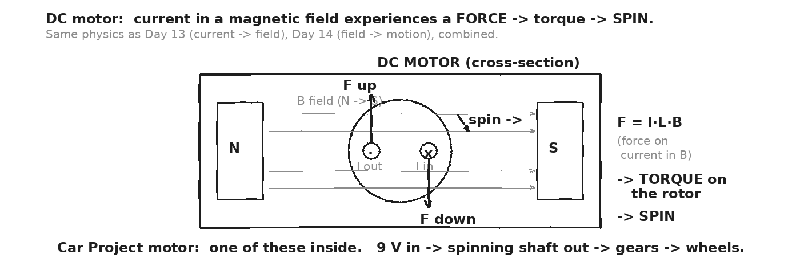

WORKED EXAMPLE — Car motor power
The Car Project motor draws 2.0 A from a 9 V battery. What's the electrical power delivered? If the motor is 40% efficient (typical for small hobby motors), how much mechanical power comes out the shaft?
GIVEN | V = 9 V · I = 2 A · efficiency η = 0.40
EQUATION | P_electrical = V · I · η = mechanical out
WORK | P_electrical = 9 · 2 = 18 W  P_mechanical = 18 · 0.40 = 7.2 W  Heat dissipated in windings: 18 − 7.2 = 10.8 W
ANSWER | P_electrical = 18 W. About 7 W becomes mechanical motion; 11 W becomes heat (motor gets warm).

YOUR TURN — efficient motor predictions
A different motor is 60% efficient at 9V and 1.5A. Compute electrical input, mechanical output, and heat dissipated.
GIVEN
EQUATION
WORK
ANSWER

★ | A real DC motor's resistance changes when it's spinning — it generates its own back-EMF (Faraday's law!) which opposes the source. Stalled motor (not spinning): R ≈ 3-4Ω, full current → too much heat → can damage. Running motor: effective R higher, current lower, runs cool. Don't stall the Car Project motor!

Fill in the frame:
A DC motor converts ________________________________________________________ energy into ________________________________________________________ rotation. The force on a current in a magnetic field is F = ________________________________________________________. A motor and a generator are the ________________________________________________________ machine — different inputs.
EXIT TICKET — Day 15
The Car Project motor pulls 2 A at 9 V. (1) What's the electrical power? (2) Where does the energy go? (Two destinations.) Show work.

Today's Targets — Rate Yourself
1 = Not Yet (I can't do this without help) 2 = Almost (I can do this with some help or some errors) 3 = Got It (I can do this independently and explain it)
Help? Check the box if you want to talk with me about this target — even if you marked yourself a 3.
Target | 1 | 2 | 3 | Help?
I can describe how a DC motor works. | ○ | ○ | ○ | ☐
I can compute motor power and efficiency. | ○ | ○ | ○ | ☐
I can explain motor ⟷ generator symmetry. | ○ | ○ | ○ | ☐

Day 16 — ★ Magnetosphere + EMP · Planetary-Scale E&M

Today's Target
I can describe Earth's magnetosphere as a planetary-scale electromagnetic shield, explain why it protects life from solar wind, and describe how a large asteroid impact could generate an EMP (electromagnetic pulse) that disrupts the field temporarily.
ASTEROID THREAD
What we know about 2026-XJ today: 2026-XJ has a non-trivial impact probability. Day 11 (Wien's law from Unit 6) tells us a large impactor will produce intense heat and EM radiation.
How today connects: Today's PAYOFF: the same E&M physics that runs the Car motor also runs the magnetosphere — the planetary shield. Without it, life on Earth wouldn't exist. A large impact could perturb it.

VOCAB · MAGNETOSPHERE
Definition: The region of space around Earth dominated by Earth's magnetic field. Extends ~10× Earth radii on the day side and ~100× on the night side (stretched by solar wind).
Example: The magnetosphere deflects most of the solar wind (charged particles, ~400 km/s). Particles that DO enter are funneled to the poles → aurora (northern + southern lights).
Cognates: Sp. magnetosfera · Pt. magnetosfera · HC mayetosfè
Watch out: The magnetosphere is the shield. The ATMOSPHERE is the air layer beneath it. Both protect us — magnetosphere from charged particles, atmosphere from radiation.

VOCAB · SOLAR WIND
Definition: A continuous stream of charged particles (mostly protons + electrons) flowing outward from the Sun at 300-800 km/s.
Example: During solar storms (CMEs — coronal mass ejections), the wind intensifies. Disruptions to satellites, GPS, and power grids on Earth can result if the magnetosphere is overwhelmed.
Cognates: Sp. viento solar · Pt. vento solar · HC van solè
Watch out: The wind is CONTINUOUS — not just during storms. The magnetosphere is always under stress from it; we just don't notice unless it spikes.

VOCAB · EMP (ELECTROMAGNETIC PULSE)
Definition: A burst of electromagnetic radiation strong enough to induce huge currents in electrical conductors — potentially damaging electronics and power grids.
Example: A large asteroid impact compresses + heats air, which ionizes it; the rapidly moving charges produce intense EM radiation = EMP. A high-altitude nuclear detonation can also produce one. Effects: from radio static to grid failure.
Cognates: Sp. PEM (pulso electromagnético) · Pt. PEM (pulso eletromagnético) · HC PEM
Watch out: EMPs come in different types and intensities. A small one disrupts radio. A large one could damage transformers, semiconductors, and grid infrastructure. The 1989 Quebec aurora-induced blackout is a real example.

DOODLE ZONE
Sun on the left sending solar wind. Earth on the right with a magnetosphere (teardrop shape). Most particles deflect around. Some funnel to poles → aurora. Annotate Day 16 scenario: how could 2026-XJ disturb this?
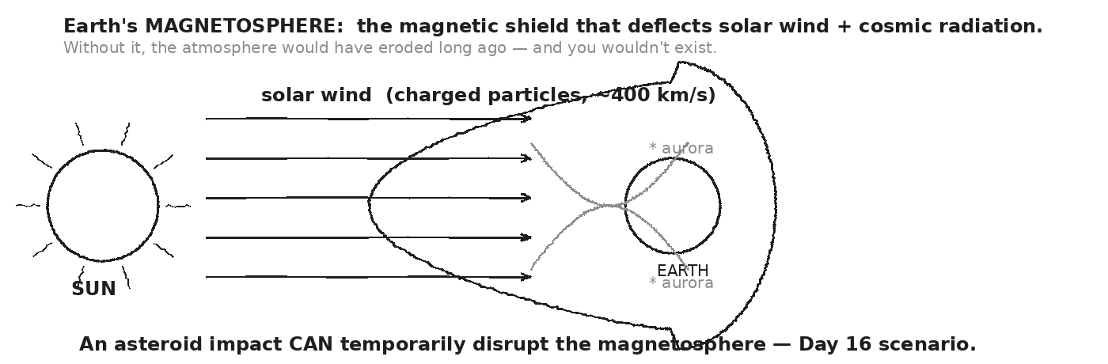

WORKED EXAMPLE — solar wind energy flux deflected
The solar wind delivers about 1 mW per square meter of energy to Earth's vicinity. Earth's cross-section (πR²) ≈ 1.27 × 10¹⁴ m². What's the total power deflected by the magnetosphere?
GIVEN | P_per_area = 10⁻³ W/m² · A = 1.27 × 10¹⁴ m²
EQUATION | P_total = P_per_area · A
WORK | P_total = 10⁻³ · 1.27 × 10¹⁴  P_total = 1.27 × 10¹¹ W  = 127 GW
ANSWER | ≈ 127 gigawatts of solar wind power deflected continuously by Earth's magnetic shield.

YOUR TURN — magnetosphere disturbance scenario
A 2026-XJ-sized impact generates an EMP. If the pulse induces 10 V/m in the atmosphere over a 10-meter-long power line, what voltage spike is delivered to a transformer at its end? (V = E · L for a uniform field.)
GIVEN
EQUATION
WORK
ANSWER

★ | The 1859 Carrington Event: a solar coronal mass ejection induced geomagnetic currents that fried telegraph lines worldwide. Operators got electric shocks. Some lines caught fire. If it happened today, modern power grids could fail for weeks. This is the SAME physics — changing B-field → induced V → current → damage.

Fill in the frame:
Earth's magnetosphere is generated by the ________________________________________________________ at the core. It deflects the ________________________________________________________ — without it, Earth's atmosphere would erode. A ________________________________________________________ from a major impact or solar storm could induce damaging currents in our electrical grid.
EXIT TICKET — Day 16
Why does Earth need a magnetosphere? Answer in two sentences using 'solar wind' and 'atmosphere'.

Today's Targets — Rate Yourself
1 = Not Yet (I can't do this without help) 2 = Almost (I can do this with some help or some errors) 3 = Got It (I can do this independently and explain it)
Help? Check the box if you want to talk with me about this target — even if you marked yourself a 3.
Target | 1 | 2 | 3 | Help?
I can describe the magnetosphere as Earth's E&M shield. | ○ | ○ | ○ | ☐
I can describe the solar wind. | ○ | ○ | ○ | ☐
I can explain how an EMP could disrupt power infrastructure. | ○ | ○ | ○ | ☐

★ DAY 17 — BRIDGE TO THE CAR PROJECT ★
Theory Becomes Engineering
Today's Target
I can preview the Car Project parts kit, identify which UNIT each part traces to, and predict the motor's CURRENT and POWER using V = IR and P = VI — BEFORE I build.
ASTEROID THREAD — final reframing
The asteroid arc is closing. Unit 8 opens the BUILD arc. For ONE year you've done physics on a cosmic backdrop — distance, gravity, energy, heat, waves, charge. Starting next week you're building a working machine, by hand, with what you've learned.
Today is the explicit handoff. We preview the parts kit, you predict the numbers, and Unit 8 Day 1 you'll measure to compare.
★ CAR PROJECT — PARTS PREVIEW
► 9V battery Unit 7 Day 4 voltage = energy per charge (V = U/q)
► Wires + switch Unit 7 Days 5-6 current (I = q/t) + resistance (V = IR)
► DC motor Unit 7 Day 15 current-in-field → torque (F = I·L·B)
► Gears (reduction) Unit 2 mechanical advantage (input/output gear teeth)
► Wheels Unit 2 rotational → translational motion (v = ωr)
► Starting impulse Unit 3 Δp = F·Δt — what gets the car moving
► Top-speed kinetic energy Unit 4 KE = ½mv² — what the motor builds up
► Friction (wheels, bearings) Unit 2 + Unit 5 µ·N + heat dissipation
DOODLE ZONE
Each Car Project part labeled with its origin unit. The visual centerpiece of this page — and of the bridge from Unit 7 to Unit 8.
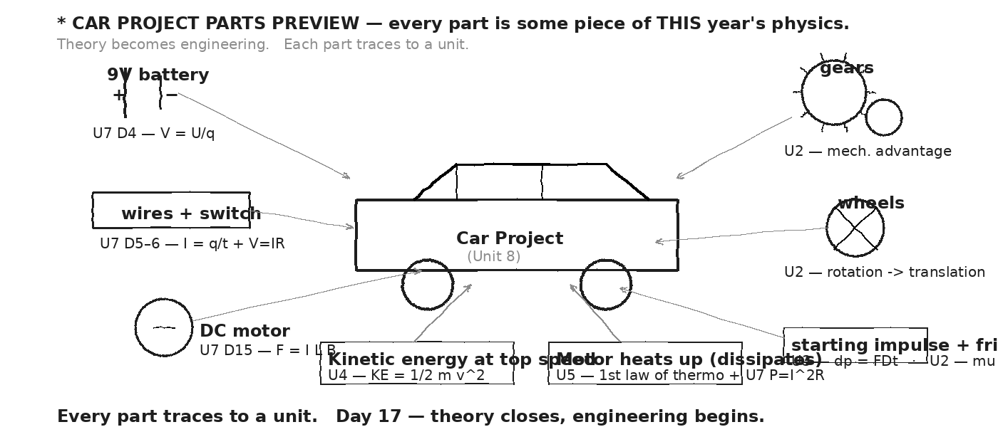

★ STEP 1 — PREDICT MOTOR CURRENT
Given: Car Project uses a 9V battery. Estimated motor resistance: R ≈ 3-5 Ω (we'll measure on Day 1 of Unit 8). Predict the current the motor will draw.
GIVEN | V = 9 V · R ≈ 3-5 Ω (motor)
EQUATION | I = V / R (Ohm's law, Day 6)
WORK | If R = 3 Ω: I = 9/3 = 3 A  If R = 4 Ω: I = 9/4 = 2.25 A  If R = 5 Ω: I = 9/5 = 1.8 A  → Expected range: I ≈ 1.8 to 3.0 A
ANSWER | PREDICTION: the motor will draw between 1.8 A and 3.0 A. Most likely ≈ 2-2.5 A.

★ STEP 2 — PREDICT MOTOR POWER
Using your predicted current from Step 1, compute the electrical power delivered to the motor. (P = V·I.)
GIVEN | V = 9 V · I ≈ 1.8 to 3.0 A (your prediction)
EQUATION | P = V · I (Day 11)
WORK | If I = 1.8 A: P = 9 · 1.8 = 16.2 W  If I = 2.25 A: P = 9 · 2.25 = 20.25 W  If I = 3.0 A: P = 9 · 3.0 = 27 W  → Expected range: P ≈ 16 to 27 W  → About 40% becomes motion; 60% becomes heat (Day 15).
ANSWER | PREDICTION: motor draws ≈ 16-27 W. Mechanical power out ≈ 7-11 W.

TEAM PREDICTION (use the most likely numbers)
Fill in the frame:
Our team predicts the motor will draw ________________________________________________________ A and consume ________________________________________________________ W. About ________________________________________________________ W will become motion; ________________________________________________________ W will become heat. The motor will (get warm / not get warm) — circle one.
★ | The PREDICTION is a Marzano-3 deliverable. The MEASUREMENT happens on Day 1 of Unit 8 (next week). The TRANSFER task (Day 18) will ask you to predict for a different motor.

EXIT TICKET — Day 17
WHY is the Car Project's circuit wired in SERIES (battery → switch → motor → back) instead of parallel? Reason about what would happen if any one wire breaks. (Hint: a series-only circuit is what an ON/OFF switch can fully control.)

Today's Targets — Rate Yourself
1 = Not Yet (I can't do this without help) 2 = Almost (I can do this with some help or some errors) 3 = Got It (I can do this independently and explain it)
Help? Check the box if you want to talk with me about this target — even if you marked yourself a 3.
Target | 1 | 2 | 3 | Help?
I can name each Car Project part and the unit it traces to. | ○ | ○ | ○ | ☐
I can predict the motor's current from V and R. | ○ | ○ | ○ | ☐
I can predict the motor's power from V and I. | ○ | ○ | ○ | ☐
I can explain WHY a SERIES circuit is right for this build. | ○ | ○ | ○ | ☐

Day 18 — Unit 7 Transfer Task — Assessment Day

ASTEROID THREAD
What we know about 2026-XJ today: Every Unit 7 tool: Coulomb's law, E field, V = U/q, I = q/t, V = IR, series + parallel rules, P = VI = I²R = V²/R, magnetism + Oersted, Faraday induction, motors.
How today connects: Problem 5 is the load-bearing PREDICT prompt: given a different motor and battery, predict current AND power BEFORE the build. Same logic as Day 17.

TRANSFER TASK — UNIT 7 · DAY 18
Today you receive the Unit 7 Transfer Task on a separate sheet. It is 5 multi-part problems. You will work independently for ~40 minutes.
• Problem 1 — COULOMB'S LAW. Two +5 μC charges are 0.20 m apart. Compute the force on each. Then compute the new force if the distance is doubled to 0.40 m. Show inverse-square scaling.
• Problem 2 — OHM'S LAW + POWER. A circuit measures V = 12 V across a resistor and I = 0.30 A through it. (a) Find R. (b) Find P dissipated. (c) Find energy dissipated in 60 s of operation.
• Problem 3 — SERIES + PARALLEL. 9V battery powers (R₁ = 2Ω in series with R₂ = 4Ω || R₃ = 4Ω). Find R_total, the battery current, and the current in each parallel branch.
• Problem 4 — MAGNETIC FIELD. A long straight wire carries current flowing into the page. (a) Describe (with right-hand rule) the direction of B in the four cardinal directions around the wire. (b) Why does a compass placed to the SOUTH of the wire deflect WEST?
• Problem 5 — ★ CAR PROJECT BRIDGE (predict). A different team's hobby motor has estimated R = 5.5 Ω. Connected to a 9 V battery: (a) Predict current. (b) Predict power. (c) If the motor is 35% efficient, estimate the mechanical power out. (d) If a 15-second race uses this power continuously, how much TOTAL energy is delivered, and how much becomes heat?
DOODLE ZONE
Five problems, five physics ideas. Match each problem to its Unit 7 idea BEFORE you begin. Problem 5 is the ★ — it bridges into Unit 8.
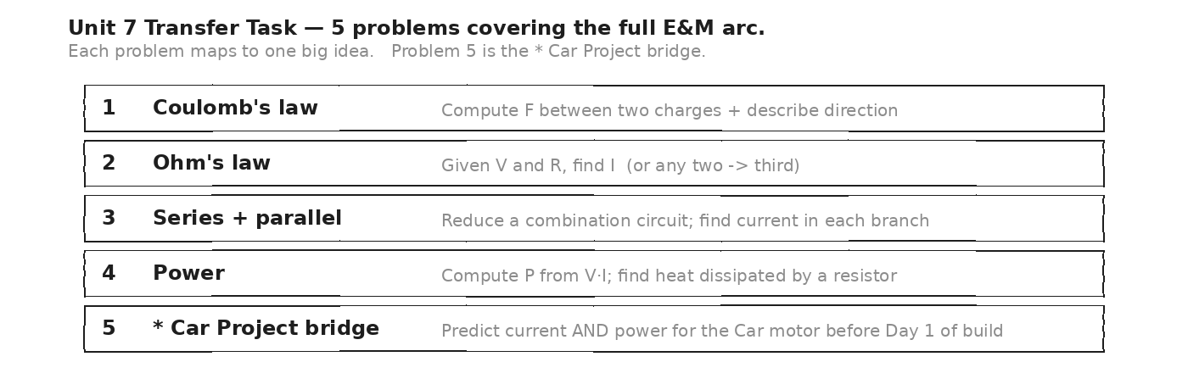

HOW THIS WILL BE SCORED — 4 DIMENSIONS, EACH 0–4
Dimension | What a strong (3–4) response shows
Science | Correct physics: vectors, kinematics, units.
Reasoning | Sound method; uncertainty explained, not just stated.
Communication | Work shown, units labeled, organized, readable.
Transfer-to-Asteroid | Honest public-facing connection to 2026-XJ.
MY WORK — DAY 18 (use additional paper as needed)
AFTER THE TASK — FINAL UNIT MARZANO (rate each Unit 7 target)
Today's Targets — Rate Yourself
1 = Not Yet (I can't do this without help) 2 = Almost (I can do this with some help or some errors) 3 = Got It (I can do this independently and explain it)
Help? Check the box if you want to talk with me about this target — even if you marked yourself a 3.
Target | 1 | 2 | 3 | Help?
K1 — Electric charge as the fundamental quantity. | ○ | ○ | ○ | ☐
K2 — Coulomb's law and inverse-square force. | ○ | ○ | ○ | ☐
K3 — Electric field as force per charge. | ○ | ○ | ○ | ☐
K4 — Voltage as energy per charge. | ○ | ○ | ○ | ☐
K5 — Current as rate of charge flow. | ○ | ○ | ○ | ☐
K6 — Ohm's law (V = IR). | ○ | ○ | ○ | ☐
K7 — Series circuits: R_series = ΣR. | ○ | ○ | ○ | ☐
K8 — Parallel circuits: 1/R_p = Σ(1/R). | ○ | ○ | ○ | ☐
K9 — Power: P = VI = I²R = V²/R. | ○ | ○ | ○ | ☐
K10 — Magnetism + Earth's field. | ○ | ○ | ○ | ☐
K11 — Oersted: current → B. | ○ | ○ | ○ | ☐
K12 — Faraday: changing B → V. | ○ | ○ | ○ | ☐
K13 — Motors + generators. | ○ | ○ | ○ | ☐
K14 — Magnetosphere + EMP at planetary scale. | ○ | ○ | ○ | ☐
S1 — Apply V = IR in any direction. | ○ | ○ | ○ | ☐
S2 — Reduce combination circuits. | ○ | ○ | ○ | ☐
S3 — Compute power from any pair of {V, I, R}. | ○ | ○ | ○ | ☐
S4 — Use Vernier voltmeter + ammeter correctly. | ○ | ○ | ○ | ☐
R5 — Predict Car Project motor current + power. | ○ | ○ | ○ | ☐

Equation Reference — Unit 7
Keep this page open while you work. Every equation below is on the MCAS Equation Sheet — you do NOT need to memorize them. You DO need to recognize when each one applies.
Concept | Equation | When to use it
Coulomb's law | F = k · q₁ · q₂ / r² | Force between two point charges. Like charges repel; unlike attract. Inverse-square — same shape as gravity. k = 9×10⁹ N·m²/C².
Electric field (force per charge) | E = F / q | Field is what a + test charge would feel per coulomb. Points OUT of + sources, IN to − sources. Units: N/C.
Voltage (energy per charge) | V = U / q | Volts = joules per coulomb. A 9V battery gives 9 J of energy to every coulomb of charge that passes through.
Current (charge per time) | I = q / t | Amperes = coulombs per second. 1 A = 1 C/s. Conventional current is the direction + charges would flow (opposite to electrons).
Ohm's law | V = I · R | Voltage = current × resistance. Triangle: cover the unknown. R in ohms (Ω).
Series resistance | R_series = R₁ + R₂ + R₃ + ... | ONE path. Same current through every component. Add resistances. Break any one → whole circuit dies.
Parallel resistance | 1 / R_parallel = 1/R₁ + 1/R₂ + ... | MULTIPLE paths. Same voltage across each branch. More branches → LOWER total R. Break one → others keep going.
Electric power | P = V · I = I² · R = V² / R | Three forms of the same equation. Watts = joules / second. Car motor (9V, ~2A) ≈ 18 W.
Right-hand rule (Oersted) | thumb = I, fingers curl = B | A straight wire with current creates a circular magnetic field around it. Coils of wire make electromagnets.
Faraday induction (qualitative) | changing flux → induced voltage | Move a magnet through a coil → a voltage is induced. Faster motion = bigger voltage. Generators run on this.
Force on current in field | F = I · L · B (qualitative) | A current-carrying wire in a magnetic field feels a sideways force. Direction by right-hand rule. THIS is what makes motors spin.
RESISTOR COLOR BANDS — reading the value
Band color | Digit | Notes
Black | 0 | Multiplier = 1
Brown | 1 | Multiplier = 10
Red | 2 | Multiplier = 100
Orange | 3 | Multiplier = 1 k
Yellow | 4 | Multiplier = 10 k
Green | 5 | Multiplier = 100 k
Blue | 6 | Multiplier = 1 M
Violet | 7 | —
Gray | 8 | —
White | 9 | —
Gold | — | Tolerance ±5%
Silver | — | Tolerance ±10%
TYPICAL VALUES — Car Project + everyday electronics
Item | Value | Note
9V battery (Car Project) | V = 9 V | Energy reservoir for the build.
DC motor resistance | R ≈ 3–5 Ω | Specific to small hobby motors. Predicted current ~2–3 A.
AA battery | V = 1.5 V | 1 cell — most appliances use 2, 3, or 4 in series.
USB phone charger | V = 5 V, I ≈ 1 A | P ≈ 5 W. Trickles current into the phone battery.
Typical lightbulb (LED) | V = 120 V, P ≈ 10 W | I = P/V ≈ 0.08 A. (Incandescent: 60 W → 0.5 A.)
US household outlet | V = 120 V (AC, 60 Hz) | Current depends on load. Breaker trips at 15–20 A.
Lightning bolt (peak) | I ≈ 30 000 A | Massive current, microsecond duration.
Earth's magnetic field | B ≈ 25–65 μT | Geographic varies. Compass needles align to it.
Constants and reference quantities:
k = 9 × 10⁹ N·m²/C² · e = 1.6 × 10⁻¹⁹ C (elementary charge) · ε₀ = 8.85 × 10⁻¹² C²/(N·m²) · μ₀ = 4π × 10⁻⁷ T·m/A · 1 V = 1 J/C · 1 A = 1 C/s · 1 Ω = 1 V/A · 1 W = 1 J/s
Mastery Growth Chart — Unit 7
Each day, transfer your Marzano 1-2-3 rating onto the chart. Use a different mark or color for each target you track. Unit 7 has ~15 targets across 18 days — track at least your top three.
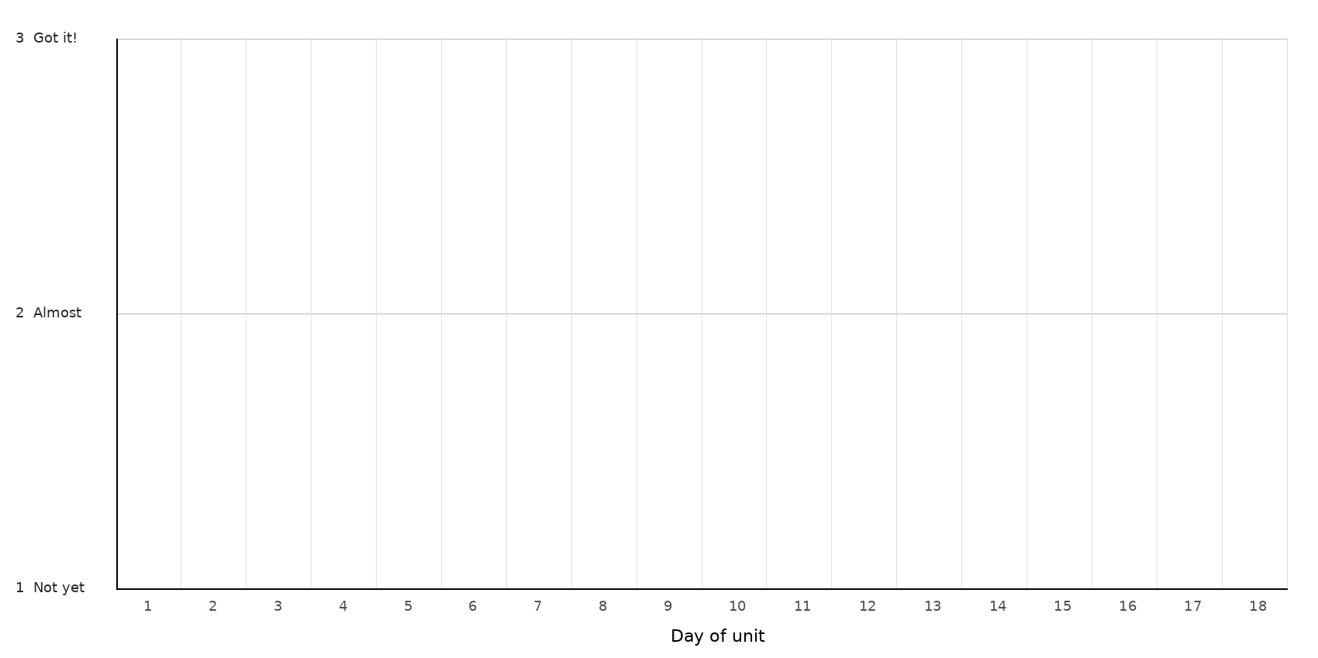
LEGEND — WHICH MARK / COLOR = WHICH TARGET
Mark: ______ Target: __________________________________________________________________
Mark: ______ Target: __________________________________________________________________
Mark: ______ Target: __________________________________________________________________
Mark: ______ Target: __________________________________________________________________
NOTES — END-OF-UNIT REFLECTION

