Ethan Balon [ebb0039]
BCDE211 Best programming practices Assessment 3 - Portfolio
BCDE211 Assessment 3 portfolio

Table of Contents
Introduction 2
Arrow functions 3
Default parameters 4
Array functional methods 5

Introduction
This report covers the language features of JavaScript and TypeScript that I have learned and demonstrated on Assessment 2 and Assessment 3. The report includes a description on the feature being demonstrated aswell as snapshots as evidence alongside the assessment and file where the code originated from.

Arrow functions
Figure 1 deleteEvent with arrow function inside ( Assessment 2, event_manager.js line 56)
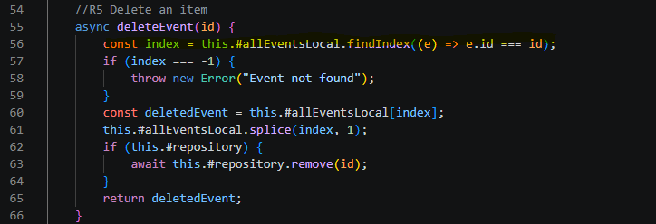
In this example, I have implemented an arrow function inside the deleteEvent function. The purpose of this is to define the event that is needed for the deleteEvent function to work, it will search for the given event id in the allEventsLocal array and return the position of the target event for it to be removed.
Figure 2 formatDate arrow function ( Assessment 3, EventCard.tsx line 28-38 )
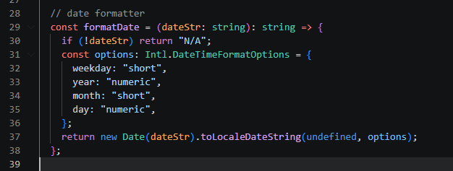
In this example, the formatDate arrow function is intended to rewrite the date property of an object to a more readable format to the user. This function uses TypeScript and requires dateStr to be a string value, the function uses the Intl.DateTimeFormatOptions type to define what the new date format will look like, then it will return a proper date object instead of a string.

Default parameters
Figure 3 addEvent function (Assessment 2, event_manager.js line 15 – 33)
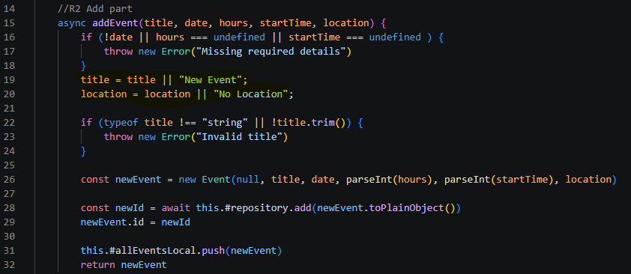
In this example, addEvent function will create an event object based on the values given by the user. However, title and location are optional values, so the user is not required to provide then. In this case, if the function detects either value to be undefined, default parameters will be used instead.

Array functional methods
Figure 4 editEvent (Assessment 2, event_manager.js line 44)
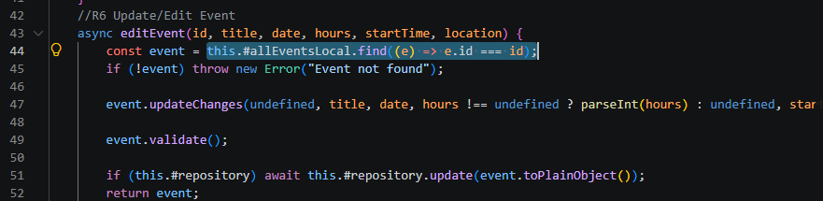
In this example, editEvent uses the .find functional method. This is used to locate the event that matches the given id in the allEventsLocal array and return the required object, from here the object’s values will be changed with the new given values from the user and then saved back into the repository.

