Microsoft Dynamics 365 Customer Engagement

DevOps 1 Day with Lab

Lab 0: Workshop Prerequisites

Student Lab Manual

Conditions and Terms of Use

Microsoft Confidential

This training package is proprietary and confidential and is intended only for the uses described in the training materials. Content and software are provided to you under a Non-Disclosure Agreement and cannot be distributed. Copying or disclosing all or any portion of the content and/or software included in such packages is strictly prohibited.

The contents of this package are for informational and training purposes only and are provided "as is" without warranty of any kind, whether express or implied, including but not limited to the implied warranties of merchantability, fitness for a particular purpose, and non-infringement.

Training package content, including URLs and other Internet Web site references, is subject to change without notice. Because Microsoft must respond to changing market conditions, the content should not be interpreted to be a commitment on the part of Microsoft, and Microsoft cannot guarantee the accuracy of any information presented after the date of publication. Unless otherwise noted, the companies, organizations, products, domain names, e-mail addresses, logos, people, places, and events depicted herein are fictitious, and no association with any real company, organization, product, domain name, e-mail address, logo, person, place, or event is intended or should be inferred.

© 2021 Microsoft Corporation. All rights reserved.

Copyright and Trademarks

© 2019 Microsoft Corporation. All rights reserved.

Microsoft may have patents, patent applications, trademarks, copyrights, or other intellectual property rights covering subject matter in this document. Except as expressly provided in written license agreement from Microsoft, the furnishing of this document does not give you any license to these patents, trademarks, copyrights, or other intellectual property.

Complying with all applicable copyright laws is the responsibility of the user. Without limiting the rights under copyright, no part of this document may be reproduced, stored in or introduced into a retrieval system, or transmitted in any form or by any means (electronic, mechanical, photocopying, recording, or otherwise), or for any purpose, without the express written permission of Microsoft Corporation.

For more information, see Use of Microsoft Copyrighted Content at

https://www.microsoft.com/en-us/legal/intellectualproperty/permissions/default.aspx

Internet Explorer, Microsoft, Microsoft Dynamics, Microsoft Dynamics logo, Outlook, Windows, Windows Live Messenger icon, double, and Windows Live Messenger icon, single are either registered trademarks or trademarks of Microsoft Corporation in the United States and/or other countries. Other Microsoft products mentioned herein may be either registered trademarks or trademarks of Microsoft Corporation in the United States and/or other countries. All other trademarks are property of their respective owners.

Table of Contents

Introduction 3

Set up a new trial 3

Set up Azure DevOps organization 8

Clone your repository locally (Visual Studio Code) 11

Prerequisites 11

Summary 12

# Introduction

To be successful in the workshop labs, you are required to setup an Azure DevOps organization as well as test environments in your own PowerApps subscription or trial environments before the day of the workshop.

# Set up a new trial

Setup a trial tenant before the workshop. To accomplish this, use the following steps:

Ensure that you are signed out of any Power Platform accounts before continuing. Navigate to [https://make.powerapps.com/](https://make.powerapps.com./). If you are logged in, be sure to log out now. Close the browser and open it again to begin.

1. Navigate to [https://trials.dynamics.com](https://trials.dynamics.com/).
2. Do not enter a work email, instead at the bottom look for the following:

"Are you signing up on behalf of a customer or using this trial for development purposes? *Sign up here*".

Select ***Sign up Here:***

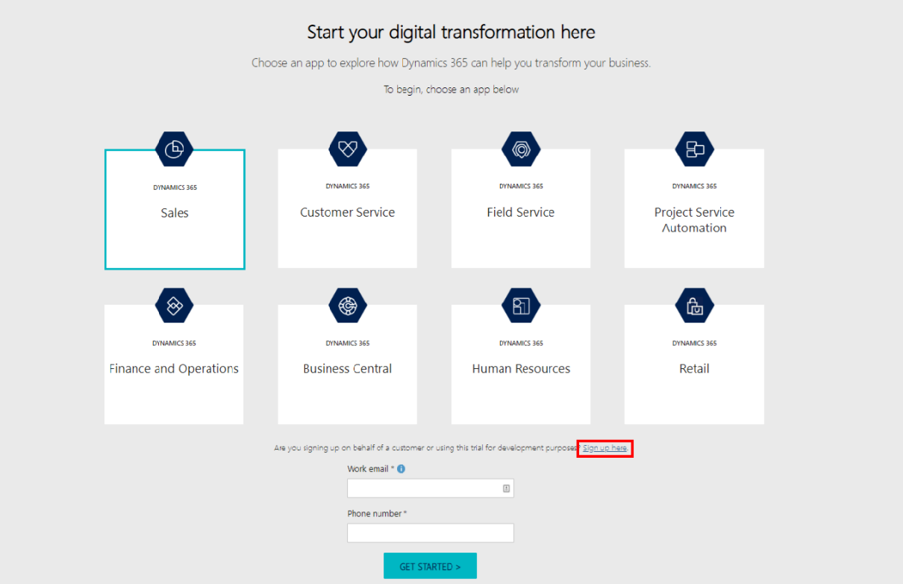

1. A prompt will appear asking if you are a partner or MSFT employee, click ***No, continue to sign up.***

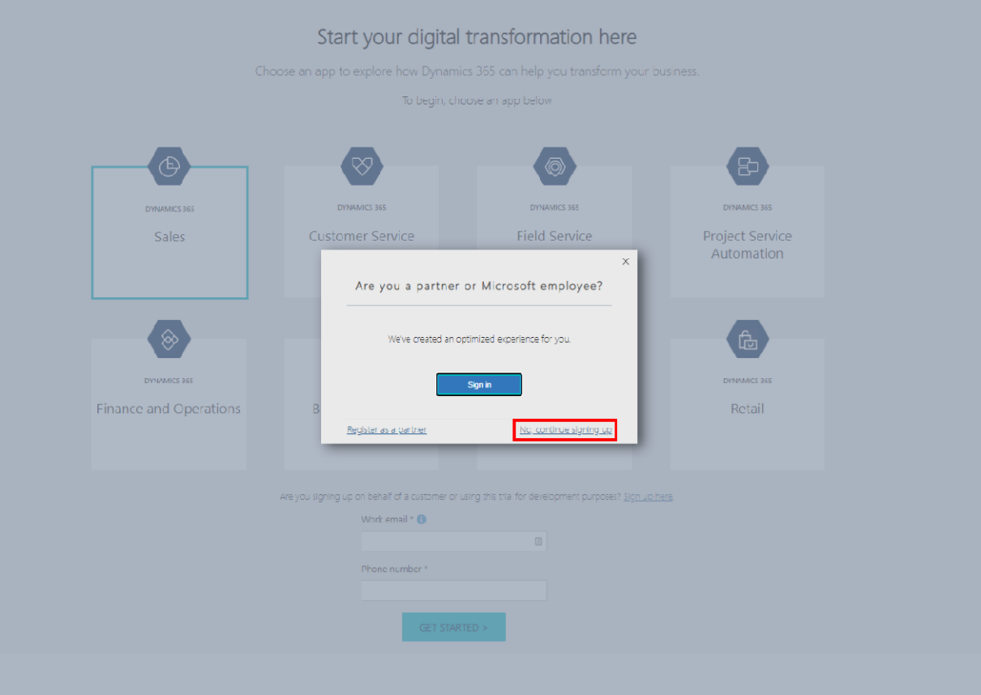

1. In section 1, *Let’s set up your account***,** enter an email that is not associated with your work or school. Doing so will allow you to create a new account with a fictitious name for our workshop.
2. Click **Create new account.**
3. In section 2, *Tell us about yourself,* fill in the form.
4. Click **Next.**

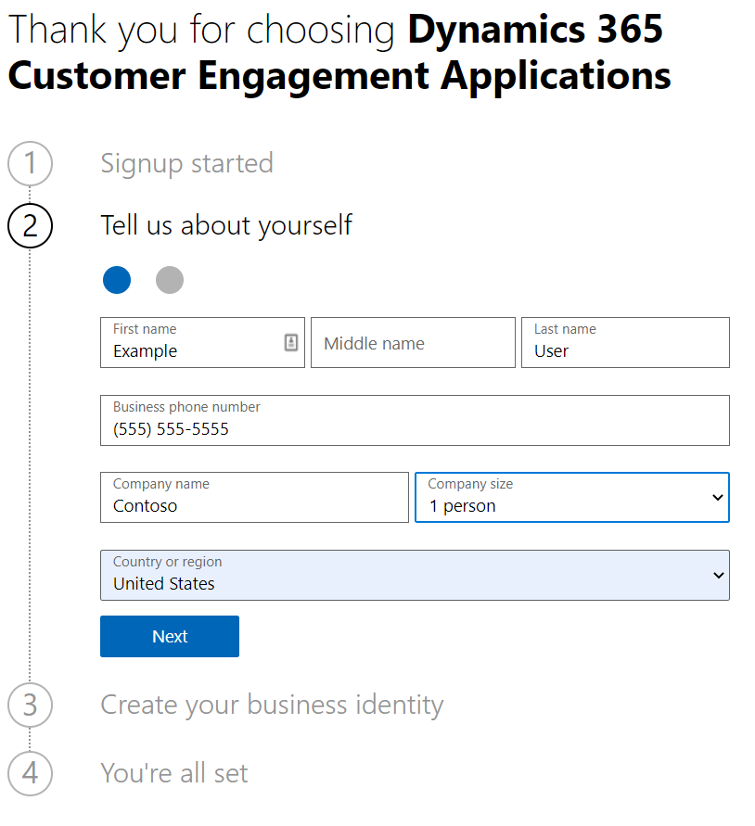

1. Fill in a valid phone number on the next screen to validate the fact that you are a valid user. The number does not need to match the business phone number you entered on the previous screen; this number is not stored by Microsoft.
2. In section 3, *Create your business identity,* Enter a unique domain name, e.g. ContosoUniversity001, co001, MyOrg, etc.
3. Click **Check availability**, then click **Next.**
4. In the final section, enter a username and password. Be sure to save the login credentials for reference.
5. Click **Sign up**
6. Click **Let’s go**

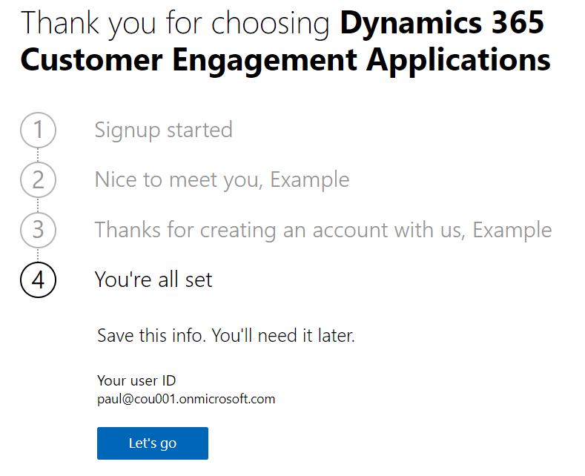

1. You will be taken to the Power Platform admin center to create your Dynamics 365 Customer Engagement environment. If you are not redirected, you may have been logged into your account. You will need to log out, close your browser and restart the process from the beginning.
   1. Enter a unique name: Contoso-University-Dev
   2. Select an appropriate region for your environment.

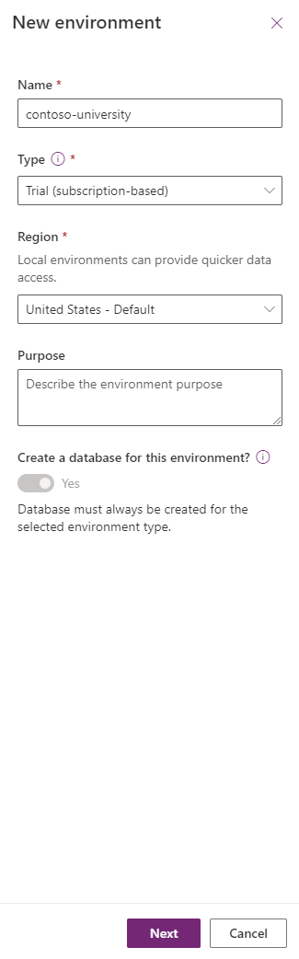

1. Click **Next**
2. On the next screen, we will add a database as seen below:
   1. Toggle *Enable Dynamics 365 apps* to **Yes**

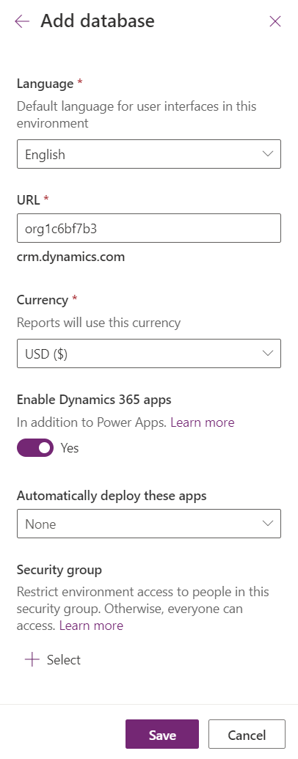

1. No changes are needed on the next screen, click **Save**.
2. You will now see the new environment listed on the Environments page in a *Preparing Instance* state. Provisioning typically takes 15 minutes; so, we will move onto setting up an Azure DevOps organization.

# Set up Azure DevOps organization

If you have followed the steps above, to create a trial organization, you may use the same login to create your Azure DevOps organization.

First, navigate to [dev.azure.com](https://dev.azure.com/).

Option 1: If you setup a trial, following the steps in the previous section, you can reuse the credentials for your Azure DevOps organization.

1. Click **Sign in to Azure DevOps**



1. On the next screen, your credentials from the trial environment will be pre-populated. Verify the entries, then click **Continue.**
2. Review the Terms of Service, Privacy Statement, and Code of Conduct. Click **Continue**.

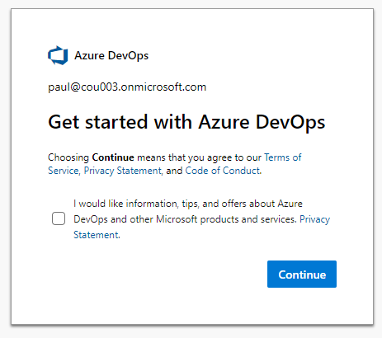

1. On the next screen, you will be prompted to name your Azure DevOps organization and set the region.

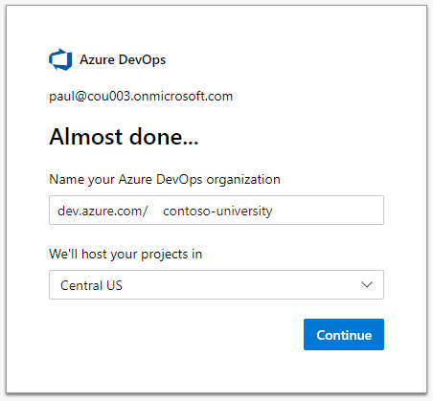

1. Click **Continue**
2. You will now be taken to your new organization to create a project.
3. Enter a project name, then click continue.

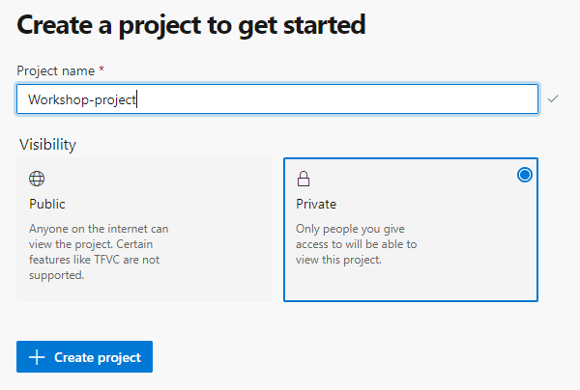

1. Next we will install the required tools and clone our default repository locally.

# Clone your repository locally (Visual Studio Code)

This lab assumes you clone the repository in C:\Users\<Current User>\Documents\repositories.

## Prerequisites

* If it’s not already installed, download a copy of Visual Studio Code (VS Code) at <https://code.visualstudio.com/>.
* To leverage Git, you must download a copy of Git for Windows from <https://git-scm.com/downloads>. This is the tool used by VS Code to manage repositories.

1. After Visual Studio Code is installed, in a browser, navigate to your Azure DevOps organization at <https://dev.azure.com/>.
2. Click the project card to load the project.

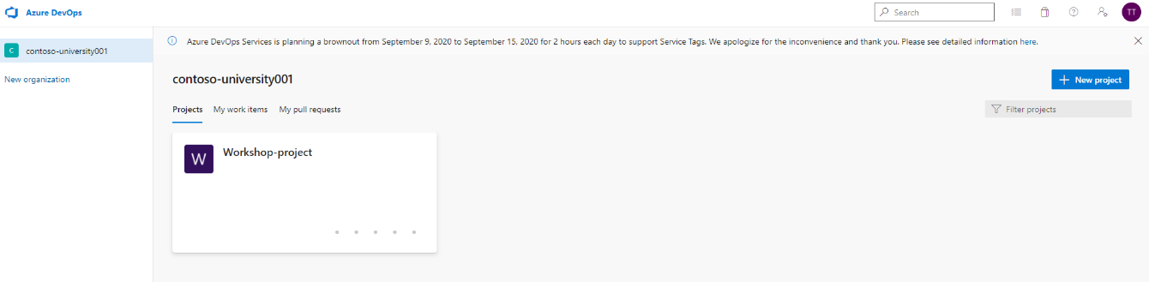

1. Click **Repos** on the left navigation pane**.**
2. The default repository will be loaded. Click **Clone in VS Code** to start the cloning process.

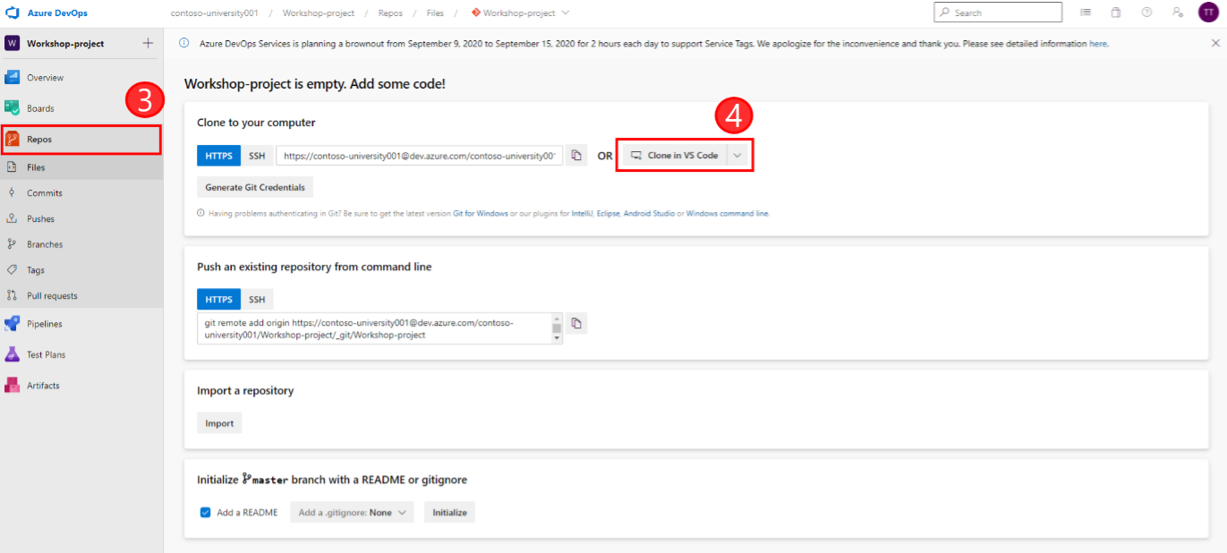

1. VS Code will launch an instance of Windows Explorer, navigate explorer to C:\Users\<Current User>\Documents\repositories and click **Ok**.
2. Once complete, VS Code will prompt you to open the current repository. Click **Open in New Window**.

* 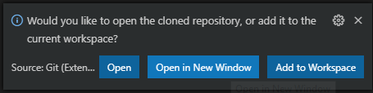

1. You will now have a copy of the empty repository. We will be adding files in the subsequent labs.

# Summary

We have now setup a *Dynamics 365 Customer Engagement trial* containing one environment. We have also created an *Azure Organization* with a project and repository, which will allow us to store our customizations.

At this point, you should have a local clone of the Azure DevOps repository. If at this point you have any issues, please check with the instructor to ensure a proper setup to achieve success in later labs.