Microsoft Dynamics 365 Customer Engagement

DevOps 1 Day with Lab

Lab 1: Setup Azure Repo and Make Your First Commit

Student Lab Manual

Conditions and Terms of Use

Microsoft Confidential

This training package is proprietary and confidential and is intended only for uses described in the training materials. Content and software is provided to you under a Non-Disclosure Agreement and cannot be distributed. Copying or disclosing all or any portion of the content and/or software included in such packages is strictly prohibited.

The contents of this package are for informational and training purposes only and are provided "as is" without warranty of any kind, whether express or implied, including but not limited to the implied warranties of merchantability, fitness for a particular purpose, and non-infringement.

Training package content, including URLs and other Internet Web site references, is subject to change without notice. Because Microsoft must respond to changing market conditions, the content should not be interpreted to be a commitment on the part of Microsoft, and Microsoft cannot guarantee the accuracy of any information presented after the date of publication. Unless otherwise noted, the companies, organizations, products, domain names, e-mail addresses, logos, people, places, and events depicted herein are fictitious, and no association with any real company, organization, product, domain name, e-mail address, logo, person, place, or event is intended or should be inferred.

© 2020 Microsoft Corporation. All rights reserved.

Copyright and Trademarks

© 2019 Microsoft Corporation. All rights reserved.

Microsoft may have patents, patent applications, trademarks, copyrights, or other intellectual property rights covering subject matter in this document. Except as expressly provided in written license agreement from Microsoft, the furnishing of this document does not give you any license to these patents, trademarks, copyrights, or other intellectual property.

Complying with all applicable copyright laws is the responsibility of the user. Without limiting the rights under copyright, no part of this document may be reproduced, stored in or introduced into a retrieval system, or transmitted in any form or by any means (electronic, mechanical, photocopying, recording, or otherwise), or for any purpose, without the express written permission of Microsoft Corporation.

For more information, see Use of Microsoft Copyrighted Content at

https://www.microsoft.com/en-us/legal/intellectualproperty/permissions/default.aspx

Internet Explorer, Microsoft, Microsoft Dynamics, Microsoft Dynamics logo, Outlook, Windows, Windows Live Messenger icon, double, and Windows Live Messenger icon, single are either registered trademarks or trademarks of Microsoft Corporation in the United States and/or other countries. Other Microsoft products mentioned herein may be either registered trademarks or trademarks of Microsoft Corporation in the United States and/or other countries. All other trademarks are property of their respective owners.

Table of Contents

Introduction 3

Check-in your first Dynamics 365 Customer Engagement Solution 3

Copy Initial Lab Resources 3

Download core tools 4

Restricted Execution Policy 5

Unpack solution files 5

Check unpacked solution(s) into repository using VS Code 6

# Introduction

In this lab, we will commit our first unpacked Dynamics 365 Customer Engagement solution using Solution Packager.

# Check-in your first Dynamics 365 Customer Engagement Solution

If you have not already done so, please follow the workshop prerequisites lab to setup your Azure Repo and clone the repository locally to continue.

**Note**: This lab assumes that you have cloned the Contoso University repository into C:\Users\<Current User>\Documents\repositories\contoso-university.

## Copy Initial Lab Resources

1. Open file explorer (Shortcut keys: Win + E).
2. Navigate to C:\Users\<Current User>\Documents\repositories\contoso-university.
3. Open another instance of file explorer.
4. Navigate to the lab-resources/lab-1/copy-to-repo folder in the provided supporting materials.

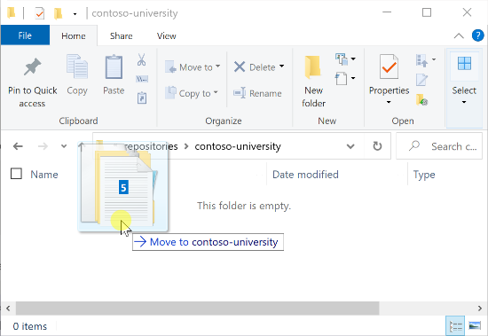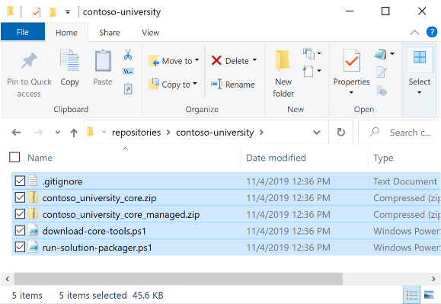

1. Select all the contents from the copy-to-repo folder and drag them into the contoso-university folder.

## Download core tools

1. From your local contoso-university repository, right-click on   
   download-core-tools.ps1 and click “Run with PowerShell.”  
   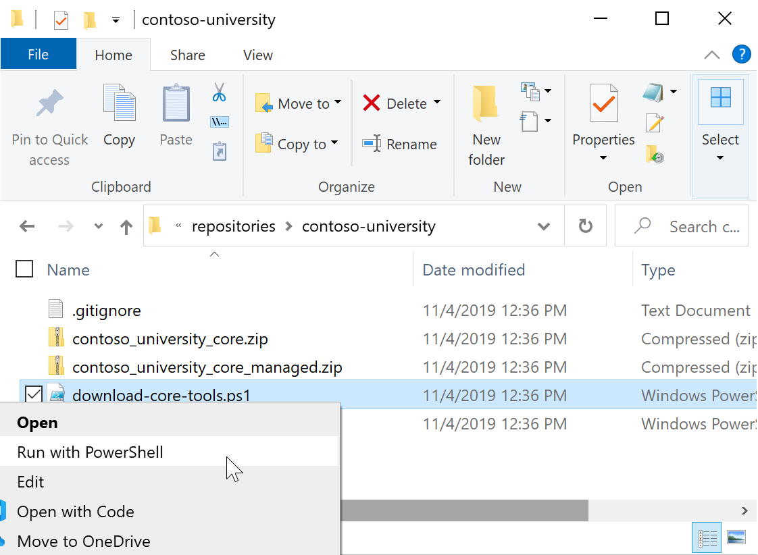

Alternately, from VS Code, where your repository should be opened, open the terminal (press Control + Backtick (`)). Then, type .\download-core-tools.ps1 and hit Enter.  
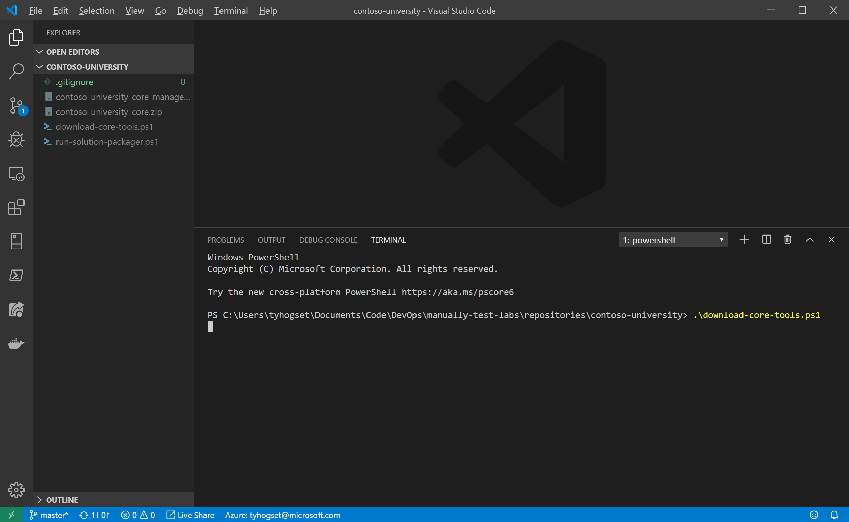

1. The PowerShell script will run, creating a tools directory in the  
   contoso-university folder.

**Note:** This script was pulled directly from the [Download tools from Nuget](https://docs.microsoft.com/en-us/powerapps/developer/common-data-service/download-tools-nuget) page in the PowerApps documentation.

### Restricted Execution Policy

Depending on your system’s policies, you may be unable to run ps1 scripts. Running the steps above, you will get an error like this:

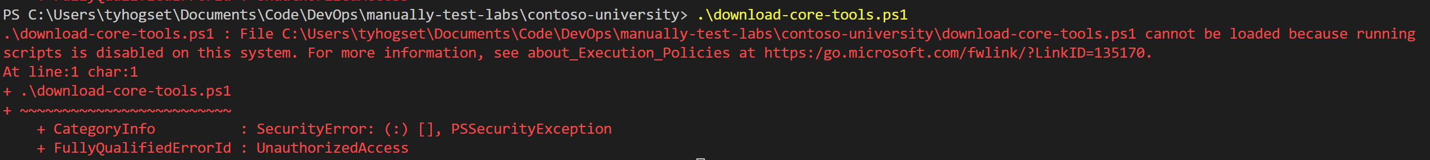

If that’s the case, you can copy the contents of copy-to-repo-restricted into your repository. This contains a copy of the tools folder that will be downloaded in this step, along with batch file, which you should be able to run without issue.

## Unpack solution files

1. From the terminal in VS Code, type .\run-solution-packager.ps1 and hit Enter.  
   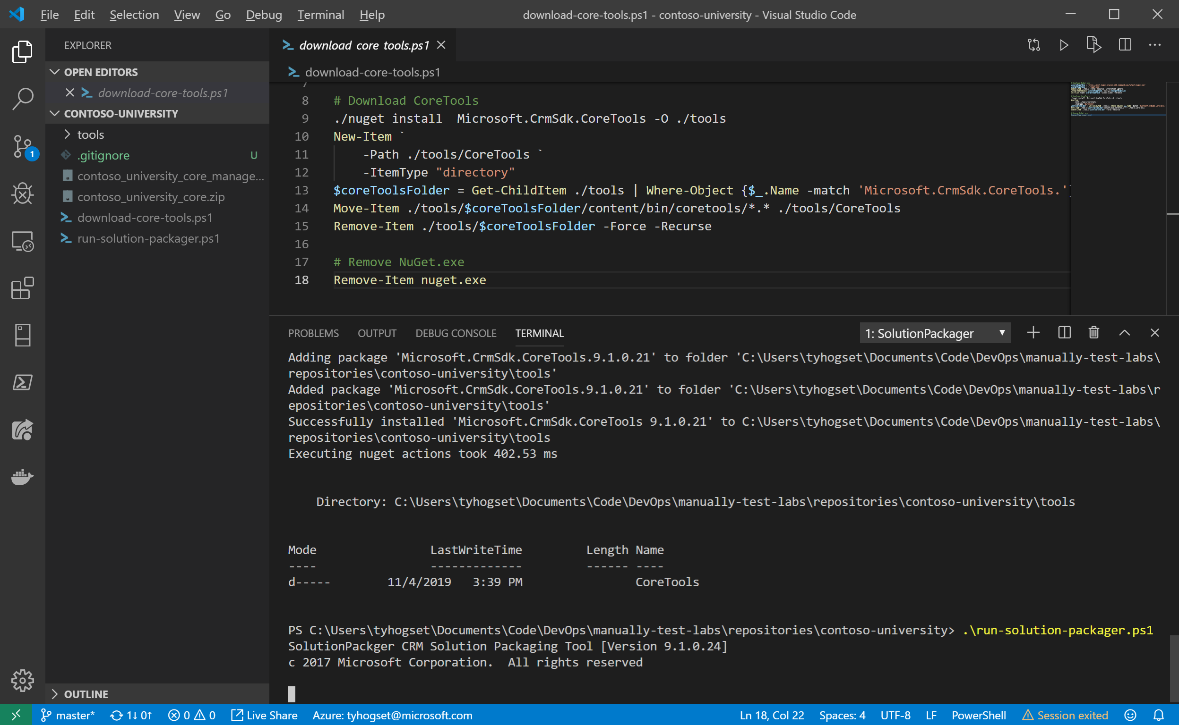  
   **Note:** If you are not able to run ps1 scripts on your machine, type   
   .\run-solution-packager.bat instead.
2. This script (shown below) will take the two .zip files in the repository folder and distribute their contents into a newly created contents folder.

.\tools\CoreTools\SolutionPackager.exe `  
 /action Extract `  
 /zipfile .\contoso_university_core.zip `  
 /folder .\contents `  
 /packagetype Both

Here, we’ve selected a packagetype of Both, so that we can later deploy this solution into either a development (unmanaged) or downstream (managed) environment.

For information on SolutionPackager, visit the [SolutionPackager tool](https://docs.microsoft.com/en-us/powerapps/developer/common-data-service/compress-extract-solution-file-solutionpackager) page in the PowerApps documentation.

## Check unpacked solution(s) into repository using VS Code

1. Open Visual Studio Code (VS Code).
2. Click the source control button  (Shortcut Ctrl+Shift+G).
3. Click the + symbol to stage all changes. If the + symbol is not visible, hover over changes, then click the button.  
     
   
4. Enter a commit message into the **Message** box, then click the check mark to commit the changes.  
   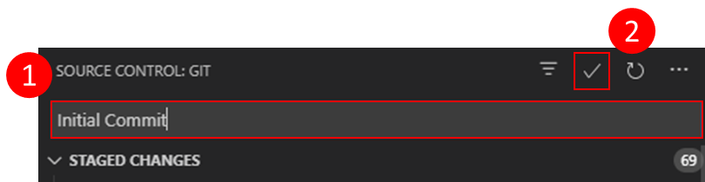
5. Click the ellipsis (), click **Pull, Push**, then **Push** to send the committed changes to your Azure DevOps repository. 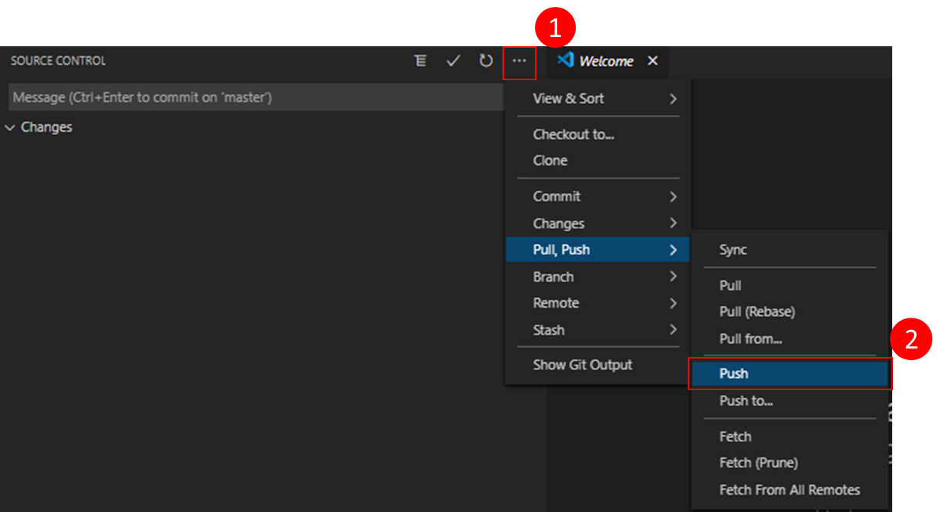

After you have pushed your changes, if you open your project in Azure DevOps and navigate to your Repo, you should see your changes reflected there.

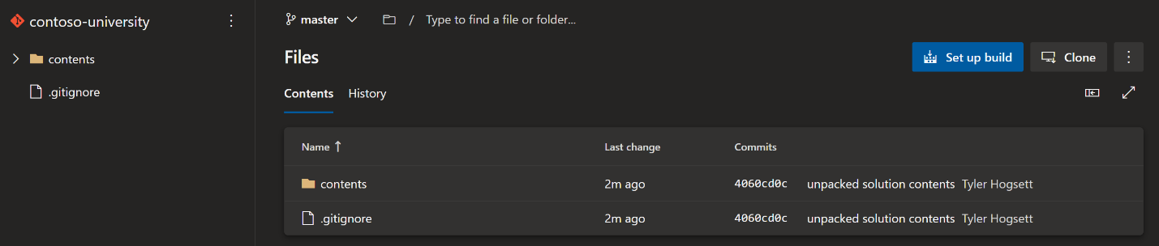

Congratulations! You have now committed your first unpacked solution into version control and pushed those changes to Azure Repos for safe keeping. You can use later in our build and release pipelines.