WaterFlex stateless API service explained
  - What the scheduler's public API is, how WaterFlex Software uses it, and how it was built
October 14 2026 | Contract version 1.4.1, pull requests #70 to #158
The WaterFlex scheduler is now a service that WaterFlex Software calls over HTTP and nothing else touches. It keeps no customer, job or technician records; every call carries a snapshot of the facts it needs, and it answers with time windows to offer a customer or whole timed routes for a day, which WaterFlex Software writes into its own records with a compare-and-set. The contract has 12 operations, 45 object schemas and 10 error codes, reached version 1.0.0 on 2026-10-13 and 1.4.1 with five additive changes the next day, and is proven against a running scheduler by a conformance kit of 27 cases. This report explains what the service is, how a host uses it safely under concurrency, and the 65 pull requests between 2026-10-07 and 2026-10-14 that built it. [1, 2, 3]

What the service offers
Facet | What it is
Surface | 12 operations under /api/v1 plus an open /health, all served, all idempotent on a host requestId
Inputs | A snapshot per call: rates, policy, technicians, technician-days with lastModified, committed appointments, coordinates
Outputs | Booking offers held for 10 minutes; daily and repair proposals; commit and confirm receipts listing every assignment to write; timed and drawn routes
State kept | Holds, offer sets, proposals, receipts and request claims, keyed by host IDs, purged after the deployment's retention period; a route cache
Concurrency | Host lastModified per technician-day compared for exact equality; row locks, versions and row-level security in the scheduler's own Postgres
Clients | One tenant per WaterFlex client, chosen by the bearer token, isolated by tenant_id and database policies; fair turns between clients
Deployment | Its own VM: a proxy, booking and daily replica pools of one jar, a routing service per metro, optional Nominatim, its own database

The design decision behind all of this was taken on 2026-10-07: a thin scheduler store. The scheduler owns only what it must to keep customer promises safe when several desks book at once, and WaterFlex Software stays the record. The sections below follow the integration guide's order, then explain what is underneath, and end with how the service was built and what still stands between it and production traffic.

How to read this report
Sections | What you will learn
1 to 3 | What the service is and is not, where it runs, and the contract's operations and conventions.
4 to 7 | The snapshot and its timestamp rules, booking, daily and repair proposals, and every error with its remedy.
8 to 11 | Underneath: many clients and replicas, the thin store, routing and geocoding, and operating the service.
12 to 14 | How it was built, how an integration is proven, and what remains before production traffic.
Appendices | Every contract change, every pull request, every schema, definitions and sources.

1 What the service is, and what it is not
The scheduler is an add-on to WaterFlex Software. WaterFlex Software owns master data (customers, addresses, jobs, appointments, technicians, qualifications, shifts, time off, depots) and the business record of every appointment. The scheduler owns only what it must to keep customer promises safe under concurrency: booking holds and the arrangement they depend on, the offer sets and proposals it issued, and the receipts of what was committed. Calculation and routing are stateless: complete data in, results out. [1]
WaterFlex Software owns | The scheduler owns
Customers, addresses, jobs, appointments, technicians, qualifications, shifts, absences, depots | Booking holds and each metro-day's common arrangement
The business record: every appointment's technician, sequence and planned times | Offer sets, proposals and receipts it issued, keyed by your IDs
The lastModified timestamp of every technician-day | The road graph per metro, its route cache, and address location (Nominatim)
Each client's policy choices and rates, sent with every call | Nothing else: it reads no master data and holds no policy settings
Overnight schedules, time off, cancellations, depot changes

Three consequences follow. The service has no screens: WaterFlex Software renders every map and schedule, and the scheduler returns data only. The service reads no policy of its own: every rule a client chooses (its fairness budget, its daily search method and times, its booking deadline and window threshold) arrives with every call, and a missing value is refused, never assumed. And no client library ships: the product stays Java, scaled on its own VM, and a host integrates from any language against the OpenAPI contract.

What it is not
It is not a database of schedules, so it cannot drift from the host's record; the host's timestamp per technician-day decides whether what the scheduler computed still applies. It is not a batch system, so overnight runs belong to the host, which queues a proposal per metro-day at the time each client chooses. And it is not reachable by anything but the API: no shared database, no callbacks, no client code from this repository.

2 Where it runs
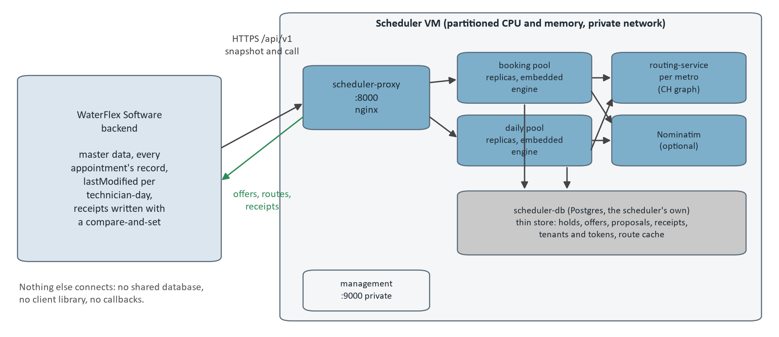
Figure 1. The scheduler VM and its host. WaterFlex Software calls one address; behind it a proxy sends booking calls to the booking pool and proposals to the daily pool, each replica embeds the calculation engine, and the VM holds a routing service per metro, an optional Nominatim and the scheduler's own database.
The scheduler runs on its own VM with a partitioned share of compute, on the same private network as the rest of WaterFlex Software, and is reached only through https://<scheduler-vm>/api/v1. On the VM, scheduler-service may run as several replicas of the same jar behind one load balancer. Booking replicas answer booking searches, confirms and route calls; daily replicas take daily and repair proposals. Every replica answers every route, holds no state of its own and shares the one thin store, so which replica answers a call never changes the answer. [1, 2]
Component | Role | Talks to
scheduler-proxy (nginx, :8000) | The one address a host calls; sends proposals and request status calls to the daily pool and everything else to the booking pool | Both pools
Booking replicas | Booking offers, select, release, confirm, route evaluation and geometry; embedded calculation engine | Routing, Nominatim, the database
Daily replicas | Daily and repair proposals, synchronous or queued; several calculations at once | Routing, Nominatim, the database
routing-service per metro | Turns coordinates into directed road legs from that metro's graph; sees coordinates only | Its map volume
Nominatim (optional) | Locates an address-only location as an exact house, in NOMINATIM mode | Its own database
scheduler-db (Postgres 16) | The thin store, tenants and tokens, and the route cache; created and migrated by the scheduler itself | Nothing else
Management port (:9000) | Health with components and Prometheus metrics; private network only | Operators

The calculation engine stays embedded in each replica by default (SCHEDULER_CALCULATION_MODE=EMBEDDED). Moving it to a remote solver pool is a configuration change already wired in, kept as a scaling lever rather than a default. Each served metro has its own routing service loaded with that metro's road graph; routing sees only coordinates, never client data, so every client in a metro shares it.

3 The contract
The machine-readable contract is docs/api/openapi-v1.yaml, OpenAPI 3.1, version 1.4.1. Every operation is marked implemented; a test validates every example in the spec against its schema and fails if the implemented operations differ from the routes the scheduler serves, and the Java types mirror every object schema, so the spec, the code and the examples cannot drift apart unnoticed. [2]
Operation | Method and path | What it does
whoami | GET /whoami | Return the tenant that the bearer token belongs to.
createDailyProposal | POST /daily/proposals | Propose optimized routes for one metro day.
commitDailyProposal | POST /daily/proposals/{proposalId}/commit | Revalidate a proposal against current technician-day timestamps and return the assignments to write.
evaluateRoutes | POST /routes/evaluate | Time one metro day's routes in their current order.
drawRoutes | POST /routes/geometry | Draw one metro day's routes on roads in their current order.
createBookingOffers | POST /booking/offers | Find up to four arrival windows for a job and hold them.
selectBookingOffer | POST /booking/offers/{offerId}/select | Keep the hold for one offer and release the others in its set.
releaseBookingOffer | POST /booking/offers/{offerId}/release | Release every hold in the offer's set.
confirmBookingHold | POST /booking/holds/{holdId}/confirm | Confirm a selected hold against the host's current snapshot of its date and return the appointments to write.
createRepairProposal | POST /repairs/proposals | Propose how to cover a technician's absence on one day without overtime.
getRequest | GET /requests/{requestId} | The status of a daily or repair proposal request, and its answer once complete.
cancelRequest | DELETE /requests/{requestId} | Best-effort cancellation of an in-flight calculation.

Conventions every call follows
Convention | Rule
Tenant | Derived from the bearer token; a request never names a tenant, and a tenantId in a body is a 400.
requestId | Every write carries a host UUID that is its idempotency key across all of the tenant's endpoints: same body replays the stored answer, different body is a 400.
IDs | WaterFlex Software's own opaque strings, 1 to 128 characters.
Money and rates | Canonical decimal strings such as "20" or "0.67", never JSON numbers.
Times | Instants are RFC 3339 with an offset; service dates are calendar dates in the metro's time zone.
Strictness | Unknown fields, duplicate keys, missing required values and dangling references are rejected with 400; nothing is assumed or filled in.
Overtime | Never assigned by any operation; a repair that would need it is reported infeasible.
Retention | Requests, proposals, offers and receipts are kept for SCHEDULER_RETENTION_DAYS, then purged; an older requestId runs as a new request.

Within version 1, changes are additive only (a new operation, optional request field, response field, error code or enum value) and raise the minor version; each is listed in the spec's version history and in the design document's change table before it is deployed. A breaking change is published as /api/v2 beside v1. The contract reached 1.0.0 on 2026-10-13 and is at 1.4.1 after 5 additive versions (section 12 and Appendix A).

4 The snapshot and the lastModified rules
Every calculating call carries a Snapshot for one metro: its rates and policy, the technicians it covers, one TechnicianDay per technician and date, and every committed appointment on those technician-days. The scheduler computes a canonical hash of it, the input revision, and every proposal and offer records which revision it was computed from. [1, 3]
Part | What it holds
metroId, timeZone | The metro whose routing service answers, and the zone of its service dates and 6 a.m. cutoff.
rates | regularHourly, overtimeHourly, mileagePerMile, travelBufferPct, travelBufferMinutes: the client's own cost model.
policy | fairnessBudget, dailySearch (TABU_KOPT or TABU), costSearchSeconds, fairnessSearchSeconds, bookingDeadlineMs, regularWindowThreshold, optional bookingRefinementMs.
technicians | ID and qualifications (the services the technician may perform).
technicianDays | Per technician and date: lastModified, shift, absences (required, [] when none), start and end locations, maxPaidMinutes.
appointments | Per committed appointment: ID, technician, date, service, duration, arrival window, location, sequence and plannedStart (required).
locations | Coordinates, used exactly as sent; or an address, located only in NOMINATIM mode and only as an exact house.

On each technician-day, sequence and plannedStart must put the appointments in the same order; a contradiction is a 422, never reordered. A location that cannot be located is never guessed: in a proposal its technician-day is left exactly as it is and listed in skippedTechnicianDays, and in a booking search an unlocatable job is a 422.

The concurrency token
The scheduler cannot lock rows it does not own, so commits use optimistic concurrency on both sides, and the token is the lastModified timestamp WaterFlex Software already keeps per technician and day. Every snapshot includes it; a proposal or offer records the values it was computed from; a commit or confirm requires the submitted values to equal the recorded ones; and the host then writes the business record with a compare-and-set on the same values. It is compared for exact equality at full precision and never ordered, so clock skew between servers cannot cause a wrong decision; at worst an unrelated change forces a retry. [1]
Rule for the host | Why
It changes on every change that affects the day: an appointment created, edited, cancelled or deleted; a shift, availability or absence change; a start or end location change; a qualification change. | A missed update is the one way an integration can overwrite a dispatcher's change.
A move touches both sides: moving an appointment from technician A on Tuesday to technician B on Wednesday updates both technician-days. | A proposal for either day would otherwise apply to facts that moved.
A shift template change updates every future day it affects. | Those days' routes were computed against the old shift.
It is sent exactly as stored: not rounded, reformatted or regenerated between the snapshot and the commit. | Equality is exact; a reformatted value is a different value.

5 Booking
Booking finds arrival windows for a new job, holds them for 10 minutes, and turns the customer's choice into an appointment the host writes. A search covers exactly the dates the host asks for (1 to 21), returns at most the client's offerLimit windows (1 to 4) of the client's windowHours (1 to 8) each, and answers within the client's bookingDeadlineMs (at most 5 seconds). An offer may move other customers' appointments to make room; those moves come back in the confirm receipt. [1, 3]
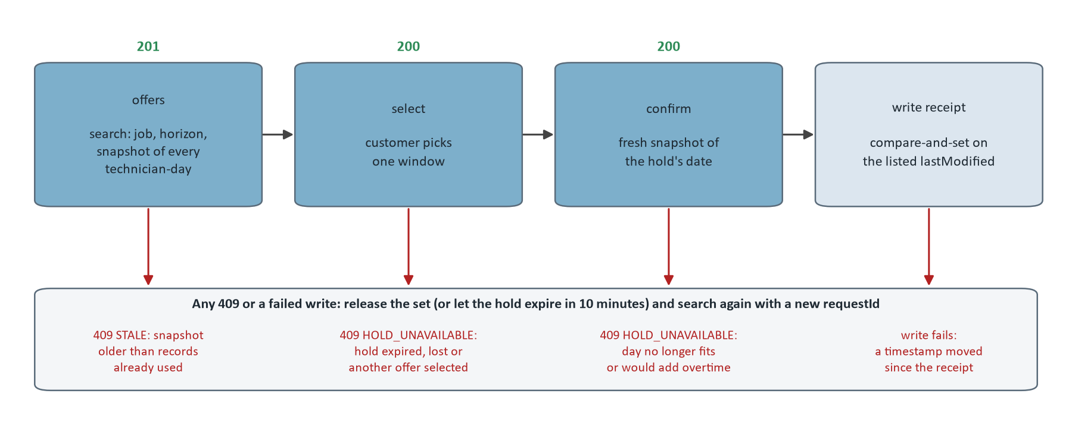
Figure 2. The booking sequence and its refusals. Each 409 and a failed receipt write lead to the same place: release the set (or let the hold expire) and search again from current records with a new requestId.
Step | Call | Answer
1 Search | POST /booking/offers with the job, horizon, offerLimit, windowHours and the snapshot of every technician-day in the horizon | 201 OfferSet: offers with windows, expiresAt, searchComplete, refinement, incompleteDates, skippedTechnicianDays
2 Select | POST /booking/offers/{offerId}/select | 200: that hold kept with its original expiry, the others in the set released
3 Confirm | POST /booking/holds/{holdId}/confirm with a fresh snapshot of the hold's metro and date only | 200 receipt: every appointment on each technician-day whose route changes, the new job under its job ID, and the timestamps to compare
4 Write | In one host transaction: compare each listed lastModified, write every listed assignment, move the timestamps | On any difference write nothing, release, search again
Release | POST /booking/offers/{offerId}/release | 200 even when nothing was still held; unreleased holds expire after 10 minutes

How a search decides what it can still promise
Each metro-day has one stored common arrangement: every technician's route with the host's appointments and every active hold, including moves pending offers depend on. Each search and confirm compares the host's snapshot with it, technician-day by technician-day, and nothing is guessed: a hold either still fits the current facts exactly as stored, or it is lost and reported.
Rule | Technician-day in the snapshot | What the scheduler does
0 | Carries a lastModified the scheduler has already moved past (it remembers the last 32), or the unchanged timestamp with exactly the route from before a confirm receipt the host has not written yet | Refused with 409 STALE before anything is reconciled, so nothing is lost; changed lists the newest timestamp seen
1 | lastModified unchanged | As stored
2 | Changed, and its appointments in order are exactly what the scheduler expects (for example after the host wrote a receipt) | Accepted; the new timestamp is recorded
3 | Changed in any other way (a dispatcher added, removed or moved an appointment) | Replaces the stored route when that route has no hold and no pending move; otherwise every hold on that date is lost and the date restarts from the host's routes
4 | The whole arrangement, re-evaluated with the snapshot's current windows, durations, shifts and absences | If it no longer fits, every hold on that date is lost the same way

Rule 0 is what keeps several booking desks safe. A request built from older records can arrive after a newer receipt was already used, and without the rule the older routes looked like a dispatcher's edit and lost every hold on the date. With it the late request is told to rebuild from current records, and the other desks' holds stand. The search itself runs two passes within the deadline: an insertion pass that places the job on each day and finds the regular windows, and a refinement that improves cost, optional when the first pass already found more distinct windows than the client's threshold, and shed while other customers wait for a slot.

6 Daily, repair and queued proposals
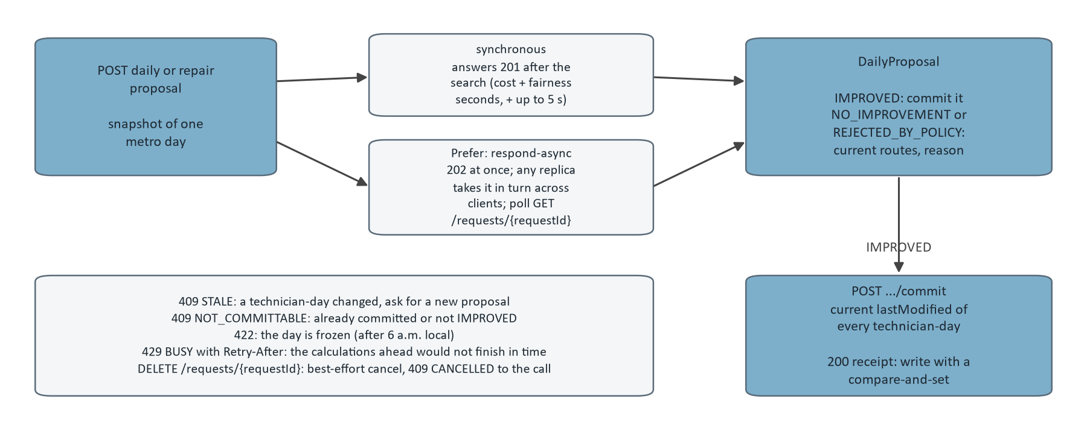
Figure 3. Daily and repair proposals: synchronous or queued, then the commit with the host's current timestamps. The lower left lists the refusals and the cancel.
POST /daily/proposals sends the snapshot of one metro day and gets back a DailyProposal: proposed routes with planned times, unresolved demand, the policy decision and a reason. The scheduler parses strictly, claims the requestId, applies the 6 a.m. cutoff in the metro's zone (a frozen day is a 422), routes the day through its metro's service under its own 30 s allowance, and then runs the calculation for the client's cost and fairness seconds plus a 5 s reserve inside the replica's admission limits. Only an IMPROVED decision can be committed; NO_IMPROVEMENT and REJECTED_BY_POLICY return the current routes. [1, 3]
Decision | Meaning | Reason codes that may begin the reason
IMPROVED | The calculation's plan was accepted; commit it | COST_REDUCTION, FAIRNESS_IMPROVEMENT, OVERTIME_REDUCTION, COMPLETE_ZERO_OVERTIME_DEMAND
REJECTED_BY_POLICY | A valid plan was found and policy rejected it; current routes returned | NO_POLICY_IMPROVEMENT, COST_CEILING_EXCEEDED, FAIRNESS_REGRESSION_WITHIN_ALLOWANCE, OVERTIME_PROHIBITED, OVERTIME_TARGET_MISMATCH
NO_IMPROVEMENT | No valid plan, or nothing to judge; current routes returned | NO_VALID_CANDIDATE, INCOMPLETE_OR_INFEASIBLE_DEMAND, or a sentence only

The commit sends the host's current lastModified for every technician-day the proposal covers, skipped ones included. Equal timestamps mean the facts are unchanged, the cutoff is checked again, and a receipt lists every assignment on the proposal's routes; the host writes them with a compare-and-set. A proposal is committed at most once: its row is locked for the commit and the receipt table is unique per proposal. A repair proposal is the daily path with an absence added to the absent technician's day, in a mode where IMPROVED means every appointment is placed without overtime; anything else means a dispatcher decides.

Queued proposals and cancellation
With the header Prefer: respond-async a proposal is queued and answered 202 at once with a RequestStatus; the host polls GET /requests/{requestId} no sooner than Retry-After and reads QUEUED, RUNNING, then COMPLETED with the status and body the call itself would have answered. Any replica's worker takes queued requests, the waiting request of the client whose last one started longest ago first, so one client's thirty overnight days never hold back another's single day. A client may have 50 requests queued or running; a request still waiting after 15 minutes completes with 429 without running. Overnight optimization is the host's to schedule with this queue; the scheduler has no batch of its own.
DELETE /requests/{requestId} cancels a proposal, booking search or confirm still running under that requestId, best effort, from any replica: a replica that does not run the call records the cancel on its claim, and the replica running it stops the call within about a second. The cancelled call answers 409 CANCELLED, stores nothing and releases its requestId, so retrying the same request later runs it again.

7 Errors, idempotency and retries
Every error is a JSON Problem with an error code and a message, except 401. A host branches on the code, never on the message, which is for people and may change. The table is the integration guide's, which the spec's enum and this report's verifier keep in step. [3]
Status | Code | Meaning | What to do
400 | INVALID_REQUEST | Malformed body, unknown field, duplicate key, missing value, a reference the snapshot does not hold, horizon over 21 dates, a reused requestId | Fix the request; send it with a new requestId. Never retry unchanged.
401 | (no body, WWW-Authenticate: Bearer) | Missing, malformed, unknown or revoked token, or a disabled tenant | Check the token; do not retry.
404 | NOT_FOUND | No such proposal, offer, hold or running request for this tenant | Do nothing (or search again for a booking).
409 | STALE | Commit: a technician-day changed since the proposal was computed. Booking search or confirm: the snapshot is older than records already used. changed lists the technician-days | Commit: new proposal from current facts. Booking: the same call from current records with a new requestId.
409 | NOT_COMMITTABLE | Already committed, or not IMPROVED | Do nothing.
409 | HOLD_UNAVAILABLE | Hold expired, lost, released, superseded, not selected, or the day would need overtime | Search again (new requestId).
409 | CANCELLED | You cancelled the call | Nothing stored; repeat the same requestId if you still want it.
422 | INCOMPLETE_FACTS | Well formed but not schedulable: a date past its 6 a.m. cutoff, an unconfigured metro, an unlocatable job, sequence and plannedStart in different orders, no road route | Fix the facts or the dates; retrying unchanged returns the same answer.
429 | BUSY | Admission limit reached, a concurrent change to the same day, or the same requestId still running. A daily or repair proposal is refused at once when the calculations ahead of it would not finish within its allowance, and Retry-After is their estimated time (up to 300 seconds). A queued proposal: the client's queue is full, or the request waited longer than the queue allows | Retry the same requestId after Retry-After.
503 | ROUTING_UNAVAILABLE | Road routing or address lookup unavailable | Retry the same requestId with backoff.
503 | CALCULATION_UNAVAILABLE | The deadline passed with nothing found, or the remote solver is unavailable | Retry the same requestId with backoff.

Caller timeout for | Set it to
Booking offers and confirm | The client's bookingDeadlineMs plus about 3 seconds
Daily and repair proposals, synchronous | costSearchSeconds + fairnessSearchSeconds plus about 15 seconds
Queued proposals | A second for the 202; give up polling after the queue's 15 minutes plus the search time
Everything else | 10 to 30 seconds
After any client-side timeout | Repeat the same requestId: the stored answer comes back, or a 429 while the call still runs

A request that ended in 429, 503 or 409 CANCELLED released its requestId, so repeating it runs it again; a 400, 404, 409 of another kind or 422 is stored and replayed, so repeating it unchanged returns the same answer. That split is what lets a host retry blindly after a timeout without ever double-booking.

8 Many clients and many replicas
One Postgres database and one set of tables serve every client. Each WaterFlex client is a tenant with its own API tokens (wfs_ plus 32 random bytes, stored only as SHA-256 digests, issued and revoked with the scheduler's own command line); the server maps the token to tenant_id, and a request cannot choose a tenant. Every client-owned table has a tenant_id column that starts every key and index, so two clients can both have technician 42. [1]
Guard | How it works
Token to tenant | The bearer token decides the tenant; a revoked token or a disabled tenant gets 401.
Keys | Every primary key, unique constraint and index starts with tenant_id.
Row-level security | Each transaction runs as the scheduler_tenant database role with app.tenant_id set; policies restrict every client-owned table to that tenant, an unset tenant sees nothing, and that role cannot read any other table. A missed filter in application code fails closed.
Least privilege | The runtime login is a member of scheduler_app, never the schema owner, so a runtime bug can never alter the schema; migrations run as the owner with --command=migrate.
Shared road legs | Route legs are not tenant data and are shared across clients in a metro; the cache holds coordinates at about 1 m, is reachable only by the scheduler, and is purged within 30 days.

Several replicas on one database
Correctness lives in the database. Holds are protected by row locks and unique constraints on (tenant, technician, date) and by the timestamp comparison inside one transaction, so any replica can serve any request and the load balancer needs no sticky sessions. The two scheduled tasks, the weekly route cache cleanup and the daily retention purge, are idempotent on every replica. There is no hold expiry sweeper: expiry is a time, applied when a day is next used. What stays per replica by design is admission (the search slots, with queued bookings started by client: the client with the fewest running, then the one whose last booking started longest ago), the memory tier of the route cache, and the in-memory list of running calls, which the cancel flag in the database reaches from any replica.
A replica's role (SCHEDULER_ROLE booking, daily or all) decides only which background work runs there: a booking replica takes no queued daily work, so a queued day never takes a slot its bookings need, and a daily replica may run several calculations at once. The pools scale apart, each with its own CPU and memory. Measured on the VM rehearsal stack, two pools at the same total capacity nearly doubled the days optimized per minute and cut a booking's tail, at the cost of confirms waiting behind searches; the performance report covers it.

9 The thin store and retention
The public API has its own tables, created by the scheduler's own migration and owned by nothing else; the portal's database holds none of them. Persisted proposal and booking state is validated again on every read, and a stored answer is validated again before it is replayed. [1]
Table | Holds
api_request | One row per host requestId per tenant: the operation, a SHA-256 of the canonical request, a 60 second claim lease, and the stored response once finished. A repeat with the same body replays the response; a different body is a conflict; an abandoned claim is taken over after its lease. Requests that failed for a passing reason (for example routing unavailable) release their claim so a retry runs again.
api_daily_proposal | A served daily proposal: host metro, time zone and date, input revision, routing identity, status (PROPOSED, COMMITTED, STALE) and the proposal body.
api_proposal_technician_day | The host lastModified of every technician-day a proposal covers, stored as exact ISO-8601 text so nanoseconds survive. A commit compares the host's current values with these.
api_commit_receipt | The one commit of a proposal: receipt ID, the commit's requestId, and the receipt body (assignments and timestamps). Unique per proposal.
api_booking_day | Each metro-day's booking state (BookingDayState): the common arrangement with every active hold, and per technician the host timestamp and the appointments WaterFlex Software is expected to have. Versioned; every write locks the row and checks the version the search read.
api_booking_offer_set, api_booking_offer | What each search offered, and what became of each hold (HELD, SELECTED, RELEASED, SUPERSEDED, LOST, CONFIRMED). Expiry is a time, not a status.
api_booking_receipt | The one confirm of a hold: receipt ID, the confirm's requestId, and the receipt body. Unique per offer.

Data | Typical lifetime
Booking holds and reservation arrangements | Minutes, until confirmed, released or expired
Offer sets and offers | Usable for hours, until selected or expired; the rows stay for the retention period
Daily and repair proposals | Committable until committed or stale; the rows stay for the retention period
Requests, commit and booking receipts | The retention period, then purged
Road route cache | Up to 30 days (see "Route cache")

The retention period is the deployment's SCHEDULER_RETENTION_DAYS (1 to 3650), required with no default: the scheduler does not start without it. A daily purge deletes rows older than the period in batches of 5,000 through a database function, children before parents; a row that a newer row still references stays until both have aged, and the function refuses a cutoff less than a day old. A host keeps its own copy of any receipt it needs longer.

10 Routing and geocoding
Coordinates in the snapshot are authoritative: when a location arrives with latitude and longitude the scheduler routes from them as given and never geocodes again. Nominatim is the fallback only for a location that arrives with an address and no coordinates, only in NOMINATIM mode, and only as an exact house: ZIP, house number and street must agree, a mailing city is accepted when the ZIP agrees, and a street-level or ambiguous result is not located. Every drawn stop says where its coordinates came from (HOST or NOMINATIM), and each stored hold notes its job's source, so a bad route can be traced to its input. [1]
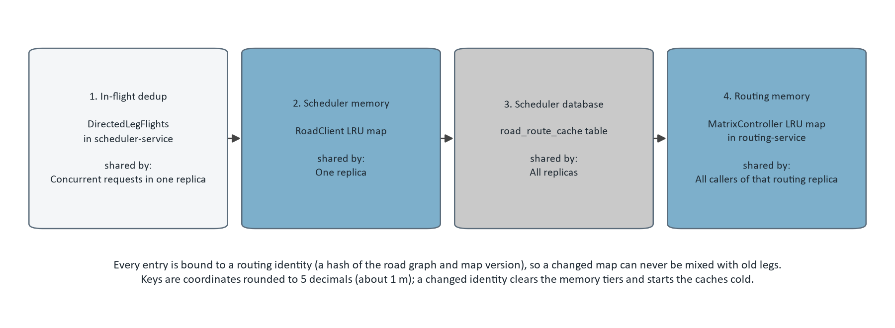
Figure 4. The four route cache tiers in lookup order, from the design document. A pair of coordinates is answered by the first tier that holds it; a leg computed by the routing service is written back to the database and memory tiers in a separate short transaction.
Tier | Where | Key | Lifetime and size | Shared by
1. In-flight dedup | DirectedLegFlights in scheduler-service | routing identity + directed pair | Until the routing call finishes; routing.flights.threads workers (8) and a queue of routing.flights.queue (64) | Concurrent requests in one replica
2. Scheduler memory | RoadClient LRU map | directed coordinate pair + routing identity | routing.cache.ttl-minutes (60) and routing.cache.max-entries (100,000); cleared when the routing identity changes | One replica
3. Scheduler database | road_route_cache table | (originKey, destinationKey, profile, mapVersion) | Read only if fetched in the last 30 days; weekly cleanup (routing.cache.cleanup-cron) deletes older rows and trims beyond 500,000 rows | All replicas
4. Routing memory | MatrixController LRU map in routing-service | directed coordinate pair | 60 minutes, 100,000 entries | All callers of that routing replica

None of the tiers is a source of truth: every entry is recomputable from the road graph, and every entry is bound to a routing identity, a hash of the graph and map version that the routing service reports and checks on every call. A map update, or a switch between the flexible and contraction hierarchy graphs, changes the identity, clears the memory tiers and leaves the database tier unused for the old identity, so a changed road network can never be mixed with old legs. Each map version is prepared as a whole (the merged OpenStreetMap extract, both road graphs, tiles, and TIGER address ranges for Nominatim), validated with preview services, and activated by switching symlinks.

11 Operating the service
The runbook (docs/operations-runbook.md) is the operator's manual: install, start, stop and upgrade order, health, logs, metrics, retention, tokens, maps, backup and restore, scaling and failure modes. Its settings table is reproduced here from the document. [4]
Setting | Required | Meaning
SCHEDULER_RETENTION_DAYS | Yes, no default | Days the thin store keeps requests, proposals, offers and receipts (1 to 3650). The scheduler refuses to start without it.
JDBC_DATABASE_URL, DATABASE_USER, DATABASE_PASSWORD | Yes | The scheduler's database login. It must be a member of scheduler_app, never the schema owner. The operator commands use the same variables with the owner's login.
ROUTING_METRO_URLS | Yes | One metro=url entry per served metro.
ROUTING_AUTH_TOKEN | Yes | Shared bearer token of the routing services, at least 32 characters.
GEOCODING_MODE, NOMINATIM_URL | No | COORDINATES_REQUIRED (default) or NOMINATIM.
SCHEDULER_CALCULATION_MODE, SCHEDULER_CALCULATION_URL, SCHEDULER_CALCULATION_AUTH_TOKEN | No | EMBEDDED (default) or REMOTE with a solver pool.
SCHEDULER_ROLE | No | booking, daily or all (default). Every replica answers every route; a booking replica takes no queued daily work. Any other value stops the replica at startup. See "Replica roles".
SCHEDULER_SEARCH_CAPACITY | No | Concurrent searches per replica. 0 means 2, or 1 on a one-processor machine.
SCHEDULER_SEARCH_BACKGROUND_LIMIT | No | Daily and repair calculations this replica runs at once, 1 (default) to the search capacity. Raise it only on daily replicas.
SCHEDULER_DAILY_QUEUE_WORKERS | No | Workers taking queued daily and repair proposals on this replica, default 1; set it to the background limit. 0 leaves the queue to other replicas, as does SCHEDULER_ROLE=booking.
SCHEDULER_CANCEL_POLL_MS | No | How often a replica reads the cancellations other replicas recorded for the calls it runs, default 500.
ROUTING_IDENTITY_TTL_MS | No | How long a routing identity fetched from a routing service's /health is trusted, default 2000; the service still refuses a call with a changed identity (409), which drops the remembered one.
ROUTING_FLIGHTS_THREADS, ROUTING_FLIGHTS_QUEUE | No | Leg batches a replica fetches from a routing service at once (8) and lets wait (64).
ROUTING_CH_ENABLED, ROUTING_PARALLELISM (routing service) | No | Serve the map version's contraction hierarchy graph (default true; false serves the flexible graph, with another routing identity) and route a request's pairs on this many threads (0, the default, means the processors available).
SCHEDULER_DAILY_QUEUE_POLL_MS, SCHEDULER_DAILY_QUEUE_MAX_WAIT_MINUTES, SCHEDULER_DAILY_QUEUE_TENANT_LIMIT | No | How often an idle worker looks for work queued on another replica (500 ms); how long a queued request may wait before it completes with 429 without running (15 minutes); how many requests one client may have queued or running (50).
MANAGEMENT_PORT | No | Port of /actuator/health and /actuator/prometheus, default 9000. Keep it private.
LOGGING_STRUCTURED_FORMAT_CONSOLE | No | ecs for JSON log lines.

Signal | Where | What it tells an operator
/health | Port 8000, open | ok or degraded with each component (schema, database, routing per metro with its identity, calculation, geocoding) and the replica's role; 503 when degraded
Request log line | Each replica's log | One line per API call: operation, status, elapsed time, and how it was spent (slot wait, routing, calculation, database, routing pairs, cache hits, legs fetched, CPU), with tenant and requestId on every line of the call
Prometheus metrics | Management port 9000, private | Request timers by operation and status, admission rejections, routing legs and cache hits by tier, solve seconds, invalid refinements, retention rows deleted
Routing /health | Each routing service | Readiness, map version, prepared graph (flexible or CH) and the routing identity

Upgrades deploy a new solver pool beside the old one when the calculation protocol or the Timefold artifact changes, then switch the scheduler; a remote result must come from the same artifact and model versions as the caller, deliberately. A map refresh starts every route cache cold, which the first searches on a new map pay for.

12 How it was built
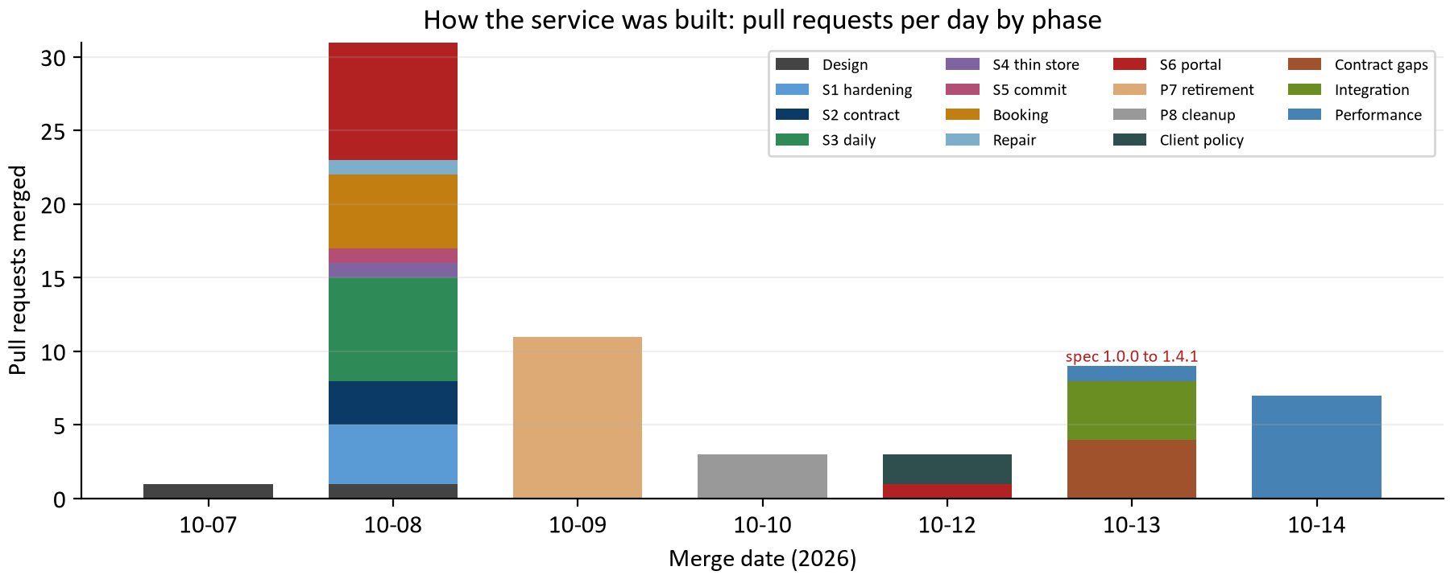
Figure 5. Pull requests merged per day in the stateless API work, by phase, with the contract versions published on each day. The design was proposed on 2026-10-07; the service was serving every operation by 2026-10-09, stable at 1.0.0 on 2026-10-13, and measured under load from then on.
The work ran in phases that the design document names. S1 hardened what the stateless service would inherit (one overnight run per metro-day across replicas, cancellation routed to the solving replica, a capped route cache, a token on the routing service). S2 added tenants, tokens, the draft OpenAPI contract and strict Java types. S3 to S5 built the daily path from a request instead of the database, the thin store, and the commit. Booking and repair followed. S6 turned the portal into the first client, feature by feature behind a setting, until P7 removed the scheduler's own endpoints and database path and P8 dropped their tables. Then the contract gaps were closed, the integration package built (operations hardening, the scheduler's own database, the conformance kit, the guide and contract 1.0.0), and the service measured and improved under load. [1, 5]
Phase | Pull requests | Dates | What it delivered
Design | #70, #76 | 10-07 to 10-08 | The stateless API and thin store proposal, and the deployment, tenancy and route cache decisions
S1 hardening | #80, #81, #82, #83 | 10-08 to 10-08 | Replica-safe overnight runs, routed cancellation, a capped route cache, routing authentication
S2 contract | #85, #86, #88 | 10-08 to 10-08 | Tenants and tokens, the draft OpenAPI 3.1 contract, strict Java types that mirror it
S3 daily | #89, #91, #92, #93, #94, #96, #97 | 10-08 to 10-08 | The daily solver input from a request, per-metro routing, address rules, TIGER, daily proposals served
S4 thin store | #95 | 10-08 to 10-08 | The api_* tables for requests and proposals
S5 commit | #98 | 10-08 to 10-08 | The daily commit with STALE and NOT_COMMITTABLE
Booking | #99, #100, #101, #102, #103 | 10-08 to 10-08 | Facts from a request, offers, select, release, confirm, Nominatim fallback
Repair | #104 | 10-08 to 10-08 | Repair proposals without overtime
S6 portal | #105, #106, #107, #108, #109, #110, #111, #112, #131 | 10-08 to 10-12 | The portal as a switchable multi-client API client: snapshots, booking, dispatch, repair, overnight, local tokens
P7 retirement | #113, #114, #115, #116, #117, #118, #119, #120, #121, #122, #123 | 10-09 to 10-09 | Every portal path moved to the API; the scheduler's own endpoints, database path and benchmarks deleted
P8 cleanup | #125, #126, #127 | 10-10 to 10-10 | Unused tables and code dropped; the design document brought up to date
Client policy | #132, #133 | 10-12 to 10-12 | Window length, daily search method and times chosen per client
Contract gaps | #138, #139, #140, #141 | 10-13 to 10-13 | Refinement fallback and reason codes, per-client policy, host cancellation, coordinate sources
Integration | #142, #143, #149, #150 | 10-13 to 10-13 | Readiness, logs, metrics, retention, least privilege, the scheduler's own database, the conformance kit, the guide and contract 1.0.0
Performance | #151, #152, #153, #154, #155, #156, #157, #158 | 10-13 to 10-14 | The load tool and the measured fixes: holds kept, early refusal, searchComplete, shedding, queued proposals, replica pools

Two proofs carried the migration. Equivalence was proven where it matters: an integration test showed that a request describing a seeded day produced exactly the daily and booking facts the database path produced, before that path was deleted. And the portal moved one feature at a time behind a setting with smoke tests of both paths, so each step could be compared with the one before it, until the setting itself was removed.

13 Proving an integration
A host proves its integration with the conformance kit (infra/host-conformance), a standalone script that runs 27 named cases against any scheduler over the network with a token for a dedicated tenant and writes a pass/fail report. The cases are the guide's sequences and refusals, with synthetic but routable snapshots inside a given area; a CI job runs the kit against the scheduler and a fixture router so the kit cannot drift from the service. [6]
Cases
unknown field | duplicate key | numeric money
missing plannedStart | missing absences | tenantId in the body
no token | whoami | evaluate
geometry | unlocatable day is skipped | offers, select and release
new search ends earlier offers | confirm | late older snapshot is stale
client refinement budget | horizon of 22 dates | job ID equal to an appointment ID
frozen date | propose and commit | stale and incomplete commits
queued proposal | frozen date | absence repair
unknown request | cancel a running proposal | cancel a queued proposal

The same folder holds the load tool that plays WaterFlex Software at scale (booking desks and daily planners against a stack), whose measurements are the subject of the performance report. Before go-live the guide's checklist asks for TLS on every connection, one tenant token per client with a rotation procedure, every served metro in ROUTING_METRO_URLS, a tested lastModified that moves on every change including both sides of a move, receipt writes that are a compare-and-set, a new requestId per request and the same one per retry, callers that branch on error codes with the timeouts of section 7, an overnight schedule per client and metro, receipts kept on the host's side beyond the retention period, and the conformance kit passing against the production scheduler.

14 What remains
Item | State | Who decides
TLS | Not set up between WaterFlex Software and the scheduler, nor from the scheduler to routing and Nominatim (the remote solver already requires https off loopback). Deferred by owner decision on 2026-10-13 and recorded as a precondition of production traffic in the guide, the runbook and the design document. Until then the API binds to a private interface only. | Owner, before production traffic
The VM itself | The deploy/vm compose is the VM's shape and has been rehearsed locally; the latency target is defined at the WaterFlex caller across the network and has not been measured there yet. | Owner and WaterFlex Software
Google Maps terms | Whether WaterFlex Software's agreement allows Google-geocoded coordinates to be passed to a non-Google routing engine and cached for up to 30 days; if not, the host sends addresses only. | WaterFlex Software
Dedicated databases | Whether any client contractually requires one; every row already carries tenant_id, so a client can be moved without an API change. | Owner
Remote mode | Wired in and covered by CI, not performance-tested; a short embedded-versus-remote study is planned. | Owner
Remote solve cancellation | Tracked in memory per solver replica; a load balancer must hash on the Solve-Request-Id header so a cancel reaches the solving replica, as the design document shows for nginx. | Operator

Everything else WaterFlex Software needs is on its own side and documented in the guide: build snapshots with a lastModified that follows the rules, write receipts with a compare-and-set, hold one tenant token per client, route each served metro, and run its own overnight schedule against the daily proposal endpoint. The portal in this repository is the worked example of each of these.

How this report was checked
Every table that describes the contract or the service is read from its source when the report is built: the operations, error codes, schemas and version history from docs/api/openapi-v1.yaml; the endpoint, contract change, thin store, lifetime and route cache tables from docs/stateless-api-design.md; the ownership and error tables from docs/integration-guide.md; the settings from docs/operations-runbook.md; and the case names from the conformance kit. verify_report.py parses the same files again on its own and checks every such table cell for cell, along with the template parts. The pull request list is the one typed input and names its source. [1 to 6]

Appendix A Every contract change
The design document's change table, newest first: what changed, the pull request or spec version it came with, and what WaterFlex Software does about it. [1]
Change | Since | What WaterFlex Software does
Routing performance: each map version carries a contraction hierarchy graph that the routing service serves by default (ROUTING_CH_ENABLED), a request's pairs are routed in parallel (ROUTING_PARALLELISM), and the scheduler remembers a routing identity for 2 s (ROUTING_IDENTITY_TTL_MS) and fetches legs on 8 workers | J | Nothing required; no contract or schema change. The routing identity differs between the CH and flexible graphs, so the first start on CH begins with cold route caches. A map version prepared before this change needs its CH graph prepared before activation.
cancelRequest stops a synchronous call from any replica: a replica that does not run it records the cancel on the request's claim, and the replica running it stops the call within about a second (spec 1.4.1). Replica roles (SCHEDULER_ROLE), several background calculations per daily replica (SCHEDULER_SEARCH_BACKGROUND_LIMIT), and the VM compose's booking and daily pools behind one nginx address | #158 | Nothing required; no schema changes. The DELETE no longer needs routing to the replica that runs the call. Migration V3 adds api_request."cancelRequestedAt" and scheduler_cancel_requested; a rollback leaves them unread.
Daily and repair proposals accept Prefer: respond-async (202 with a RequestStatus, polled at GET /api/v1/requests/{requestId}); queued requests are taken round-robin across tenants by any replica; cancelRequest reaches queued requests from any replica; booking slots are shared fairly between clients (spec 1.4.0) | #157 | Nothing required. A strict reader takes 1.4.0 before the upgrade. A host may queue overnight and background proposals instead of holding calls open. Migration V2 adds api_daily_job and api_tenant_turn; a rollback leaves them unread.
OfferSet.incompleteDates lists the dates a needed pass did not finish; refinement gains SHED; optional Policy.bookingRefinementMs (spec 1.3.0) | #155 | Nothing required. A strict reader takes 1.3.0 before the upgrade. A host may narrow a repeated search to the dates after the last complete one, and may send its own optional refinement budget. Each window's coverage in the calculation protocol now says whether that window's own work finished, so an older remote solver-service only under-reports finished dates.
OfferSet.refinement reports how the booking refinement ended; searchComplete is false only when the deadline or a failure stopped a pass the offers need (spec 1.2.0) | #154 | Nothing required. A strict reader takes 1.2.0 before the upgrade. A host that read searchComplete: false as "search other dates" now sees it only when the offers really may be missing windows; refinement is for monitoring.
Booking offers and confirm answer 409 STALE for a snapshot older than one already used (spec 1.1.0) | #152 | Treats it like a commit's STALE: rebuilds the snapshot from current records and sends it with a new requestId. Nothing changed and no hold was lost; changed lists the newest timestamp the scheduler has seen for each technician-day concerned.
Spec version 1.0.0; every operation served; integration guide | #150 | Builds against docs/integration-guide.md and proves the integration with the host conformance kit (infra/host-conformance). No field changed.
TechnicianDay.absences is required | #88 | An empty list when the technician has no absence that day. A missing list is rejected, never read as "no absences".
Appointment.plannedStart is required | #89 | The appointment's currently planned arrival, as an instant. The solver records it as the appointment's original start, and proposals report moves against it. A missing value is rejected, never guessed.
DailyProposal.reason and DailyProposal.skippedTechnicianDays added | #96 | Reads reason to see why the scheduler decided as it did. Leaves every technician-day in skippedTechnicianDays exactly as it is (it is not in routes), and sends coordinates for the location its message names to include it next time.
Snapshot.policy.fairnessBudget is required | #97 | Sends each client's own fairness budget: "0" for none, or a share such as "0.02" (2 percent) by which the daily plan's cost may rise to spread work more evenly. A missing value is rejected, never assumed.
DailyProposal.reason begins with the policy code | #138 | Nothing required. A host that wants the code takes the text before the first colon (for example NO_POLICY_IMPROVEMENT); the text after it is for people. Decisions without a policy judgement stay a sentence.
Snapshot.policy.dailySearch, costSearchSeconds and fairnessSearchSeconds are required | #133 | Sends each client's daily search method (TABU_KOPT or TABU) and how many seconds the cost search (5 to 240) and the fairness search (0 to 240, 0 skips it) may run, at most 240 together. A proposal request then takes about that long plus up to 5 seconds. Missing values are rejected, never assumed.
Thin store rows purged after the deployment's retention period | #142 | Keeps its own copy of any receipt it needs beyond SCHEDULER_RETENTION_DAYS. A requestId older than the period is no longer remembered: repeating it runs a new request, so retries belong within the period (they normally come within seconds).
LocatedStop.source added to route geometry | #141 | Reads source on each drawn stop: HOST when the snapshot sent the coordinates, NOMINATIM when the scheduler located an address. A strict reader must accept the new required field.
DELETE /api/v1/requests/{requestId} served; new error CANCELLED | #140 | Cancels a call it no longer needs by its requestId (202, or 404 when nothing is running under it on that replica). The cancelled call answers 409 CANCELLED; nothing was stored, and retrying with the same requestId runs it again.
Snapshot.policy.bookingDeadlineMs and regularWindowThreshold are required | #139 | Sends each client's booking search deadline (1000 to 5000 ms; a booking search or confirm answers within it, with searchComplete false when it was cut short) and window threshold (0 to 1000: when the first booking pass finds more distinct regular windows than this, the refinement pass is kept short). The scheduler's shared settings are gone, and missing values are rejected, never assumed. The calculation protocol moves to version 3 with this change, so the scheduler and a remote solver-service are deployed together.
Repeated and reused requestId | #96 | Retries with the same requestId and the same body after a timeout or a 429/503; the stored answer is replayed. Uses a new requestId for different facts: reusing one gets 400.
Daily commit served; 409 split into STALE and NOT_COMMITTABLE; 422 after the cutoff | #98 | Sends the current lastModified of every technician-day the proposal covers, skipped ones included (a missing or extra one is a 400). On 200, writes every assignment in the receipt with a compare-and-set on the receipt's timestamps. On STALE, requests a new proposal. On NOT_COMMITTABLE, does nothing: the proposal was already committed (the message names the receipt) or its decision is not IMPROVED. On 422, the day's routes are frozen.
Booking horizon at most 21 dates; job.id must differ from every appointment and technician ID | #99 | Sends a horizon of 1 to 21 dates. Uses a job ID that is not already an appointment or technician ID in the snapshot; a clash is a 400.
Repair proposals served | #104 | Sends the absence and the snapshot of its date. Commits an IMPROVED repair with the daily commit endpoint, then records the absence itself. Any other decision means the absence cannot be covered without overtime or leaving an appointment unplaced, so a dispatcher resolves it.
Address-only locations can be located (deployment option geocoding.mode=NOMINATIM) | #103 | Nothing required. Sending coordinates is still best. With the option on, an address-only location is located only as an exact house; a lookup outage is a 503 ROUTING_UNAVAILABLE to retry.
Confirm sends {requestId, snapshot}; a confirmed job's appointment ID is its job ID | #102 | Selects an offer, then confirms its hold with the current snapshot of the hold's metro and date (no other dates). Writes every appointment in the receipt with a compare-and-set on the listed technician-day timestamps, creating the job's appointment under the job's ID. A 409 HOLD_UNAVAILABLE (expired, lost, not selected, or the day would need overtime or repair) or a failed write means search again. Confirming again returns the same receipt.
BookingOffersRequest.offerLimit is required | #101 | Sends each client's own cap on offers per search, 1 to 4. A missing or out-of-range value is a 400, never assumed.
BookingOffersRequest.windowHours is required |  | Sends each client's own arrival window length in whole hours, 1 to 8. Windows start on the hour. A missing or out-of-range value is a 400, never assumed.
Select and release served; new error HOLD_UNAVAILABLE | #101 | Treats a 409 HOLD_UNAVAILABLE from select as "search again": the hold expired or ended, or another offer in the set was selected. Releases a set it no longer needs; a release is a 200 even when nothing was still held.
Booking offers served; OfferSet.skippedTechnicianDays added | #100 | Reads skippedTechnicianDays: nothing is offered on those technician-days until their locations have coordinates. Starts the horizon after any date already past 6 a.m. local (a frozen date is a 422). Treats a new search for a job as replacing that job's earlier offers, which are no longer held. Retries a 429 or 503 with the same requestId.

Appendix B Every pull request
The merged pull requests of the stateless API work, in order, as listed in the repository on 2026-10-14. Pull requests about other work in the same period (the Timefold audit, benchmark studies, the dispatch board, CI) are not listed. [5]
PR | Merged | Phase | Title
#70 | 2026-10-07 | Design | Propose the stateless scheduling API and thin store design
#76 | 2026-10-08 | Design | Record integration, deployment, tenancy and route cache decisions
#80 | 2026-10-08 | S1 hardening | Run each overnight metro-day once per night across scheduler replicas
#81 | 2026-10-08 | S1 hardening | Route remote solve cancellation to the replica running the solve
#82 | 2026-10-08 | S1 hardening | Trim the persistent route cache until it is within its cap
#83 | 2026-10-08 | S1 hardening | Require a shared bearer token on routing-service computation endpoints
#85 | 2026-10-08 | S2 contract | Add tenants and per-tenant API tokens for the public /api/v1 surface
#86 | 2026-10-08 | S2 contract | Add the draft OpenAPI 3.1 contract for the public /api/v1 surface
#88 | 2026-10-08 | S2 contract | Add strict Java types for the public /api/v1 contract
#89 | 2026-10-08 | S3 daily | Build the daily solver input from a public request
#91 | 2026-10-08 | S3 daily | Route public daily requests through their own metro's routing service
#92 | 2026-10-08 | S3 daily | Record the address quality rules for the public API
#93 | 2026-10-08 | S3 daily | Standardize address formatting edge cases before matching
#94 | 2026-10-08 | S3 daily | Import US Census TIGER address ranges into Nominatim
#95 | 2026-10-08 | S4 thin store | Thin store for public API requests and daily proposals
#96 | 2026-10-08 | S3 daily | Serve POST /api/v1/daily/proposals
#97 | 2026-10-08 | S3 daily | Let each client set its own fairness budget
#98 | 2026-10-08 | S5 commit | Serve the daily commit endpoint
#99 | 2026-10-08 | Booking | Build booking search facts from a host request
#100 | 2026-10-08 | Booking | Serve POST /api/v1/booking/offers
#101 | 2026-10-08 | Booking | Serve booking select and release; client sends its offer limit
#102 | 2026-10-08 | Booking | Serve booking confirm with the day's snapshot
#103 | 2026-10-08 | Booking | Locate address-only public API locations with Nominatim
#104 | 2026-10-08 | Repair | Serve POST /api/v1/repairs/proposals
#105 | 2026-10-08 | S6 portal | Scope the portal to switchable clients
#106 | 2026-10-08 | S6 portal | Add per-client solver settings
#107 | 2026-10-08 | S6 portal | Build each client's public API snapshot
#108 | 2026-10-08 | S6 portal | Book through the public scheduling API
#109 | 2026-10-08 | S6 portal | Optimize dispatch days through the public scheduling API
#110 | 2026-10-08 | S6 portal | Repair time off through the public scheduling API
#111 | 2026-10-08 | S6 portal | Let two clients serve the same metro
#112 | 2026-10-08 | S6 portal | Run each client's overnight optimization from the portal
#113 | 2026-10-09 | P7 retirement | Change depots and depot assignments through the public API
#114 | 2026-10-09 | P7 retirement | Cancel appointments and draw dispatch roads through the public API
#115 | 2026-10-09 | P7 retirement | Generate and clear fake data through the public API
#116 | 2026-10-09 | P7 retirement | Run the booking test runner through the public API
#117 | 2026-10-09 | P7 retirement | Book only through the public API
#118 | 2026-10-09 | P7 retirement | Run dispatch, fake data and the test runner only through the public API
#119 | 2026-10-09 | P7 retirement | Schedule everything through the public API and remove SCHEDULER_PUBLIC_API
#120 | 2026-10-09 | P7 retirement | Retire the campaign workflow benchmark layer
#121 | 2026-10-09 | P7 retirement | Retire the booking benchmarks and /internal/benchmark
#122 | 2026-10-09 | P7 retirement | Delete the scheduler's internal booking endpoints
#123 | 2026-10-09 | P7 retirement | Delete the remaining portal-only scheduler endpoints
#125 | 2026-10-10 | P8 cleanup | Drop the tables only the retired scheduler paths used
#126 | 2026-10-10 | P8 cleanup | Remove code left unused by the move to the public API
#127 | 2026-10-10 | P8 cleanup | Update the stateless API design doc for the finished move
#131 | 2026-10-12 | S6 portal | Show the scheduling API connection and provision local tokens
#132 | 2026-10-12 | Client policy | Let each client choose its arrival window length (1 to 8 hours)
#133 | 2026-10-12 | Client policy | Let each client choose its daily search method and search times
#138 | 2026-10-13 | Contract gaps | Keep insertion offers when a refinement fails validation and report policy codes
#139 | 2026-10-13 | Contract gaps | Make every policy rule the client's own and drop omaha_setting
#140 | 2026-10-13 | Contract gaps | Serve host cancellation of running calculations
#141 | 2026-10-13 | Contract gaps | Record where hold and geometry coordinates came from
#142 | 2026-10-13 | Integration | Harden scheduler operations: readiness, logs, metrics, retention, least-privilege login
#143 | 2026-10-13 | Integration | The scheduler owns its database; the portal becomes a pure API client
#149 | 2026-10-13 | Integration | Host conformance kit: prove a scheduler over its public API
#150 | 2026-10-13 | Integration | Integration guide and public contract 1.0.0
#151 | 2026-10-13 | Performance | API load tool, load measurement, and a booking 500 fix
#152 | 2026-10-14 | Performance | Keep holds when late snapshots arrive and let concurrent bookings publish
#153 | 2026-10-14 | Performance | Refuse daily proposals early with Retry-After and route them before the slot
#154 | 2026-10-14 | Performance | Report searchComplete false only when a needed pass was cut short
#155 | 2026-10-14 | Performance | Report which dates a booking search finished, and shed its optional refinement
#156 | 2026-10-14 | Performance | Let a remote solve wait for its slot, and answer 503 when the remote solver cannot calculate
#157 | 2026-10-14 | Performance | Queue daily and repair proposals (Prefer: respond-async) with per-client fair queuing
#158 | 2026-10-14 | Performance | Run booking and daily replica pools behind one load balancer, and cancel from any replica

Appendix C Schemas and endpoints
The 45 object schemas of the contract, and the design document's endpoint table. [1, 2]
Schemas
Address | Appointment | Assignment | BookingOffersRequest
CommitConflict | CommitReceipt | CommitRequest | ConfirmRequest
DailyProposal | DailyProposalRequest | Decimal | GeometryLeg
GeometryRoute | Hold | Id | Instant
LocatedStop | Location | Offer | OfferSet
PlannedRoute | PlannedStop | Policy | Problem
ProblemOrStale | Rates | Released | RepairProposalRequest
RequestId | RequestOnly | RequestResult | RequestStatus
RouteEvaluation | RouteEvaluationRequest | RouteGeometry | ServiceDate
SkippedTechnicianDay | Snapshot | StaleProblem | Technician
TechnicianDay | TechnicianDayVersion | TenantId | WhoAmI
Window

Endpoint | Purpose
POST /api/v1/daily/proposals | Snapshot of one metro day. Returns a proposal ID, proposed routes, unresolved demand, policy decision and diagnostics. Stores the proposal and revision in the thin store.
POST /api/v1/daily/proposals/{id}/commit | Host sends its current timestamp for every technician-day the proposal covers. Equal timestamps mean the facts the proposal was computed and validated from are unchanged, so the scheduler checks the 6 a.m. cutoff again and returns a commit receipt with every assignment on the proposal's routes. 409 if anything changed; nothing is changed then.
POST /api/v1/booking/offers | Snapshot of the booking horizon plus the job to book. Returns at most the request's offerLimit offers (1 to 4, the client's own cap), each an arrival window windowHours long (1 to 8, the client's own length), and holds each for 10 minutes in the thin store.
POST /api/v1/booking/offers/{id}/select and /release | Keep the chosen hold and release its siblings, or release the whole set.
POST /api/v1/booking/holds/{id}/confirm | Host sends its current snapshot of the hold's date; scheduler reconciles it with its holds, turns the selected hold into the job's appointment, and returns the appointments to write.
POST /api/v1/repairs/proposals | Absence repair for a technician-day, same pattern as daily. Repair never adds overtime. Served (DailyProposals.repair).
POST /api/v1/routes/evaluate | Times one metro day's routes in their given order and reports whether the day holds; nothing is optimized or stored.
POST /api/v1/routes/geometry | Draws one metro day's routes on roads in their given order; nothing is stored.
GET /api/v1/whoami | The tenant the token belongs to.
DELETE /api/v1/requests/{requestId} | Best-effort cancellation of a daily or repair proposal, booking search or confirm still running on this replica (RunningRequests): 202 without a body, or 404. The cancelled call answers 409 CANCELLED, stores nothing and releases its requestId.

Appendix D Definitions and evidence
Term | Meaning in this report
Snapshot | The facts one call needs: rates, policy, technicians, technician-days with lastModified, committed appointments.
Input revision | A canonical hash of a snapshot; every proposal and offer records the one it was computed from.
Technician-day | One technician on one service date; the unit the lastModified token and every receipt are keyed by.
Hold | A slot kept for 10 minutes for one offer; a set holds one per offer until one is selected.
Common arrangement | The scheduler's stored routes for a metro-day with every active hold and pending move.
Receipt | The assignments a commit or confirm asks the host to write, with the timestamps to compare.
Claim | The row that holds a requestId while its call runs; released by 429, 503 and CANCELLED, kept with the stored answer otherwise.
Routing identity | A hash of the road graph and map version, reported by the routing service and checked on every call.
Tenant | One WaterFlex client as the scheduler sees it: chosen by the token, isolated by tenant_id and row-level security.

[1] docs/stateless-api-design.md: the design, its decisions (marked Decided), the contract change table, the thin store, the route cache, the portal phases, remaining gaps and open questions.
[2] docs/api/openapi-v1.yaml, version 1.4.1: the machine-readable contract with its version history; web/scripts/openapi-v1.test.ts validates its examples and the served routes; PublicApiContractTest keeps the Java types in step.
[3] docs/integration-guide.md: the host's guide, with every sequence, payload, error and the go-live checklist.
[4] docs/operations-runbook.md: the operator's manual, with the settings table reproduced in section 11.
[5] The repository's merged pull requests, listed on 2026-10-14, as recorded in report_data.py.
[6] infra/host-conformance: the conformance kit (src/cases.ts names the cases) and the load tool.
Reproduce with docs/stateless-api-service-2026-10-14/requirements.txt, then run report_data.py, build_report.py and verify_report.py there. The builder reads the documents, regenerates the five figures and chart_data.json, and writes this editable Word file. EVIDENCE.md records methods.

