Booking configuration study
Waterflex scheduler, VM rehearsal stack. Studies run 2026-10-17 to 2026-10-19; report written 2026-10-19.
Evidence: docs/evidence/api-load-2026-10-19-booking-configuration.json.gz (1184 cells) and docs/evidence/api-load-2026-10-19-booking-configuration-full.json.gz (35 cells, the full-schedule rerun). Every figure below is computed from those files by infra/summarize_booking_configuration.py.

Summary
- On a booked-out (full) schedule, today's default (threshold 2, 250 ms refinement) books jobs $0.85 to $3.70 dearer per booking in modeled fleet cost than an uncapped search, about the same as no refinement at all ($0.92 to $2.78). At 250 ms the refinement barely starts on a 15-weekday horizon.
- A 3000 ms cap closes the gap: -$0.05 to +$0.79 mean, median $0.00 at every fleet size, and it stops on its own cap, not the deadline. 2000 ms gets most of the way at 5 and 15 technicians but not at 10, 20 or 30.
- The price is latency and slot time: a 3000 ms search takes about 2.7 to 3.6 s at one desk against 0.3 to 0.8 s at 250 ms, so one slot serves about 18 searches a minute instead of 140 (10 technicians). Under several clients the optional refinement is shed on 80 to 100 percent of searches on every layout up to 4 threads, so under load a bigger cap costs little throughput and also buys little quality.
- The window threshold is inert on every schedule studied: the first pass always found at least 16 regular windows on 2-date horizons and 168 on full ones, so thresholds 0 to 10 never made the refinement required. Only the cap matters.
- The publish reserve floor is now 800 ms (commit 530d356). Below about 800 ms a search that uses its whole deadline is refused BUSY at publish by the database admission guard (250 ms connect + 250 ms validation); the first study's 500 and 250 ms arms lost every long search that way. At 800 ms the rerun had no BUSY, no 503 and no unanswered run at any fleet size, and commit p95 stayed at or under 259 ms.
- For the booking pool at 3 and 4 vCPU, one replica with more slots wins: 1x4 gives the highest throughput and the lowest p95 at 10 clients and 1x3 beats 3x1. At 2 vCPU two single-slot replicas beat 1x2.

Recommendation (for the owner to decide)
- Raise the scheduler's default optional refinement cap from 250 ms to 3000 ms, or 2000 ms if a p50 near 3 s per booking search is too slow for the desk. The refinement is optional and shed under load, so a high cap degrades to the insertion-only answer when the pool is busy instead of refusing bookings. This is a policy change and needs the owner's call.
- Keep the window threshold at 2. It never fired in this study, and changing it changes nothing measurable.
- Keep the publish reserve at its 1000 ms default with the new 800 ms floor. 800 ms is safe, but the extra 200 ms only lengthens searches that the deadline stops (5 to 17 percent fewer a minute) with no quality gain beyond noise, so there is no reason to lower the default.
- Lay the booking pool out as one replica with 3 or 4 slots on as many threads; add replicas for isolation and rolling restarts, not speed.

What changed since the first study
The first study (1184 cells) finished with no contract defects but had two problems that made the full-schedule results unusable, and both were fixed before the rerun:
- Quality horizon. quality.ts read the dynamic horizon after its overnight optimization. Optimized days fall below the 85 percent full mark, so every quality case searched 2 dates and 16 windows instead of the 15-weekday horizon the schedule called for. Fixed in 530d356: the horizon is read from the booked schedule before optimizing. On full schedules the rerun searched 21 calendar days and 168 windows on every case. Empty and light schedules have a 2-date horizon either way, so their first-study quality results stand. Half schedules (9 dates) were not rerun; their quality figures are for 2-date searches and are marked so below.
- Reserve floor. The 500 and 250 ms reserve arms answered every uncapped long search 429 BUSY: the kit resent it for about 3 minutes (20 runs unanswered). The cause is SearchDatabaseTelemetry refusing database admission when less than the Hikari connection timeout plus validation timeout (500 ms) is left, not the commit phase. The floor is now 800 ms, enforced at startup and by a test that reads both timeouts from application.properties and requires 270 ms of headroom over them (the slowest commit p95 measured).

Setup
Item | Value
Stack | deploy/vm rehearsal: nginx proxy, booking and daily pools, VM compute caps, shipped routing defaults (CH on, Omaha graph)
Booking pool (default shape) | 1 replica x 3 slots on 3 vCPU, 4g, DB pool 9
Daily pool | 1 slot on 1 vCPU (overnight optimization for quality cases)
Routing | 2 vCPU cap
Deadline | 5000 ms booking search deadline (owner decision, unchanged)
Horizon | dynamic: 2 lead weekdays past the last day over 85 percent full, at most 15 weekdays
Schedules | empty (2 dates), light (1 visit a day, 2 dates), half (7 weekdays booked, 9 dates), full (15 weekdays booked, the 15-weekday cap)
Fleets | 5, 10, 15, 20, 30 technicians
Variants | threshold:cap; 1000 is the uncapped reference (refinement always required and never capped); x:0 is insertion only
Hardware | Docker cpus count hardware threads (Ryzen 9 7900X, 12 cores / 24 threads); a VM vCPU is also a thread, so figures are per vCPU

1. Offer quality on full schedules (rerun)
Each case is one job address searched once per variant on the same optimized schedule; the best offer is confirmed onto a copy of the day and priced with routes/evaluate. The change is that cost minus the uncapped search's cost on the same case: positive means the variant booked a dearer slot. 40 cases per cell (2 schedules x 20).
Techs | Variant | Mean $ | Median $ | Cheaper / dearer | Same offers | Search p50 ms | Stopped by
5 | 2:0 | +$0.92 | +$0.75 | 2 / 27 | 15 | 66 | none
5 | 2:250 | +$0.97 | +$0.72 | 2 / 26 | 14 | 338 | CAP 40
5 | 2:1000 | +$0.70 | +$0.10 | 2 / 20 | 15 | 1,098 | CAP 40
5 | 2:2000 | +$0.00 | +$0.00 | 2 / 1 | 35 | 2,102 | CAP 40
5 | 2:3000 | +$0.06 | +$0.00 | 3 / 2 | 33 | 2,714 | CAP 1
5 | 1000 (ref) |  |  |  |  | 2,702 | DEADLINE 1; searchComplete false 1
10 | 2:0 | +$2.78 | +$2.96 | 6 / 34 | 1 | 120 | none
10 | 2:250 | +$3.70 | +$3.90 | 2 / 38 | 0 | 411 | CAP 40
10 | 2:1000 | +$2.92 | +$3.10 | 2 / 36 | 4 | 1,174 | CAP 40
10 | 2:2000 | +$1.21 | +$0.22 | 1 / 22 | 14 | 2,181 | CAP 40
10 | 2:3000 | -$0.05 | +$0.00 | 5 / 3 | 29 | 3,186 | CAP 40
10 | 1000 (ref) |  |  |  |  | 3,894 | DEADLINE 8; searchComplete false 8
15 | 2:0 | +$1.02 | +$0.47 | 4 / 26 | 18 | 190 | none
15 | 2:250 | +$0.85 | +$0.66 | 2 / 29 | 19 | 488 | CAP 40
15 | 2:1000 | +$0.66 | +$0.48 | 2 / 25 | 21 | 1,254 | CAP 40
15 | 2:2000 | +$0.25 | +$0.00 | 3 / 13 | 26 | 2,261 | CAP 40
15 | 2:3000 | +$0.09 | +$0.00 | 2 / 4 | 33 | 3,270 | CAP 39, DEADLINE 1
15 | 1000 (ref) |  |  |  |  | 4,159 | DEADLINE 31; searchComplete false 31
20 | 2:0 | +$1.97 | +$1.75 | 9 / 30 | 3 | 270 | none
20 | 2:250 | +$2.53 | +$2.27 | 5 / 33 | 4 | 580 | CAP 40
20 | 2:1000 | +$2.16 | +$2.04 | 4 / 33 | 7 | 1,350 | CAP 40
20 | 2:2000 | +$0.88 | +$0.48 | 7 / 23 | 9 | 2,356 | CAP 40
20 | 2:3000 | +$0.79 | +$0.00 | 7 / 19 | 11 | 3,366 | CAP 38, DEADLINE 2
20 | 1000 (ref) |  |  |  |  | 4,209 | DEADLINE 39; searchComplete false 40
30 | 2:0 | +$1.56 | +$0.87 | 6 / 29 | 6 | 472 | none
30 | 2:250 | +$1.56 | +$1.08 | 6 / 29 | 5 | 832 | CAP 40
30 | 2:1000 | +$1.61 | +$0.87 | 5 / 29 | 5 | 1,563 | CAP 40
30 | 2:2000 | +$1.33 | +$0.32 | 4 / 25 | 10 | 2,572 | CAP 38, DEADLINE 2
30 | 2:3000 | +$0.36 | +$0.00 | 5 / 13 | 18 | 3,586 | CAP 38, DEADLINE 2
30 | 1000 (ref) |  |  |  |  | 4,282 | DEADLINE 40; searchComplete false 40

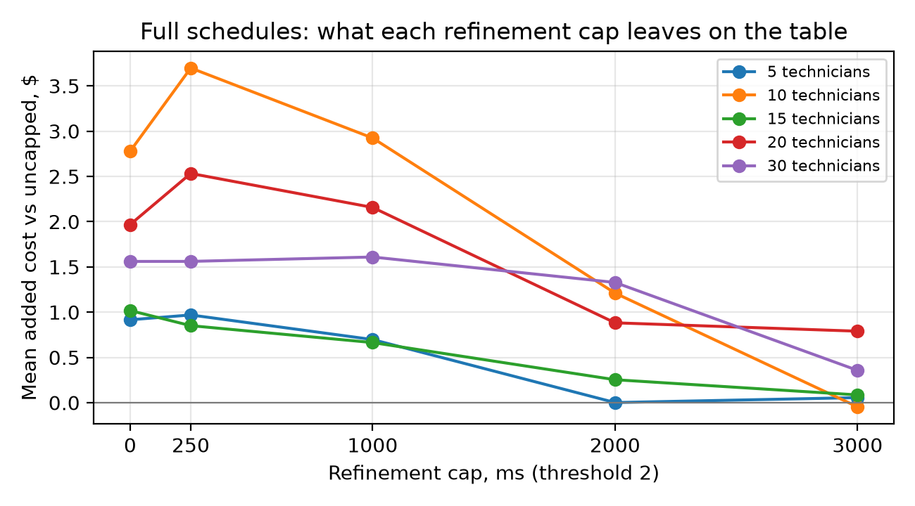
Figure 1. Mean added cost per booking against the uncapped search, by refinement cap, full schedules.
Reading it:
- Cap 250 is no better than cap 0 on full schedules. The first pass covers 168 windows; a quarter second of refinement over 15 weekdays moves almost nothing.
- The gap shrinks steadily with the cap and is near zero at 3000 ms. 10 and 20 technicians are the hardest cases (the 250 ms gap is $3.70 and $2.53).
- The uncapped reference itself runs out of time from 15 technicians: its refinement stopped on the deadline in 31, 39 and 40 of 40 cases at 15, 20 and 30 technicians, with searchComplete false. So 1000 is the best the 5 s deadline allows, not a true optimum, and 3000 ms is close to it because both are spending most of the deadline.
- Thresholds 0, 5 and 10 give the same picture as 2 (full table in docs/api-load.md): with 168 windows found, no threshold up to 20 makes the refinement required.
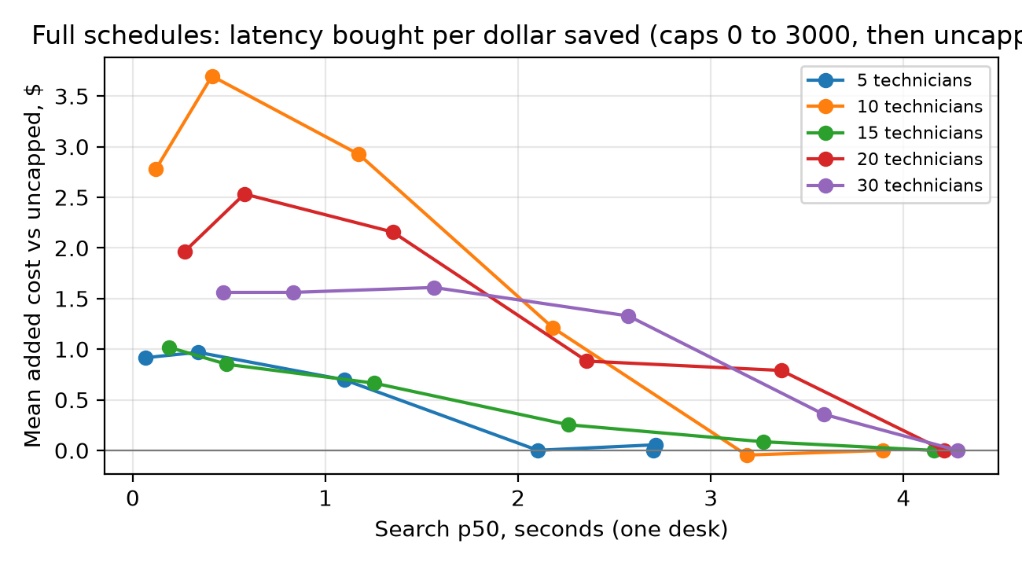
Figure 2. Latency against cost: each line runs from cap 0 (left) to cap 3000, then the uncapped search (cost 0).

2. Offer quality on shorter horizons (first study)
Empty and light schedules have a 2-date horizon, so the first study's results are valid for them. Half-schedule figures are from 2-date searches because of the horizon bug (a real half schedule searches 9 dates) and are shown only as an indication. Mean change in dollars against the uncapped search, 40 cases per cell.
Schedule | Techs | 2:0 | 2:250 | 2:1000 | 2:3000
light | 5 | +$0.18 | +$0.10 | -$0.27 | -$0.13
light | 10 | +$0.64 | +$0.01 | -$0.10 | -$0.10
light | 15 | +$0.59 | +$0.07 | -$0.33 | -$0.33
light | 20 | +$0.49 | +$0.08 | -$0.10 | -$0.10
light | 30 | +$0.57 | +$0.13 | -$0.02 | -$0.02
half (2 dates, bug) | 5 | +$2.31 | -$0.07 | -$0.07 | -$0.07
half (2 dates, bug) | 10 | +$2.19 | -$0.00 | +$0.00 | +$0.00
half (2 dates, bug) | 15 | +$1.60 | -$0.01 | +$0.00 | +$0.01
half (2 dates, bug) | 20 | +$1.43 | +$0.14 | -$0.14 | -$0.14
half (2 dates, bug) | 30 | +$2.59 | +$0.45 | +$0.00 | +$0.00

- Empty schedules: every variant gave the same offers as the uncapped search ($0.00 everywhere); on a free day insertion is already optimal.
- Light schedules: no refinement (2:0) costs $0.18 to $0.64 a booking; 250 ms recovers nearly all of it.
- On 2-date searches 250 ms is enough. The full-schedule results show that this stops being true once the horizon is long.

3. One desk: latency and throughput (first study load part)
One desk per tenant, cold roads, the schedule filling as confirms land, 2 repeats pooled. The load part used the dynamic horizon correctly, so full-schedule figures are valid.
Techs | Variant | Searches / min | p50 ms | p95 ms | Engine p50 ms | Routing p50 ms | searchComplete false
5 | 2:0 | 292.8 | 102 | 395 | 18 | 38 | 0
5 | 2:250 | 151.7 | 374 | 396 | 251 | 42 | 0
5 | 2:1000 | 51.6 | 1,142 | 1,154 | 1,004 | 48 | 0
5 | 2:3000 | 19.2 | 3,105 | 3,120 | 3,008 | 12 | 0
5 | 1000 | 15.6 | 3,990 | 4,088 | 3,598 | 261 | 33
10 | 2:0 | 162.4 | 192 | 706 | 61 | 60 | 0
10 | 2:250 | 139.7 | 398 | 495 | 258 | 48 | 0
10 | 2:1000 | 47.7 | 1,231 | 1,252 | 1,036 | 62 | 0
10 | 2:3000 | 18.4 | 3,240 | 3,326 | 3,033 | 70 | 0
10 | 1000 | 14.6 | 4,116 | 4,132 | 3,386 | 588 | 60
15 | 2:0 | 110.8 | 292 | 1,174 | 122 | 74 | 0
15 | 2:250 | 97.2 | 582 | 615 | 298 | 140 | 0
15 | 2:1000 | 43.5 | 1,350 | 1,372 | 1,050 | 128 | 0
15 | 2:3000 | 17.7 | 3,354 | 3,401 | 3,048 | 129 | 0
15 | 1000 | 14.7 | 4,151 | 4,170 | 2,554 | 1,394 | 60
20 | 2:0 | 73.6 | 453 | 1,712 | 220 | 104 | 0
20 | 2:250 | 70.1 | 806 | 942 | 364 | 264 | 0
20 | 2:1000 | 38.2 | 1,526 | 1,616 | 1,056 | 252 | 0
20 | 2:3000 | 16.8 | 3,526 | 3,613 | 3,051 | 246 | 0
20 | 1000 | 14.8 | 4,189 | 4,217 | 580 | 3,039 | 61
30 | 2:0 | 47.2 | 788 | 2,502 | 455 | 147 | 0
30 | 2:250 | 40.6 | 1,332 | 1,942 | 677 | 412 | 0
30 | 2:1000 | 30.8 | 1,890 | 1,977 | 1,178 | 420 | 0
30 | 2:3000 | 15.2 | 3,884 | 3,960 | 3,220 | 351 | 0
30 | 1000 | 15.4 | 3,701 | 3,749 | 458 | 3,057 | 62

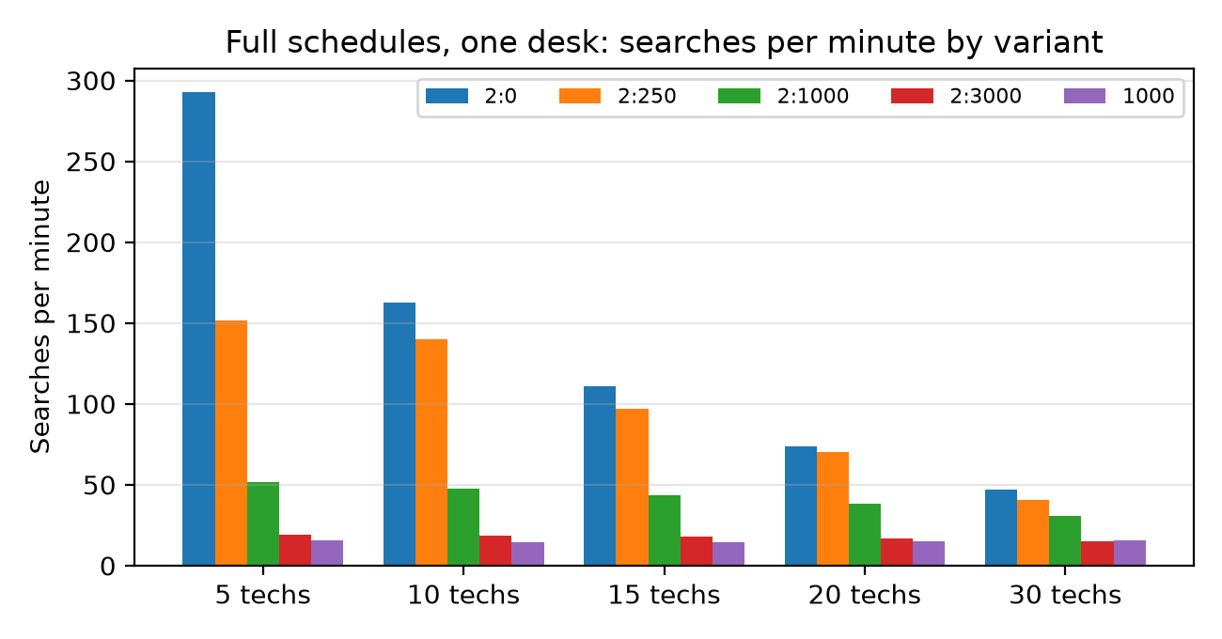
Figure 3. Searches per minute at one desk on full schedules.
A desk books far fewer than 15 jobs a minute, so even 2:3000 keeps up with one desk. Throughput matters when several clients share the pool, which is part 4.

4. Several clients: booking pool layouts (first study capacity part)
5 or 10 dealerships at once, each its own tenant with one desk, against seven booking pool layouts inside 4 vCPU (replicas x slots, one vCPU a slot). 10 technicians, full schedule, variant 2:1000:
Layout | vCPU | Clients | Searches / min, all | p50 ms | p95 ms | Shed | 503s
1x2 | 2 | 5 | 233.5 | 905 | 2,734 | 100% | 0
1x2 | 2 | 10 | 330.2 | 1,438 | 3,064 | 100% | 0
2x1 | 2 | 5 | 338.6 | 722 | 1,848 | 87% | 0
2x1 | 2 | 10 | 490.1 | 1,155 | 2,570 | 97% | 0
1x3 | 3 | 5 | 522.8 | 348 | 1,634 | 98% | 0
1x3 | 3 | 10 | 674.3 | 692 | 2,069 | 100% | 0
3x1 | 3 | 5 | 256.7 | 1,205 | 2,190 | 58% | 0
3x1 | 3 | 10 | 543.6 | 1,011 | 2,214 | 92% | 0
1x4 | 4 | 5 | 330.9 | 588 | 1,638 | 61% | 0
1x4 | 4 | 10 | 779.5 | 661 | 1,010 | 100% | 0
2x2 | 4 | 5 | 251.1 | 1,341 | 2,025 | 43% | 0
2x2 | 4 | 10 | 604.2 | 852 | 1,947 | 94% | 0
4x1 | 4 | 5 | 236.4 | 1,331 | 2,170 | 44% | 0
4x1 | 4 | 10 | 403.5 | 1,323 | 2,842 | 80% | 0

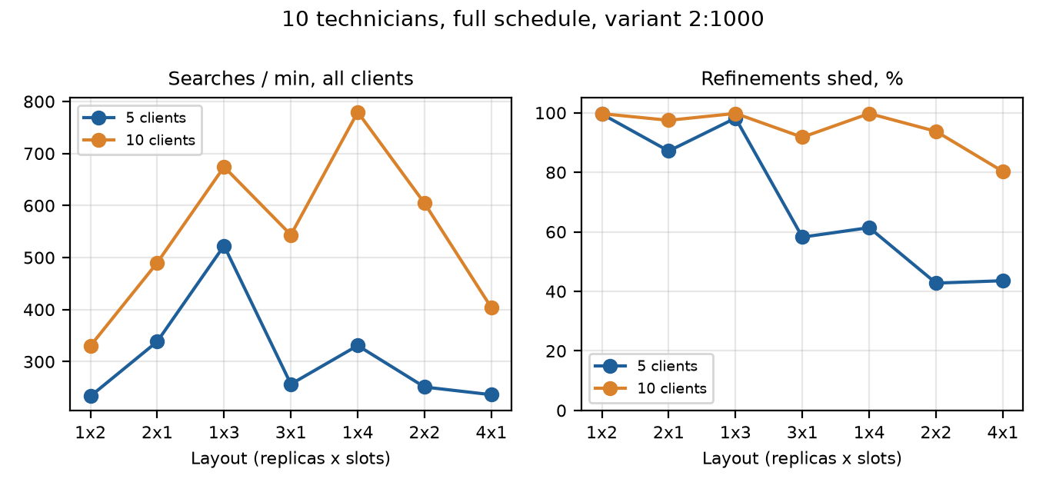
Figure 4. Aggregate throughput and refinement shed share by layout.
- With 5 to 10 clients the optional refinement is shed on most searches on every layout, 80 to 100 percent at 10 clients. Under load every variant behaves like insertion only, which on full schedules costs $0.92 to $2.78 a booking (2:0 row of part 1).
- At 3 and 4 vCPU one replica wins: 1x4 gives the best throughput and p95 at 10 clients and 1x3 beats 3x1; at 2 vCPU 2x1 beats 1x2. One admission queue sees all its slots; several replicas behind round-robin DNS let a call wait at a busy replica while another is idle, and their per-replica road and identity caches are colder.
- Multi-replica layouts shed less because each replica's queue is shorter, which means more refinement work and higher latency. They are the choice for isolation and rolling restarts, not for speed.
- Sizing: keeping quality under concurrency needs slots, not a bigger cap. Each extra client running a 3000 ms refinement needs about one more vCPU to avoid shedding it.

5. The publish reserve
The reserve is the part of the 5 s deadline kept back from exploration so the search can validate candidates, prepare the offer set and publish its holds. The rerun ran the reserve arm at the new 800 ms floor on full schedules (2 load repeats per variant and 20 quality cases).
Techs | Variant | Commit p50 / p95 ms | Searches / min at 800 | at 1000 | BUSY resends | 503s | searchComplete false
5 | 1000 | 64 / 72 | 14.3 | 15.6 | 0 | 0 | 35
5 | 2:3000 | 62 / 74 | 18.9 | 19.2 | 0 | 0 | 0
10 | 1000 | 101 / 110 | 13.8 | 14.6 | 0 | 0 | 56
10 | 2:3000 | 102 / 117 | 18.1 | 18.4 | 0 | 0 | 0
15 | 1000 | 134 / 152 | 13.7 | 14.7 | 0 | 0 | 56
15 | 2:3000 | 136 / 150 | 17.4 | 17.7 | 0 | 0 | 0
20 | 1000 | 165 / 189 | 13.6 | 14.8 | 0 | 0 | 56
20 | 2:3000 | 163 / 185 | 13.9 | 16.8 | 0 | 0 | 0
30 | 1000 | 241 / 259 | 13.3 | 15.4 | 0 | 0 | 54
30 | 2:3000 | 229 / 250 | 14.8 | 15.2 | 0 | 0 | 0

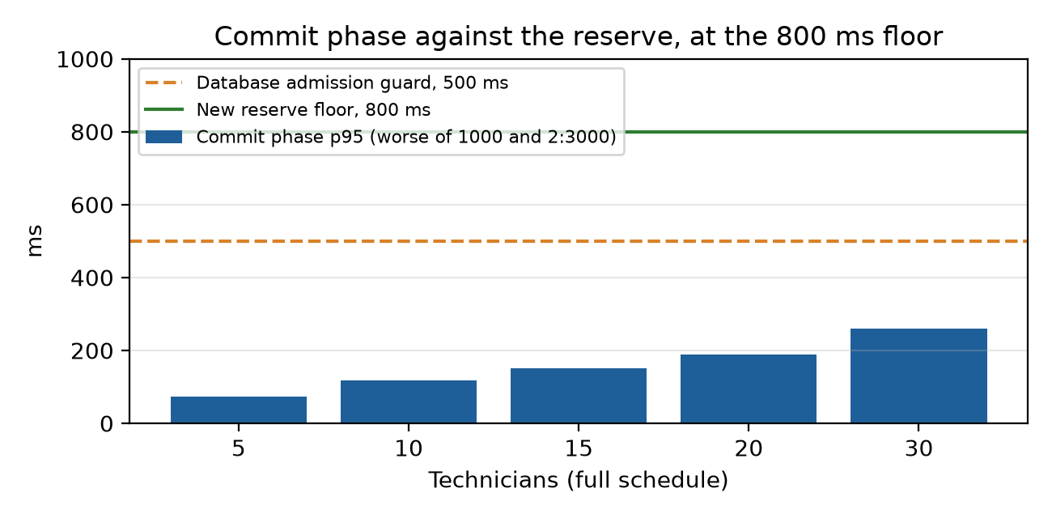
Figure 5. The commit phase stays far inside the reserve; what the floor protects is database admission at publish.
- Commit time grows with the fleet (about 70 ms p95 at 5 technicians, 260 ms at 30) and never came near the reserve.
- Long searches at the 500 and 250 ms reserves in the first study were refused at publish by the database admission guard, which needs 500 ms of deadline left. At 800 ms no search was refused BUSY or answered 503 at any fleet.
- Searches stopped by their cap (2:3000 at 5 to 15 and 30 technicians) ran at the same rate as at 1000 ms, within 3 percent. Searches stopped by the deadline (the uncapped one everywhere, 2:3000 at 20) use the extra 200 ms of exploration and ran 5 to 17 percent fewer a minute. On quality, 2:3000 against 1000 at the 800 ms reserve was within -$0.86 to +$1.10 on 20 cases per fleet, noise of the same size as the 40-case figures at 1000 ms. The lower reserve is safe; it is not a quality lever.
- The searchComplete false counts belong to the uncapped variant hitting its deadline, not to publishing.

6. Hypotheses recorded before the run
# | Hypothesis | Verdict
1 | Cap needed grows with the fleet; at 20 and 30 caps above 2000 stop on the deadline and none matches 1000. | Partly supported. 2:1000 does not match at 5 technicians on full schedules (+$0.70 mean) but 2:2000 does; 10 technicians needs 3000. At 20 and 30 caps of 2000 and 3000 still stopped on their cap in 38 or more of 40 cases, and 2:3000 is within $0.36 to $0.79 mean (median $0.00). It is the uncapped search that hits the deadline.
2 | x:0 is $1 to $3 dearer on half and full at 10 to 20 technicians, within $0.50 on empty and light. | Supported with an outlier. Full schedules: +$3.37 at 10, +$2.01 at 20, but only +$0.29 at 15. Empty $0.00; light $0.22 to $0.70 (0:0), above $0.50 at 10, 15 and 30. Half (2-date searches) $1.43 to $2.82.
3 | Thresholds 5 and 10 make the refinement required on a share of empty and light searches; inert on half and full. | Refuted for empty and light, supported for full. The first pass found at least 16 windows on every 2-date search and 168 on every full one, so no threshold up to 10 ever fired.
4 | calculationMs grows with cap and fleet; routingMs with fleet and dates; queueMs near zero at one desk. | Supported. Engine time tracks the cap; routing grows from about 12 to 39 ms with the fleet on full schedules; slot wait is 0 at one desk and reaches hundreds of ms to 2 s under 5 to 10 clients.
5 | Throughput falls with the cap at one desk; 80 percent shed on 2 slots, under 30 percent on 4; 4 cores at least 1.8x of 2; 10 clients shed everywhere. | Mostly supported. One-desk throughput falls with the cap as predicted, 2 slots shed 87 to 100 percent and 10 clients shed 80 to 100 percent everywhere. Refuted on 4 vCPU at 5 clients: 43 to 61 percent shed, not under 30. The 4-core gain is 1.4x at 5 clients and 2.4x at 10 (1x4 against 1x2).
6 | At equal cores one replica with more slots beats several replicas by 10 to 20 percent on p50 and routing. | Partly supported. At 3 and 4 vCPU, larger than predicted: 1x3 against 3x1 at 5 clients is 348 against 1205 ms p50 with twice the throughput. Reversed at 2 vCPU (2x1 beat 1x2). Confounded: the multi-replica layouts also refine more (they shed less).
7 | Offer limit 8. | Dropped before the run: the API allows at most 4 offers per set.
8 | Commit under 150 ms p99 at 5 to 15 and 400 to 900 ms at 30; 500 ms reserve safe to 15; 250 fails at 20 and above. | Refuted. Commit p95 is 72 to 152 ms at 5 to 15 and about 260 ms at 30, far under the guess. But 500 ms was not safe at any fleet: the database admission guard, not commit time, sets the floor, which is why it is now 800 ms.

Limits
- Half schedules were not rerun after the horizon fix; their quality results are for 2-date searches. Their load, capacity and reserve results are valid.
- The rehearsal ran on a 12-core / 24-thread desktop with the VM's caps. Docker counts threads, so a vCPU here is one hardware thread, as on the VM; absolute times on the VM may differ by its clock speed.
- Cost is the scheduler's modeled fleet cost from routes/evaluate on a copy of the day, not money billed. Quality is judged against the best the 5 s deadline allows, which at 15 technicians and up is itself cut short.
- Roads were cold on every run, as for real new addresses. The remote solver, fixed horizons, longer deadlines and fleets over 30 were out of scope.

Reproducing
- Study: infra/run-booking-configuration-study.ps1 (resumable); rerun command in .scratch/start-full-rerun.ps1.
- Tables: python infra/summarize_booking_configuration.py <evidence .json.gz> [--part quality|load|price|capacity|reserve].
- Code at the rerun: 530d356 (reserve floor 800 ms, quality horizon before optimizing).

