CareerOS
Complete Architecture, System Design & Codebase Analysis
Technical review edition — prepared for investors, technical leads, engineering,
product management, UX, and future developers.
July 11, 2026
Codebase snapshot: ~34,000 lines TypeScript/TSX · 321 files · 64 API routes · 32 data models
Stack: Next.js 16 · React 19 · Prisma 6 · Neon Postgres
Contents
1. Executive Summary 8
2. Complete System Overview 9
2.1 What the system is 9
2.2 Technology stack 9
2.3 Codebase inventory 10
2.4 Runtime topology 10
2.5 Design principles actually observed in the code 12
3. Frontend Architecture Analysis 13
3.1 Shell model and route protection 13
3.2 Provider stack and state management 13
3.3 Frontend architecture diagram 14
3.4 Design system 16
3.5 PWA layer 16
4. Backend Architecture Analysis 17
4.1 API conventions 17
4.2 API surface by family (64 routes) 18
4.3 Service layer 18
4.4 Authentication layer 19
4.5 Permissions model 21
4.6 Request lifecycle 21
5. Database Analysis 23
5.1 Model inventory (32 models) 23
5.2 Conventions and their trade-offs 24
5.3 The dual-candidate design (the schema's key idea) 24
5.4 The append-only event spine 25
5.5 Entity-relationship overview 25
5.6 Integrity assessment 29
6. Candidate Journey Analysis 30
7. Employer Journey Analysis 34
8. System Design Analysis 38
8.1 Module map 38
8.2 An end-to-end information flow (worked example) 40
8.3 Search, ranking, and "indexing" 40
8.4 Requested subsystems vs. reality 40
9. Career Intelligence Engine Analysis 42
9.1 The contract 42
9.2 Engine inventory 42
9.3 Inputs available vs. the aspirational model 45
9.4 Requested scores without direct equivalents 45
9.5 Matching engine detail 45
10. Event-Driven Architecture Analysis 48
10.1 The honest headline 48
10.2 Actual event catalogue (trigger → effects) 48
10.3 Consequences of the synchronous design 51
10.4 Notification subsystem 51
11. UX Design Review 54
12. Code Quality Audit 56
12.1 What is excellent 56
12.2 Findings register 56
12.3 React/Next practices 58
13. Strengths 60
14. Weaknesses 61
15. Missing Features 62
15.1 Technical 62
15.2 Product 63
16. Improvement Roadmap 65
17. Technical Debt Report 66
18. Recommended Future Architecture 68
19. Conclusion 69
Appendix A — Figure index & Mermaid sources 70
Appendix B — Method & coverage 85

1. Executive Summary
CareerOS is a dual-sided career intelligence platform — not a job board. Candidates build a continuously-improving, evidence-backed career profile (skills with trust tiers, a living portfolio, career-health diagnostics); employers discover, evaluate and engage that talent through an explainable matching marketplace. The system is built as a modular monolith: Next.js 16 (App Router) serving both the React 19 client and 64 API route handlers, backed by Prisma 6 on Neon Postgres.
The verdict in one paragraph. For a prototype of this age, CareerOS is unusually well-engineered where it matters: authentication fails closed, every API is session-scoped server-side, errors are classified into a clean taxonomy, the data model is documented in-schema and evolved additively, and the platform's core differentiator — the Career Intelligence layer — is implemented as eleven pure, deterministic, CI-checked scoring engines that return an explainable ScoreResult (score + human-readable reasons + explicit uncertainty) instead of black-box numbers. The honest gaps are equally clear: there is no asynchronous backbone (no event bus, queue, or scheduled jobs — all side effects run inside the request), no automated test suite beyond eight deterministic check scripts, no observability stack, notifications are poll-on-navigation rows rather than a delivery service, and several aspirational subsystems of a "career OS" (learning records, analytics, vector search, interview workflow) exist only in embryonic or curated-data form.
Key figures:
Metric | Value
Source volume | ≈ 34,000 lines of TypeScript/TSX across 321 tracked files
API surface | 64 route handlers under src/app/api
Screens | 35 page routes (plus error/not-found/loading boundaries)
Data model | 32 Prisma models, 1 native enum, cuid primary keys
Intelligence layer | 11 engine modules sharing one ScoreResult contract, CI-verified
Automated verification | ESLint + TypeScript strict + 8 deterministic check scripts; no unit/E2E test runner
External dependencies at runtime | Neon Postgres, optional Google OAuth — no LLM, no payment processor, no email service
The recommended path forward (Section 16) is staged: first productionize trust (tests, monitoring, email verification, durable rate limiting), then extract an asynchronous event/outbox layer to power real notifications and background expiry, then deepen the product loops (learning integrations, real billing, richer matching) on top of the already-solid deterministic core.

2. Complete System Overview

2.1 What the system is
CareerOS serves two audiences on one chassis:
- Candidates get a phase-aware cockpit (student → executive) answering four questions — What are you? Where are you? What's possible? How do I get there? — backed by: a skills system with 3-tier trust (self-claimed / evidence-backed / endorsed), a living portfolio with versioned resumes and PDF export, a personality quiz (descriptive only, never a ranking input), career-health diagnostics for mid-career+ (fair pay, skill bridge, next-move simulation), a jobs catalogue with personalized match scores, an applications timeline, gamified check-ins with age-tuned cadence, and candidate-controlled marketplace discovery.
- Employers get onboarding that captures hiring intent (EmployersAI), a candidate marketplace ranked by an explainable match score, save/invite/chat workflows, job posting with a weighted skill matrix, an applicant pipeline with status management, and notifications.
The two sides meet through three bridges: the marketplace mirror (real candidates who opt into discovery are projected into the same Candidate catalogue employers already browse), the applications spine (candidate applies → employer transitions status → append-only event log renders both sides' timelines), and messaging (invites open persistent conversations that surface in both inboxes).

2.2 Technology stack
Layer | Technology | Notes
Framework | Next.js ^16.2.6 (App Router, Turbopack dev) | Pages + API route handlers in one deployable
UI | React 19.2.4, Tailwind CSS v4 | Dark-only design system; hand-rolled SVG charts (no chart library)
Language | TypeScript 5, strict | no any convention; unknown + guards
ORM / DB | Prisma ^6.19.3 → Neon Postgres | DATABASE_URL (pooled) + DIRECT_URL (migrations)
Auth | jose (HS256 JWT) + bcryptjs | httpOnly cookie career-os-session, 7-day expiry
Validation | Zod ^4 | At every mutating API boundary
Documents | @react-pdf/renderer (resume PDF), mammoth + pdfjs-dist (CV import parsing) | CV parsing is deterministic/heuristic — no LLM
Icons | lucide-react
Tooling | ESLint 9 (next core-web-vitals + TS), tsx for check scripts
CI/CD | GitHub Actions (lint + engine checks + build), Vercel auto-deploy | Secret-free CI; migrations applied out-of-band
Total production dependency count is deliberately small (11). There is no state-management library (React context + localStorage paint cache), no data-fetching library (plain fetch), no component framework beyond the in-house primitive set.

2.3 Codebase inventory
Area | Lines | Content
src/app | 12,676 | 35 pages, 64 API routes, root layout/manifest/error boundaries
src/components | 10,881 | 17 feature folders + ui/ primitives
src/lib | 9,777 | auth, api helpers, intelligence engines, services, contexts/hooks, billing, skills, resume, market data, dev harness
prisma | 1,584 | schema (32 models), 705-line seed, CSV fixtures (jobs, companies, salary benchmarks, universities)
docs | 1,698 (md) | candidate PRD, SSO design, deployment runbook, judge demo script, mobile pass
Largest files (complexity hot-spots examined in Section 12): candidate/onboarding/page.tsx (1,521), employers/onboarding/page.tsx (863), prisma/seed.ts (705), JudgeTourViews.tsx (668), CareerHealthHome.tsx (634), PortfolioBuilder.tsx (631), usePortfolio.tsx (630).

2.4 Runtime topology
Figure 3 — System architecture (see Section 8 for the module-level view).
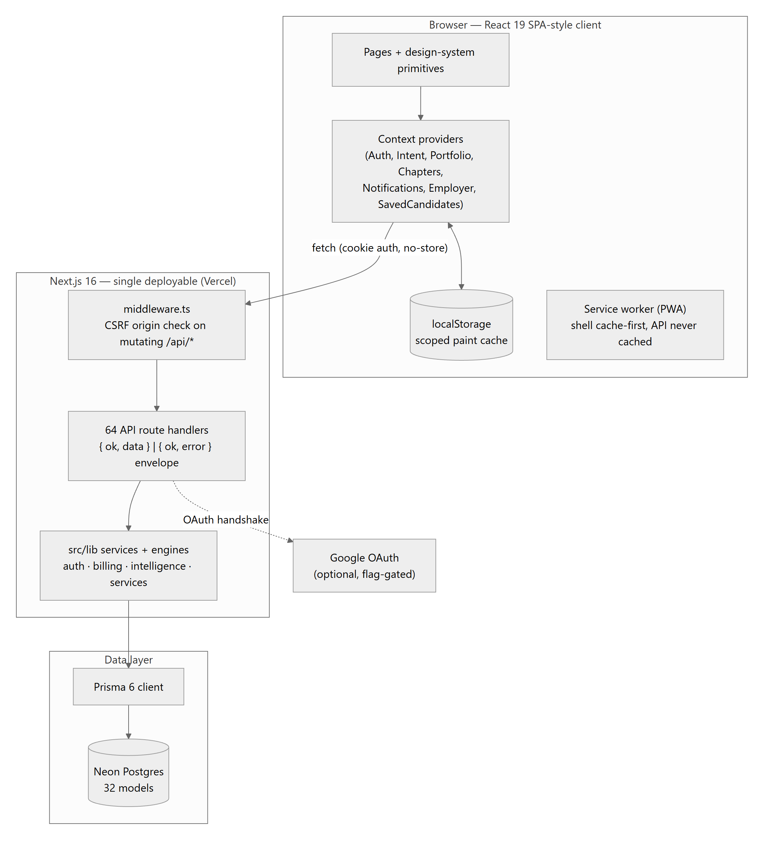
Everything is request-scoped: there are no workers, cron jobs, websockets, or external queues. Time-based state transitions (application/job expiry) use an expire-on-read pattern — stale rows are flipped when next queried.

2.5 Design principles actually observed in the code
These recur consistently enough to count as the project's working architecture philosophy:
- Explainability over opacity. Every score ships with reasons and an uncertainty statement; weights are printed in the reasons themselves (src/lib/marketplace/match.ts).
- The TypeScript layer owns legal values. Enum-like columns are String in Postgres; unions + Zod own validity. Deliberate trade-off: schema flexibility over DB-enforced integrity (Section 5.2).
- DB-backed truth, cache-first paint. localStorage is only a paint cache, keyed per user+role, purged on account switch/logout; the server response always wins.
- Additive evolution. cuid PKs are kept (a native-UUID rewrite is explicitly forbidden as destructive); new features add nullable/defaulted columns.
- Fail closed on security. Missing AUTH_SECRET throws in production; judge/demo/test affordances are independently flag-gated and inert by default.
- Honest demo data. Everything seeded carries isDemo/source-URL labelling; deterministic fallbacks are labelled "Demo data" in the UI; real users are never faked.
- Marked shortcuts. Deliberate simplifications carry ponytail: comments naming the ceiling and upgrade path (e.g. fixed 30-day TTL, in-memory rate limiter) — an unusually disciplined debt ledger (Section 17).

3. Frontend Architecture Analysis

3.1 Shell model and route protection
There is no server-side page protection — middleware.ts only does CSRF checks on mutating API calls. Protection lives in two client shells:
- AppShell (candidate): a zero-scroll 100dvh frame — header (logo slot mirrors sidebar width, streak chip, notification bell, TopMenu) + persistent CandidateSidebar (desktop) + internally-scrolling content region.
- EmployerAppShell: the employer equivalent; sets data-role-accent="employer" so the shared Button/accent system recolors from Luminous (blue) to Clover (green) via --btn-* CSS variables.
Both gate on useAuth: no user → /auth; wrong role → the other side's home; un-onboarded → the role's onboarding. Onboarding completion is DB-backed (CandidatesAI.onboardingCompleted / EmployerProfile.hasCompletedOnboarding), read via GET /api/auth/me — never trusted from localStorage. The trade-off of client-side gating: protected page shells are publicly downloadable (data is not — every API re-checks the session), and there is a brief unauthenticated flash risk on cold loads. Acceptable for a prototype; Section 16 recommends promoting the check to middleware for defense in depth.

3.2 Provider stack and state management
The root layout mounts a fixed provider tree (order matters — everything hangs off Auth):
AuthProvider
├── PwaProvider (SW registration + install banner)
├── MotionProvider (html.reduce-motion class ← performance toggle)
└── IntentProvider → NotificationsProvider → PortfolioProvider
→ ChaptersProvider → EmployerProvider → SavedCandidatesProvider
State management is deliberately library-free. Each domain context follows the same contract:
- Hydrate cache-first from a user+role-scoped localStorage key (career-os-* via scopedCacheKey) so navigation paints instantly.
- Fetch the authoritative server value and reconcile.
- Auth-keyed loading: every provider's load effect depends on [authStatus, userId, userRole], fetches only for its own role, and resets to a clean slate when signed out — so login/logout/account-switch rehydrate without a page reload.
- AuthContext is the scope authority: reconcileActiveUser() purges all caches when a different user signs in on the same browser; clearAllAppCache() wipes everything on logout (privacy: next user starts clean).
AuthContext.login()/signup() deliberately re-fetch /api/auth/me (refresh()) instead of trusting the login response — the response carries only user, and a partial update would leave onboarding flags stale and bounce already-onboarded users back into onboarding.
Notable inconsistency: a typed httpAdapter (src/lib/api/httpAdapter.ts, 394 lines) exists as "the single data adapter", but it only covers ~11 operations (candidate profile, intent, portfolio, employer goal/onboarding, marketplace list, chat, invites). Most newer pages and AuthContext itself call fetch directly with a locally-declared envelope type. The abstraction is half-adopted — either finish it or fold it away (Section 12, finding Q-07).

3.3 Frontend architecture diagram
Figure 5 — Frontend architecture.
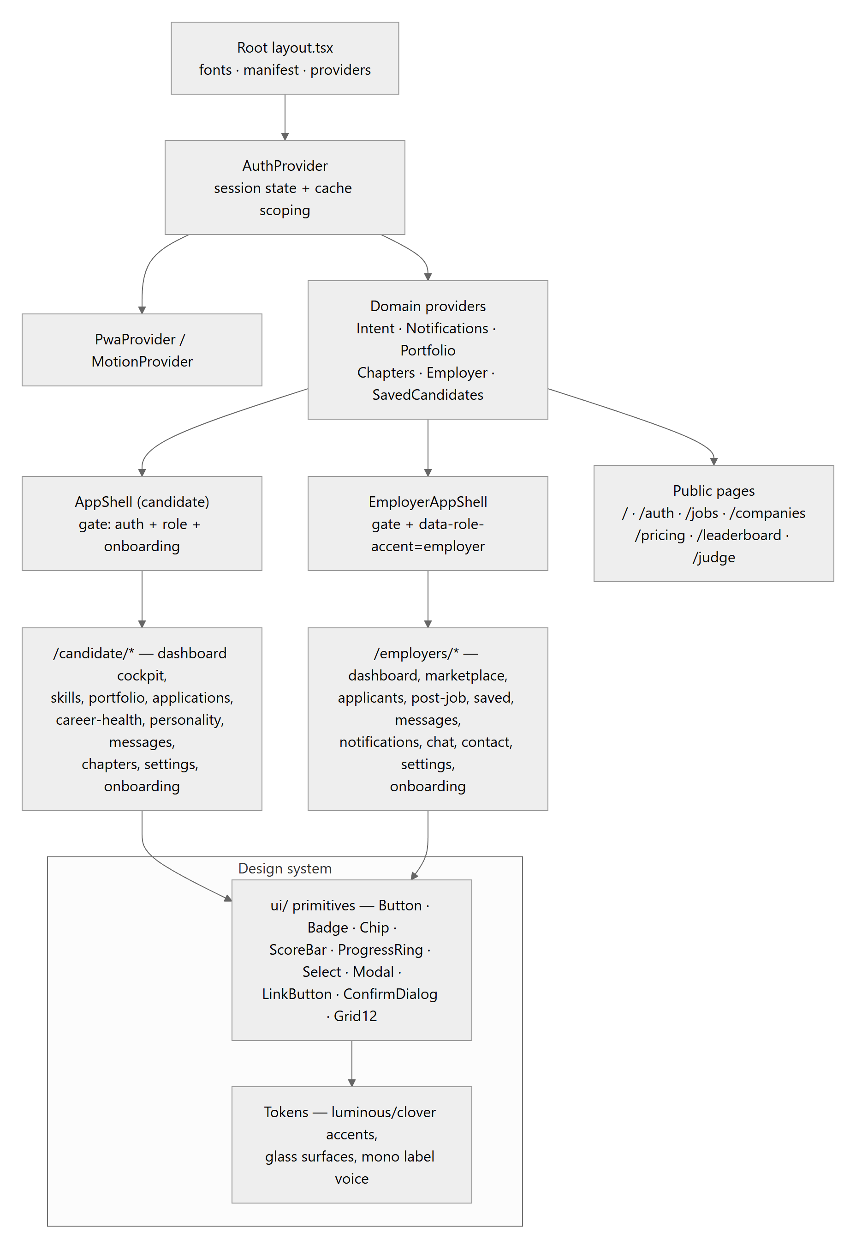

3.4 Design system
The design system is a first-class subsystem with its own enforcement skill (.claude/skills/career-os-design/SKILL.md) and canonical reference. Dark-only; two accents on one neutral chassis — Luminous #4D7AFF (candidate) and Clover #4CBB55 (employer); two type voices — Inter for display/body, IBM Plex Mono for every small uppercase label; glass surface scale (glass-1..5); a fixed radius scale; score signals animate in at a shared cubic-bezier. Role accent is structural: employer shells flip --btn-* variables rather than components hardcoding green. Charts (skill radar, rings, funnels) are hand-rolled SVG with accessibility baked in (aria labels, shape-encoded reference series legible without color vision). Age-adaptive density (data-ui-density="calm" for mid-career+, user-overridable in Settings) enlarges text and removes decorative glows without touching contrast; html.reduce-motion (an in-app performance toggle persisted in localStorage) disables all animation with static fallbacks. This is genuinely mature UI infrastructure for a prototype.

3.5 PWA layer
src/app/manifest.ts + icons generated at request time via ImageResponse (no binary assets), a minimal public/sw.js (app-shell cache-first, navigations network-first, /api/* never cached), and PwaProvider handling registration + a dismissible install banner. Offline support is shell-only by design — the app is online-only for data.

4. Backend Architecture Analysis

4.1 API conventions
Every route handler speaks one envelope, produced by src/lib/api/respond.ts:
{ ok: true, data: T } // 200
{ ok: false, error: { code, message } } // 4xx/5xx
failFromUnknown(err) is the shared catch-all classifier:
Thrown | Status | Code
UnauthorizedError | 401 | unauthenticated
PaymentRequiredError | 402 | payment_required (freemium gate)
ForbiddenError | 403 | forbidden
NotFoundError | 404 | not_found
ConflictError / Prisma P2002 | 409 | conflict
ZodError | 400 | validation (first issue's message)
Prisma P2025 | 404 | not_found
anything else | 500 | server — generic message in production, detail logged server-side only
This is an excellent pattern: routes are thin try { … } catch (err) { return failFromUnknown(err) } wrappers; semantic errors thrown anywhere in the service layer surface with correct HTTP semantics; production responses never leak stacks, causes, or Prisma internals; expected 401/403/404s are not logged as errors (log-noise hygiene).
Caller resolution (src/lib/api/currentUser.ts): getAuthUser() reads the session cookie and loads the User row; getCurrentCandidateProfile() / getCurrentEmployerProfile() enforce the role and return the caller's own profile row (auto-creating a missing one defensively). Every /api/me/* and /api/employer/* route is scoped through these helpers — client-supplied user ids are never trusted. Ownership of nested resources is enforced by querying through the profile relation.
Validation: mutating routes parse bodies with Zod schemas (.strict() where shape drift matters), often with normalization (e.g. job-post skills dedupe through normalizeSkill so match engines see canonical names).

4.2 API surface by family (64 routes)
Family | Routes | Purpose
auth/* | signup, login, logout, me, google/{start,callback,role} | First-party + optional Google SSO
me/* (candidate) | 24 routes — onboarding, intent, portfolio (+collections), skills, resume (+versions, pdf), personality, chapters, checkin, gamification, applications, conversations (+id), notifications (+id), discovery, timeline, mid-career, fair-pay, subscription, ui-density | The candidate's entire private surface
employer/* | 13 routes — me, goal, onboarding, onboarding-data, profile, jobs, applications (+id), saved, invited, notifications (+id), messages | The employer's private surface
Marketplace/public | marketplace (+id), candidates?, jobs (+id, apply), companies (+id), leaderboard, invites, messages/[candidateId] | Catalogue + cross-side actions
account | PATCH/DELETE | Safe field edits; password-confirmed cascade delete
dev/* | 8 routes — seed, session, state, status, reset, data, demo-login | Test harness, double-gated by NEXT_PUBLIC_ENABLE_TEST_MODE

4.3 Service layer
src/lib/services holds the operations that own business invariants:
- applications.service.ts — TS-owned status union (submitted|reviewing|interview|offer|rejected|withdrawn|expired); apply() creates the Application plus its submitted event atomically and maps the unique-constraint violation to a friendly 409; transition() appends a status_changed event (no-op statuses write nothing); expireOnRead() flips stale non-terminal rows past their 30-day TTL. responseScore(status) converts pipeline position into the 0–100 company-responsiveness signal.
- jobs.service.ts — DB-first job listing with the curated TARGET_JOBS array as a defensive fallback (DB down or unseeded → the catalogue still renders); expireStale() sweep before listings; fulfillment rule: an employer's job auto-fulfills when an application on it reaches offer AND at least one chat message has been exchanged between the two parties — checked from both triggers (status PATCH and message POST). Soft-delete only; posts never hard-delete.
- gamification.service.ts — age-tuned cadence (daily below mid-career, monthly "Career Check-Up" for mid-career+); one deliberate check-in per period; forgivable streaks (one missed period bridges); XP only for real actions (10/25 per check-in); milestone badges; all three writes (streak, XP ledger, badges) in one transaction. Explicit anti-dark-pattern stance documented in the module.
- companies.service.ts / leaderboard.service.ts — company responsiveness aggregation from real application statuses (zero-applicant companies get a deterministic seeded score labelled "Demo data"); curated, cited university leaderboard (never ranks real users).
- candidates/projection.ts — the marketplace mirror (Section 8.3), deliberately never throwing into its caller.

4.4 Authentication layer
Figure 6 — Authentication flow.
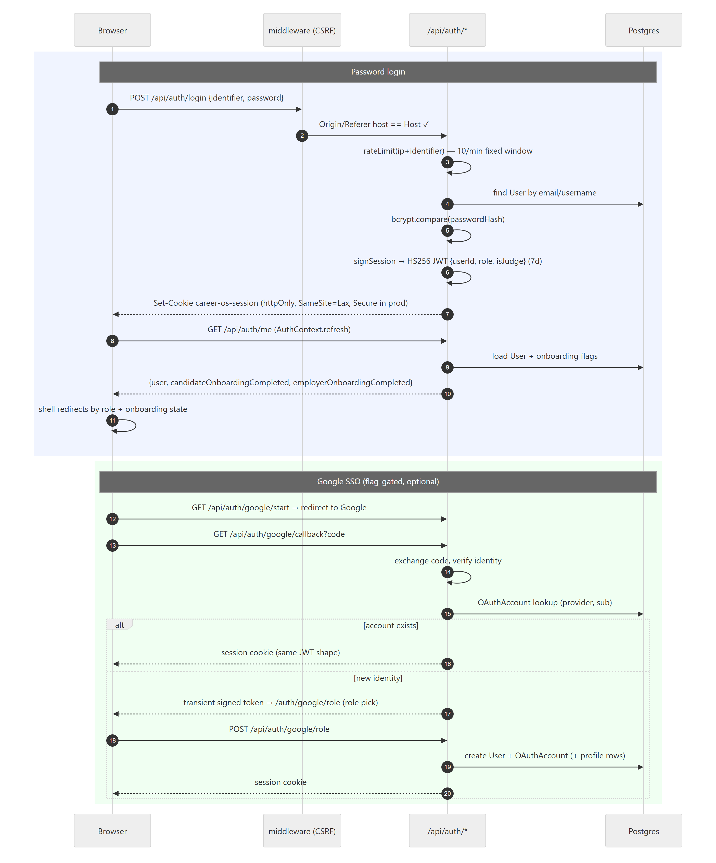
Strengths: the signing key is resolved lazily and fails closed in production (a missing AUTH_SECRET throws rather than falling back); the dev fallback is loud and clearly marked; SSO reuses the exact same session shape (one session system, not two); the OAuth handshake state travels in short-lived signed transient tokens that can never be replayed as sessions (different payload shape). Password hashing is bcrypt. CSRF is handled by Origin/Referer host validation on all mutating /api/* requests, which pairs correctly with SameSite=Lax cookies.
Known limitations (Sections 12/15): the JWT is stateless with no revocation list (logout clears the cookie but a stolen token stays valid up to 7 days); no email verification, password reset, or 2FA; the rate limiter is per-instance in-memory (documented as best-effort — serverless deploys reset it per lambda).

4.5 Permissions model
Authorization is role + ownership + entitlement, enforced in three layers:
- Role: getCurrentCandidateProfile / getCurrentEmployerProfile throw ForbiddenError for the wrong role (JWT role is advisory; the DB row is re-checked per request).
- Ownership: all queries go through the caller's own profile id resolved from the session; nested resources (portfolio items, chapters, resume versions, applications) are fetched via the owning relation, so cross-tenant access is structurally impossible rather than filter-dependent.
- Entitlement (src/lib/billing/entitlements.ts): plan-grained freemium — resolveIsPro() re-reads isJudgeAccount || subscription.plan === "pro" fresh from the DB each request (never trusted from the JWT); requireEntitlement() throws the 402; checkEntitlement-style redaction trims Pro fields (fair-pay benchmark, skill-bridge detail) from free responses instead of blocking the whole route. Exactly three Pro gates exist (resume PDF, fair-pay report, skill-bridge detail); the headline Career Health Score is deliberately always free.
There is no admin role — administrative affordances exist only as the flag-gated dev harness, which re-checks its flag in every /api/dev/* route and operates solely on the seeded test account resolved server-side by username.

4.6 Request lifecycle
Figure 7 — API request lifecycle.
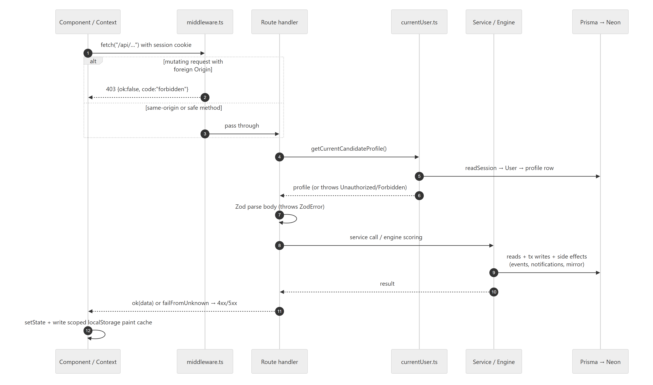

5. Database Analysis

5.1 Model inventory (32 models)
Group | Models | Notes
Identity | User, OAuthAccount, Subscription | One User per account, role CANDIDATE|EMPLOYER; passwordHash optional (SSO-only accounts); isJudgeAccount bypass flag
Candidate profile | CandidateProfile, CandidatesAI, MidCareerProfile, PersonalityResult | Profile = the living CV; CandidatesAI = 5-step guided onboarding answers powering personalization; MidCareer adds problemsSolved + private salary; Personality = deterministic archetype (descriptive only)
Evidence | SkillClaim, Certificate, Award, Project, Experience, ResumeVersion, ChapterEvent | SkillClaim carries the 3-tier trust system (@@unique(profileId, name)); ResumeVersion stores full JSON snapshots so old versions stay reproducible
Gamification | XpLedger, Streak, Badge | Ledger (append-only), one streak per profile, @@unique(profileId, key) badges
Employer | EmployerProfile, EmployersAI, EmployerSavedCandidate, EmployerInvitedCandidate, EmployerNotification | Saved/Invited are composite-key join tables
Marketplace | Candidate | The catalogue employers browse: seeded demo rows and projected real users (id = real-<userId>, source="real", visible mirrors the candidate's opt-in)
Jobs | Company, Job, Application, ApplicationEvent | Jobs: CSV-seeded catalogue + employer-posted rows (owner, status lifecycle, weighted skillWeights, budget/timeline); Application unique per (candidate, job) with append-only event log
Messaging | ChatConversation, ChatMessage | Unique per (employer, candidate-mirror); sender is "employer"|"candidate"
Notifications | CandidateNotification, EmployerNotification | Independent per side; kind/severity as string unions
Reference data | SalaryBenchmark, University | Curated, cited, isDemo-labelled; natural unique keys keep seeds idempotent

5.2 Conventions and their trade-offs
- cuid() primary keys everywhere (except natural-slug seed ids on Job/Candidate) — opaque, collision-resistant, URL-safe. The schema explicitly forbids a native-UUID migration as a destructive rewrite; correct call.
- String pseudo-enums. Statuses, kinds, tiers-adjacent values are String columns whose legal values live in TS unions + Zod. Trade-off: no DB-level integrity (a buggy writer could store an illegal value), but zero-migration evolution of value sets. Given single-writer discipline through the service layer, this is a reasonable prototype choice; the checks in Section 12 recommend CHECK constraints only if non-TS writers ever appear.
- Cascade deletes flow from User down through every owned row — account deletion (DELETE /api/account) is real and complete.
- Indexes exist on every FK plus query-shaped composites ([employerId, createdAt] on notifications, [profileId, createdAt] on candidate notifications, category/matchScore/visible/source on the catalogue). No obvious missing index for current query patterns; Application could use [candidateProfileId, createdAt] if the timeline list grows.
- JSON columns are used for genuinely schema-less payloads (skill levels map, timeline display metadata, resume snapshots, personality answers, job skill weights) — appropriate, all owner-scoped.
- In-schema documentation is exceptional: nearly every model carries a design-note comment explaining intent and ownership of legal values. This is the best-documented Prisma schema most reviewers will see.

5.3 The dual-candidate design (the schema's key idea)
The Candidate catalogue and real users are deliberately separate, then bridged:
- Seeded demo rows (source="seed", isDemo) keep the employer marketplace populated and demo-safe regardless of real signups.
- A real candidate who flips discovery on is projected into the same table by syncMarketplaceMirror(userId): id real-<userId>, source="real", userId FK back to the account, visible mirroring CandidateProfile.discoverable. The projection derives category/stage/availability/growth-signal heuristically, computes readiness through the shared rubric, mirrors the personality archetype as a descriptive tag, and writes an honest "signals are self-reported" recommendation blurb.
- Because every employer flow (list, save, invite, chat) was already keyed on Candidate, real people join the marketplace with zero changes to employer code, and the userId link lets the candidate's inbox resolve employer conversations from the mirror.
Turning discovery off hides the row (visible=false) but preserves saves/invites/conversations — a thoughtful referential-integrity decision. The projection never throws into its caller (a mirror failure must not break a profile write); the cost is that mirror consistency is eventual-by-write-path rather than guaranteed (no reconciliation sweep exists — noted in Section 17).

5.4 The append-only event spine
Application (current status) + ApplicationEvent (immutable history: submitted / status_changed / expired, with from/to statuses) is the closest thing to an event log in the system. It powers the candidate's per-application timeline, the employer pipeline, company responsiveness metrics, and job fulfillment. Both TTL mechanics (application 30-day expiry, job-post 30-day expiry) are enforced expire-on-read rather than by a scheduler — correct results with lazy timing, at the cost of stale rows lingering until someone looks (and of writes occurring during GET requests).

5.5 Entity-relationship overview
Figure 8a — Database relationships: identity & candidate space. For legibility, sibling child tables are collapsed into group boxes — each named row inside a group is its own physical table, FK'd to the parent shown (full inventory in §5.1).
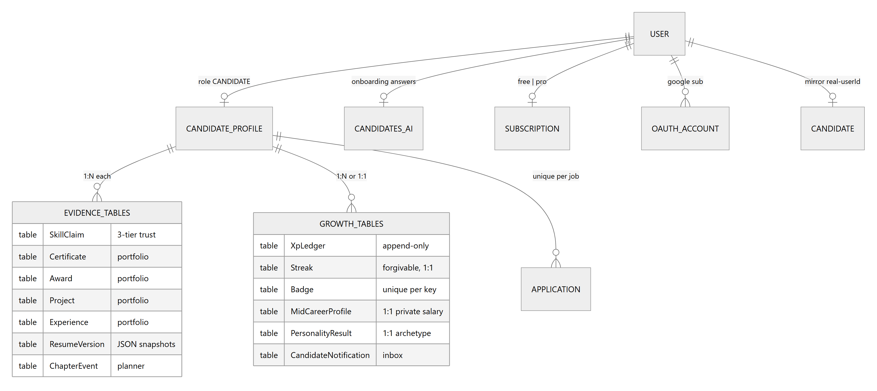
Figure 8b — Database relationships: employer side, marketplace, jobs & messaging.
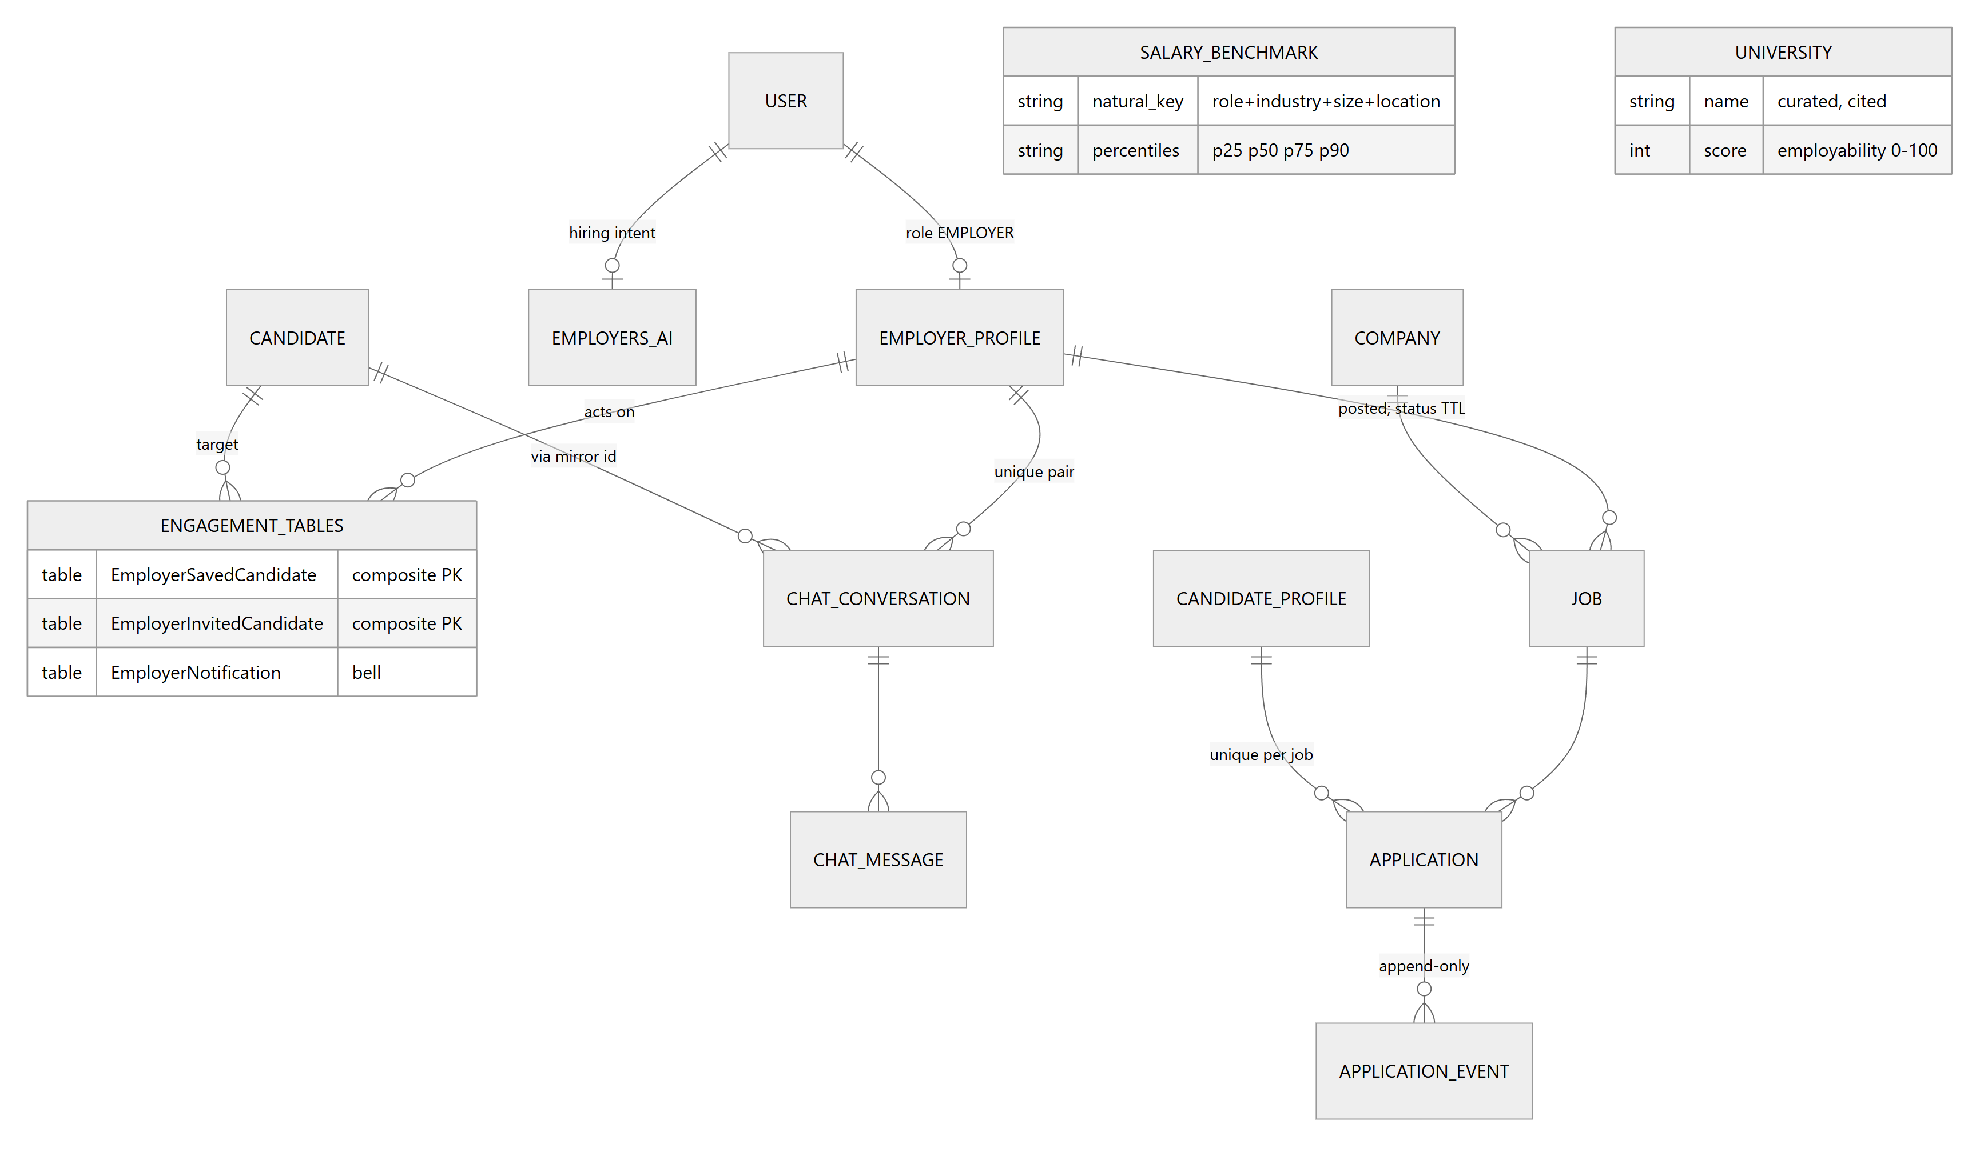

5.6 Integrity assessment
Referential integrity is strong (FKs + cascades everywhere; composite PKs on join tables; @@unique guards on one-per-user rows, per-profile skill names, per-pair conversations, per-(candidate,job) applications). The deliberate soft spots are the string pseudo-enums (TS-owned) and two heuristic bridges that trade precision for simplicity, both documented in-code: employer notification targeting by organization-name match to the job's company (no owner on catalogue jobs), and job fulfillment's "message between the two parties" standing in for job-scoped threads. Both are flagged in the debt register (Section 17).

6. Candidate Journey Analysis
The requested ideal journey (Landing → Sign Up → Onboarding → Assessment → Growth Plan → Dashboard → Learning → Portfolio → Skill Verification → Matching → Job Discovery → Application → Interview → Feedback → Continuous Growth) maps onto CareerOS as follows. Stages marked ◐ are partially implemented; ✗ marks stages that exist only as data points, not workflows.
Ideal stage | CareerOS reality | Status
Landing | Marketing homepage (/), pricing, public jobs/companies/leaderboard | ✓
Sign up | /auth — password or Google SSO; role selection; rate-limited | ✓
Onboarding | 5-step guided flow (stage, discovery, growth, progression, feedback) + CV import (PDF/DOCX parsed client-side, deterministic heuristics) → CandidatesAI | ✓
Assessment | No formal assessment; the analogues are the personality quiz (descriptive archetype) and the self-reported skill levels from onboarding | ◐
Growth plan | Cockpit dashboard's "How do I get there" + skill-gap analysis + ONE recommended next step from the Skills Truth engine; career-health suite for mid-career+ | ◐
Dashboard | Four-question cockpit, phase-aware (student → executive), age-adaptive density | ✓
Learning | Curated per-skill improvement suggestions (src/lib/skills/learning.ts) surfaced in the skill bookshelf — a static map, not a learning-management system; no progress records | ◐
Portfolio | Living Portfolio: experiences/projects/certificates/awards, completeness checklist, named resume versions, PDF export (Pro) | ✓
Skill verification | 3-tier trust: self-claimed ×0.5 → evidence-backed ×0.8 → endorsed ×1.0; tier derived server-side from evidence/endorsement fields, never client-set | ✓ (self-attested evidence — no third-party verification)
Matching | Per-caller job match via skill-bridge coverage; marketplace visibility via opt-in discovery projection | ✓
Job discovery | /jobs catalogue (seeded + employer-posted), search/filter by field/location, personalized re-ranking | ✓
Application | One-click apply → Application + event log; employer notified; 30-day auto-expiry | ✓
Interview | A pipeline status only (interview) — no scheduling, no interview artifacts | ✗
Feedback | Status transitions render as a timeline with stage explanations; no structured employer feedback | ◐
Continuous growth | Check-in loop (daily / monthly Career Check-Up by phase), forgivable streaks, XP for real actions, badges; profile edits re-project the marketplace mirror | ✓
Figure 1 — Candidate process flow (DB = database write, N = notification created).
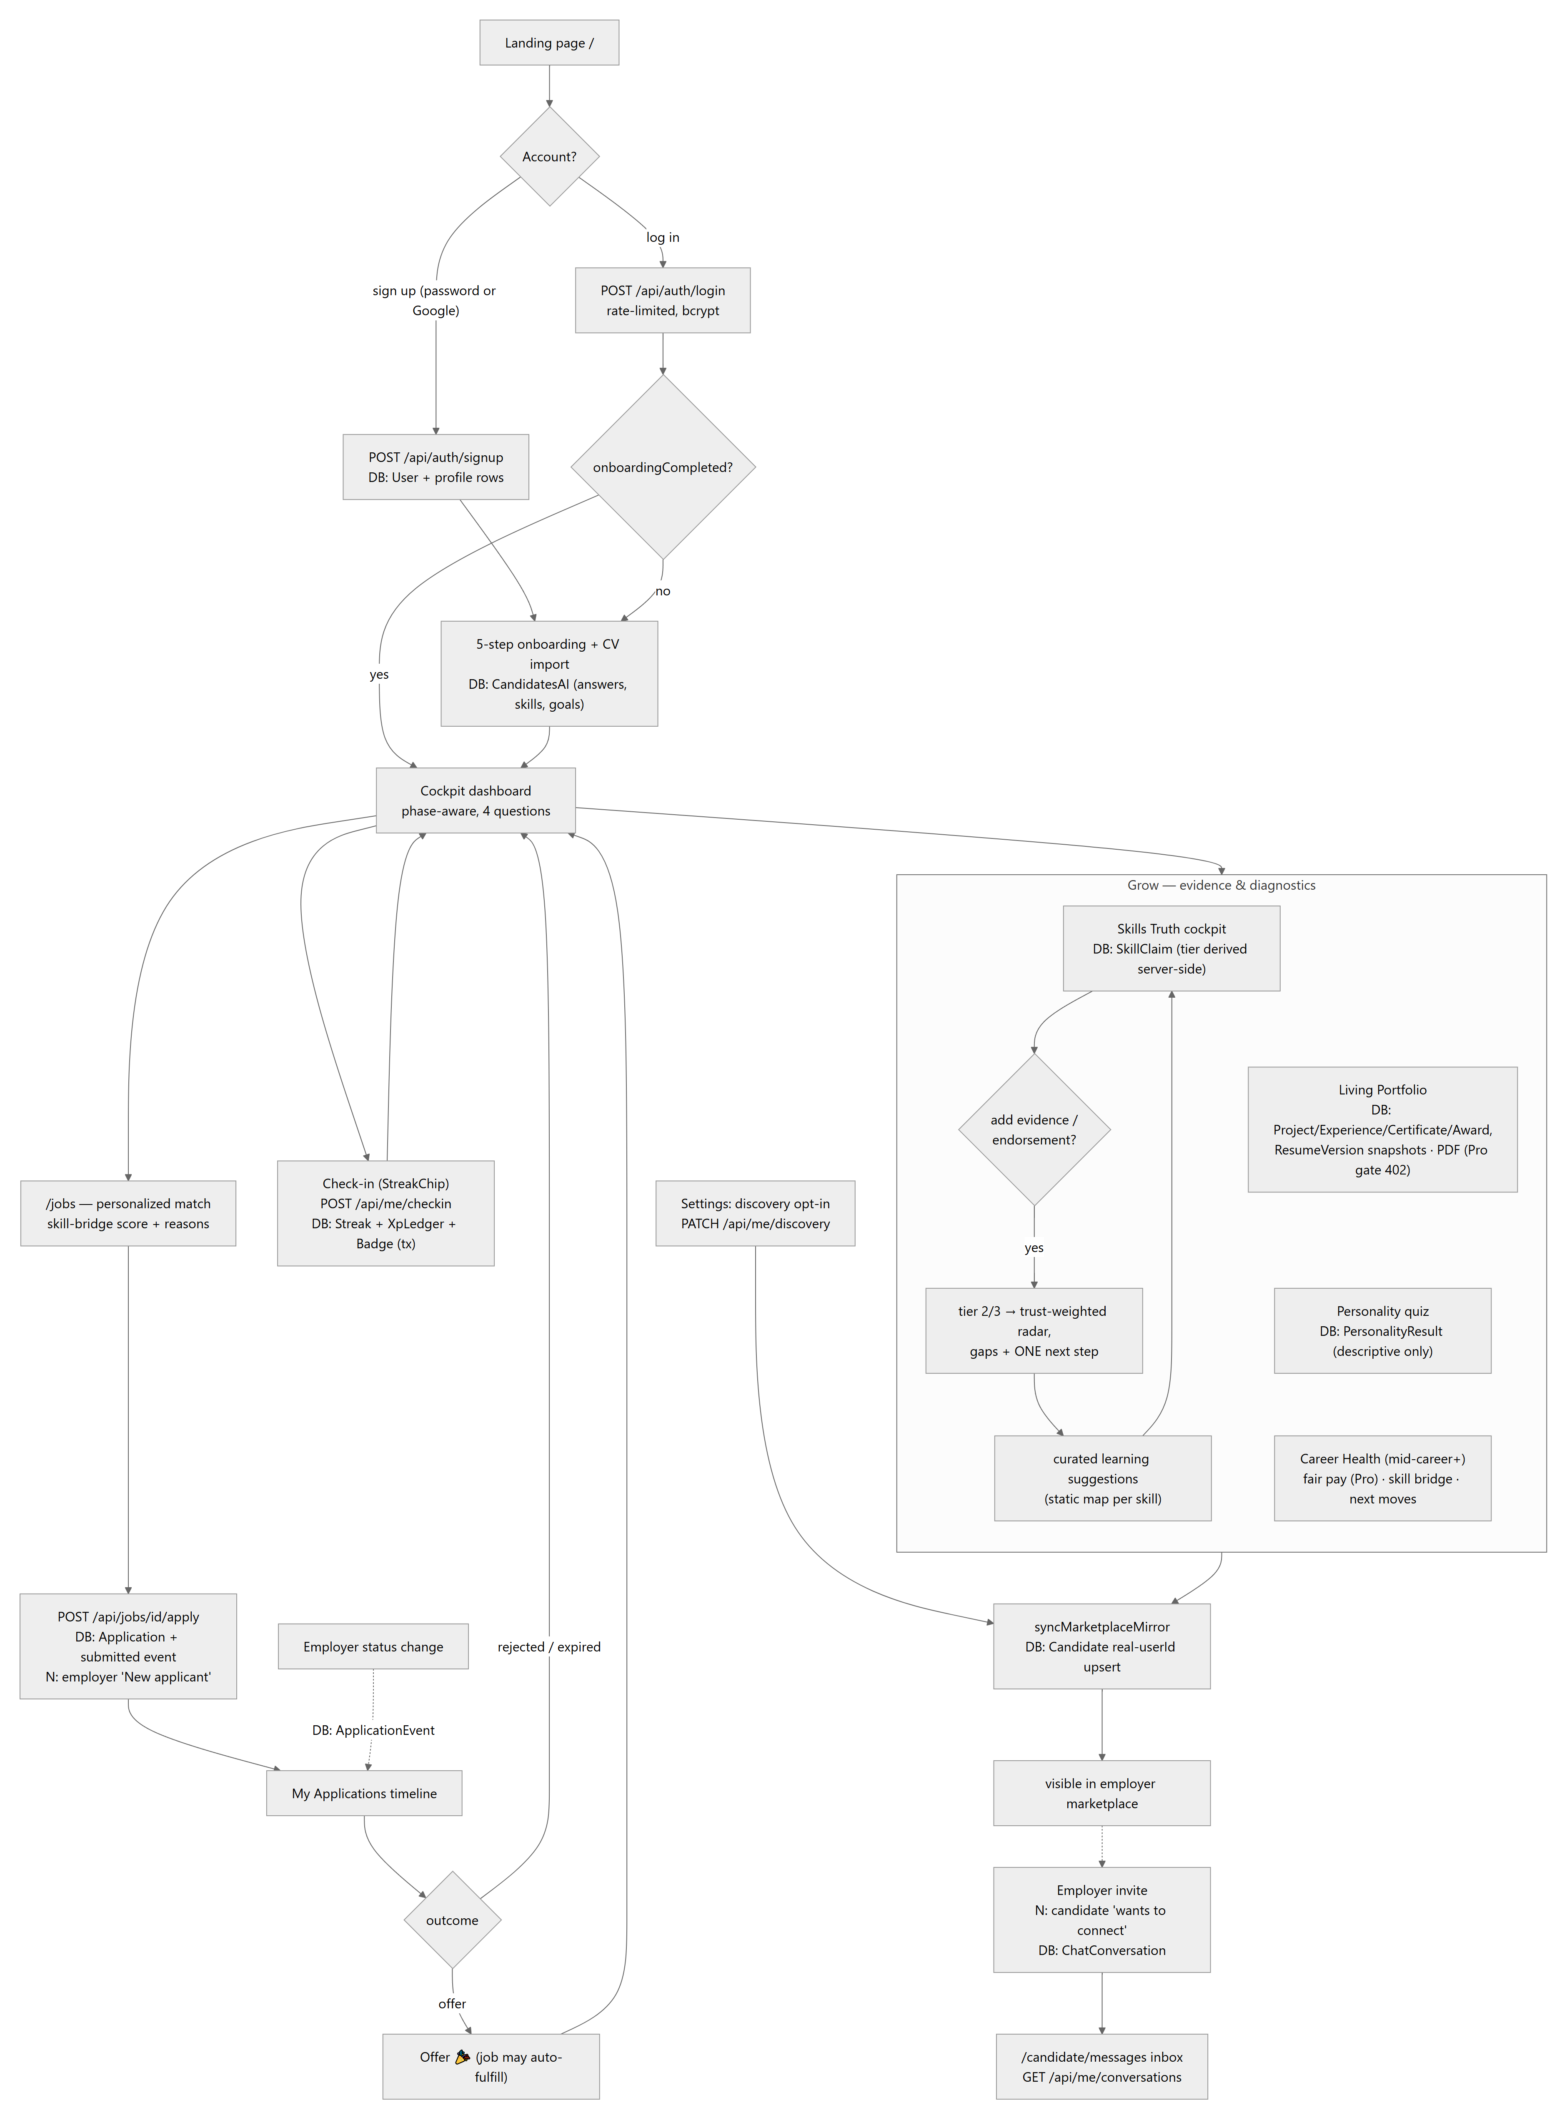
The invisible system layer under each candidate action:
Candidate action | Synchronous system effects
Completes/edits onboarding | CandidatesAI upsert → onboardingCompleted flips → shells re-route; personalization summary regenerates; mirror re-projects if discoverable
Edits portfolio/skills/profile | Owning rows written → CandidateProfile.skills mirror of claim names maintained → readiness recomputed on next projection → syncMarketplaceMirror refreshes the employer-facing row (never throws into the save)
Adds evidence/endorsement to a skill | Tier re-derived server-side in /api/me/skills → trust-weighted radar/score shift → marketplace mirror picks up new top skills
Applies to a job | Application + submitted event (atomic); org-name-matched employers get an EmployerNotification; company responsiveness metrics gain a data point
Opens applications list | expireOnRead flips stale rows to expired (writes an event) — reads can mutate
Checks in | One transaction: streak upsert (forgivable bridge), XP ledger append, milestone badges; cadence re-tuned to current phase
Toggles discovery | Mirror row created/updated or hidden (visible=false) — saves/invites/conversations preserved
There is no background recalculation, no visibility-score refresh, no analytics pipeline, and no notification fan-out beyond the specific rows described — every effect above happens inside the originating HTTP request.

7. Employer Journey Analysis
Ideal stage | CareerOS reality | Status
Landing / registration | Same /auth flow, role EMPLOYER | ✓
Company setup | 5-step onboarding → EmployersAI (company context, hiring goal, role direction, candidate signals, matching prefs) + narrative summaries; org name on EmployerProfile | ✓
Employer dashboard | /employers/dashboard — hiring snapshot, pipeline shortcuts | ✓
Create talent need | Two forms: onboarding preferences (drive marketplace personalization) and job posting (/employers/post-job — 3–5 weighted skills, requirements, budget/timeline; lands in the public candidate feed immediately) | ✓
AI candidate matching | explainMatch — deterministic weighted scoring (role 35 / skills 30 / industry 15 / green flags 10 / baseline 10) with per-reason weights printed and an explicit uncertainty note | ✓ (deterministic, not ML)
Review profiles | Marketplace rows (match-first), candidate detail modal with insight engine + readiness factor breakdown + Bias-Check note on the archetype tag | ✓
Invite candidate | Transactional invite: invited-row upsert + employer notification + conversation with the intro message; real candidates also get an inbox notification | ✓
Interview | Status transition only | ✗
Hire | offer status + fulfillment rule (offer + message exchanged → job auto-fulfills, leaves the public feed) | ◐
Market intelligence | Salary benchmarks (curated CSV), company responsiveness scores, marketplace composition — no trend reports or demand analytics | ◐
Pipeline management | /employers/applicants — per-application status PATCH with append-only history | ✓
Continuous hiring | Saved candidates, invited list, refreshed marketplace on preference edits (?edit=1 re-entry), job-post lifecycle | ✓
Figure 2 — Employer process flow.
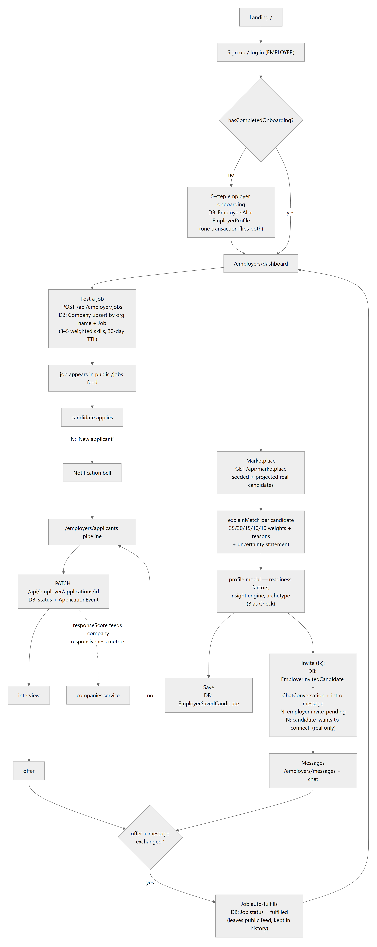
The invisible system layer under employer actions:
Employer action | Synchronous system effects
Completes onboarding | EmployersAI + hasCompletedOnboarding flip in one transaction; marketplace personalization summary computes from the stored intent
Opens marketplace | Live re-scoring of every visible catalogue row against the employer's stored prefs (no precomputed index — Section 8.4); demo fallback only under test mode
Posts a job | Company upsert by organization name; skills normalized to canonical taxonomy names so candidate-side engines match; 30-day expiresAt
Changes application status | Event appended; company responsiveness updates on next read; maybeFulfillJobs checks the offer+message rule
Sends a message | ChatMessage insert; maybeFulfillJobs re-check (chat is the second fulfillment trigger); optional simulated reply only when NEXT_PUBLIC_ENABLE_DEMO_CHAT
Marks notifications read | EmployerNotification.read only — never touches messages (the two systems are deliberately independent)

8. System Design Analysis

8.1 Module map
Figure 4 — Backend module map.
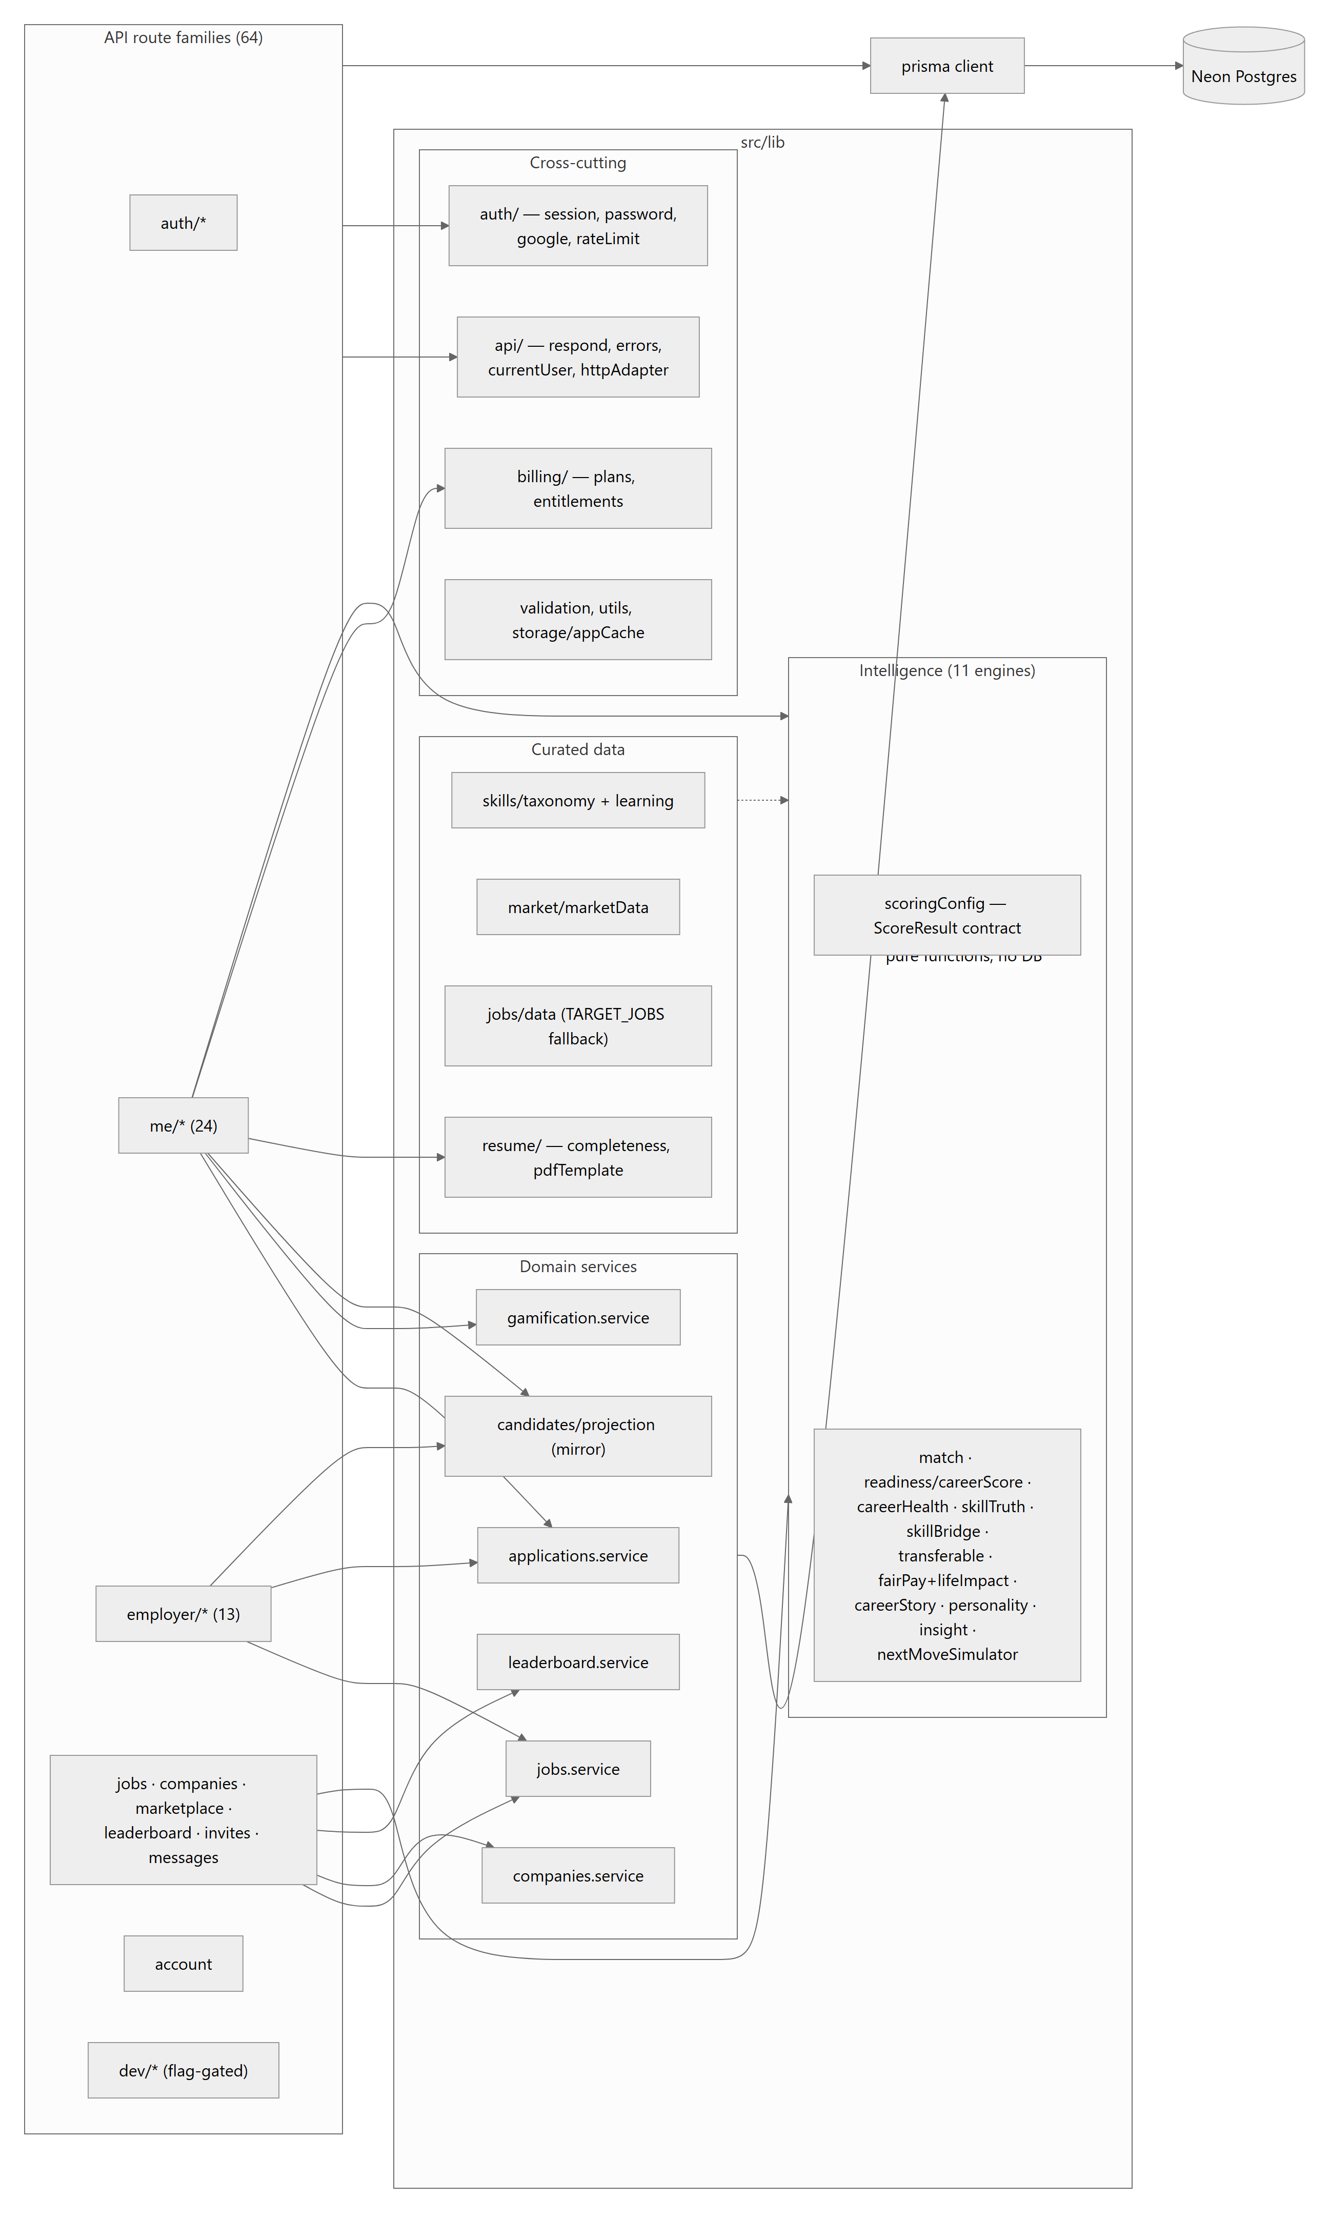
The dependency direction is clean and acyclic: routes → services/engines → prisma. Engines are pure (no I/O) — routes assemble their inputs from Prisma and pass plain objects in, which is what makes the CI check harness possible. No circular dependencies were found in the import graph spot-checks; contexts depend on lib/api types but never the reverse.

8.2 An end-to-end information flow (worked example)
A candidate adds endorsement evidence to a skill:
- Skills page PATCHes /api/me/skills; Zod validates; getCurrentCandidateProfile() scopes the write.
- The route derives the tier from the evidence/endorsement fields (tier is never accepted from the client), updates SkillClaim, and maintains CandidateProfile.skills as the mirror of claim names — the compatibility view every older engine and the marketplace read.
- scoreSkillTruth recomputes the trust-weighted score, radar axes, gaps, and the single recommended next step; the response carries the full explanation.
- syncMarketplaceMirror re-projects the candidate: new top skills, recomputed readiness — the employer marketplace reflects the change on its next query (no index refresh step exists; scoring is at read time).
- The client updates context state and its scoped localStorage paint cache.
Steps 1–4 are one HTTP request; nothing else in the system learns about the change until it reads the database.

8.3 Search, ranking, and "indexing"
There is no search infrastructure. "Search" is Prisma contains filters (jobs by title/company, marketplace by category/filters) over indexed columns; ranking is computed at read time — the jobs list runs scoreSkillBridge per row per request, the marketplace runs explainMatch per visible candidate per request. At catalogue scale (tens of rows) this is free and always fresh; at real scale it becomes the primary hot spot (Section 15/18: pagination first, then precomputed or cached scores, then a real index).

8.4 Requested subsystems vs. reality
The analysis brief names an idealized component set. The honest mapping:
Requested component | CareerOS implementation | Status
Matching Engine | explainMatch + scoreSkillBridge + candidateMatchEngine — deterministic, explainable | ✓
Skills Graph | Flat canonical taxonomy + normalizer (skills/taxonomy.ts); no relationships between skills | ◐
Candidate / Employer Index | Postgres B-tree indexes + read-time scoring; no search index | ◐
Growth Engine | Gamification service + skill-gap "one next step" + phase-aware cockpit | ◐
Gap Analysis Engine | skillTruthEngine (radar gaps) + skillBridgeEngine (per-job missing skills) | ✓
Intelligence Engine | The 11-engine layer (Section 9) | ✓
Recommendation Engine | nextMoveSimulator (career pathways), job re-ranking, next-step suggestions | ✓
Notification Service | Notification rows written inline + fetch-on-navigation bells; no dispatch/delivery service, no email/push | ◐
Learning Engine / Records | Curated static suggestions per skill; no records, progress, or providers | ✗ (embryonic)
Analytics Engine | None (no product analytics, no warehouse) | ✗
Event Bus | None — synchronous side effects + the append-only ApplicationEvent log | ✗
Vector Search | None — and deliberately: matching is explainable arithmetic, not embeddings | ✗ (by design, for now)
This table is the single most important calibration for readers of this document: CareerOS's architecture language (engines, scores, signals) sounds like a large distributed system, but the implementation is a well-factored monolith where "engines" are pure functions and "events" are rows. That is the right shape for the current stage — the risk is only in forgetting which parts are real when planning.

9. Career Intelligence Engine Analysis

9.1 The contract
Every engine returns the shared shape defined in src/lib/intelligence/scoringConfig.ts:
interface ScoreResult {
score: number; // 0–100, clamped
reasons: string[]; // human-readable, strongest first, weights named
factors?: ScoreFactor[];// per-factor earned/max breakdown
uncertainty?: string; // what the score does NOT know
}
plus shared helpers (clampScore, tokensOverlap, fromFactors, standard uncertainty copy) and the ARCHETYPES definitions. Engines are pure and deterministic: same inputs → same outputs, no I/O, no randomness, no LLM. npm run check:intelligence runs assertion suites over all of them in CI on every push — including behavioral invariants like an endorsed expert must outrank an identical self-claim (the anti-gaming property of the trust system).

9.2 Engine inventory
Engine | Input | Output (beyond ScoreResult) | Consumers
skillTruthEngine (flagship) | SkillClaims (level + tier) + target-role requirements | trust-weighted radar axes, gap list, ONE next step, marketValue | Skills cockpit, dashboard, mirror projection
careerScoreEngine / readiness | visible profile signals | factor breakdown (basics 15 / skills 30 / portfolio 30 / growth 15 / availability 10) | Marketplace rows, projection, insight modal
candidateMatchEngine → explainMatch | Candidate row + EmployersAI prefs | weighted reasons (35/30/15/10/10) + uncertainty | Marketplace ranking, detail modal, employer summary
skillBridgeEngine | job requiredSkills + candidate skills | matched/missing per job, coverage score | Jobs feed match badge, career-health top jobs (Pro detail gate)
careerHealthEngine | tenure, growth, skills, market signals | pillar factors | Career Health home (mid-career+)
fairPayEngine | private salary + SalaryBenchmark percentiles | band (below/fair/above), pickBenchmark fallback chain, scoreLifeImpact | Fair Pay calculator (Pro), mid-career API
transferableSkillEngine | current skills + target field | transferable subset + narrative | Career health, pivot views
careerStoryEngine | experiences | story arc analysis | Portfolio/resume narrative
personalityEngine | quiz answers | archetype + per-archetype points ("the why") | Personality page; archetype mirrors to marketplace as a descriptive tag only
employerCandidateInsightEngine | Candidate row | strengths/risks summary | Employer detail modal
nextMoveSimulator | profile + pathway jobs | ranked Pathway[] with reasoning | Next Move Navigator
Figure 10 — Intelligence engine dataflow.
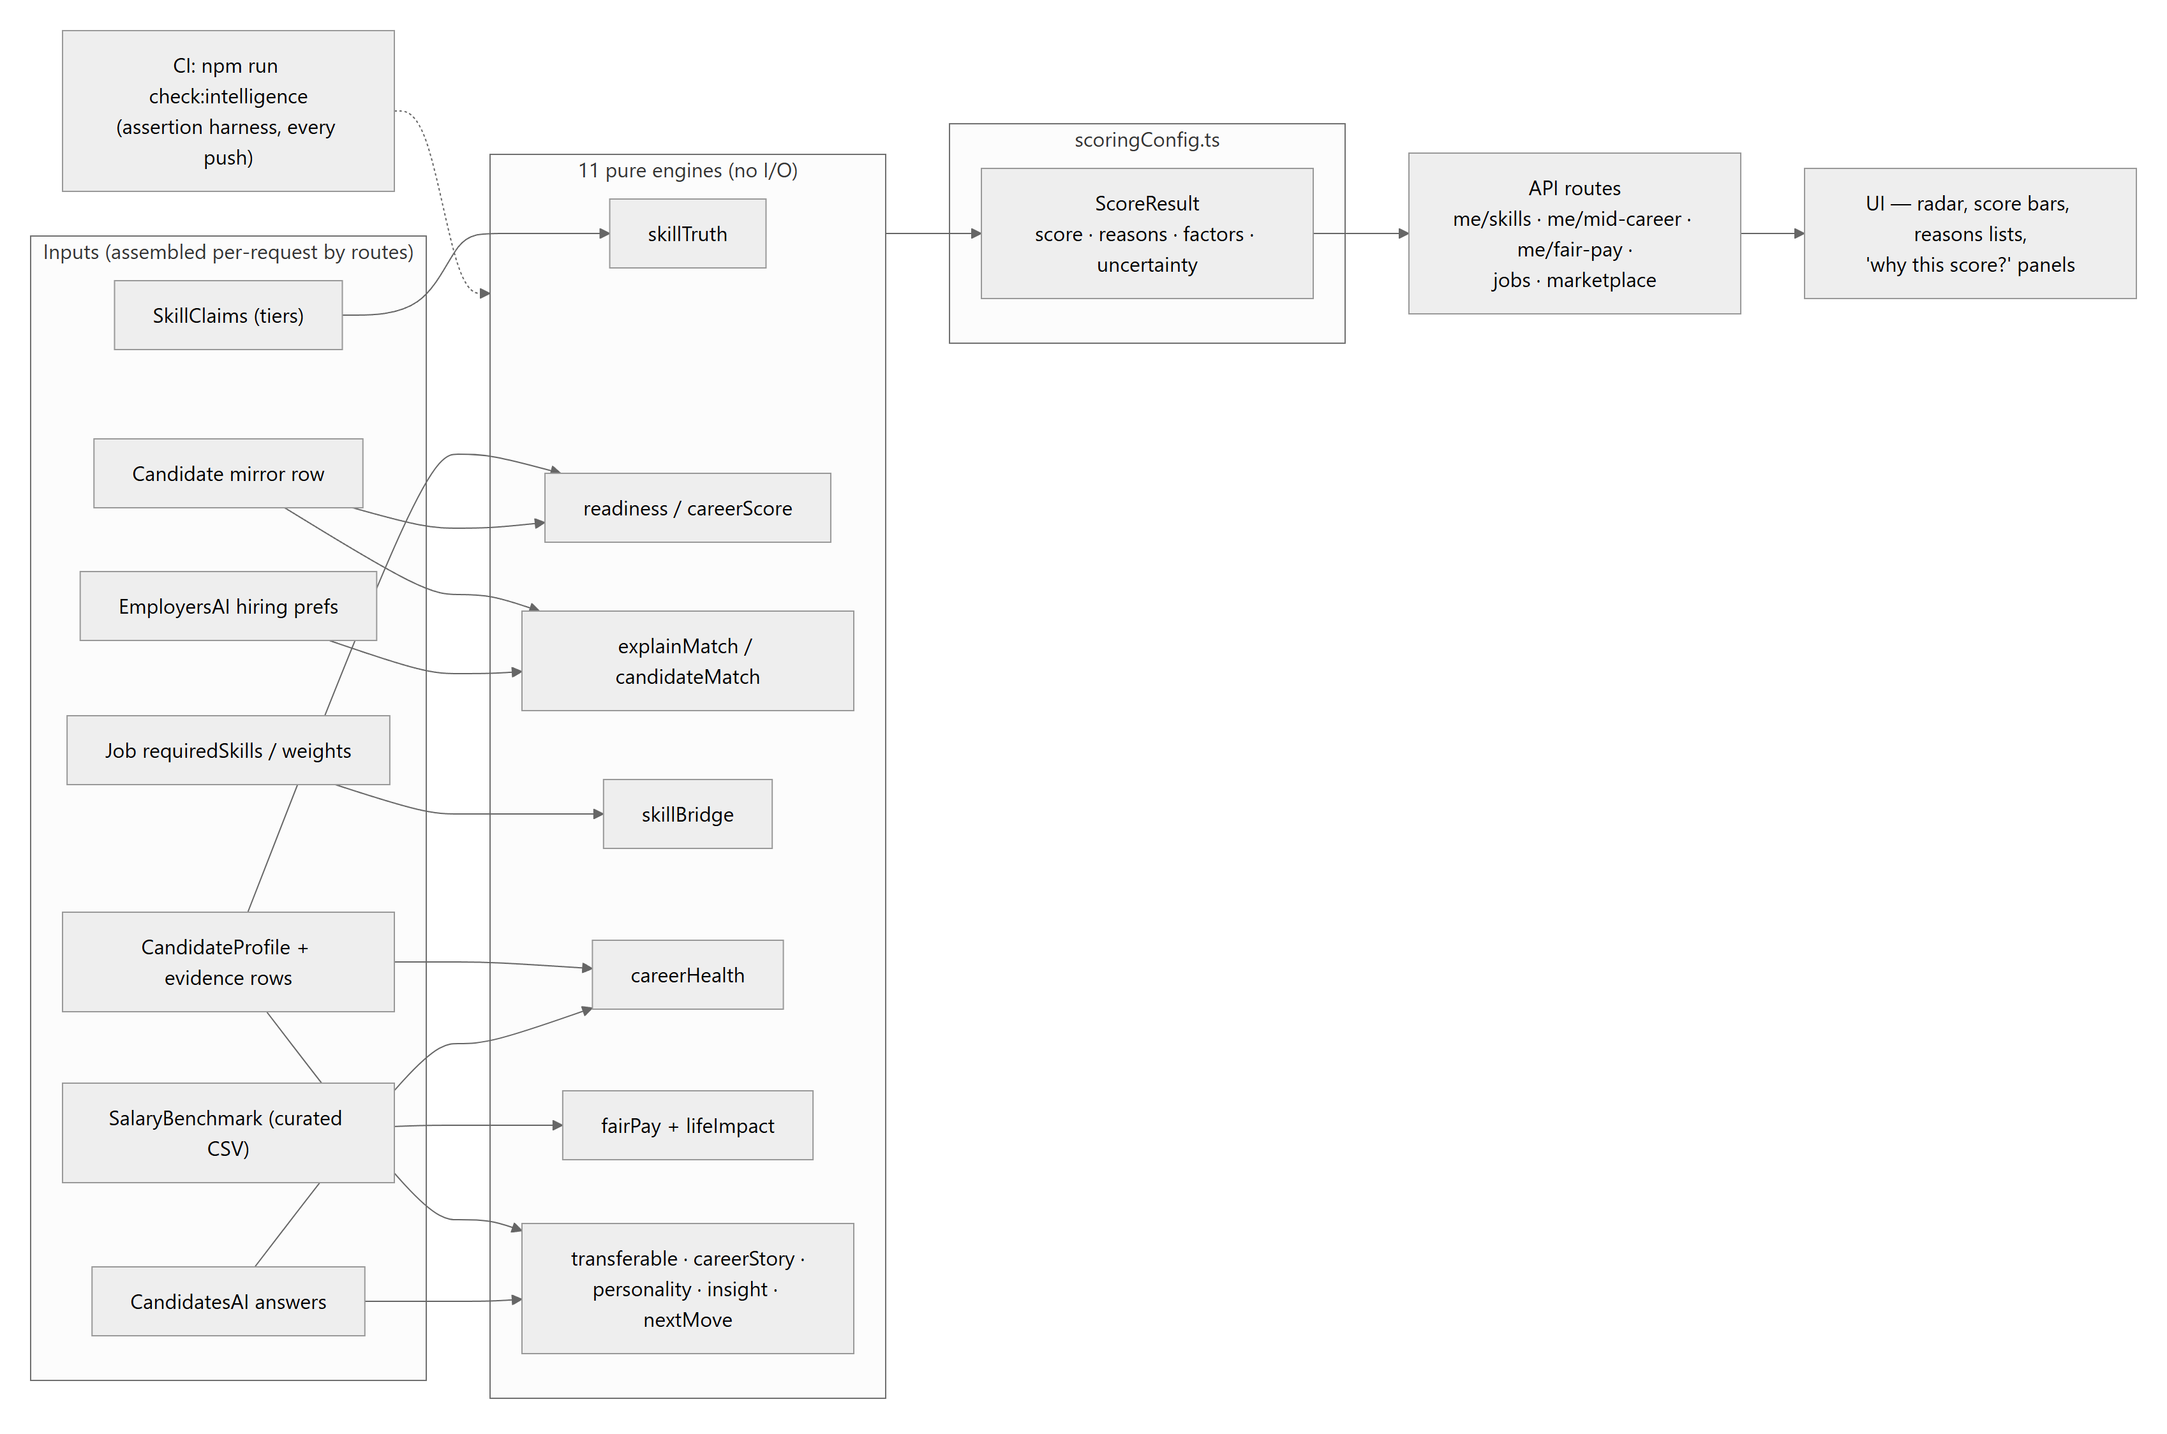

9.3 Inputs available vs. the aspirational model
Of the brief's ideal input set — candidate skills ✓, employer demand ✓ (stored prefs + posted-job skills), learning completion ✗ (no records), engagement ◐ (streak/XP exist but never feed scores), applications ✓, interviews ◐ (status only), hiring outcomes ◐ (offer + fulfillment, unused as a learning signal), external market trends ✗ (static curated benchmarks stand in), salary benchmarks ✓ (curated, cited, demo-labelled).
The significant architectural fact: the intelligence layer does not learn. Weights are hand-set constants; outcomes never feed back into scoring. That is a deliberate, defensible stage-appropriate choice (explainability, zero bias-training risk, demo determinism) — but it means "the platform's intelligence continuously improves through user activity" is today true only in the sense that data accumulates, not that models improve. Section 18 sketches the upgrade path that preserves explainability.

9.4 Requested scores without direct equivalents
- Candidate Visibility Score — closest: readiness (drives marketplace baseline) + resume completeness. No dedicated visibility metric or "profile views" analytics.
- Career Capital Score — closest: career health score + marketValue from skill truth. No unified longitudinal capital metric.
Both would be natural, cheap additions on top of the existing factor pattern.

9.5 Matching engine detail
Figure 9 — Matching flows on both sides.
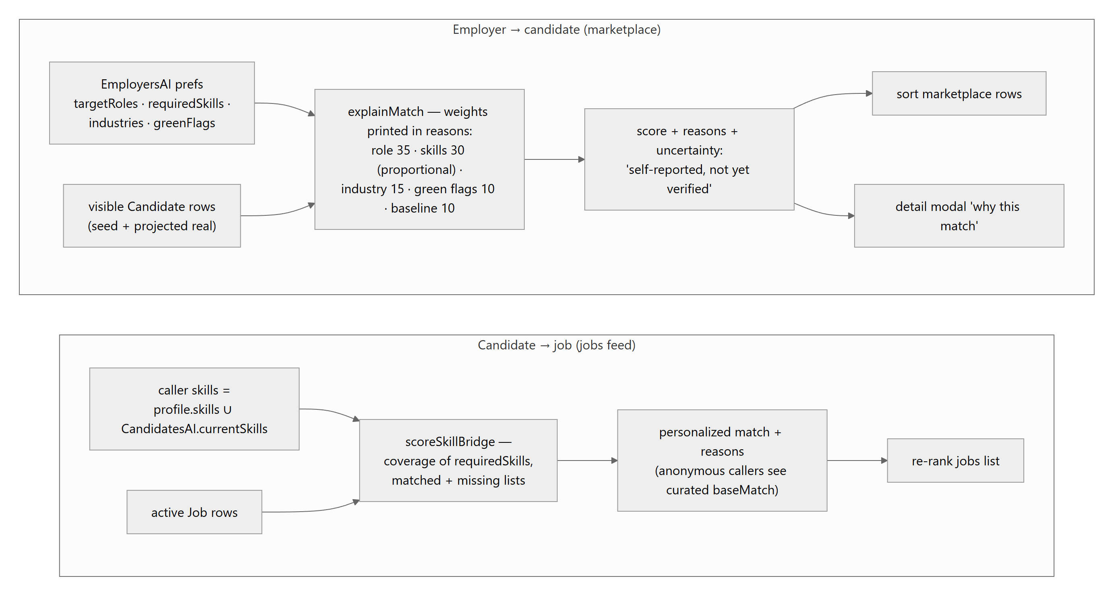
Fairness properties worth stating: the personality archetype is excluded from every score (enforced by convention + a Bias Check note on employer surfaces); scores clamp to 0–100; every surface that shows a number can show its reasons; and the uncertainty string explicitly tells employers the signals are self-reported. The main fairness gap is inherent to token matching: skill-name normalization exists, but a candidate who phrases skills unusually under-scores — a semantic-matching upgrade (Section 18) should be paired with an explanation-preserving design.

10. Event-Driven Architecture Analysis

10.1 The honest headline
CareerOS has no event-driven architecture. There is no bus, no queue, no pub/sub, no webhooks, no scheduler. What it has instead — and it is a coherent pattern, consistently applied — is:
- Synchronous request-scoped side effects: the route that handles an action also performs its consequences (write notification rows, sync the mirror, check fulfillment) before responding.
- One append-only domain log: ApplicationEvent, the auditable history that both sides' timelines render.
- Expire-on-read: time-driven transitions happen lazily when data is next queried, instead of via cron.
- Poll-on-navigation delivery: bells and inboxes fetch on mount/route-change (no setInterval polling loops, no sockets) — a deliberate zero-infrastructure choice; freshness is bounded by user navigation.

10.2 Actual event catalogue (trigger → effects)
Domain event | Trigger | Synchronous effects
ProfileUpdated | any profile/portfolio/skills/onboarding PATCH | mirror re-projection (readiness, top skills, growth signal recomputed); completeness changes on next read
SkillVerified (tier up) | evidence/endorsement added | tier derived server-side → trust-weighted scores shift → mirror refresh
DiscoveryToggled | settings PATCH | mirror shown/hidden (visible), relations preserved
CandidateApplied | apply POST | Application + submitted event (atomic); EmployerNotification to org-name-matched employers
ApplicationStatusChanged | employer PATCH | status_changed event append; responsiveness signal updates; maybeFulfillJobs (offer path)
ApplicationExpired | next read past TTL | expired event; status flip
InviteSent | invites POST | transaction: invited row + employer notification + conversation w/ intro message; cross-side CandidateNotification for real candidates
MessageSent | messages POST | ChatMessage insert; maybeFulfillJobs re-check; flag-gated simulated reply (demo only)
JobCreated | employer jobs POST | Company upsert; job enters public feed immediately
JobExpired / JobFulfilled | read sweep / offer+message rule | status flip; leaves public feed, stays in employer history
CheckInCompleted | checkin POST | transaction: streak (forgivable), XP ledger, milestone badges
AccountDeleted | account DELETE | password re-check; cascade delete of every owned row; session cleared
Events from the brief with no implementation: EmployerSavedSearch (no saved searches — only saved candidates), InterviewCompleted (status only), LearningCompleted, CertificationEarned (certificates are rows, not events — adding one is just a portfolio edit). HiringCompleted exists only as the offer/fulfillment approximation.
Figure 11 — Effect flow as implemented (all synchronous).
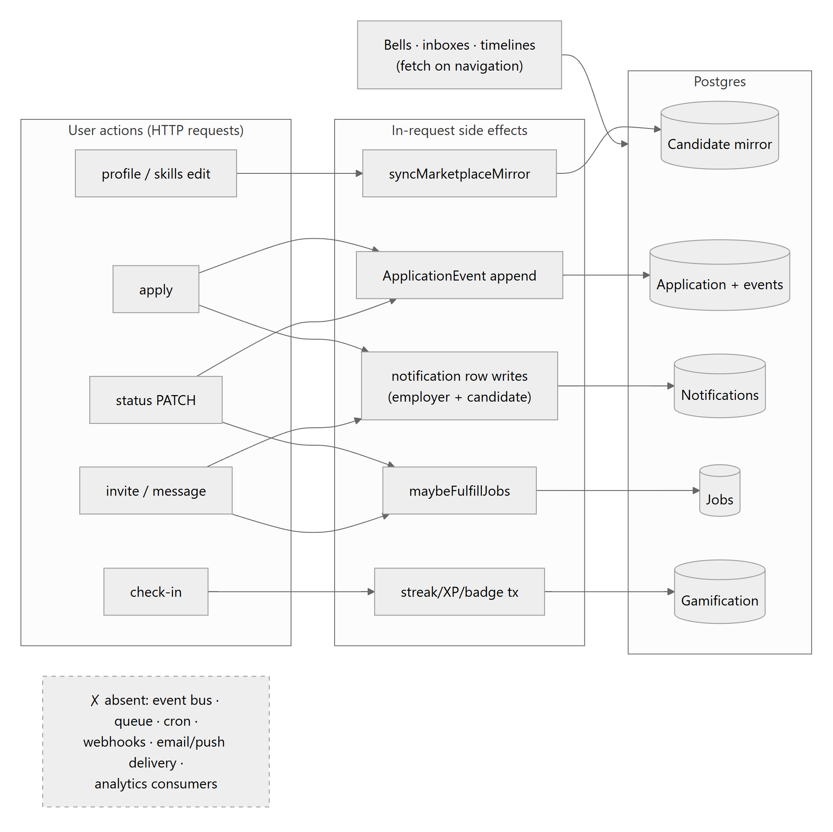

10.3 Consequences of the synchronous design
Wins: zero infrastructure, transactional consistency where it matters (invite, check-in, apply are atomic), trivially debuggable (one stack trace per action), no delivery-ordering problems.
Costs: side-effect latency rides on user requests (mirror projection adds queries to every profile save); failure coupling is managed ad hoc (the mirror swallows errors; notification writes after apply do not — a failed notification write fails the whole apply even though the application was created); effects are invisible to any future consumer (no outbox to subscribe to); and anything time-based only happens when someone looks. The extraction path — an outbox table written in the same transaction as the domain change, drained by a worker — is the single highest-leverage architectural upgrade available and is detailed in Section 18.

10.4 Notification subsystem
Figure 12 — Notification flow.
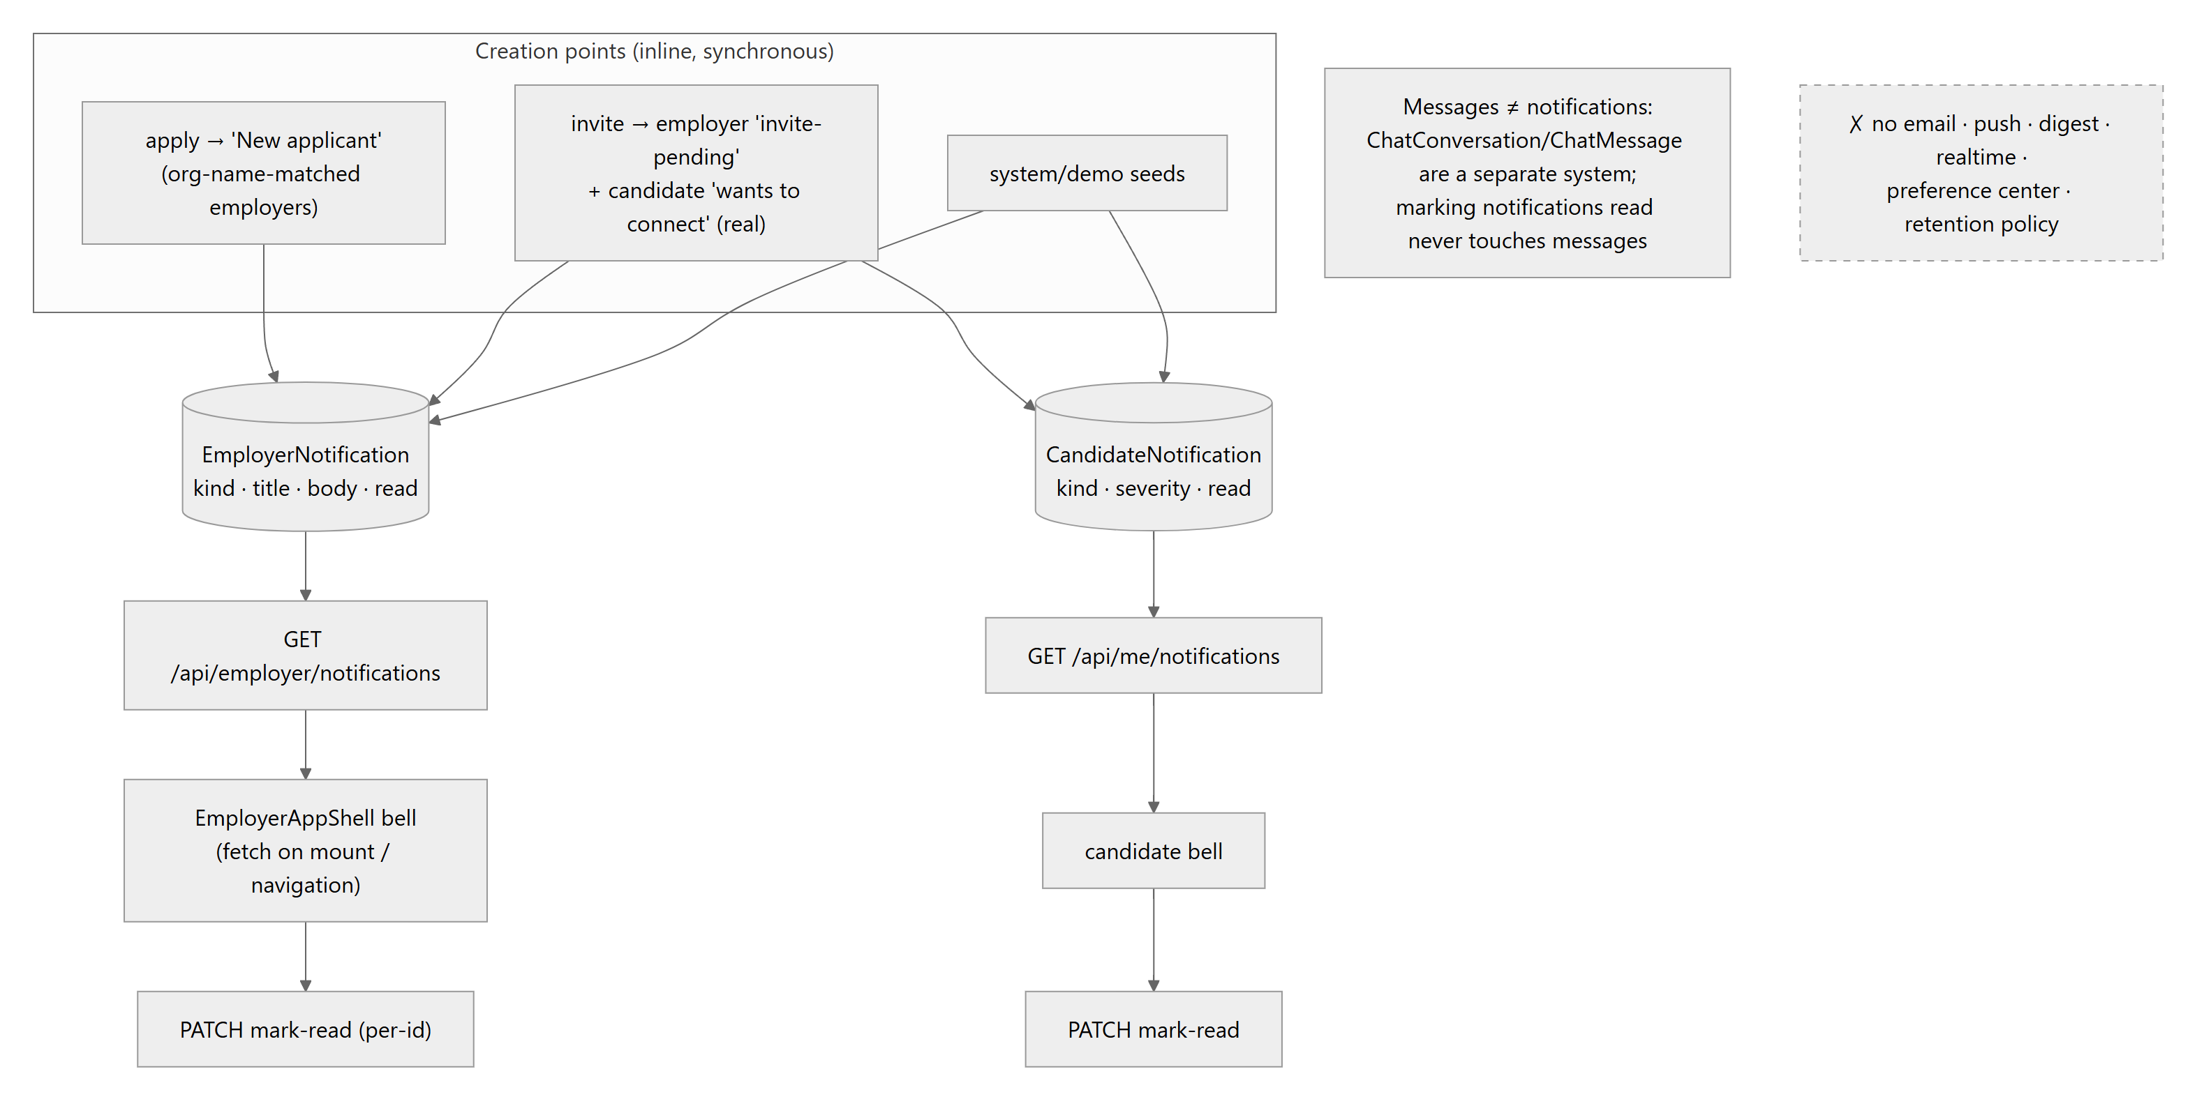
The messages/notifications separation is clean and correct. The gaps are delivery (nothing reaches a user who isn't in the app — despite the PWA groundwork that could host web push), lifecycle (no retention/archival), and preferences (no per-kind mute).

11. UX Design Review
Assessed from a product-design perspective across all 35 screens (this review follows a full-application design pass, so observations are grounded in every page, not a sample).
Navigation. The two-shell model is coherent: candidates get a persistent desktop sidebar + a mobile TopMenu whose nav groups are mobile-only (Settings/account persist everywhere); employers mirror it in clover. Cross-side redirects are automatic and role-correct. The four-question cockpit is a genuinely strong IA move — every card deep-links into the owning module, so the dashboard is a router, not a dumping ground. Minor friction: some destinations are reachable only through the cockpit or TopMenu but not the sidebar, and breadcrumbs are absent on deep pages (job detail → back relies on browser history).
Information hierarchy & visual language. Excellent and unusually consistent: mono uppercase eyebrows label every zone; display type is reserved for greetings/scores; accent color = ownership (luminous candidate / clover employer) rather than decoration; score signals always pair number + bar/ring + reasons. Employer marketplace rows lead with the match box (the decision-driving number) followed by identity, evidence chips, then actions — correct scan order.
Onboarding. The 5-step guided flow with CV import is well-paced conceptually (stage → discovery → growth → progression → feedback), supports ?edit=1 re-entry from Settings (answers editable without restarting — a detail most prototypes miss), and choice cards use explicit radio affordances. Frictions: the flow is long for younger phases (many optional fields presented with equal weight); CV import quality depends on deterministic heuristics, and partially-parsed fields are marked "from your CV" but there's no confidence signal; there is no save-and-resume indicator mid-flow (state survives, but the user isn't told).
Dashboards. Phase-awareness is real: younger phases get vibrant density and daily streaks; mid-career+ gets calm density (larger type, no decorative glows), a quiet monthly check-up, and the Career Health suite as the "how do I get there" answer. The age-adaptive density is user-overridable — adaptation without lock-in, the right pattern.
States. Empty states exist and are designed (messages placeholder, applications empty, skills bookshelf prompt, notification empties); loading is mostly skeleton/Loading… cards (visible flashes on cold compiles; some pages fetch sequentially and could parallelize); error handling has a global error.tsx + not-found.tsx, and API failures surface as inline messages rather than toasts everywhere — acceptable but inconsistent between pages. Freemium gates use a shared UpgradeModal with honest copy (mock billing is labelled).
Accessibility. Above-prototype average: semantic controls (role="switch", aria-pressed chips, role="alert" errors, labelled inputs), the skill radar has an aria description and a shape-encoded (dashed) reference series legible without color vision, native <details>/<select> are used where possible, animations respect an in-app reduce-motion toggle mapped to html.reduce-motion, and calm density raises readability. Gaps: no skip-to-content link, focus management on route change is default, modal focus-trap behavior should be verified, and a contrast audit for muted-on-glass text at small sizes is warranted. No automated a11y checks run in CI.
Responsiveness. The zero-scroll shell holds on desktop; mobile gets the TopMenu structure and a docs/mobile-pass.md exists documenting a dedicated pass. Wide tables (applicants pipeline) scroll within their region.
Top UX improvements (ordered): (1) notification delivery — an in-app-only bell that updates on navigation reads as "nothing happens here"; even a lightweight poll/badge count changes perceived liveness. (2) Onboarding progressive disclosure — defer optional preference fields to a post-onboarding "complete your profile" loop. (3) Consistent async feedback — one toast/inline pattern for save states across pages. (4) Candidate messaging depth — the inbox lists conversations; replying flows should match the employer side's completeness. (5) Add skip-nav + focus-on-heading after route change. (6) Explain scores at first touch — first-run tooltips on match/readiness leverage the reasons the engines already produce.

12. Code Quality Audit
Method. Full read of the backend core (schema, auth, api, services, engines, key routes), structural sweep of all 64 routes and 35 pages, import-graph spot checks, dead-code search, and lint/typecheck/build/check-suite runs (all green at time of writing).

12.1 What is excellent
Area | Evidence
Error architecture | Semantic error classes + one classifier → correct HTTP semantics everywhere; production leak-proofing; log-noise hygiene (respond.ts)
Auth discipline | Fail-closed secret resolution; DB-re-checked role/entitlements per request; transient tokens distinct from sessions; scoped cache purge on account switch
Intelligence layer | Pure, deterministic, one shared contract, behavioral invariants asserted in CI (__checks__/engines.check.ts)
Schema literacy | Every model documents intent, ownership of legal values, and privacy notes (salaryPrivate "never projected") in-schema
Debt honesty | Deliberate shortcuts carry ponytail: markers naming the ceiling and upgrade path — a self-maintaining debt ledger
Type discipline | Strict TS, no any (convention + lint), unknown+guards at boundaries, TS unions as single source of truth for enums
Naming | Consistent: *.service.ts, *Engine.ts, route families, PascalCase components, kebab routes, scoped cache keys

12.2 Findings register
Severity: how much damage if unaddressed. Priority: when to act.
# | Finding | Category | Severity | Priority | Recommended solution
Q-01 | No automated tests beyond 8 check scripts — auth flows, route authz, services, and UI have zero regression coverage | Testing | High | Now | Vitest for services/routes (the pure-engine pattern already proves testability); Playwright smoke for the 5 core journeys; wire into CI
Q-02 | Stateless JWT with no revocation — logout doesn't invalidate stolen tokens for up to 7 days; account deletion leaves live tokens | Security | Medium | Now | Add a sessionVersion on User checked in getAuthUser (cheap), or short-lived access + refresh rotation later
Q-03 | Rate limiter is per-instance in-memory — near-zero effect on serverless (per-lambda state) | Security | Medium | Now | Upstash/Redis fixed-window (drop-in at the same call sites); keep the in-memory fallback for dev
Q-04 | Client-only page gating — protected shells flash and are downloadable pre-auth (data itself is server-guarded) | Security/UX | Low–Med | Next | Session-cookie presence check in middleware.ts for /candidate/*, /employers/* as defense-in-depth
Q-05 | candidate/onboarding/page.tsx at 1,521 lines (state machine + 5 steps + CV import in one file); employers/onboarding 863; usePortfolio 630 | Maintainability | Medium | Next | Extract per-step components + a useOnboardingMachine hook; target <400 lines/file
Q-06 | Dead code: src/components/employer-onboarding/steps/* (5 files, zero importers — the live flow is inline in the page) | Dead code | Low | Now (trivial) | Delete; also remove the vestigial /candidate/resume page if the redirect is no longer linked
Q-07 | Data-access inconsistency: typed httpAdapter covers ~11 operations; everything newer uses raw fetch + ad-hoc envelope types (incl. AuthContext) | Consistency | Medium | Next | Either finish the adapter (one generated client from route types) or delete it and standardize on a tiny apiFetch<T>() — half-adopted abstractions cost more than none
Q-08 | Post-create side effects aren't transactional with their trigger: a failed notification write fails the whole apply (application already created → user sees an error for a succeeded action) | Correctness | Medium | Next | Wrap in $transaction where consistency matters, or isolate best-effort effects in try/catch (mirror-sync already models this correctly); long-term: outbox (§18)
Q-09 | Employer notification targeting by organization-name string match can mis-deliver on name collisions/renames | Correctness | Low–Med | Next | Now that Job.employerId exists, notify the owner directly for posted jobs; keep org-match only for catalogue rows
Q-10 | Read-time scoring + no pagination: marketplace scores every visible candidate per request; jobs list scores every job (in-code note: fine ≤~200 rows) | Performance | Low today / High at scale | Later (before growth) | Cursor pagination first; then cache scores keyed on (prefs-hash, candidate-updatedAt); precompute only if measurements demand
Q-11 | Expire-on-read mutates during GETs — surprising semantics, write amplification on hot lists, and nothing expires unobserved rows | Design | Low | Later | Move sweeps to a scheduled job once any scheduler exists (Vercel cron)
Q-12 | All context providers mount globally — employer contexts initialize (and read caches) on candidate pages and vice versa | Performance | Low | Later | Providers already no-op off-role; optionally split provider trees per shell
Q-13 | Docs drift: CLAUDE.md still describes candidate messages as a placeholder and "no employer job posting", both since shipped | Docs | Low | Now (trivial) | Sync CLAUDE.md/README with the current system (this document can seed it)
Q-14 | seed.ts at 705 lines mixes catalogue seeding, demo accounts, and CSV ingestion | Maintainability | Low | Later | Split per-domain seed modules
Q-15 | Only root-level error.tsx/not-found.tsx — a render error inside a shell page blanks the whole route | Resilience | Low | Later | Add segment error boundaries to the two shells
Q-16 | String pseudo-enums (accepted trade-off) rely on single-writer discipline; no DB CHECK constraints | DB design | Info | — | Revisit only if non-TS writers appear
Explicitly verified as clean: no circular imports found (routes → services → prisma is one-directional; engines are leaf-pure); no unused Prisma models (all 32 are referenced by live routes/services — ChapterEvent and CandidateNotification, the two most suspect, are wired to /candidate/chapters and the candidate bell respectively); no secrets in the repo; no dangerouslySetInnerHTML; dev/test surface properly double-gated server-side.

12.3 React/Next practices
Client components are properly marked; one-time set-state-in-effect sites carry the sanctioned eslint-disable with justification; memoization is applied where re-render pressure exists (SkillRadar memo over referentially-stable axes); no server components misuse client APIs (build enforces). Route handlers are uniformly thin. The Promise<params> App-Router convention is handled correctly. Areas to watch: several pages fetch sequentially where Promise.all would do; a few large client components would be cheaper as server-rendered shells with client islands — not urgent at current scale.

13. Strengths
- A real, defensible differentiator implemented honestly — the trust-tiered Skills Truth system with explainable, CI-guarded scoring is the product thesis in code, not a slide.
- Security posture beyond prototype norm — fail-closed secrets, server-scoped sessions on every route, CSRF middleware, entitlements re-read from the DB, real cascade account deletion.
- One error/response grammar across 64 routes — the single strongest maintainability asset in the codebase.
- The mirror-projection bridge — real candidates joined the marketplace without touching any employer flow; a textbook example of extending by projection instead of rewrite.
- Design system as infrastructure — tokens, two type voices, role-aware accent variables, hand-rolled accessible charts, age-adaptive density, reduce-motion support.
- Deterministic everything — no LLM/randomness in scoring means reproducible demos, testable invariants, and zero prompt-injection/bias-training surface today.
- Ethical guardrails in code — personality never scores, private salary never projected, demo data always labelled, forgivable streaks, XP only for real actions.
- Cache-first UX without cache-truth bugs — the scoped, purge-on-switch localStorage pattern is disciplined and documented.
- Additive, documented schema evolution — 32 models with intent comments; no destructive migrations.
- Honest engineering culture — shortcuts marked in-code with upgrade paths; fallbacks (jobs catalogue, dev secrets) clearly labelled.

14. Weaknesses
- No test suite — the highest-risk gap; every refactor is a leap of faith outside the engine layer.
- No asynchronous backbone — side effects, expiry, and delivery all ride user requests; the platform cannot act when no one is looking.
- Notifications don't notify — rows + a bell polled on navigation; no email/push/digest despite PWA groundwork.
- Single-instance assumptions — in-memory rate limiting (and any future in-process state) breaks on serverless/multi-instance.
- Static intelligence — hand-set weights, no outcome feedback loop, curated benchmarks standing in for market data.
- Read-time scoring without pagination — the marketplace/jobs hot paths scale linearly with catalogue size.
- Monolithic page components at the top of the size table (onboarding flows especially).
- No observability — no error tracker, no structured logs, no metrics; production issues are invisible until reported.
- Workflow depth stops at status — interview/offer/hire are labels, not workflows (no scheduling, artifacts, or structured feedback).
- Docs drift — the in-repo architecture notes lag the code they describe.

15. Missing Features

15.1 Technical
Category | Missing | Impact | Recommendation
Security | Email verification, password reset, 2FA, session revocation/device list, secret rotation, dependency audit in CI | Account takeover/lockout risk; unverified emails pollute identity | Reset+verification first (needs the email service below); sessionVersion now
Audit logs | No admin/audit trail of privileged or destructive actions (account deletion, status changes are only partially event-logged) | Compliance + forensics | Extend the append-only event pattern to a generic AuditEvent
Monitoring | No Sentry/OTel, no health endpoint, no uptime checks | Blind production | Sentry + /api/health + Vercel alerting — days, not weeks
Logging | console.* only, unstructured | Hard to trace | Structured logger with request ids; redact PII
Caching | No HTTP cache headers on public GETs (jobs/companies/leaderboard), no server-side memoization | Wasted compute | s-maxage+SWR headers on public catalogue routes
Rate limiting | Auth-only, in-memory | Abuse of apply/invite/message loops | Durable store; extend to mutation families
Background jobs | None — expiry is on-read; no digests, no reconciliation sweeps (mirror can drift if a sync write is missed) | Correctness at rest | Vercel cron + outbox worker (§18)
Search | SQL contains only; no FTS, facets, or typo tolerance | Discovery ceiling | Postgres FTS/pg_trgm first; engine later
Email service | None (blocks verification, reset, digests, invite emails) | Activation + retention | Resend/Postmark integration behind a small mailer port
Analytics | No product analytics or metrics warehouse | Flying blind on funnels | PostHog (self-hostable) + the event catalogue in §10.2 as the schema
AI capabilities | No LLM anywhere: CV parsing is heuristic, narratives are templates, matching is lexical | Quality ceiling on parsing/matching/story polish | Optional LLM layer with the guardrail: LLMs draft prose, never scores (§18)
Testing/CI | No unit/E2E; CI doesn't run check:applications/check:skills/etc. (only check:intelligence), no preview-deploy smoke, no migration step | Regression risk | Add all check scripts + Vitest + Playwright smoke to CI; prisma migrate deploy step gated on main
Accessibility | No automated a11y testing | Regression risk on a good baseline | axe smoke in Playwright
DX/Docs | No API reference, no ADRs beyond scattered design notes, no Storybook | Onboarding cost | Generate a route reference from this document's §4.2; keep CLAUDE.md synced
Admin/support | No admin panel, impersonation, or support tooling (dev harness is dev-only by design) | Ops cost post-launch | Minimal read-only admin over users/applications first
I18n / offline | English-only hardcoded strings; offline = app shell only | Market reach | Defer; extract strings when first locale lands

15.2 Product
Gap | Notes
Interview workflow | Scheduling, structured feedback forms, outcome capture — would also unlock the missing intelligence inputs
Candidate → candidate-side apply management | Withdraw action exists as a status but no candidate-facing API/UI to trigger it
Saved searches / job alerts | EmployerSavedSearch and candidate job alerts both absent; natural consumers of the notification upgrade
Learning loop | Records/progress/providers behind the curated suggestions; XP could reward completed learning (real action)
Employer team accounts | One user = one employer; no seats, roles, or shared pipelines
Real billing | Mock subscription flips a column; Stripe + webhooks + entitlement cache invalidation
Verified skills | Third-party verification (assessments, endorser identity) — today tier 3 trusts a typed-in endorser name
Candidate analytics | "Who viewed/saved you", visibility score — the data exists (saves, invites) but isn't surfaced
Trend reports | The "career intelligence OS" promise eventually needs longitudinal market views, not static CSVs

16. Improvement Roadmap
Phase 0 — Hygiene (days). Delete dead employer-onboarding steps; sync CLAUDE.md/README; add remaining check scripts to CI; sessionVersion revocation; segment error boundaries; org-owner notification for posted jobs (Q-09).
Phase 1 — Trust & safety net (1–2 sprints). Vitest over services + route authz (the highest-value tests: "candidate A cannot read B", "free user gets 402/redaction"); Playwright smoke ×5 journeys; Sentry + structured logs + health endpoint; Upstash rate limiting; email service + verification + password reset; middleware session gate for app shells.
Phase 2 — Asynchronous backbone (1–2 sprints). Outbox table + Vercel cron worker (§18); move expiry sweeps + mirror reconciliation there; notification fan-out (email digest + web push on the existing PWA); job alerts + saved searches as the first new consumers.
Phase 3 — Scale & product depth (quarter). Pagination + score caching on marketplace/jobs; Postgres FTS; real billing (Stripe); interview workflow + structured feedback (which unlocks outcome-aware intelligence); candidate visibility analytics; learning records.
Phase 4 — Intelligence evolution (after data accrues). Outcome-informed weight tuning (offline, explainable — factors stay human-readable); semantic skill matching (embeddings as a recall aid feeding the same explainable scorer); LLM narrative layer for CV parsing fallback and story polish under the never-touches-scores guardrail.

17. Technical Debt Report
Ranked by carrying cost. A distinctive asset of this codebase: much of its debt is self-declared via ponytail: markers with named upgrade paths — items 5–9 below come straight from those markers.
Rank | Debt item | Carrying cost | Paydown
1 | Zero test coverage outside engines | Every change risks silent regression; refactors deferred | Phase 1
2 | Synchronous side-effect architecture (no outbox/queue) | Latency on user requests; effects can't be retried, observed, or subscribed to; expiry only on-read | Phase 2
3 | Onboarding monolith pages (1,521 / 863 lines) | Highest-churn surfaces are the hardest to change safely | Phase 1–2, opportunistic
4 | Half-adopted httpAdapter | Two data-access idioms; envelope types re-declared ad hoc | Phase 1 decision: finish or fold
5 | ponytail: fixed 30-day TTLs (applications, job posts) | One-size expiry | Per-job column when needed (marker names it)
6 | ponytail: responsiveness score = status-only heuristic | Coarse company metric | Fold in time-to-first-response (marker names it)
7 | ponytail: in-memory rate limiter | Weak on serverless | Redis swap (marker names it)
8 | ponytail: curated learning map / market data | Static content masquerading as an engine | Provider integration (marker names it)
9 | ponytail: jobs list unpaginated | Fine ≤ ~200 rows | Cursor pagination (marker names the threshold)
10 | Mirror consistency is write-path-only (no reconciliation sweep) | Drift possible after failed syncs | Reconciliation job in Phase 2
11 | Docs drift (CLAUDE.md vs shipped features) | Misleads future contributors (and AI assistants) | Phase 0
12 | Dead employer-onboarding step components | Cognitive noise | Phase 0 (delete)
13 | Org-name notification bridge | Occasional mis/missed delivery | Phase 0 for owned jobs
14 | Global provider mounting | Minor wasted work per navigation | Phase 3, if measured
Not debt (deliberate, correctly-priced choices): string pseudo-enums with TS ownership; cuid PKs; expire-on-read at current scale; localStorage paint caches; demo/judge/test flag triad.

18. Recommended Future Architecture
The monolith is the right shape — do not introduce microservices. The recommended target keeps one Next.js deployable and adds four capabilities around it:
1. Transactional outbox → worker. Add an OutboxEvent table (type, payload, createdAt, processedAt). Every route that today performs inline side effects writes its domain change and an outbox row in one transaction; a worker (Vercel cron every minute, or QStash push) drains it through per-type handlers: notification fan-out, mirror sync/reconciliation, expiry sweeps, digests, analytics emission. The event catalogue in §10.2 becomes the type registry — the system's implicit events become explicit without a broker. Handlers must be idempotent; failures retry with backoff; the bell keeps reading rows exactly as it does now.
2. Delivery + durable shared state. Email (Resend/Postmark) and web push (the service worker already exists) as outbox consumers, with a per-user notification-preference row. Upstash Redis for rate limits and hot caches (marketplace score cache keyed on prefs-hash + candidate updatedAt).
3. Search & scale path. Cursor pagination on marketplace/jobs → Postgres FTS + pg_trgm for text search → only if warranted, pgvector for semantic skill recall feeding the existing explainable scorer (embeddings retrieve candidates; explainMatch still produces the number and the reasons — explainability is preserved by construction).
4. Observability + tests as permanent infrastructure. Sentry (client+server), OTel traces on route handlers, structured request-id logging; the Phase-1 test pyramid in CI; migration deploy step; preview-environment smoke.
The intelligence layer needs no structural change — its purity is exactly what lets outcome data (from the eventual interview/hire workflow) tune weights offline while every score remains a explainable factor sum. The one hard rule to carry forward: generative models may draft prose; only deterministic, inspectable functions produce scores.

19. Conclusion
CareerOS is a prototype with production-grade bones in the places that are hardest to retrofit — identity, authorization, error semantics, data-model integrity, and an explainable intelligence core — and prototype-grade scaffolding in the places that are straightforward to add when needed — tests, async processing, delivery, observability. The codebase's most valuable cultural artifact is its honesty: demo data is labelled, shortcuts are marked with their upgrade paths, uncertainty is printed on every score. The architecture recommendation is therefore conservative: keep the monolith, keep the determinism, add the safety net (tests, monitoring), then the asynchronous backbone (outbox → worker → delivery), and let the intelligence layer grow into its data rather than ahead of it. Executed in that order, the platform can scale its trust story — which is, after all, the product.

Appendix A — Figure index & Mermaid sources
Figure | Title | Section
1 | Candidate process flow | §6
2 | Employer process flow | §7
3 | System architecture | §2.4
4 | Backend module map | §8.1
5 | Frontend architecture | §3.3
6 | Authentication flow | §4.4
7 | API request lifecycle | §4.6
8 | Database relationships | §5.5
9 | Matching engine flow | §9.5
10 | Intelligence engine dataflow | §9.2
11 | Event/effect flow | §10.2
12 | Notification flow | §10.4
All diagrams are authored in Mermaid. In the Markdown edition of this document the sources are embedded at their sections (and render natively on GitHub); the sources are reproduced below for the exported edition.
Figure 3 — System architecture (see Section 8 for the module-level view).
flowchart TD
subgraph Client["Browser — React 19 SPA-style client"]
UI["Pages + design-system primitives"]
CTX["Context providers<br/>(Auth, Intent, Portfolio, Chapters,<br/>Notifications, Employer, SavedCandidates)"]
LS[("localStorage<br/>scoped paint cache")]
SW["Service worker (PWA)<br/>shell cache-first, API never cached"]
UI --> CTX
CTX <--> LS
end

subgraph Server["Next.js 16 — single deployable (Vercel)"]
MW["middleware.ts<br/>CSRF origin check on mutating /api/*"]
API["64 API route handlers<br/>{ ok, data } | { ok, error } envelope"]
LIB["src/lib services + engines<br/>auth · billing · intelligence · services"]
MW --> API --> LIB
end

subgraph Data["Data layer"]
PRISMA["Prisma 6 client"]
PG[("Neon Postgres<br/>32 models")]
PRISMA --> PG
end

GOOGLE["Google OAuth<br/>(optional, flag-gated)"]

CTX -- "fetch (cookie auth, no-store)" --> MW
LIB --> PRISMA
API -. "OAuth handshake" .-> GOOGLE
Figure 5 — Frontend architecture.
flowchart TD
RL["Root layout.tsx<br/>fonts · manifest · providers"] --> AP["AuthProvider<br/>session state + cache scoping"]
AP --> PWA["PwaProvider / MotionProvider"]
AP --> DOM["Domain providers<br/>Intent · Notifications · Portfolio<br/>Chapters · Employer · SavedCandidates"]

DOM --> SHELLC["AppShell (candidate)<br/>gate: auth + role + onboarding"]
DOM --> SHELLE["EmployerAppShell<br/>gate + data-role-accent=employer"]
DOM --> PUB["Public pages<br/>/ · /auth · /jobs · /companies<br/>/pricing · /leaderboard · /judge"]

SHELLC --> CPAGES["/candidate/* — dashboard cockpit,<br/>skills, portfolio, applications,<br/>career-health, personality, messages,<br/>chapters, settings, onboarding"]
SHELLE --> EPAGES["/employers/* — dashboard, marketplace,<br/>applicants, post-job, saved, messages,<br/>notifications, chat, contact, settings,<br/>onboarding"]

subgraph DS["Design system"]
PRIM["ui/ primitives — Button · Badge · Chip ·<br/>ScoreBar · ProgressRing · Select · Modal ·<br/>LinkButton · ConfirmDialog · Grid12"]
TOK["Tokens — luminous/clover accents,<br/>glass surfaces, mono label voice"]
end
CPAGES --> PRIM
EPAGES --> PRIM
PRIM --> TOK
Figure 6 — Authentication flow.
sequenceDiagram
autonumber
participant B as Browser
participant M as middleware (CSRF)
participant A as /api/auth/*
participant DB as Postgres

rect rgb(240,244,255)
note over B,DB: Password login
B->>M: POST /api/auth/login {identifier, password}
M->>A: Origin/Referer host == Host ✓
A->>A: rateLimit(ip+identifier) — 10/min fixed window
A->>DB: find User by email/username
A->>A: bcrypt.compare(passwordHash)
A->>A: signSession → HS256 JWT {userId, role, isJudge} (7d)
A-->>B: Set-Cookie career-os-session (httpOnly, SameSite=Lax, Secure in prod)
B->>A: GET /api/auth/me (AuthContext.refresh)
A->>DB: load User + onboarding flags
A-->>B: {user, candidateOnboardingCompleted, employerOnboardingCompleted}
B->>B: shell redirects by role + onboarding state
end

rect rgb(240,255,242)
note over B,DB: Google SSO (flag-gated, optional)
B->>A: GET /api/auth/google/start → redirect to Google
B->>A: GET /api/auth/google/callback?code
A->>A: exchange code, verify identity
A->>DB: OAuthAccount lookup (provider, sub)
alt account exists
A-->>B: session cookie (same JWT shape)
else new identity
A-->>B: transient signed token → /auth/google/role (role pick)
B->>A: POST /api/auth/google/role
A->>DB: create User + OAuthAccount (+ profile rows)
A-->>B: session cookie
end
end
Figure 7 — API request lifecycle.
sequenceDiagram
autonumber
participant C as Component / Context
participant MW as middleware.ts
participant H as Route handler
participant CU as currentUser.ts
participant S as Service / Engine
participant P as Prisma → Neon

C->>MW: fetch("/api/…") with session cookie
alt mutating request with foreign Origin
MW-->>C: 403 {ok:false, code:"forbidden"}
else same-origin or safe method
MW->>H: pass through
end
H->>CU: getCurrentCandidateProfile()
CU->>P: readSession → User → profile row
CU-->>H: profile (or throws Unauthorized/Forbidden)
H->>H: Zod parse body (throws ZodError)
H->>S: service call / engine scoring
S->>P: reads + tx writes + side effects<br/>(events, notifications, mirror)
S-->>H: result
H-->>C: ok(data) or failFromUnknown → 4xx/5xx
C->>C: setState + write scoped localStorage paint cache
Figure 8a — Database relationships: identity & candidate space. For legibility, sibling child tables are collapsed into group boxes — each named row inside a group is its own physical table, FK'd to the parent shown (full inventory in §5.1).
erDiagram
USER ||--o| CANDIDATE_PROFILE : "role CANDIDATE"
USER ||--o| CANDIDATES_AI : "onboarding answers"
USER ||--o| SUBSCRIPTION : "free | pro"
USER ||--o{ OAUTH_ACCOUNT : "google sub"
USER ||--o| CANDIDATE : "mirror real-userId"

CANDIDATE_PROFILE ||--o{ EVIDENCE_TABLES : "1:N each"
CANDIDATE_PROFILE ||--o{ GROWTH_TABLES : "1:N or 1:1"
CANDIDATE_PROFILE ||--o{ APPLICATION : "unique per job"

EVIDENCE_TABLES {
table SkillClaim "3-tier trust"
table Certificate "portfolio"
table Award "portfolio"
table Project "portfolio"
table Experience "portfolio"
table ResumeVersion "JSON snapshots"
table ChapterEvent "planner"
}
GROWTH_TABLES {
table XpLedger "append-only"
table Streak "forgivable, 1:1"
table Badge "unique per key"
table MidCareerProfile "1:1 private salary"
table PersonalityResult "1:1 archetype"
table CandidateNotification "inbox"
}
Figure 8b — Database relationships: employer side, marketplace, jobs & messaging.
erDiagram
USER ||--o| EMPLOYER_PROFILE : "role EMPLOYER"
USER ||--o| EMPLOYERS_AI : "hiring intent"

EMPLOYER_PROFILE ||--o{ ENGAGEMENT_TABLES : "acts on"
CANDIDATE ||--o{ ENGAGEMENT_TABLES : "target"
ENGAGEMENT_TABLES {
table EmployerSavedCandidate "composite PK"
table EmployerInvitedCandidate "composite PK"
table EmployerNotification "bell"
}

EMPLOYER_PROFILE ||--o{ CHAT_CONVERSATION : "unique pair"
CANDIDATE ||--o{ CHAT_CONVERSATION : "via mirror id"
CHAT_CONVERSATION ||--o{ CHAT_MESSAGE : ""

EMPLOYER_PROFILE ||--o{ JOB : "posted; status TTL"
COMPANY ||--o{ JOB : ""
JOB ||--o{ APPLICATION : ""
CANDIDATE_PROFILE ||--o{ APPLICATION : "unique per job"
APPLICATION ||--o{ APPLICATION_EVENT : "append-only"

SALARY_BENCHMARK {
string natural_key "role+industry+size+location"
string percentiles "p25 p50 p75 p90"
}
UNIVERSITY {
string name "curated, cited"
int score "employability 0-100"
}
Figure 1 — Candidate process flow (DB = database write, N = notification created).
flowchart TD
L["Landing page /"] --> AUTH{"Account?"}
AUTH -- "sign up (password or Google)" --> SU["POST /api/auth/signup<br/>DB: User + profile rows"]
AUTH -- "log in" --> LI["POST /api/auth/login<br/>rate-limited, bcrypt"]
SU --> ONB
LI --> GATE{"onboardingCompleted?"}
GATE -- no --> ONB["5-step onboarding + CV import<br/>DB: CandidatesAI (answers, skills, goals)"]
GATE -- yes --> DASH
ONB --> DASH["Cockpit dashboard<br/>phase-aware, 4 questions"]

subgraph GROW["Grow — evidence & diagnostics"]
direction TB
SKILLS["Skills Truth cockpit<br/>DB: SkillClaim (tier derived server-side)"] --> EVID{"add evidence /<br/>endorsement?"}
EVID -- yes --> TIER["tier 2/3 → trust-weighted radar,<br/>gaps + ONE next step"]
TIER --> LEARN["curated learning suggestions<br/>(static map per skill)"]
LEARN --> SKILLS
SKILLS ~~~ PORT["Living Portfolio<br/>DB: Project/Experience/Certificate/Award,<br/>ResumeVersion snapshots · PDF (Pro gate 402)"]
PORT ~~~ PERS["Personality quiz<br/>DB: PersonalityResult (descriptive only)"]
PERS ~~~ HEALTH["Career Health (mid-career+)<br/>fair pay (Pro) · skill bridge · next moves"]
end

DASH --> GROW
DASH --> CHECK["Check-in (StreakChip)<br/>POST /api/me/checkin<br/>DB: Streak + XpLedger + Badge (tx)"]
CHECK --> DASH

GROW --> MIRROR["syncMarketplaceMirror<br/>DB: Candidate real-userId upsert"]
DISC["Settings: discovery opt-in<br/>PATCH /api/me/discovery"] --> MIRROR
MIRROR --> MKT["visible in employer marketplace"]
MKT -.-> INV["Employer invite<br/>N: candidate 'wants to connect'<br/>DB: ChatConversation"]
INV --> MSG["/candidate/messages inbox<br/>GET /api/me/conversations"]

DASH --> JOBS["/jobs — personalized match<br/>skill-bridge score + reasons"]
JOBS --> APPLY["POST /api/jobs/id/apply<br/>DB: Application + submitted event<br/>N: employer 'New applicant'"]
APPLY --> TL["My Applications timeline"]
EMP["Employer status change"] -. "DB: ApplicationEvent" .-> TL
TL --> OUT{"outcome"}
OUT -- offer --> WIN["Offer 🎉 (job may auto-fulfill)"]
OUT -- "rejected / expired" --> DASH
WIN --> DASH
Figure 2 — Employer process flow.
flowchart TD
L["Landing /"] --> A["Sign up / log in (EMPLOYER)"]
A --> G{"hasCompletedOnboarding?"}
G -- no --> ONB["5-step employer onboarding<br/>DB: EmployersAI + EmployerProfile<br/>(one transaction flips both)"]
G -- yes --> DASH["/employers/dashboard"]
ONB --> DASH

DASH --> POST["Post a job<br/>POST /api/employer/jobs<br/>DB: Company upsert by org name + Job<br/>(3–5 weighted skills, 30-day TTL)"]
POST --> FEED["job appears in public /jobs feed"]

DASH --> MKT["Marketplace<br/>GET /api/marketplace<br/>seeded + projected real candidates"]
MKT --> RANK["explainMatch per candidate<br/>35/30/15/10/10 weights + reasons<br/>+ uncertainty statement"]
RANK --> VIEW["profile modal — readiness factors,<br/>insight engine, archetype (Bias Check)"]
VIEW --> SAVE["Save<br/>DB: EmployerSavedCandidate"]
VIEW --> INVITE["Invite (tx):<br/>DB: EmployerInvitedCandidate +<br/>ChatConversation + intro message<br/>N: employer invite-pending<br/>N: candidate 'wants to connect' (real only)"]
INVITE --> CHAT["Messages<br/>/employers/messages + chat"]

FEED -.-> APPLIED["candidate applies"]
APPLIED -. "N: 'New applicant'" .-> BELL["Notification bell"]
BELL --> PIPE["/employers/applicants pipeline"]
PIPE --> STATUS["PATCH /api/employer/applications/id<br/>DB: status + ApplicationEvent"]
STATUS --> IV["interview"]
IV --> OFFER["offer"]
OFFER --> FULFILL{"offer + message<br/>exchanged?"}
FULFILL -- yes --> DONE["Job auto-fulfills<br/>DB: Job.status = fulfilled<br/>(leaves public feed, kept in history)"]
FULFILL -- no --> PIPE
CHAT --> FULFILL

DONE --> DASH
STATUS -. "responseScore feeds company<br/>responsiveness metrics" .-> METRICS["companies.service"]
Figure 4 — Backend module map.
flowchart LR
subgraph ROUTES["API route families (64)"]
RA["auth/*"]
RME["me/* (24)"]
REM["employer/* (13)"]
RPUB["jobs · companies · marketplace ·<br/>leaderboard · invites · messages"]
RACC["account"]
RDEV["dev/* (flag-gated)"]
end

subgraph LIB["src/lib"]
subgraph CORE["Cross-cutting"]
AUTHL["auth/ — session, password,<br/>google, rateLimit"]
APIL["api/ — respond, errors,<br/>currentUser, httpAdapter"]
BILL["billing/ — plans, entitlements"]
VAL["validation, utils, storage/appCache"]
end
subgraph DOMAIN["Domain services"]
SAPP["applications.service"]
SJOB["jobs.service"]
SGAM["gamification.service"]
SCOM["companies.service"]
SLEAD["leaderboard.service"]
PROJ["candidates/projection (mirror)"]
end
subgraph INTEL["Intelligence (11 engines)"]
SC["scoringConfig — ScoreResult contract"]
ENG["match · readiness/careerScore ·<br/>careerHealth · skillTruth · skillBridge ·<br/>transferable · fairPay+lifeImpact ·<br/>careerStory · personality · insight ·<br/>nextMoveSimulator"]
end
subgraph DATA["Curated data"]
TAX["skills/taxonomy + learning"]
MKTD["market/marketData"]
JOBD["jobs/data (TARGET_JOBS fallback)"]
RES["resume/ — completeness, pdfTemplate"]
end
end

PR["prisma client"] --> NEON[("Neon Postgres")]

ROUTES --> APIL
ROUTES --> AUTHL
RME --> SAPP & SGAM & PROJ & INTEL & RES
REM --> SJOB & SAPP & PROJ
RPUB --> SJOB & SCOM & SLEAD & INTEL
RME --> BILL
DOMAIN --> PR
ROUTES --> PR
INTEL -.->|pure functions, no DB| SC
DATA -.-> INTEL
Figure 10 — Intelligence engine dataflow.
flowchart LR
subgraph INPUTS["Inputs (assembled per-request by routes)"]
P["CandidateProfile + evidence rows"]
AI["CandidatesAI answers"]
SK["SkillClaims (tiers)"]
JB["Job requiredSkills / weights"]
EP["EmployersAI hiring prefs"]
BM["SalaryBenchmark (curated CSV)"]
MV["Candidate mirror row"]
end

subgraph CONTRACT["scoringConfig.ts"]
SR["ScoreResult<br/>score · reasons · factors · uncertainty"]
end

subgraph ENGINES["11 pure engines (no I/O)"]
E1["skillTruth"]
E2["readiness / careerScore"]
E3["explainMatch / candidateMatch"]
E4["skillBridge"]
E5["careerHealth"]
E6["fairPay + lifeImpact"]
E7["transferable · careerStory ·<br/>personality · insight · nextMove"]
end

SK --> E1
P --> E2
MV --> E2 & E3
EP --> E3
JB --> E4
P & AI --> E5 & E7
BM --> E6

ENGINES --> SR
SR --> API2["API routes<br/>me/skills · me/mid-career · me/fair-pay ·<br/>jobs · marketplace"]
API2 --> UI2["UI — radar, score bars, reasons lists,<br/>'why this score?' panels"]
CI["CI: npm run check:intelligence<br/>(assertion harness, every push)"] -.-> ENGINES
Figure 9 — Matching flows on both sides.
flowchart TD
subgraph EMP["Employer → candidate (marketplace)"]
PREFS["EmployersAI prefs<br/>targetRoles · requiredSkills ·<br/>industries · greenFlags"]
CAND["visible Candidate rows<br/>(seed + projected real)"]
EM["explainMatch — weights printed in reasons:<br/>role 35 · skills 30 (proportional) ·<br/>industry 15 · green flags 10 · baseline 10"]
PREFS --> EM
CAND --> EM
EM --> OUT1["score + reasons + uncertainty:<br/>'self-reported, not yet verified'"]
OUT1 --> RANK1["sort marketplace rows"]
OUT1 --> MODAL["detail modal 'why this match'"]
end

subgraph CANDSIDE["Candidate → job (jobs feed)"]
SKL["caller skills =<br/>profile.skills ∪ CandidatesAI.currentSkills"]
JOBS2["active Job rows"]
SB["scoreSkillBridge —<br/>coverage of requiredSkills,<br/>matched + missing lists"]
SKL --> SB
JOBS2 --> SB
SB --> OUT2["personalized match + reasons<br/>(anonymous callers see curated baseMatch)"]
OUT2 --> RERANK["re-rank jobs list"]
end

EMP ~~~ CANDSIDE
Figure 11 — Effect flow as implemented (all synchronous).
flowchart LR
subgraph ACTIONS["User actions (HTTP requests)"]
A1["profile / skills edit"]
A2["apply"]
A3["status PATCH"]
A4["invite / message"]
A5["check-in"]
end

subgraph EFFECTS["In-request side effects"]
MIR["syncMarketplaceMirror"]
EVT["ApplicationEvent append"]
NOTI["notification row writes<br/>(employer + candidate)"]
FUL["maybeFulfillJobs"]
GAM["streak/XP/badge tx"]
end

subgraph STATE["Postgres"]
T1[("Candidate mirror")]
T2[("Application + events")]
T3[("Notifications")]
T4[("Jobs")]
T5[("Gamification")]
end

A1 --> MIR --> T1
A2 --> EVT & NOTI
A3 --> EVT --> T2
A3 --> FUL --> T4
A4 --> NOTI --> T3
A4 --> FUL
A5 --> GAM --> T5

READERS["Bells · inboxes · timelines<br/>(fetch on navigation)"] --> STATE

ABSENT["✗ absent: event bus · queue · cron ·<br/>webhooks · email/push delivery ·<br/>analytics consumers"]
style ABSENT stroke-dasharray: 5 5
Figure 12 — Notification flow.
flowchart TD
subgraph WRITERS["Creation points (inline, synchronous)"]
W1["apply → 'New applicant'<br/>(org-name-matched employers)"]
W2["invite → employer 'invite-pending'<br/>+ candidate 'wants to connect' (real)"]
W3["system/demo seeds"]
end

W1 --> EN[("EmployerNotification<br/>kind · title · body · read")]
W2 --> EN
W2 --> CN[("CandidateNotification<br/>kind · severity · read")]
W3 --> EN & CN

EN --> GE["GET /api/employer/notifications"]
CN --> GC["GET /api/me/notifications"]
GE --> BELL2["EmployerAppShell bell<br/>(fetch on mount / navigation)"]
GC --> BELLC["candidate bell"]
BELL2 --> MR["PATCH mark-read (per-id)"]
BELLC --> MRC["PATCH mark-read"]

NOTE2["Messages ≠ notifications:<br/>ChatConversation/ChatMessage are a separate system;<br/>marking notifications read never touches messages"]
MISSING2["✗ no email · push · digest · realtime ·<br/>preference center · retention policy"]
style MISSING2 stroke-dasharray: 5 5

Appendix B — Method & coverage
Analysis basis: full reads of the Prisma schema (32 models), the auth/api/billing core, all domain services, the matching/readiness/projection layer, representative route handlers across every family, client state architecture (AuthContext, provider tree, cache scoping), environment/CI configuration, and structural inventories (all 64 routes, all 35 pages, all lib modules, component folders, seed fixtures); plus a complete page-by-page UI pass of all 35 screens conducted immediately prior to this review. Verification state at time of writing: npm run lint, npx tsc --noEmit, npm run check:intelligence, and npm run build all pass. Line counts via git ls-files | wc -l. Statements about absent capabilities (no queue, no LLM, no polling loops, no tests) were established by targeted search, not assumption.

