# Abstract

The idea that some abilities might be enhanced by adversity is gaining traction. Adaptation-based approaches have uncovered a few specific abilities enhanced by particular adversity exposures. Yet, for a field to grow, we must not dig too deep, too soon. In this paper, we complement confirmatory research with principled exploration. We draw on two insights from adaptation-based research: 1) enhanced performance manifests within individuals, and 2) reduced and enhanced performance can co-occur. Although commonly assumed, *relative* performance differences are rarely tested. To quantify them, we need a wide variety of ability measures. However, rather than using adaptive-logic to predict which abilities are enhanced or reduced, we develop statistical criteria to identify three data patterns: reduced, enhanced, and intact performance. With these criteria, we analyzed data from the NICHD Study of Early Child Care and Youth Development to investigate how adversity shapes within-person performance across 10 abilities in a cognitive and achievement battery. Our goals are to document adversity-shaped cognitive performance patterns, identify drivers of reduced performance, identify sets of ‘intact’ abilities, and discover new enhanced abilities. We believe principled exploration with clear criteria can help break new theoretical and empirical ground, re-map old territory, and advance theory development.

# How does adversity relate to performance across different abilities within individuals?

Developmental science commonly asserts that adversity-exposure during development reduces cognitive performance—a claim founded on decades of empirical findings (Duncan et al., 2017; Farah et al., 2006; Fraley et al., 2013; Hackman et al., 2010; McLaughlin et al., 2019; Raby et al., 2015). In recent years, however, adaptation-based frameworks, rooted in the idea that adversity might enhance certain abilities, have complemented this work (Ellis et al., 2017; Ellis et al., 2022; Frankenhuis, Young, et al., 2020; Frankenhuis & de Weerth, 2013; Frankenhuis & Nettle, 2020). Since their inception, the goal of adaptation-based frameworks has been to inspire a more well-rounded view of adversity and its influence on abilities—one that incorporates both the struggles and strengths of people from disadvantaged backgrounds (Frankenhuis & de Weerth, 2013). As such frameworks develop further, the core task of adaptation-based research is to “uncover a high-resolution map of specific cognitive abilities that are enhanced as a result of growing up under high-adversity conditions” (Ellis et al., 2017, p. 562). To do so, researchers to date have used confirmatory study designs, which have gleaned useful insights. However, to cultivate growth in an emerging research program—where there is little known and much to learn—we must not dig too deep, too soon. Without complementary approaches, exclusive use of confirmatory designs can create tunnel vision and miss new insights and findings (McIntosh, 2017; Roisman, 2021; Rozin, 2001; Scheel et al., 2021). Research programs benefit from taking a pluralistic approach, especially in the early stages. Based on this realization, there have been calls for more observational and exploratory research, alongside confirmatory research, both for the psychological sciences generally (Roisman, 2021; Scheel et al., 2021) and for the study of human evolution and behavior in particular (Barrett, 2020).

In this paper, we use a complementary approach to confirmatory research: principled exploration. To guide our exploration, we build on two basic insights from adaptation-based research: 1) enhanced performance manifests within individuals, and 2) reduced and enhanced performance can co-occur. The first insight implies we need designs and models that can tease apart both within- and between-person performance differences. The second suggests that, in order to map out more of the adversity-ability landscape, we must examine multiple abilities measured within the same person. Doing so will allow us to describe cognitive performance in three distinct data patterns: reduced, intact, and enhanced performance. Past research has focused primarily on reduced and enhanced performance on tests of single abilities. However, we know little about intact abilities, defined as cases in which test performance is unrelated to adversity exposure. Our goal, therefore, is to document adversity-shaped cognitive performance patterns that include reduced performance, intact abilities, *and* enhanced test performance patterns.

# Essential Features and Empirical Insights from Adaptation-based Frameworks

Adaptation-based research has two essential features. First, such research assumes that development shapes the individual, as well as their abilities, to fit their local environment (Frankenhuis, Young, et al., 2020). Second, because environments differ in the challenges they pose (e.g., resource-scarcity versus violence exposure), development also shapes abilities according to specific challenges. Thus, one’s abilities should match the challenges of an individual’s lived experience. These features are useful guideposts for confirmatory hypothesis generation. Using them as building blocks, it is possible to construct an intuitive bridge between an ability and an environmental challenge. For example, a researcher might identify a specific challenge posed by a dimension of adversity (e.g., threats to safety in high-crime neighborhoods) and an ability needed to meet the challenge (e.g., enhanced threat detection).

This approach is appealing because it forces researchers to be specific and logically tie together challenges and abilities. It has also been successful in discovering a handful of adversity-enhanced abilities, especially in harsh and unpredictable environments. For example, some scholars have proposed that constantly changing environments (i.e., unpredictable environments) might shape the ability to track and respond to changing information. Using this logic, prior research has built an intuitive bridge between changing environments and two specific abilities–attention-shifting and working memory updating—and some empirical results are consistent with this logic (e.g., Fields et al., 2021; Mittal et al., 2015; Nweze et al., 2021; Young et al., 2018).

There are two limitations to this approach. First, previous studies are difficult to compare because they use different measures and designs. Second, the logic behind confirmatory hypotheses can be easily flipped. For example, exposure to unpredictable environments is thought to reduce inhibition, or the ability to resist distractions. If opportunities are fleeting and threats are unpredictable, inhibition is costly because focusing on long-term goals might cause one to miss opportunities or fail to detect a threat. However, we can also assert the exact opposite. For example, inhibition might be enhanced by unpredictable environments because attending to every possible opportunity or threat will derail most goal-directed actions. Thus, adaptive logic can afford different or (in some cases) opposing hypotheses. This does not diminish the enterprise—empirical research is the ultimate arbiter—but there is a risk of becoming too focused on a particular corner of hypothesis space, when other regions would be just as reasonable to explore (Andrews et al., 2002; Ketelaar & Ellis, 2000; Lewis et al., 2017). It is important to recognize that just because adaptive logic can be reversed does not make it invalid. Instead, we highlight that, by design, adaptive logic restricts inquiry to those abilities for which it can be constructed.

Adaptation-based research has also focused on testing content, or the notion that performance should improve when the testing content matches the lived experience of people exposed to adversity. For example, studies have examined relational memory, attention shifting, and working memory task performance using more ecologically-relevant testing content (e.g., social dominance, real-world, and socioemotional stimuli) compared to neutral or abstract content. In some cases, ecologically-relevant content tends to equalize performance for people exposed to adversity, but this depends on the specific adversity measure and task (Frankenhuis, de Vries, et al., 2020; Rifkin-Graboi et al., 2021; Young et al., 2022). In other studies, however, conditions thought to be well-matched to the lived experience of those exposed to adversity actually lower performance. For example, youth from low socioeconomic backgrounds tend to score lower on math items about social relations, money, and food—items thought to be particularly relevant to lived experience—compared to other math items (Duquennois, 2022; Muskens, 2019).

In light of these caveats, this body of work has generated at least two broad empirical insights. First, although it is possible for adversity to enhance performance between individuals (e.g., low versus high adversity exposure), empirical findings suggest effects mostly occur *within* individuals (Fields et al., 2021; Frankenhuis, de Vries, et al., 2020; Young et al., 2022). Second, associations between specific types of adversity and enhanced performance appear to be context specific—enhancements depend on the testing content, context, and ability type (Fields et al., 2021; Frankenhuis, de Vries, et al., 2020; Mittal et al., 2015; Nweze et al., 2021; Young et al., 2018; Young et al., 2022). As a result, we know little about how enhanced abilities relate to broader sets of ability measures.

# **Motivating Principled Exploration**

We believe that adaptation-based frameworks offer useful guidance. However, it is essential to use shovels, not scalpels, when breaking new theoretical and empirical ground. Emerging research programs have yet to lay the basic groundwork for testing theories, such as key auxiliary assumptions or boundary conditions (Scheel et al., 2021). Our goal is to complement adaptation-based, confirmatory research with principled exploration (Flournoy et al., 2020; Rozin, 2001).

To motivate principled exploration, we can compare how it differs from confirmatory approaches. Both start with a research question, such as “How does adversity exposure shape cognitive performance?” A confirmatory approach then generates hypothesis and predictions. For example, the hypothesis “cognitive abilities are shaped by adaptive challenges in one’s local environment” can lead to the prediction “individuals exposed to unpredictable environments enhance attention shifting to track changes.” Useful predictions are clear and specific. Methods and analysis are then chosen based on their potential to reveal the expected result.

Principled exploration approaches the research question differently. Instead of generating hypotheses and predictions, it asks, “What are the logically possible ways adversity might shape cognition?” This prompts us to define different scenarios like “unpredictability could enhance, reduce, or leave attention shifting intact.” We then design methods and analyses to distinguish between these possibilities and select those with the best potential to discern possible outcomes. In this sense, principled exploration shifts the focus from finding an expected pattern to exploring alternative patterns and describing which empirical patterns constitute evidence for and against different possibilities.

Confirmatory approaches use predictions like a scalpel – they attempt to carve out a narrow space for an expected result. They work best when much ground has already been coarsely excavated and ready for precise incision. In contrast, when little ground has been broken, we need a strategy for broad excavation and tools for exposing the general contours of what is underneath. In the words of Paul Rozin: “Just as biologists have learned about life by studying different species and different environments, we would do well to open our eyes more widely before we dig too deep a hole at one place in the broad and varied terrain of human social life” (Rozin, 2001, p. 13).

Principled exploration can benefit both deficit and adaptation-based research. In a field dominated by confirmatory approaches, it encourages re-examination of assumed and established patterns with a new lens. For example, both deficit- and adaptation-based perspectives assume that adversity should reduce performance on standard assessments of cognitive ability (Ellis et al., 2022; Frankenhuis, Young, et al., 2020; Hackman et al., 2010; McLaughlin et al., 2019; Ursache & Noble, 2016). Yet, these tests are often comprised of many different subtests, and individual tests may show unique patterns that diverge from widely used composite scores (e.g., Fraley et al., 2013; Raby et al., 2015). For the deficit literature, principled exploration prompts a closer examination of such tests, because it is clear deficits are not the only possible outcome. For adaptation-based approaches, a broad but systematic exploration can help generate better and more precise hypotheses and predictions.

More broadly, principled exploration adds important descriptive information to the theory or model believed to account for a given set of findings. One reason why we know relatively little about broad sets of abilities is that adaptive logic has not been developed for some abilities. However, the lack of such logic does not imply the presence or absence of a functional link. A complementary approach involves exploring, describing, and then following up associations between adversity and abilities to advance theory development. One can then return to the larger set of cognitive abilities shaped by adversity and ask, “What territory needs exploration and which areas may need re-mapping?”

The cornerstones of principled exploration are clear inferential criteria. For example, rather than generating adaptive logic to predict which abilities are enhanced or reduced, we can develop criteria that can discern between data patterns. Confirmatory research typically focuses on reduced versus enhanced test performance, but performance on some tests might remain intact (unaffected) by exposure to adversity (Frankenhuis, Young, et al., 2020). We know little about the intact performance of people exposed to adversity. We also know little about the drivers of reduced performance on broad and generic measures of ability and achievement. For example, deficit approaches have collapsed many abilities into composites and have found that adversity exposure tends to be associated with reduced performance (Fraley et al., 2013; Raby et al., 2015). One possibility, however, is that a smaller set of specific performance measures are driving effects. In sum, there is much to learn about how adversity shapes cognitive abilities. Principled exploration can complement confirmatory research to draw a more complete and accurate map of the theoretical and empirical terrain, especially in the early stages of a new field.

# The Current Study

We conduct a principled exploration of how adversity relates to performance on a widely-used cognitive achievement battery – the Woodcock-Johnson (WJ) – using prospective, longitudinal data from the NICHD Study of Early Childcare and Youth Development (SECCYD). Drawing on the general insights of adaptation-based research, we employ a within-person performance design to explore performance across 10 abilities. This design allows us to assess how exposure to each measure of adversity is associated with relative performance differences across several abilities (see Figure 1). Cast another way, we can compare specific abilities (e.g., short-term memory performance) to overall performance (within-person average performance on all tests) to gain a clearer picture of how enhanced and reduced performance manifest in parallel within an individual.

The Woodcock-Johnson is an ideal measure for principled exploration for two reasons. First, some theory actively turns inquiry away from tests like the Woodcock-Johnson. This might happen because there are no current adaptive hypotheses about performance on the Woodcock-Johnson and adversity exposure or researchers uniformly assume performance should be reduced because it is a general/abstract test battery. Yet, if we take a step back and return to our goal of drawing a high-resolution map of abilities enhanced by adversity, the Woodcock-Johnson and its subtests are clearly of interest as it measures a diverse set of abilities. Second, the Woodcock-Johnson contains many diverse subscales measuring different aspects of cognitive performance, each of which was measured multiple times. These subscales can be used to measure general ability (e.g., *g*) by averaging all subscales and they can be used individually. This makes it a desirable assessment for comparing and contrasting a general overall ability to specific abilities to uncover relative performance patterns.

We focus on adversity measures of two constructs, environmental harshness and unpredictability, because they are often featured in adaptation-based research on cognitive abilities (Ellis et al., 2017; Ellis et al., 2022; Fields et al., 2021; Frankenhuis, Young, et al., 2020; Mittal et al., 2015; Young et al., 2018; Young et al., 2022). Conceptually, harshness is defined as external causes of mortality-morbidity and unpredictability is defined as random variation in harshness over space and time (Ellis et al., 2009). To measure harshness, studies typically use socioeconomic indicators, such as income (Belsky et al., 2012; Doom et al., 2016, 2022; Hartman et al., 2018; Li et al., 2018; Simpson et al., 2012; Sung et al., 2016; Szepsenwol et al., 2015, 2019; Zhang et al., 2022). To measure unpredictability, studies have used a variety of approaches (see Young et al., 2020), including counting family transitions and computing variability in income scores (Belsky et al., 2012; Hartman et al., 2018; Li et al., 2018).

In the current study, we leverage both previously-used (i.e., income for harshness; family transitions and income variability for unpredictability) and unexplored measures of both constructs. Unexplored measures include neighborhood disadvantage (i.e., the mean for harshness and the variability for unpredictability). We leverage data from the 1990 Census to index the individuals’ neighborhood ecological context, which has been used in the SECCYD previously (Bleil, Spieker, et al., 2021; Bleil, Appelhans, et al., 2021).

We use two sets of criteria for evaluating our results. First, our expectations change according to the conceptual framework. For example, from a traditional deficit perspective, we would expect negative overall effects of adversity. Performance on subtests should closely match the overall effect. In contrast, from an adaptation-based perspective, we would expect an overall negative effect, but performance on some subtests may be either less reduced, intact, or even enhanced.

Our second set of criteria are statistical. Our modeling strategy allows us to quantify performance as a function of adversity in two ways. First, we can test whether the effect of adversity on each subtest is different from zero using a simple slopes test. A positive and negative effect suggests enhanced and reduced performance, respectively. Second, we can compare subset performance (simple slopes) against overall performance (the main effect of adversity across all tests), which is measured by the interaction between subtest category and adversity. This interaction term indicates whether performance is significantly more negative, less negative, or positive compared to overall performance. For both types of effects, we can then determine whether they are practically equivalent to either zero (a simple effect) or overall performance (a main effect). Subtest performance is intact when the effect of adversity on a subtest is practically equivalent to zero. Using these criteria, we can position ourselves to identify the drivers of reduced overall cognitive performance, map out sets of ‘intact’ cognitive abilities, and discover possible enhancements.

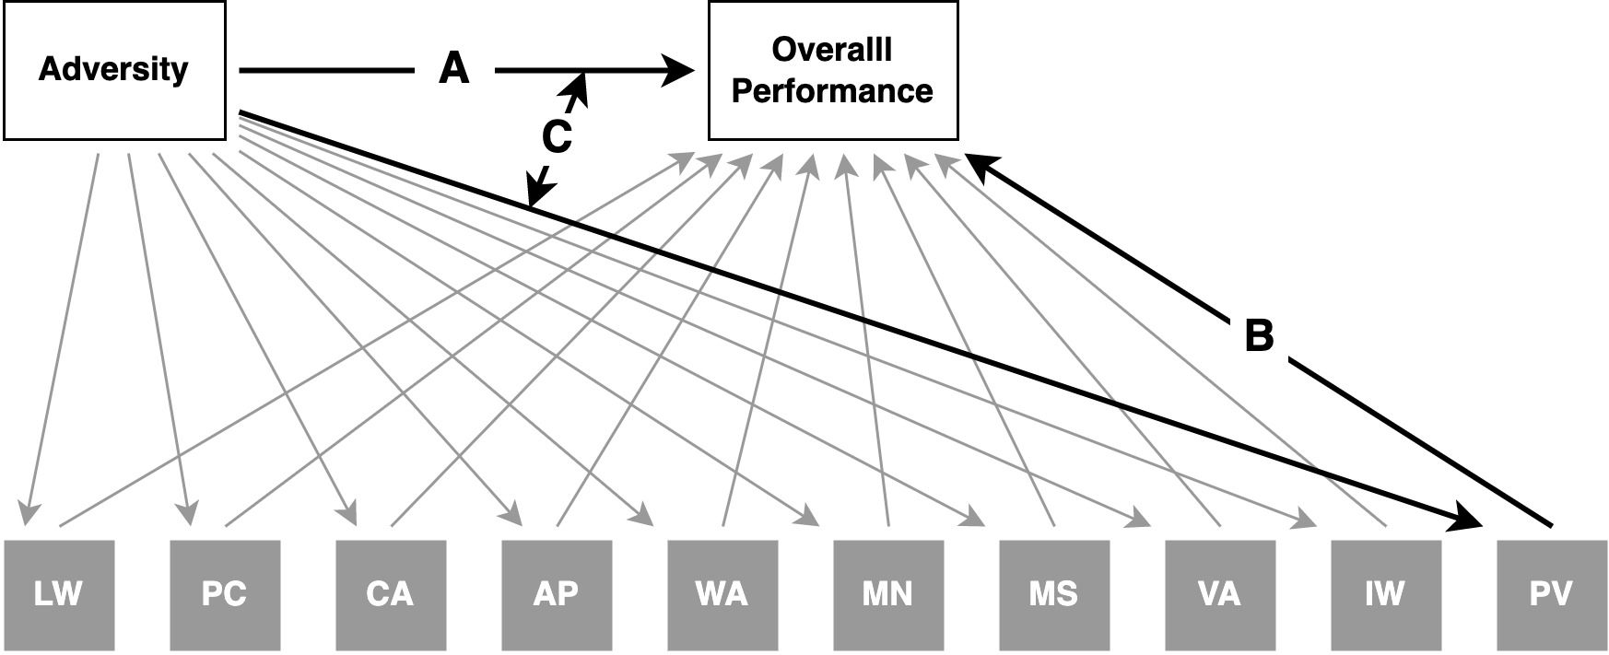

**Figure 1.** Conceptual visualization of Woodcock-Johnson statistical models. A) is the main effect of adversity on overall performance; B) is the main effect of a subtest, which reflects the average performance on a subtest; C) is the simple effect (slope) of adversity for a particular subtest; and D) is the interaction effect that measures the difference between A and C. A significant simple effect means C ≠ 0, and a significant interaction means A ≠ C. Put differently, when C is significant, adversity is associated with performance on a subtest. When D is significant, the association between adversity and a subtest (C) is different than the association between adversity and the overall effect (A).

# Method

## Participants

Families were initially recruited for the NICHD SECCYD in 1991. A total of 1364 families met all the prescreening criteria, namely that mothers: were age 18 or older, did not plan to move, had a newborn without any known disabilities (and could leave the hospital within one week), had no history of substance abuse, could speak English, lived within one hour driving distance from the research lab, and were in a relatively safe neighborhood (NICHD ECCRN, 2005). More information about recruitment and selection procedures is available from the study (see <https://www.icpsr.umich.edu/web/ICPSR/series/00233>). The current analyses included participants with non-missing data on most predictors and outcome variables through age 15 years (*N* = 1156). In terms of race and ethnicity, the sample was mostly White (*n* = 940) with the remaining mothers reporting their child as Black (*n* = 138), Asian or Pacific Islander (*n* = 18), Native American, Eskimo, or Aleutian (*n* = 5), or another racial/ethnic group (*n* = 55).

## Measures

### **Cognitive Ability Test Battery**

We used the Woodcock-Johnson (WJ) Cognitive and Achievement standardized test battery to examine performance across 10 subtests (Woodcock et al., 1990; Woodcock, 1990). The SECCYD administered the WJ five times: in the 54th month, 1st grade, 3rd grade, 5th grade, and 15-year assessments.

There are two WJ test batteries: the cognitive and achievement tests. The WJ cognitive test includes the Memory for Names, Memory for Sentences, Verbal Analogies, Incomplete Words, and Picture Vocabulary subtests (described later). The WJ achievement battery includes Letter-Word Identification, Passage Comprehension, Calculations, Applied Problems, and Word Attack subtests (described later).

For all tests, we analyzed standard scores, which are equivalent to IQ scores (e.g., *M* = 100, *SD* = 15). Using standard scores for subtests puts all tests on the same scale to facilitate comparison (see Figure 2). For each subtest, we averaged standard scores over time to create one score per subtest, per participant. However, the specific set of subtests administered at each assessment varied (see Figure 2). For example, the Verbal Analogies test was measured at grade three and age 15, whereas Passage Comprehension was measured at grades 3, 5, and age 15 (see Table 1). Thus, to create overall scores for each subtest, we averaged over all time-points available for each subtest (see <https://github.com/ethan-young/seccyd-wj-subtests/blob/master/scripts/2-aggregate-dvs.R> for code).

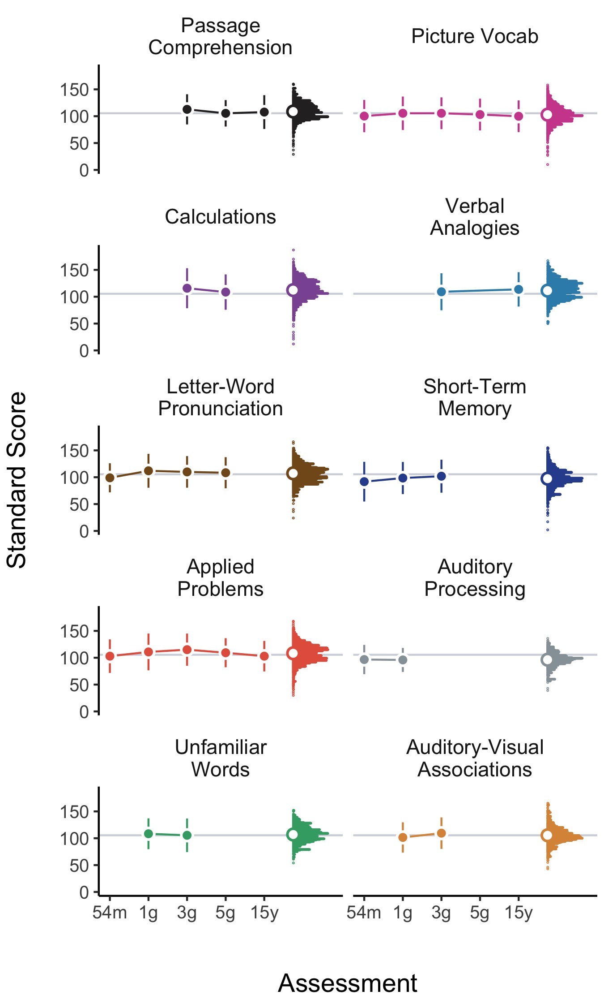

***Figure 2.*** WJ subtest standard scores across assessments. Different sets of subtests were administered at each assessment. Scores were averaged over assessments to create an overall subtest score. Vertical histograms reflect distributions of overall scores per subtest. Gray horizontal lines are sample average scores for all subtests (e.g., the overall WJ score).

**Picture Vocabulary.** This subtest measures verbal comprehension and crystallized knowledge. The test contains 58 items requiring participants to view and name familiar and unfamiliar objects. The test was administered five times: at 54 months, grades 1, 3, 5, and at 15 years. Higher scores indicate more verbal comprehension and more crystallized knowledge.

**Verbal Analogies.** This subtest measures the ability to reason about analogies between relatively simple words. Although the words remain simple, relations between words increase in complexity of over the test items. The test contains 35 items and was assessed twice: at grades 3 and 5. Higher scores indicate more reasoning and more verbal/crystallized knowledge.

**Passage Comprehension.** This subtest test measures the ability to read a short passage and name an appropriate key word that is missing. The test contains 43 items and was administered three times: at grades 3, 5, and at age 15. Higher scores indicate more vocabulary, comprehension, and reading skill.

**Applied Problems.** This subtest contains a set of practical math problems. Participants must read and identify a strategy for solving the problem and execute simple arithmetic calculations. The test contains 60 items and was administered five times: at the 54-month, 1st, 3rd and 5th grade, and 15-year assessments. Higher scores indicate more practical math and problem-solving skill.

**Calculations.** This subtest required participants to solve traditional math problems containing addition, subtraction, multiplication, division, and different combinations of each. The test also includes some geometry and trigonometry problems. Some items require logarithmic operations and calculus. The test contains 58 items and was administered twice: at the 3rd and 5th grade assessments. Higher scores indicate more mathematical/quantitative skill.

**Auditory-Visual Associations.** This subtest (also called Memory for Names) is an auditory-visual association test. It requires participants to learn a set of ‘space creatures’ and their names. After learning a set of creature-name pairs, participants are presented with nine creatures and must identify which were just shown and which were shown previously. The test difficulty is controlled by (decreasing) increasing the creature-name pairs presented in each set. The test contains 72 items and was administered twice: at the 1st and 3rd grade assessments. Higher scores indicate more visual-auditory association and long-term memory skill.

**Auditory Processing.** This subtest (also called the Incomplete Words test) measures the ability to listen to words containing missing phonemes and complete the word. The test contains 40 items and was administered twice: at the 54 month and 1st grade assessments. Higher scores indicate more auditory processing skill.

**Short-term Memory.** This subtest (also called the Memory for Sentences test) measures the ability to listen to and remember words, phrases, and sentences. The words, phrases, and sentences are played on an audio tape and participants must recall as many as possible. The test contains 32 items and was administered three times: at the 54-month, 1st grade, and 3rd grade assessments. Higher scores indicate more short-term memory skill.

**Letter-word Pronunciation.** This subtest measures reading and pronunciation ability. Participants must initially read letters and then words, which gradually increase in difficulty. The test contains 57 items and was administered four times: at the 54-month, 1st, 3rd, and 5th grade assessments. Higher scores indicate more verbal knowledge.

**Unfamiliar Words.** This subtest (also called Word Attack) measures the ability to pronounce unfamiliar words. Participants must read aloud phonetically logical but nonsense or infrequent words. It contains 30 items and was administered twice: at the 1st and 3rd grade assessments. Higher scores indicate more auditory processing and linguistic structural analysis knowledge and skill.

| **Table 1. Bivariate correlations and descriptive statistics for WJ subtests.** | | | | | | | | | | |
| --- | --- | --- | --- | --- | --- | --- | --- | --- | --- | --- |
| Variable | 1 | 2 | 3 | 4 | 5 | 6 | 7 | 8 | 9 | 10 |
| 1. Passage Comprehension | - |  |  |  |  |  |  |  |  |  |
| 2. Picture Vocab | 0.66** | - |  |  |  |  |  |  |  |  |
| 3. Calculations | 0.75** | 0.75** | - |  |  |  |  |  |  |  |
| 4. Verbal Analogies | 0.66** | 0.73** | 0.76** | - |  |  |  |  |  |  |
| 5. Letter-Word Pronunciation | 0.61** | 0.56** | 0.66** | 0.64** | - |  |  |  |  |  |
| 6. Short-Term Memory | 0.49** | 0.43** | 0.48** | 0.51** | 0.50** | - |  |  |  |  |
| 7. Applied Problems | 0.45** | 0.42** | 0.47** | 0.43** | 0.35** | 0.30** | - |  |  |  |
| 8. Auditory Processing | 0.64** | 0.63** | 0.78** | 0.71** | 0.57** | 0.47** | 0.50** | - |  |  |
| 9. Unfamiliar Words | 0.48** | 0.55** | 0.67** | 0.59** | 0.47** | 0.39** | 0.43** | 0.84** | - |  |
| 10. Auditory-Visual Associations | 0.50** | 0.58** | 0.65** | 0.76** | 0.46** | 0.43** | 0.39** | 0.65** | 0.60** | - |
| N | 1156 | 1064 | 1080 | 1155 | 1142 | 1092 | 1103 | 1154 | 1103 | 1075 |
| Mean | 102.64 | 111.08 | 108.63 | 107.91 | 97.04 | 96.21 | 105.39 | 106.94 | 106.84 | 112.10 |
| SD | 13.65 | 15.65 | 12.85 | 13.62 | 14.68 | 10.74 | 13.32 | 13.14 | 14.30 | 16.72 |
| Min | 31.50 | 50.00 | 42.00 | 33.50 | 45.00 | 39.00 | 46.00 | 30.00 | 54.00 | 12.00 |
| Median | 102.55 | 110.25 | 108.67 | 108.67 | 96.33 | 96.50 | 105.00 | 107.00 | 106.00 | 113.50 |
| Max | 147.00 | 156.00 | 146.00 | 149.00 | 144.00 | 128.00 | 162.00 | 150.00 | 152.00 | 178.50 |
| *Note: * p* < .05, *\*\* p* < .01 | | | | | | | | | | |
|  | | | | | | | | | | |

### Indicators of Harshness

We measured environmental harshness in two ways. First, following previous studies using data from the SECCYD, we used family income-to-needs ratio scores from the 1, 6, 15, 24, 36, and 54-month assessments (Belsky et al., 2012; Hartman et al., 2018; Li et al., 2018; Sung et al., 2016; Zhang et al., 2022). We calculated a simple average of all income-to-needs scores across assessments to create an overall income-to-needs score (see <https://github.com/ethan-young/seccyd-wj-subtests/blob/master/scripts/2-merge-aggregate-ivs.R> for code). We reverse-scored income-to-needs mean scores to create a family income disadvantage score, where higher values indicate more disadvantage.

Second, we used data from the 1990 Census about participants’ broader economic and ecological context in a similar way to previous analyses of neighborhood-level socioeconomic conditions in the SECCYD (Bleil, Spieker, et al., 2021; Bleil, Appelhans, et al., 2021). Specifically, addresses were tracked for each participant over time. Each family address start and stop dates were recorded, geocoded, and linked to the 1990 decennial Census block groups. These block groups are the smallest Census-tracked geographical unit released for external analysis. For each Census block group, sociodemographic data were extracted from the Census databases to measure neighborhood-level economic conditions for each participant.

We extracted five variables: 1) percent of people living under the poverty line, 2) median household income, 3) Gini coefficients of income inequality based on income frequency data, 4) percent of unemployed individuals over age 16 in the workforce, and 5) the percent of occupied houses that were being rented. These neighborhood variables were standardized and then averaged to create a neighborhood socioeconomic disadvantage score for each home in which a participant lived. Next, we averaged these neighborhood scores over time (up until the 54-month assessment). Thus, if a participant lived in two homes between birth and the 54-month assessment, neighborhood-level variables were standardized and averaged within the first and second Census block group, and then averaged between them. These scores served as measures of neighborhood socioeconomic disadvantage where higher scores indicate higher rates of poverty, income-inequality, unemployment, lower education, and more rental housing (see <https://github.com/ethan-young/seccyd-wj-subtests/blob/master/scripts/1-compile-ivs-census.R> for processing and aggregation).

### **Indicators of Unpredictability**

Environmental unpredictability is harder to define and measure (Young et al., 2020). Studies leveraging data from the SECCYD have used two approaches. The first is to track and count family transitions, including changes in paternal figures living in the home, parental job transitions, and residential changes (Belsky et al., 2012; Hartman et al., 2018; Simpson et al., 2012). The second approach is to quantify variability in repeated measures of harshness indicators (e.g., computing variance in family income disadvantage across time). For example, Li and colleagues (2018) fit a linear model to each participants’ income-to-needs scores over time. Then, they computed the residual variance around participant-level linear trends in income-to-needs to create an income variability score. In the current study, we compute unpredictability scores using both approaches and extend the Li and colleagues (2018) approach to the neighborhood-level Census block-group data.

To calculate family transitions, we computed the number of paternal figure changes (father figures moving in and out of the home), mother and father (figure) job changes, and residential changes across 17 assessments from 1 to 54 months (Belsky et al., 2012; Hartman et al., 2018). After computing scores across time, we standardized each variable and averaged them to compute an overall family transitions variable (see <https://github.com/ethan-young/seccyd-wj-subtests/blob/master/scripts/2-merge-aggregate-ivs.R> for code).

We next calculated variability scores for both family income and neighborhood socioeconomic disadvantage. For family income disadvantage scores, we computed a standard deviation of all income-to-needs scores for each participant from the 1, 6, 15, 24, 36, and 54-month assessments (see <https://github.com/ethan-young/seccyd-wj-subtests/blob/master/scripts/2-merge-aggregate-ivs.R> for code). For neighborhood socioeconomic disadvantage variability, we computed the standard deviation of neighborhood socioeconomic disadvantage scores (see Indicators of Harshness, above). If participants had only lived in one Census block group from 1 to 54 months, their neighborhood socioeconomic disadvantage variability score was zero.

### **Control Variables**

We used a standard set of three control variables typically used in analyses of SECCYD data: 1) maternal education, 2) sex assigned at birth (1 = female; 0 = male), and 3) the race/ethnicity of each child coded as White/non-Hispanic = 0, otherwise = 1. We chose to code race/ethnicity this way because the SECCYD sample is mostly White, making the sample sizes for other racial/ethnic groups small.

| **Table 2. Bivariate correlations and descriptive statistics for adversity measures.** | | | | | |
| --- | --- | --- | --- | --- | --- |
| Variable | 1 | 2 | 3 | 4 | 5 |
| 1. Family Transitions | - |  |  |  |  |
| 2. Family Income Disadvantage | 0.34** | - |  |  |  |
| 3. Family Income Variability | -0.11** | -0.70** | - |  |  |
| 4. Neigh. Socioeconomic Disadvantage | 0.25** | 0.45** | -0.24** | - |  |
| 5. Neigh. Socioeconomic Variability | 0.44** | 0.19** | -0.06* | 0.31** | - |
| N | 1155 | 1154 | 1146 | 1139 | 1139 |
| Mean | 0.04 | -3.52 | 1.11 | -0.02 | 0.02 |
| SD | 0.71 | 2.68 | 1.17 | 0.74 | 0.80 |
| Min | -0.82 | -23.79 | 0.00 | -1.95 | -0.69 |
| Median | -0.15 | -2.87 | 0.82 | -0.10 | -0.11 |
| Max | 3.86 | -0.17 | 17.78 | 3.35 | 3.09 |
| *Note: * p* < .05, *\*\* p* < .01 | | | | | |
|  | | | | | |

# Results

## Preregistration, Statistical Power, and Computational Reproducibility

We preregistered this study using a template for secondary data analysis (Akker et al., 2021). The preregistration document and its entire version history was tracked on GitHub (see <https://github.com/ethan-young/seccyd-wj-subtests/tree/master/preregistration>).

We also conducted a power analysis as part of our preregistration (see <https://github.com/ethan-young/seccyd-wj-subtests/tree/master/preregistration/power-analysis> for write up and see <https://github.com/ethan-young/seccyd-wj-subtests/blob/master/scripts/prereg-power-simulation.R> for code). We used a simulation approach to conduct power analyses. These analyses were based on simulated adversity scores and actual WJ test scores from the SECCYD data used in this study. We used actual WJ test scores in order to fully leverage their variance-covariance structure. Simulations showed that, with a sample size of (*N* = 1156), the smallest interaction effect we can detect is = -.075 (or .075) with 90% power, if error is small. When error is larger, we can detect the same effect size with only 65% power. However, even with larger error, we can detect a = -.10 (or .10) with 83% power.

All relevant files (data processing, analysis code, manuscript etc.) for this project are tracked on GitHub (see <https://github.com/ethan-young/seccyd-wj-subtests/tree/master>), including the data needed to reproduce all results (see <https://github.com/ethan-young/seccyd-wj-subtests/tree/master/data>). Raw data (data provided by the SECCYD) is available only via Inter-university Consortium for Political and Social Research (ICPSR, see <https://www.icpsr.umich.edu/web/pages/>). However, documentation for the study is free to download (see <https://www.icpsr.umich.edu/web/ICPSR/studies/21940>), which contains lists of raw datasets and variables. For those who have access to raw SECCYD data, we provide a table of raw datasets and variables used in this project (see <https://github.com/ethan-young/seccyd-wj-subtests/tree/master/data>).

We used R, Rstudio, and Quarto to process, analyze, and report results (Allaire, 2022; Posit team, 2023; R Core Team, 2023). For reading raw SECCYD data, we used the haven and readxl R packages (Wickham et al., 2023; Wickham & Bryan, 2023). For data processing, visualizations, and table creation, we used the tidyverse, sjlabelled, ggdist, ggsci, flextable, and the patchwork R packages (Gohel & Skintzos, 2023; Kay, 2023; Lüdecke, 2022; Pedersen, 2022; Wickham et al., 2019; Xiao, 2023). For analyses, including mixed models, simple slopes, and equivalence tests, we used lme4, faux, ggeffects, marginaleffects, multitool, and the parameters R packages (Arel-Bundock, 2023; Bates et al., 2015; DeBruine, 2023; Lüdecke, 2018; Lüdecke et al., 2020; Young & Vermeent, 2024).

## Data Analysis Strategy and Inferential Criteria

We used a mixed effects modeling approach to analyze how adversity relates to WJ performance. For our primary analyses, we ran one model per adversity variable. Each model contained sex assigned at birth, race/ethnicity, and maternal education as covariates. Adversity and covariates were standardized or recoded to center these variables at zero.

To analyze and compare WJ subtest performance with overall WJ performance, we restructured the data so that each participant was represented by 10 rows, one for each WJ subtest score. Then, we created a sum-coded contrast variable for WJ subtests with 10 levels (one for each subtest). This type of contrast sets the model intercept to the grand mean (i.e., the mean of all subtest scores). To analyze the effects of adversity on test performance, we entered adversity as a main effect and the interaction between adversity and the contrast-coded subtest variable.

A model with this structure contains a main effect for each covariate, a main effect of adversity, and an interaction term for each subtest (i.e., 10 interaction terms). The main effect of adversity reflects the association between adversity and overall WJ performance (i.e., within-person average across all subtests; see Figure 1). Interaction terms reflect the association between adversity and subtest performance *compared to the main effect of adversity* (see Figure 1). That is, they reflect the difference between the effect of adversity on overall performance and simple effects of adversity on subtest performance. Whereas simple effects test whether an association between adversity and subtest performance is different from zero, interaction terms measure whether a simple effect is different from the main effect.

Using this modeling strategy, we computed three types of effect sizes: 1) the main effect of each adversity measure (tested in separate models), 2) the interaction effect between an adversity measure and subtest, and 3) the simple effect of adversity for each subtest. We did not have specific point or range predictions for the effect size types above. However, we decided a priori to consider standardized regression coefficients (i.e., ’s) of .10 (or higher) and -.10 (or lower) as meaningful, or large enough to serve as a basis for future confirmatory research. For main effects, coefficients outside this range indicate that overall performance is meaningfully positive or negative across levels of adversity. For interactions, effect sizes outside these bounds indicate that associations between adversity and subtest performance are meaningfully more negative or more positive than overall performance. For simple effects, effects outside these bounds indicate that the effect of adversity on a specific subtest is meaningfully different from zero.

We were also interested in null effects. Specifically, we used equivalence testing to determine whether a given effect is practically equivalent to a Range of Practical Significance (ROPE). We chose a ROPE falling between = -.10 and = .10 (Kruschke, 2018; Lakens et al., 2018). Although we report standardized coefficients, we converted our ROPE to the WJ standard score scale by multiplying the standard deviation of standard WJ scores (*SD* = 15) by .1. Thus, our ROPE was -1.5 to 1.5 for unstandardized coefficients.

To guide interpretation, we also applied a set of inferential criteria for categorizing data patterns. We were interested in three data patterns: 1) enhanced performance, 2) reduced performance, and 3) intact performance. We inferred ‘enhanced performance’ when main and simple effects were positive, statistically different from zero, and outside the ROPE. We inferred ‘reduced performance’ when main and simple effects were negative, statistically different from zero, and outside the ROPE. We inferred intact performance when a main or simple effect (and its confidence bounds) was practically equivalent to zero (i.e., fell inside the ROPE), irrespective of statistical significance.

We used the same criteria for interaction terms with one difference. Because interaction terms test the difference between main and simple effects, they quantify relative performance patterns. For ‘enhanced relative performance’, interaction terms must be meaningfully positive (outside the ROPE) and statistically significant. For ‘reduced relative performance’, an interaction term must be meaningfully negative (outside the ROPE) and statistically significant. Interaction terms that are practically equivalent to zero reflect simple effects that closely resemble the main effect on overall performance. However, inferring ‘enhanced’, ‘reduced’, or ‘intact’ relative performance depends on the size and direction of the main effect. We were particularly interested in cases where a main effect is negative and interaction terms are positive. This may reflect either ‘enhanced relative performance’ (e.g., meaningful and significant positive interactions) or ‘less reduced’ performance on a particular subtest in the context of an overall reduced pattern of performance.

## Primary Analyses

Our primary analyses examined how indicators of harshness and unpredictability were associated with WJ overall and subtest performance. We ran one mixed model per indicator for a total of five primary analyses (two for harshness and three for unpredictability). We use our statistical models for description and our inferential criteria–which include equivalence tests—to unpack data patterns. Although these analyses are exploratory (i.e., we are not testing specific hypotheses), we correct for multiple testing for all interaction term and simple slope *p-*values using the Benjamini-Hochberg approach (Benjamini & Hochberg, 1995).

All analyses controlled for the main effects of maternal education, race/ethnicity, and sex assigned at birth. Across all models, there were main effects for both maternal education and race/ethnicity. Lower maternal education and having a non-White racial/ethnic background was associated with lower WJ overall performance. No model contained statistically significant effects for sex assigned at birth. Below we describe the effects of our primary analysis predictors (see Supplemental Materials for full model results). Primary analysis code can be found on GitHub (see <https://github.com/ethan-young/seccyd-wj-subtests/blob/master/scripts/3-primary-analysis.R>).

### Indicators of Harshness

**Overview**. In general, exposure to more income- and socioeconomic-related indicators of harshness was associated with reduced overall WJ performance. For both family income and neighborhood-level socioeconomic disadvantage, seven out of 10 WJ subtests were reduced. Performance was particularly reduced for the Picture Vocabulary and Verbal Analogies subtests. However, across both family and neighborhood models, economic disadvantage appeared to leave the Auditory Processing and Auditory-Visual Associations subtests intact (see below and Figure 3; see Supplemental Materials for full regression tables).

**Family Income Disadvantage (mean)**. Our mixed model analyzed the effect of family income disadvantage on overall compared with subtest WJ performance. There was a main effect of family income disadvantage such that a higher disadvantage was associated with lower overall WJ performance. Equivalence tests show that this overall main effect was meaningfully negative (outside the ROPE, see Figure 3).

Interaction effects between family income disadvantage and subtests revealed a more nuanced pattern of associations. The association between disadvantage and performance did not differ from the overall main effect for the following subtests: Passage Completion, Calculations, Verbal Analogies, Letter-Word, and Short-Term Memory (see Figure 3). However, the association between income disadvantage and performance on the Picture Vocabulary subtest was significantly and meaningfully more negative than the overall main effect (see Figure 3). Interestingly, the association between disadvantage and performance on the Auditory Processing, Unfamiliar Words, and Auditory-Visual Associations subtests were significantly more positive than the overall main effect (see Figure 3). However, equivalence tests suggest that the income disadvantage and Unfamiliar Words performance association was inside the ROPE and, thus, practically equivalent to the main effect. The associations between income disadvantage and Auditory Processing and Auditory-Visual performance were outside the ROPE, suggesting performance was meaningfully more positive than the main effect for those with income disadvantaged families.

Our simple effects analysis tested whether the associations between family income disadvantage and subtest performance was statistically different from zero and whether they were practically equivalent to the ROPE (see Figure 3). Analyses revealed that the association between family income disadvantage and each of the subtests where significantly and meaningfully negative, except for the Auditory Processing, Unfamiliar Words, and Auditory-Visual Associations subtests (see Figure 3). For these tests, the association between income disadvantage and test performance was not statistically different from zero and practically equivalent to the ROPE (see Figure 3), suggesting performance on these tasks was intact.

**Neighborhood Socioeconomic Disadvantage (Mean)**. Analyses revealed a main effect of neighborhood socioeconomic disadvantage, such that living in high neighborhood socioeconomic disadvantage was associated with reduced overall WJ performance (see Figure 3). Equivalence tests show that this overall main effect was outside the ROPE.

Interaction effects between neighborhood socioeconomic disadvantage and subtests were varied. The association between socioeconomic disadvantage and performance did not statistically differ from the overall main effect for the following subtests: Passage Completion, Letter-Word Pronunciation, Short-Term Memory, and Unfamiliar Words (see Figure 3). However, associations were significantly more negative than the main effect for Picture Vocabulary, Calculations, Verbal Analogies, and Applied Problems subtests (see Figure 3). However, equivalence tests revealed that only the association between socioeconomic disadvantage and Verbal Analogies subtest performance was meaningfully more negative than the main effect.

Similar to the family income disadvantage analysis, neighborhood socioeconomic disadvantage was associated with significantly more positive performance for the Auditory Processing and Auditory-Visual Associations compared to the overall main effect. Equivalence tests revealed that both associations were also meaningfully more positive, suggesting that performance on these tests was relatively enhanced (compared to the main effect) for participants living in socioeconomically disadvantaged neighborhoods (see Figure 3).

Simple effects revealed that higher neighborhood socioeconomic disadvantage was associated with statistically and meaningfully negative performance for all subtests except for the Auditory Processing and Auditory-Visual Associations subtests. For these two subtests, performance among those living in socioeconomically disadvantaged neighborhoods was not statistically or meaningfully different from zero, suggesting an intact pattern of performance.

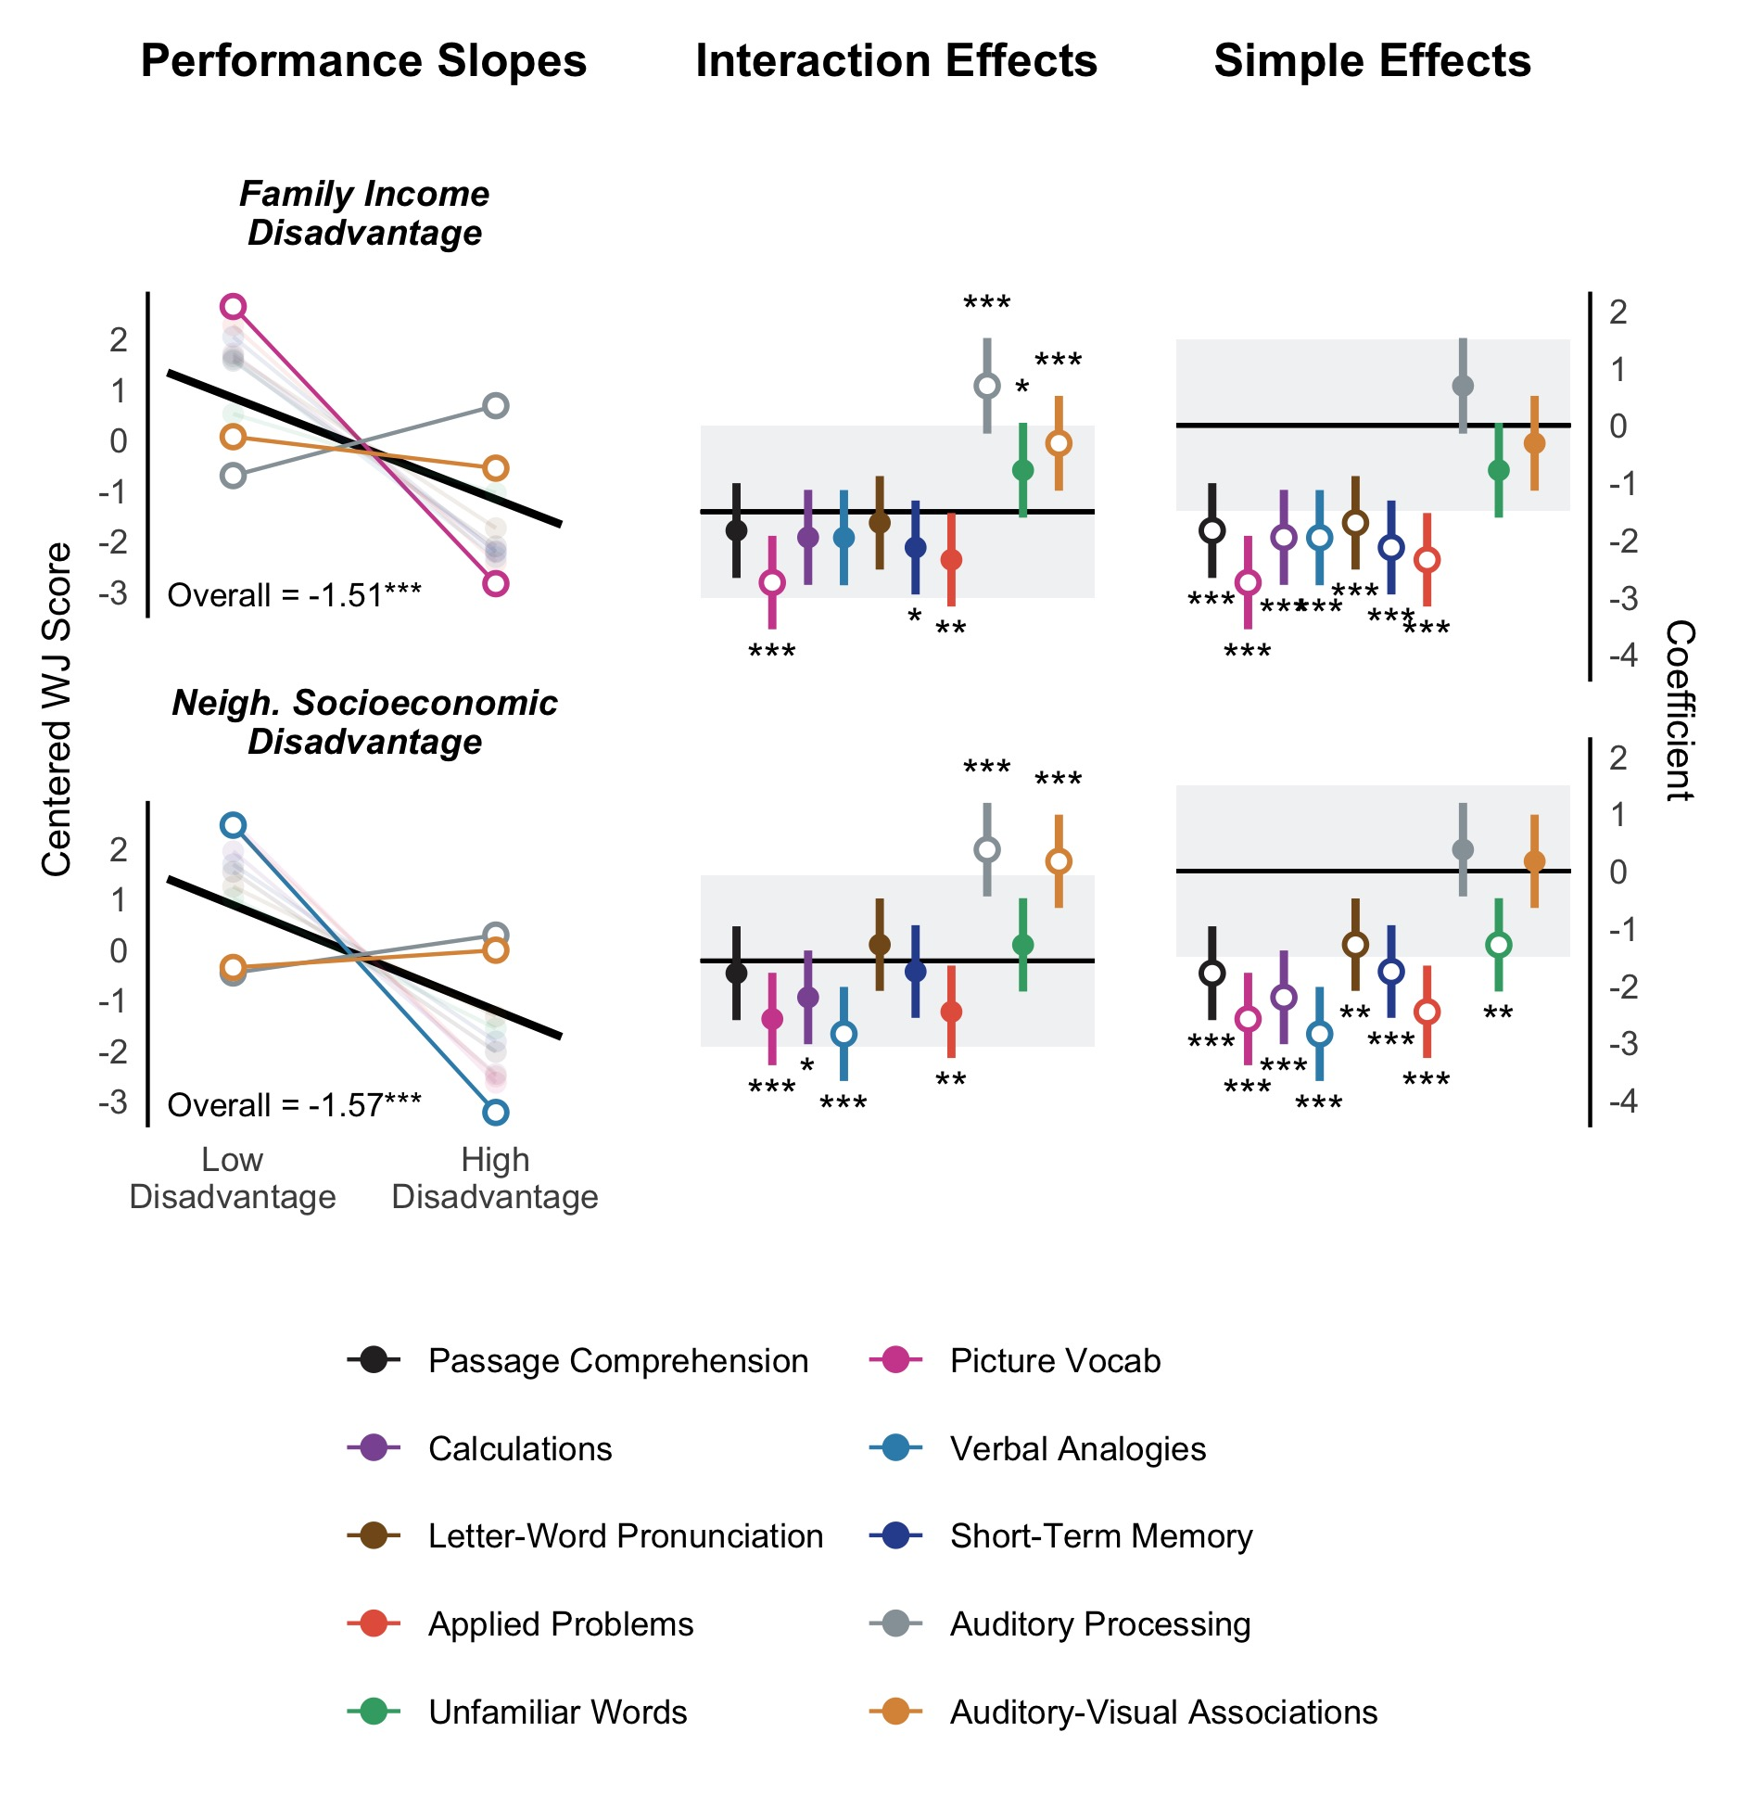

**Figure 3.** Results of models testing the effect of family and neighborhood economic disadvantage on WJ performance. The top and bottom rows depict family and neighborhood socioeconomic disadvantage, respectively. The left column plots the overall slope (thick black lines) against the subtest slopes across low to high socioeconomic disadvantage. Unfaded and faded lines are practically inequivalent and equivalent to the overall slope, respectively. The middle and right columns show interaction and simple effects. Black horizontal lines are the main effect and zero for interactions and simple effects, respectively. The gray ribbon reflects the ROPE. Solid points indicate interactions and simple effects that are practically equivalent to the ROPE. Hollow points reflect interaction and simple effects that are outside the ROPE. Statistical significance for interactions (tested against the main effect) and simple effects (tested against zero) are flagged with significance stars.  
*** *p* < .001, ** *p* < .01, * *p* < .05

### Indicators of Unpredictability

**Overview**. In general, exposure to more unpredictability, indexed by family transitions and neighborhood socioeconomic variability, was associated with intact overall WJ test performance (see below and Figure 4; see Supplemental Materials for full regression tables). Only one WJ subtest showed a deviation from the overall pattern–Applied Problems–which was associated with reduced performance among participants who experience more family transitions (see Figure 4). Results for family income variability raised a number of questions, which we address in our Secondary Analyses (see below for details).

**Family Transitions**. Our analysis of family transitions revealed no main effect on overall WJ performance. The main effect also fell inside the ROPE range, suggesting that overall performance was not associated with exposure to more family transitions (see Figure 4).

Three interaction terms were statistically significant: Calculations (more negative), Auditory Processing (more positive), and Audio-Visual Associations (more positive). However, only the association between family transitions and performance on the Calculations subtest was meaningfully different from the main effect (see Figure 4).

Simple effects indicated that exposure to family transitions was only associated with the Calculations and Applied Problems subtests. For Calculations, exposure to more family transitions was associated with significantly and meaningfully lower performance. For Applied Problems, more family transitions were associated with meaningfully lower performance, but this difference was not statistically different from zero (i.e., the association was not significant and outside the ROPE).

**Family Income Variability (*SD*).** Models examining the effect of family income variability on WJ overall and subtest performance yielded surprising results. Specifically, the directions of all effects were opposite to analyses using family income average scores. For subtests that showed reduced performance at high *mean* levels of family income disadvantage, we found enhanced performance at high levels of *variability* in family income. We believe such effects are driven by the fact that family income disadvantage mean and variability scores are strongly negatively related (*r* = -0.70), which has been reported before (Li et al., 2018). That is, families experiencing more income disadvantage tended to experience less income variability. Put differently, richer families were more likely to experience income fluctuations.

Li and colleague’s (2018) strategy involved computing interactions between mean and variability scores, which provides some level of statistical control but tests a different research question entirely (see Supplement). However, we believe the strong negative correlation in an unexpected direction raises questions about using family income variability as an indicator of adversity. In most empirical cases, higher levels of harshness are associated with higher levels of unpredictability. Yet here, income variability and average income are correlated in the opposite direction. One possibility is that it matters how variability scores are computed over repeated measures of income. Thus, to address this issue, we conducted a set of secondary analyses that used different methods for computing variability over income-to-needs scores. Below, we report analyses using different methods for quantifying variability in our Secondary Analyses (see <https://github.com/ethan-young/seccyd-wj-subtests/tree/master/preregistration/update-1> for the update to our analysis plan).

**Neighborhood Socioeconomic Variability**. In contrast to family income variability, more neighborhood socioeconomic variability was related to higher average neighborhood socioeconomic disadvantage. That is, families living in more socioeconomically disadvantaged neighborhoods (more harsh) were more likely to experience variability in neighborhood economic disadvantage (more unpredictable) from one to 54 months (*r* = 0.31). Additionally, the associations between average and variability scores were moderate rather than strong (see Table 2).

There was no main effect of neighborhood socioeconomic variability on overall WJ scores (see Figure 4) or interaction with subtest performance. All interaction effects were inside the ROPE, suggesting none were meaningfully different from the overall effect. In addition, simple effects showed that high neighborhood socioeconomic variability was not associated with performance on any subtest and all simple effects were inside the ROPE.

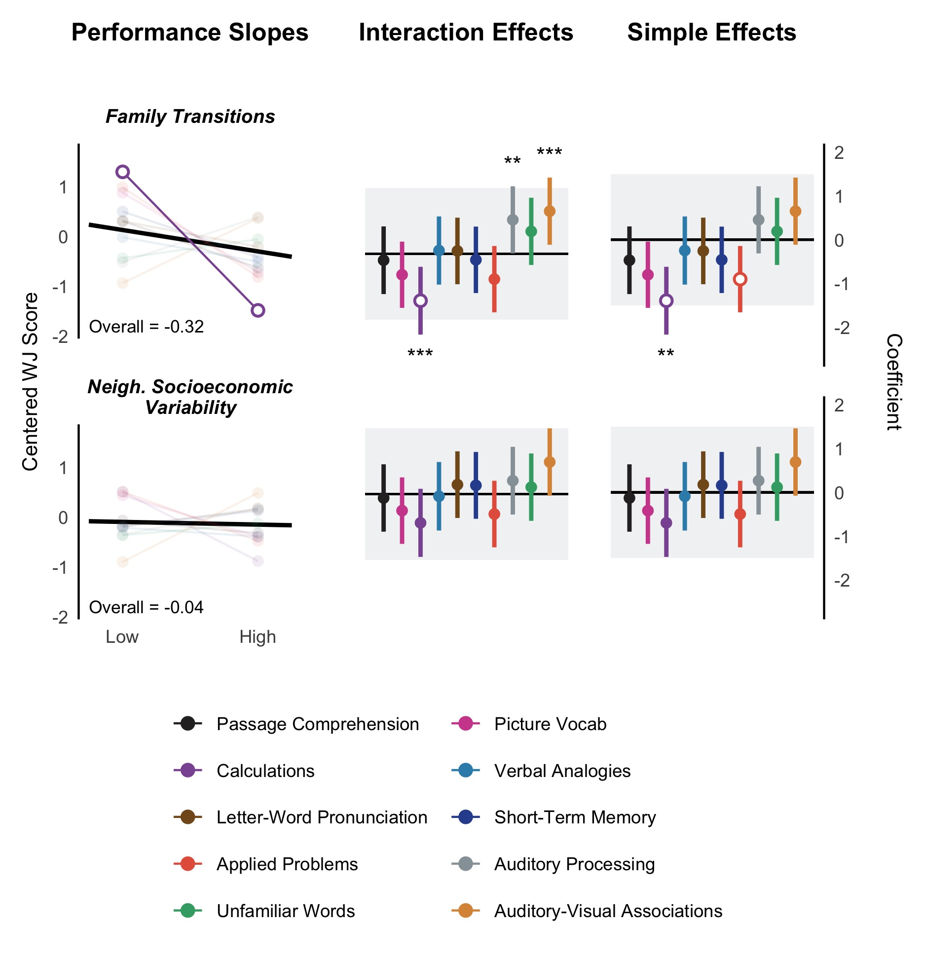

**Figure 4.** Results of models testing the effect of family transitions and neighborhood socioeconomic variability on WJ performance. The top and bottom rows reflect family transitions and neighborhood socioeconomic variability, respectively. The left column plots the overall slope (thick black lines) against the subtest slopes across low to high unpredictability. Unfaded and faded lines are practically inequivalent and equivalent to the overall slope, respectively. The middle and right columns show interaction and simple effects. Black horizontal lines are the main effect and zero for interactions and simple effects, respectively. The gray ribbon reflects the ROPE. Solid points indicate interactions and simple effects that are practically equivalent to the ROPE. Hollow points reflect interaction and simple effects that are outside the ROPE. Statistical significance for interactions (tested against the main effect) and simple effects (tested against zero) are flagged with significance stars.  
*** *p* < .001, ** *p* < .01, * *p* < .05

## Secondary Analyses

Our primary analyses examining family income variability raised questions about its validity as an adversity measure. More specifically, analyses using a simple within-person standard deviation of income-to-needs to measure unpredictability revealed counterintuitive results. Whereas average income analyses showed that lower family income was associated with lower overall WJ performance, income variability showed enhanced effects. In addition, the two WJ subtests that showed relative enhancements as a function of lower average family income - Auditory Processing and Auditory-Visual Associations– showed relatively reduced performance as a function of more income variability. These effects are surprisingly opposite. Although different adversity measures are not expected to produce the same results, we suspect most would not expect different measures to produce exactly opposite results.

We believe that this pattern may be driven by the strong association between average income and income variability. There are two approaches to addressing this issue. The first is to evaluate *how variability is computed* by using different methods for summarizing within-person variability. This method addresses the validity of variability scores at the *measurement* level. That is, we closely examine the properties of the measurement scale and how variability is computed and then explore whether different methods create better approximations of the construct of interest.

The second is to statistically adjust the effect of family income variability on WJ test performance by controlling for average family income in the same model. This method addresses the *validity of the association between income variability and WJ test performance* rather than the validity of the measure of variability itself. In other words, it is a *modeling* rather than a measurement solution.

From a causal inference perspective, we argue that addressing validity at the measurement level is more appropriate than at the modeling level. Statistical controls require justification from a *data-independent causal model* or a Directed Acyclic Graph (DAG). That is, the decision to control for a variable in a statistical model depends a conceptual model of its causal role, and more specifically, whether the variable is a confound (Cinelli et al., 2022; Rohrer, 2018). In the current work, controlling for average family income would be appropriate if we believed (theoretically) that average family income *causes* both income variability *and* WJ test performance. Yet, in theory, harshness and unpredictability are characterized as independent environmental constructs. Moreover, there are other plausible DAGs that do not situate harshness as a confound between unpredictability and cognitive performance, even when average income and income variability are correlated (see Causal Inference Discussion in the Supplement).

Despite these conceptual arguments, one could argue that variability scores should not be modeled without controlling for average levels. However, a statistical correlation between two proxies (i.e., average family income and family income variability) is not necessarily causal and does not, by itself, make either one a confounder of the other. This creates tension between the statistical models implied by a particular DAG and the desire to ensure variability is modeled correctly. We propose that addressing how variability is computed at the measurement level alleviates this tension. Nonetheless, we conducted both sets of analyses. Secondary analysis code can be found on GitHub (see set one <https://github.com/ethan-young/seccyd-wj-subtests/blob/master/scripts/4-secondary-analysis-1.R> and see set two <https://github.com/ethan-young/seccyd-wj-subtests/blob/master/scripts/4-secondary-analysis-2.R>).

We believe that both analyses are important and instructive for future research. We emphasize, however, that handling measurement issues should precede modeling solutions. Including statistical controls requires specifying an underlying causal model. In new exploratory fields, there are many alternative and justifiable models. Before adhering to one over another, we need to understand each variable on its own.

### Computing Different Income Variability Scores

We computed four types of variability scores over the income-to-needs data. The first was identical to our primary analyses; we computed a within-person standard deviation of income-to-needs from 1 to 54 months.

Second, we computed residual standard deviations (Bania & Leete, 2009; Hardy, 2014; Li et al., 2018; Prause et al., 2009). To do so, we fit a linear slope to each participant’s income-to-needs data, extracted residual scores, and computed the standard deviation of these residuals.

The third method computed percent change scores over each participant’s income-to-needs data. In time series analysis, percent change reflects how much a score changes relative to the previous time-point and scales income, accordingly. For example, if one’s income is $1,000 at one time-point and increases to $1,500 at the next time-point, the percent change score would be .50 or 50% ($500 increase is half of income at the first time-point). The percent change score is always relative to the previous time-point. Thus, if income increases another $500 at time-point 3, the percent change score would be .33 or 33% ($500 is 1/3 of the second time-point income of $1,500). For low-income families, percent change scores can account for the fact that smaller income fluctuations have a larger impact. For example, a family with a monthly income of $1,500 that loses $500 the next month (33% of their income) is impacted more than a family earning $5,000 a month (10% of their income). After computing percent change scores for each assessment, we averaged percent change scores to create a single percent change score per participant.

Fourth, we computed within-person coefficients of variation, or the ratio of the within-person standard deviation in income-to-needs divided by the within-person average income-to-needs mean (Mills & Amick, 2016; Newman, 2006; Nichols & Zimmerman, 2008). The coefficient of variation is useful because it expresses income variability relative to the average. That is, given a particular income-to-needs average value, the coefficient of variation measures variation as a proportion of the mean. Coefficient of variation statistics are particularly useful for scales with a meaningful zero value (i.e., zero income means the complete lack of income) as opposed to other scales in which zero is not meaningful (e.g., temperature where zero degrees Fahrenheit means freezing temperature, not the complete lack of heat).

Simple and residual standard deviation family income scores were strongly related to both each other and to the average family income disadvantage (see Table 3). However, average percent change and coefficient of variation scores were only weakly to moderately related to income standard deviation and residual standard deviation scores. In addition, average percent change and coefficient of variation scores were weakly and positively related to mean family income disadvantage scores (for average percent change *r* = 0.17; for coefficient of variation *r* = 0.24 see Table 3). That is, families experiencing higher mean levels of income disadvantage also experienced larger average percent changes and show larger coefficients of variation in income over time. This aligns with prior empirical work that finds harsher environments tend to be more unpredictable (Belsky et al., 2012; Brumbach et al., 2009; Ellis et al., 2009; Simpson et al., 2012; Szepsenwol et al., 2015).

| **Table 3. Bivariate correlations and descriptive statistics for family income variability scores.** | | | | | |
| --- | --- | --- | --- | --- | --- |
| Variable | 1 | 2 | 3 | 4 | 5 |
| 1. Mean | - | 1146 | 1140 | 1146 | 1146 |
| 2. Standard Deviation | -0.70** | - | 1140 | 1146 | 1146 |
| 3. Residual Standard Deviation | -0.67** | 0.95** | - | 1140 | 1140 |
| 4. Average Percent Change | 0.17** | 0.16** | 0.19** | - | 1146 |
| 5. Coefficient of Variation | 0.24** | 0.33** | 0.32** | 0.63** | - |
| N | 1154 | 1146 | 1140 | 1146 | 1146 |
| Mean | -3.52 | 1.11 | 1.02 | 0.59 | 0.36 |
| SD | 2.68 | 1.17 | 1.10 | 0.83 | 0.23 |
| Min | -23.79 | 0.00 | 0.00 | 0.00 | 0.00 |
| Median | -2.87 | 0.82 | 0.74 | 0.35 | 0.31 |
| Max | -0.17 | 17.78 | 14.39 | 12.16 | 1.97 |
| *Note: * p* < .05, *\*\* p* < .01 | | | | | |
|  | | | | | |

### Residual Variance, Percent Change, and Coefficient of Variation Results

After computing each type of family income variability scores, we ran analyses with each as the primary predictor. We used the same modeling strategy, covariates, and inferential criteria as our primary analyses.

The findings for family income residual variance were nearly identical to our previous analysis with family income simple standard deviation. More residual variance in family income was associated with enhanced performance, in contrast to the negative associations with average family income disadvantage (see Supplement Figure 3). Again, we believe this is an artifact of the relation between family income average and standard deviation-based variability scores.

In contrast, however, average family percent change in income did not follow this pattern. Instead, higher percent changes in income were consistent with intact overall WJ test performance. The only subtest that differed from the overall effect was the Picture Vocabulary subtest, which showed that higher percent changes in income was associated with a significant, but not meaningful, reduction in performance. Simple effects indicated higher percent changes in income were associated with intact performance for all subtests except the Auditory Processing subtest, which was meaningfully more positive but not statistically different from zero.

The coefficient of variation also differed from family income standard deviation analyses. The effect of the coefficient of variation in family income revealed a negative but non-significant overall effect on WJ performance. However, the coefficient of variation revealed five effects on WJ subtest performance. First, larger coefficients of variation were associated with a significantly more positive Auditory Processing and Auditory-Visual Associations performance than overall performance. However, only Auditory Processing performance was outside the ROPE. In addition, larger coefficients of variation in family income were associated with significantly reduced performance in Picture Vocab, Verbal Analogies, and Applied Problems compared to the overall effect. However, only performance on Verbal Analogies was outside the ROPE. Simple effects revealed that both Auditory Processing and Auditory-Visual Associations performance were inside the ROPE, meaning that these effects were practically equivalent to zero, suggesting intact performance on both subtests. Simple effects for Picture Vocab, Verbal Analogies, and Applied Problems subtest were significantly and practically negative, suggesting that higher income variability (as measured by the coefficient of variation) is associated with reduced performance on each.

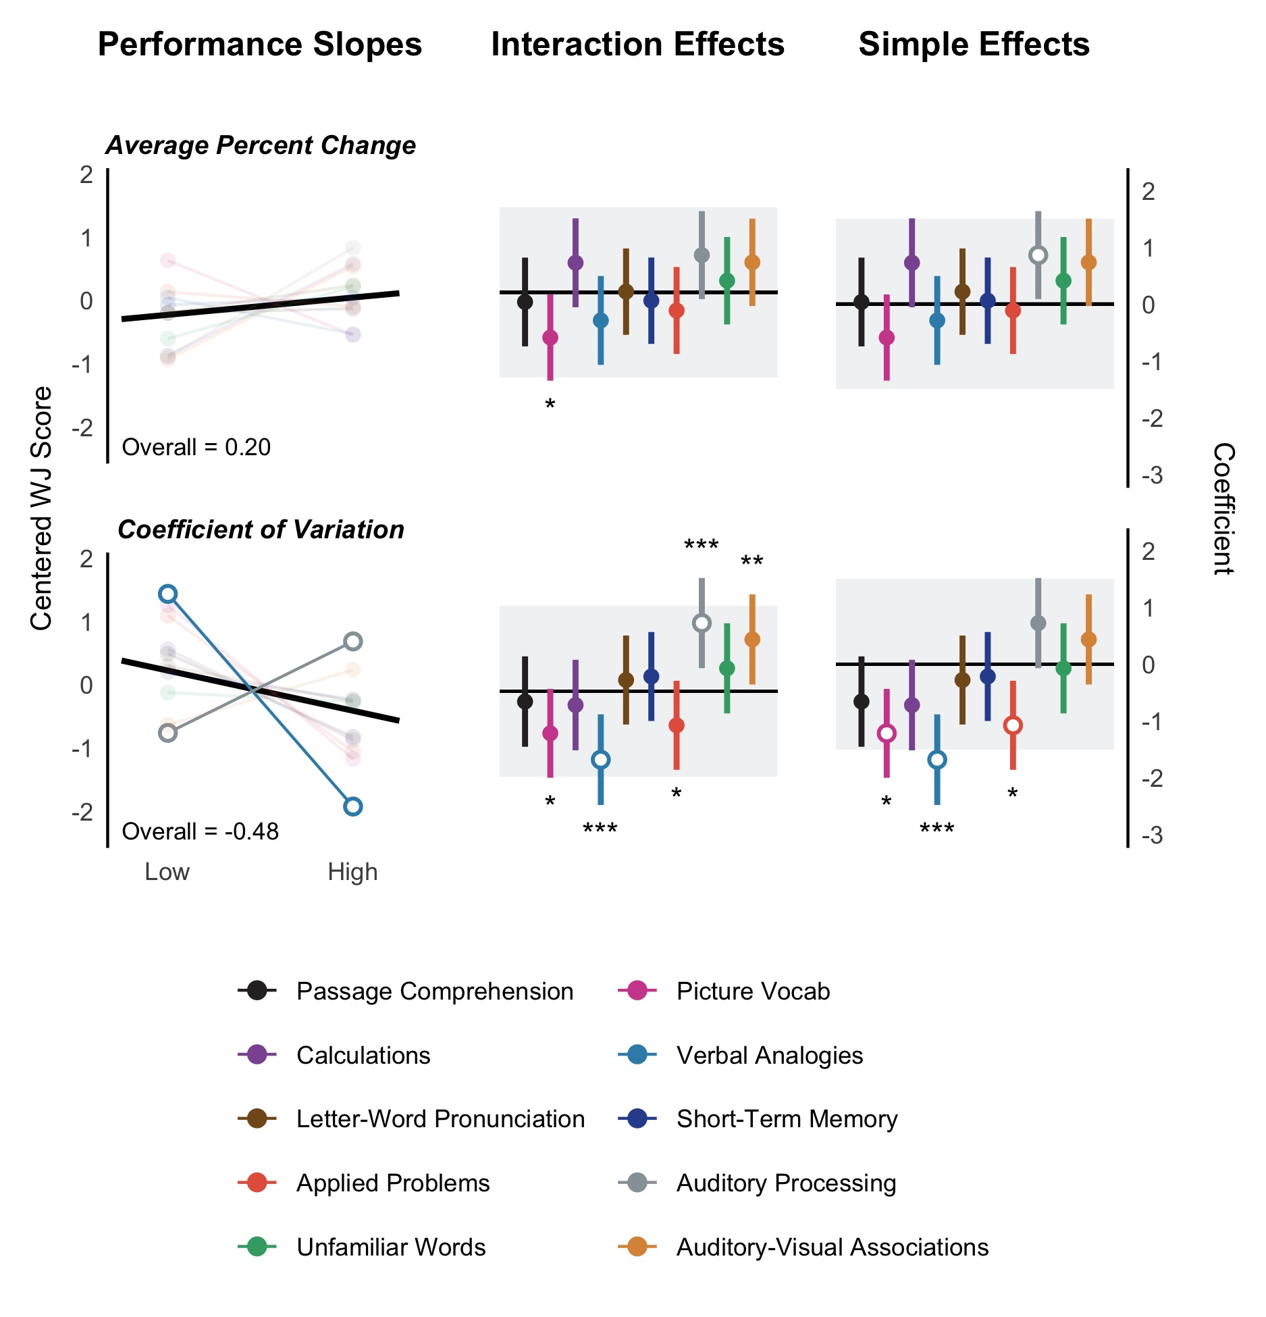

**Figure 5.** Results of models testing the effect of alternative family income variability scores to standard deviation and residual standard deviation scores on WJ performance. The top and bottom rows reflect average percent change and the coefficient of variation in family income from one to 54 months. The left column plots the overall slope (thick black lines) against the subtest slopes across low to high variation in family income. Unfaded and faded lines are practically inequivalent and equivalent to the overall slope, respectively. The middle and right columns show interaction and simple effects. Black horizontal lines are the main effect and zero for interactions and simple effects, respectively. The gray ribbon reflects the ROPE. Solid points indicate interactions and simple effects that are practically equivalent to the ROPE. Hollow points reflect interaction and simple effects that are outside the ROPE. Statistical significance for interactions (tested against the main effect) and simple effects (tested against zero) are flagged with significance stars.  
*** *p* < .001, ** *p* < .01, * *p* < .05

# Discussion

In this research, we set out to document adversity-related patterns of cognitive performance. We used a principled exploration approach to complement confirmatory approaches to adaptation-based research. Using the basic insights of prior work, we analyzed how exposure to indicators of harshness and unpredictability relate to different patterns of adversity-related cognitive performance across 10 WJ subtests. However, instead of using adaptive logic, we developed inferential criteria to aid interpretation of three data patterns of interest: reduced, intact, and enhanced performance. We quantified performance using two types of comparisons. First, we compared whether WJ subtest performance differed from overall performance, which quantified relative reductions and enhancements in performance. Second, we compared performance on each subtest to zero, which quantified absolute performance reductions and enhancements. This approach allowed us to describe how exposure to indicators of harshness and unpredictability are associated with different adversity-related performance patterns. It also afforded the opportunity to document how reduced, intact, and enhanced performance co-occur.

## Exploratory Insights

We did not find any instance of absolute enhancement or cases where subtest performance was significantly and practically more positive than zero. For indicators of harshness (family income and neighborhood socioeconomic disadvantage), however, we found two basic patterns. First, socioeconomic harshness was associated with reduced overall cognitive performance. Performance on Picture Vocabulary and Verbal Analogies subtests was particularly reduced. Second, compared to the overall reduced pattern, Auditory Processing and Auditory-Visual Associations subtest performance tended to be enhanced. In an absolute sense (i.e., when each subtest was compared to zero), they appeared to remain intact.

In contrast, all indicators of unpredictability (family transitions, family/neighborhood socioeconomic disadvantage variability, percent change in family income, and the coefficient of variation) were associated with intact overall WJ performance, an unexpected and noteworthy result. However, only family transitions and the coefficient of variation were associated with WJ subtest performance that differed from overall performance. Family transitions were associated with reduced Calculations performance in both a relative (compared to overall) and absolute sense (compared to zero). The effect of the coefficient of variation revealed the most similar effects to the harshness analyses among all unpredictability indicators. Larger coefficients of variation were associated with relatively enhanced Auditory Processing performance and reduced Verbal Analogies performance.

These findings are striking for three reasons. First, achievement and cognitive batteries like the WJ assessment have abstract content that is relatively detached from the real world. Adaptation-based models often assert that such tests are a poor fit to the lives of those living in harsh and/or unpredictable conditions (Ellis et al., 2017; Ellis et al., 2022; Frankenhuis, Young, et al., 2020; Frankenhuis & de Weerth, 2013). For this reason, most current theoretical accounts of the skills and abilities of people living in harsh and unpredictable conditions assume that exposure to adversity should reduce performance on traditional achievement tests (e.g., Ellis et al., 2022; Frankenhuis, Young, et al., 2020; Hackman et al., 2010; McLaughlin et al., 2019; Ursache & Noble, 2016). Yet, for family income and neighborhood socioeconomic disadvantage, we found that—at least for two standard tasks—performance remained intact. Exposure to unpredictability was associated with intact performance across all tasks except for the Calculations subset (but it was intact for Neighborhood Socioeconomic Variability).

Standardized tests have many problems, but the ecological validity of a cognitive test battery has different dimensions. The ecological validity of a test’s content, for example, is different than the ecological validity of the ability itself, or the extent to which an ability is ecologically relevant to a person’s lived experience. We believe the *abilities* tested in the WJ are clearly ecologically relevant. Language, vocabulary, working memory, reading, math, auditory processing, etc. are all important skills that most children need and use. The fact that many are intact *even without any ecologically relevant content manipulation* is striking and important. It suggests that deficits among those who are exposed to income disadvantage might not be as widespread as previously thought. Without a principled exploration of a standard, abstract achievement battery, research may have overlooked these novel patterns.

Second, our harshness analyses demonstrate that patterns of reductions, relative enhancements, and intact performance occur within individuals. Overall performance was reduced, as revealed by tests of reading, math, reasoning, and short-term memory. Relatively stronger reductions emerged for tests of verbal and crystallized knowledge (i.e., Picture Vocabulary and Verbal analogies). At the same time, Auditory Processing and Auditory-Visual Associations performance was relatively enhanced (or less reduced) compared to overall performance, and it was intact when considering the simple effect ROPE (e.g., comparing performance to zero). These data patterns are consistent with the notion that adversity exposure is associated with nuanced patterns of within-person performance. To our knowledge, this is the first demonstration of how adversity relates to multiple co-occurring and within-person patterns of performance across several standard cognitive tests.

Third, the Auditory Processing and Audio-Visual Associations subtests, both of which showed intact performance patterns, appear to have two things in common. First, both contain a listening component, suggesting that auditory stimuli might be less difficult to process for people living in socioeconomically disadvantaged contexts. However, performance on the short-term memory task, which also presented auditory stimuli, was generally reduced. Other research examining the skills and abilities of disadvantaged populations suggests that different types of oral and oral narrative skills may also be intact or enhanced among those from low socioeconomic context (Ellis et al., 2022; Gardner-Neblett et al., 2012; Gardner-Neblett & Iruka, 2015), perhaps because auditory/oral means of learning and knowledge acquisition/transmission are important when materials for other forms of learning, such as books and other visual learning materials, are scarce (Amso & Lynn, 2017). Other research suggests that the high levels of noise exposure found in low-income communities (Blair & Raver, 2016; Seltenrich, 2017) could lead to adaptive processing of audio processing (Vannucci et al., 2023; Werchan et al., 2022).

In addition, the Auditory Processing and Audio-Visual Associations subtests require little crystallized or verbal knowledge. The Auditory Processing task requires listening to words with missing phonemes and completing them. The Auditory-Visual Association tasks requires memorizing names with pictures. Other WJ subtests, which were reduced in socioeconomically disadvantaged individuals, either directly measure or require accumulated formal knowledge, such as math operations, reading passages, identifying objects, and verbal analogies. This suggests that tests requiring less accumulated knowledge may remain intact for those experiencing socioeconomic disadvantage. Interestingly, other abilities found to be enhanced by adversity require less crystallized or verbal knowledge. For example, attention-shifting and working memory updating (especially on visual tasks) do not require an extensive vocabulary or formal knowledge to for individuals to perform well. However, because this research is exploratory, we caution against drawing any conclusive inferences.

## Income Variability Scores and Unpredictability

Our secondary analyses provided insights about measuring socioeconomic variability over repeated measures. In line with work by others (e.g., Li et al., 2018), we found a high correlation between average family income and family income variability scores in the SECCYD. Although this does not invalidate variability scores, it raises questions about whether such scores are capturing adversity, especially when families with higher incomes tend to experience greater variance in income. We found that percent change and coefficient of variation scores attenuated the association between average family income and family income variability. Nonetheless, measures of unpredictability quantifying variability from repeated measures would benefit from further validation and more comparisons with different data reduction techniques. Leveraging time-series techniques is one promising direction, especially for assessing concepts such as unpredictability (Frankenhuis et al., 2019; Ugarte & Hastings, 2023; Young et al., 2020). However, future researchers should exercise caution when computing such scores and pay special attention to appropriate validation procedures to verify that such scores are, in fact, capturing the intended construct.

In addition, it is important to acknowledge that past research has operationalized income variability beyond the current work. Some examples include the frequency of income shocks (Yeung et al., 2002), and “fixed-effect estimation” which uses the within-person deviation at a specific time point as an indicator of income dynamics (Dearing et al., 2006; Dearing & Taylor, 2007; Zachrisson & Dearing, 2015).

More broadly, our null results for unpredictability might be related to the challenges associated with defining and operationalizing it. Consider the claim, described earlier, that in unpredictable environments, it is adaptive to exhibit high levels of attention shifting and working memory updating, but low levels of inhibition. First, it is not clear to which timescales this claim applies. This ambiguity creates disagreement about which measures are needed to test the claim. For instance, should we measure changes on short timescales (e.g., household chaos over seconds or minutes), on longer timescales (e.g., residential changes over months or years), or any timescale? Second, one widely used definition of *unpredictability* is stochastic variation in space or time (Ellis et al., 2009; Young et al., 2020). However, formal models show that different behaviors are frequently adaptive in temporally varying environments compared with spatially varying environments (e.g., how much individuals gain from investing in acquiring information about their environment across different life stages). Third, this definition of unpredictability affords different operationalizations (Walasek et al., 2023; Young et al., 2020) because it can refer to autocorrelations, standard deviations, entropy, and more (Frankenhuis et al., 2016; Walasek et al., 2023). Fourth, when the logic from assumptions to predictions is not fully explicit, scholars can arrive at different or even opposing predictions. Consider the example of inhibition. Some argue that in unpredictable environments, inhibition should be *reduced* because, if opportunities are fleeting and threats occur unexpectedly, people who are focused on long-term goals may fail to seize sudden opportunities or detect threats (Mittal et al., 2015; Young et al., 2018). However, others argue the opposite—that inhibition should be *enhanced*, because attending to every opportunity or threat is likely to derail executing goal-directed actions (Lucon-Xiccato et al., 2023; Tello-Ramos et al., 2019). To advance theoretical debates, formal models can provide predictions to guide empirical work and improve integration with formal theory in allied disciplines, such as biology and economics (Frankenhuis & Tiokhin, 2018).

## Strengths, Limitations, and Future Directions

The current research has several strengths and limitations. First, the SECCYD is a longitudinal, prospective dataset that allowed us to analyze indicators of harshness, unpredictability, and WJ cognitive data from birth to age 15 years. By using the WJ achievement and cognitive batteries, we were able to analyze a rich set of 10 subtests, each with at least two assessments. However, the fact that different subtests were administered across the five assessments from 54 month to age 15 is a limitation. In addition, the SECCYD is not an at-risk sample; the majority of families are White, consistent with the 1991 US birth cohort from which it was drawn. And, although we selected adversity measures that align well with previous work, we were unable to examine other potentially relevant forms of adversity, such as exposure to threat (e.g., violence exposure), deprivation, and variability in each of these constructs across time. However, we did extend the literature by incorporating neighborhood-level measures of socioeconomic disadvantage. Finally, the current work did not assess the timing of adversity and its association with cognitive performance. Our goal was to unpack relative performance differences in the WJ, which traded-off with addressing development timing. However, future research is well-positioned to address developmental timing questions.

The value of principled exploration is uncovering new and (potentially unexpected) directions for testing confirmatory hypotheses. For example, future research is well-positioned to tease apart different testing modalities (visual, verbal, oral, auditory, etc.) from the specific skills assessed by different tests. Future research could also investigate how exposure to harshness affects performance on Auditory-Visual Associations compared with other more visual, spatial, or verbal association tests. Additionally, future research might compare cognitive tests that do and do not require prior or accumulated knowledge. For instance, manipulating tests by changing the test content to be more relevant to people living in socioeconomically disadvantaged families and contexts may help to “even the playing field.” Another direction could involve examining broader sets of auditory and oral skills.

We also found a number of intact patterns of performance, especially for exposure to unpredictability. We believe these effects are useful for challenging the widespread assumption that adversity leads to reduced performance. One possibility is that adversity does not affect some types of cognitive performance. A more complicated possibility might be that adversity shapes compensatory mechanisms that counter deficits in certain areas. Future research needs to explore such compensatory mechanisms. Intact patterns might also point towards new manipulations of either testing context or content as fruitful for discovering ways to enhance performance among people exposed to unpredictability. Finally, our modeling approach could be applied to other broad cognitive batteries such as the NIH toolbox and other executive function test batteries. Doing so might provide new insights into relative enhancements and intact performance across broad sets of executive functions.

## Conclusion

Our goal was to advance progress toward constructing a higher-resolution map of the cognitive skills and abilities of people who develop in conditions that vary in the degree of harshness and unpredictability. Within developmental science, we see great value in confirmatory studies, but we also need exploratory approaches. In this research, we used principled exploration to begin to remap and chart new territory. We believe more principled exploration of standard test batteries could yield new discoveries, replicate (conceptually or directly) current findings, and advance both theory testing and development. Especially for an emerging field, it is important to broadly explore and describe the hypothesis space thoroughly, creating and maintaining a healthy synergy between confirmation and exploration.

# References

Akker, O. R. van den, Weston, S., Campbell, L., Chopik, B., Damian, R., Davis-Kean, P., Hall, A., Kosie, J., Kruse, E., Olsen, J., Ritchie, S., Valentine, K. D., Veer, A. van ’t, & Bakker, M. (2021). Preregistration of secondary data analysis: A template and tutorial. *Meta-Psychology*, *5*. <https://doi.org/10.15626/MP.2020.2625>

Allaire, J. (2022). *Quarto: R interface to ’quarto’ markdown publishing system*. <https://CRAN.R-project.org/package=quarto>

Amso, D., & Lynn, A. (2017). Distinctive mechanisms of adversity and socioeconomic inequality in child development: A review and recommendations for evidence-based policy. *Policy Insights from the Behavioral and Brain Sciences*, *4*(2), 139–146. <https://doi.org/gjqz2s>

Andrews, P. W., Gangestad, S. W., & Matthews, D. (2002). Adaptationism - how to carry out an exaptationist program. *Behavioral and Brain Sciences*, *25*(4), 489–504.

Arel-Bundock, V. (2023). *Marginaleffects: Predictions, comparisons, slopes, marginal means, and hypothesis tests*. <https://CRAN.R-project.org/package=marginaleffects>

Bania, N., & Leete, L. (2009). Monthly household income volatility in the US, 1991/92 vs. 2002/03. *Economics Bulletin*, *29*(3), 2100–2112. <https://econpapers.repec.org/article/eblecbull/eb-08i30028.htm>

Barrett, H. C. (2020). Towards a Cognitive Science of the Human: Cross-Cultural Approaches and Their Urgency. *Trends in Cognitive Sciences*. <https://doi.org/gg3dv6>

Bates, D., Mächler, M., Bolker, B., & Walker, S. (2015). Fitting linear mixed-effects models using Lme4. *Journal of Statistical Software*, *67*(1). <https://doi.org/gcrnkw>

Belsky, J., Schlomer, G. L., & Ellis, B. J. (2012). Beyond cumulative risk: Distinguishing harshness and unpredictability as determinants of parenting and early life history strategy. *Developmental Psychology*, *48*(3), 662–673. <https://doi.org/b7r3m4>

Benjamini, Y., & Hochberg, Y. (1995). Controlling the False Discovery Rate: A Practical and Powerful Approach to Multiple Testing. *Journal of the Royal Statistical Society: Series B (Methodological)*, *57*(1), 289–300. <https://doi.org/gfpkdx>

Blair, C., & Raver, C. C. (2016). Poverty, stress, and brain development: New directions for prevention and intervention. *Academic Pediatrics*, *16*(3), S30–S36. <https://doi.org/ggp3zb>

Bleil, M. E., Appelhans, B. M., Thomas, A. S., Gregorich, S. E., Marquez, N., Roisman, G. I., Booth-LaForce, C., & Crowder, K. (2021). Early life predictors of positive change during the coronavirus disease pandemic. *BMC Psychology*, *9*(1), 83. <https://doi.org/gk5dzv>

Bleil, M. E., Spieker, S. J., Gregorich, S. E., Thomas, A. S., Hiatt, R. A., Appelhans, B. M., Roisman, G. I., & Booth-LaForce, C. (2021). Early life adversity and pubertal timing: Implications for cardiometabolic health. *Journal of Pediatric Psychology*, *46*(1), 36–48.

Brumbach, B. H., Figueredo, A. J., & Ellis, B. J. (2009). Effects of harsh and unpredictable environments in adolescence on development of life history strategies. *Human Nature*, *20*(1), 25–51. <https://doi.org/b68cdk>

Cinelli, C., Forney, A., & Pearl, J. (2022). A Crash Course in Good and Bad Controls. *Sociological Methods & Research*, 00491241221099552. <https://doi.org/grwp6n>

Dearing, E., Kreider, H., Simpkins, S., & Weiss, H. B. (2006). Family Involvement in School and Low-Income Children’s Literacy: Longitudinal Associations between and within Families. *Journal of Educational Psychology*, *98*(4). <https://doi.org/bthtwv>

Dearing, E., & Taylor, B. A. (2007). Home improvements: Within-family associations between income and the quality of children’s home environments. *Journal of Applied Developmental Psychology*, *28*(5-6), 427444. <https://doi.org/dgdqtr>

DeBruine, L. (2023). *Faux: Simulation for factorial designs*. <https://doi.org/10.5281/zenodo.2669586>

Doom, J. R., Vanzomeren-Dohm, A. A., & Simpson, J. A. (2016). Early unpredictability predicts increased adolescent externalizing behaviors and substance use: A life history perspective. *Development and Psychopathology*, *28*(4), 1505–1516. <https://doi.org/gjqwq6>

Doom, J. R., Young, E. S., Farrell, A. K., Roisman, G. I., & Simpson, J. A. (2022). Behavioral, cognitive, and socioemotional pathways from early childhood adversity to BMI: Evidence from two prospective, longitudinal studies. *Development and Psychopathology*, 1–17. <https://doi.org/10.1017/s0954579421001887>

Duncan, G. J., Magnuson, K., & Votruba-Drzal, E. (2017). Moving Beyond Correlations in Assessing the Consequences of Poverty. *Annual Review of Psychology*, *68*(1), 413–434. <https://doi.org/gd889f>

Duquennois, C. (2022). Fictional money, real costs: Impacts of financial salience on disadvantaged students. *American Economic Review*, *112*(3), 798–826. <https://doi.org/gp5b3p>

Ellis, B. J., Abrams, L. S., Masten, A. S., Sternberg, R. J., Tottenham, N., & Frankenhuis, W. E. (2022). Hidden talents in harsh environments. *Development and Psychopathology*, *34*(1), 95–113. <https://doi.org/10.1017/S0954579420000887>

Ellis, B. J., Bianchi, J., Griskevicius, V., & Frankenhuis, W. E. (2017). Beyond risk and protective factors: An adaptation-based approach to resilience. *Perspectives on Psychological Science*, *12*(4), 561–587. <https://doi.org/gdtj9h>

Ellis, B. J., Figueredo, A. J., Brumbach, B. H., & Schlomer, G. L. (2009). Fundamental dimensions of environmental risk. *Human Nature*, *20*(2), 204–268. <https://doi.org/b35prn>

Farah, M. J., Shera, D. M., Savage, J. H., Betancourt, L., Giannetta, J. M., Brodsky, N. L., Malmud, E. K., & Hurt, H. (2006). Childhood poverty: Specific associations with neurocognitive development. *Brain Research*, *1110*(1), 166–174. <https://doi.org/fv2dn8>

Fields, A., Bloom, P. A., VanTieghem, M., Harmon, C., Choy, T., Camacho, N. L., Gibson, L., Umbach, R., Heleniak, C., & Tottenham, N. (2021). Adaptation in the face of adversity: Decrements and enhancements in children’s cognitive control behavior following early caregiving instability. *Developmental Science*, *24*(6), e13133. <https://doi.org/gj7gh7>

Flournoy, J. C., Vijayakumar, N., Cheng, T. W., Cosme, D., Flannery, J. E., & Pfeifer, J. H. (2020). Improving practices and inferences in developmental cognitive neuroscience. *Developmental Cognitive Neuroscience*, *45*, 100807. <https://doi.org/gnbxdn>

Fraley, R. C., Roisman, G. I., & Haltigan, J. D. (2013). The legacy of early experiences in development: Formalizing alternative models of how early experiences are carried forward over time. *Developmental Psychology*, *49*, 109–126. <https://doi.org/f4mnf8>

Frankenhuis, W. E., de Vries, S. A., Bianchi, J., & Ellis, B. J. (2020). Hidden talents in harsh conditions? A preregistered study of memory and reasoning about social dominance. *Developmental Science*, *23*(4), e12835. <https://doi.org/ggb8qd>

Frankenhuis, W. E., & de Weerth, C. (2013). Does Early-Life Exposure to Stress Shape or Impair Cognition? *Current Directions in Psychological Science*, *22*(5), 407–412. <https://doi.org/f5cxhb>

Frankenhuis, W. E., & Nettle, D. (2020). The Strengths of People in Poverty. *Current Directions in Psychological Science*, *29*(1), 16–21. <https://doi.org/ggf5d6>

Frankenhuis, W. E., Nettle, D., & Dall, S. R. X. (2019). A case for environmental statistics of early-life effects. *Philosophical Transactions of the Royal Society B-Biological Sciences*, *374*(1770), 20180110. <https://doi.org/gjqwb2>

Frankenhuis, W. E., Panchanathan, K., & Belsky, J. (2016). A mathematical model of the evolution of individual differences in developmental plasticity arising through parental bet-hedging. *Developmental Science*, *19*(2), 251–274. <https://doi.org/f79g55>

Frankenhuis, W. E., & Tiokhin, L. (2018). Bridging Evolutionary Biology and Developmental Psychology: Toward An Enduring Theoretical Infrastructure. *Child Development*, *89*(6), 2303–2306. <https://doi.org/gfsd8g>

Frankenhuis, W. E., Young, E. S., & Ellis, B. J. (2020). The hidden talents approach: Theoretical and methodological challenges. *Trends in Cognitive Sciences*, *24*(7), 569–581. <https://doi.org/10.1016/j.tics.2020.03.007>

Gardner-Neblett, N., & Iruka, I. U. (2015). Oral narrative skills: Explaining the language-emergent literacy link by race/ethnicity and SES. *Developmental Psychology*, *51*, 889–904. <https://doi.org/10.1037/a0039274>

Gardner-Neblett, N., Pungello, E. P., & Iruka, I. U. (2012). Oral narrative skills: Implications for the reading development of African American children. *Child Development Perspectives*, *6*, 218–224. <https://doi.org/10.1111/j.1750-8606.2011.00225.x>

Gohel, D., & Skintzos, P. (2023). *Flextable: Functions for tabular reporting*. <https://CRAN.R-project.org/package=flextable>

Hackman, D. A., Farah, M. J., & Meaney, M. J. (2010). Socioeconomic status and the brain: Mechanistic insights from human and animal research. *Nature Reviews Neuroscience*, *11*(9), 651–659. <https://doi.org/b254c6>

Hardy, B. L. (2014). Childhood income volatility and adult outcomes. *Demography*, *51*(5), 1641–1665. <https://doi.org/f6n5d5>

Hartman, S., Sung, S., Simpson, J. A., Schlomer, G. L., & Belsky, J. (2018). Decomposing environmental unpredictability in forecasting adolescent and young adult development: A two-sample study. *Development and Psychopathology*, *30*(4), 1321–1332. <https://doi.org/gjqzzj>

Kay, M. (2023). *Ggdist: Visualizations of distributions and uncertainty*. <https://doi.org/10.5281/zenodo.3879620>

Ketelaar, T., & Ellis, B. J. (2000). Are evolutionary explanations unfalsifiable? Evolutionary psychology and the Lakatosian philosophy of science. *Psychological Inquiry*, *11*(1), 1–21. <https://doi.org/dsds7m>

Kruschke, J. K. (2018). Rejecting or accepting parameter values in Bayesian estimation. *Advances in Methods and Practices in Psychological Science*, *1*(2), 270–280. <https://doi.org/gfvh58>

Lakens, D., Scheel, A. M., & Isager, P. M. (2018). Equivalence testing for psychological research: A tutorial. *Advances in Methods and Practices in Psychological Science*, *1*(2), 259–269. <https://doi.org/10.1177/2515245918770963>

Lewis, D. M. G., Al-Shawaf, L., Conroy-Beam, D., Asao, K., & Buss, D. M. (2017). Evolutionary psychology: A how-to guide. *American Psychologist*, *72*, 353–373. <https://doi.org/f97kk7>

Li, Z., Liu, S., Hartman, S., & Belsky, J. (2018). Interactive effects of early-life income harshness and unpredictability on children’s socioemotional and academic functioning in kindergarten and adolescence. *Developmental Psychology*, *54*(11), 2101–2112. <https://doi.org/gfmd6w>

Lucon-Xiccato, T., Montalbano, G., & Bertolucci, C. (2023). Adaptive phenotypic plasticity induces individual variability along a cognitive trade-off. *Proceedings of the Royal Society B: Biological Sciences*, *290*(2001), 20230350. <https://doi.org/gsqrdk>

Lüdecke, D. (2018). *Ggeffects: Tidy data frames of marginal effects from regression models.* *3*, 772. <https://doi.org/10.21105/joss.00772>

Lüdecke, D. (2022). *Sjlabelled: Labelled data utility functions (version 1.2.0)*. <https://doi.org/10.5281/zenodo.1249215>

Lüdecke, D., Ben-Shachar, M. S., Patil, I., & Makowski, D. (2020). *Extracting, computing and exploring the parameters of statistical models using r.* *5*, 2445. <https://doi.org/10.21105/joss.02445>

McIntosh, R. D. (2017). Exploratory reports: A new article type for Cortex. *Cortex: A Journal Devoted to the Study of the Nervous System and Behavior*, *96*, A1–A4. <https://doi.org/10.1016/j.cortex.2017.07.014>

McLaughlin, K. A., Weissman, D., & Bitrán, D. (2019). Childhood adversity and neural development: A systematic review. *Annual Review of Developmental Psychology*, *1*(1), 277–312. <https://doi.org/gj59n7>

Mills, G. B., & Amick, J. (2016). *Can Savings Help Overcome Income Instability?* <https://policycommons.net/artifacts/633999/can-savings-help-overcome-income-instability/1615285/>

Mittal, C., Griskevicius, V., Simpson, J. A., Sung, S., & Young, E. S. (2015). Cognitive adaptations to stressful environments: When childhood adversity enhances adult executive function. *Journal of Personality and Social Psychology*, *109*(4), 604–621. <https://doi.org/10.1037/pspi0000028>

Muskens. (2019). *Hidden obstacles in education for students from low socioeconomic backgrounds:* [PhD thesis, Maastricht University]. <https://doi.org/10.26481/dis.20191115mm>

Newman, C. (Ed.). (2006). *The Income Volatility See-Saw: Implications for School Lunch*. <https://doi.org/10.22004/ag.econ.7237>

NICHD Early Child Care Research Network. (2005). *Child care and child development: Results from the NICHD study of early child care and youth development*. The Guilford Press.

Nichols, A., & Zimmerman, S. (2008). *Measuring Trends in Income Variability*. <https://policycommons.net/artifacts/1175691/measuring-trends-in-income-variability/1728820/>

Nweze, T., Nwoke, M. B., Nwufo, J. I., Aniekwu, R. I., & Lange, F. (2021). Working for the future: Parentally deprived Nigerian children have enhanced working memory ability. *Journal of Child Psychology and Psychiatry, and Allied Disciplines*, *62*(3), 280–288. <https://doi.org/gphn59>

Pedersen, T. L. (2022). *Patchwork: The composer of plots*. <https://CRAN.R-project.org/package=patchwork>

Posit team. (2023). *RStudio: Integrated development environment for R* [Manual]. Posit Software, PBC.

Prause, J., Dooley, D., & Huh, J. (2009). Income volatility and psychological depression. *American Journal of Community Psychology*, *43*(1-2), 57–70. <https://doi.org/10.1007/s10464-008-9219-3>

R Core Team. (2023). *R: A language and environment for statistical computing* [Manual]. R Foundation for Statistical Computing.

Raby, K. L., Roisman, G. I., Fraley, R. C., & Simpson, J. A. (2015). The enduring predictive significance of early maternal sensitivity: Social and academic competence through age 32 years. *Child Development*, *86*(3), 695–708. <https://doi.org/gjh5cc>

Rifkin-Graboi, A., Goh, S. K.-Y., Chong, H. J., Tsotsi, S., Sim, L. W., Tan, K. H., Chong, Y. S., & Meaney, M. J. (2021). Caregiving adversity during infancy and preschool cognitive function: Adaptations to context? *Journal of Developmental Origins of Health and Disease*, *12*(6), 890–901. <https://doi.org/gphn6c>

Rohrer, J. M. (2018). Thinking clearly about correlations and causation: Graphical causal models for observational data. *Advances in Methods and Practices in Psychological Science*, *1*(1), 27–42. <https://doi.org/gcvj3r>

Roisman, G. I. (2021). Editorial: A vision of a fair and efficient, diverse and inclusive, cumulative science of child development in the best and worst of times. *Child Development*, *92*(2), 451–465. <https://doi.org/10.1111/cdev.13538>

Rozin, P. (2001). Social psychology and science: Some lessons from Solomon Asch. *Personality and Social Psychology Review*, *5*(1), 2–14. <https://doi.org/bhqn85>

Scheel, A. M., Tiokhin, L., Isager, P. M., & Lakens, D. (2021). Why hypothesis testers should spend less time testing hypotheses. *Perspectives on Psychological Science*, *16*(4), 744–755. <https://doi.org/ghp4k7>

Seltenrich, N. (2017). Inequality of Noise Exposures: A Portrait of the United States. *Environmental Health Perspectives*, *125*(9). <https://doi.org/10.1289/ehp2471>

Simpson, J. A., Griskevicius, V., Kuo, S. I.-C., Sung, S., & Collins, W. A. (2012). Evolution, stress, and sensitive periods: The influence of unpredictability in early versus late childhood on sex and risky behavior. *Developmental Psychology*, *48*(3), 674–686. <https://doi.org/f3xfqp>

Sung, S., Simpson, J. A., Griskevicius, V., Kuo, S. I.-C., Schlomer, G. L., & Belsky, J. (2016). Secure infant-mother attachment buffers the effect of early-life stress on age of menarche. *Psychological Science*, *27*(5), 667–674. <https://doi.org/f8n843>

Szepsenwol, O., Simpson, J. A., Griskevicius, V., & Raby, K. L. (2015). The effect of unpredictable early childhood environments on parenting in adulthood. *Journal of Personality and Social Psychology*, *109*(6), 1045–1067. <https://doi.org/f74hdp>

Szepsenwol, O., Zamir, O., & Simpson, J. A. (2019). The effect of early-life harshness and unpredictability on intimate partner violence in adulthood: A life history perspective. *Journal of Social and Personal Relationships*, *36*(5), 1542–1556. <https://doi.org/gjqwrm>

Tello-Ramos, M. C., Branch, C. L., Kozlovsky, D. Y., Pitera, A. M., & Pravosudov, V. V. (2019). Spatial memory and cognitive flexibility trade-offs: To be or not to be flexible, that is the question. *Animal Behaviour*, *147*, 129–136. <https://doi.org/gsjftk>

Ugarte, E., & Hastings, P. D. (2023). Assessing unpredictability in caregiverchild relationships: Insights from theoretical and empirical perspectives. *Development and Psychopathology*, 1–20. <https://doi.org/gr8f8x>

Ursache, A., & Noble, K. G. (2016). Neurocognitive development in socioeconomic context: Multiple mechanisms and implications for measuring socioeconomic status. *Psychophysiology*, *53*(1), 71–82. <https://doi.org/f8jcxn>

Vannucci, A., Fields, A., Hansen, E., Katz, A., Kerwin, J., Tachida, A., Martin, N., & Tottenham, N. (2023). Interpersonal early adversity demonstrates dissimilarity from early socioeconomic disadvantage in the course of human brain development: A meta-analysis. *Neuroscience & Biobehavioral Reviews*, *150*, 105210. <https://doi.org/gs93p4>

Walasek, N., Young, E. S., & Frankenhuis, W. (2023). *A framework for studying environmental statistics in developmental science*. <https://doi.org/gs9shr>

Werchan, D. M., Brandes-Aitken, A., & Brito, N. H. (2022). Signal in the noise: Dimensions of predictability in the home auditory environment are associated with neurobehavioral measures of early infant sustained attention. *Developmental Psychobiology*, *64*(7), e22325. <https://doi.org/gs93p5>

Wickham, H., Averick, M., Bryan, J., Chang, W., McGowan, L. D., François, R., Grolemund, G., Hayes, A., Henry, L., Hester, J., Kuhn, M., Pedersen, T. L., Miller, E., Bache, S. M., Müller, K., Ooms, J., Robinson, D., Seidel, D. P., Spinu, V., … Yutani, H. (2019). *Welcome to the tidyverse*. *4*, 1686. <https://doi.org/10.21105/joss.01686>

Wickham, H., & Bryan, J. (2023). *Readxl: Read excel files*. <https://CRAN.R-project.org/package=readxl>

Wickham, H., Miller, E., & Smith, D. (2023). *Haven: Import and export ’SPSS’, ’stata’ and ’SAS’ files*. <https://CRAN.R-project.org/package=haven>

Woodcock, R. W. (1990). Theoretical foundations of the Wj-R measures of cognitive ability. *Journal of Psychoeducational Assessment*, *8*(3), 231–258. <https://doi.org/ft7mjn>

Woodcock, R. W., Johnson, M. B., & Mather, N. (1990). *Woodcock-Johnson psycho-educational battery– revised*. DLM Teaching Resources.

Xiao, N. (2023). *Ggsci: Scientific journal and sci-fi themed color palettes for ’ggplot2’*. <https://CRAN.R-project.org/package=ggsci>

Yeung, W. J., Linver, M. R., & BrooksGunn, J. (2002). How Money Matters for Young Children’s Development: Parental Investment and Family Processes. *Child Development*, *73*(6), 1861–1879. <https://doi.org/10.1111/1467-8624.t01-1-00511>

Young, E. S., Frankenhuis, W. E., DelPriore, D. J., & Ellis, B. J. (2022). Hidden talents in context: Cognitive performance with abstract versus ecological stimuli among adversity-exposed youth. *Child Development*, *93*(5), 1493–1510. <https://doi.org/10.1111/cdev.13766>

Young, E. S., Frankenhuis, W. E., & Ellis, B. J. (2020). Theory and measurement of environmental unpredictability. *Evolution and Human Behavior*, *41*(6), 550–556. <https://doi.org/10.1016/j.evolhumbehav.2020.08.006>

Young, E. S., Griskevicius, V., Simpson, J. A., Waters, T. E. A., & Mittal, C. (2018). Can an unpredictable childhood environment enhance working memory? Testing the sensitized-specialization hypothesis. *Journal of Personality and Social Psychology*, *114*(6), 891–908. <https://doi.org/10.1037/pspi0000124>

Young, E. S., & Vermeent, S. (2024). *Multitool: Run multiverse style analyses*. <https://CRAN.R-project.org/package=multitool>

Zachrisson, H. D., & Dearing, E. (2015). Family Income Dynamics, Early Childhood Education and Care, and Early Child Behavior Problems in Norway. *Child Development*, *86*(2), 425–440. <https://doi.org/10.1111/cdev.12306>

Zhang, X., Schlomer, G. L., Ellis, B. J., & Belsky, J. (2022). Environmental harshness and unpredictability: Do they affect the same parents and children? *Development and Psychopathology*, *34*(2), 667–673. <https://doi.org/gnsdkr>