**Computer Graphics**

**Final Project:**

**My Parthenon**

**Submitted to Prof. Haim Levkowitz**

**Submitted by Yaolung Su(Student ID: 01695005)**

**04/25/2018**

**g**

**outline**

1. **Introduction………………………………..3**
2. **Week1…………………………………………4**
3. **Week2…………………………………………5**
4. **Week3…………………………………………6**
5. **Week4…………………………………………7**
6. **Week5…………………………………………8**
7. **What did I learn…………………………..9**
8. **Unexpected Events…………………….10**
9. **Conclusion………………………………...11**

**1.Introduction**

I take my project named “My Parthenon”, because I draw the building referencing it as picture below. I used SVG and THREE.js to implement my project. I began with 2D elevations, and extent it to 3D. Later I add some 3D functions in building, for example, rotate, skew, and translate…etc. I also put textures to make it look like a real one.

**More details in** [**http://www.cs.uml.edu/~slung/427546s2018/finalProject/finalProject.html**](http://www.cs.uml.edu/~slung/427546s2018/finalProject/finalProject.html)

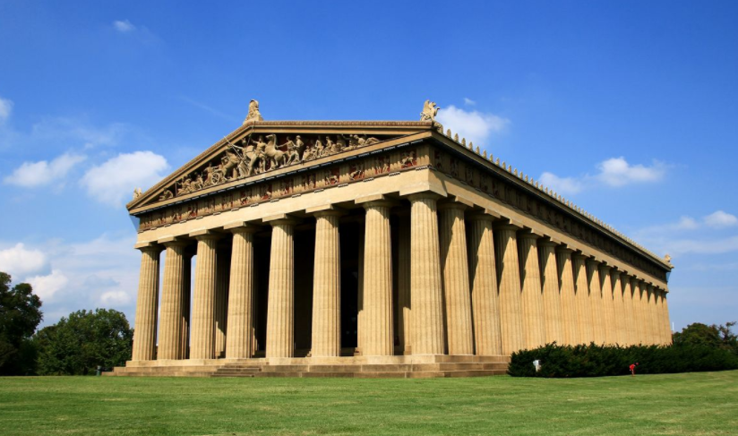

**2.Week1**

I completed drawing three 2D "elevations" (front, top, side).

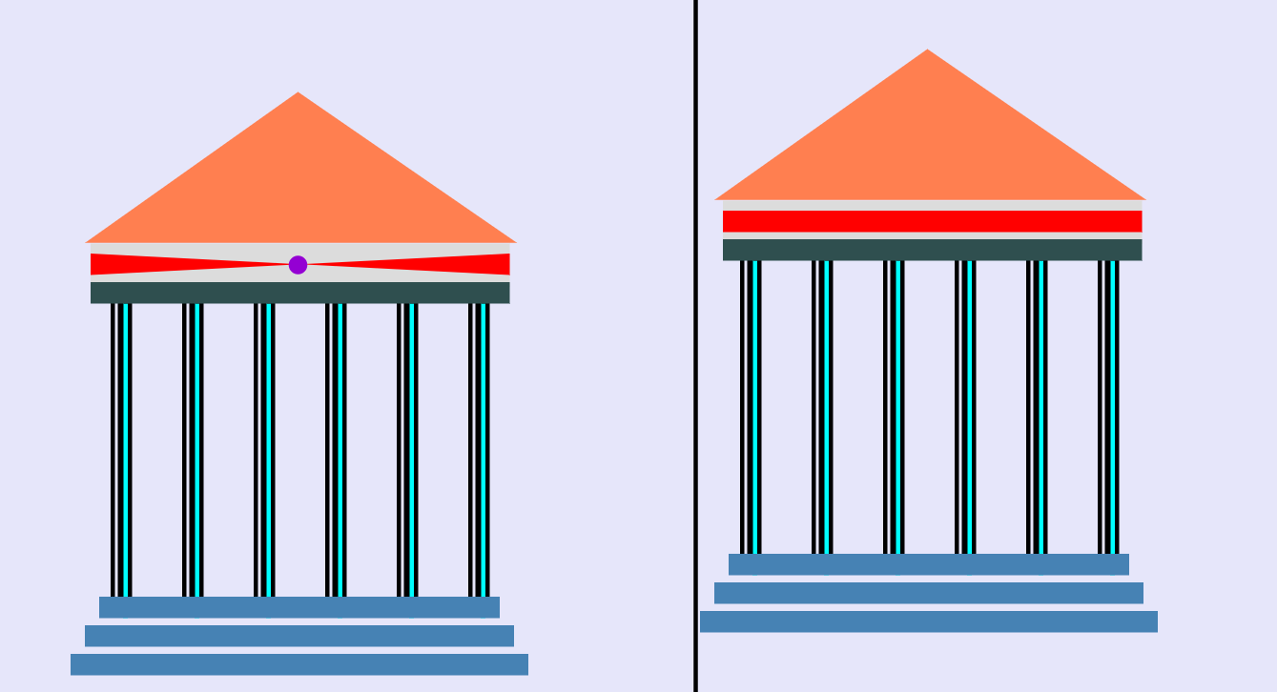

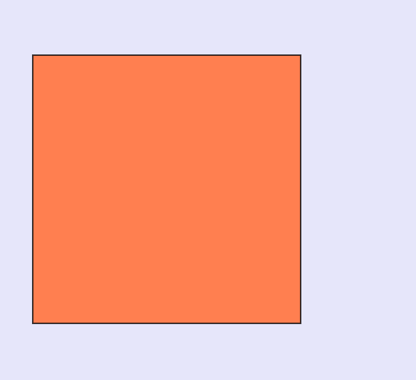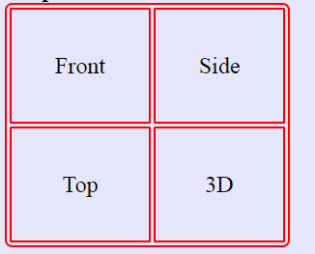

**3.Week2**

I made some transform objects: apply 3D (Translate/Rotate/Scale/SHear)

And I used jQuery to pass my parameters.



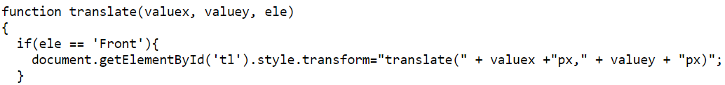

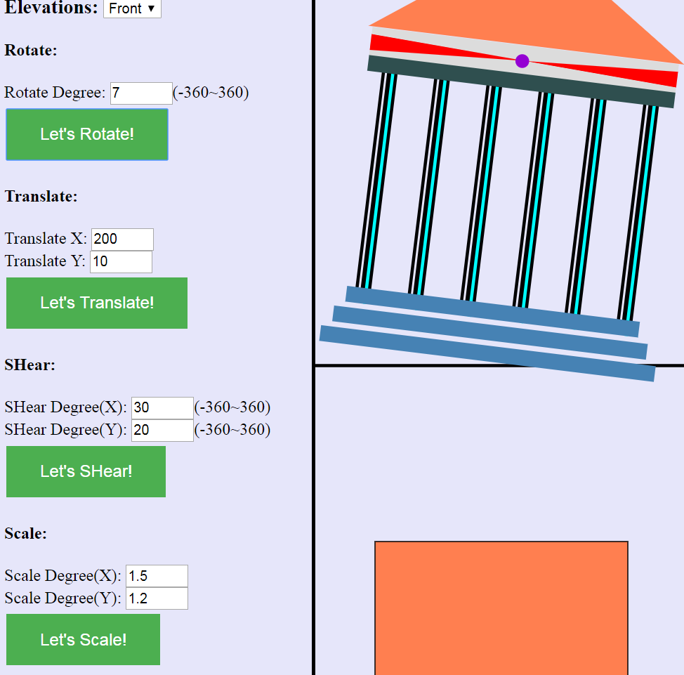

**4.Week3**

I combined 2D elevations to 3D and make it spin, so that I can view my created object from multiple views. And add a new button "Go to Camera/Light", which can link to transform camera/viewer/light sources. I put a cylinder in the side and a cube in the middle, user can click mouse and drag content to view effects of different light sources. The shadow will change according to light direction.

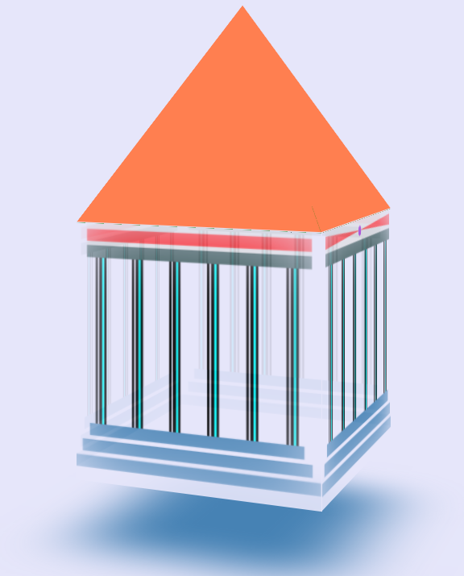 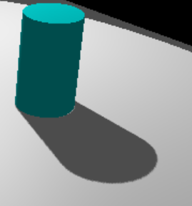

**5.Week4**

Take a cube as a building, I draw “1 point perspective” in left-up side, “2 points perspective” in right-up side, and “3 points perspective” in left-down side. In addition, I added the Isometric of my Parthenon in right-down side.

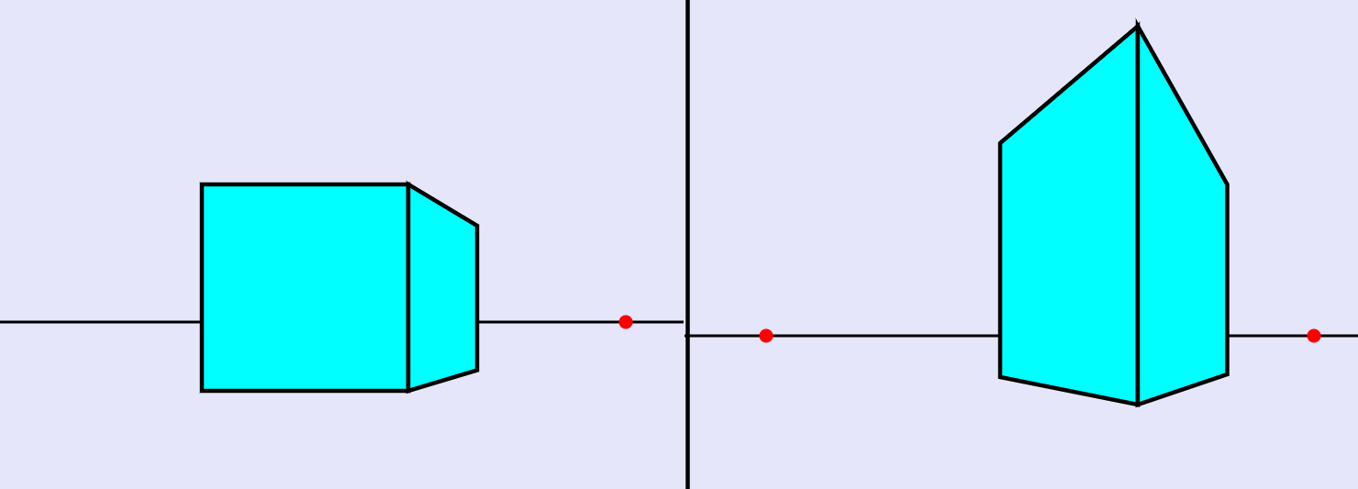

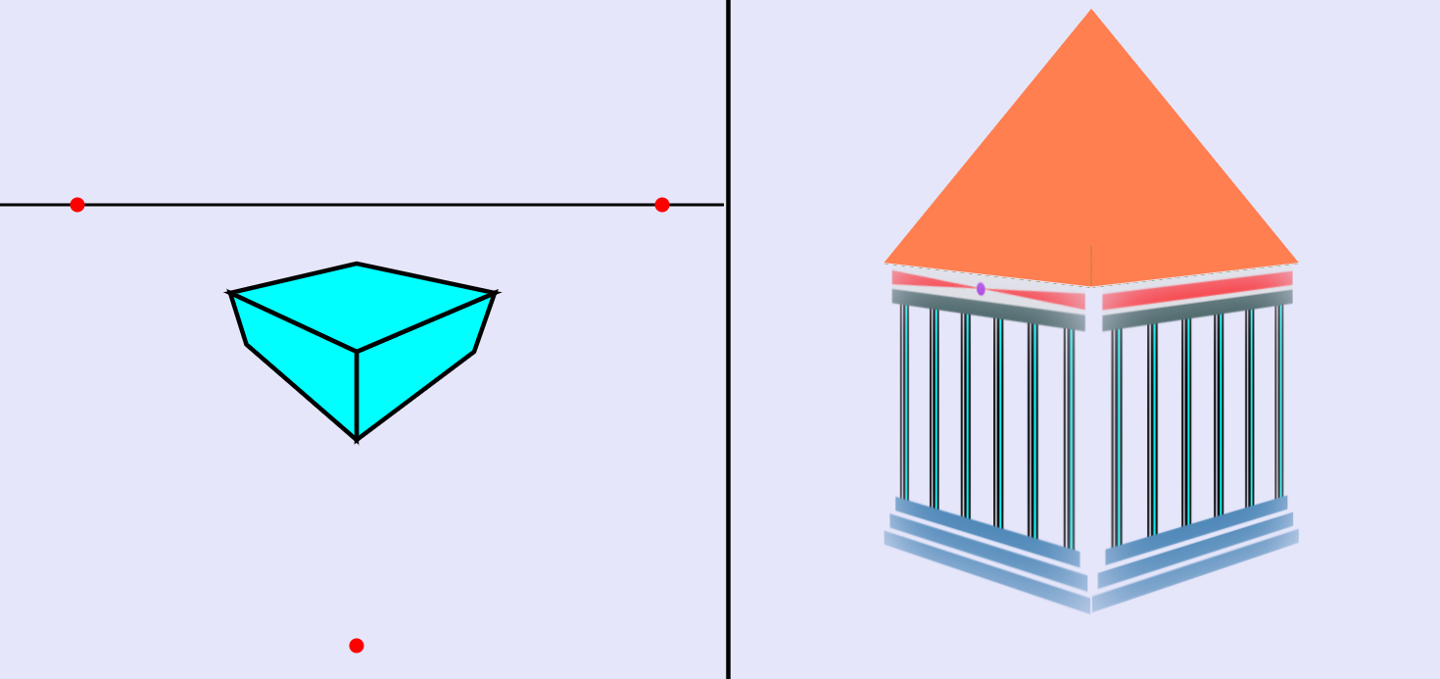

**6.Week5**

According to my 3D objection, I added texture mapping in my objection, and used a nature scene for environmental mapping.

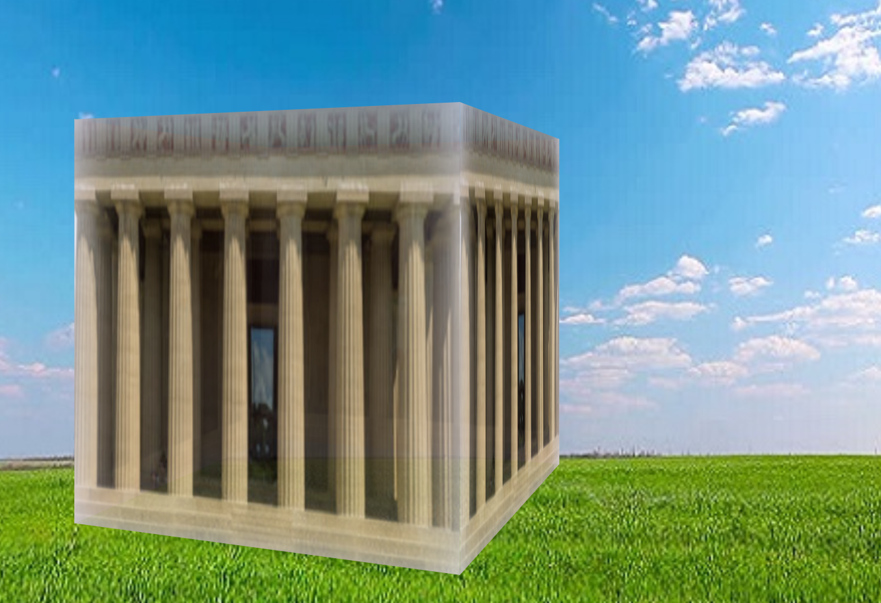

**7. What did I learn**

|  |  |
| --- | --- |
| **Issue** | **Description** |
| How to control variances what you want to change? | I learned how to use jQuery to implement the parameters change, for example, angle degrees, heights or sizes…etc. |
| Html, CSS, JavaScript | Before this class, they are strangers to me. But I am more familiar with them, due to I use them a lot of time in this semester. |
| Draw a graphic | I learned how to use SVG to draw a scalable vector graphic, it includes many functions that I can use to draw different shapes, and do transform functions. |
| Perform a 3D model | Compared to SVG, THREE.js is a better choice. Because it creates and displays animated 3D computer graphics in a web browser. More over, it has PerspectiveCamera function, that is why I choose THREE.js to solve camera and light part. |

**8.Unexpected Events**

|  |  |  |
| --- | --- | --- |
| **Description** | **Impact** | **Actions Taken** |
| Access to Image at 'file:///Users/XXX.png' from origin 'null' has been blocked by CORS policy: Invalid response. Origin 'null' is therefore not allowed access. | Cannot use image file from out source | Tried to bypass CORS, but it still failed. |
| Three.js cannot apply | The 3D functions cannot implement | I downloaded the three.js library documents and put in my project’s folder. The problem solved. |
| Objection location is not I want | Objection was almost gone in the view | To figure out the relative distant with other objections, and find out which one is causing the problem. Make fixation and solve it. |

**9.Conclusion**

Based on real Parthenon picture, I try to draw it or other objects by following methods:

1.(a) Draw three 2D "elevations" (front, top, side) (b) Enter coordinates: choose your model format(s)

2. Transform object: apply 3D (Translate/Rotate/Scale/SHear) transformations to the created object.

3. Viewing: view your created object from multiple views.(in 3d part)

4. Transform camera/viewer/light sources(s).

5. Generate different projections of the objects (refer to class discussions about different projections, see projection "tree" see figure).

6. Edit/Change perspective projection vanishing points (1, 2, 3).

7. Create texture/bump/environmental mappings for the object.

I learned a lot from this class. It helped me get into front-end quickly. And I will keep learning in this field.