Integer Partitions

1. Introduction

1.1 Definition of partitioning

A partition of a positive integer n is written as a sum of positive integers. Same partitions in different orders do not count.

1.2 Examples

Let P(n) output the number of partitions for any number n. By default, P(0) = 1.

1 can be written as 1, hence P(1) = 1.

2 can be written as 1+1 and 2, hence P(2) = 2

3 can be written as 1+1+1, 1+2 and 3. 1+2 is the same thing as 2+1, so it is only counted once. Hence, P(3) = 3.

4 can be written as a 1+1+1+1, 1+1+2, 1+3, 2+2 and 4, hence 𝑃(4) = 5.

1.3 Different representations of the partitions

A partition can be written graphically, as a Ferres diagram, named after the British mathematician Norman Macleod Ferres. For example, 5 = 2+2+1 can be drawn as

2 2 1

. . .

. .

A conjugate for this graph can also be drawn, by swapping the columns with rows.

5=3+2 can be drawn as

3 2

. .

. .

.

Hence, the conjugate of (2,2,1) is (3,2)

If the conjugate of a partition happens to be the same as itself, it is called a self-

conjugate. An example of this is 10 = (4,3,2,1)

4 3 2 1

4 . . . .

3 . . .

2 . .

1 .

Alfred Young created the Young Diagram, which was similar to the Ferres diagram. The

dots are replaced by squares instead.

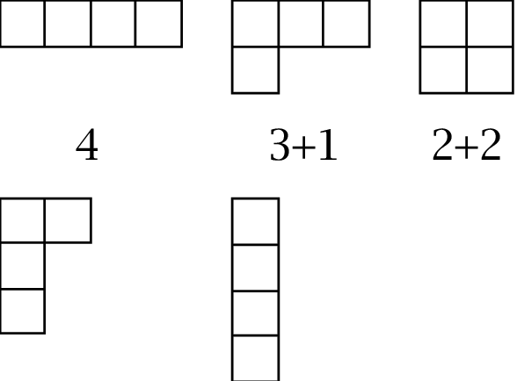

Although Young diagrams are very similar to Ferres diagrams, Young diagrams are very

useful for studying group representation theory and symmetric functions.

1.4 Euler’s Generating Function

Euler discovered several theorems related to integer partitioning, but his generating

function is the greatest. This is given by:



For example, if we want to find the number of partitions of 7, we take the coefficient of x7

(1 + x1 + x1(2) + x1(3) + ….. )(1 + x2(1) + x2(2) + x2(3) + ….. )(1 + x3 + x3(2) + x3(3) + ….. ) …..

Expanding this, we get 1 + x + 2x2 + 3x3 + 5x4 + 7x5 + 11x6 + 15x7 + 22x8 + …..

Hence, the number of partitions of 7 is 15.

1.4.1 Proof using coins

In how many ways can you change one dollar?

Let’s generalize the question.

Let $P_{n}$ denote the number of ways of paying n cents with cents, nickels, dimes, quarters,

and half dollars. This means $P_{4}$ = 1, $P_{6}$ = 2, $P_{10}$ = 4. The problem requires us to find $P_{100}$.

Let’s visualize the various possibilities. We could use no cents, 1 cent, 2 cents, and so

on.

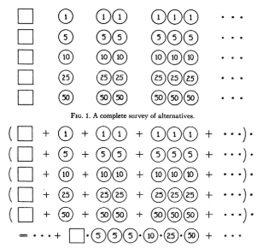



If we have each line of the first figure as the sum of pictures in it and we consider the

product of the five infinite sums, we get the second figure. Once this is expanded, it will

give us the number of different ways of paying. For example, if we take the term with two

coins in line two, it represents paying two nickels.

In order to make this work, we substitute each pictorial variable as a power of a new

variable x. The exponent of x would be the joint value of the coins represented by the

picture. So we have

+ + + … + + …

In this series, the coefficient of $x^{n}$ counts the number of different ways of paying the

amounts of n cents. This is called the enumerating series. We can substitute the

second figure into a geometric series

1 + $x$ + $x^{2}$ + $x^{3}$ + … = $\frac{1}{1-x}$

In fact, this changes each of the first five lines into a geometric series and equation in the second figure. So we have

+ + + … + ..

This sum is usually termed as the generating function. This function expanded in powers of $x$ generates the numbers $P_{0}$, $P_{1}$, …, $P_{n}$, …, our starting point. To get our generating function, we put every single power of $x$ instead of just the coin values. This gives us all the partitions of an integer.

Now we have reduced this combinatorial problem to a different kind of problem. We must expand it in powers of $x$. Let’s assume we have already obtained the expansion of the product of the first two factors.

$(1-x)^{-1}(1-x^{5})^{-1} = a_{0}+a_{1}x+a_{2}{x^{2}}_{}+ ...$,

We can use this to find the expansion for 3 factors

$(1-x)^{-1}(1-x^{5})^{-1} (1-x^{10})^{-1} =$ $b_{0}+b_{1}x+b_{2}{x^{2}}_{}+ ...$

This means

$a_{0}+a_{1}x+a_{2}{x^{2}}_{}+ ...$ = ${(b}_{0}+b_{1}x+b_{2}{x^{2}}_{}+ ...)$ $(1-x^{10})$

If we compare the coefficients of $x^{n}$, we find that

$b_{n}$ = $a_{n}$ + $b_{n-10}$

With this, we can conveniently compute the coefficients of $b_{n}$ if the coefficients of $a_{n}$ are already known. Let’s add a table that computes $P_{50}$.

| n = | 0 | 5 | 10 | 15 | 20 | 25 | 30 | 35 | 40 | 45 | 50 |
| --- | --- | --- | --- | --- | --- | --- | --- | --- | --- | --- | --- |
| ${(1-x)^{-1}}_{}$ | 1 | 1 | 1 | 1 | 1 | 1 | 1 | 1 | 1 | 1 | 1 |
| ${(1-x^{5})^{-1}}_{}$ | 1 | 2 | 3 | 4 | 5 | 6 | 7 | 8 | 9 | 10 | 11 |
| ${(1-x^{10})^{-1}}_{}$ | 1 | 2 | 4 | 6 | 9 | 12 | 16 | 20 | 25 | 30 | 36 |
| ${(1-x^{25})^{-1}}_{}$ | 1 | 2 | 4 | 6 | 9 | 13 |  |  |  |  | 49 |
| ${(1-x^{50})^{-1}}_{}$ | 1 |  |  |  |  |  |  |  |  |  | 50 |

This table yields $P_{50}$ = 50, which means one can pay 50 cents in 50 different ways. Although this table only computes up to $P_{50}$, we can continue this computation and verify that $P_{100}$ = 292.

Another interesting theorem by Euler states that the number of odd-partitions is equal to

the number of distinct parts

(1) Odd parts: A partition of any number n which contains only odd numbers.

(2) Distinct parts: A partition that contains no repeated numbers.

Example:

5 can be written as

(5): Odd part, Distinct part

(4, 1): Distinct part

(3, 2): Distinct part

(3, 1, 1): Odd part

(2, 2, 1)

(2, 1, 1, 1)

(1, 1, 1, 1, 1): Odd part

Hence, we have 3 of each. This makes it that the # of odd parts = # of distinct parts.

1.5 Hardy-Ramanujan’s Asymptotic Expression  
Godfrey Hardy was an English mathematician who had many achievements in number theory. In 1918, him and another mathematician named Srinivasa Ramanujan used the circle method along with modular functions to create an asymptotic solution given by



If we plug in the numbers 20 and 100,

| ***n*** | ***p(n)*** | ***p(n) using formula*** | ***p(n) using formula/p(n)*** |
| --- | --- | --- | --- |
| 20 | 627 | 692.3846405 | 1.104281723 |
| 50 | 204226 | 217590.4992 | 1.065439754 |
| 100 | 190569292 | 199280893.3 | 1.045713563 |
| .  .  . | .  .  . | .  .  . | .  .  . |
| $∞$ | $∞$ | $∞$ | 1 |