FPT UNIVERSITY
CLASS: SE2044
NAME: LÊ GIA HUY - ID: SE204117
PROJECT REPORT: HOMESTAY AND TOUR MANAGEMENT SYSTEM
Introduction
This project is a comprehensive Travel Service Management System developed in Java. It provides a robust Command Line Interface (CLI) to manage three interconnected entities: Homestays, Tours, and Bookings. The system ensures data persistence by reading from and writing to structured text files (.txt).
Problem Analysis
The system is designed to handle the following 10 specific functional requirements:
Add a new Tour: Create tours with ID, name, time, price, and linked Homestay ID.
Update a Tour: Modify existing tour information by ID.
List Past Tours: Filter and display tours with departure dates earlier than today.
Future Revenue Analysis: Calculate and sort potential revenue (Price * Tourists) for upcoming tours.
Add a new Booking: Create reservations while validating tour availability and booking dates.
Remove a Booking: Cancel a reservation and restore the tour's availability status.
Update a Booking: Modify customer details or linked tour information.
Search Functionality: Find bookings by full name or partial name matches.
Business Statistics: Generate reports on total tourists handled by each specific Homestay.
Data Persistence: Ensure all changes are saved back to Tours.txt and Bookings.txt upon exiting.
Computational Thinking
Decomposition
The project is divided into specialized packages:
model: Contains data structures (Homestay, Tour, Booking).
business: Contains logic managers (HomestayManager, TourManager, BookingManager).
tool: Contains utility classes for input handling (Inputter) and validation (Acceptable).
data: Bookings.txt, Tours.txt, Homestays.txt
dispatcher: Main.java
Pattern Recognition
Validation Pattern: Uses Regular Expressions (Regex) defined in Acceptable.java to ensure IDs (T00001, B00001), phone numbers, and date formats are consistent.
File I/O Pattern: Uses StandardCharsets.UTF_16 for Homestays and UTF_8 for others to handle special characters in addresses.
Abstraction
The system abstracts complex file operations into simple readFromFile() and saveToFile() methods.
The Inputter class abstracts the Scanner logic, providing clean methods like getDate() or inputAndLoop().
Algorithm Design (Key Functions)
Case 4 (Sorting):
Input: Current date.
Process: Filter tours where departureDate > today. Sort using Comparator based on the product of price and numberOfTourist.
Output: A descending list of future revenue.
Case 9 (Statistics):
This algorithm correlates three lists: It iterates through Homestays, finds related Tours via homeId, and aggregates numberOfTourist from the Bookings list.
OOP Design
Inheritance: TourManager, HomestayManager, and BookingManager all extend ArrayList<>, allowing them to act as both a data collection and a logic handler.
Encapsulation: Uses private fields and public getters/setters in all model classes to protect data integrity.
Interface: Acceptable acts as a contract for validation constants and static matching methods.
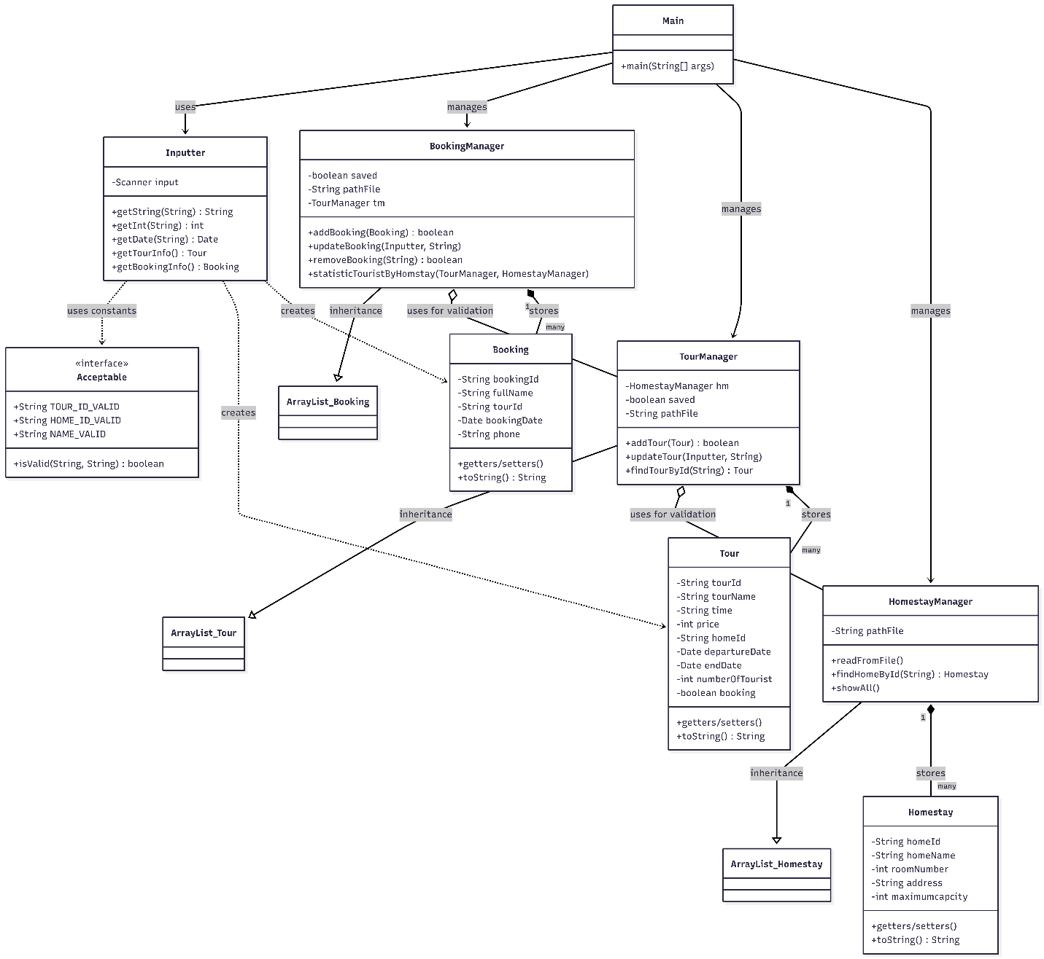

Flowchart
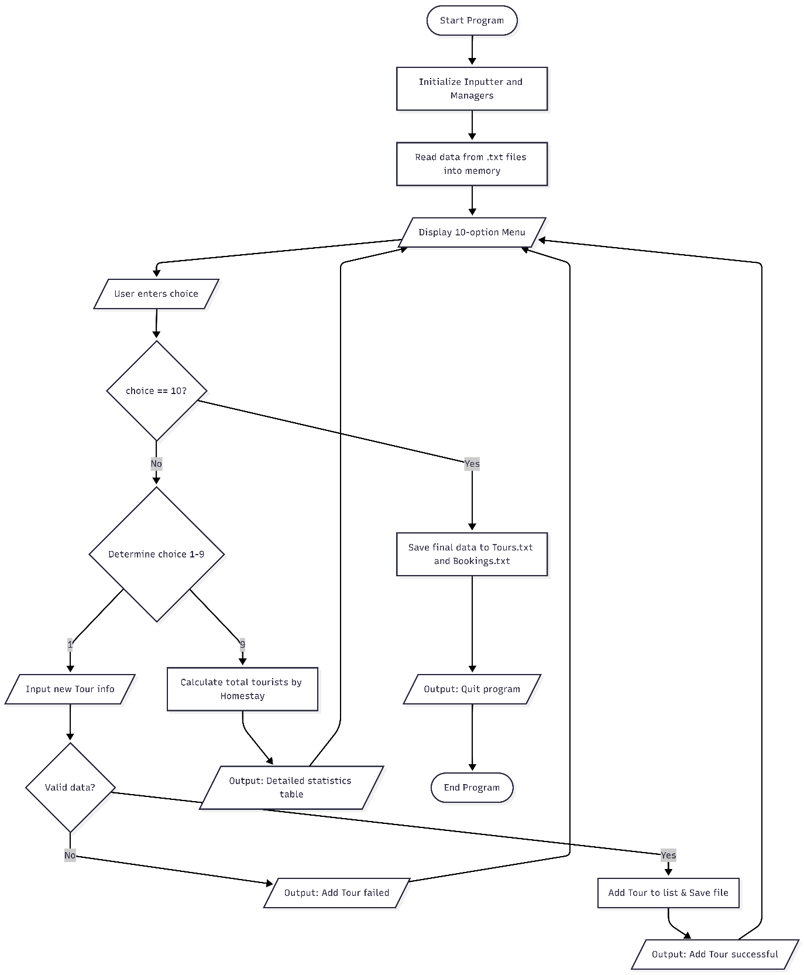
CONCLUSION
The system successfully integrates all 10 required functions. By utilizing Computational Thinking and OOP principles, it provides a reliable solution for travel management with strict data validation and persistent storage.

