SP2026
CLASS:SE2044
NAME: LE GIA HUY
ID: SE204117
REPORT-LAB3 : SOFTWARE DEVELOPER MANAGEMENT
1.Introduction
The Developer and Project Management System is a Java-based application designed to streamline the management of software personnel and their assigned technical projects. The system facilitates core administrative tasks, including tracking developer skills (programming languages), managing project timelines, and ensuring data persistence through file-based storage. It aims to provide a robust structure for organizations to monitor resource allocation and developer experience.
2.Problem Analysis
Organizations often struggle to maintain accurate records of which developers are assigned to specific projects and what their total professional experience entails. Key challenges addressed by this system include:
Data Integrity: Ensuring that developers cannot be removed if they are currently assigned to active projects.
Input Validation: Preventing errors such as invalid IDs, negative salaries, or incorrect date formats using strict regular expressions.
Relationship Management: Maintaining a logical link between a Dev entity and a Project entity.
Persistence: Safely storing information in developers.txt and projects.txt to prevent data loss between sessions.
3.Computational Thinking Decomposition
The system is broken down into smaller, manageable modules:
Model Layer: Defines the structure of data (Dev.java, Project.java).
Business Layer: Contains the logic for managing collections (DevManager.java, ProjectManager.java).
Tool Layer: Handles reusable utilities for user input and data validation (Inputter.java, Acceptable.java).
Dispatcher: The entry point that manages the user interface and program flow (Main.java).
3.1 Pattern Recognition
Several recurring patterns were identified and utilized:
CRUD Operations: Standardized methods for Creating, Reading, Updating, and Deleting records across both Developers and Projects.
Data Parsing: Recognizing the CSV (Comma Separated Values) pattern in text files to convert raw strings into objects.
Validation Patterns: Using Regex for consistent checks on IDs (e.g., DEV001, PROJ01) and names.
3.2 Abstraction
The system hides complex implementation details from the user:
Input Handling: The user only sees a prompt, while the Inputter class handles the complexity of loops and validation.
Data Storage: The user "Saves" data without needing to know how BufferedWriter or OutputStreamWriter manages file encoding.
Interface: The Acceptable interface abstracts validation constants, making the code cleaner and more maintainable.
3.3 Algorithm Design
Key algorithms implemented include:
Experience Calculation: Iterating through the project list to sum durMonths for a specific devId.
Sorting: Utilizing Collections.sort with a lambda comparator to arrange developers by salary in ascending order.
Referential Integrity Check: An algorithm that searches for a devId within the Project list before allowing a deletion in the Developer list.
4.OOP DESIGN (UML)
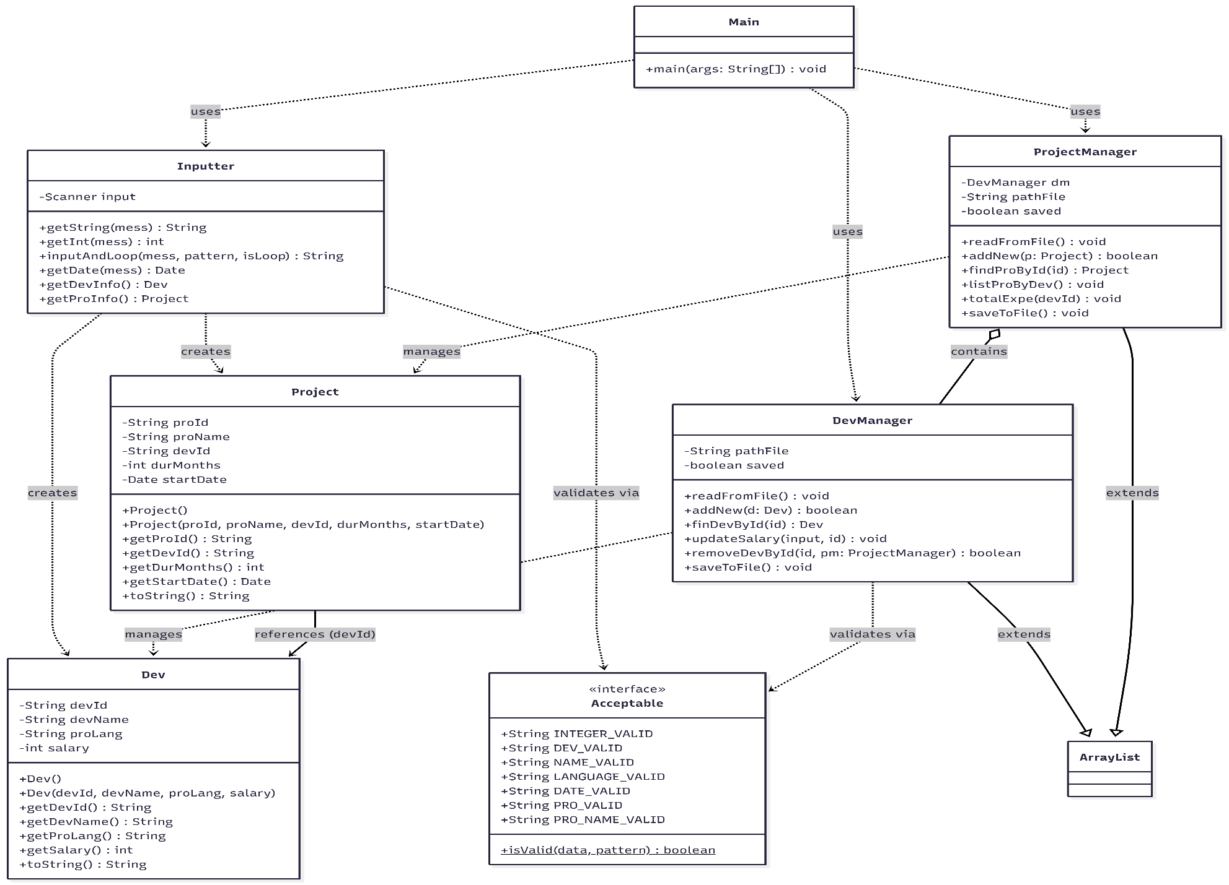
5.FLOWCHART
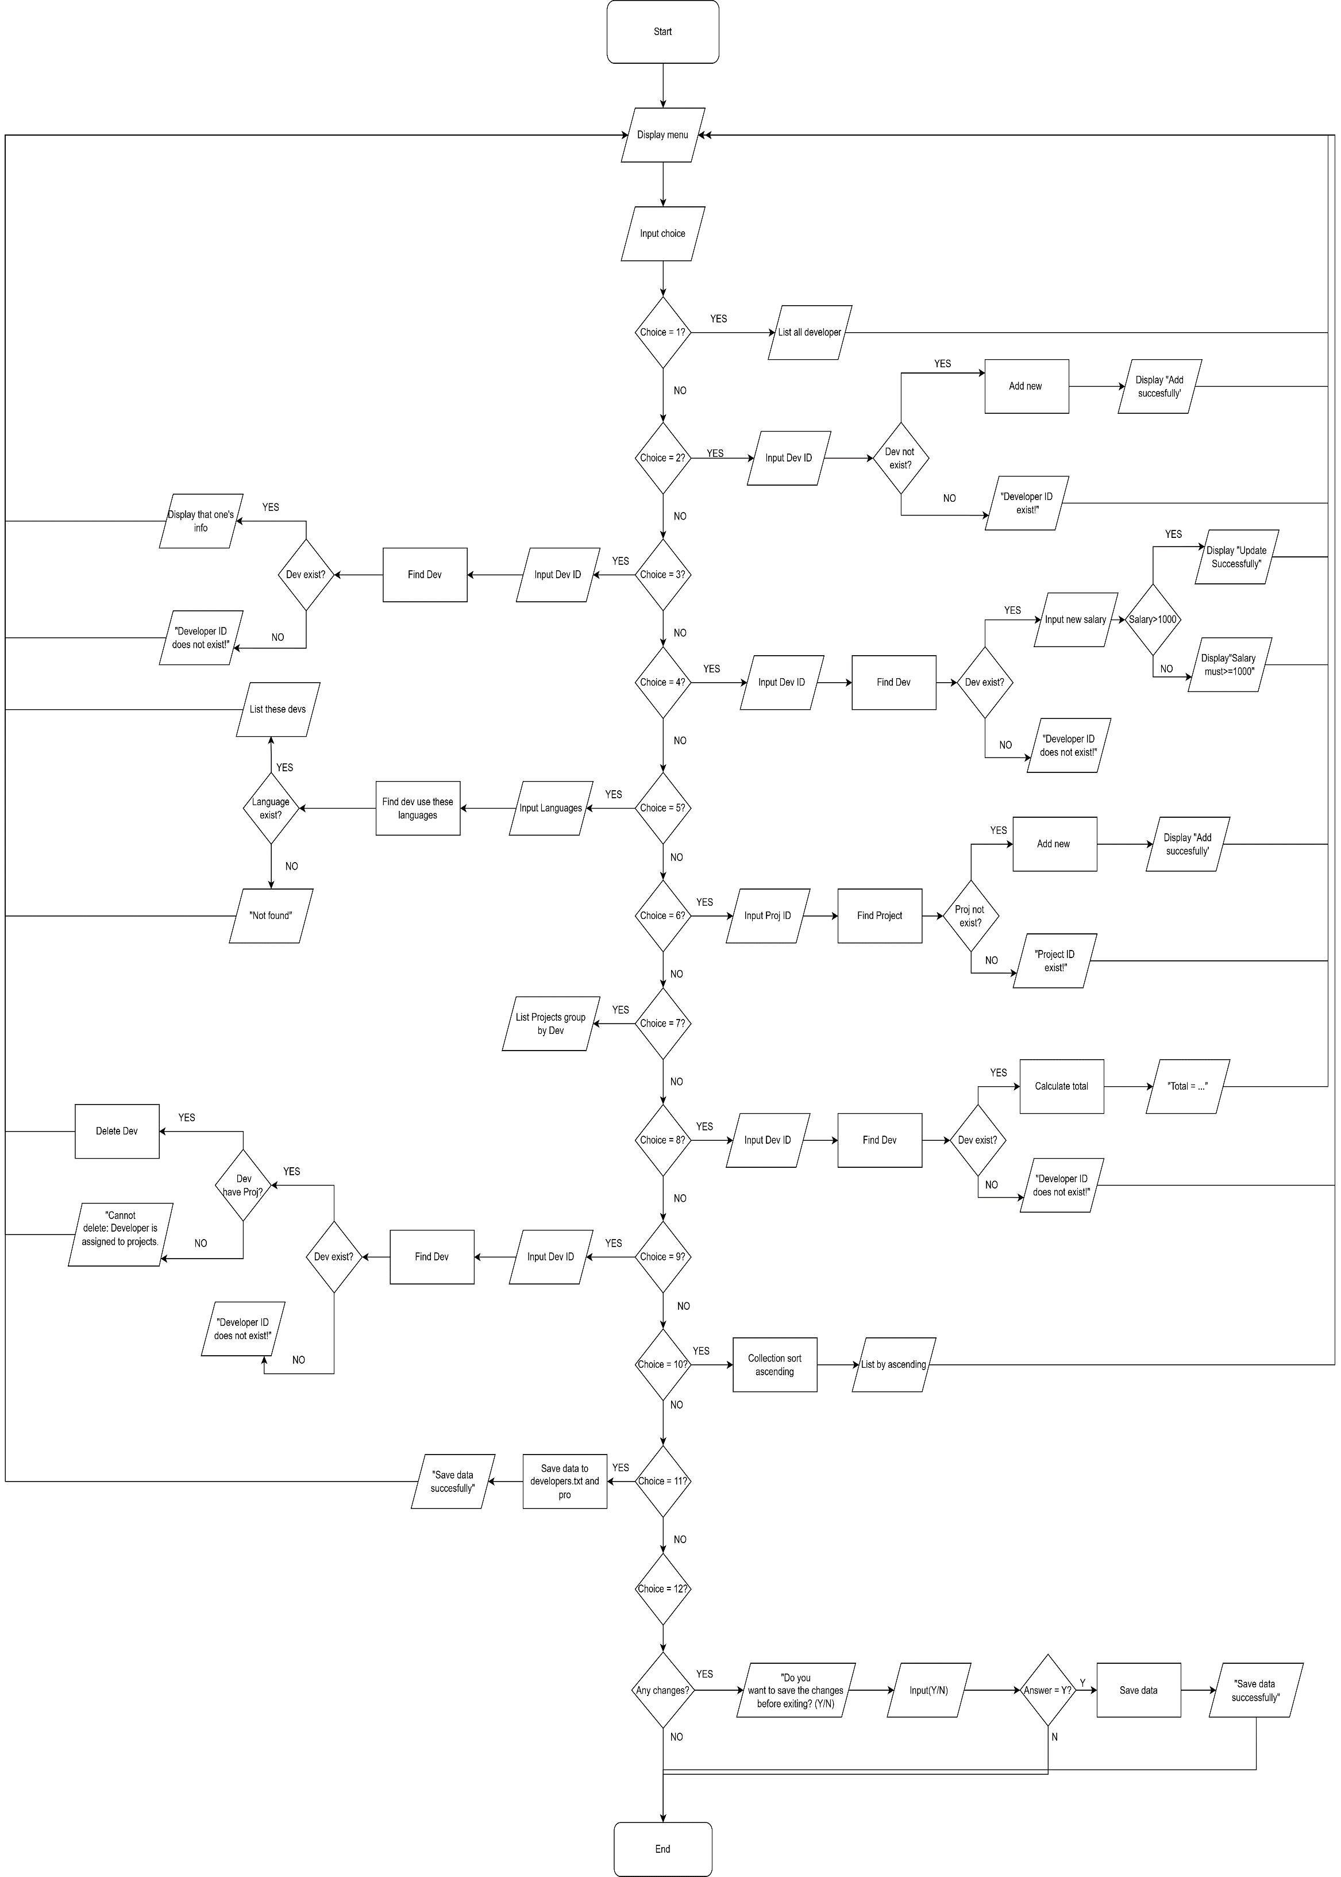

6.CONCLUSION
Project demonstrates that robust software is built on logical constraints. By decomposing the problem and implementing strict validation and referential integrity checks, the system ensures that the data remains consistent and reliable. The design reflects a disciplined approach to computational thinking, ensuring the system is maintainable and logically sound.

