Class diagram for Evacuation management system :

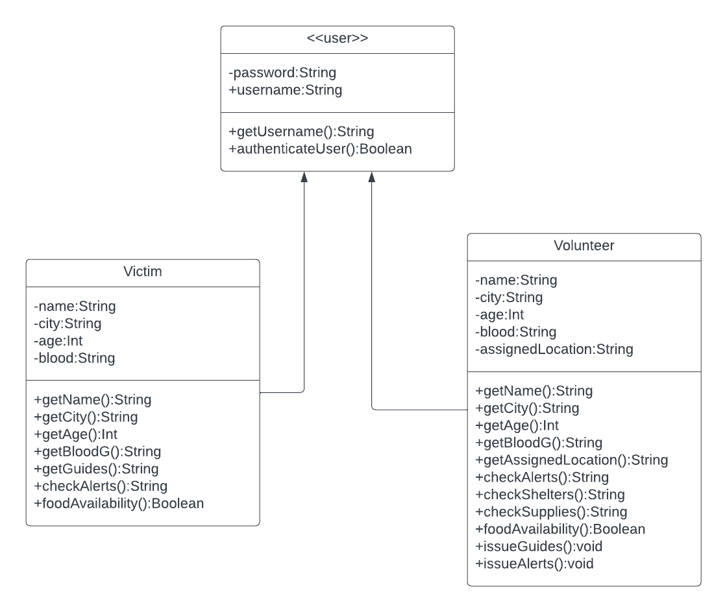

This is a simple class diagram showing the various uses of the class diagram which is useful to show relationships between classes and the various functions of the classes in a single diagram.

>The user class is a base class which has the attributes of username and password for the purpose of logging in and registering

>The Victim class is a inherited class used for victims in evacuation sites and victims of a disaster

>The Volunteer class is an inherited class used for volunteers who have signed in to help those victims who have been stranded and in shelters.