The Evacuation management system:

Description:

This is a simple app made using Visual studio 2022 and and the Microsoft express sql server

The IDE has a built-in designing tool to help visualize the output of the form quickly which is used in this project to speed up development.

LOGIN SCREEN: (FORM 1)

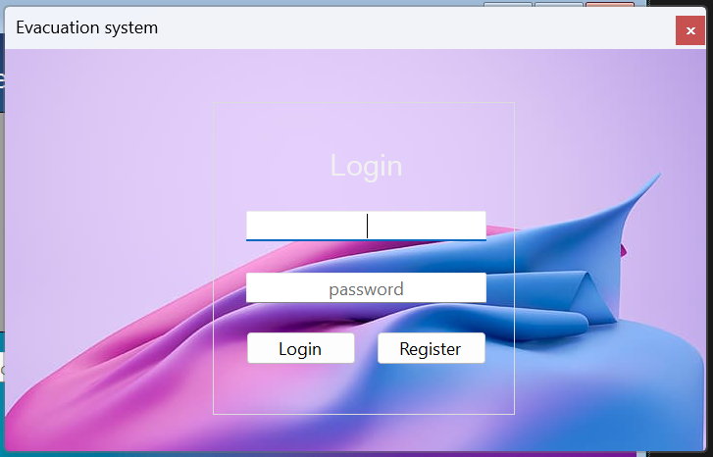

AFTER LOGIN :

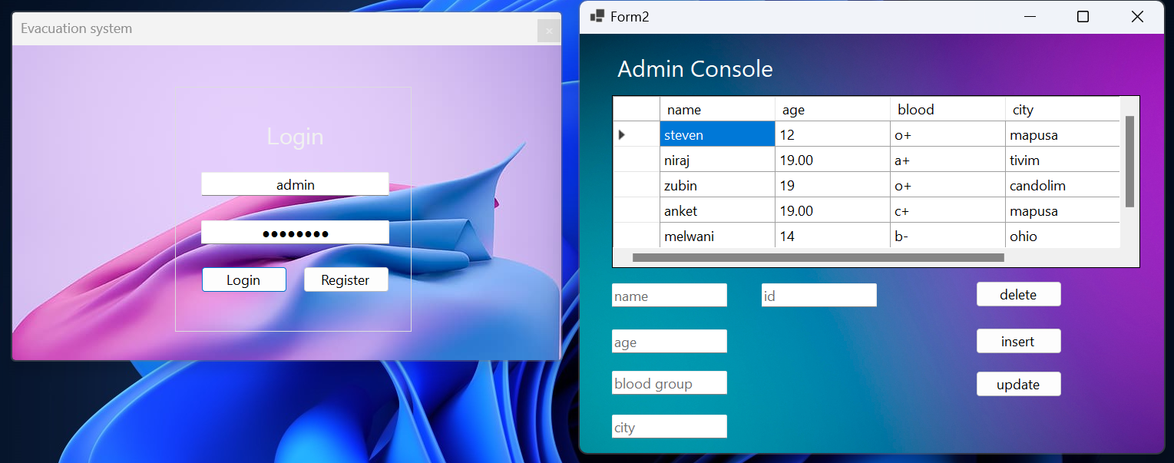

THE DATABASE VIEWER: (FORM 2)

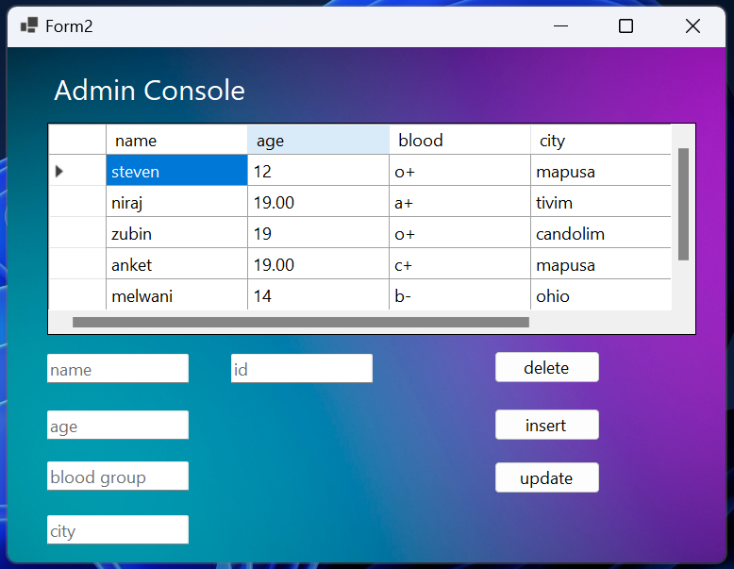

CRUD OPERATIONS:

CREATE:

Inserting a new entry into the database using the insert button

New data entry:

{

name:chloe

age:18

blood:a+

city:mumbai

id:534

}

Before:

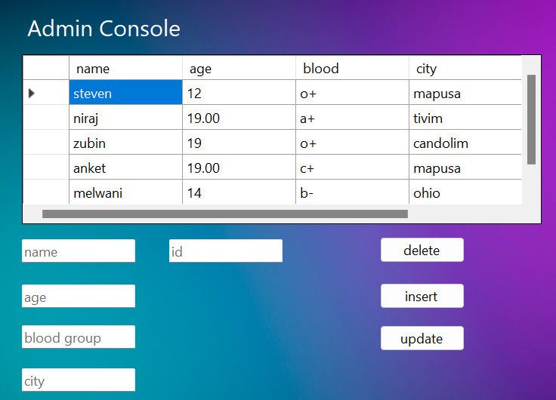

After:

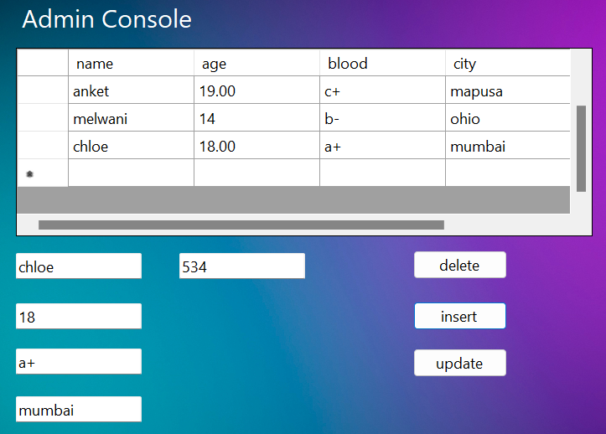

UPDATE:

Updating entry in the database using the update button

Edited entry:

{

name:chloe

age:**19**

blood:a+

city:mumbai

id:534

}

Before updating:



After updating:

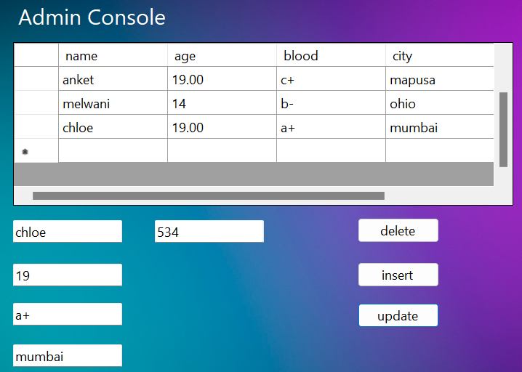

DELETE:

Deleting entry in the database using the delete button

Entry to be deleted:

{

name:chloe

age:19

blood:a+

city:mumbai

id:534

}

Before:



After:

