;WALP to check if the number is positive or negative(-51H)

section .data

pos_msg db "The number is positive",13,10

len1 equ $-pos_msg

neg_msg db "The number is negative",13,10

len2 equ $-neg_msg

section .text

global _start

_start:

mov eax,-51h

rol eax,1

jc neg

mov ecx,pos_msg

mov edx, len1

mov ebx,1

mov eax,4

int 80h

jmp exit

neg:

mov ecx,neg_msg

mov edx, len2

mov ebx,1

mov eax,4

int 80h

jmp exit

exit:

mov eax,1

int 80h

OUTPUT: IF NUMBER IS NEGATIVE (-51H)

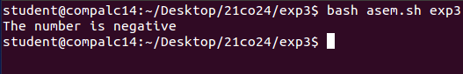

;WALP to check if the number is positive or negative(51H)

section .data

pos_msg db "The number is positive",13,10

len1 equ $-pos_msg

neg_msg db "The number is negative",13,10

len2 equ $-neg_msg

section .text

global _start

_start:

mov eax,51h

rol eax,1

jc neg

mov ecx,pos_msg

mov edx, len1

mov ebx,1

mov eax,4

int 80h

jmp exit

neg:

mov ecx,neg_msg

mov edx, len2

mov ebx,1

mov eax,4

int 80h

jmp exit

exit:

mov eax,1

int 80h

IF NUMBER IS POSITIVE (51H)

